**Mini Project 1**

Adarsh Raghupati NetID: axh190002

Contribution: Question 1 a) b) 1,2,3,4,5

Keerti Keerti NetID: kxk190012

Contribution: Question 2 and Question 1 b) 6 and c

Question 1:

It is given that XA and XB follow independent exponential distributions with mean 10 years.

*λ* = 1*/*10

= 0.1

Lifetime of satellite = Max(XA, XB)

Given E(T) = 15

1. probability that the lifetime of the satellite exceeds 15 years = P( X > 15)

1. Monte Carlo approach to compute E(T) and P(T > 15):
2. One draw of the block lifetimes XA and XB

set.seed(100) #Setting seed to 100

x_a = rexp(1,0.1) #Draw for XA

x_b = rexp(1,0.1) #Draw for XB

T = max(x_a,x_b) #lifeTime = 9.242116

One line code for above operation:

Satellite life time T = max(rexp(1, 0.1), rexp(1, 0.1))

1. Repeating the previous step 10,000 times.

T = replicate(10000, max(rexp(1, 0.1), rexp(1, 0.1)))

#Used replicate function of R to draw 10000 times

1. Histogram of the draws. Using hist and curve functions

hist (T, probability = TRUE, breaks = 100)

Superimposing the density function given above

curve (0.2*exp(-0.1*x)-0.2*exp(-0.2*x), col ="red", add=TRUE)

Observation: From the below figure we can see that histogram values and density curve values are similar.

Hence it can be said that there is good agreement between density and histogram

1. Estimating E(T)

mean Value = mean(T) # R code to find mean

mean Value = 14.90889

Mean value from 10000 draws is very near to the given value 15

1. Estimate of P(x > 15) from saved samples:

P(x > 15) = 0.3921

Obtained from R code:

length(which(T>15))/length(T)

Probability value found in part (a) is 0.3964 which is very near to the computed value from the sample

1. Repeating above process 4 more times:

|  |  |  |
| --- | --- | --- |
| Trial # | E(T) | P(X > 15) |
| 1 | 15.16428 | 0.3982 |
| 2 | 14.88494 | 0.3933 |
| 3 | 14.9092 | 0.3971 |
| 4 | 14.96616 | 0.3979 |

1. Repeating the similar process with 1000 draws

|  |  |  |
| --- | --- | --- |
| Trial # | E(T) | P(X > 15) |
| 1 | 15.16085 | 0.407 |
| 2 | 14.96916 | 0.394 |
| 3 | 14.9932 | 0.386 |
| 4 | 14.52492 | 0.374 |
| 5 | 14.26848 | 0.368 |

Repeating the similar process with 100000 draws

|  |  |  |
| --- | --- | --- |
| Trial # | E(T) | P(X > 15) |
| 1 | 14.98211 | 0.39737 |
| 2 | 14.99169 | 0.39381 |
| 3 | 15.04843 | 0.3969 |
| 4 | 14.99765 | 0.39611 |
| 5 | 15.006 | 0.39532 |

Observation: From the above two tables we can observe that estimated value with 100000 draws is more accurate than estimation with 1000 draws. When the values of 10000 draws is compared to the estimate of 100000 draws we can see that there is no significant change in the accuracy. Hence it can be concluded that accuracy of estimated value becomes better with the increase in number of draws upto certain limit.

Question 2: Use a Monte Carlo approach estimate the value of π based on 10,000 replications.

Firstly, considering a square with co-ordinates (0,0) (0,1) (1,0) (1,1) and inscribing a circle with the center at

(0.5,0.5).

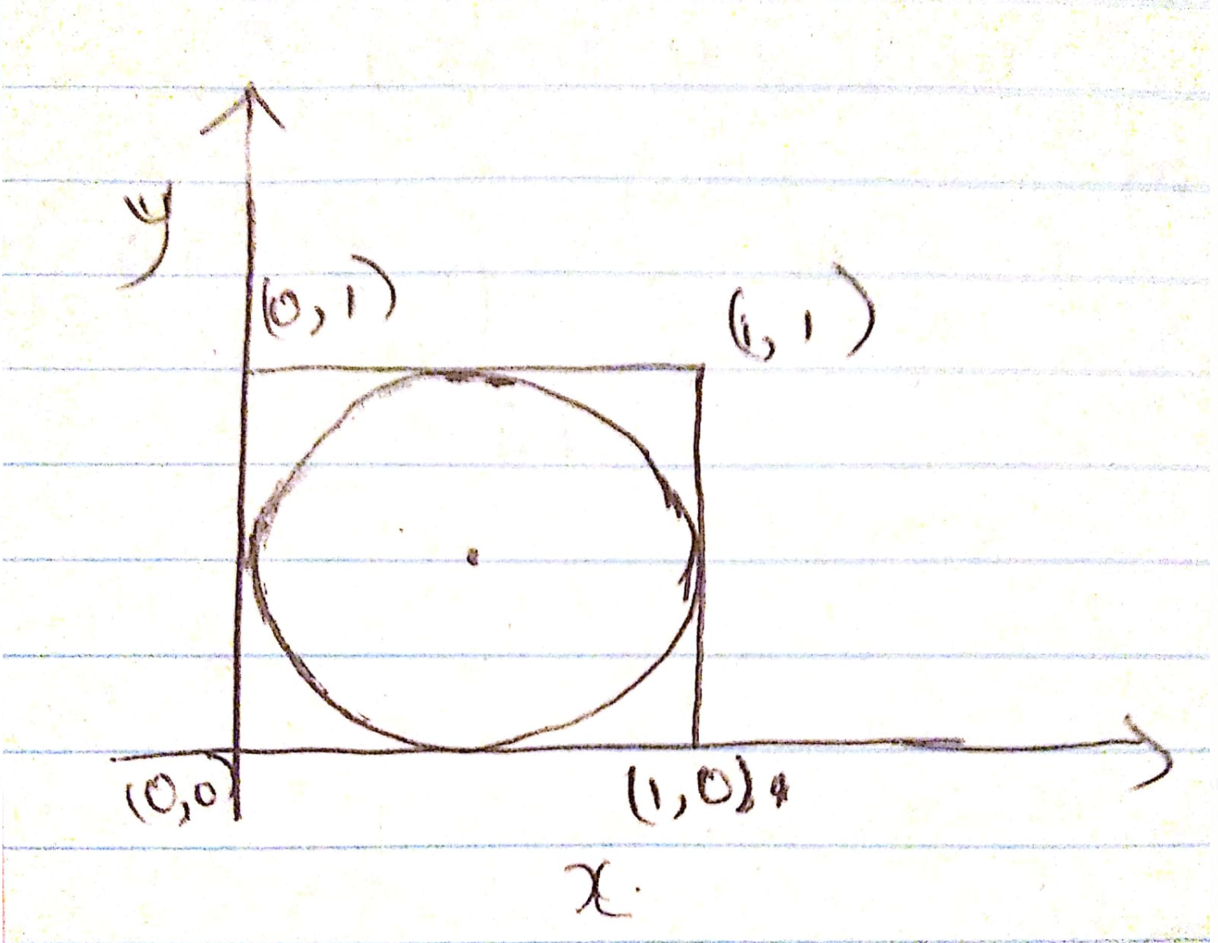

The probability of the points being inside the circle or on the circle is =

(Area of the circle) / (Area of the square)

(Π * radius ^2) / (side^2)

(Π * 0.5*0.5) / (1*1)

(Π * 0.25)

i.e., The probability of the points being inside the circle or on the circle is = (Π * 0.25)

**The probability of the points being inside the circle or on the circle is * 4 = (Π) -------equation 1**

**Estimating the above rules using R simulation:**

// generate random uniformly distributed 10000 numbers from 0-1

> x = runif(10000)

> y = runif(10000)

> plot(x,y)

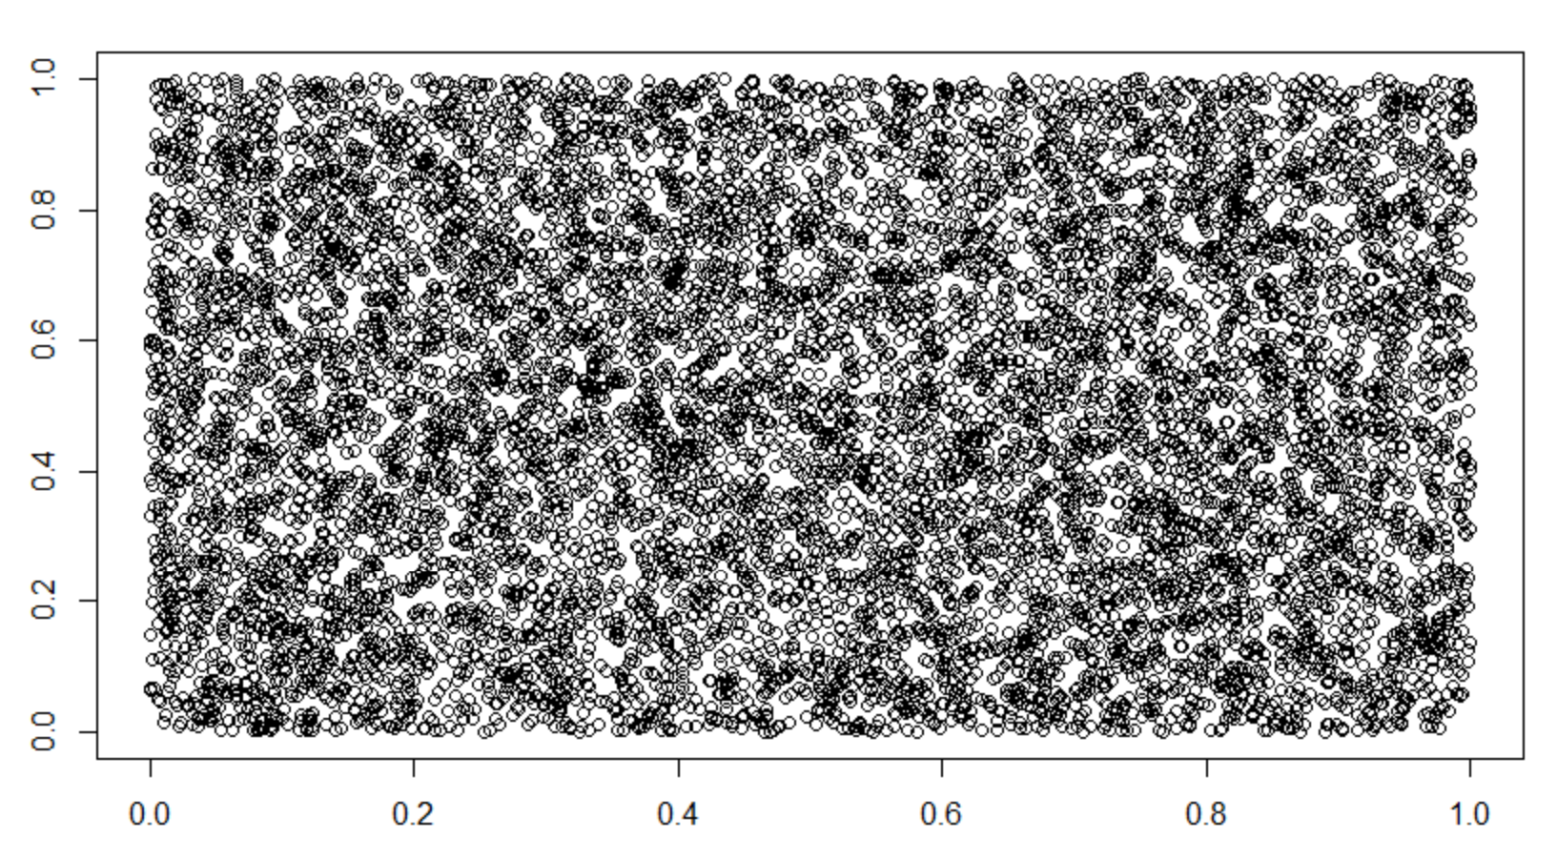

p = mean((x-0.5)^2+(y-0.5)^2 <= 0.25)

> print("Value of pi : ")

[1] "Value of pi : "

> print(4*p)

[1] 3.1324

Hence using the random uniformly generated points, the probability of any point lying inside the circle is 0.7831.

The value of pi then will be = 4*0.7831(using Equation 1) = 3.1324 ~ actual value of pi 3.14159.