**Homework 1**

**Student Name:** Keertikeya Gupta

**SJSU ID:** 010034700

**Solution a)**

Assumptions for this solution are:

1. The date of purchase of a drug from a particular pharmacy is also recorded.
2. A Pharmaceutical company has to manufacture at least one drug.

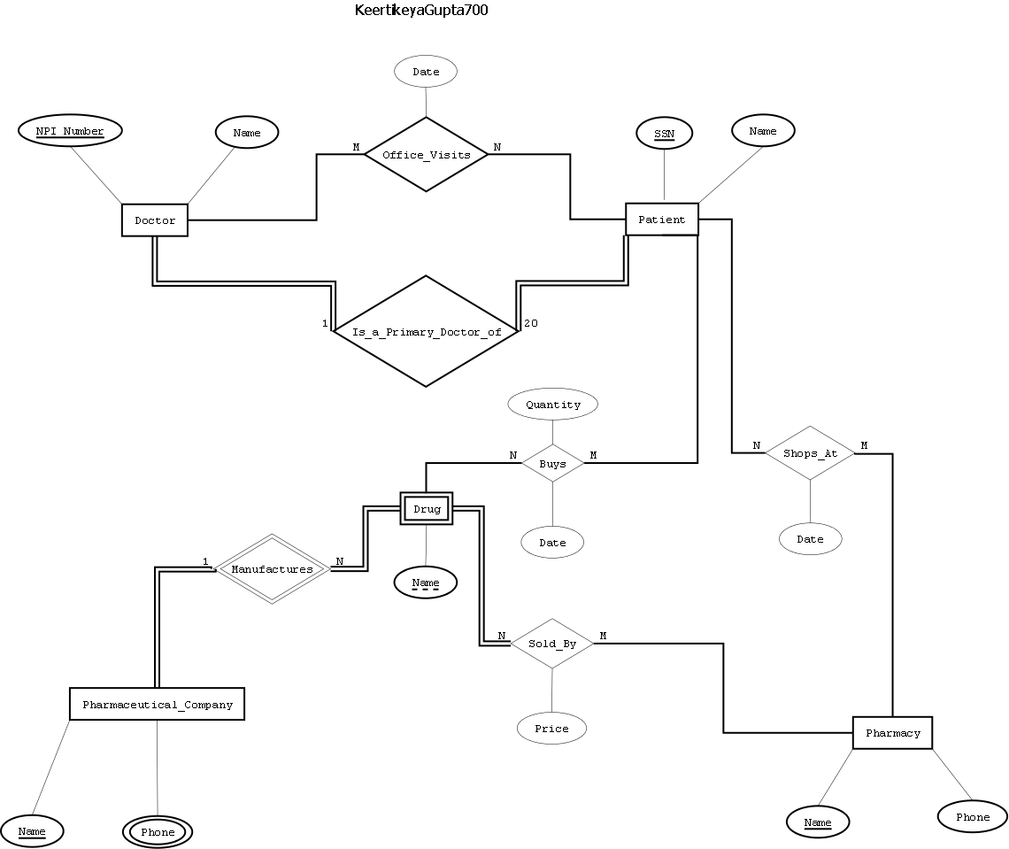

**Solution b)**

Assumptions for this solution are:

1. The date of purchase of a drug from a particular pharmacy is also recorded.
2. A Pharmaceutical company has to manufacture at least one drug.

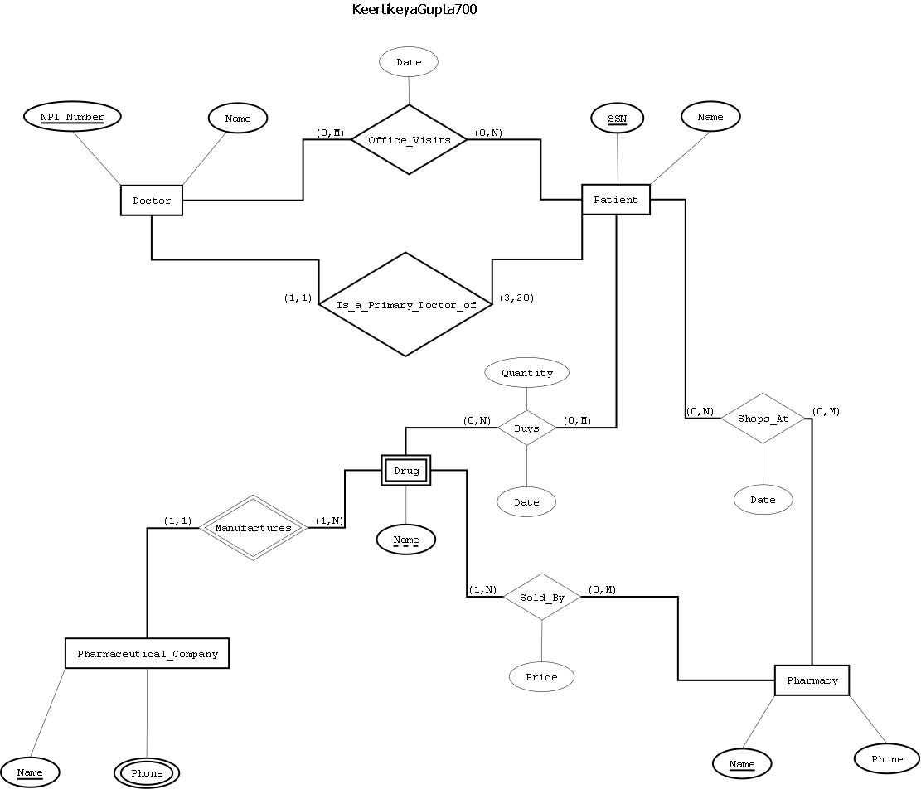

**Solution c)**

Both the regular ER diagram and the one with Min/Max notations are mostly similar to each other. The major difference between them shows when it comes to expressing the requirements of the system.

In terms of expressing the requirements, the ER Diagram with Min/Max notations provides more power than the regular ER diagram. The regular ER diagram works perfectly in case where the minimum participation of an entity in a relationship is either 0 or 1. However, it fails in case where the minimum participation of an entity is supposed to be more than 1. Using the Min/Max notations in the ER diagram solves this problem.

Consider, for example, the requirement that “Each Doctor is the primary Doctor of at least 3 up to 20 patients”. The regular ER diagram fails to show the minimum number of 3 here, and can show only 0 or 1. The diagram with Min/Max notation captures this requirement perfectly.

**Solution d)**

The software tool used for solutions a and b is Dia.