**Soln 1)**

**Assumption**: A customer may have multiple phone numbers.

(Link for diagram without this assumption: *https://drive.google.com/open?id=0B9QcN2kMKM_9VkMxdjJ6TmVQQk0*)

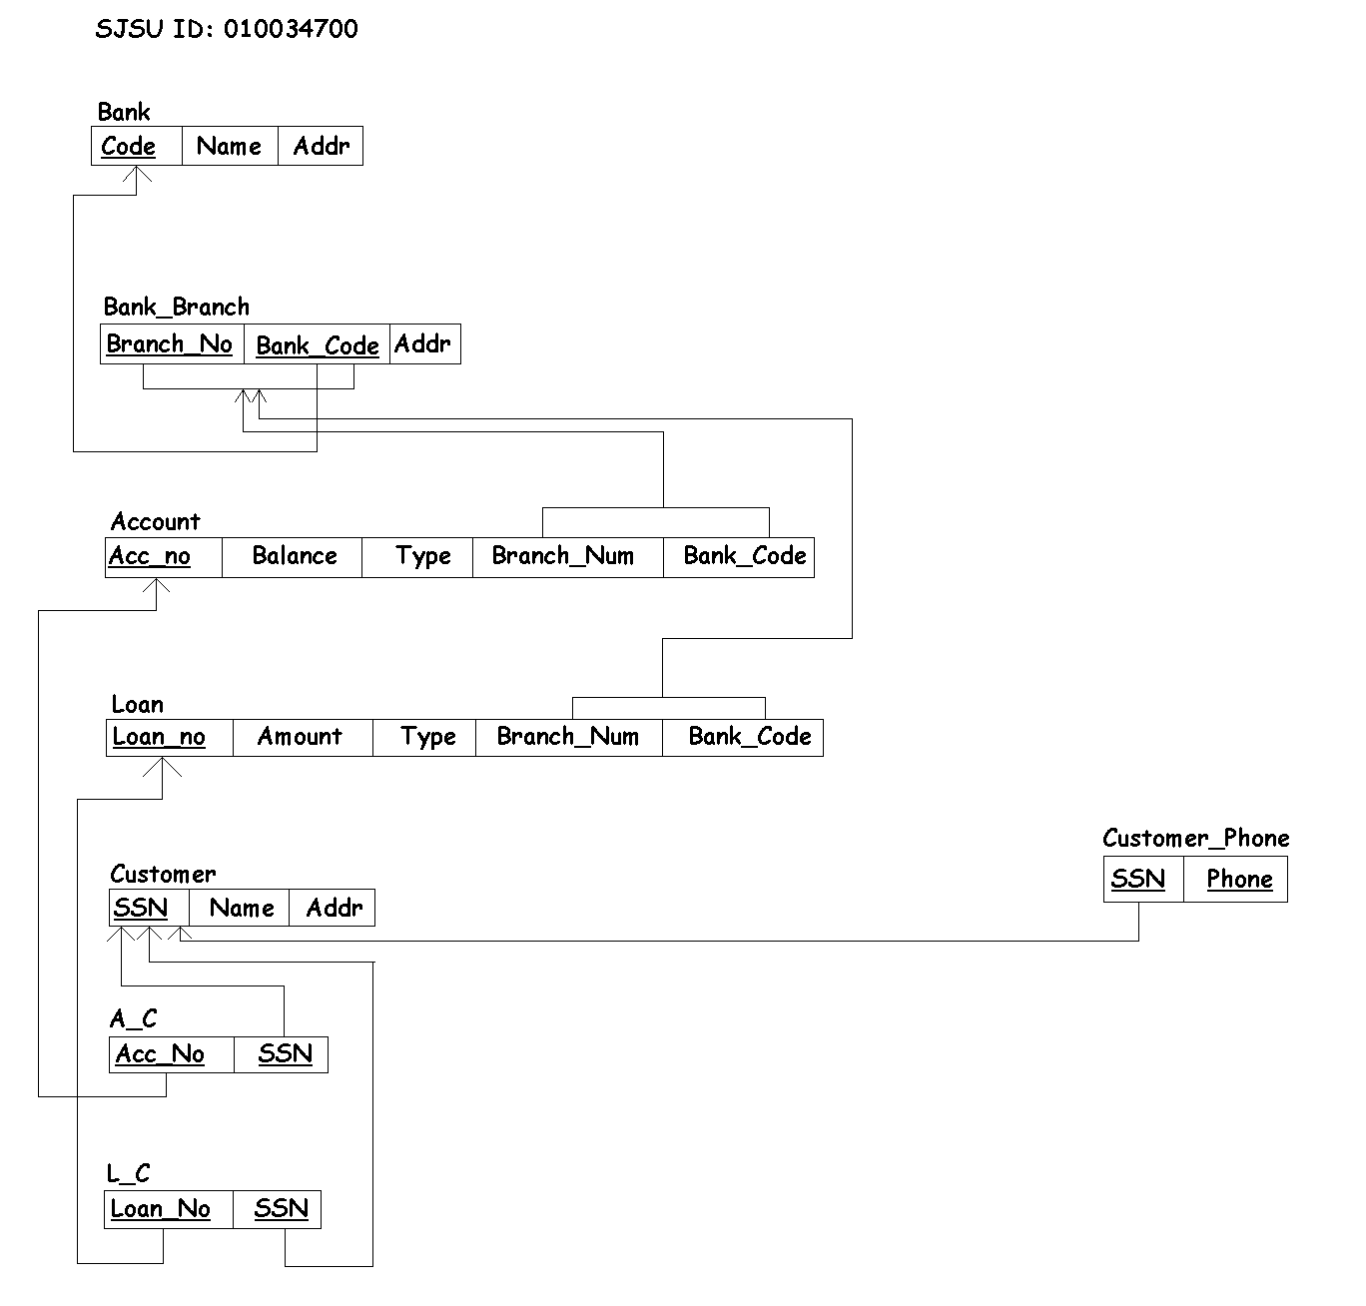

**Soln 2. a)**

**1NF – YES**

* Has a PK and all columns other than PK depend on PK
* No multivalued/composite attributes
* No nested relations or repeating attributes

**2NF – NO**

* All non-key columns are not fully functionally dependent on the PK.
* There are partial dependencies ( {A}->{D,E} and {B}->{F} )

**3NF – NO**

* Not 2NF
* There are transitive dependencies ( {A}->{D,E}, {D}->{I,J}, {B}->{F}, {F}->{G,H} )

**Soln 2.b)**

For 1NF:

R = {A, B, C, D, E, F, G, H, I, J}

Here all non-PK columns depend on the PK.

For 2NF

The table in 1NF form has a PK, but there are partial dependencies present in the table. Hence, to normalize to 2NF, we have to remove those partial dependencies.

R1 = {A, B, C} {A, B} -> {C}; no partial dependencies

R2 = {A, D, E, I, J} {A} -> {D, E} and {D} -> {I, J}; {A} -> {I, J}; no partial dependencies

R3 = {B, F, G, H} {B} -> {F} and {F} -> {G, H}; {B} -> {G, H}; no partial dependencies

For 3NF

The tables in 2NF do not contain partial dependencies, however, there are transitive dependencies present there. For 3NF normalization, we remove the transitive dependencies.

R1 = {A, B, C} {A, B} -> {C}; no partial or transitive dependencies

R21 = {A, D, E} {A} -> {D, E}; no partial or transitive dependencies

R22 = {D, I, J} {D} -> {I, J}; no partial or transitive dependencies

R31 = {B, F} {B} -> {F}; no partial or transitive dependencies

R32 = {F, G, H} {F} -> {G, H}; no partial or transitive dependencies