**CMPE 282 – Cloud Services**

**Homework 1**

**Student ID: 010034700**

**Submitted by: Keertikeya Gupta**

**Soln. 1.**

**a.**

Dev Tools: Eclipse EE Luna 4.4.1 on Ubuntu 14.04

REST Client: HTML Page

REST Server: web/app component, servlet, Tomcat 7.0

REST Server (NoSQL) database component: MongoDB on Ubuntu

**b.**

REST Server: used Servlet directly without relying on JAX-RS or Spring. Then deployed on Tomcat.

**c.**

**MongoDB Script:**

use CMPE282KeertikeyaGupta700

db.createCollection(“employee”)

db.createCollection(“project”)

db.employee.insert({_id: 1, first_name: “John”, last_name: “Doe”})

db.project.insert({_id: 1, name: “ProjectX”, budget:12345.67})

Soln. 2.

|  |  |  |  |  |
| --- | --- | --- | --- | --- |
| **HTTP Method + URI** | **Description** | **HTTP Status – successful** | **HTTP Status –err, in addition 400, 500** | **Status** |
| GET/…/rest/project/m | Retrieve employee with id m. Resp Body: XML | OK (200) | Not found (404) | Partial |
| GET/…/rest/project/n | Retrieve project with id n. Resp Body: XML | OK(200) | Not found (404) | Partial |
| POST/…/rest/employee | Create a new employee.  Req body: XML | Created (201) | Conflict (409) | Done |
| POST/…/rest/project | Create a new project.  Req body: XML | Created (201) | Conflict (409) | Done |
| PUT/…/rest/project/m | Update employee with id m.  Req body XML | OK (200) | Not found (404) | Done |
| PUT/…/rest/project/n | Update project with id n.  Req body XML | OK (200) | Not found (404) | Done |
| DELETE/…/rest/project/m | Delete employee with id m | OK (200) | Not found (404) | Done |
| DELETE/…/rest/project/n | Delete project with id n | OK (200) | Not found (404) | Done |
| GET | Retrieve all employees.  Resp body XML | OK (200) | Not found (404) | Partial |
| GET/…/rest/project | Retrieve all projects.  Resp body XML | OK (200) | Not found (404) | Partial |

**GET/…/rest/employee/m** is partially implemented. They data is being retrieved but it is not in XML format.

**GET/…/rest/project/m** is partially implemented. They data is being retrieved but it is not in XML format.

**GET/…/rest/employee** is partially implemented. They data is being retrieved but it is not in XML format.

**GET/…/rest/project** is partially implemented. They data is being retrieved but it is not in XML format.

**Database before any GET/PUT/POST/DELETE operations:**

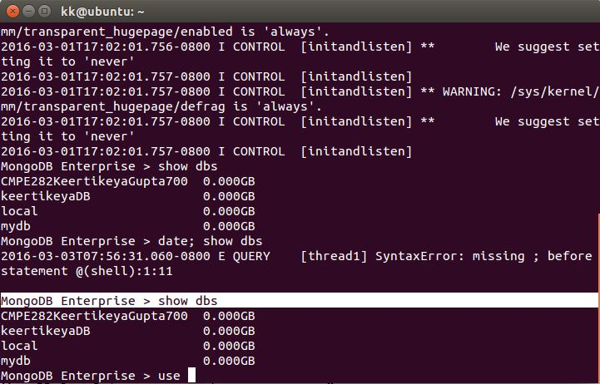

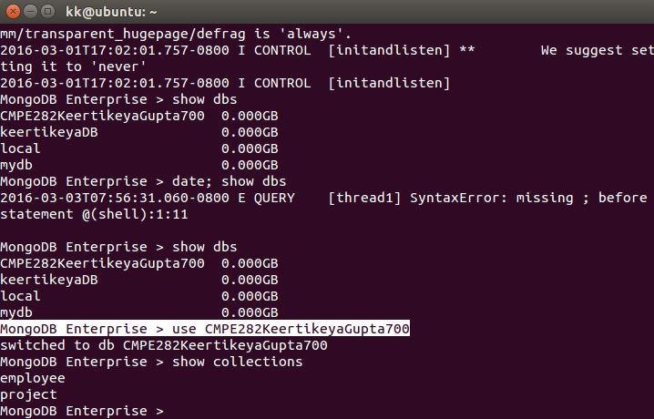

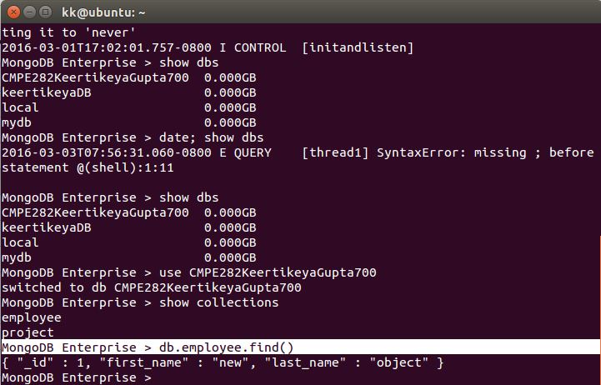

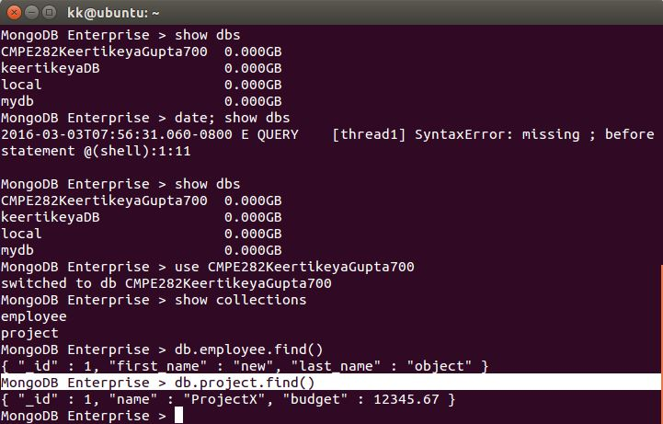

**PUT Operations:**

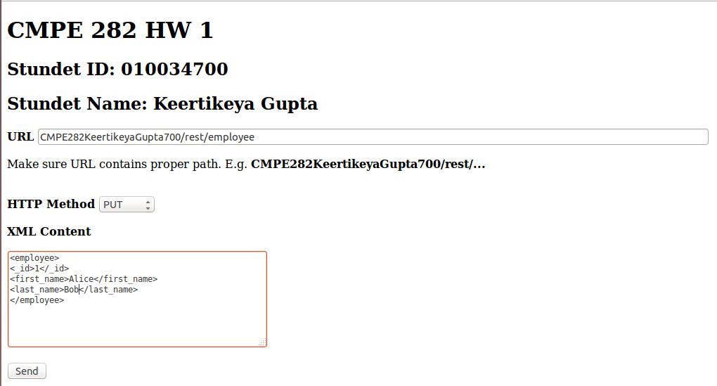

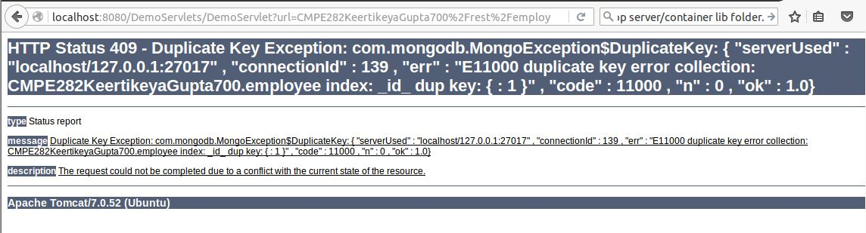

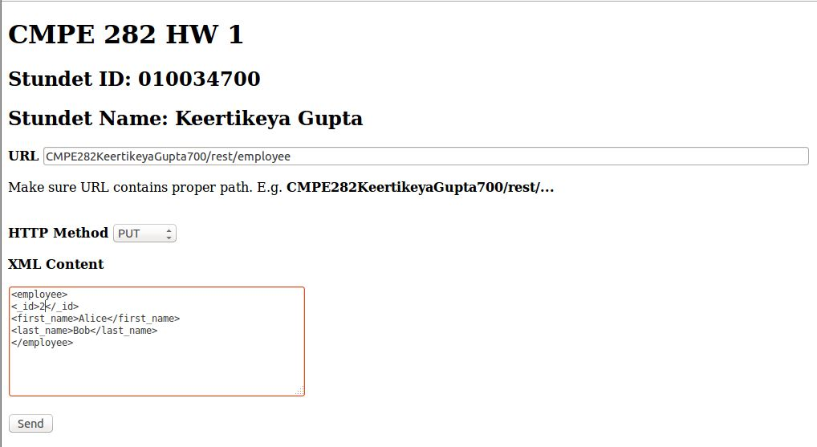

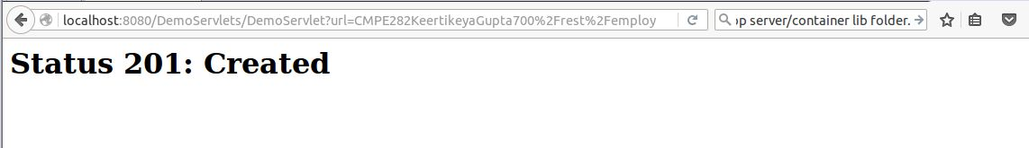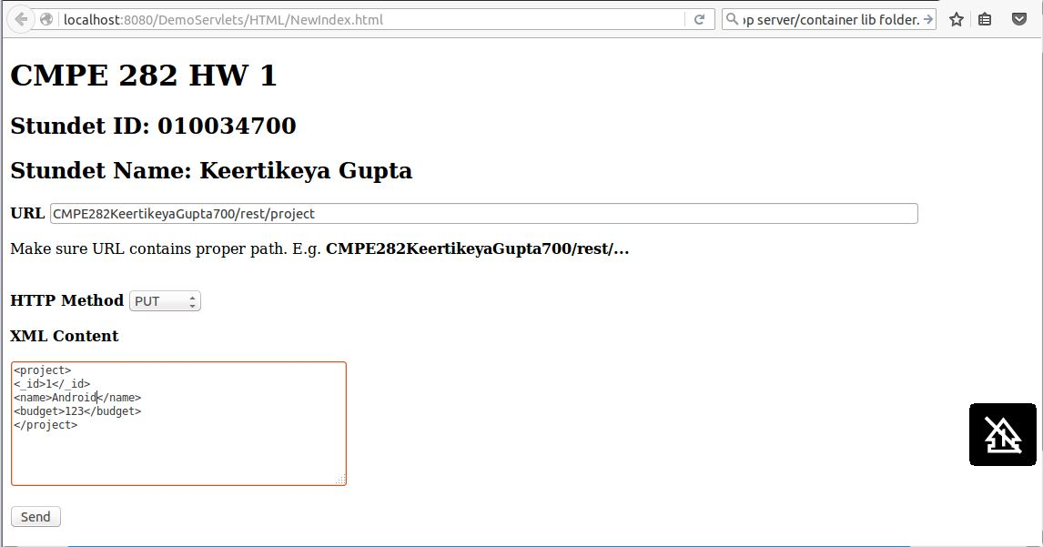

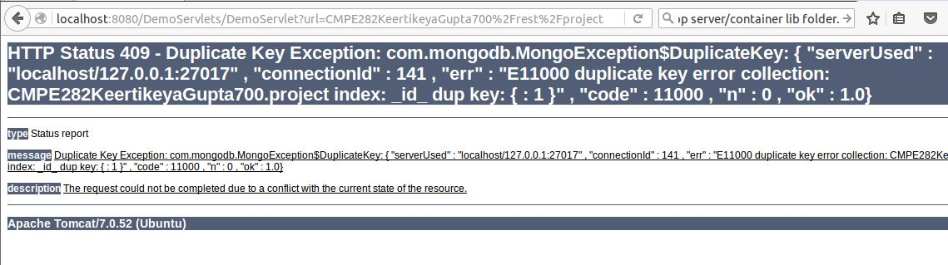

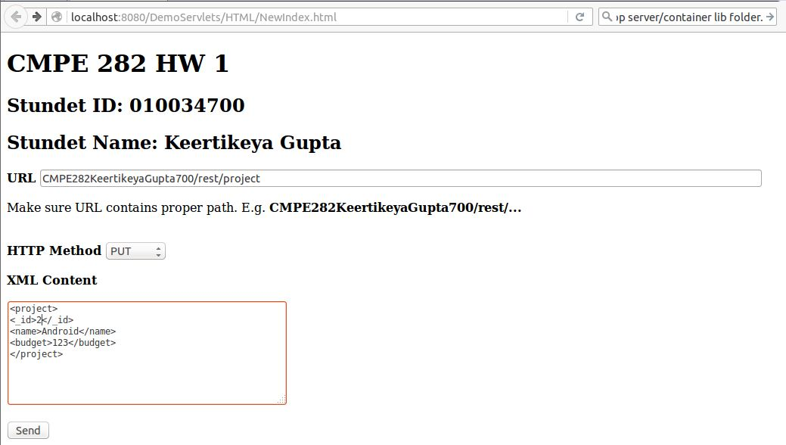



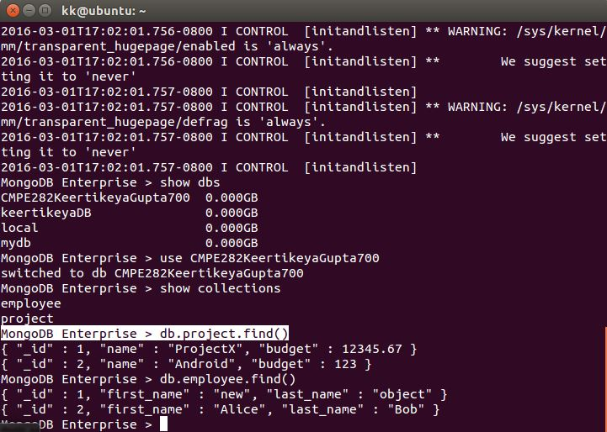

**POST Operations:**

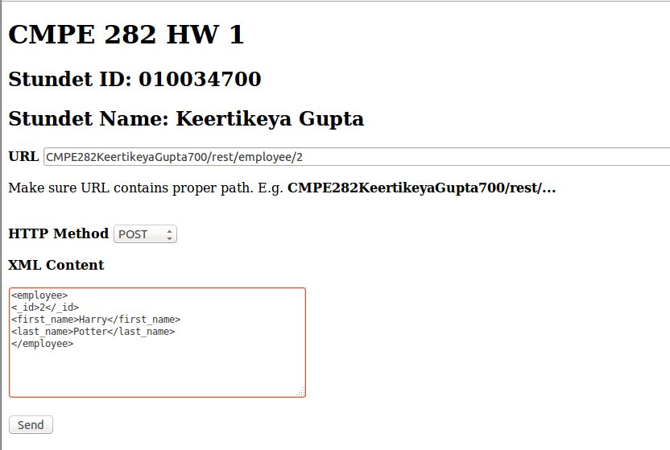

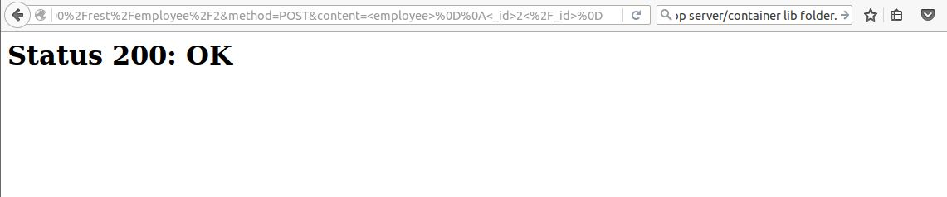

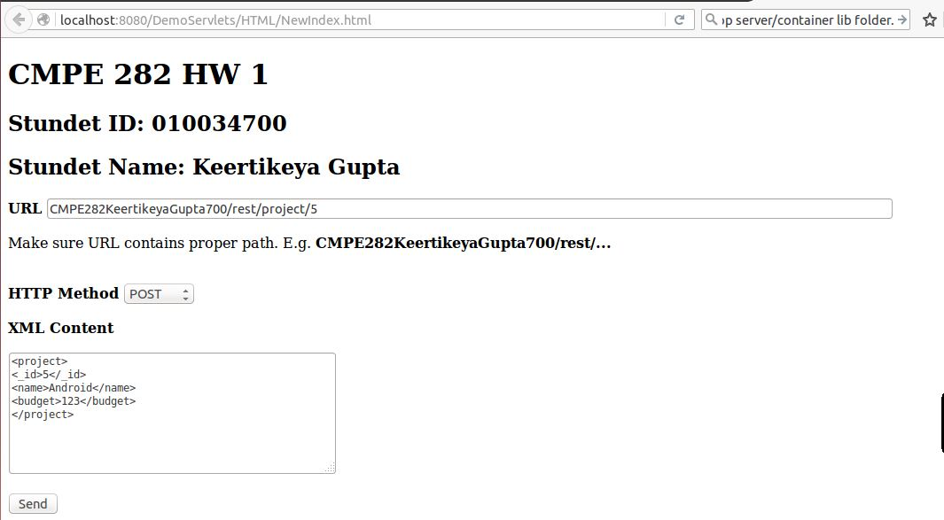

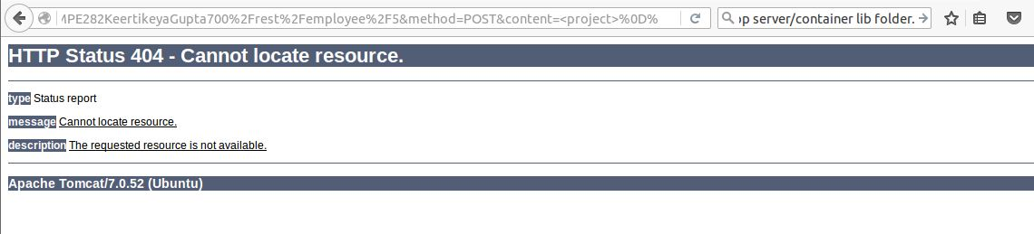

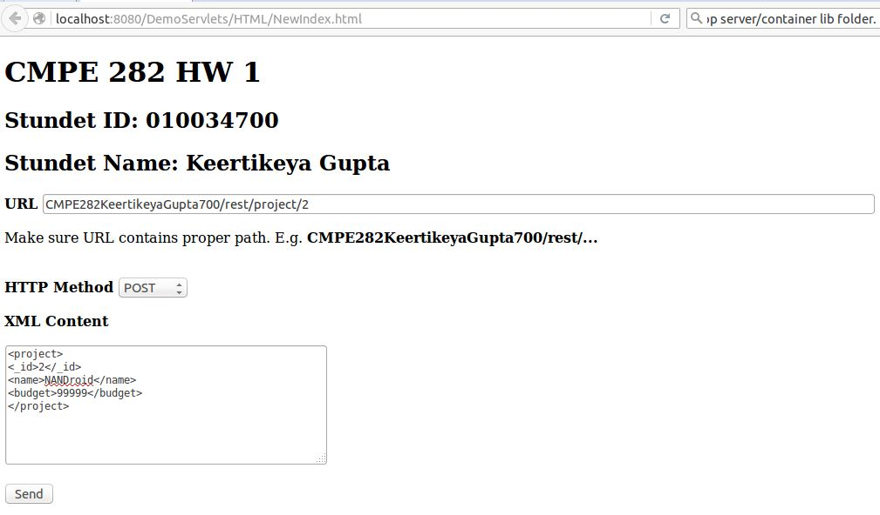

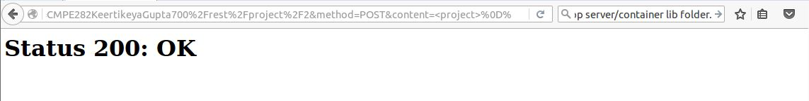

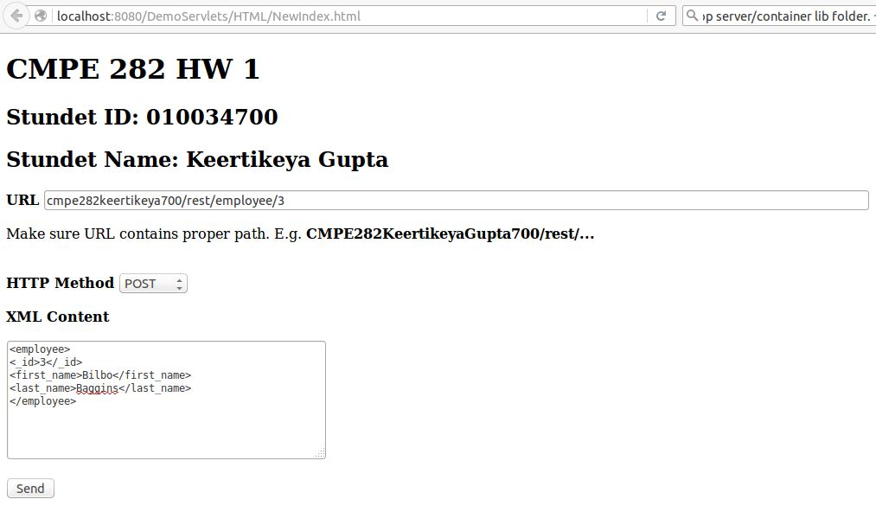

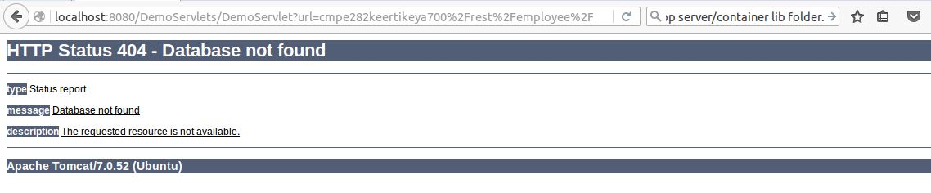

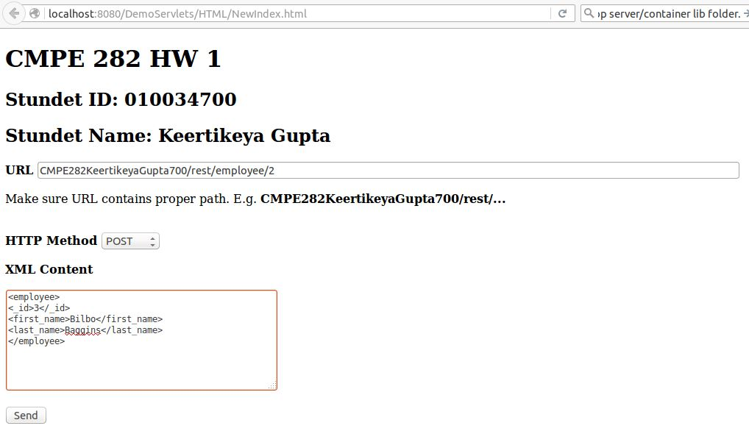

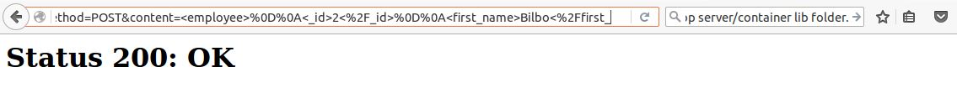

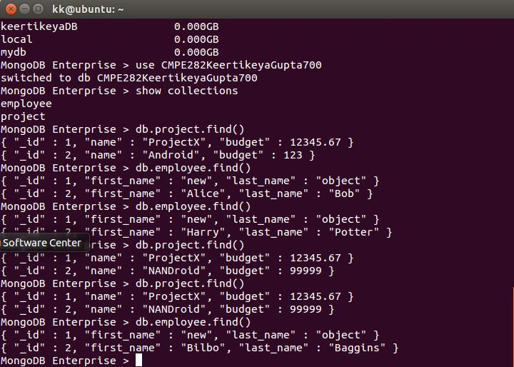

Delete Operations:

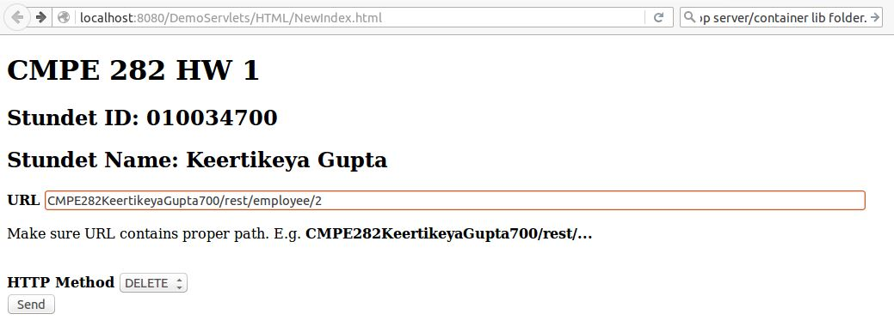

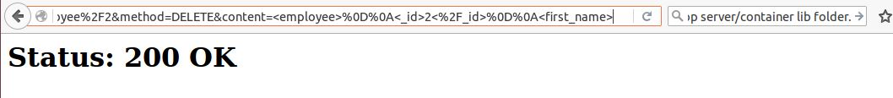

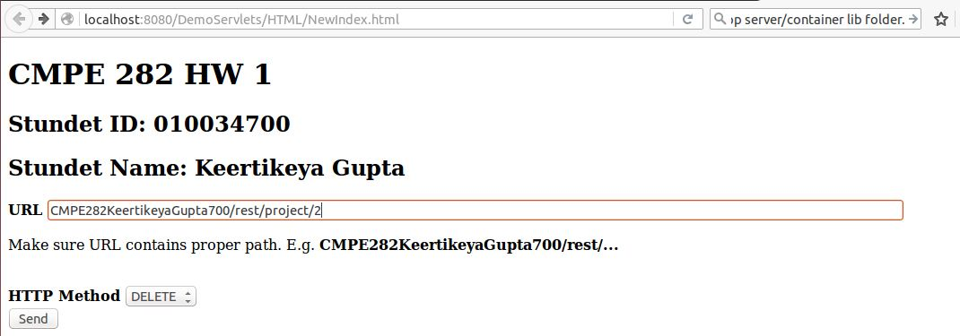

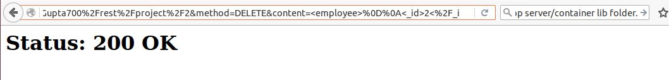

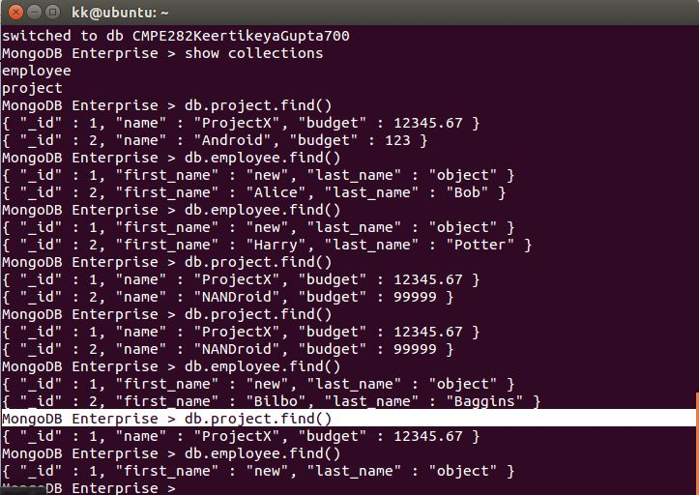

**Known Issues:**

Session manage has not been implemented fully, so there are a few client side errors.

E.g. After a successful PUT operation, if you hit the back button in the browser and repeat the same PUT operation, it will still give a success message though actually no data is being inserted into the database.

**Additional unique design feature:**

Made the client by myself, and will be working on it to make it better.