Pre-Seed 2026 · MIT Open Source
The AI took
the wheel.
There are
no brakes.
MartinLoop is the control plane for AI coding agents — hard limits, safety checks, and a signed receipt for every run. Install it once. Every agent your team runs lives inside it.

MIT Licensed · Free Core
$1.19 per task
10/10 correct outcomes

martin — governed loop
$ martin run "fix auth regression" --budget 3.00 ✓ Budget cap $3.00 hard stop ✓ Safety leash 14 classes armed ✓ Verifier pnpm test active ⟳ Running attempt 1... ✓ Patch applied ✓ Tests: 24/24 pass — Grade A ──────────────────────────────── ✓ Cost: $1.19 / $3.00 cap ✓ Signed proof — Ed25519 sealed ✓ Zero files on failure

63/63
Safety Checks

417
Tests Green

The Vision
Every company will be an AI company.
Every AI company will run autonomous agents.
Every agent will need a governor.
MartinLoop is that governor.
The internet needed protocols. Cars needed safety ratings. AI agents need governance. We are building the infrastructure layer that defines how every autonomous agent operates in production — before anyone else names the category.

Today · Shipping
Govern the loop
Hard stops, safety checks, signed proof for every AI coding agent run.

M6–18 · Roadmap
Govern the fleet
Enterprise teams run agent workforces. MartinLoop governs cost, permissions, and audit at scale.

MartinLoop360
Govern the economy
Agents hire other agents. MartinLoop360 is the settlement and governance layer for autonomous companies.

The Problem
Something went wrong overnight. Again.
- —Your agent ran all night and charged you for it. No limit. No stop. No receipt. You woke up to a bill and nothing shipped.
- —There's no proof of what it did. When an AI agent ships a bug, you have no signed record of what it touched, decided, or why. You can't audit what you can't see.
- —You gave your AI a company card with no limit. Every team running AI coding agents today does it with zero cost ceiling, zero safety enforcement, zero accountability.

"Your CFO is like what do you mean each engineer now costs $2000 extra per month in LLM bills?"
Dax Raad, creator of OpenCode · X, Feb 14 2026 · 793K views · Business Insider

Why Now
AI agents just entered your production environment.
18 months ago, AI coding tools autocompleted lines. Today they write functions, merge PRs, and trigger deployments — autonomously, overnight. The tools outpaced the governance. Now every engineering team is flying blind.

20M+
GitHub Copilot users
All running agents. None governed.

$2B
Cursor ARR · 2 years
Fastest SaaS growth ever. No safety layer.

$0
Governance tooling shipped
This is the gap. This is MartinLoop.

"Everybody has gotten infatuated with these Ralph Wiggum loops... A, it never figures anything out. And B, you just get this ginormous bill."
Chamath Palihapitiya — All-In Podcast, March 2026 · Source: MSN / Business Insider

The Solution
MartinLoop. The brakes every agent needs.
Martin Loop does not make AI coding safer by asking the model nicely. It enforces the rules before damage happens.

It Stops.
Set a dollar limit. The loop stops when it hits it. Not slows. Not alerts. Stops. Your card doesn't run all night.

It Blocks.
Dangerous moves — deleting files, injecting commands, going off-script — are stopped before they execute. Not logged after. Prevented before.

It Proves.
Did it actually work? We grade A, B, or C from real test output — not what the AI claims it did.

It Records.
Every run gets a cryptographically signed receipt. What it did, what it spent, what passed. Tamper-proof. Forever.
Martin is not another agent. It is the control layer around the agents teams already want to use.

The Product
One command.
Every agent governed.
MartinLoop wraps any AI coding agent — Claude Code, Codex CLI, or any terminal-based agent. Your team doesn't change how they work. They just add MartinLoop first.

MIT Licensed — free forever
Works with Claude, Codex, any CLI agent
Runs entirely in your repo — no SaaS needed
npm install -g @martin/cli

Dashboard — Pro & above
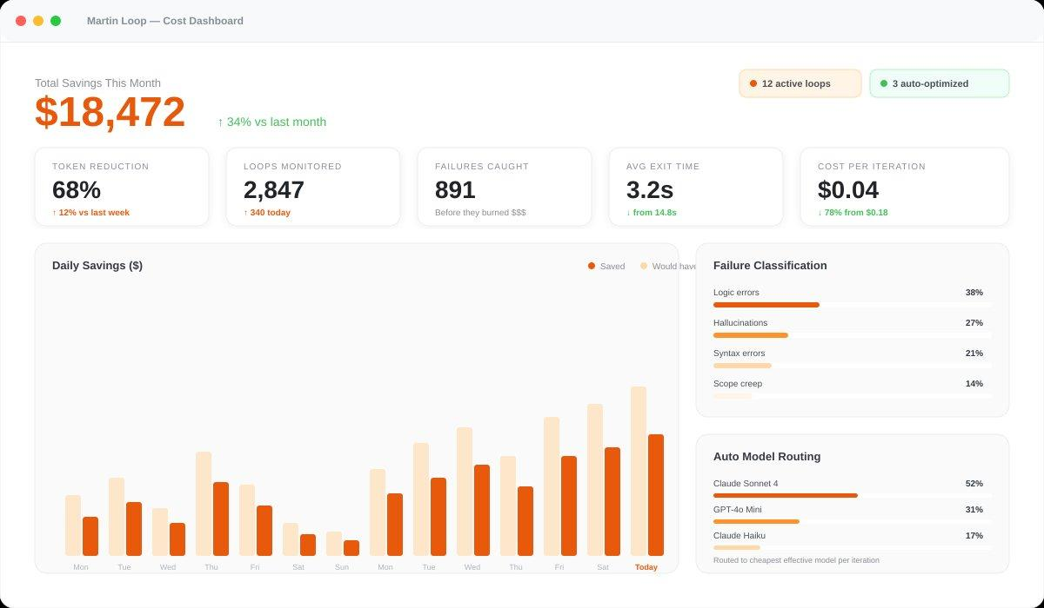

martin — live run
$ martin run "repair flaky CI gate" \ --budget 5.00 --verify "pnpm test" ✓ Policy martin.policy.yaml loaded ✓ Budget cap $5.00 hard stop ✓ Leash 14 classes armed ⟳ Attempt 1... ✓ CI config patched ✓ Verifier: pnpm test — 44/44 pass ✓ Grade A ────────────────────────────────── ✓ Cost: $2.30 / $5.00 cap ✓ Signed audit trail — Ed25519 ✓ Rollback ready — 0 files on failure
Real benchmark number — "Repair flaky CI gate" task · latest.md

Proof
We didn't just build it. We proved it.
Run bun run benchmark from a fresh clone. Every number reproduces.

417
Tests Green
63/63
Safety Checks
10/10
Correct Outcomes
$1.19
Per Task

Runner | Got It Right | Tests Passed | Safety Issues | Total (10 tasks)
MartinLoop ★ | 10/10 | 8/10 | None | $11.90
Ralphy | 5/10 | 5/10 | 1 flagged | $24.00
Ralph | 4/10 | 4/10 | 1 flagged | $30.70
Source: github.com/Keesan12/MartinLoop · benchmarks/comparative/history/latest.md · April 2026

Market Opportunity
Our beachhead: teams actively shipping AI products.
GitHub Copilot: 20M+ users. Cursor: $2B ARR in under 3 years. Claude Code, Codex, Qwen — all growing. None of them ship a governance plane. That's the gap.
Same infrastructure moment that built HashiCorp ($6B), Grafana ($6B), Datadog ($26B).

TAM — Total Market
$8.6B
AI agent governance

Teams using AI agents~180,000
Avg seats per team8
ACV per seat$199/yr

180,000 × 8 × $199
= $8.6B addressable

SAM — Our Market
$2.3B
NA + EU, shipping AI products

Eng. teams (NA+EU)200,000
Deploying AI agents50% = 100K
Without governance~90% = 90K

90,000 teams
× avg 6 seats × $199
= $2.3B SAM

SOM → Year 3
$50M ARR
1.4% of SAM · 2,500 teams

Enterprise ($499 × 10)500 teams
Growth ($199 × 6)800 teams
Pro ($49 × 5)1,200 teams

2,500 teams = 1.4% SAM
Leaves 98.6% untouched
Sources: TechCrunch: Copilot 20M · Sacra: Cursor $2B ARR · OpenView PLG Benchmarks

Competition
Adjacent tools solve one piece. We solve all of it.
No one else combines OSS + pre-execution blocking + hard cost stop + filesystem rollback + signed audit trail. Most do zero of these.

Tool | Stops overspend | Blocks before run | Rolls back files | Signs a receipt | Free/OSS | Agent-specific
MartinLoop ★ | ✓ | ✓ | ✓ | ✓ | ✓ | ✓
GitHub Agent CP | ✗ | ✗ | ✗ | partial | ✗ | partial
Datadog / W&B | ✗ | ✗ | ✗ | partial | partial | ✗
Onyx / Fiddler | ✗ | ✗ | ✗ | ✓ | ✗ | ✗
Ralph / Ralphy | ✗ | ✗ | ✗ | ✗ | ✓ | partial
Martin Loop makes AI coding accountable: it completes good work, refuses bad work, stops uneconomical work, and leaves evidence behind.

Business Model
Free gets them in. Enterprise keeps us growing.
Same playbook as HashiCorp, Grafana, Datadog: OSS creates trust, enterprise creates revenue.

Free · OSS Core
$0
- Full CLI runtime
- 14 safety leash classes
- Ed25519 audit trail
- Filesystem rollback
- Policy-as-code YAML

Pro
$49/seat
- Team cost dashboard
- SIEM export (OCSF/CEF)
- Failure classification
- Audit export reports
- Priority support

Growth
$199/seat
- Auto model routing (30–60% cost cut)
- Custom policy per project
- OpenTelemetry spans
- CVE-watch at install
- Multi-workspace governance

Enterprise
$499/seat
- SSO/SAML
- Uptime SLA
- Full audit export bundle
- Circuit breaker / failover
- Dedicated security review

~$0
Organic Dev CAC

$15–40
Blended CAC (with budget)

~85%
Gross Margin

>10×
LTV / CAC Target

Revenue Model
Conservative path to $50M ARR in Year 3.
Driven by 2,500 teams — just 1.4% of our SAM. Enterprise mix anchors revenue; Pro and Growth drive volume.

ARR Milestones

Month 6
OSS launch · first pilots
$50K

Month 12
20 accounts · Pro live
$600K

Month 18
100 accounts · Growth tier
$5M

Month 24
400 accounts · Series A
$15M

Month 36
2,500 teams · 1.4% SAM
$50M

Revenue Mix at $50M

Enterprise (500 × $59.9K)$30M
Growth (800 × $14.3K)$11.5M
Pro (1,200 × $2.9K)$3.5M
Expansion + upsell+$5M

ARR Growth · 36 Months
OSS launch M2 → $50M ARR M36 · Conservative at 1.4% SAM

Go-to-Market
Developers find us. Enterprises pay us.

Phase 0 · Done
Production Ready
- 417 tests green
- SLSA L3 provenance
- External audit pack
- 22-step RC validation

Phase 1 · Week 1
OSS Launch
- npm publish @martin/cli
- HN Show HN · Product Hunt
- martinloop.com live
- Dev community outreach

Phase 2 · M1–M6
Community
- Claude Code, Cursor guides
- Technical blog content
- 500 GitHub stars target
- First enterprise pilots

Phase 3 · M6–M18
Enterprise
- Fintech · healthtech focus
- Pro billing live
- 5+ design partners
- $5M ARR · SOC2 track
The old AI coding story was speed. The next story is control: what changed, what it cost, and why it was allowed.

The Team
Founders who built this because they needed it.
20+ years of friendship. 2 startups shipped together. Both use AI agents daily — and hit this problem themselves. They didn't read about it in a white paper. They lived it. Then fixed it for everyone.


Vakeesan Mahalingam, CFA
Co-Founder · CEO
3× founder. Co-built AMARI AI and Torram with Gobi. CFA charterholder with capital markets and enterprise sales background. Founder-led sales — closes deals himself. Drives product, investors, and GTM. Has taken products from zero to revenue, twice.
linkedin.com/in/vakeesanm · keesan@martinloop.com

Gobi Shanthan
Co-Founder · Engineering
Full-stack engineer with production experience across web2 and web3. Leads all hardening, testing, and production readiness of MartinLoop. Pioneered the TSB token standard for asset tokenization on Bitcoin. Builds systems that survive contact with reality.
linkedin.com/in/gobi-shanthakumar
A repeat founder who executes across capital markets and AI — paired with an engineer who ships at the frontier of web3 and AI. This is not a team assembled for a pitch. It is a team with a decade of proof they execute together.

Pre-Seed Round · 2026
$1.25M.
$8M pre-money · 18 months runway

$1.25M
Raise Amount

$8M
Pre-Money Val

18mo
Runway

Month 2
OSS launch. 500 stars. Benchmark public. Community live.

Month 6
5 enterprise pilots. Pro tier billing. $50K MRR.

Month 18
$5M ARR. SOC2 initiated. Series A ready.

60%
Engineering

25%
GTM

15%
Operations
martinloop.com · github.com/Keesan12/MartinLoop · keesan@martinloop.com

Thank you!
"MartinLoop finally put a rope around the Ralph Loop — stopping runaway AI agents before they burn through your budget."
martinloop.com github.com/Keesan12/MartinLoop keesan@martinloop.com
Pre-Seed Round · 2026 · MIT Licensed
←
1/15 →

