**Digital Alarm Clock**

**Description of the study**

This code is a simple GUI alarm clock application using the Tkinter library in python. It allows user to set an alarm time and receive a notification when the alarm goes off, also has an option for the users to choose from stopping the alarm or snoozing it for 5 minutes. The user must input the set time in 12 hour, minute and AM/PM respectively to work the alarm, or else it would notify the user that they input the wrong format to set the alarm.

It provides a simple and customizable alarm clock, easy to use interface with the use of Tkinter GUI, and helps users to manage their time effectively by setting alarms especially when they have to wake up in a certain time. The objective of this code is to create a functional alarm clock application using Python and Tkinter, allowing users to set alarms and receive notifications at specified times.

The purpose of this code is to provide users with a convenient way to set and manage alarms using a graphical interface. It aims to improve time management and productivity by ensuring users are alerted at specific times.

**Significance of the code**

This code is significant as it demonstrates how to create a basic GUI application in Python using Tkinter and addresses a common need for alarm clock functionality. It can serve as a starting point for more complex time management applications or be integrated into other projects.

**Features of the code**

* Displays current time, day, and date in 12 hour, minute, second, AM/PM, weekday, month, day, and year respectively.
* Allows users to set custom alarm time.
* Notifies users when the alarm time goes off.
* Includes a snooze option to delay the alarm for 5 minutes.
* Includes a stop option to stop the ongoing alarm.

**Code**

From tkinter import *

From time import strftime

Import datetime

Import tkinter.messagebox

Alarm_active = False

Alarm_time = “”

Def update_clock():

Current_time = datetime.datetime.now().strftime(“%I:%M:%S %p”)

Time_label.config(text=current_time)

Current_day = datetime.datetime.now().strftime(“%A”)

Day_label.config(text=current_day)

Current_date = datetime.datetime.now().strftime(“%B %d, %Y”)

Date_label.config(text=current_date)

Window.after(1000, update_clock)

Def update_alarm():

If alarm_active:

Check_alarm()

Window.after(1000, update_alarm)

Def set_alarm():

Global alarm_active, alarm_time

Alarm_time = entry_alarm.get()

Try:

Datetime.datetime.strptime(alarm_time, “%I:%M %p”)

Alarm_active = True

Update_alarm()

Except ValueError:

Tkinter.messagebox.showerror(“Error”, “Invalid time format. Please enter time in HH:MM AM/PM format.”)

Def stop_alarm():

Global alarm_active

Alarm_active = False

Def check_alarm():

Current_time = datetime.datetime.now().strftime(“%I:%M %p”)

If current_time == alarm_time:

Alarm_window = tkinter.Toplevel(window)

Alarm_window.title(“Alarm”)

Alarm_window.geometry(“320x250”)

Alarm_window.attributes(‘-topmost’, True)

Alarm_label = Label(alarm_window, text=”Wake up!”, font=(“Arial”, 20))

Alarm_label.pack()

Snooze_button = Button(alarm_window, text=”Snooze”, font=(“Arial”, 15), command=snooze_alarm)

Snooze_button.pack()

Stop_button = Button(alarm_window, text=”Stop”, font=(“Arial”, 15), command=stop_alarm)

Stop_button.pack()

Def snooze_alarm():

Global alarm_time

Snooze_time = (datetime.datetime.now() + datetime.timedelta(minutes=5)).strftime(“%I:%M %p”)

Alarm_time = snooze_time

Window = Tk()

Time_label = Label(window, font=(“Arial”, 50), fg=”#00FF00”, bg=”black”)

Time_label.pack()

Day_label = Label(window, font=(“Ink Free”, 25))

Day_label.pack()

Date_label = Label(window, font=(“Ink Free”, 30))

Date_label.pack()

Entry_alarm = Entry(window, font=(“Arial”, 20))

Entry_alarm.pack()

Button_set_alarm = Button(window, text=”Set Alarm”, font=(“Arial”, 20), command=set_alarm)

Button_set_alarm.pack()

Update_clock()

Window.mainloop()

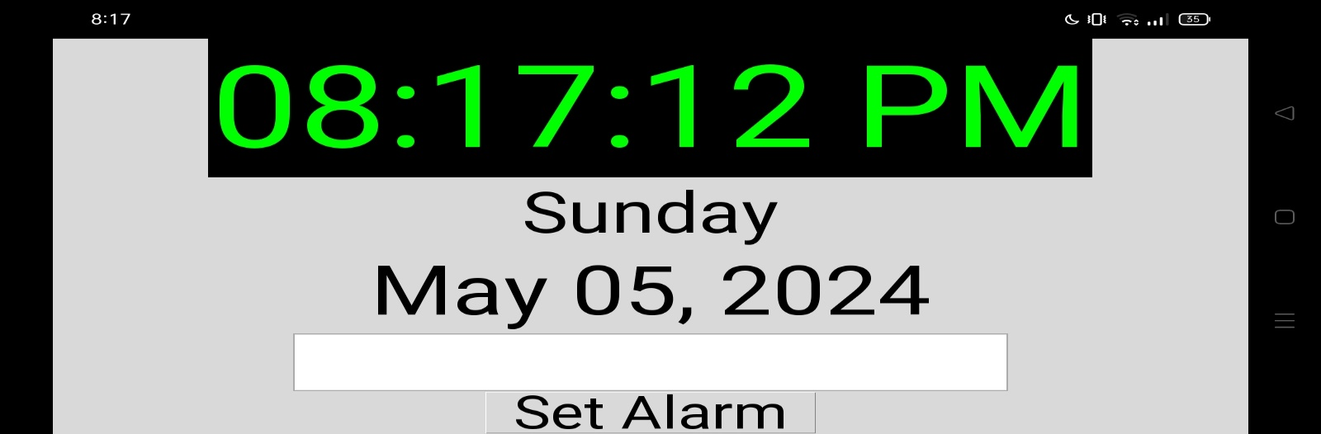

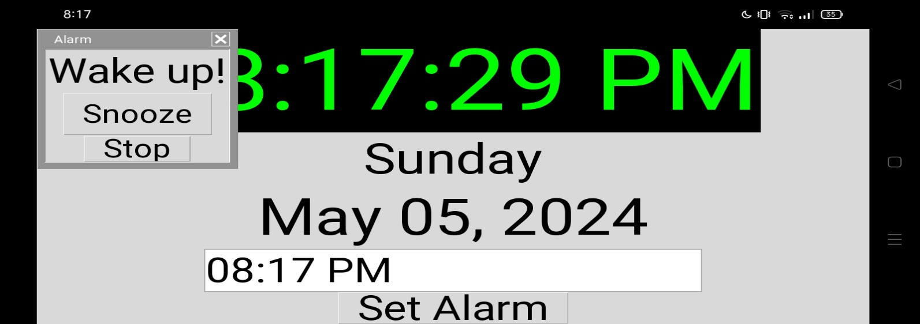

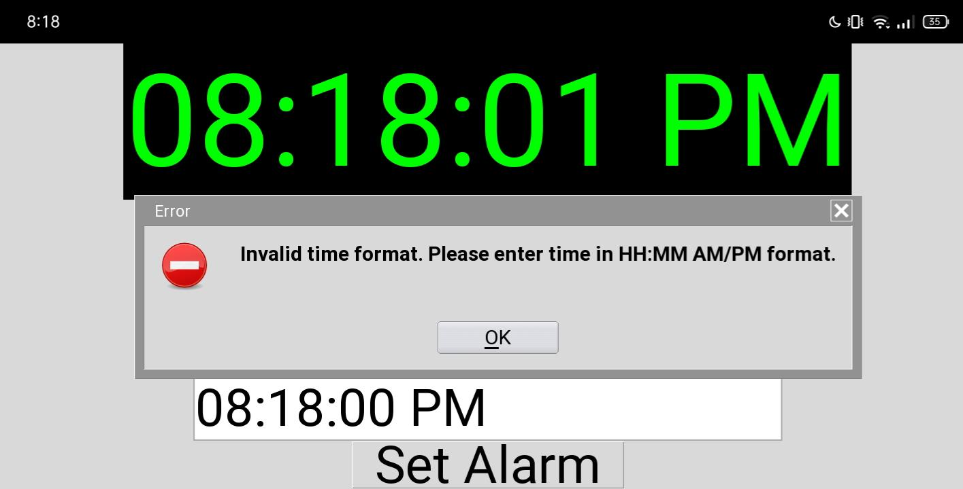

Kyla Claire Y. Fermilan

Little Tondo Purok-Santan, Brgy. Washington, Surigao City

Contact no: 09631912082

Email address: [fermilankylaclaire@gmail.com](mailto:fermilankylaclaire@gmail.com)

PERSONAL BACKGROUND

Age: 19

Sex: Female

Birthdate: May 02, 2005

Birthplace: Caraga Regional Hospital Surigao City, Surigao Del Norte

Height: 5’1 inches

Weight: 49kg

Civil status: Single

Religion: Roman Catholic

Nationality: Filipino

Parents: George C. Fermilan and Meraluna Y. Fermilan

Spouse: N/A

Language Spoken: Bisaya, Surigaonon, Tagalog, and English ______________________________________________________________________

EDUCATIONAL BACKGROUND

College SURIGAO NORTE STATE UNIVERSITY

Narciso St., Surigao City, 8400 Surigao del Norte

Batch 2023

High School NORTHEASTERN MINDANAO COLLEGES

Rizal corner Amat st. Surigao City

Batch 2022-2023

Elementary SURIGAO WEST CENTRAL ELEMENTARY SCHOOL

Nestor Eguna st. Brgy. San Juan, Surigao City

Batch 2017