Name: Keezum Tenzing Bhutia

Reg no: 201900265

Create a todo application having following components

1. Todo List Component - Display todo in list format (Create a route to access todo list in **/todo-list**)

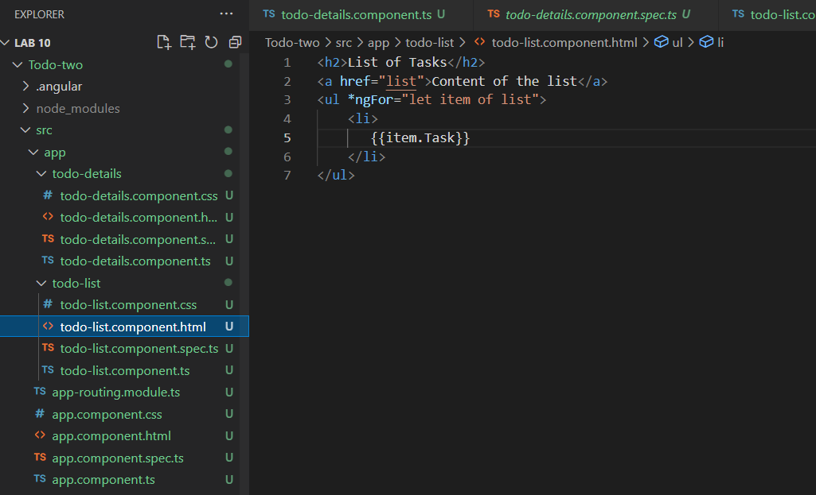

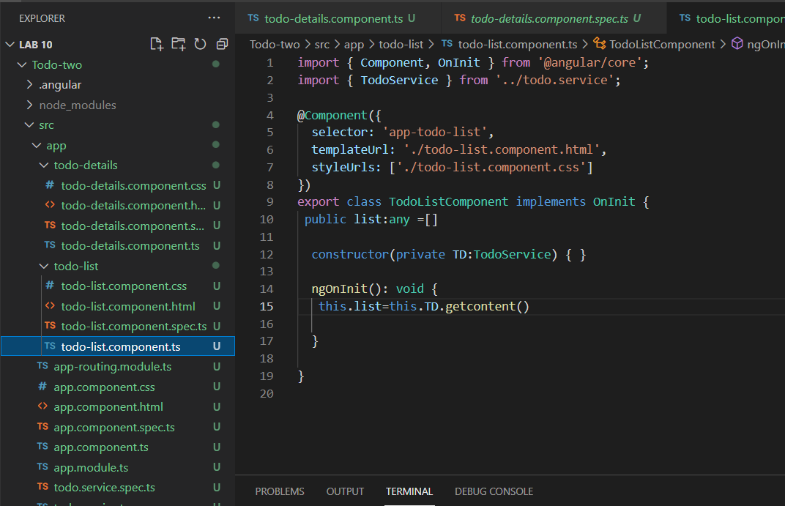

1. Todo Details Component - Display todo in table format ((Create a route to access todo list in **/todo-details)**

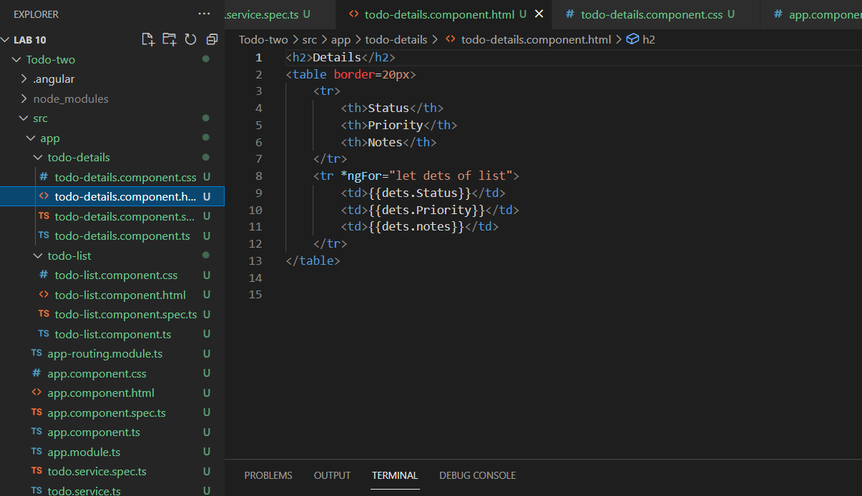

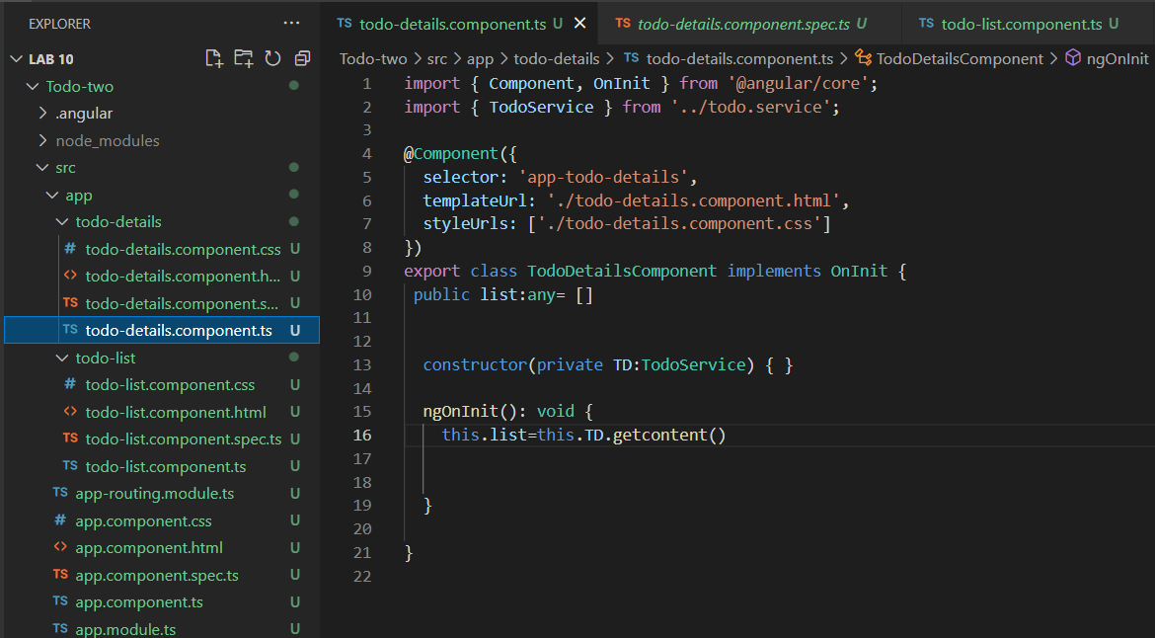

1. app root (main) component

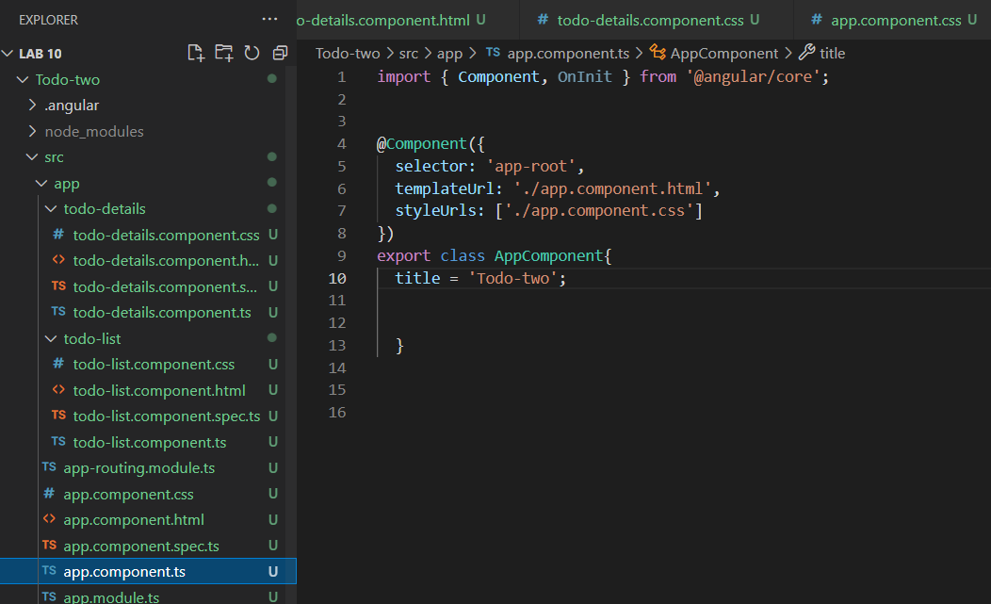

1. Create a service (TodoService) and share data amongst Todo List & Todo Details Components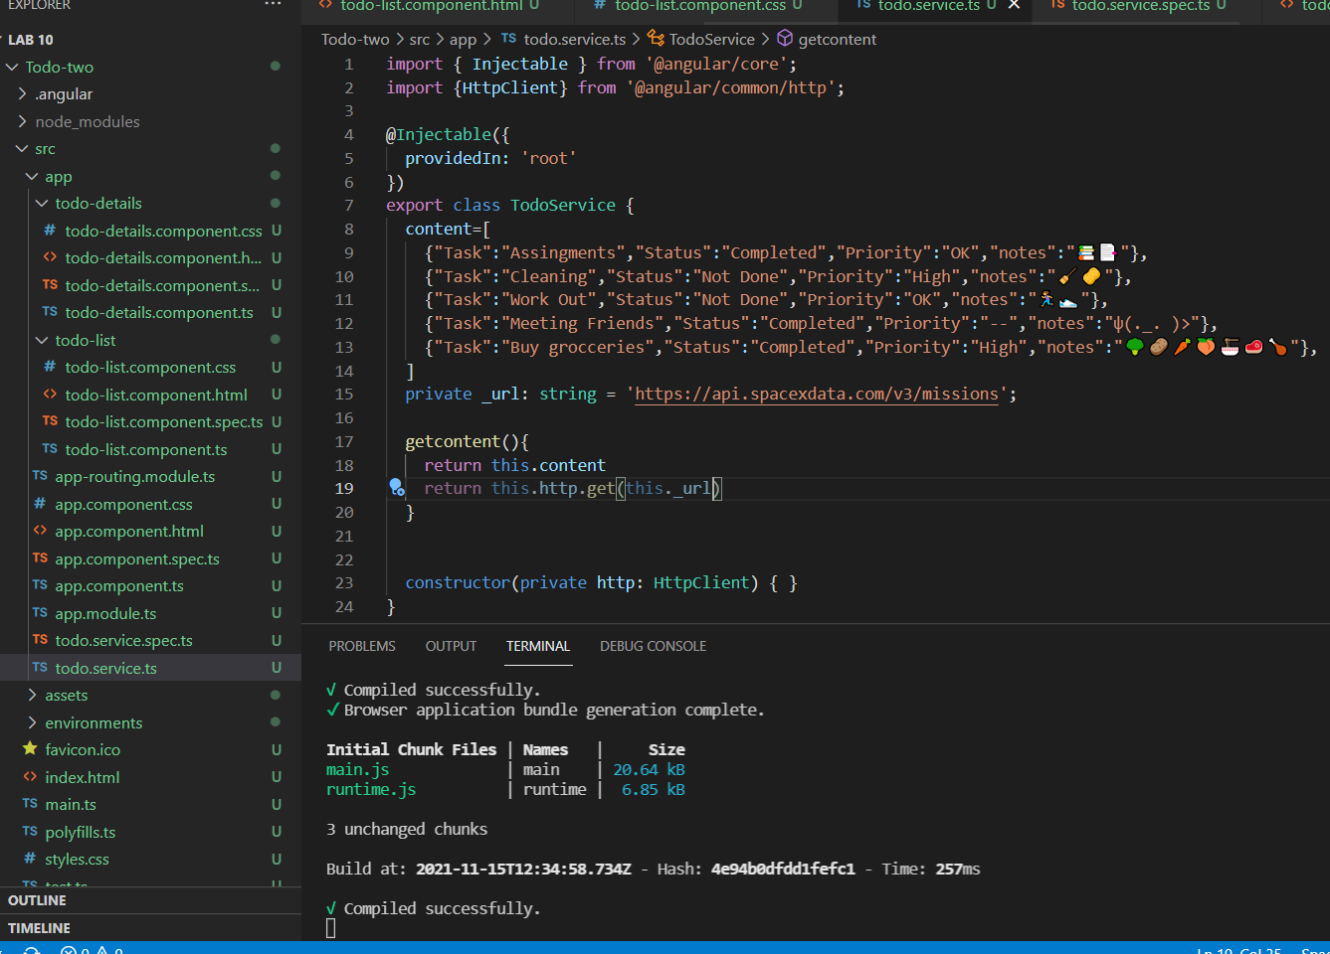

5. Create a component named SpaceX and fetch data from api

<https://api.spacexdata.com/v3/missions> (Display the same in table format)

