Student Name : Keh Jing Xiang

Group : SCSE

Date : 25/3/2025

LAB 4: ANALZING NETWORK DATA LOG

You are provided with the data file, in .csv format, in the working directory. Write the program to extract the following informations.

Exercise 4A: TOp TALKERS and LISTENERS

One of the most commonly used function in analyzing data log is finding out the IP address of the hosts that send out large amount of packet and hosts that receive large number of packets, usually know as TOP TALKERS and LISTENERS. Based on the IP address we can obtained the organization who owns the IP address.

List the TOP 5 TALKERS

Rank | IP address | # of packets | Organisation
1 | 193.62.192.8 | 3041 | European Bioinformatics Institute
2 | 155.69.160.32 | 2975 | Nanyang Technological University
3 | 130.14.250.11 | 2604 | National Library of Medicine
4 | 14.139.196.58 | 2452 | Indian Institute of Technology (IIT), Guwahati
5 | 140.112.8.139 | 2056 | Taiwan Academic Network

TOP 5 LISTENERS

Rank | IP address | # of packets | Organisation
1 | 103.37.198.100 | 3841 | A*star
2 | 137.132.228.15 | 3715 | National University of Singapore
3 | 202.21.159.244 | 2446 | Republic Polytechnic, Singapore
4 | 192.101.107.153 | 2368 | Battelle Memorial Institute, Pacific Northwest Division
5 | 103.21.126.2 | 2056 | Indian Institute of Technology Bombay

Exercise 4B: TRANSPORT PROTOCOL

Using the IP protocol type attribute, determine the percentage of TCP and UDP protocol

 | Header value | Transport layer protocol | # of packets
1 | 6 | TCP | 56064 (82.37%)
2 | 17 | UDP | 9462 (13.9%)

Exercise 4C: ApplicationS PROTOCOL

Using the Destination IP port number determine the most frequently used application protocol.
(For finding the service given the port number https://www.adminsub.net/tcp-udp-port-finder/ )

Rank | Destination IP port number | # of packets | Service
1 | 443 | 13423 | HTTPS (IANA)
2 | 80 | 2647 | HTTP (IANA)
3 | 52866 | 2068 | Dynamic and/or Private Ports (IANA)  Xsan. Xsan Filesystem Access (Apple)
4 | 45512 | 1356 | Unassigned (IANA)
5 | 56152 | 1341 | Dynamic and/or Private Ports (IANA)  Xsan. Xsan Filesystem Access (Apple)

Exercise 4D: Traffic

The traffic intensity is an important parameter that a network engineer needs to monitor closely to determine if there is congestion. You would use the IP packet size to calculate the estimated total traffic over the monitored period of 15 seconds. (Assume the sampling rate is 1 in 2048)

Total Traffic( MB) | 15814.9MB

Exercise 4E: ADDITIONAL ANALYSIS

Top 5 communication pairs:
Rank | Source IP Address | Destination IP Address | # of packets | Source Organisation | Destination Organisation
1 | 193.62.192.8 | 137.132.228.15 | 3041 | European Bioinformatics Institute | National University of Singapore
2 | 130.14.250.11 | 103.37.198.100 | 2599 | National Library of Medicine | A*star
3 | 14.139.196.58 | 192.101.107.153 | 2368 | Indian Institute of Technology (IIT), Guwahati | Battelle Memorial Institute, Pacific Northwest Division
4 | 140.112.8.139 | 103.21.126.2 | 2056 | Taiwan Academic Network | Indian Institute of Technology Bombay
5 | 137.132.228.15 | 193.62.192.8 | 1910 | National University of Singapore | European Bioinformatics Institute

Visualization of communications between different IP hosts:
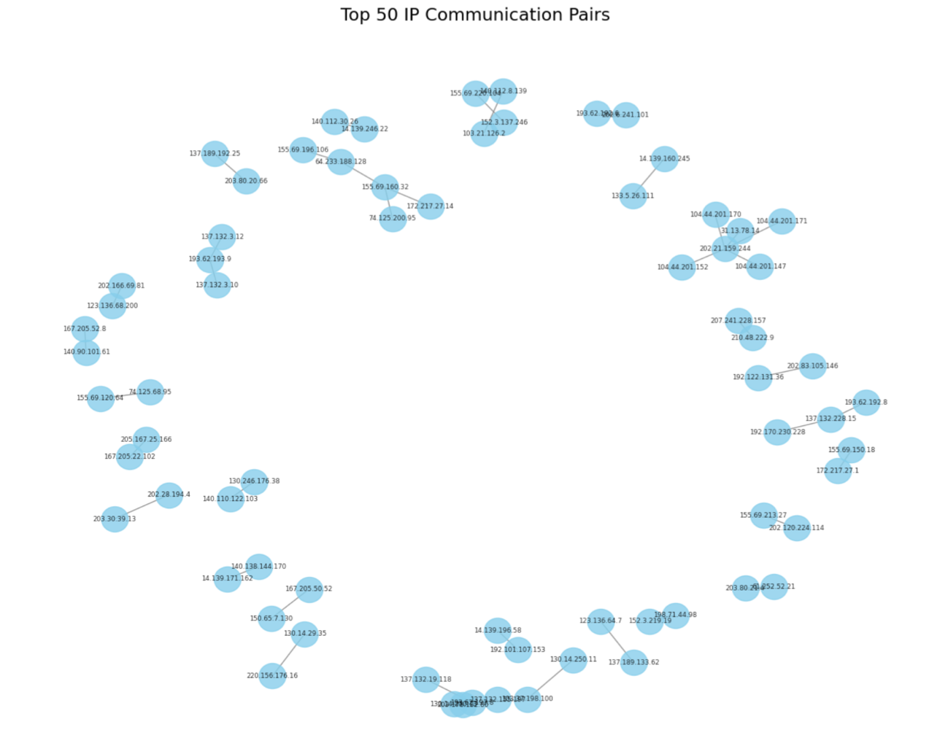

Exercise 4F: SOFTWARE CODE

Please also submit your code to the NTULearn lab site.

