Report

BD-30 KehanZhang

In this project, i learned how to use docker to build a container and how to build an image. I made a website to input picture, use minst tech to recognize the number it could be. Though i met lots of difficulties, i tried my best and succeeded in finish the project.

Training part:

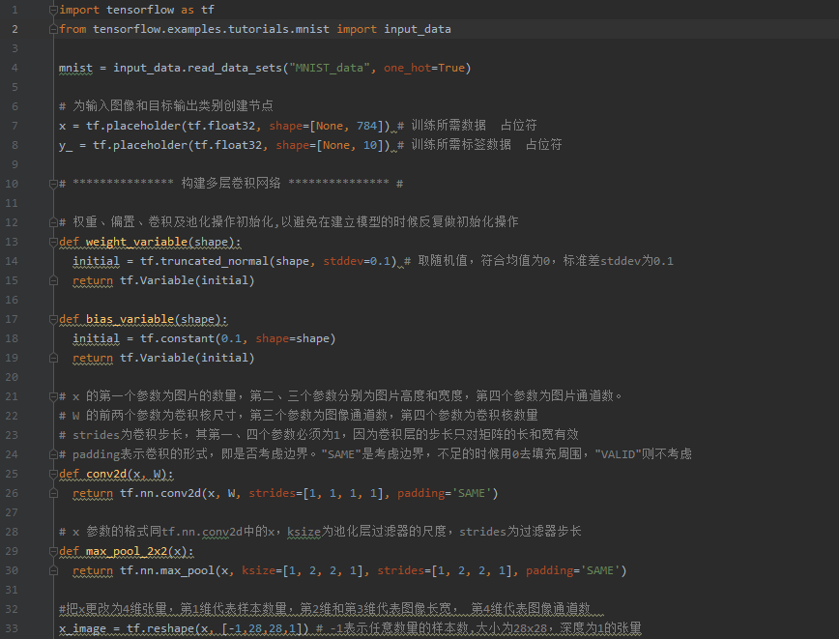

turn the picture into numbers so that we can calculate the digital picture

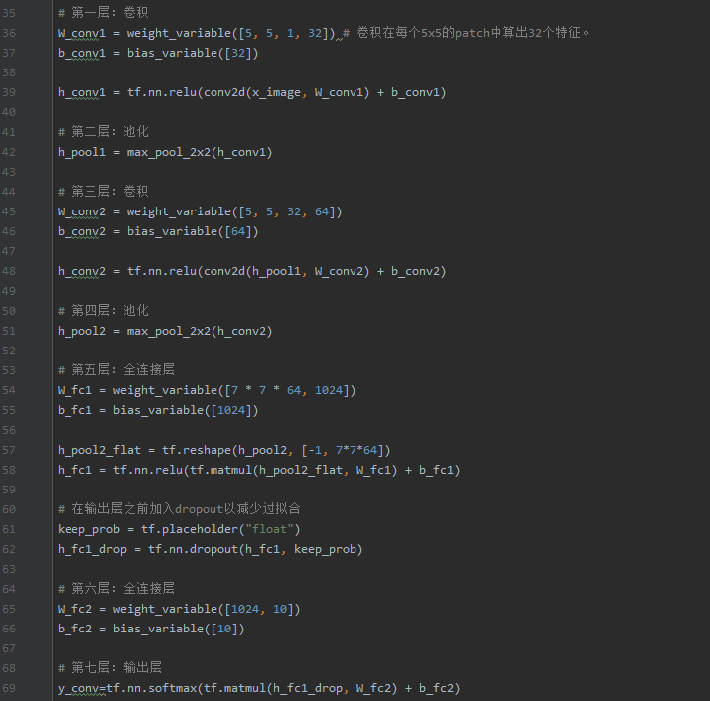

The details of calculating and training

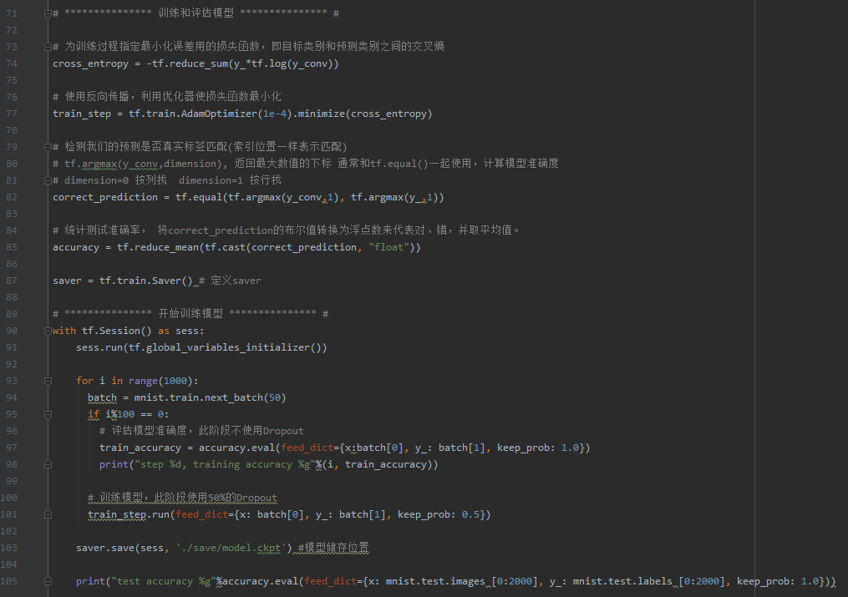

The process of training and the calculate of accuracy

Handing in the picture and recognize it

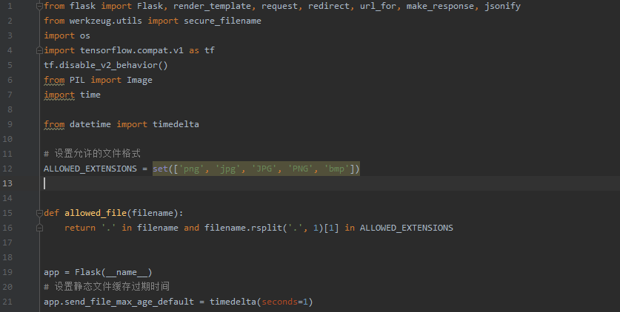

Some preparation package for programming

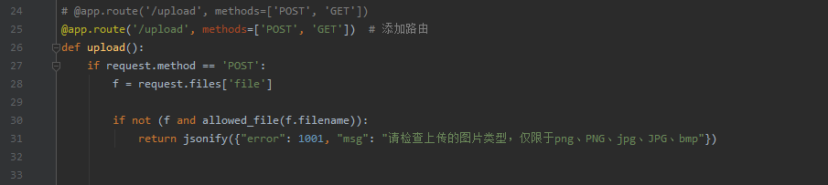

Get the picture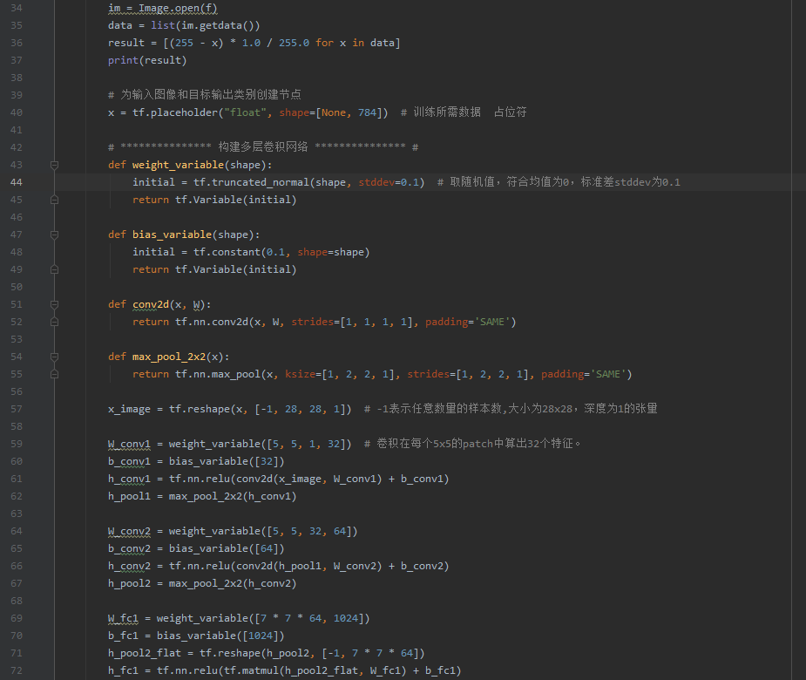

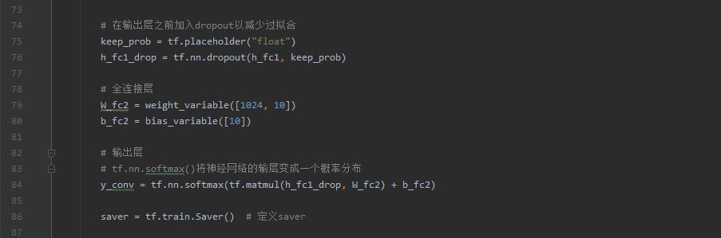

Use the training model

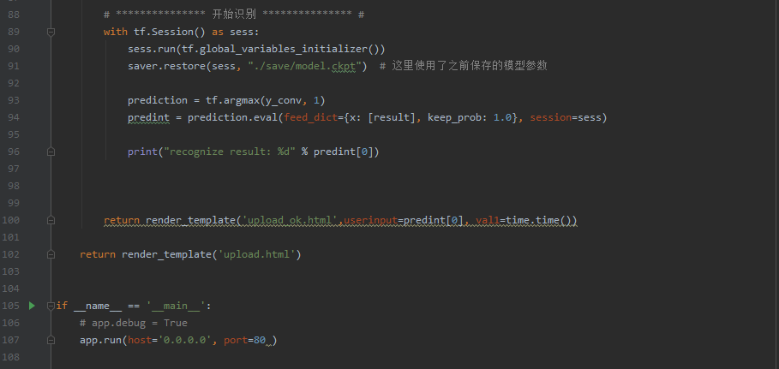

Recognize the number and open ports

Internet pages

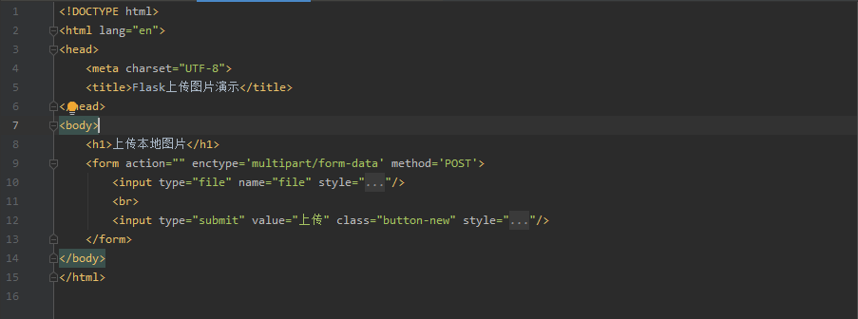

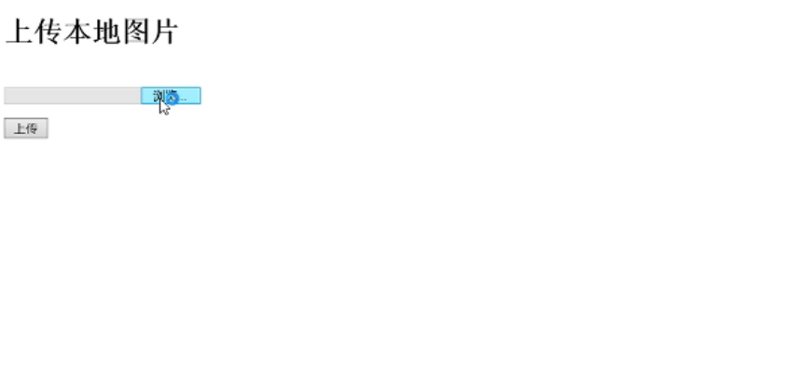

The first internet page

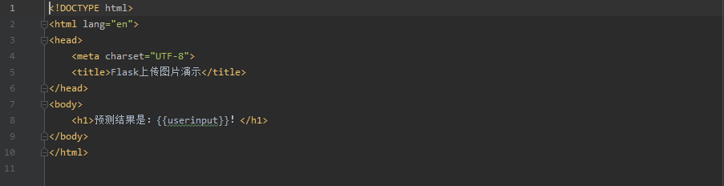



The second

The Docker

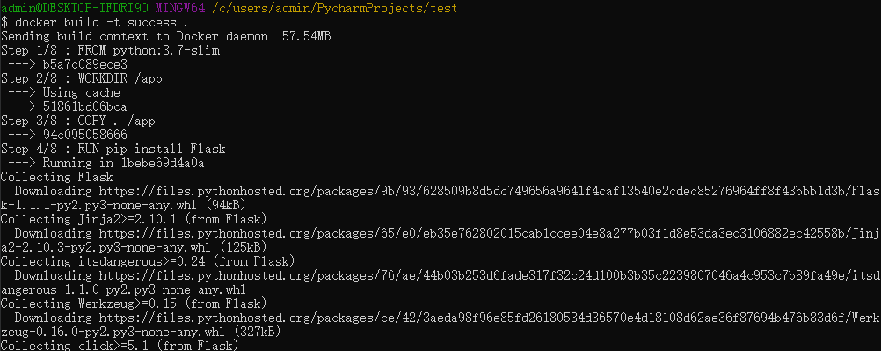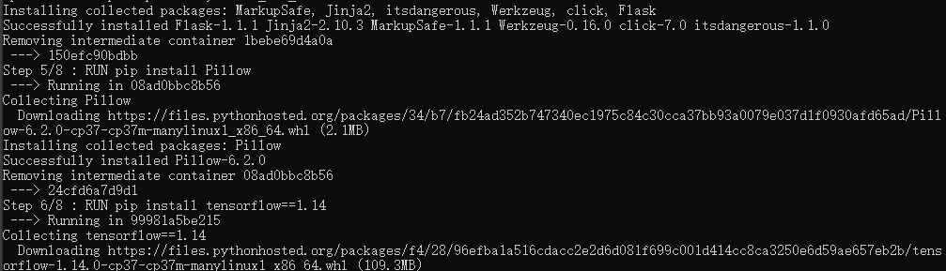

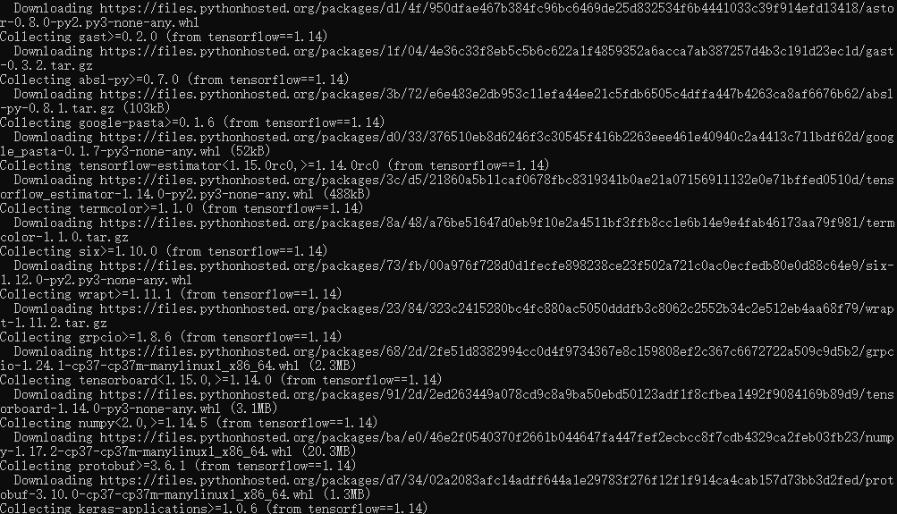

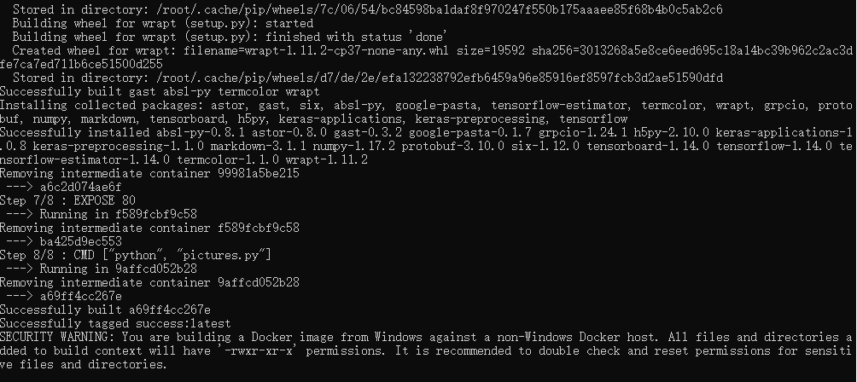

Build an image and download necessary packages



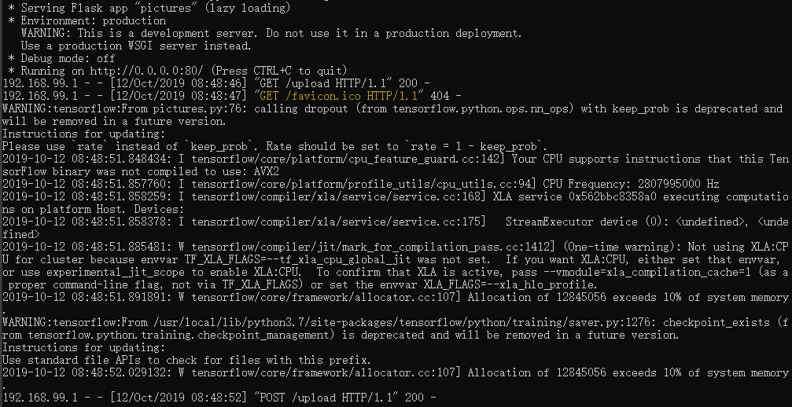

Run the program in the container

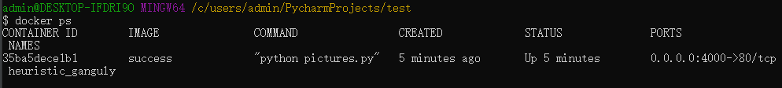

The running container

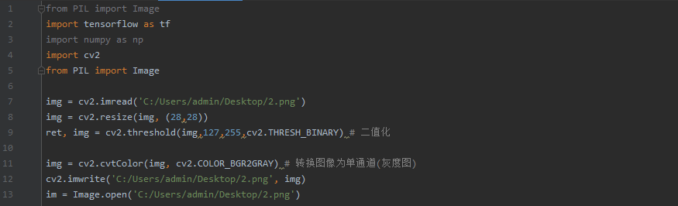

The picture should be fit for the program