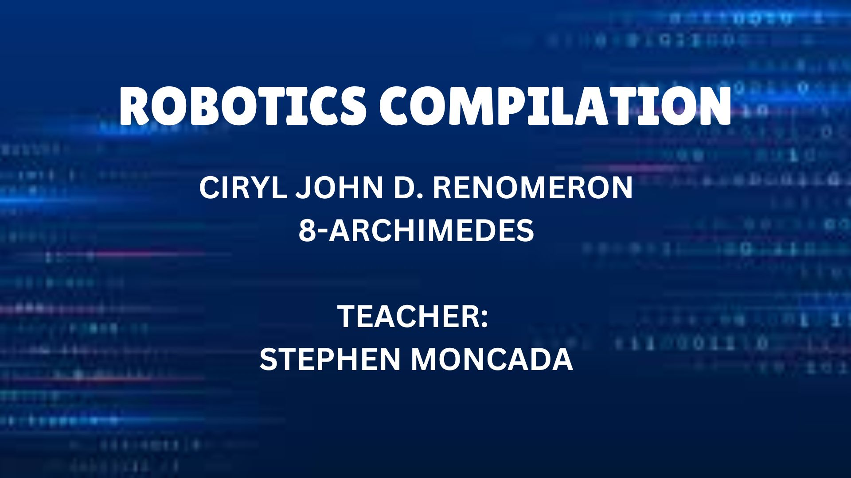

ROBOTICS COMPILATION:
Ciryl John D. Renomeron 8-STE ARCHIMEDES

HANDS ON #1: GRADING CALCULATOR

#include<stdio.h>
#include<conio.h>

int main()
{

int robo, sci, eng, sum;
float avg;
char ans;

clrscr();
gotoxy(1,1);
printf(“CIRYL JOHN D. RENOMERON”);
gotoxy(63,1);
printf(“8-STE-ARCHIMEDES”);
gotoxy(38,3);
printf(“HANDS ON #1”);
gotoxy(34,4);
printf(“4TH GRADING PERIOD”);
gotoxy(27,5);
printf(“________________________________”); //32: _

gotoxy(29,7);
printf(“ENTER YOUR ROBOTICS GRADE: “);
scanf(“%d”, &robo);

gotoxy(40,8);

if(robo >=95);
{printf(“A++”);}
else if(robo >=90);
{printf(“A+”);
else if(robo >=85);
{printf(“A”);
else if(robo >=80);
{printf(“B+”);
else if(robo >=75);
{printf(“B”);
else
{printf(“FAILED!”);

gotoxy(29,10);
printf(“ENTER YOUR SCIENCE GRADE: “);
scanf(“%d”, &sci);

gotoxy(40,11);

if(sci >=95);
{printf(“A++”);}
else if(sci >=90);
{printf(“A+”);
else if(sci >=85);
{printf(“A”);
else if(sci >=80);
{printf(“B+”);
else if(sci >=75);
{printf(“B”);
else
{printf(“FAILED!”);

gotoxy(29,13);
printf(“ENTER YOUR ENGLISH GRADE: “);
scanf(“%d”, &eng);

gotoxy(40,14);

if(eng >=95);
{printf(“A++”);}
else if(eng >=90);
{printf(“A+”);
else if(eng >=85);
{printf(“A”);
else if(eng >=80);
{printf(“B+”);
else if(eng >=75);
{printf(“B”);
else
{printf(“FAILED!”);

gotoxy(27,16);
printf(“Yo, wanna get your average? (Y/N): “);
scanf(“ %c”, &ans);
if(ans == ‘Y’ ||ans == ‘y’)
{
sum = (robo + sci + eng);
avg = sum/3;
gotoxy(31,17);
printf(“Your grade is just: %.2f “, avg);
}
else if (ans == ‘N’)
{
gotoxy(31,17);
printf(“Fine, you just scared”);
}
else
{
printf(“Eror”);
}

getch();
}

OUTPUT:

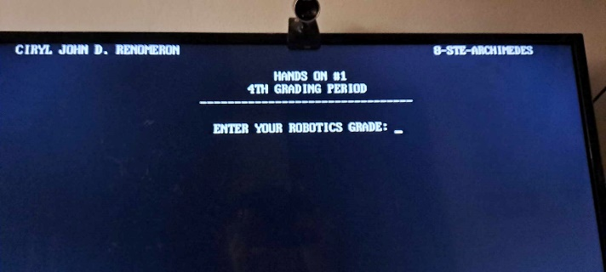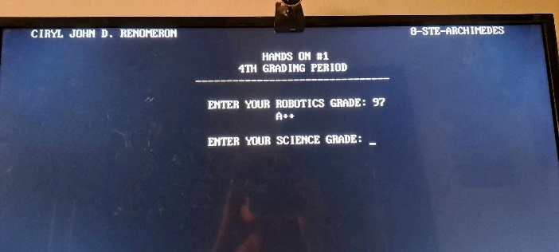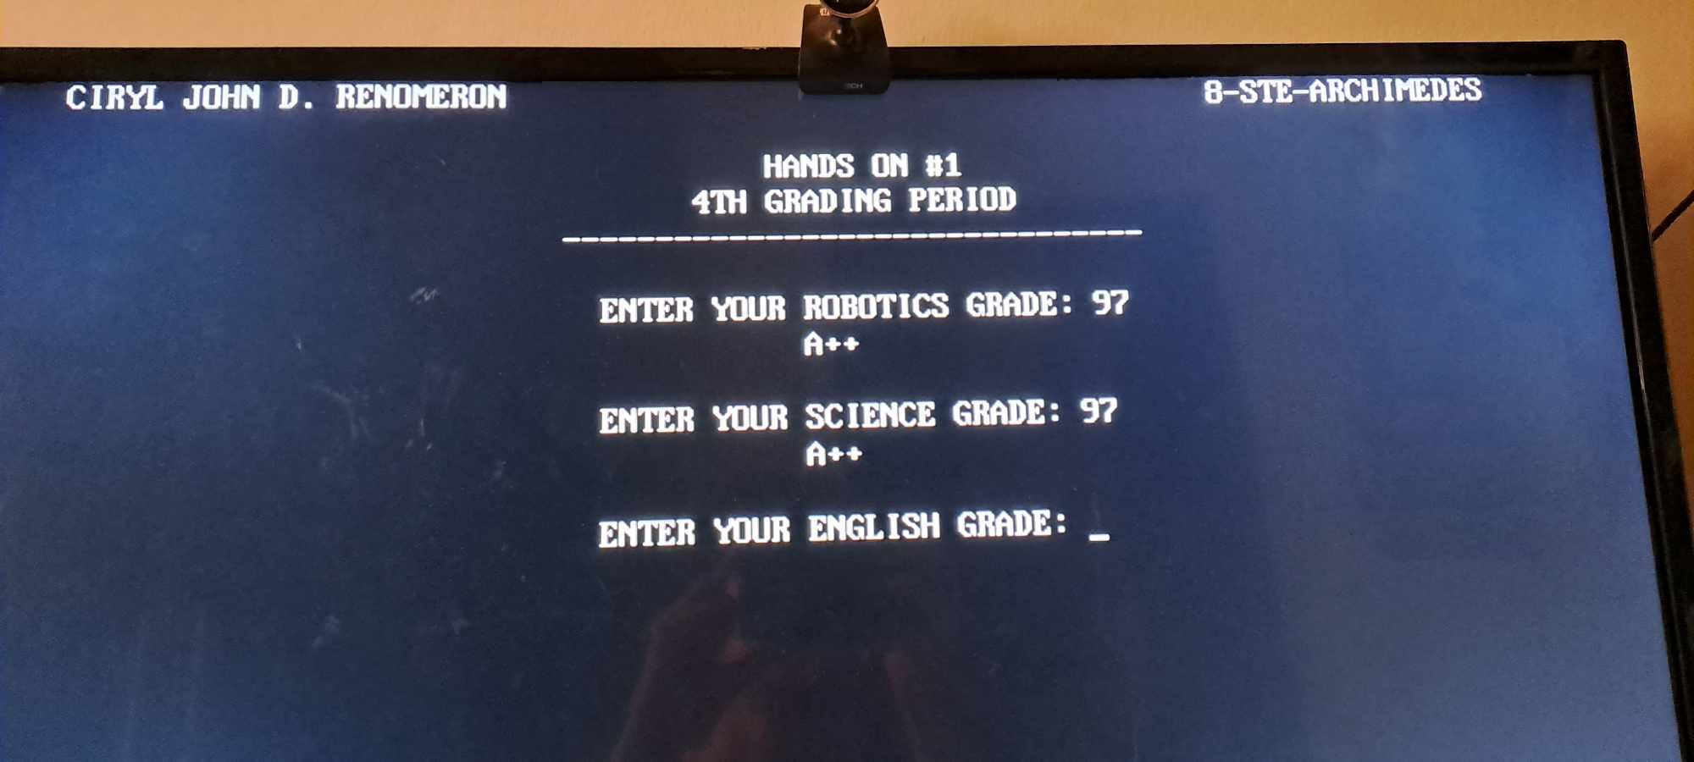

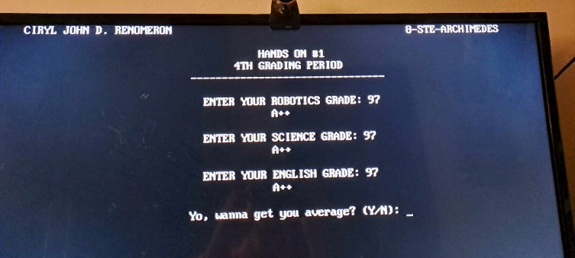
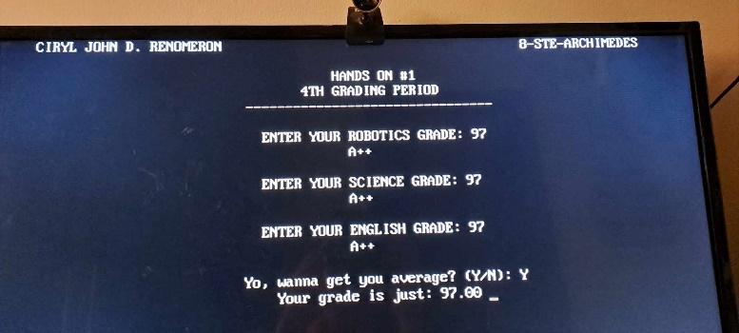

HANDS ON #2:
CODE:

#include<stdio.h>
#include<conio.h>

int main()
{

char op;
int num1, num2, result=0;
clrscr();
printf("CIRYL JOHN D. RENOMERON");
gotoxy(63,1);
printf("8-STE ARCHIMEDES");
gotoxy(38,3);
printf("HANDS ON #2");
gotoxy(34,4);
printf("4TH GRADING PERIOD");
gotoxy(27,5);
printf("________________________________");
gotoxy(27,13);
printf("________________________________");

gotoxy(29,7);
printf("SELECT OPERATION (+,-,*,/)");
gotoxy(31,8);
printf("Enter the operation: ");
scanf(" %c", &op);
gotoxy(31,9);
printf("ENTER 1ST NUMBER: ");
scanf("%d", &num1);
gotoxy(31,10);
printf("ENTER 2ND NUMBER: ");
scanf("%d", &num2);

gotoxy(26,11);

if(op=='+')
{
result = num1 + num2;
printf("The sum of the two numbers is: %d", result);
}

else if(op=='-')
{
result = num1 - num2;
printf("The differnce of the two numbers is: %d", result);
}

else if (op == '*') {
result = num1 * num2;
printf("The product of the two numbers is: %d", result);
}

else if (op=='/') {
if(num2 == 0) {
printf("Error: Division by zero is not allowed");
}
else{
result = num1 / num2;
printf("The quotient of the two numbers is: %d", result);
}
}

else {
printf("Error! Invalid operation. \n");
}

getch();
}

OUTPUT:

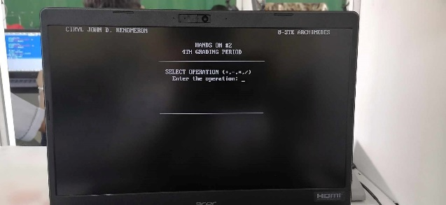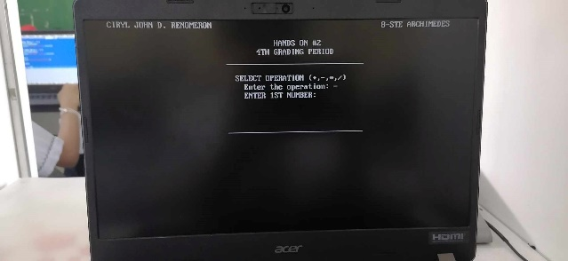
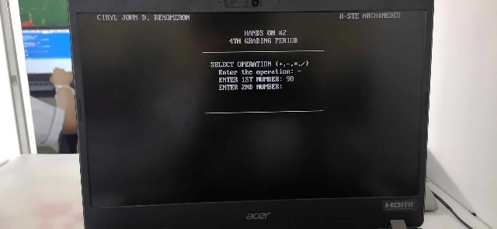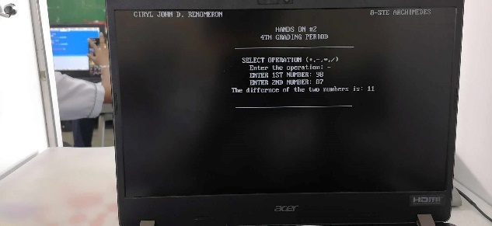

ESSAY:

Coding in Turbo C++ is quite an interesting topic. Some people find it hard while some people find it easy. For me, I find its difficulty in the middle. Most of the time, I usually get it right. But the times when I don’t get it right, I spend so long trying to fix it and when I can’t I ask for help from a few people. So, for the entire 8th grade, I have been learning coding. Honestly, it’s so annoying that I find it fun to do. This is like a hobby that I can do if I ever get bored. So, here are my experiences while coding for turbo c++.

At first, it was all pretty easy. Especially the Christmas tree and the Star activity. It was fun racing against everyone else to get a better score. Those were probably the only time in my entire 8th grade coding career where I am first. Of course, I was listening intently that time since I find coding interesting even before we started the topic. I’ve always wanted to code ever since I saw my cousin doing it just because it looks fun. I don’t remember what I did for the 3rd quarter so I probably didn’t find it fun. So now, here we are in the 4th quarter, doing else-if statements. This is probably the most annoying activity I have ever gotten since all it takes is one mistake and you would have to spend a long time trying to fix it (like me, maybe I’m just bad at coding). The first activity was the grading activity.

It only needed one subject which should be easy enough, but I’m pretty sure I was feeling lazy that time and relied on ChatGpt which has been a bad decision. I spent way too much time on that activity than I intended too. It was only when I saw Clark’s code (thanks Clark), that I saw my mistake and I fixed it. By that time though, we already needed to do the 2nd activity which was the calculator. Since we have done that activity before, I decided to do the calculator activity first before the grading system activity. This way would’ve been so much more helpful to me but I instead I decided to just keep on switching whenever I feel like it. Because of that, it took so much longer for me to finish the code. But after 2 – 3 weeks of doing it, I’m finally done.

To sum it all up, I like coding. I find it so interesting, just as I said earlier. Even though most of the time I end up getting angry since I almost always get an error, I always go back. I guess I’m just so bored, I just want to do anything to cure the boredom. That’s one of the main reasons of why I code. But, there is something in coding that just sits right with me, so I don’t mind if I get angry at my code. That just means I have to improve and try to perfect it.

WORD COUNT: 518 words

