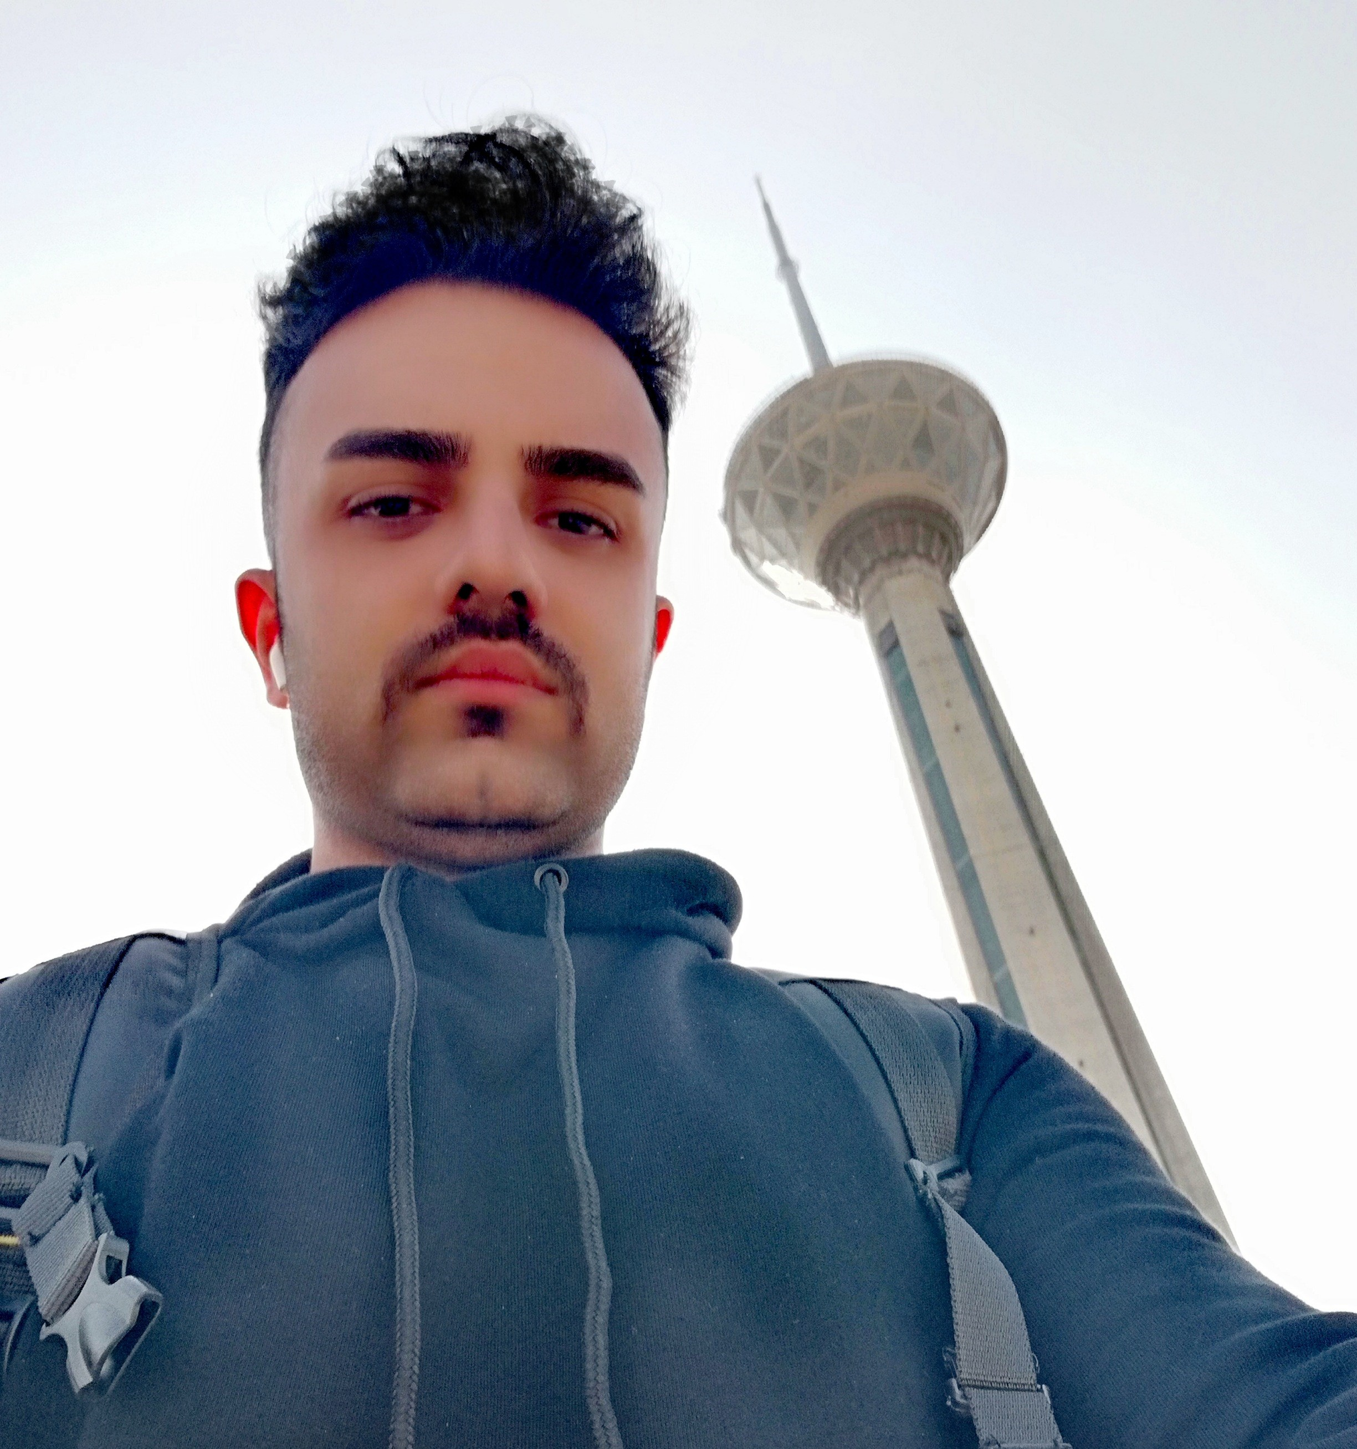

**Belal Keikhosravi**

ProgrammeRimage2.png

+98 918 417 1809image3.png

belal.keikhosravi@gmail.comimage4.png

Soon(Kei01) ... 95%image5.png

Sanandaj-Iran

**SUMMARY**

Junior Front-End Developer with some months of proven experience in an innovative startup environment. Highly skilled in JavaScript, front end frameworks, and development of single page applications with real-time communication. component based programming and able to built a web site based on user comfort and modern design. make exclusive plugins of "wordpress" for some free WP Templates ...

**EXPERIENCE**

web Developer 01/2024 - Present Kei01 I Entered the university in the field of computer engineering in 2018 (Kurdistan University), I had no background in programming and algorithms, Even though I did not perform well in the first encounter with programming that was taught in the "C" language But the situation changed soon and my interest in programming was increasing day by day, this interest took another face in dealing with the object oriented language "Java", and I was able to do my first mini-projects with this language; With the arrival of the Covid_19 , the education became weak and the quality of teaching decreased, I was forced to turn to self-learning and practice myself through educational videos, like YouTube ... The academic process continued until 2022 and I got my bachelor's degree. After graduating from university, I did not see the educational process in such a way that I could enter the work, since 2022, by being a member of the Sanandaj Science and Technology Park, I started a different process in the world of programming, from back-end and Java language to design. I started working on the webs and develope sites, the reason for this work was my interest in the front-End field and also in the powerful "JavaScript" language... After taking courses from Front and despite the many problems that existed, I was able to raise my resume to a good level ( CV ) and be busy in this field...! The beginning of my interest in the world of programming was first formed through computer games and gradually increased! Interest in solving complex problems and challenges was also very effective in this process.

**EDUCATION**

computer Engineering  
 Kurdistan University - bachelor degree

* Familiarity with functional and object-oriented programming using C and Java languages
* Limited acquaintance with Security of Networks
* Interested in Web design

**SKILLS**

Git

Intermediate

Figma

Intermediate

HTML5

Advanced

CSS3/SCSS

Advanced

ReactJs

Intermediate

JS/Scripting

Advanced

**LANGUAGES**

IR Persian

Native

KR Kurdish

Native

US English

about Fluent

UAE Arabic

Basic

**PROJECTS**

* Meteorological project
* Personal Website
* Gold online Shop
* "To Do List" Project
* Mobile online Shop
* Body Building Web site design
* BMI project