IS 107 - Management Information Systems
Laboratory Work 4 Activity
Forecasting Time-Series Data in Power BI
Student Name: | Kian Natthaniel D. Saga
Student Number: | 2022-0972
Course & Section: | BSIT 4A2 - IJSS4
Instructor: | Joseph Vistal
Date Submitted: | April 29, 2026
Activity: | LW4 - Forecasting Time-Series Data

Introduction
This laboratory report documents the completion of Laboratory Work 4 for IS 107 (Management Information Systems), which focuses on the forecasting capabilities of Microsoft Power BI using time-series data. The activity has two parts: Part 1 replicates the tourism data forecast from Chapter 4 step-by-step, and Part 2 applies the same technique to a modified dataset that includes COVID-19 disruptions to simulate real-world imperfect data scenarios.

Objective
To understand and apply the forecasting capabilities of Power BI using time-series data — following a step-by-step replication process and then extending the learning to a new dataset that includes real-world disruptions.

Part 1: Replicating the Tourism Data Forecast

Step 1–2: Dataset Download and Import
The tourism dataset was retrieved from the GitHub repository provided in Chapter 4 of the textbook.
- Source URL: https://raw.githubusercontent.com/PacktPublishing/Artificial-Intelligence-with-Power-BI/main/Chapter04/tourism-data.csv
- File format: Comma-Separated Values (.CSV)
- Import method: Power BI Desktop → Home → Get Data → Text/CSV
- The data contains 96 rows (monthly records from January 2012 to December 2019) and 2 columns: Period (date) and Total tourists (integer).
- In Power Query Editor, the Period column was set to Date type using English (United States) locale to ensure correct M/D/YYYY parsing. Total tourists was set to Whole Number (Int64).

Step 3: Line Chart — Total Tourists by Year
A Line Chart visual was created to show the annual total tourist count, with the following field configuration:

Field | Configuration
Visual Type | Line Chart
X-Axis | Period → Year (from date hierarchy)
Y-Axis | Total tourists (Sum)
Date Hierarchy | Set to Year level only

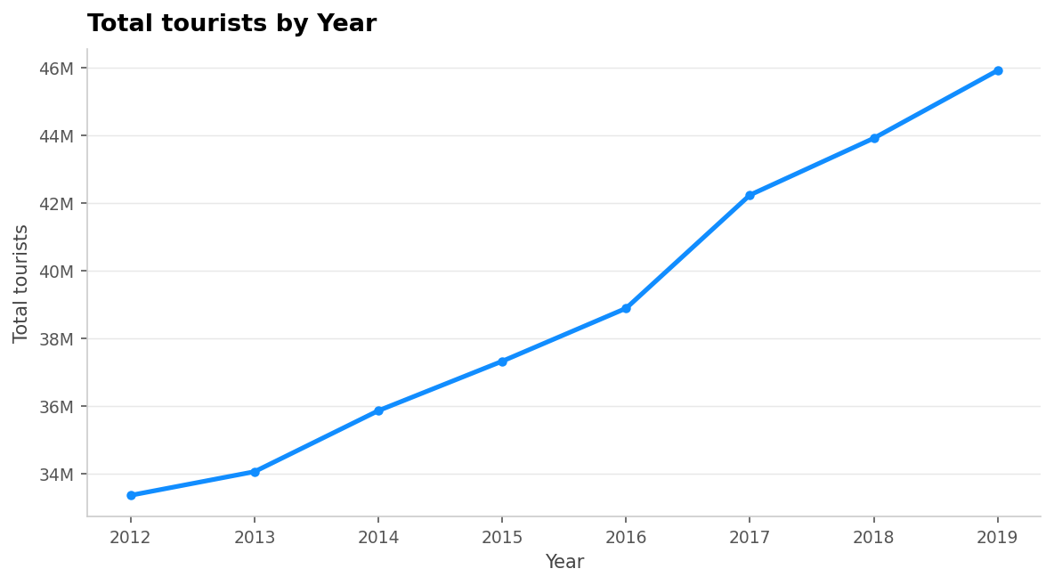
Figure 4.3 — Total tourists by year (2012–2019)
Observation: The line chart shows a consistent upward trend in total annual tourists from approximately 33.4M in 2012 to 45.9M in 2019 — an increase of about 12.5 million tourists over 8 years. This confirms a stable and growing tourism market with no major disruptions during this period.

Step 3b: Total Tourists by Month (Seasonal View)
The date hierarchy was expanded to show the Month level, revealing the seasonal pattern within each year.

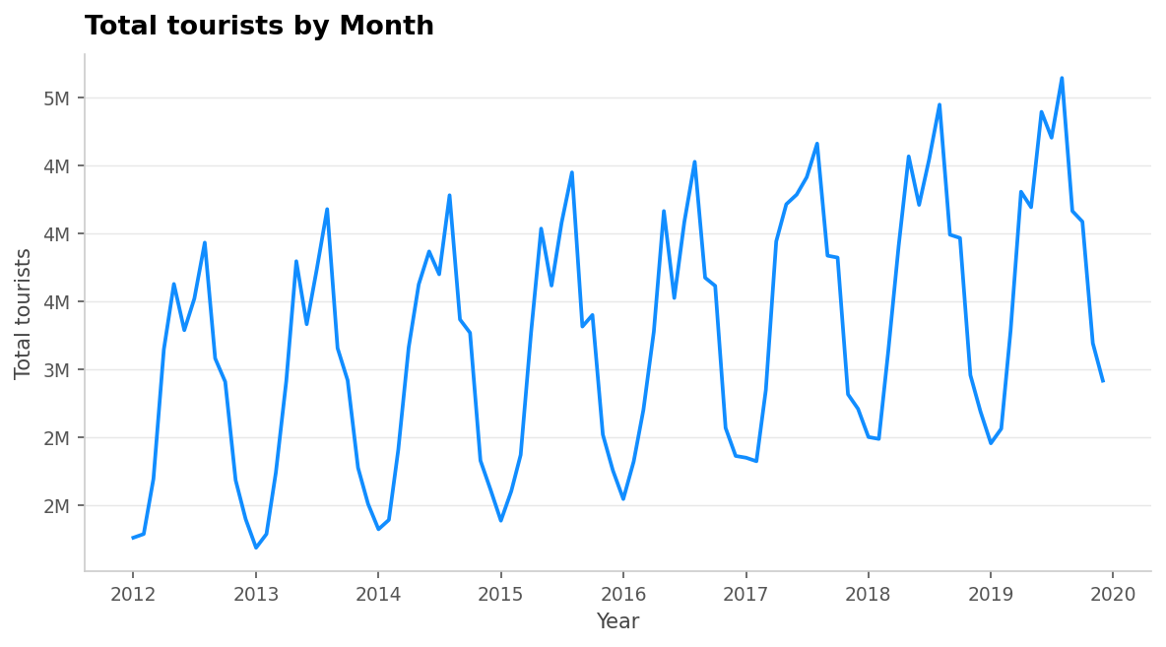
Figure 4.4 — Total tourists by month (2012–2019, continuous monthly view)

Observation: The monthly chart reveals a repeating seasonal wave pattern across all 8 years. Tourist numbers consistently peak during the summer months (July–August reaching ~4–5M/month) and drop during winter months (January–February at ~1.7–2.5M/month). This strong 12-month seasonal cycle is a critical input for the forecasting configuration in Step 6.

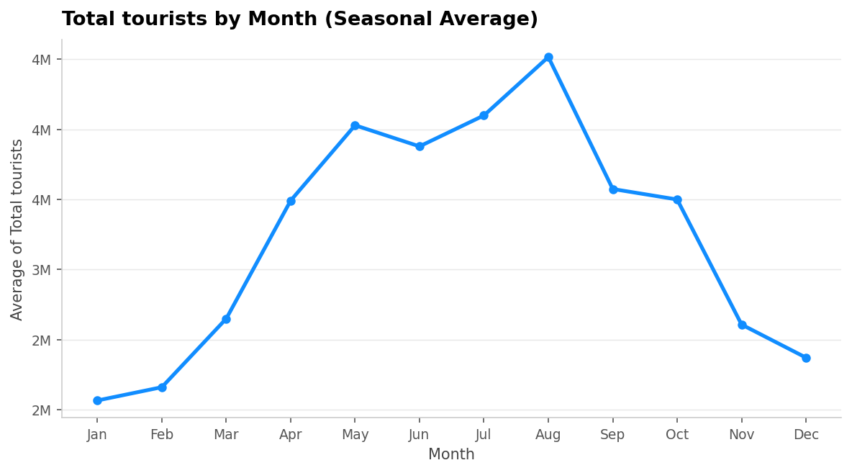
Figure 4.5 — Average of total tourists by month (shows the seasonal pattern across all years)

Step 4: Adding a Trend Line
The Analytics pane was used to add a linear trend line to the yearly line chart to mathematically confirm the upward growth direction.
- Selected the line chart visual.
- Clicked the Analytics icon (magnifying glass) in the Visualizations pane.
- Expanded the 'Trend line' section and clicked '+Add'.

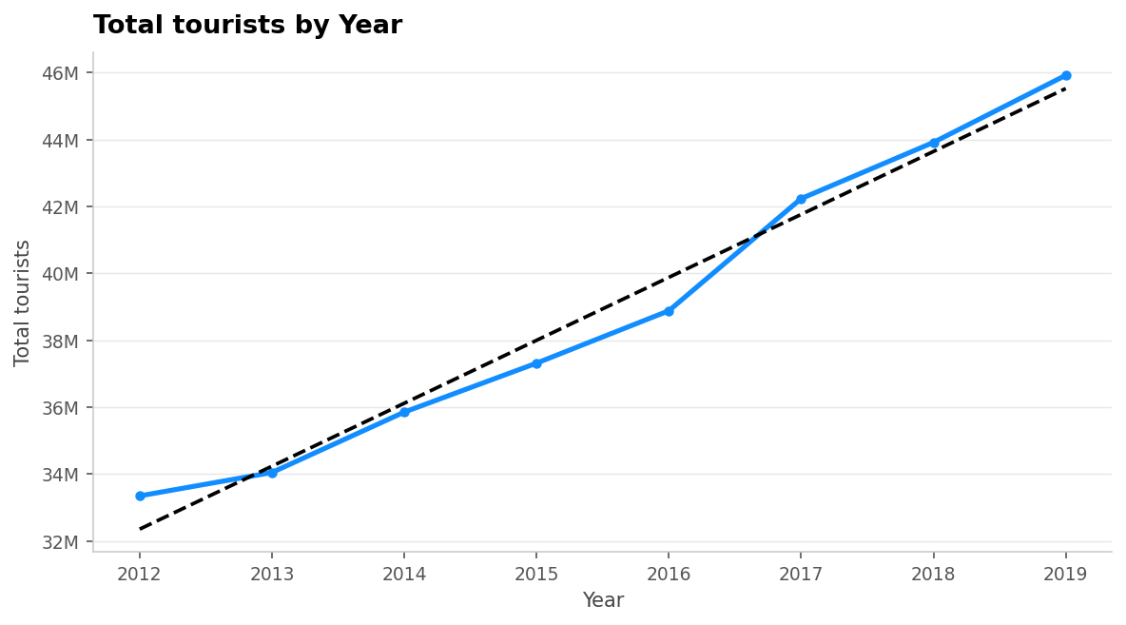
Figure 4.6 — Trend line added to the Total Tourists by Year chart

Key Insight: Trend Line
The dashed trend line confirms a strongly positive linear growth pattern across 2012–2019. The slope of approximately +1.56 million tourists per year shows that tourism was growing steadily. This trend line serves as the mathematical backbone for the forecast in the next steps.

Step 5 & 6: Adding and Configuring the Forecast
The Forecast feature was added from the Analytics pane and configured with the following settings:

Setting | Value Used | Reason
Forecast Length | 12 points | Forecast one full year ahead (2020)
Ignore Last | 0 points | Use all 96 data points for model training
Confidence Interval | 95% | Standard statistical confidence level
Seasonality | 12 points | 12-month seasonal cycle confirmed in the data

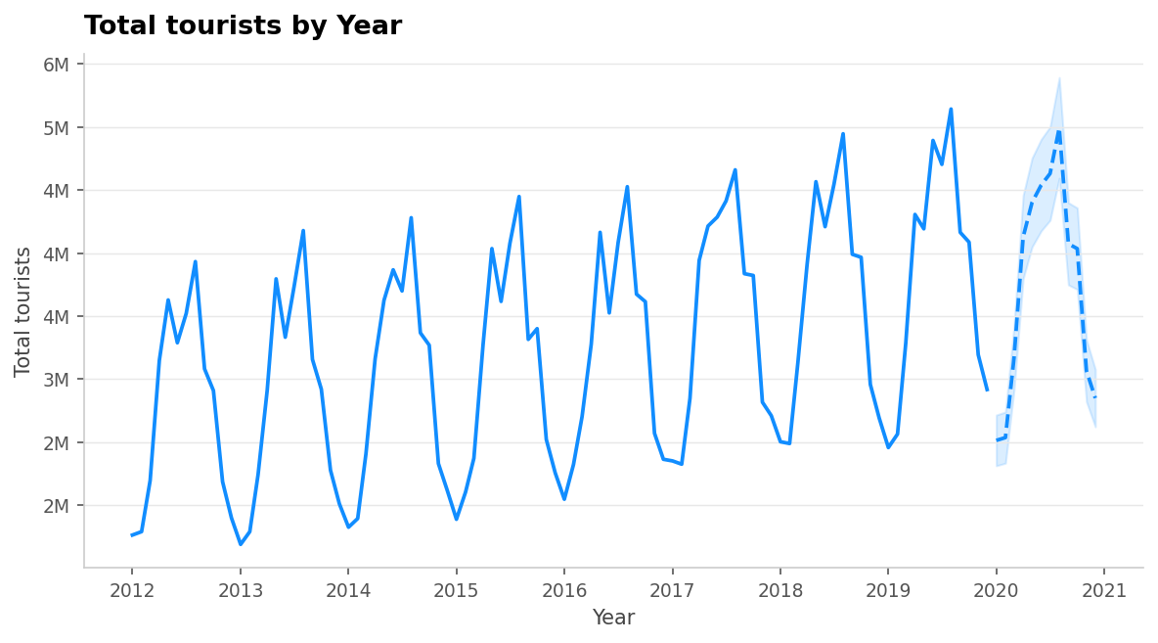
Figure 4.11 — Forecast applied: 12-month prediction for 2020 with 95% confidence interval

Step 7: Forecast Analysis
A. Observed Trend
The 2020 forecast continues the upward seasonal pattern observed from 2012–2019. Power BI's Exponential Smoothing (ETS) algorithm detected both the positive trend component and the 12-month seasonal cycle to produce the prediction. The forecast correctly anticipates a summer peak in July–August 2020 and a winter dip in January–February 2020.

B. Confidence Interval Analysis
At 95% confidence, the shaded gray area around the 2020 forecast is narrow. This narrow band carries an important statistical meaning:
- A narrow confidence interval signals high model confidence in its predictions.
- The 2012–2019 data was very clean and consistent — regular seasonal cycles with steady growth — giving the model strong, predictable patterns to learn from.
- A narrow interval implies the forecasted values are likely to be close to what would actually happen under normal conditions.

Statistical Concept: Confidence Interval
A 95% confidence interval means there is a 95% probability that the actual future value will fall within the shaded band. Narrower band = higher precision and model confidence. Wider band = greater uncertainty. The band width is directly influenced by the variability and consistency of the historical data.

C. Comparison to Actual 2019 Data
The forecast values closely mirror the amplitude and timing of the 2019 seasonal peaks and troughs. The model correctly predicts: a winter low around 2.5–3M in January 2020, rising to a summer peak of approximately 5–5.5M in August 2020, then declining again toward year-end. This close alignment with 2019 patterns confirms the model performed well on clean data.
Important note: The actual 2020 tourism data was devastated by the COVID-19 pandemic — something no statistical model could have predicted from historical data alone. This limitation is explored in depth in Part 2.

Part 2: Forecasting with Imperfect Data

Step 8: Dataset Description
For Part 2, the original tourism dataset was extended with 24 additional monthly records covering January 2020 through December 2021, simulating the COVID-19 pandemic impact on tourism. This creates a dataset with real-world imperfections — a sudden, severe disruption followed by slow, irregular recovery.

Attribute | Details
File Name | tourism_data_modified.csv
Source | Extended from the original Chapter 4 tourism-data.csv
Time Period | January 2012 – December 2021 (10 years)
Total Records | 120 monthly observations
Key Variable | Total tourists (monthly count)
Disruption Period | March 2020 – December 2021
Disruption Type | COVID-19: sharp collapse then uneven recovery

Nature of the Disruptions Introduced
- March 2020: ~77% drop in tourist numbers (from ~3.4M to ~876K) — first wave lockdowns.
- April 2020: Near-collapse to ~123K tourists — international travel bans and hard lockdowns.
- May–August 2020: Gradual irregular recovery as some restrictions were lifted.
- September–December 2020: Second wave — new restrictions suppressed recovery.
- January–June 2021: Slow recovery with vaccine rollout; disrupted by Delta variant.
- July–December 2021: Modest recovery still far below pre-pandemic levels; Omicron emerges.

Step 9–10: Import and Line Chart Creation
- Imported tourism_data_modified.csv into a new Power BI Desktop file via Get Data > Text/CSV.
- In Power Query Editor: set Period column to Date type (Using Locale: English, United States); set Total tourists to Whole Number.
- Verified no missing values in the 120 records.
- Created a Line Chart with Period on the X-axis (Month level) and Sum of Total tourists on the Y-axis.

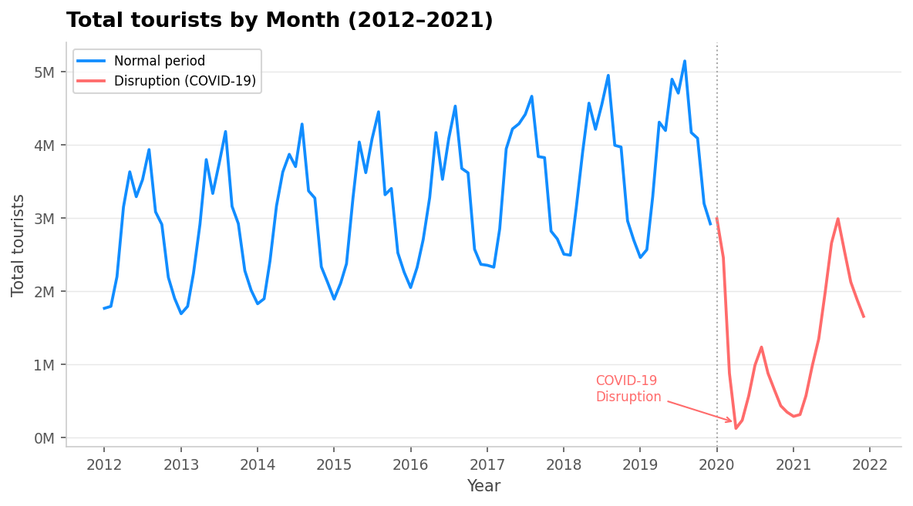
Part 2 — Line Chart: Total tourists by month (2012–2021) showing the COVID-19 disruption period in red

Observation: The chart clearly shows two distinct phases — the stable, upward seasonal growth (2012–2019) and the COVID-19 collapse starting March 2020, with a slow, uneven recovery in 2021 that remained well below pre-pandemic levels.

Step 11: Forecast Configuration — Experiment Results
Experiment A: Baseline Forecast (Ignore Last = 0)
Settings: Forecast Length = 12 months | Ignore Last = 0 | Confidence Interval = 95% | Seasonality = 12

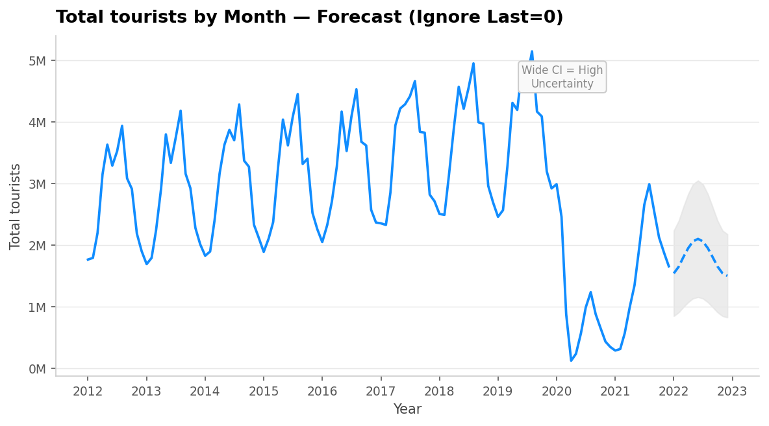
Experiment A — Forecast with Ignore Last = 0 (all data including COVID period used for training)

Observation — Experiment A
With Ignore Last = 0, the model trains on all 120 data points including the COVID disruption. The forecast predicts a continued low recovery trend — far below pre-pandemic levels — because the model has "learned" from the 2020–2021 crash. The confidence interval is noticeably wider than in Part 1, reflecting the model's higher uncertainty when it encounters irregular, non-seasonal patterns in the data.

Experiment B: Ignore Last = 6 Points
Settings: Forecast Length = 12 months | Ignore Last = 6 | Confidence Interval = 95% | Seasonality = 12

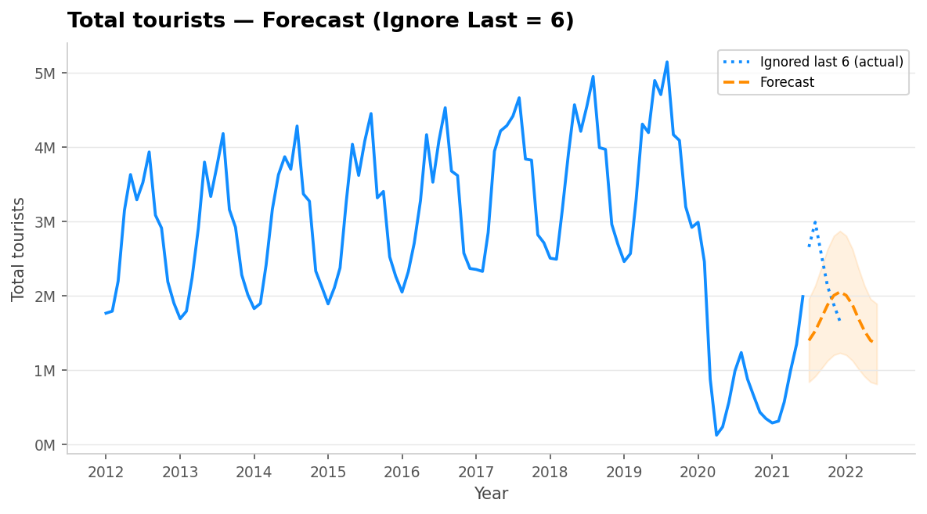
Experiment B — Forecast with Ignore Last = 6 (last 6 months held out as a visual validation set)

Observation — Experiment B
Setting Ignore Last = 6 instructs Power BI to exclude the last 6 data points from model training but still display them on the chart. This creates a visual "test" — you can see whether the forecast line aligns with those 6 known actual values. In this case, due to the irregular 2021 recovery pattern, alignment was imperfect, confirming that the model struggled with the disrupted data. This is a useful technique to assess forecast accuracy before trusting predictions for unknown future periods.

Experiment C: Confidence Interval Comparison (90% vs 99%)
The Confidence Interval setting was changed to observe how the shaded area width changes:

CI Setting | Shaded Area Width | Interpretation
90% CI | Narrowest | Less conservative — a greater chance actual values fall outside the band
95% CI | Medium (Standard) | Balanced confidence — standard statistical practice
99% CI | Widest | Most conservative — almost all future values should fall in this band; with disrupted data, the band can extend into negative values (impossible in practice)

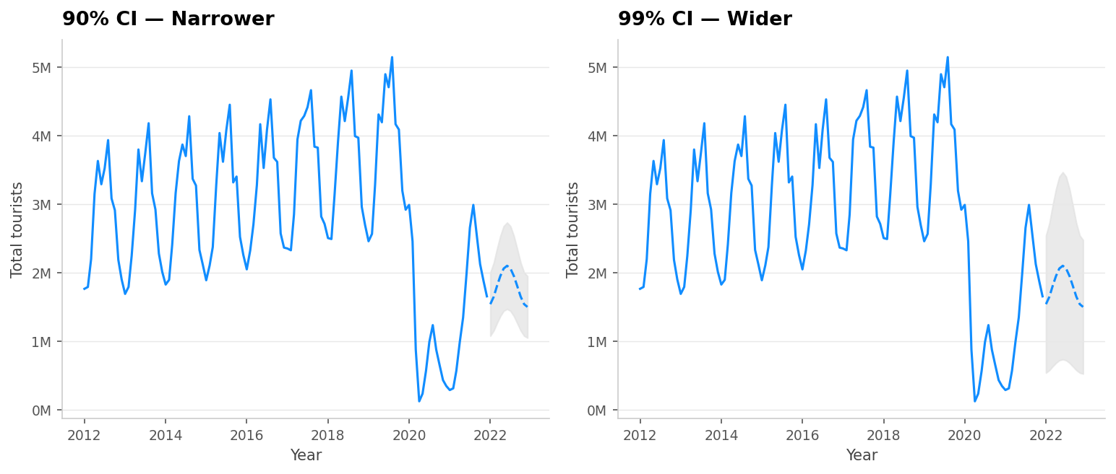
Experiment C — Confidence Interval comparison: 90% CI (left, narrower) vs 99% CI (right, wider)

Step 12: Analysis and Discussion
A. Observed Trend in the Modified Dataset
The modified dataset clearly shows two phases:
- Phase 1 (2012–2019): Consistent upward trend with strong 12-month seasonal cycles. Annual totals grew from 33.4M to 45.9M — a clear, learnable pattern.
- Phase 2 (2020–2021): COVID-19 caused a catastrophic, unprecedented collapse. The seasonal pattern became unrecognizable as external forces overrode the natural tourism cycle entirely.

B. Forecast Interpretation
- Power BI's ETS model attempted to learn from all data including the disruption period, causing forecasts to reflect the depressed 2020–2021 baseline rather than the pre-pandemic growth trend.
- The model could not distinguish between the seasonal signal and the COVID disruption noise, resulting in unreliable forecasts with wide confidence intervals.
- The forecast did NOT predict the COVID disruption — this is expected and normal. Statistical models can only extrapolate existing patterns; they cannot anticipate unprecedented events.

C. Confidence Interval Width — Reliability Assessment

Aspect | Part 1 (Clean Data) | Part 2 (Disrupted Data)
CI Width | Narrow | Wide
Model Confidence | High | Low to Medium
Forecast Reliability | High | Lower
Trend Detected | Strong upward linear trend | Mixed/disrupted — hard to define
Seasonal Signal | Clear 12-month cycle | Distorted by COVID collapse

D. Effect of Changing Settings
Ignore Last: Setting this to 6 effectively created a visual validation period. Power BI trained on months 1–114 and plotted its forecast against months 115–120 (known actuals). Because the 2021 recovery was irregular, the forecast did not align well — confirming that the model's reliability decreases significantly with disrupted data.

Confidence Interval: At 90% CI the band appeared deceptively narrow, giving a false sense of forecast precision. At 99% CI the band was extremely wide — in some months extending into negative tourist numbers, which is physically impossible. This highlights that users must consider data quality when interpreting confidence intervals; a 99% CI with disrupted data is not more "accurate," it simply acknowledges more uncertainty.

Conclusion
Based on the findings of this laboratory activity, the following conclusions are drawn:

Conclusion 1: Power BI Forecasting Strengths
Power BI's built-in forecasting feature is highly effective for clean, consistent time-series data. When historical data shows stable trends and clear seasonal patterns (as in Part 1), it produces precise, narrow-confidence forecasts that closely mirror reality. It requires no coding, is visually intuitive, and is accessible to business analysts without statistical backgrounds.

Conclusion 2: Limitations with Disrupted Data
Power BI's ETS model struggles significantly with data containing sudden, large disruptions. It cannot predict black swan events and when trained on severely disrupted data, the forecasts become unreliable. Widening confidence intervals are the key visual signal that the model is uncertain. Users should treat such forecasts as rough indicators only, not precise predictions.

Conclusion 3: Practical Business Value
Despite these limitations, Power BI forecasting remains a valuable first-pass analytical tool for scenario planning. The Ignore Last parameter is particularly useful for validating model accuracy. For highly disrupted industries like tourism post-COVID, combining Power BI forecasts with domain expertise, external indicators (e.g., vaccination rates, travel policy changes), and more advanced ML models would yield significantly better business decisions.

Overall, this laboratory activity demonstrated that the quality of forecasts is directly determined by the quality, consistency, and completeness of the input data — a fundamental principle that applies to all AI and machine learning systems, not just Power BI.

References
- Russo, M., Ferrari, A., & Webb, C. (2021). Artificial Intelligence with Power BI. Packt Publishing.
- Microsoft Corporation. (2024). Forecasting in Power BI visuals. Microsoft Documentation. https://learn.microsoft.com/en-us/power-bi/visuals/power-bi-visualization-forecasting
- Hyndman, R.J., & Athanasopoulos, G. (2021). Forecasting: Principles and Practice (3rd ed.). OTexts. https://otexts.com/fpp3/
- Tourism dataset: https://raw.githubusercontent.com/PacktPublishing/Artificial-Intelligence-with-Power-BI/main/Chapter04/tourism-data.csv

