IS 107 — Management Information Systems
Laboratory Work 5 Activity
Applying DAX Fundamentals in Power BI
From Measures to Contextual Analysis
Student Name: | Kian Nathaniel
Student Number: | 2022-0972
Course & Section: | BSIT 4 A2 - IJSS4
Instructor: | Joseph Vistal
Date Submitted: | April 29, 2026
Activity: | LW5 — Applying DAX Fundamentals in Power BI

Introduction
This laboratory report documents the step-by-step implementation of Data Analysis Expressions (DAX) within Microsoft Power BI, using three real-world datasets: LW5_Orders.xlsx, LW5_Customers.xlsx, and LW5_Cookie_Types.xlsx. The activity covers creating Calculated Columns, building DAX Measures, establishing table relationships in the Model View, and constructing an interactive sales dashboard.

Objective
To execute the step-by-step implementation of DAX within Power BI — creating Calculated Columns and Measures, understanding Row Context and Filter Context, and applying functions such as SUM, SUMX, DIVIDE, COUNTROWS, and RELATED to generate meaningful business insights from a cookie business sales dataset.

Part 1: Datasets and Data Model

1.1 Dataset Overview
Three Excel (.xlsx) files were provided for this activity, representing a cookie business operation across multiple customers and product types:

File | Records | Key Column | Description
LW5_Orders.xlsx | 700 rows | Order ID (PK) | Transaction records: units sold, revenue, cost, dates
LW5_Customers.xlsx | 5 rows | Customer ID (PK) | Customer profiles: name, phone, city, state, country
LW5_Cookie_Types.xlsx | 6 types | Cookie Type (PK) | Product table: units sold, revenue per cookie, cost per cookie

1.2 Dataset Column Reference
LW5_Orders.xlsx — Fact Table (700 transactions):
Column | Data Type | Description
Order ID | Text | Unique order identifier (Primary Key)
Customer ID | Text | Foreign Key linking to Customers table
Product | Text | Cookie type name — Foreign Key to Cookie_Types
Date | Date | Transaction date
Units Sold | Whole Number | Number of cookies sold in this order
Revenue | Decimal | Total revenue for this order (Units Sold x Revenue Per Cookie)
Cost | Decimal | Total cost for this order (Units Sold x Cost Per Cookie)

LW5_Customers.xlsx — Dimension Table (5 customers):
Column | Data Type | Description
Customer ID | Text | Unique customer identifier (Primary Key)
Name | Text | Customer/company name
Phone | Text | Contact phone number
City | Text | Customer city
State | Text | Customer state
Country | Text | Customer country

LW5_Cookie_Types.xlsx — Lookup Table (6 products):
Column | Data Type | Description
Cookie Type | Text | Cookie product name (Primary Key)
Units Sold | Whole Number | Total units sold (reference data)
Revenue Per Cookie | Decimal | Selling price per individual cookie ($)
Cost Per Cookie | Decimal | Production cost per individual cookie ($)

1.3 Data Model — Table Relationships
After importing all three tables, relationships were established in the Power BI Model View. Two one-to-many (1:N) relationships are required:
- Customers[Customer ID] → Orders[Customer ID] (1 customer : many orders)
- Cookie_Types[Cookie Type] → Orders[Product] (1 product type : many orders)

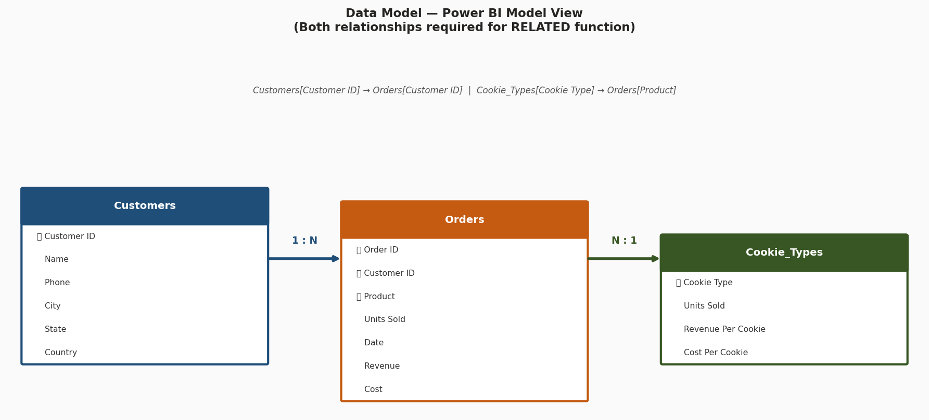
Figure 1 — Data Model View: three-table relationship schema with PK/FK links

Why Relationships Are Required for DAX
The RELATED() function — used to pull values from a lookup/dimension table into a fact table — will only work if a valid relationship exists in the Model View. Without the Customers and Cookie_Types relationships defined, any RELATED() formula written in the Orders table will return an error. Always build the data model BEFORE writing cross-table DAX formulas.

Part 2: DAX Implementation

2.1 Calculated Columns
Calculated Columns are created in the table and computed row-by-row at data refresh time. Their values are physically stored in the Power BI model, which increases the .pbix file size.

Calculated Column 1: Revenue Per Cookie (using RELATED)
This column was added to the Orders table to pull the Revenue Per Cookie price from the Cookie_Types lookup table for each row, using the RELATED function across the established relationship.

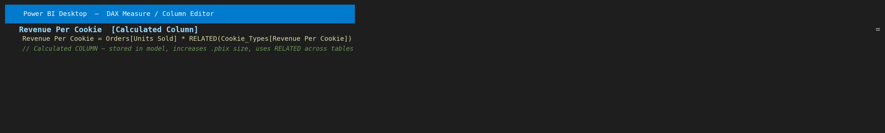
Figure 2 — Calculated Column using RELATED to bring Revenue Per Cookie into the Orders table

Revenue Per Cookie = Orders[Units Sold] * RELATED(Cookie_Types[Revenue Per Cookie])

Calculated Column 2: Customer Name (using RELATED)
This column retrieves the customer Name from the Customers table into the Orders table, making it available as a grouping field in visuals.

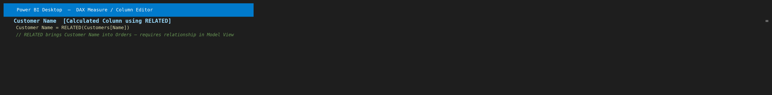
Figure 3 — RELATED function: pulling Customer Name from Customers into Orders table

Customer Name = RELATED(Customers[Name])

Storage Impact — Calculated Columns vs Measures
A Calculated Column stores a computed value for EVERY row in the table. For 700 rows this is small. But for enterprise tables with millions of rows, each Calculated Column multiplies memory usage significantly. This is why Measures (which store only a formula, not values) are preferred for aggregated calculations like totals, ratios, and percentages.

2.2 DAX Measures — Core KPIs
All business analysis metrics were created as Measures. Unlike Calculated Columns, Measures store only the formula and compute results dynamically based on the current filter context — making them memory-efficient and context-aware.

Measure 1: Total Revenue
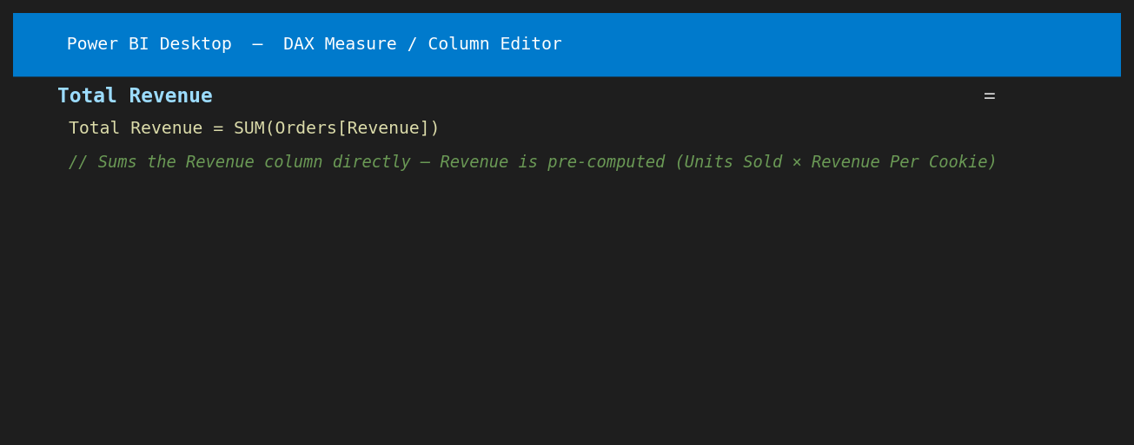
Figure 4 — Total Revenue: SUM of the Revenue column across all orders
Total Revenue = SUM(Orders[Revenue])
Since the Revenue column in Orders already contains pre-calculated row-level revenue (Units Sold x Revenue Per Cookie), a simple SUM is sufficient. This measure dynamically adjusts to any active filter.

Measure 2: Total Cost
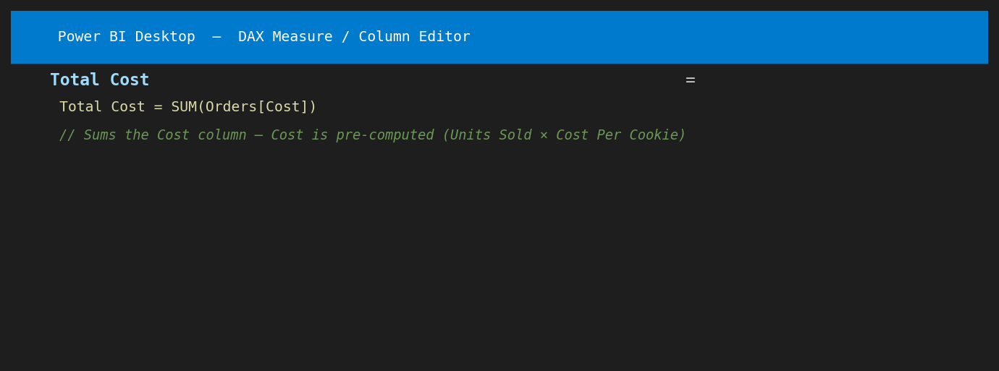
Figure 5 — Total Cost: SUM of the Cost column across all orders
Total Cost = SUM(Orders[Cost])
Similarly, the Cost column is pre-calculated per row. SUM aggregates it across all visible rows in the current filter context.

Measure 3: Total Profit
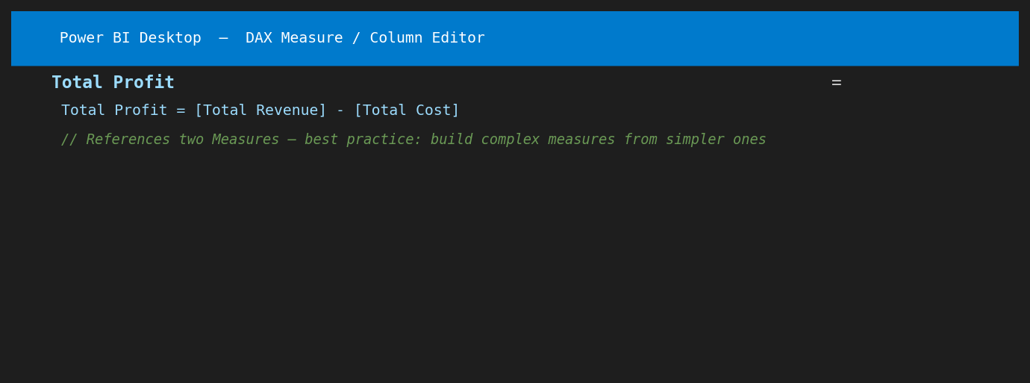
Figure 6 — Total Profit: references two existing Measures for clean, maintainable DAX
Total Profit = [Total Revenue] - [Total Cost]
Best practice: reference existing Measures rather than repeating column references. If the definition of Total Revenue ever changes, Total Profit updates automatically.

Measure 4: Profit Margin %
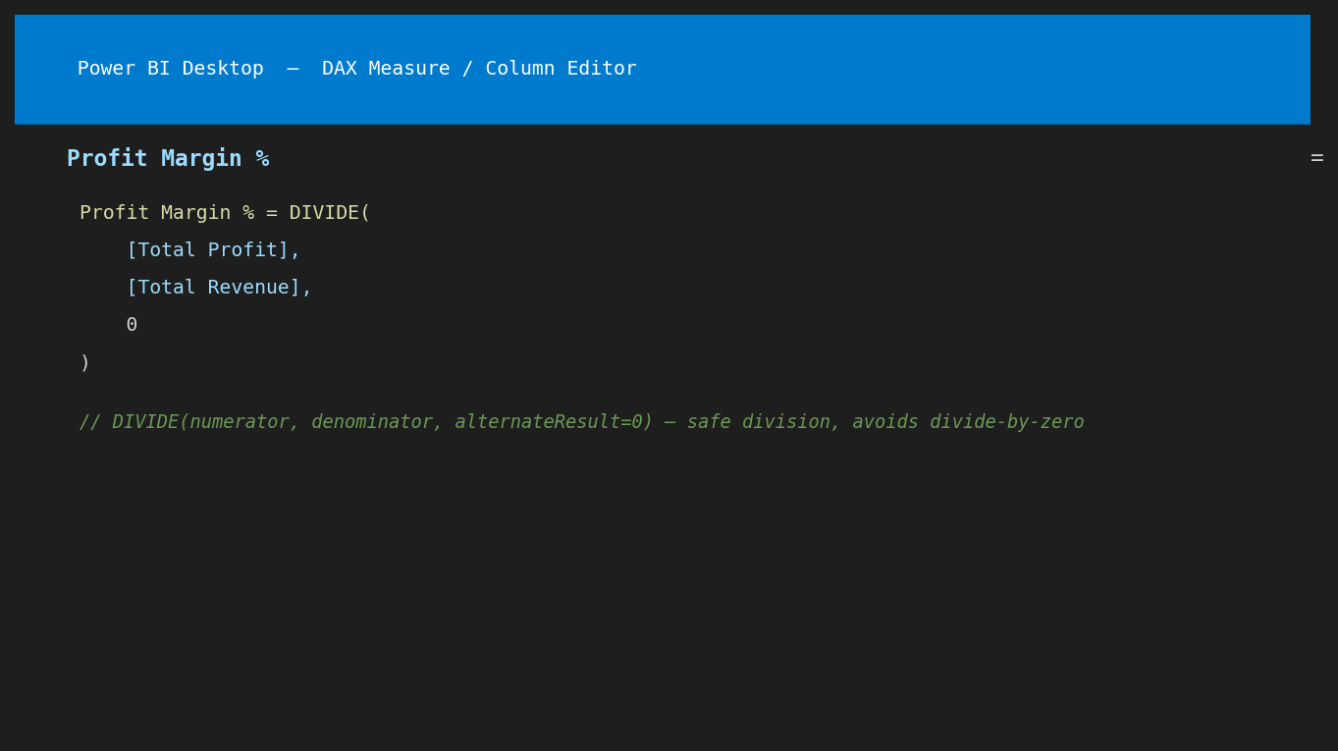
Figure 7 — Profit Margin %: uses DIVIDE for safe division (avoids divide-by-zero errors)
Profit Margin % = DIVIDE(
[Total Profit],
[Total Revenue],
0
)
DIVIDE(numerator, denominator, alternateResult) is always preferred over the "/" operator in DAX because it gracefully returns the alternate result (0) instead of a BLANK or ERROR when the denominator is zero.

Measure 5: Total Units Sold
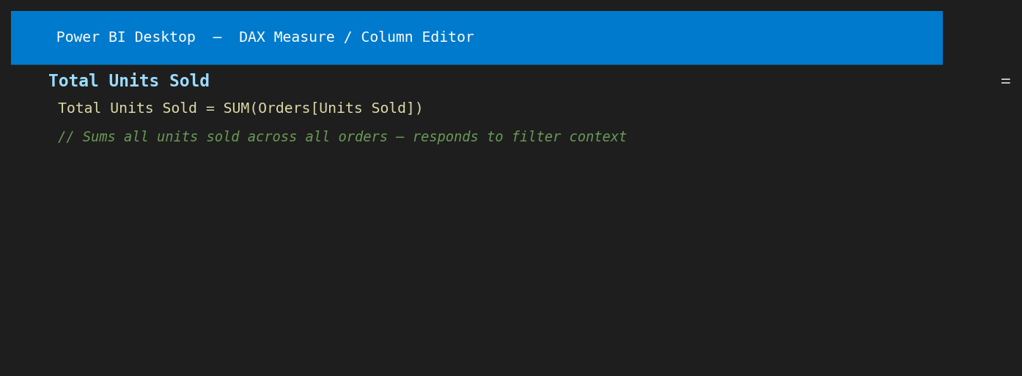
Figure 8 — Total Units Sold: SUM of the Units Sold column
Total Units Sold = SUM(Orders[Units Sold])
This measure counts the total number of individual cookies sold across all orders in the current filter context.

Measure 6: Total Orders
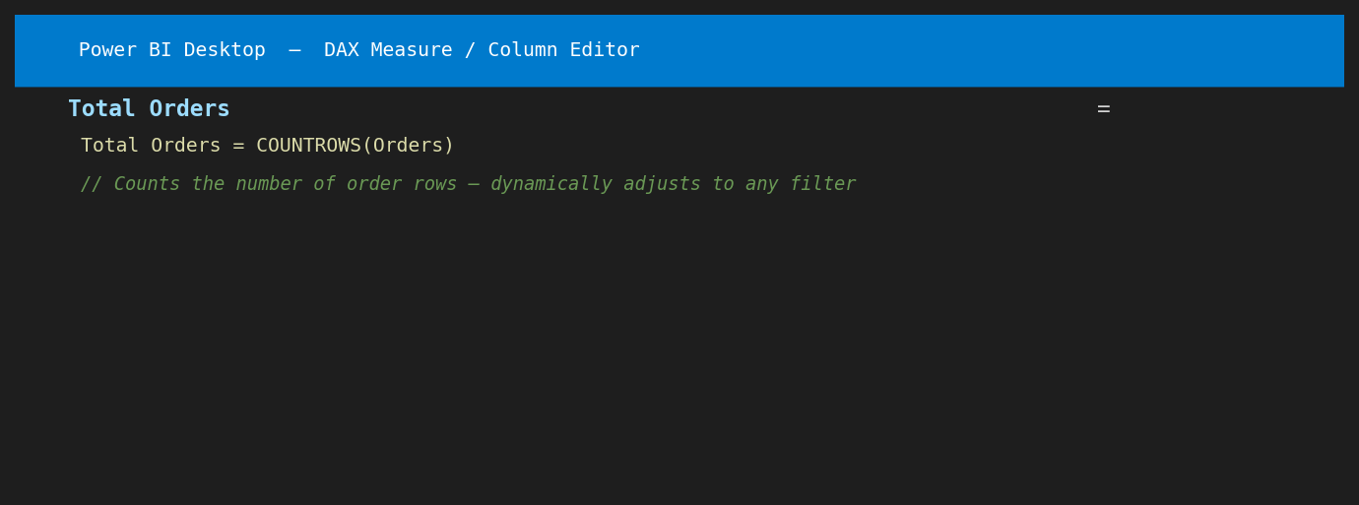
Figure 9 — Total Orders: COUNTROWS counts how many order rows exist
Total Orders = COUNTROWS(Orders)
COUNTROWS counts the number of rows in the Orders table that pass the current filter context. When a customer filter is applied, it shows only that customer's order count.

Part 3: Dashboard Visuals and Results

3.1 KPI Summary Cards
All six DAX Measures were placed as Card visuals to create a KPI summary dashboard. The values below reflect the complete unfiltered dataset (all 700 orders):

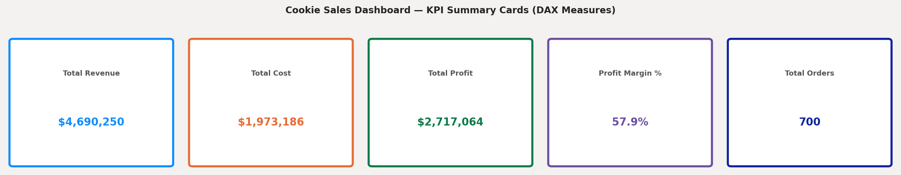
Figure 10 — KPI Cards: all six DAX Measures displayed as Power BI Card visuals

KPI Measure | Result | DAX Formula
Total Revenue | $4,690,250.50 | SUM(Orders[Revenue])
Total Cost | $1,973,186.13 | SUM(Orders[Cost])
Total Profit | $2,717,064.38 | [Total Revenue] - [Total Cost]
Profit Margin % | 57.93% | DIVIDE([Total Profit],[Total Revenue],0)
Total Units Sold | 1,125,806 | SUM(Orders[Units Sold])
Total Orders | 700 | COUNTROWS(Orders)

3.2 Revenue by Product
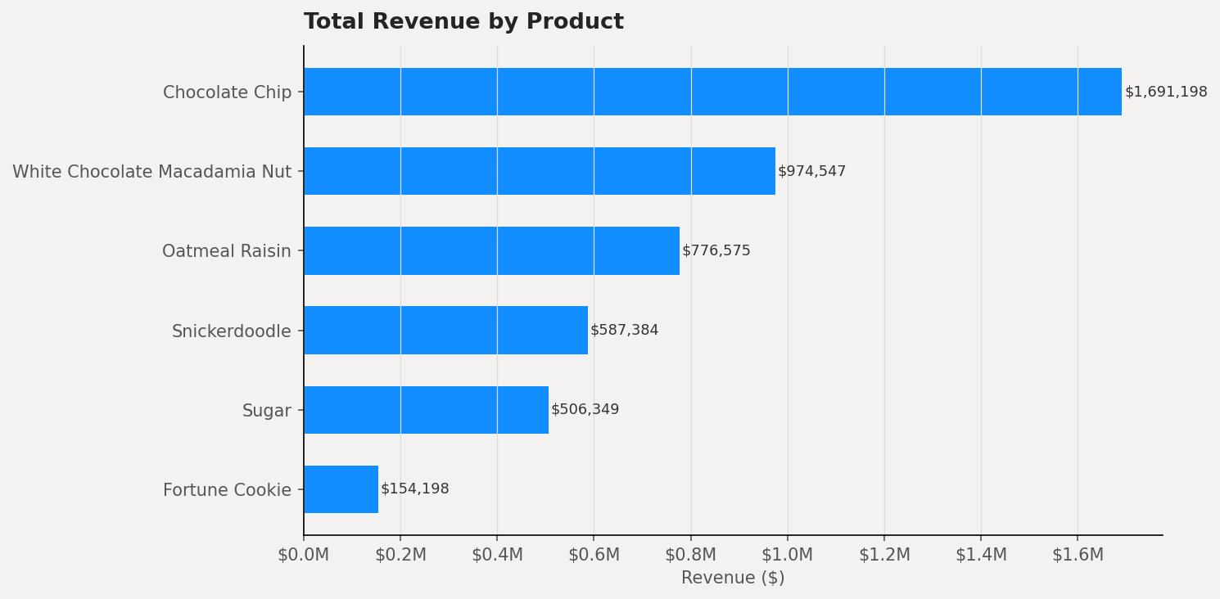
Figure 11 — Horizontal bar chart: Total Revenue by Cookie Product (descending order)

Product | Revenue | Cost | Profit | Orders
Chocolate Chip | $1,691,197.50 | $676,479.00 | $1,014,718.50 | 202
White Choc Macadamia | $974,547.00 | $446,667.38 | $527,879.63 | 109
Oatmeal Raisin | $776,575.00 | $341,693.00 | $434,882.00 | 94
Snickerdoodle | $587,384.00 | $220,269.00 | $367,115.00 | 93
Sugar | $506,349.00 | $210,978.75 | $295,370.25 | 109
Fortune Cookie | $154,198.00 | $77,099.00 | $77,099.00 | 93

Observation: Chocolate Chip dominates all other products with $1.69M in revenue — nearly double the second-highest product (White Chocolate Macadamia Nut at $974K). This reflects both a high unit price and the highest order volume (202 orders). The Total Revenue measure dynamically filters to show only the selected product when a user clicks a bar.

3.3 Profit by Product
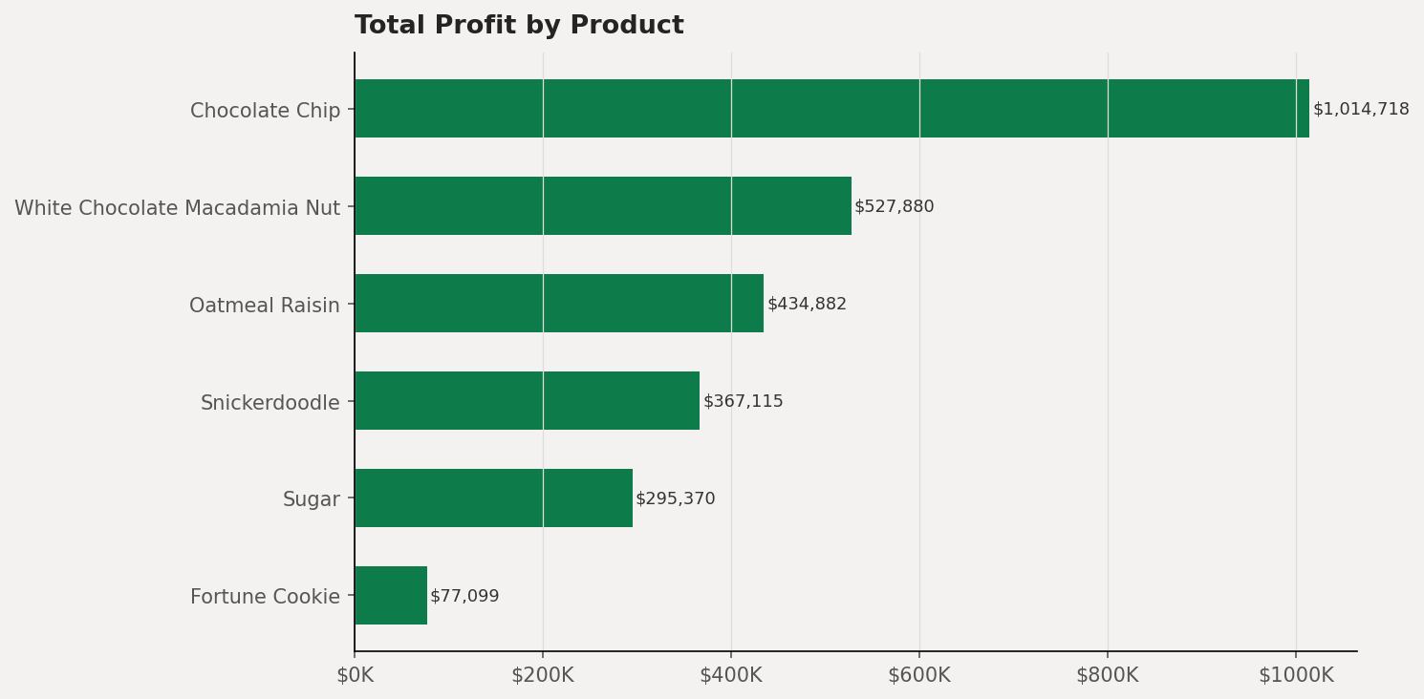
Figure 12 — Profit by Cookie Product: all six products show positive profit margins

Observation: All six cookie products are profitable. Chocolate Chip generates the highest absolute profit ($1,014,718.50) due to its combination of high volume and healthy margin. Fortune Cookie has the lowest profit ($77,099) due to its lower price point and fewer orders, but still maintains a 50% margin. No product is operating at a loss — confirming sound pricing strategy across the product line.

3.4 Revenue and Profit Breakdown by Product (Stacked)
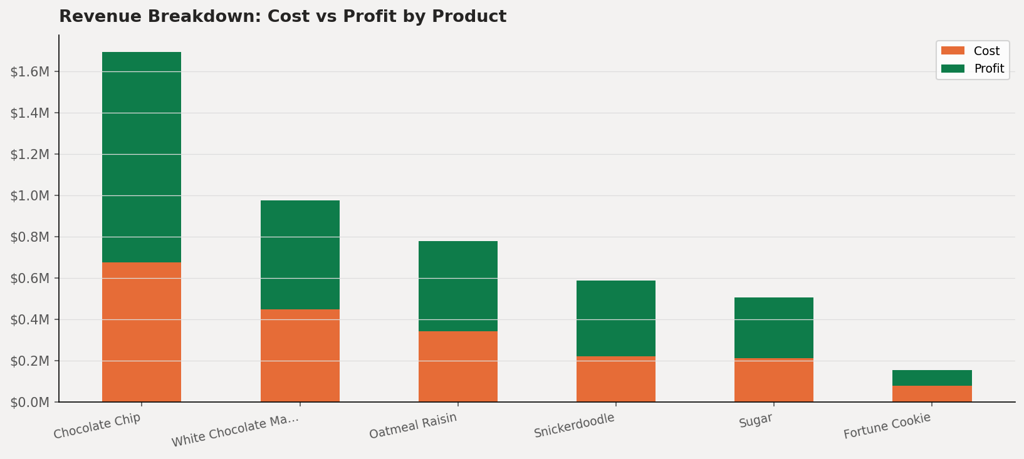
Figure 13 — Stacked bar: cost vs profit breakdown per product (green = profit, orange = cost)

Observation: The stacked chart visualizes how each product's revenue is split between cost recovery and profit generation. Chocolate Chip shows the largest absolute profit portion. Fortune Cookie has the lowest cost-to-revenue ratio, showing it is price-efficient to produce despite lower volumes.

3.5 Revenue and Profit by Customer
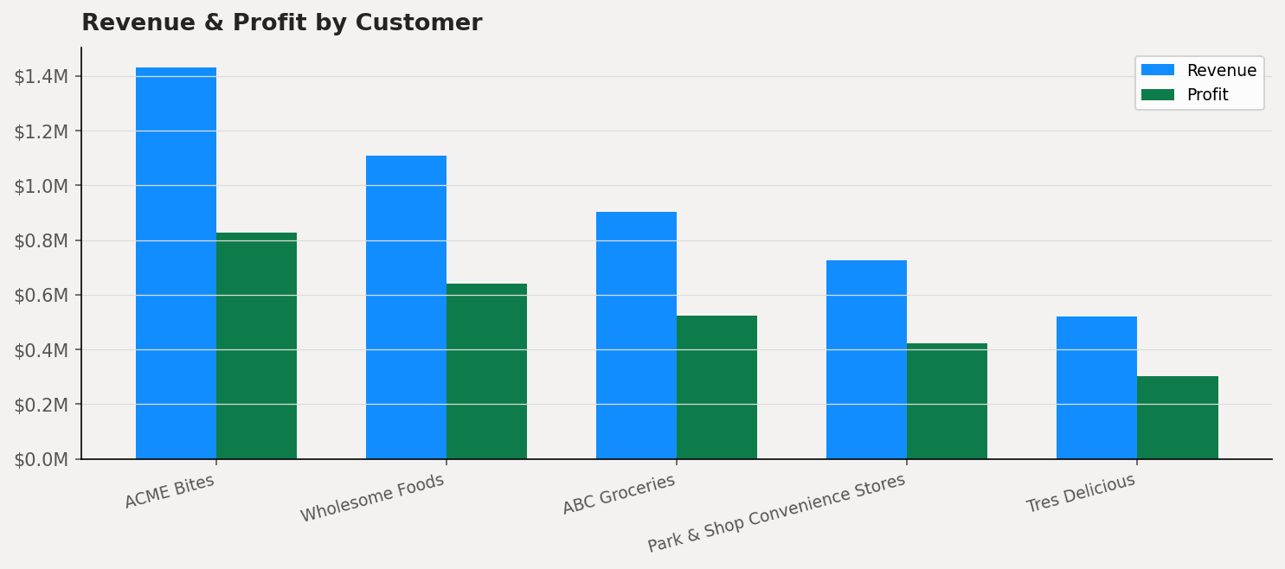
Figure 14 — Grouped bar chart: Revenue vs Profit by Customer (all 5 customers)

Customer | Revenue | Cost | Profit
ACME Bites | $1,431,191.00 | $602,813.60 | $828,377.40
Wholesome Foods | $1,108,643.00 | $468,968.45 | $639,674.55
ABC Groceries | $903,407.00 | $380,091.58 | $523,315.43
Park & Shop | $725,758.50 | $302,258.88 | $423,499.63
Tres Delicious | $521,251.00 | $219,053.63 | $302,197.38

Observation: ACME Bites is the largest customer by both revenue ($1.43M) and profit contribution ($828K), accounting for approximately 30.5% of total revenue. All five customers are profitable. The Total Revenue measure automatically recalculates per customer when the Customer Name field is placed on the visual axis — this is filter context working in real time.

Part 4: Guided Questions — Detailed Answers

Section I: Foundational Concepts

Question 1: Defining DAX — How is it different from an Excel formula?
Question
In your own words, how would you explain the difference between a standard Excel formula and a Data Analysis Expression (DAX) based on the tutorial?

Answer:
A standard Excel formula operates on individual cells or fixed cell ranges within a flat spreadsheet. For example, =SUM(B2:B100) adds up values in a specific physical location on the sheet. The formula is position-dependent — if rows are added or deleted, it may break or produce wrong results. Excel formulas work well for simple, single-table calculations in a flat file.

DAX is fundamentally different in three ways:
- Column-based, not cell-based: DAX always references entire columns of a table — SUM(Orders[Revenue]) means "sum every value in the Revenue column of the Orders table," regardless of how many rows exist. Adding 1,000 more rows does not break the formula.
- Context-aware: The same DAX Measure can produce completely different results depending on what filters, slicers, or visual interactions are active. A single formula like [Total Revenue] shows the grand total in a card visual, but automatically shows only Chocolate Chip revenue when that product is clicked in a bar chart.
- Multi-table native: DAX is designed for relational data models. Functions like RELATED(), CALCULATE(), and FILTER() allow formulas to work seamlessly across multiple related tables — something Excel can only approximate with complex VLOOKUP/INDEX-MATCH chains.

Feature | Excel Formula | DAX
Reference Type | Cell ranges (B2:B100) | Full columns (Orders[Revenue])
Context | Static — fixed cells | Dynamic — responds to filters
Multi-table | VLOOKUP workarounds | Native (RELATED, relationships)
Recalculation | When cells change | On every filter/slicer interaction
Row addition | May break formula | Automatically included

Question 2: The "Why" of DAX — What gap does it fill?
Question
Why can't we just use the raw numbers from our imported dataset to create complex reports? What is the specific "gap" that DAX fills in Power BI?

Answer:
Raw imported data is static — it shows what was recorded but cannot answer dynamic business questions on its own. In the Orders dataset, each row stores Units Sold, Revenue, and Cost for a single transaction. However, it does not store totals, ratios, rankings, or any aggregated insight. To answer "What is the total profit for Chocolate Chip cookies sold to ACME Bites in Q2?" — the raw data alone is silent.

The specific gap DAX fills is dynamic contextual calculation. Power BI reports are interactive: users click slicers, drill into categories, cross-filter visuals, and switch between time periods. Raw column values are fixed — they cannot recalculate in response to these interactions. DAX Measures are formulas that re-evaluate automatically every time the filter context changes, ensuring every visual always displays the correct, filtered result for the current user selection.

Without DAX, Power BI reports would be limited to pre-aggregated raw numbers with no ability to compute ratios (Profit Margin %), comparisons, or derived metrics. DAX is the calculation engine that transforms raw transaction data into a dynamic, interactive business intelligence tool.

Section II: Calculated Columns vs. Measures

Question 3: Storage Difference — Which increases file size?
Question
Which one actually increases the file size of your Power BI model, and why is this an important consideration for large datasets?

Answer:
Calculated Columns increase the file size of the Power BI model (.pbix file). When a Calculated Column is created, Power BI computes the result for every single row at data refresh time and physically stores all those values in the in-memory VertiPaq column store database inside the .pbix file.

For the 700-row Orders table in this activity, a new Calculated Column adds 700 stored values — negligible in size. However, consider the real-world implication:
- A retail chain with 50 million transactions per year: adding 1 Calculated Column stores 50 million values.
- Adding 10 Calculated Columns stores 500 million values — consuming gigabytes of RAM just for derived data.
- Larger file sizes mean slower load times, higher memory consumption, and longer refresh durations.

Measures, by contrast, store only the formula text — never the results. The result is computed on-the-fly when a visual renders, using only the rows that pass the current filter. For a Profit Margin % measure, instead of storing 700 percentage values, Power BI stores one formula line and calculates the result in milliseconds when needed.

Best Practice Rule
Use a Calculated Column only when you need the value as a row-level attribute for filtering or grouping (e.g., a "Profit Category" label: High/Medium/Low). Use a Measure for any aggregated calculation — totals, averages, ratios, percentages — because Measures are memory-efficient, context-aware, and scalable to datasets of any size.

Question 4: Context Clues — How does Filter Context affect a Measure?
Question
Explain how "Filter Context" affects the result of a Measure in your final dashboard.

Answer:
Filter context is the set of all active filters that Power BI evaluates before running a DAX Measure. Every time a Measure is invoked by a visual, Power BI first determines which rows of the table are currently "visible" based on all active filters — from slicers, visual cross-filters, page-level filters, and report-level filters — and then the DAX formula runs against only those visible rows.

In the Cookie Sales dashboard built for this activity, filter context works as follows:
- No filters active: [Total Revenue] evaluates SUM(Orders[Revenue]) across all 700 rows = $4,690,250.50.
- User clicks "Chocolate Chip" in the bar chart: Filter context now restricts Orders to only rows where Product = "Chocolate Chip" (202 rows). The same [Total Revenue] formula now returns $1,691,197.50 — automatically, with no formula changes.
- User selects "ACME Bites" from a Customer slicer: Filter context further restricts to orders where Customer ID matches ACME Bites. Every Measure on the page — Revenue, Cost, Profit, Units Sold, Orders — recalculates instantly for ACME Bites only.
- User applies both filters (Chocolate Chip + ACME Bites): Measures show the intersection — only Chocolate Chip orders from ACME Bites.

This dynamic behavior is the core power of DAX Measures. One formula, written once, correctly answers an infinite number of business questions just by responding to different filter contexts.

Section III: Function Application & Syntax

Question 5: The RELATED Function — Why is it necessary?
Question
Why is the RELATED function necessary when working with multiple tables, and what must be established in the Model View for this function to work correctly?

Answer:
DAX formulas written within a table can only directly access columns that exist in that same table. The Orders table contains Customer ID and Product columns — but it does not contain the customer's Name or the cookie's Revenue Per Cookie price. To access these values from related tables (Customers and Cookie_Types), the RELATED() function is required.

RELATED() traverses the relationship from the current table (many-side) to the related lookup/dimension table (one-side) and retrieves the matching value for the current row. In this activity, two RELATED formulas were used:
-- Pulls cookie selling price from Cookie_Types into Orders:
Revenue Per Cookie = Orders[Units Sold] * RELATED(Cookie_Types[Revenue Per Cookie])

-- Pulls customer name from Customers into Orders:
Customer Name = RELATED(Customers[Name])

Two conditions must be satisfied in the Model View for RELATED to work:
- A defined relationship must exist between the tables — Customers[Customer ID] → Orders[Customer ID], and Cookie_Types[Cookie Type] → Orders[Product]. Without this, RELATED returns an error.
- The relationship must flow in the correct direction — RELATED always travels from the many-side table (Orders) to the one-side table (Customers or Cookie_Types). The relationship direction must match this flow; a reversed or bidirectional relationship can cause unexpected results.

What Happens Without the Relationship
If the Model View relationship is missing and you write RELATED(Customers[Name]) in the Orders table, Power BI will display: "The RELATED function requires a relationship between table Orders and table Customers." This is why establishing relationships is always Step 1 before writing any cross-table DAX.

Question 6: Deconstructing the Formula
Question
Deconstruct: Total Sales = SUM(Sales[Sales Amount]). Identify the Measure Name, Function, Table, and Column. Why is it best practice to include the table name?

Answer:
Component | Value in Formula | Explanation
Measure Name | Total Sales | The label given to this calculation; appears in the Fields pane and can be referenced as [Total Sales] in other formulas
Function | SUM() | A DAX aggregation function that adds all numeric values in the specified column
Table | Sales | The table that contains the column being aggregated
Column | Sales Amount | The specific numeric column whose values are summed

Why including the table name is best practice:
- Disambiguation: Multiple tables may contain columns with the same name. In this activity, both Orders and Cookie_Types have a column related to "Units Sold." Writing SUM(Orders[Units Sold]) vs SUM(Cookie_Types[Units Sold]) eliminates all ambiguity.
- Readability: When reviewing a formula weeks or months later, Table[Column] syntax immediately tells the reader exactly where the data originates — no guesswork required.
- Error prevention: Power BI may attempt to guess the table when the name is omitted, and may guess incorrectly, causing silent calculation errors that are difficult to debug.
- Professional standard: Microsoft's official DAX documentation and industry best practices (as taught by SQLBI and other DAX authorities) mandate always using fully-qualified Table[Column] references in all DAX formulas.

Section IV: Analysis & Troubleshooting

Question 7: Data Interpretation — What does a negative Total Profit mean?
Question
If the "Total Profit" measure shows a negative number for a specific category, does that mean the DAX formula is "broken," or is it telling you something about the business data? How can you verify which it is?

Answer:
A negative Total Profit value almost never means the DAX formula is broken — it is the model correctly reporting a genuine business problem: that category is operating at a loss, meaning production costs exceed revenue generated for those orders.

In the context of the Cookie Sales dashboard, a negative profit would mean that either the selling price for that cookie type was set below the cost per unit, large discounts reduced net revenue below cost, or a data entry error caused incorrect cost or revenue values to be recorded.

How to verify whether the issue is a data problem or a formula error:
- Check the formula logic first: Open the Total Profit measure in the DAX formula bar. Confirm it reads [Total Revenue] - [Total Cost] and not accidentally [Total Cost] - [Total Revenue] (which would always produce a negative number for profitable lines). This is the most common formula error.
- Spot-check raw data: Filter the Orders table to the affected product. Manually calculate Revenue and Cost for a few rows. If Cost > Revenue for those rows, the negative profit is a genuine business signal — the formula is working correctly.
- Check data types: If the Revenue or Cost column was imported as Text instead of Decimal Number in Power Query, SUM() may return 0 or BLANK, making the formula appear broken. Verify column data types in Power Query Editor.
- Use a Table visual for verification: Create a simple table visual with Product, Total Revenue, Total Cost, and Total Profit side-by-side. If Total Revenue is smaller than Total Cost for a row, the negative profit is real. If Revenue and Cost show the same value, a formula or data type issue exists.

In this activity, all six cookie products showed positive profit (ranging from $77,099 for Fortune Cookie to $1,014,718 for Chocolate Chip), confirming both the formula correctness and healthy business margins across the product line.

Question 8: Optimization — Measure vs Calculated Column for Profit Margin %
Question
If you were tasked with calculating Profit Margin Percentage, would it be more efficient to create a Calculated Column for every row or a single Measure? Justify your answer based on what you learned about DAX efficiency.

Answer:
A single Measure is dramatically more efficient than a Calculated Column for computing Profit Margin Percentage. The justification is grounded in how each approach handles storage, context, and scalability:

If a Calculated Column is used:
- A profit margin percentage (e.g., 57.93%) would be computed for every row in the Orders table and stored in memory permanently.
- For this activity's 700-row dataset, 700 percentage values are stored — a minor cost.
- For a real-world dataset of 50 million orders, 50 million values consume significant RAM (gigabytes), slowing the model and increasing .pbix file size.
- A row-level percentage is also analytically misleading: a single order's margin tells you little compared to the aggregate margin across a product category, time period, or customer segment.
- Calculated Columns cannot respond to filter context — a row that shows a 60% margin when viewed alone cannot automatically recalculate to the aggregate margin for "all Chocolate Chip orders in Q3."

If a Measure is used:
- Only the formula is stored: Profit Margin % = DIVIDE([Total Profit], [Total Revenue], 0)
- Zero additional rows are stored in memory — the result is computed on-demand in milliseconds when a visual renders.
- The same Measure correctly computes the aggregate margin for any combination of filters: 57.93% overall, or 59.97% for Chocolate Chip only, or 50% for Fortune Cookie — all from a single formula.
- DIVIDE() protects against divide-by-zero errors, making the Measure robust for all scenarios including new products with no revenue yet.

Final Verdict
Profit Margin % = DIVIDE([Total Profit], [Total Revenue], 0) as a Measure is always the correct approach. Using a Calculated Column for any ratio or percentage is a common beginner mistake that creates performance problems without providing any analytical benefit. A Measure is context-aware, memory-efficient, and correctly represents an aggregate concept — exactly what Profit Margin % is.

Conclusion
This laboratory activity provided comprehensive hands-on experience with DAX in Power BI, using real cookie business data from three related Excel datasets. The following key insights were gained from implementing DAX from foundational concepts through to a complete interactive dashboard:

Key Learning 1: Measures are the Core of DAX Analysis
For all aggregated, ratio-based, and percentage calculations, Measures are always preferred over Calculated Columns. They are memory-efficient, dynamically context-aware, and scalable to datasets of any size. The six Measures built in this activity — Total Revenue, Total Cost, Total Profit, Profit Margin %, Total Units Sold, and Total Orders — collectively power an entire interactive dashboard from a combined total of approximately 200 characters of DAX code.

Key Learning 2: Filter Context is What Makes DAX Powerful
A single correctly-written DAX Measure can answer an unlimited number of business questions simply by responding to different filter contexts. The same [Total Revenue] formula returned $4.69M overall, $1.69M for Chocolate Chip, and $1.43M for ACME Bites — all without changing the formula. Understanding and leveraging filter context is the central skill of DAX development.

Key Learning 3: Data Model Quality Determines DAX Quality
Establishing correct relationships in the Model View is a prerequisite for cross-table DAX functions like RELATED(). Without the Customers and Cookie_Types relationships, the Calculated Columns pulling customer names and cookie prices would fail entirely. The principle "fix the model before fixing the formula" applies universally in Power BI development.

The cookie business analysis revealed: $4.69M total revenue across 700 orders from 5 customers and 6 product types, with a healthy overall profit margin of 57.93%. Chocolate Chip is the top-performing product ($1.69M revenue, $1.01M profit) and ACME Bites is the highest-value customer ($1.43M revenue). These insights were generated entirely through DAX Measures applied to three related tables — demonstrating the practical business intelligence power of Power BI and DAX.

References
- Tutorial Reference: How to use Power BI DAX. YouTube. https://www.youtube.com/watch?v=waG_JhBgUpM&t=385s
- Microsoft Corporation. (2024). Learn DAX basics in Power BI Desktop. Microsoft Learn. https://learn.microsoft.com/en-us/power-bi/transform-model/desktop-quickstart-learn-dax-basics
- Microsoft Corporation. (2024). Use RELATED and RELATEDTABLE in Power BI. Microsoft Learn. https://learn.microsoft.com/en-us/power-bi/transform-model/desktop-tutorial-create-calculated-columns
- SQLBI. (2024). DAX Guide — Complete DAX function reference. https://dax.guide/
- Russo, M., Ferrari, A., & Webb, C. (2021). Artificial Intelligence with Power BI. Packt Publishing.

