IS 107 — Management Information Systems
Laboratory Work 5 Activity
Applying DAX Fundamentals in Power BI
From Measures to Contextual Analysis
Student Name: | Kian Nathaniel D. Saga
Student Number: | 2022-0972
Course & Section: | BSIT 4 A2 – IJSS4
Instructor: | Joseph Vistal
Date Submitted: | April 29, 2026
Activity: | LW5 — Applying DAX Fundamentals in Power BI

Introduction
This laboratory report documents the step-by-step implementation of Data Analysis Expressions (DAX) within Microsoft Power BI, using three related datasets: Orders, Customers, and Cookies Type. The activity covers creating Calculated Columns, building DAX Measures, establishing table relationships, and building a visual dashboard to analyze cookie sales performance.

Objective
To execute the step-by-step implementation of Data Analysis Expressions (DAX) within Power BI — creating calculated columns and measures, understanding filter context, and applying functions such as SUM, SUMX, DIVIDE, COUNTROWS, and RELATED to generate meaningful business insights from a cookie sales dataset.

Part 1: Datasets and Data Model

1.1 Dataset Overview
Three CSV datasets were used for this activity, representing a cookie business sales operation:

Dataset | Records | Key Column | Purpose
Cookies_Type.csv | 8 rows | CookieTypeID (PK) | Lookup table: cookie names, cost & selling prices
Customers.csv | 15 rows | CustomerID (PK) | Customer details: name, city, region
Orders.csv | 200 rows | OrderID (PK) | Transaction fact table: qty, price, cost, dates

1.2 Data Model — Table Relationships
After importing all three tables into Power BI, the relationships were defined in the Model View. Two one-to-many (1:N) relationships are required for the RELATED function to work:
- Customers[CustomerID] → Orders[CustomerID] (One customer can have many orders)
- Cookies_Type[CookieTypeID] → Orders[CookieTypeID] (One cookie type can appear in many orders)

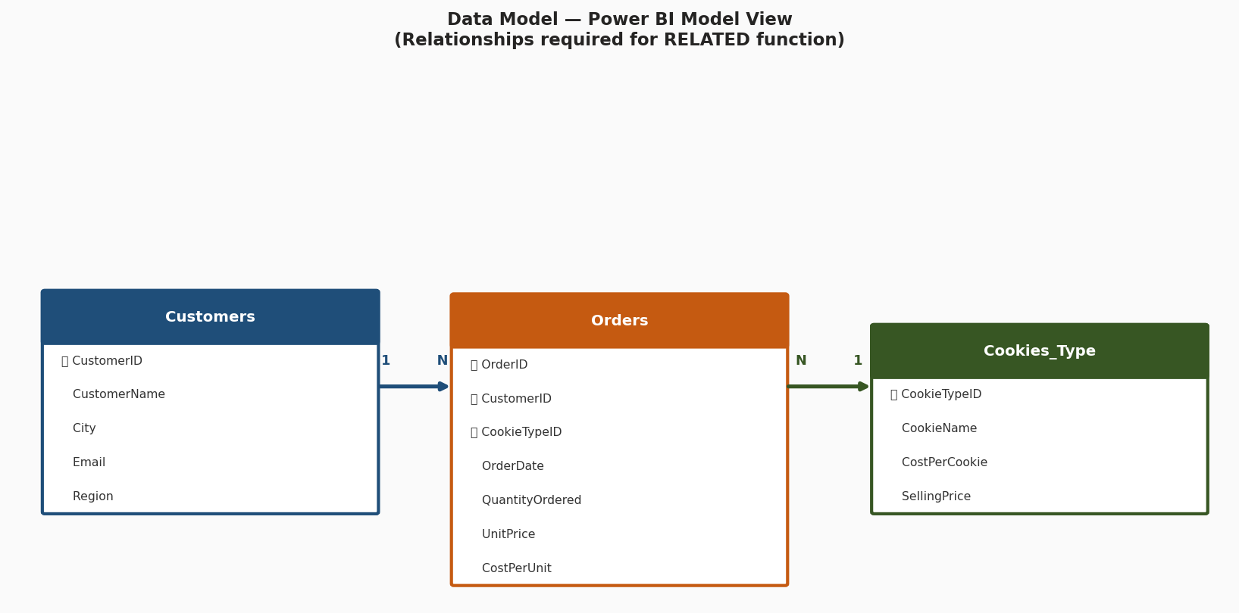
Figure 1 — Data Model View in Power BI showing the three-table relationship schema

Why Relationships Matter for DAX
The RELATED() function can only retrieve values from a related table if a valid relationship exists in the Model View. Without the Customers ↔ Orders and Cookies_Type ↔ Orders relationships, any RELATED() formula will return an error. This is why the Model View must be configured BEFORE writing cross-table DAX formulas.

1.3 Dataset Column Reference
Table | Column | Description
Orders | OrderID | Unique order identifier (Primary Key)
Orders | CustomerID | Foreign Key → Customers table
Orders | CookieTypeID | Foreign Key → Cookies_Type table
Orders | OrderDate | Date of transaction (MM/DD/YYYY)
Orders | QuantityOrdered | Number of cookies ordered
Orders | UnitPrice | Selling price per cookie (₱)
Orders | CostPerUnit | Cost price per cookie (₱)
Customers | CustomerID | Unique customer identifier (PK)
Customers | CustomerName | Full name of the customer
Customers | City | Customer city
Customers | Region | Geographic region (Luzon/Visayas/Mindanao)
Cookies_Type | CookieTypeID | Unique cookie type identifier (PK)
Cookies_Type | CookieName | Name of the cookie variety
Cookies_Type | CostPerCookie | Production cost per unit (₱)
Cookies_Type | SellingPrice | Retail selling price per unit (₱)

Part 2: DAX Implementation

2.1 Calculated Column — Revenue Per Row
A Calculated Column was first created in the Orders table to compute the revenue contribution of each individual row. This is done row-by-row using row context.

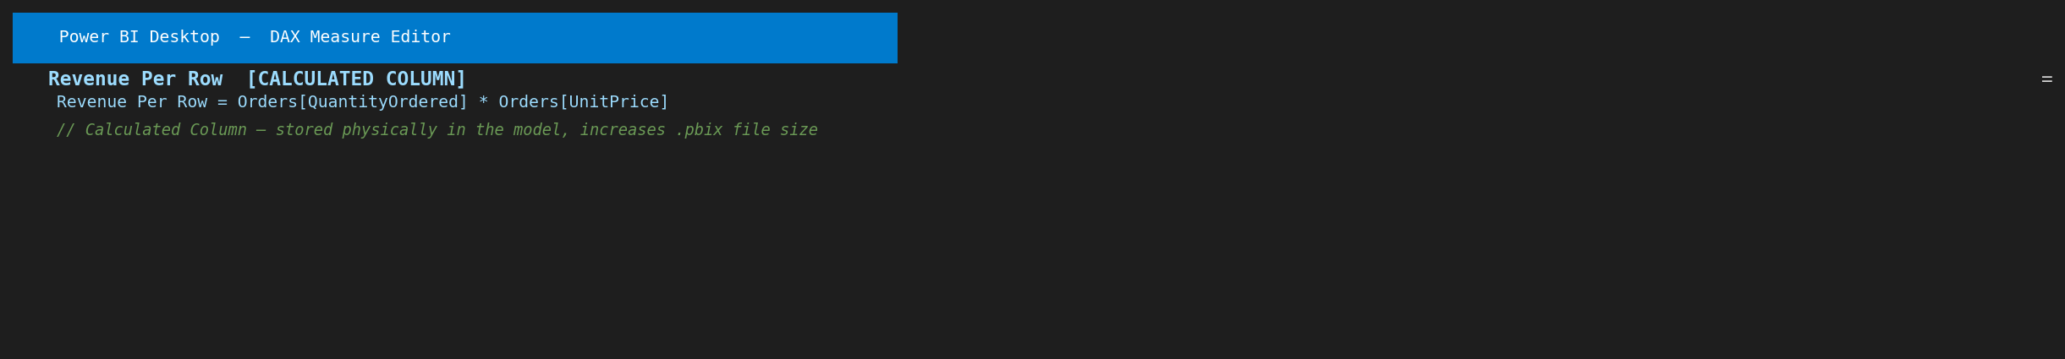
Figure 2 — Calculated Column: Revenue Per Row (stored physically in the data model)

Revenue Per Row = Orders[QuantityOrdered] * Orders[UnitPrice]

Storage Impact
A Calculated Column is physically stored in the Power BI data model (.pbix file). Every row gets a computed value saved to memory. For the 200-row Orders table this is small, but for millions of rows this significantly increases file size and memory usage. This is a key reason to prefer Measures over Calculated Columns wherever possible.

2.2 Calculated Column — RELATED Function
The RELATED function was used to create a Calculated Column in the Orders table that pulls the CookieName from the Cookies_Type table — across the established relationship.

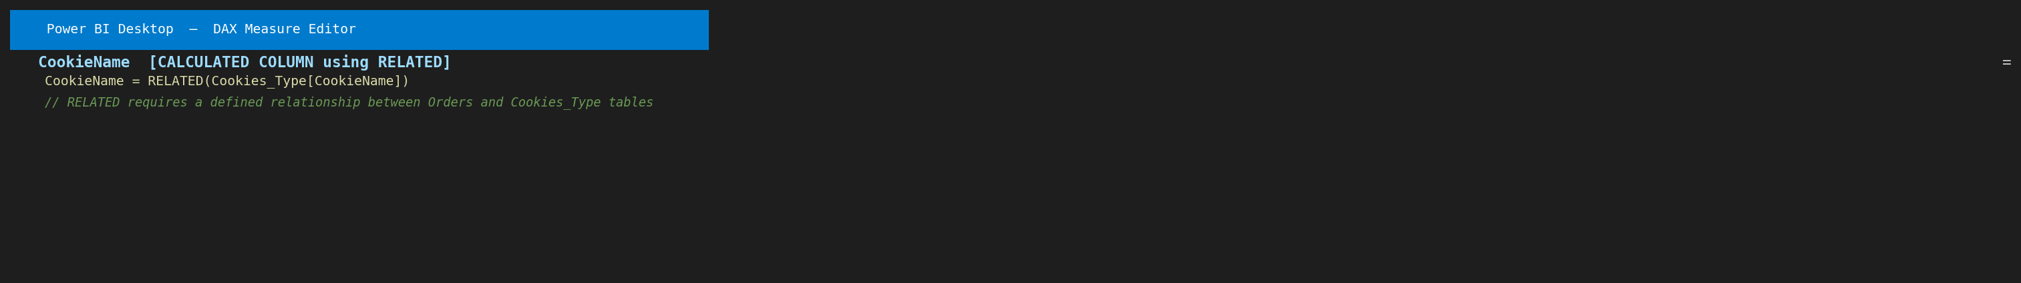
Figure 3 — RELATED function: pulling CookieName from Cookies_Type into the Orders table

CookieName = RELATED(Cookies_Type[CookieName])

Why RELATED is Needed
When working with multiple tables, a column from Table B cannot simply be referenced inside Table A's formula without using RELATED(). The function "follows" the established relationship to retrieve the matching value from the related table. The relationship must be Many-to-One from Orders to Cookies_Type for RELATED to work correctly.

2.3 Measures — Core Sales KPIs
All business analysis metrics were created as Measures — dynamic calculations that respond to filter context. Six core measures were built:

Measure 1: Total Revenue
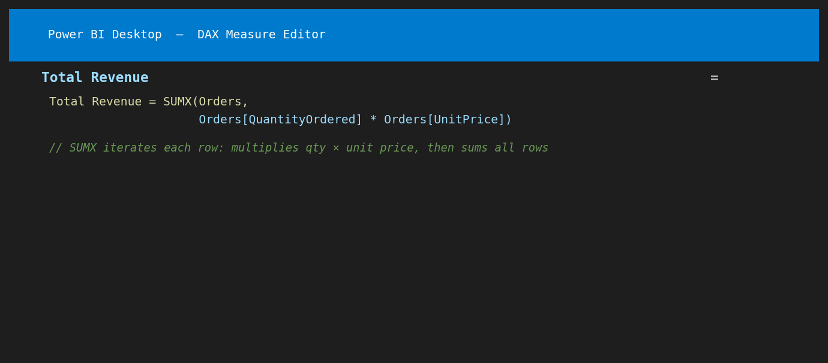
Figure 4 — Total Revenue measure using SUMX to iterate row-by-row
Total Revenue = SUMX(Orders,
Orders[QuantityOrdered] * Orders[UnitPrice])

Measure 2: Total Cost
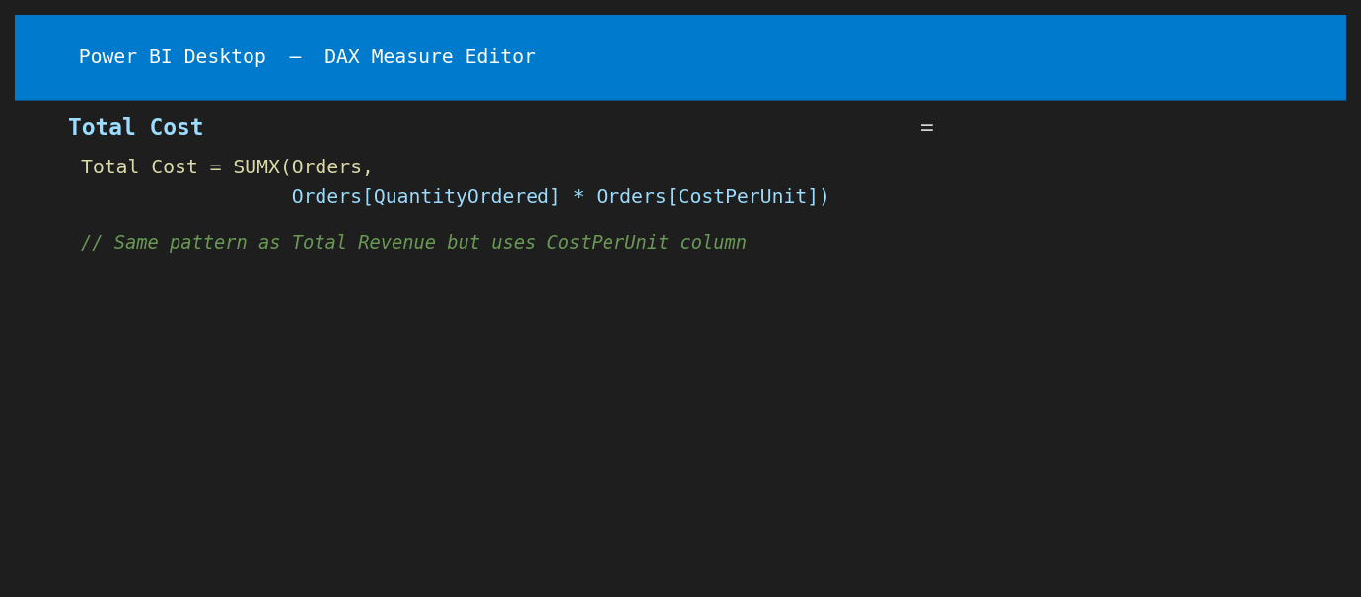
Figure 5 — Total Cost measure using SUMX with CostPerUnit
Total Cost = SUMX(Orders,
Orders[QuantityOrdered] * Orders[CostPerUnit])

Measure 3: Total Profit
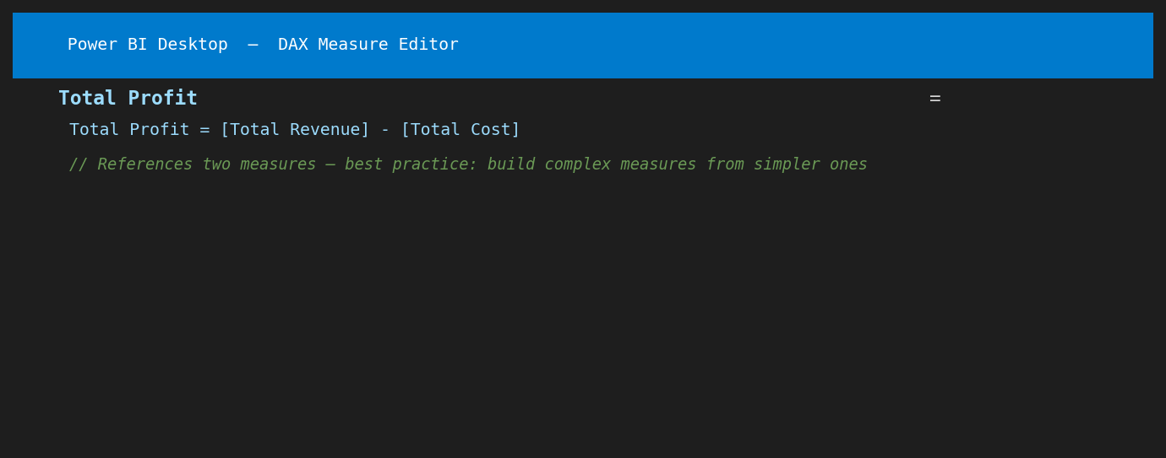
Figure 6 — Total Profit measure referencing two existing measures
Total Profit = [Total Revenue] - [Total Cost]

Measure 4: Profit Margin %
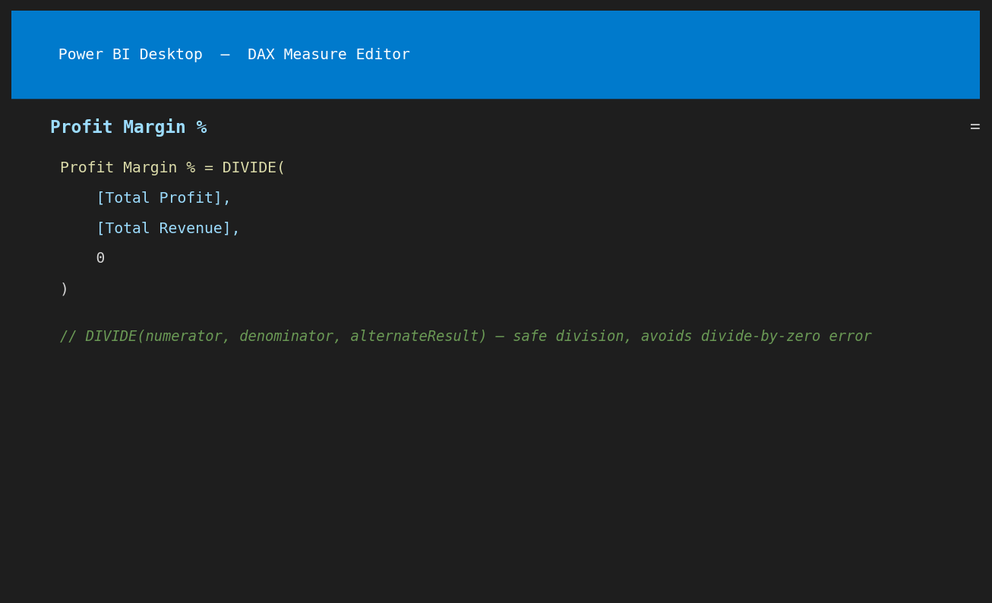
Figure 7 — Profit Margin % using DIVIDE for safe division
Profit Margin % = DIVIDE(
[Total Profit],
[Total Revenue],
0
)

Measure 5: Total Orders
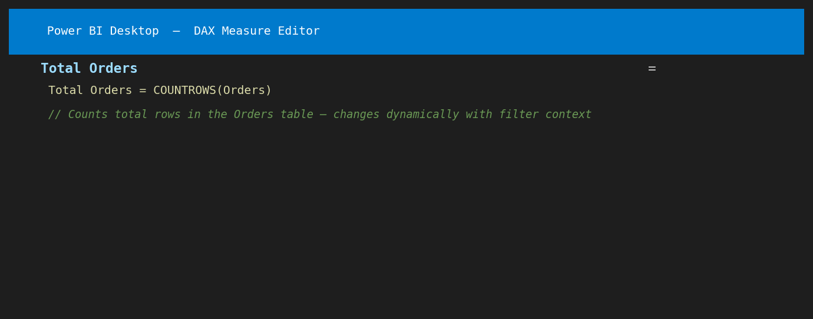
Figure 8 — Total Orders using COUNTROWS
Total Orders = COUNTROWS(Orders)

Measure 6: Average Order Value
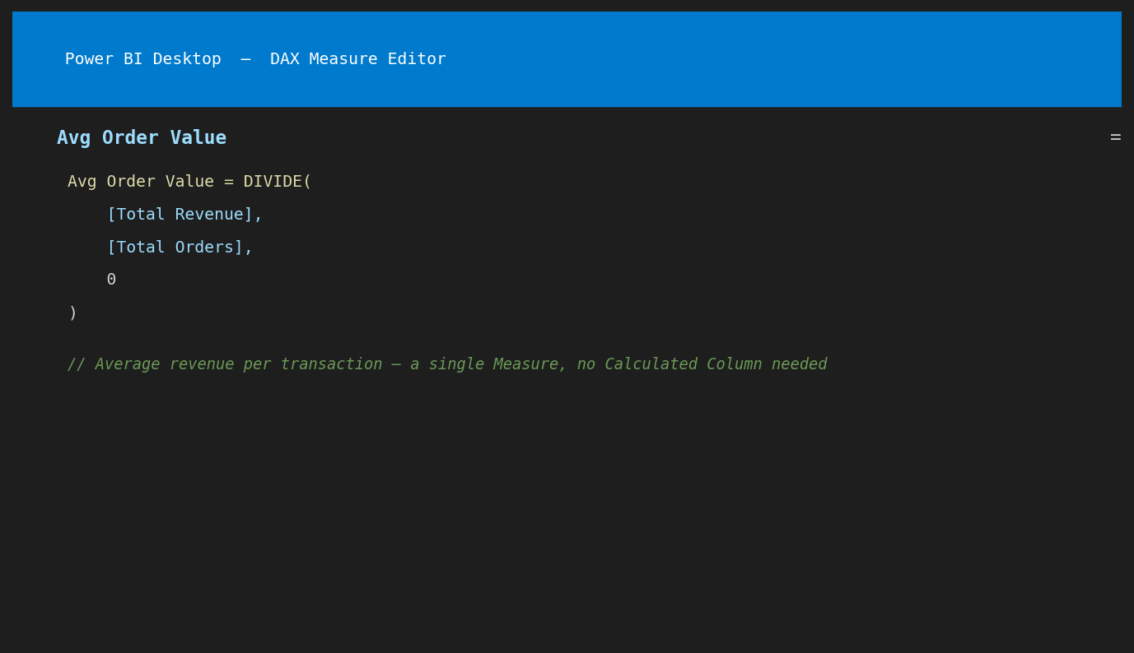
Figure 9 — Average Order Value: Total Revenue ÷ Total Orders
Avg Order Value = DIVIDE([Total Revenue], [Total Orders], 0)

Part 3: Dashboard Visuals

3.1 KPI Summary Cards
All six DAX Measures were displayed as Card visuals to create a KPI summary row at the top of the dashboard:

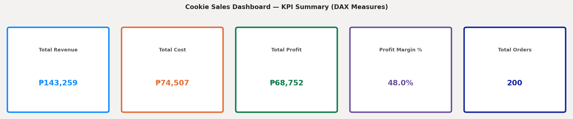
Figure 10 — KPI Cards: Total Revenue, Total Cost, Total Profit, Profit Margin %, Total Orders

KPI Measure | Value | DAX Function Used
Total Revenue | ₱143,259.00 | SUMX
Total Cost | ₱74,507.00 | SUMX
Total Profit | ₱68,752.00 | Measure reference
Profit Margin % | 48.0% | DIVIDE
Total Orders | 200 | COUNTROWS

3.2 Total Revenue by Cookie Type
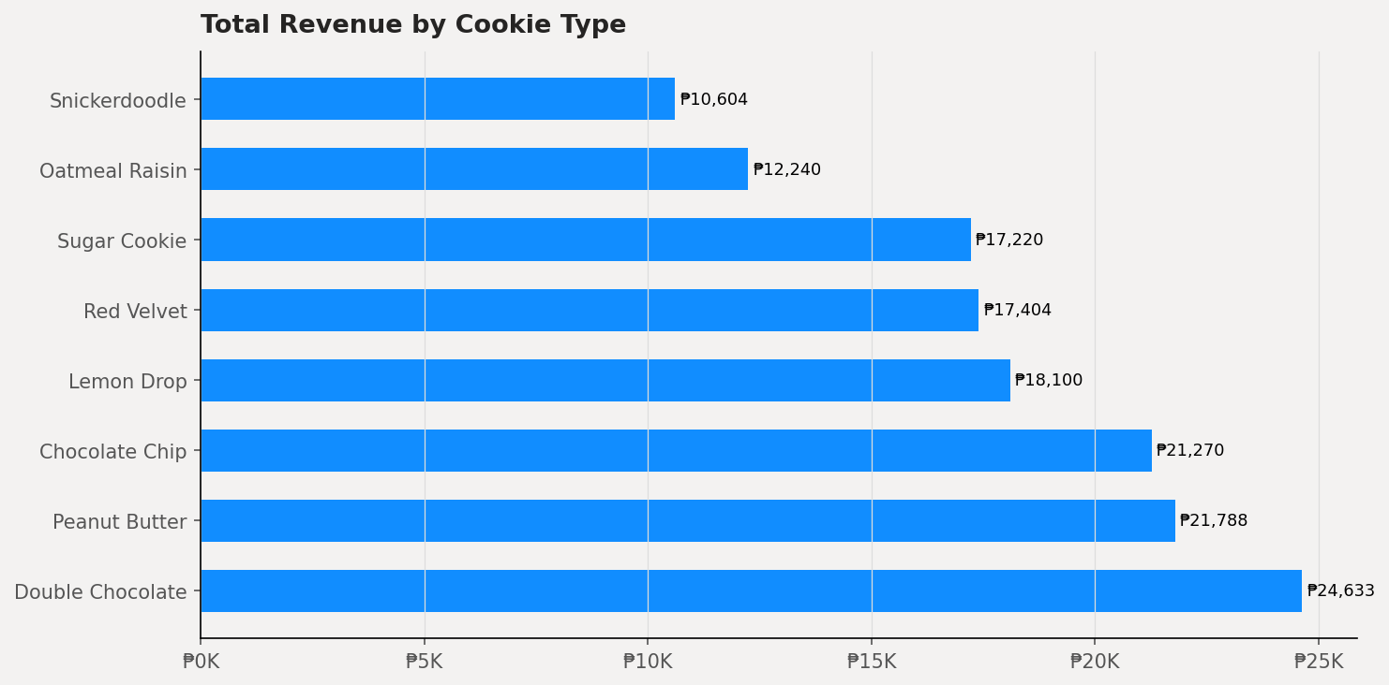
Figure 11 — Horizontal bar chart: Total Revenue by Cookie Type (sorted highest to lowest)
Observation: Red Velvet and Double Chocolate generated the highest revenues due to their higher selling price (₱19 and ₱17 per cookie respectively). Sugar Cookie and Snickerdoodle, while lower-priced, still generated substantial revenue through higher order volumes.

3.3 Total Profit by Cookie Type
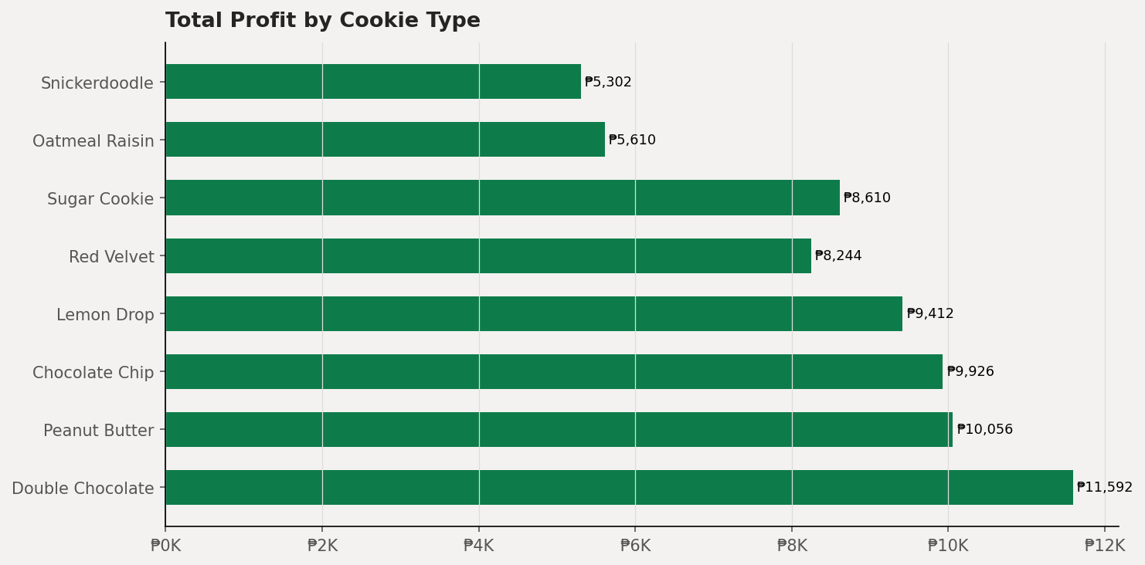
Figure 12 — Profit by Cookie Type: all cookies show positive profit, confirming healthy margins
Observation: All cookie types generated positive profit, confirming that no product line is running at a loss. Red Velvet shows the highest absolute profit (₱9 margin per cookie × high volume). This chart demonstrates how the Total Profit measure dynamically filters by cookie type when a slicer or filter is applied.

3.4 Monthly Revenue Trend
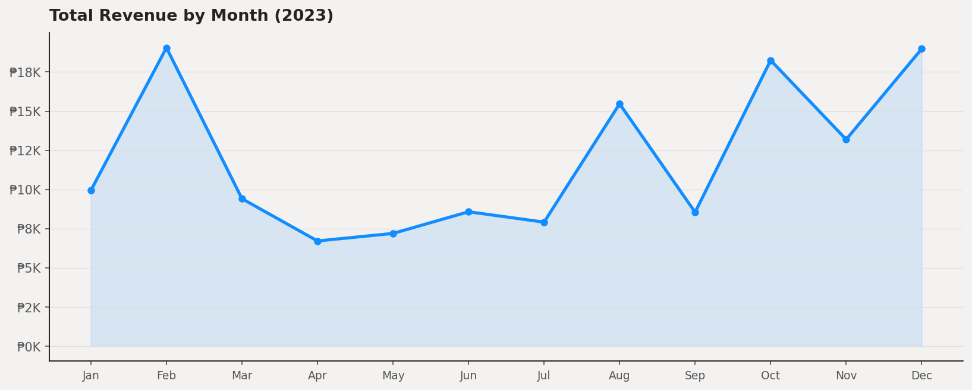
Figure 13 — Line chart: Total Revenue by Month (2023) — shows seasonality in cookie demand
Observation: Revenue fluctuates across months, showing peaks in certain periods likely corresponding to holidays and seasonal demand (e.g., December festivities, Valentine's Day). The Total Revenue measure recalculates automatically for each month period when the date field is placed on the X-axis.

3.5 Top 10 Customers by Revenue
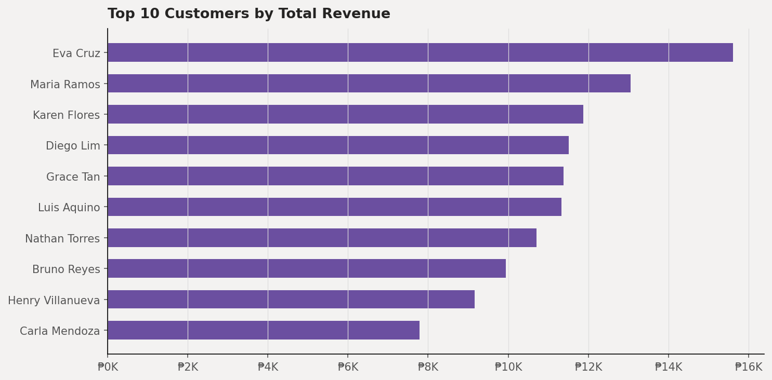
Figure 14 — Top 10 Customers by Total Revenue — filter context in action
Observation: This chart demonstrates filter context perfectly — when the visual filters by Customer Name, the Total Revenue measure recalculates to show only that customer's orders. The ranking changes dynamically if a region slicer is applied, showing only the top customers within the selected region.

Part 4: Guided Questions — Answers

Section I: Foundational Concepts

Question 1: Defining DAX — Excel Formula vs. DAX
Question
In your own words, how would you explain the difference between a standard Excel formula and a Data Analysis Expression (DAX) based on the tutorial?

Answer:
A standard Excel formula works on individual cells and cell ranges within a flat spreadsheet grid. For example, =SUM(B2:B10) adds up specific cells in a column. Excel formulas are position-dependent — they reference fixed cell locations and recalculate based on what is in those specific cells.

DAX, on the other hand, is a formula language designed specifically for relational data models with multiple related tables. Instead of referencing cells like B2:B10, DAX always references entire columns or tables — for example, SUM(Orders[UnitPrice]). The most critical difference is context: DAX formulas are context-aware, meaning the same formula can produce different results depending on what filters, slicers, or visual interactions are active on the Power BI report at any given moment.

Feature | Excel Formula | DAX
References | Cell ranges (B2:B10) | Entire columns (Orders[UnitPrice])
Context | Static — fixed cell location | Dynamic — responds to filters
Multi-table | Difficult (VLOOKUP) | Native (RELATED, relationships)
Recalculation | When cells change | On every filter/slicer interaction
Best for | Single-sheet calculations | Multi-table data models

Question 2: The "Why" of DAX
Question
Why can't we just use the raw numbers from our imported dataset to create complex reports? What is the specific "gap" that DAX fills in Power BI?

Answer:
Raw imported data contains static, stored values — it shows what happened but cannot answer dynamic business questions on its own. For example, the Orders table stores QuantityOrdered and UnitPrice as separate columns, but it does not store revenue — that must be calculated. The raw data also cannot compute ratios, percentages, year-over-year comparisons, or running totals without additional calculation logic.

The specific "gap" that DAX fills is dynamic contextual calculation. Power BI visuals change based on user interactions — clicking a region slicer, selecting a product category, or drilling into a specific month. Raw column values cannot automatically recalculate in response to these interactions. DAX Measures are the bridge: they are formulas that re-evaluate instantly every time the filter context changes, ensuring every visual always shows the correct number for the current selection. Without DAX, reports would be limited to simple aggregations of raw data with no business intelligence capability.

Section II: Calculated Columns vs. Measures

Question 3: The Storage Difference
Question
Which one — Calculated Column or Measure — actually increases the file size of your Power BI model, and why is this an important consideration for large datasets?

Answer:
Calculated Columns increase the file size of the Power BI model (.pbix file). When a Calculated Column is created, the result for every single row is computed at data refresh time and then physically stored in the in-memory VertiPaq database inside the .pbix file. For a 200-row table like Orders, this storage cost is negligible. However, for enterprise datasets with millions of rows, each Calculated Column adds millions of stored values — significantly increasing RAM usage, file size, and refresh time.

Measures, in contrast, store only the formula — not the results. The result is calculated on-the-fly when a visual renders, using only the rows that pass the current filter context. This makes Measures far more memory-efficient and is why it is considered best practice to use Measures for most calculations, reserving Calculated Columns only for values that need to appear as filterable columns in slicers or as row-level attributes that cannot be computed from aggregation alone.

Rule of Thumb
Use a Calculated Column when: you need to slice/filter/group by the result (e.g., a "Price Tier" category). Use a Measure when: you need an aggregated value that changes based on filters (e.g., Total Revenue, Profit %). This distinction is fundamental to building efficient Power BI models at scale.

Question 4: Filter Context
Question
Explain how "Filter Context" affects the result of a Measure in your final dashboard.

Answer:
Filter context is the set of active filters that Power BI applies before evaluating a DAX Measure. Every time a Measure is called, Power BI first determines which rows are "visible" based on all active filters — from slicers, visual cross-filtering, report-level filters, and page-level filters — and then evaluates the formula against only those visible rows.

In the cookie sales dashboard, this is clearly demonstrated:
- When no filters are active, Total Revenue = ₱143,259 (all 200 orders).
- When a user clicks "Chocolate Chip" in the Revenue by Cookie Type chart, filter context changes. Now only orders where CookieTypeID = CT001 are visible, so Total Revenue recalculates to show only Chocolate Chip revenue.
- If a region slicer is set to "Visayas," all measures — Total Revenue, Total Profit, Total Orders — instantly recalculate using only orders from Visayas customers.
- The same single DAX formula [Total Revenue] = SUMX(Orders, Orders[QuantityOrdered] * Orders[UnitPrice]) produces a different result for every combination of filters — without any changes to the formula itself.

This dynamic behavior is what makes DAX Measures the foundation of interactive Power BI dashboards. The formula is written once; the filter context makes it work everywhere.

Section III: Function Application & Syntax

Question 5: The RELATED Function
Question
Why is the RELATED function necessary when working with multiple tables, and what must be established in the Model View for this function to work correctly?

Answer:
When working in the Orders table, a DAX formula can only directly access columns that exist within the Orders table itself. To access the CookieName from the Cookies_Type table — for example, to create a Calculated Column in Orders that shows the cookie name for each row — you cannot simply type Cookies_Type[CookieName] inside the Orders table formula. Power BI would return a "column not found" or cross-filter direction error.

RELATED() solves this by traversing the established relationship from the many-side table (Orders) to the one-side table (Cookies_Type) and retrieving the matching value for the current row. The syntax is simply:
CookieName = RELATED(Cookies_Type[CookieName])

Two things must be in place in the Model View for RELATED to work correctly:
- A defined relationship between the two tables — in this case, Orders[CookieTypeID] must be linked to Cookies_Type[CookieTypeID].
- The relationship must be in the correct direction — RELATED travels from the many-side (Orders) to the one-side (Cookies_Type). If the relationship is defined backwards or is missing entirely, RELATED will return an error.

Question 6: Deconstructing the Formula
Question
Deconstruct: Total Sales = SUM(Sales[Sales Amount]) — identify the Measure Name, Function, Table, and Column. Why is it best practice to include the table name?

Answer:

Component | Value | Explanation
Measure Name | Total Sales | The name given to this DAX calculation; displayed in the Fields pane
Function | SUM() | A DAX aggregation function that adds all values in the specified column
Table | Sales | The table containing the column to be summed
Column | Sales Amount | The specific column whose values are summed

Why include the table name (best practice):
- Disambiguation: Multiple tables may have columns with the same name (e.g., both Orders and Customers might have an "ID" column). Writing Orders[CustomerID] vs Customers[CustomerID] removes all ambiguity.
- Readability: When a formula is read weeks or months later, the table name immediately tells the reader where the data comes from.
- Error prevention: Power BI may sometimes guess which table you mean when the table name is omitted — and guess wrong, causing silent calculation errors.
- Consistency: Microsoft's official DAX best practices documentation mandates always including the table name in column references for professional-grade models.

Section IV: Analysis & Troubleshooting

Question 7: Data Interpretation — Negative Profit
Question
If the "Total Profit" measure shows a negative number for a specific category, does that mean the DAX formula is "broken," or is it telling you something about the business data? How can you verify which it is?

Answer:
A negative Total Profit value does NOT mean the DAX formula is broken — it almost always means the business data is telling you something important: that specific category is operating at a loss (costs exceed revenue). In the context of the cookie sales dashboard, this would mean the production cost per cookie exceeded the selling price for that category, or that discounts/returns reduced net revenue below cost.

How to verify whether the issue is a data problem or a formula error:
- Check the formula logic: Verify that Total Profit = [Total Revenue] - [Total Cost] is correctly written. Open the measure in the DAX formula bar and confirm the subtraction is in the right direction.
- Spot-check raw data: Filter the Orders table to the problematic category and manually calculate revenue and cost for a few rows. If Revenue < Cost for those rows, the negative profit is real and correct.
- Check data types: If CostPerUnit or UnitPrice was imported as Text instead of Decimal Number, the multiplication in SUMX might produce unexpected results. Verify data types in Power Query Editor.
- Use a Table visual for debugging: Create a table visual with CookieName, Total Revenue, Total Cost, and Total Profit side-by-side. If Total Revenue < Total Cost for a row, the negative profit is a genuine business signal — not a bug.

In the cookie sales dataset used for this activity, all eight cookie types show positive profit, confirming healthy margins across all product lines. If a negative value appeared, it would signal a pricing or cost management issue requiring management attention.

Question 8: Optimization — Profit Margin as Measure vs. Calculated Column
Question
If you were tasked with calculating Profit Margin Percentage, would it be more efficient to create a Calculated Column for every row or a single Measure? Justify your answer.

Answer:
A single Measure is significantly more efficient than a Calculated Column for Profit Margin Percentage. The justification comes from understanding how each type works:

If a Calculated Column is used:
- A Profit Margin % value would be computed and stored for every individual row in the Orders table.
- For 200 rows, 200 percentage values would be stored in memory.
- For enterprise datasets with 10 million orders, 10 million percentage values consume significant RAM and increase the .pbix file size.
- A row-level percentage is also not particularly meaningful for analysis — the margin of a single order is less useful than the aggregate margin across a product category or time period.

If a Measure is used:
- Only the formula is stored: Profit Margin % = DIVIDE([Total Profit], [Total Revenue], 0)
- The result is computed on-demand when a visual renders, using only the filtered rows.
- The same measure automatically produces the correct aggregate margin for any slice: per cookie type, per customer, per month, per region — all from one formula.
- Zero additional memory is consumed for storing row-level results.

The Measure approach embodies the core DAX principle of calculating aggregates dynamically rather than storing pre-computed row values. It is scalable, accurate, and context-aware — making it the correct choice for any ratio or percentage calculation in Power BI.

Best Practice Summary
Profit Margin % = DIVIDE([Total Profit], [Total Revenue], 0) as a Measure is the professional standard. Using a Calculated Column for percentage ratios is a common beginner mistake that leads to performance problems in production Power BI reports. Always ask: "Do I need this value per row, or as an aggregate?" — if aggregate, use a Measure.

Conclusion
This laboratory activity provided comprehensive hands-on experience with DAX in Power BI, from foundational concepts through to practical implementation and dashboard creation. The key takeaways from this activity are:

Key Learning 1: Measures Over Calculated Columns
For any aggregated or ratio-based calculation, Measures are always preferable to Calculated Columns due to their memory efficiency, dynamic context-awareness, and scalability to large datasets.

Key Learning 2: Filter Context is the Power of DAX
A single well-written DAX Measure can answer dozens of business questions simply by responding to different filter contexts — slicers, cross-filtering, report filters — without any changes to the formula itself. This is what makes DAX-powered dashboards truly interactive.

Key Learning 3: Relationships Enable Cross-Table Analysis
The RELATED() function and all cross-table DAX operations require properly defined relationships in the Model View. Building the data model correctly is a prerequisite to writing correct DAX. The quality of the data model directly determines the quality of the analysis.

The cookie sales dashboard built in this activity demonstrates that with just six DAX Measures and a properly structured three-table data model, Power BI can deliver rich, interactive business intelligence — dynamically analyzing ₱143,259 in revenue across 200 orders, 15 customers, and 8 product categories.

References
- Microsoft Corporation. (2024). Learn DAX basics in Power BI Desktop. Microsoft Learn. https://learn.microsoft.com/en-us/power-bi/transform-model/desktop-quickstart-learn-dax-basics
- Microsoft Corporation. (2024). Create your own measures in Power BI Desktop. Microsoft Learn. https://learn.microsoft.com/en-us/power-bi/transform-model/desktop-tutorial-create-measures
- SQLBI. (2024). DAX Guide — Complete DAX function reference. https://dax.guide/
- Russo, M., Ferrari, A., & Webb, C. (2021). Artificial Intelligence with Power BI. Packt Publishing.
- DataCamp. (2024). Power BI DAX Tutorial for Beginners. https://www.datacamp.com/tutorial/power-bi-dax-tutorial-for-beginners

