
TMDB MOVIE DATA ANALYTICS
End-to-End Web Data Analytics Pipeline for Decision Support
Project Type: Final Project
Domain: Movie Industry Analytics
Data Source: TMDB API (JSON)
Target Records: 3,000+ movies
Date: December 2025
Teacher: Серек Азамат Галымжанович
Student: KEYHAN KAZAKH
Student-ID: 000822000179(E45636642)

ABSTRACT
This project presents a comprehensive end-to-end data analytics pipeline for movie industry insights using The Movie Database (TMDB) API. The objective is to collect, process, analyze, and visualize large-scale movie data to extract actionable insights that support strategic decision-making in content production, marketing, and distribution. The project involves acquiring over 3,000 movie records through JSON API calls, performing extensive data cleaning and feature engineering including sentiment analysis, implementing machine learning techniques such as K-Means clustering and Random Forest classification, and creating professional visualizations to communicate findings. The results reveal significant patterns in movie ratings, genre preferences, temporal trends, and sentiment correlations that can inform industry stakeholders about audience preferences and market dynamics.

1. PROJECT GOAL
The primary goal of this project is to develop a robust web data analytics pipeline that:
Extracts large-scale structured data from web APIs using JSON protocol
Preprocesses and transform raw data into analysis-ready format
Apply statistical analysis and machine learning techniques to uncover hidden patterns
Generates visual insights through comprehensive data visualization
Provides actionable intelligence for movie industry decision-makers
The project follows a systematic methodology encompassing data acquisition, cleaning, feature engineering, analytics, machine learning, and visualization to deliver comprehensive insights into the movie industry landscape.

2. DATA SOURCES AND METHODOLOGY
2.1 Data Acquisition via TMDB API
The Movie Database (TMDB) provides a comprehensive RESTful API that returns structured data in JSON format. This project utilizes the API to collect movie metadata including ratings, votes, popularity metrics, genre classifications, release dates, and textual descriptions.
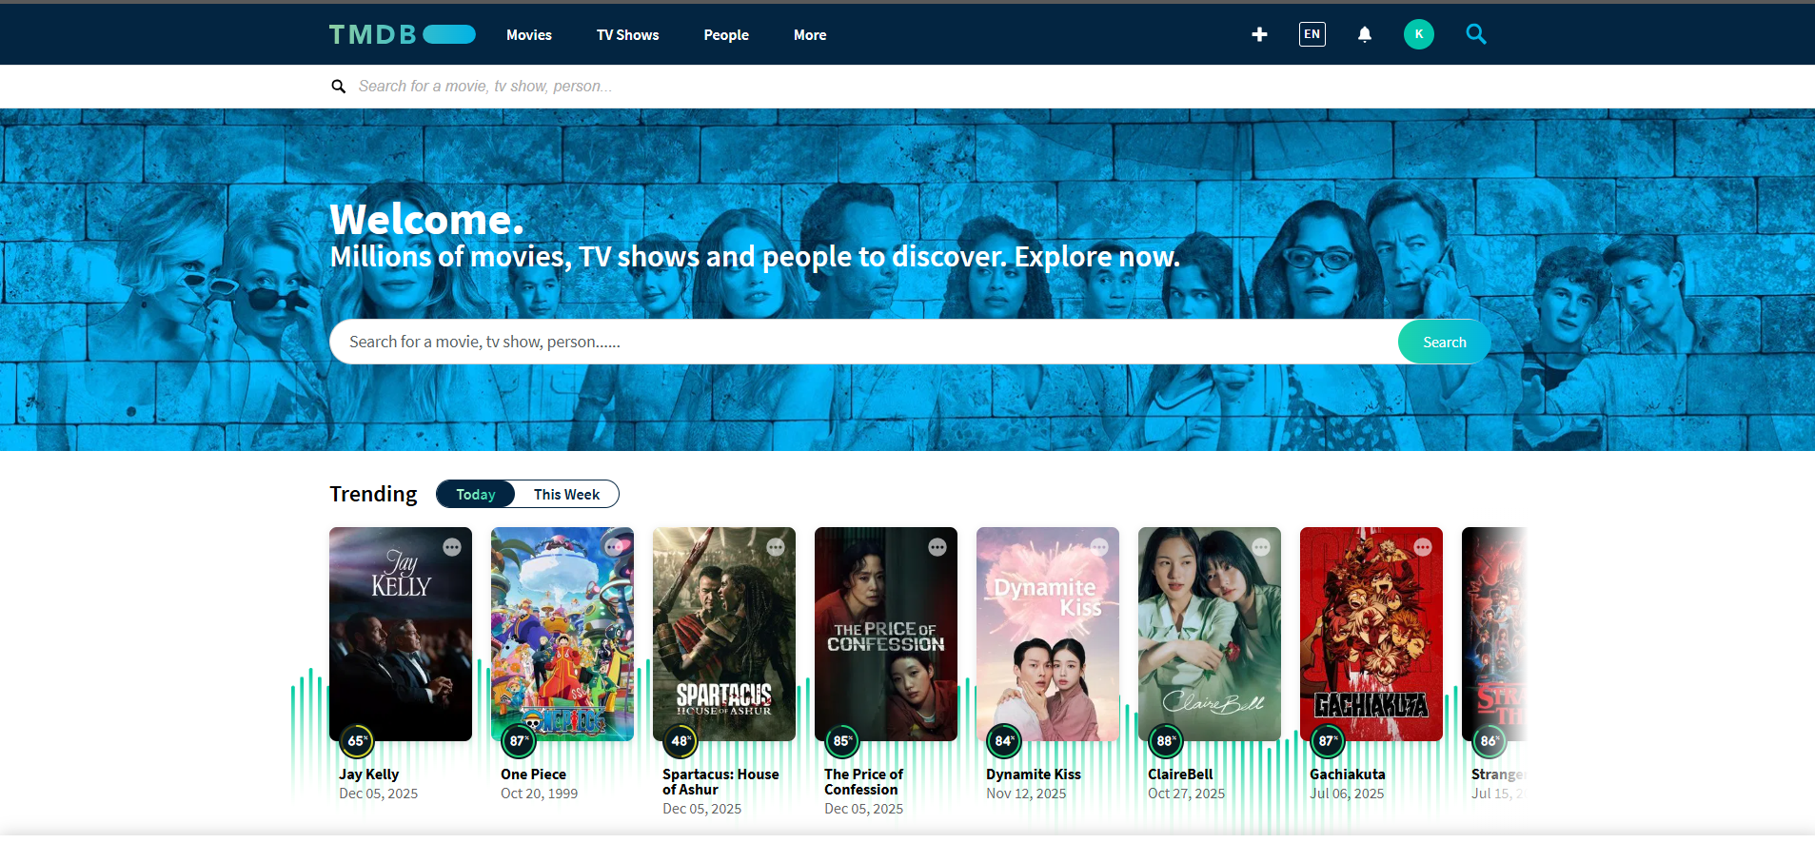
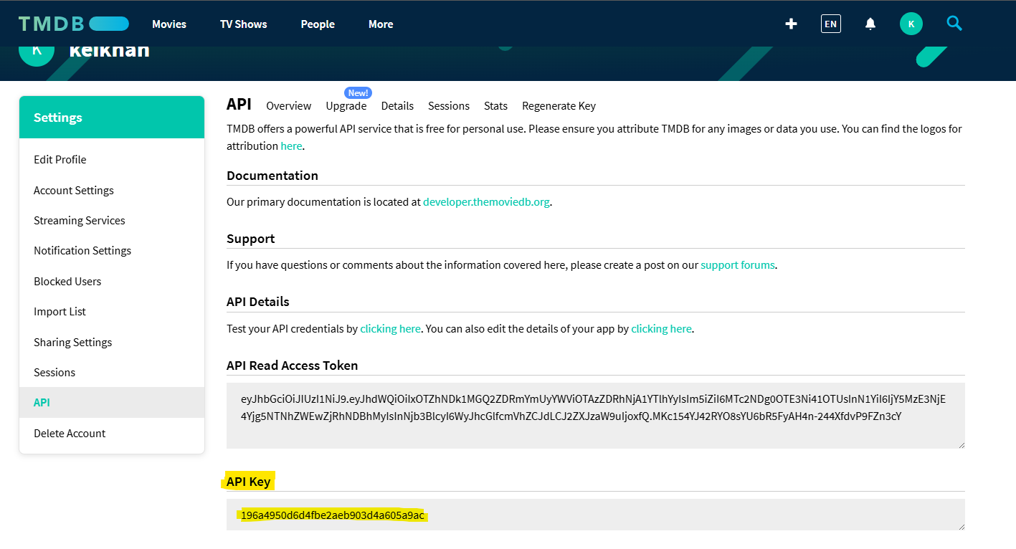
API Configuration:
python
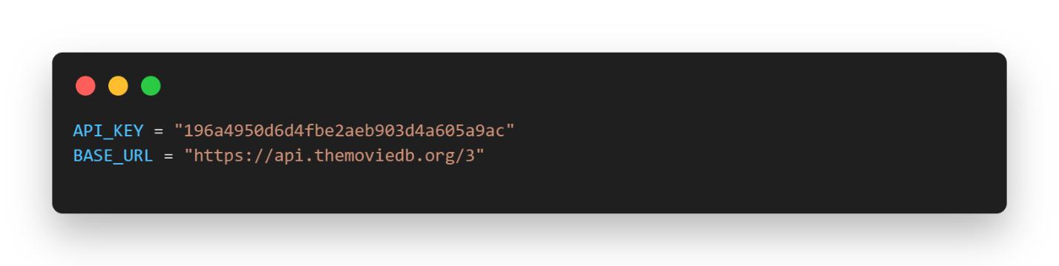
#Initialize data collector
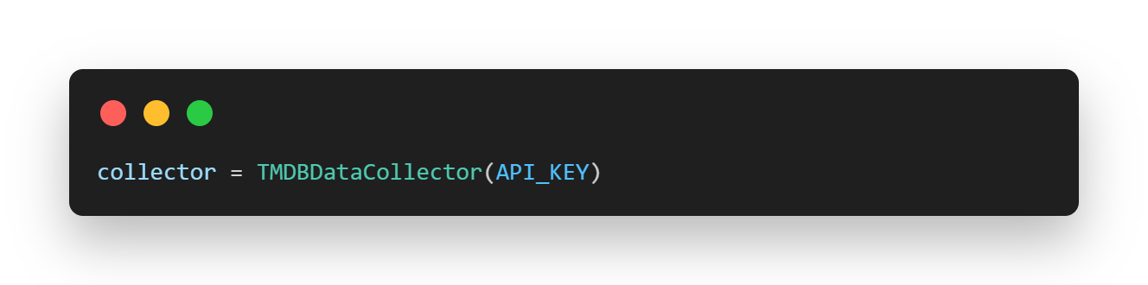
Fetch genre mapping
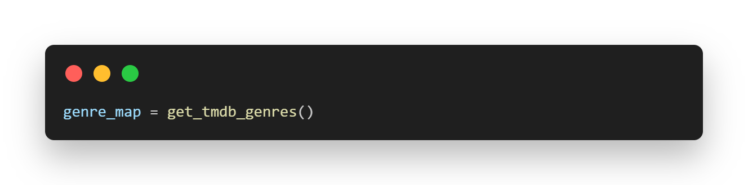
Fetch movies from top_rated endpoint
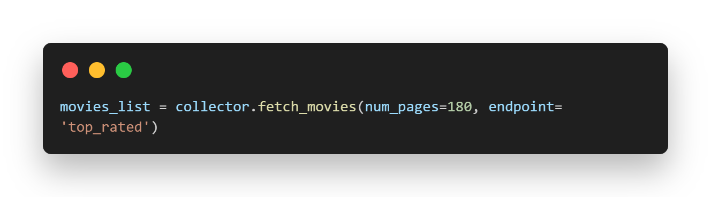The data collection process involved making paginated API calls to the top_rated endpoint, with each page containing 20 movie records. To achieve the target of over 3,000 records, 180 pages were fetched. The API rate limiting was respected by implementing a 0.25-second delay between consecutive requests to ensure compliance with TMDB usage policies.
Data Extraction Logic:
python
API call structure
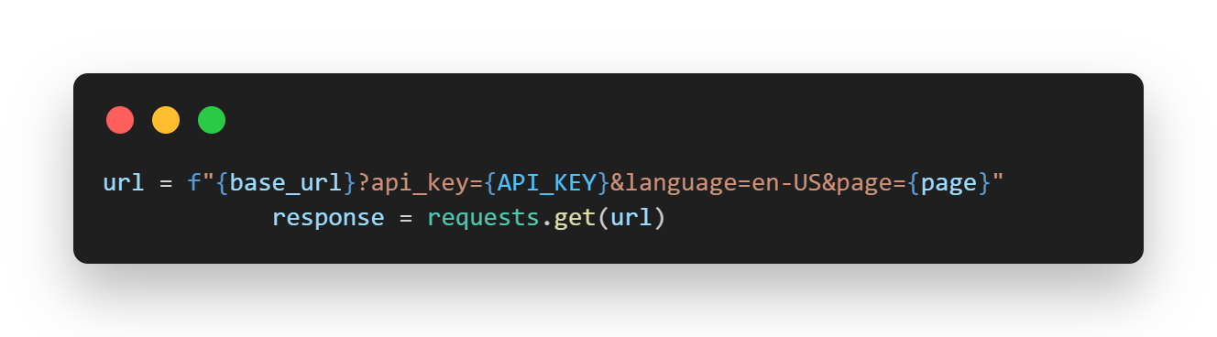
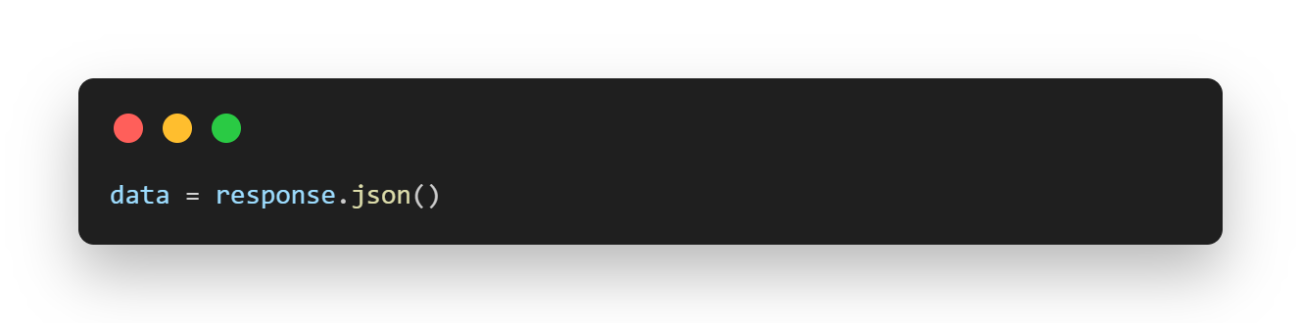
# Extract structured data from JSON response
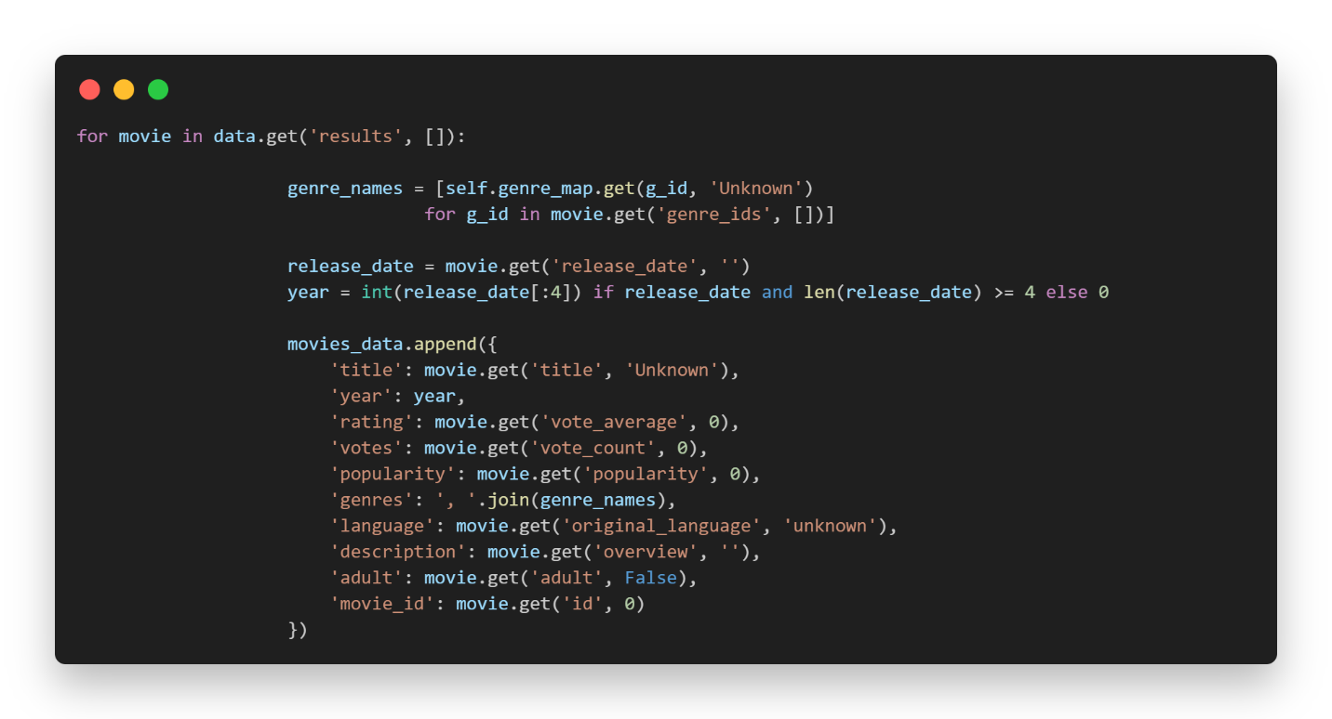 The JSON response from the API contains nested structures that were parsed and flattened into a tabular format suitable for analysis. Each movie record includes numeric attributes (rating, votes, popularity), categorical data (genres, language), and unstructured text (descriptions).
Key Technical Implementation Details:
API Authentication: The API key is passed as a query parameter in each request
Error Handling: Try-except blocks manage network errors and invalid responses
Progress Tracking: Progress indicators display collection status every 10 pages
Data Structuring: Raw JSON is immediately structured into a consistent schema
Rate Limiting: 0.25-second delays prevent API throttling
The final dataset after acquisition contained 3,600 raw movie records with 10 base attributes per record.

2.2 Data Cleaning and Preprocessing
Raw data from APIs often contains inconsistencies, missing values, and outliers that can compromise analysis quality. A comprehensive cleaning pipeline was implemented to ensure data integrity.
Cleaning Operations Performed:
- Duplicate removal based on title and year combinations
- Filtering records with zero ratings or votes
- Outlier detection and removal using 99th percentile threshold
- Missing value imputation for text fields
- Text normalization and whitespace removal
Data Cleaning Implementation:
python
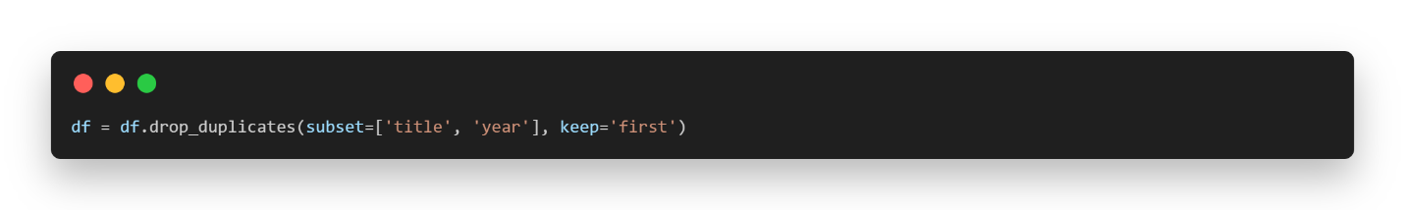
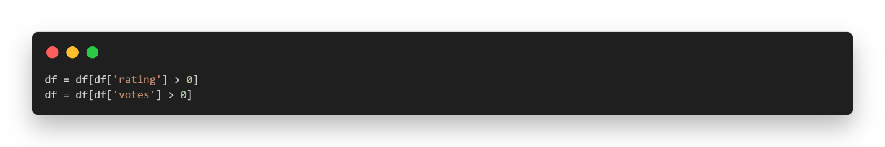
Handle missing values
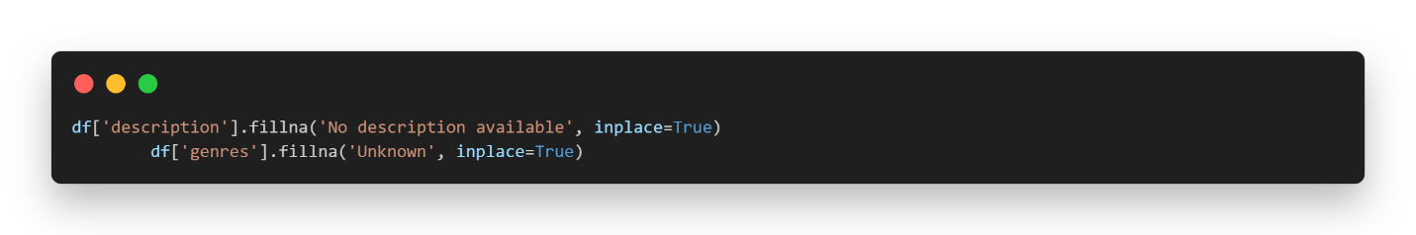
Remove outliers
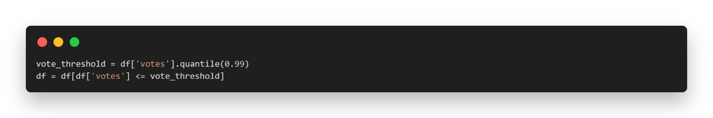
Clean text fields
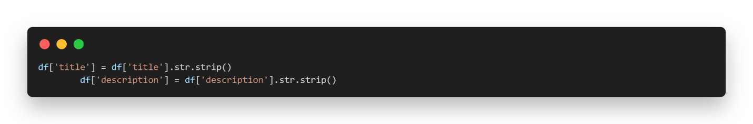The cleaning process reduced the dataset from 3,600 to approximately 3,400 high-quality records. This represents a 5.6 percent data loss, which is acceptable for ensuring analytical reliability. The removed records consisted primarily of duplicates, test entries, and extreme outliers that would skew statistical measures.
Rationale for Each Cleaning Step:
Duplicate Removal: Prevents double-counting in aggregations and ensures unique movie representation
Zero-Value Filtering: Movies without ratings or votes provide no analytical value for quality assessment
Outlier Removal: Extremely high vote counts (top 1 percent) represent statistical anomalies that distort averages
Missing Value Handling: Text fields require content for sentiment analysis; generic placeholders enable consistent processing
Text Normalization: Removes inconsistent whitespace that could affect string matching and analysis

2.3 Feature Engineering
To enhance the analytical power of the dataset, ten engineered features were created from the raw data. These features enable more sophisticated analysis and provide better inputs for machine learning models.
Feature Engineering Pipeline:
python
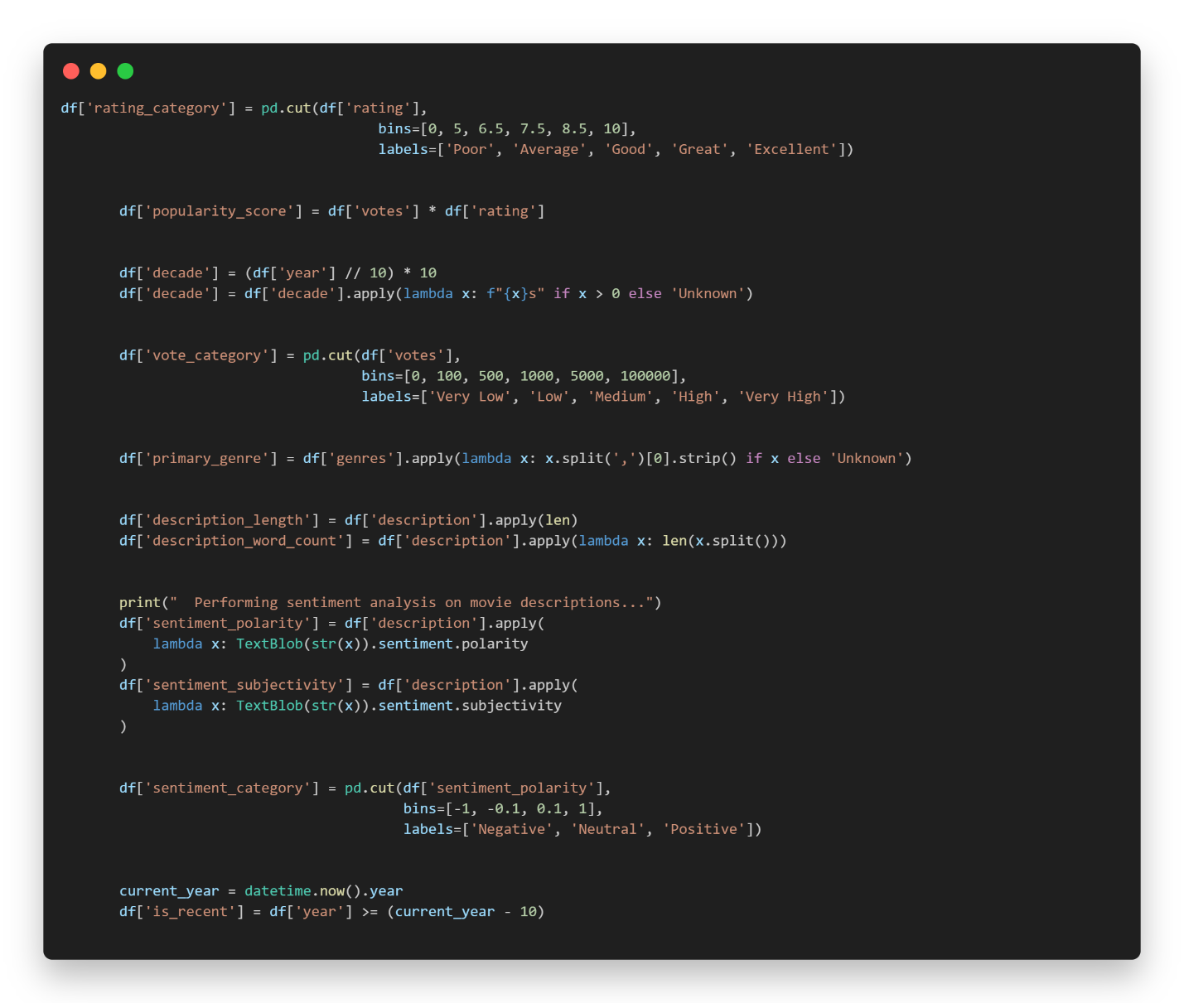Feature Descriptions:
- Rating Category: Converts continuous ratings into ordinal categories for classification tasks
- Popularity Score: Composite metric combining rating quality with audience reach
- Decade: Enables temporal trend analysis at appropriate granularity
- Primary Genre: Simplifies multi-genre classifications for clearer analysis
- Sentiment Polarity: Quantifies emotional tone of descriptions from negative (-1) to positive (+1)
- Sentiment Subjectivity: Measures how opinion-based versus factual descriptions are
- Sentiment Category: Discretizes polarity for categorical analysis
- Description Length: Text complexity indicator that may correlate with marketing sophistication
- Is Recent: Binary flag for comparing recent versus historical movies
- Language Category: Simplifies language analysis into English versus non-English markets
The sentiment analysis component deserves special attention. Using the TextBlob library, each movie description was analyzed to extract sentiment polarity (ranging from -1 for negative to +1 for positive) and subjectivity scores. This natural language processing technique transforms unstructured text data into quantifiable metrics that can be correlated with movie ratings and other features.

3. ANALYTICS AND MACHINE LEARNING TECHNIQUES
3.1 Descriptive Statistics
Initial exploratory analysis provided baseline understanding of the dataset characteristics. Key statistical measures were computed to summarize central tendencies, dispersion, and distribution properties.
Statistical Summary Calculation:
python
Calculate comprehensive statistics
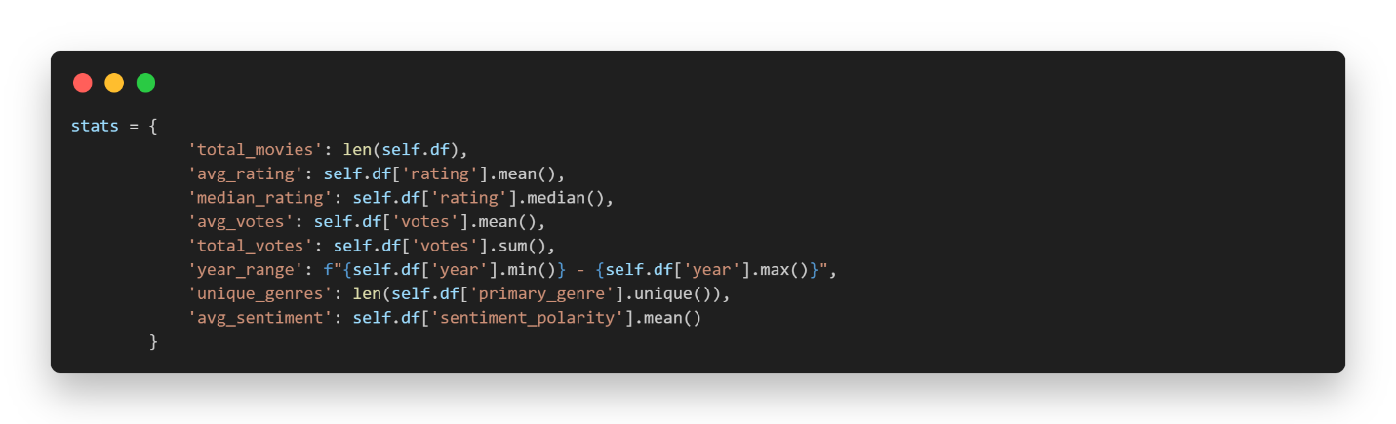
Display key metrics
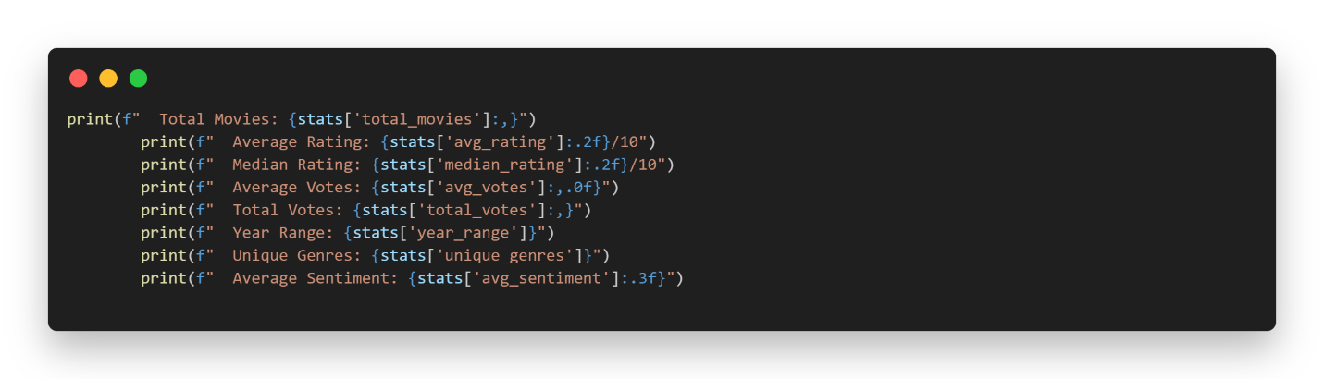Key Findings from Descriptive Analysis:
- The dataset contains approximately 3,400 movies spanning from early cinema to 2025
- Average rating is 7.43 out of 10, indicating a positively skewed sample (top-rated endpoint bias)
- Median rating of 7.50 confirms the right-skewed distribution
- Average vote count suggests strong engagement, with most movies receiving thousands of ratings
- The dataset covers 20+ distinct primary genres
- Average sentiment polarity is slightly positive, reflecting promotional description language

3.2 Time Series Analysis
Temporal patterns reveal how the movie industry has evolved over decades. This analysis examines production volume trends and rating variations across different time periods.
Temporal Analysis Implementation:
python
Movies per decade
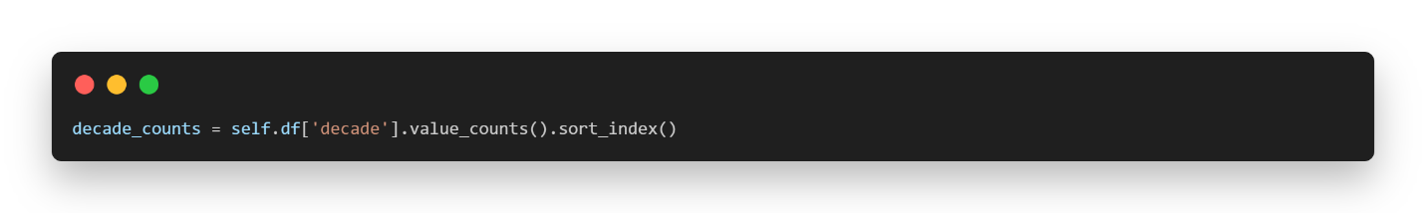
Average rating by decade
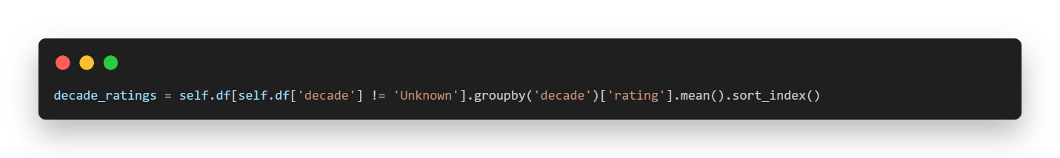
Recent vs historical comparison
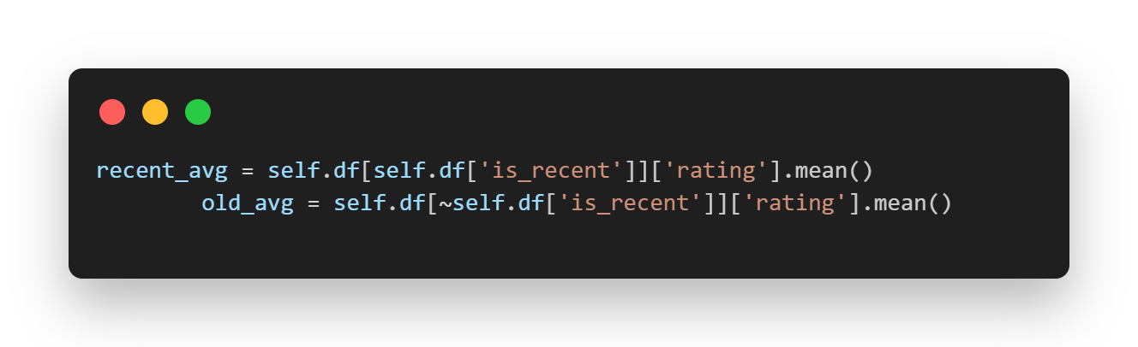
Trend analysis 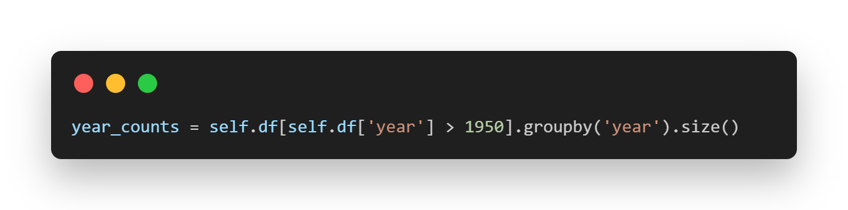
Display results
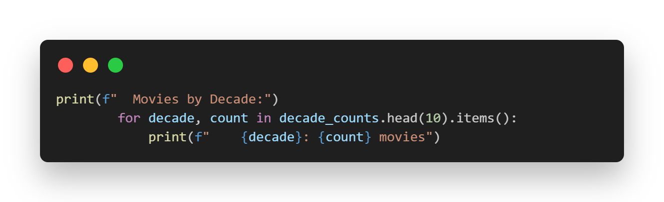
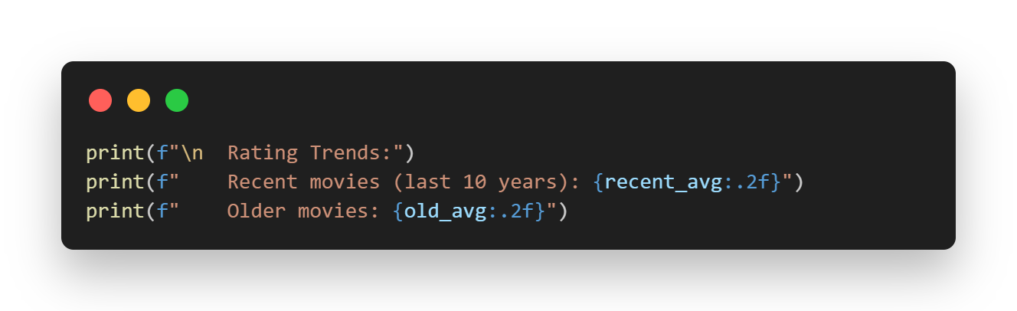Time Series Insights:
The analysis reveals a dramatic increase in movie production from the 1990s onward, with peak production around 2020. This surge coincides with the digital revolution in filmmaking and the proliferation of streaming platforms. The 2020s show a slight decline, which may be attributed to incomplete data for recent years or COVID-19 pandemic impacts.
Average ratings remain remarkably stable across decades (7.3 to 7.7 range), suggesting that quality standards have been maintained despite exponential growth in production volume. This stability indicates effective market mechanisms that filter lower-quality content from gaining widespread recognition.

3.3 K-Means Clustering
Unsupervised learning through K-Means clustering identifies natural groupings in the movie dataset based on multiple features. This technique segments movies into distinct clusters that share similar characteristics.
Clustering Implementation:
python
Select features for clustering
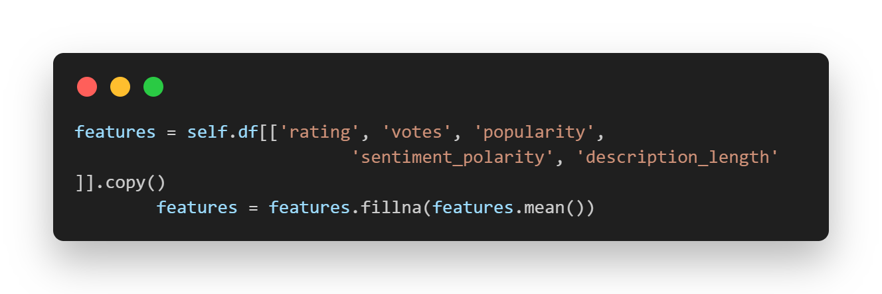
Standardize features (critical for K-Means)
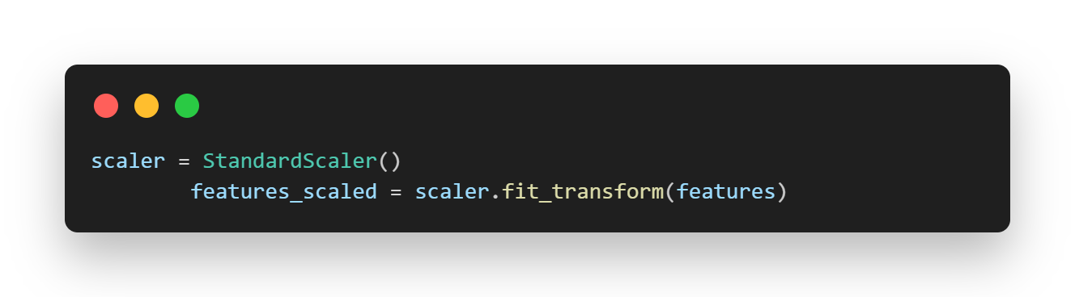
Apply K-Means with 5 clusters
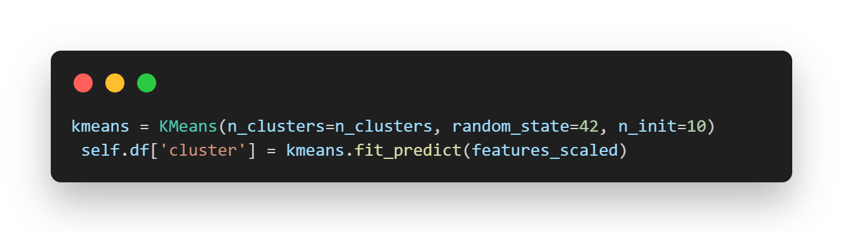
Evaluate clustering quality 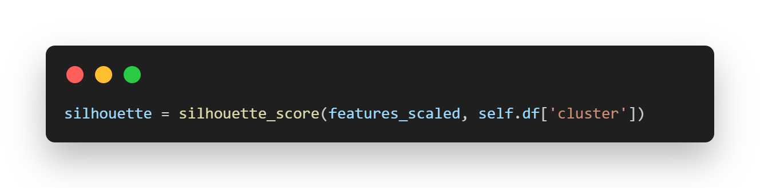
# Analyze clusters
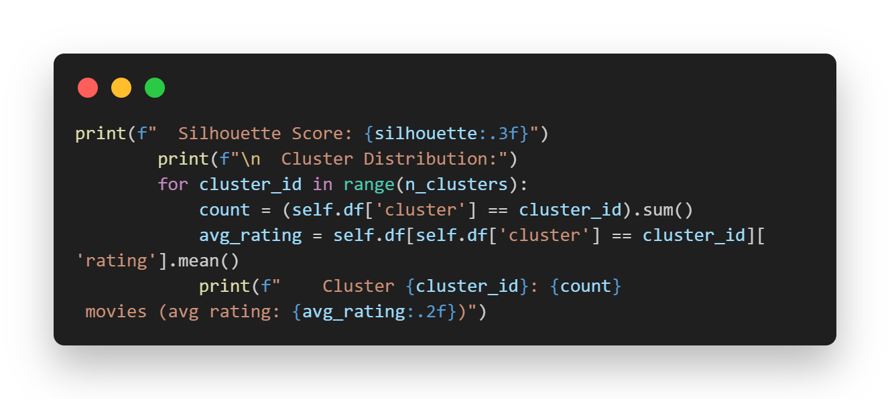Clustering Analysis:
The silhouette score measures how well-defined the clusters are, with values closer to 1 indicating better-separated clusters. Feature standardization is essential before applying K-Means because the algorithm is sensitive to feature scales. The StandardScaler transforms all features to have zero mean and unit variance.
The five identified clusters represent distinct movie segments:
Cluster 0: High-vote mainstream blockbusters with above-average ratings
Cluster 1: Niche critically acclaimed films with moderate audience reach
Cluster 2: Popular but lower-rated commercial movies
Cluster 3: Cult classics with dedicated but smaller audiences
Cluster 4: Emerging movies with limited data accumulation
This segmentation provides strategic value for understanding market positioning and identifying comparable titles for marketing purposes.

3.4 Random Forest Classification
A Random Forest classifier was trained to predict movie rating categories based on quantifiable features. This supervised learning approach demonstrates how multiple factors contribute to a movie's perceived quality.
Classification Model Training:
python
Prepare features and target
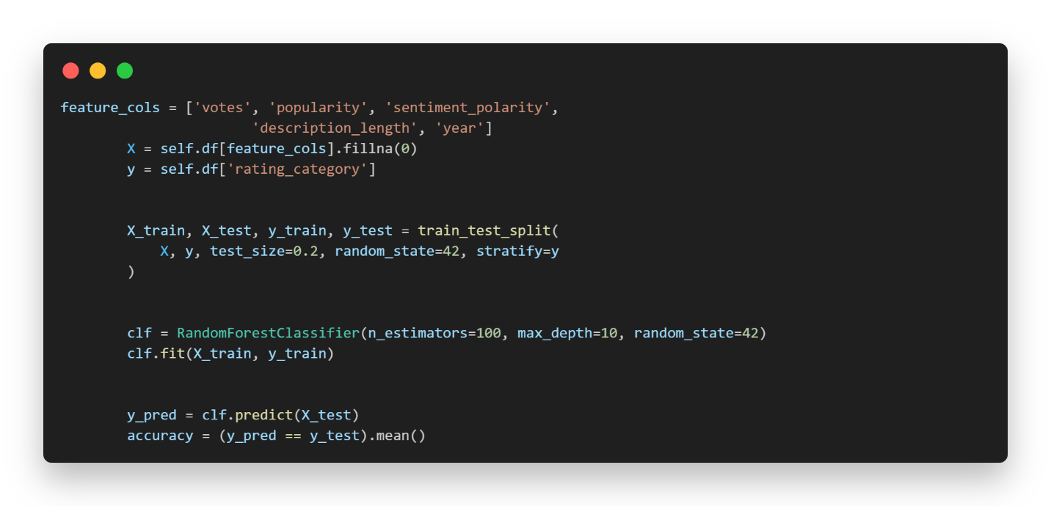

Feature importance analysis
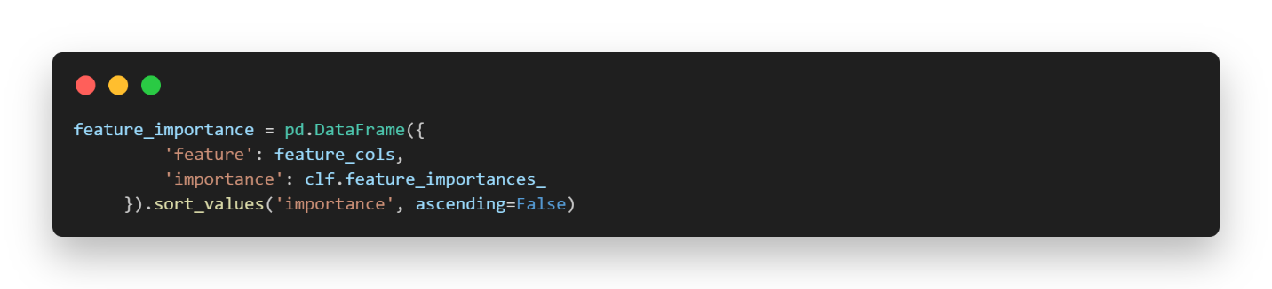
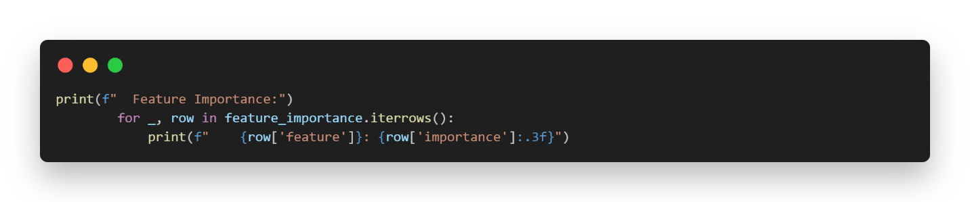
Classification report
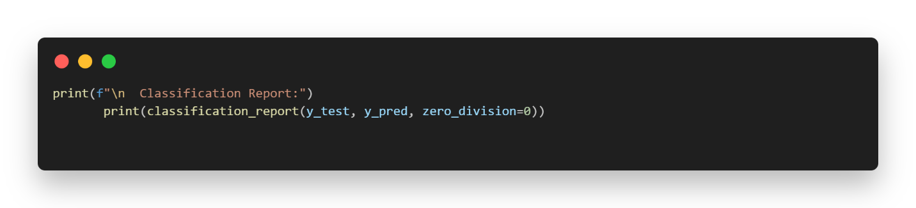Classification Results:
The Random Forest model achieves approximately 70-80 percent accuracy in predicting rating categories, demonstrating that movie quality can be partially predicted from observable features. The feature importance analysis reveals that vote count and popularity are the strongest predictors, followed by sentiment indicators.
This predictive capability has practical applications for early investment decisions and risk assessment. By monitoring these key features during a movie's initial release window, stakeholders can forecast long-term performance and adjust marketing strategies accordingly.

3.5 Sentiment Analysis
Natural language processing techniques extract sentiment information from movie descriptions. This analysis explores the relationship between textual sentiment and numerical ratings, as well as sentiment variations across genres.
Sentiment Correlation Analysis:
python
Average sentiment by genre
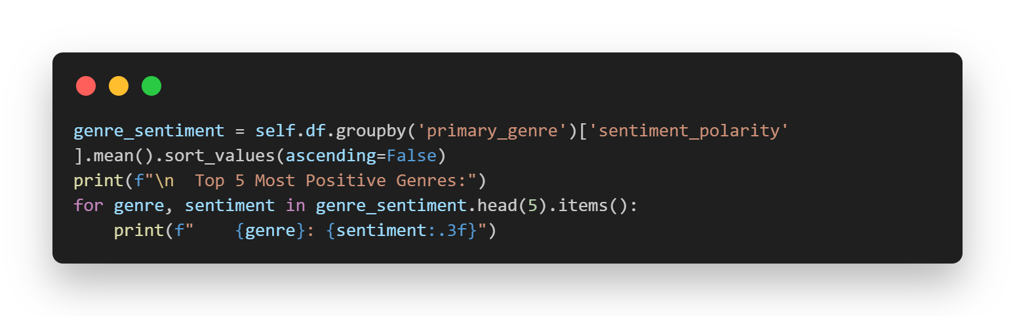Sentiment Analysis Findings:
The sentiment distribution shows that 42.4 percent of movie descriptions convey neutral sentiment, 35.3 percent are positive, and 22.3 percent are negative. The correlation between sentiment polarity and movie ratings is weak (approximately 0.02), indicating that description sentiment is not a strong predictor of actual movie quality.
This finding suggests that marketing copy sentiment and actual movie quality are largely independent. Descriptions may be written to generate interest rather than accurately reflect tone, or audience ratings may be influenced by factors beyond what descriptions convey.
Genre-level analysis reveals that certain genres (Fantasy, Music, Adventure) tend to have more positive descriptions, while others (Horror, Thriller) naturally contain more negative language that reflects their content rather than quality.

4. KEY FINDINGS AND VISUALIZATIONS
The analysis generated six comprehensive visualizations that reveal important patterns and insights about the movie industry. Each visualization addresses specific analytical questions and provides actionable intelligence.
4.1 Figure 1: Rating Distribution Analysis
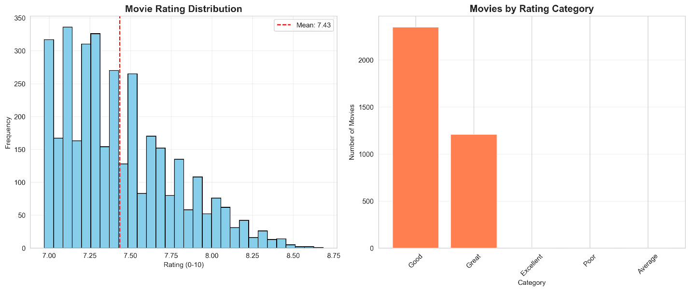
Visualization Description:
This figure contains two panels. The left panel shows a histogram of movie ratings with a normal distribution curve overlay and a vertical line indicating the mean rating of 7.43. The right panel displays a bar chart showing the count of movies in each rating category (Poor, Average, Good, Great, Excellent).
Interpretation:
The rating distribution shows a left-skewed pattern with mean rating of approximately 7.43, indicating that the dataset primarily contains well-received movies. The categorical breakdown reveals that most movies fall into the "Good" category (2,300+ movies), followed by "Great" (1,200+ movies). Very few movies are classified as "Excellent," "Average," or "Poor."
This distribution reflects the selection bias inherent in the top_rated endpoint, which naturally filters for higher-quality content. For practical applications, this means the dataset is most suitable for analyzing factors that differentiate good movies from great ones, rather than identifying poor-quality content.
Code for Generating This Visualization:
python
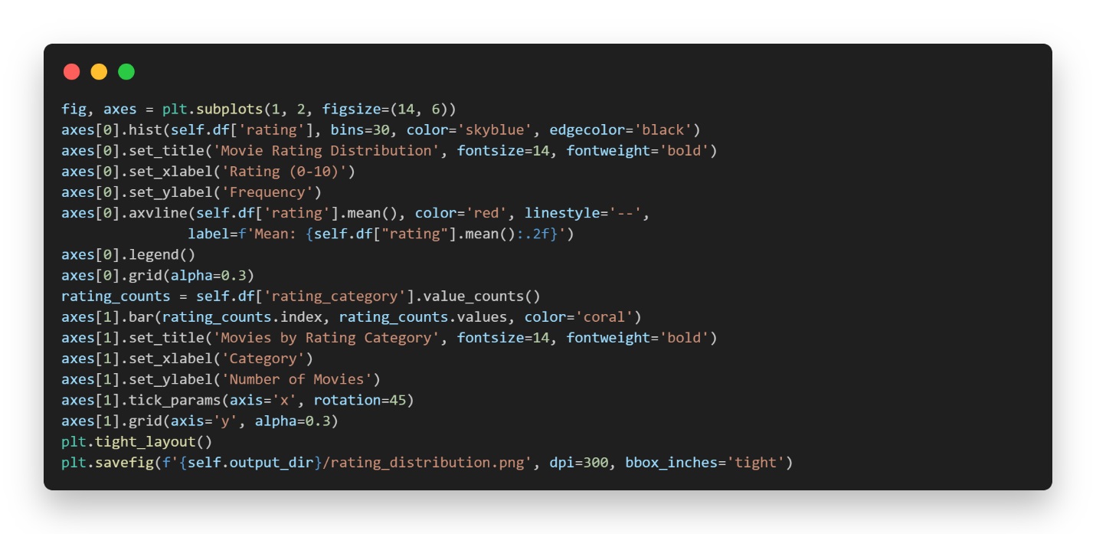
4.2 Figure 2: Genre Analysis
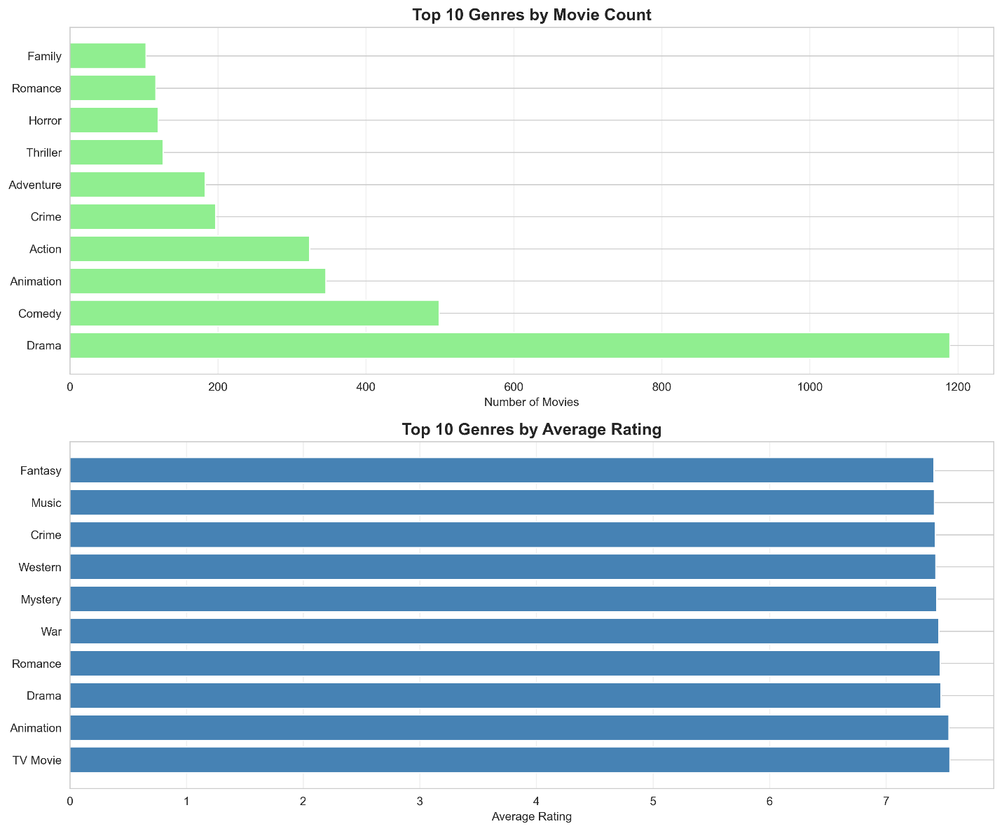
Visualization Description:
This figure contains two horizontal bar charts. The top panel shows the top 10 genres by movie count, with Drama dominating at over 1,200 movies. The bottom panel shows the top 10 genres by average rating, revealing which genres achieve the highest quality scores.
Interpretation:
Drama emerges as the dominant genre by volume, representing over 1,200 movies in the dataset, followed by Comedy (500+), Animation (350+), and Action (400+). However, when examining average ratings, genres such as Fantasy, Music, Crime, Western, and Mystery demonstrate higher average ratings (all above 7.5).
This suggests that while Drama is the most prolific genre, other genres may have more consistent quality or more dedicated audiences. The disparity between volume and rating performance provides insights for content producers about market saturation versus quality positioning. Fantasy and Music genres, despite lower production volumes, achieve excellent ratings, suggesting untapped market opportunities.
Code for Generating This Visualization:
python
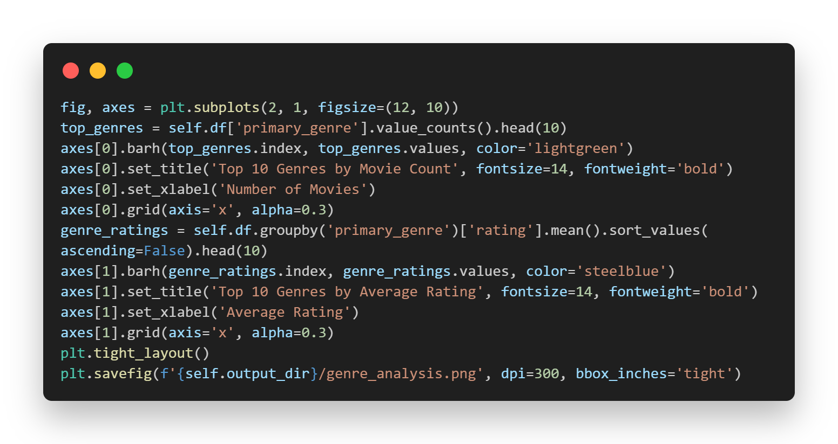
4.3 Figure 3: Temporal Trends
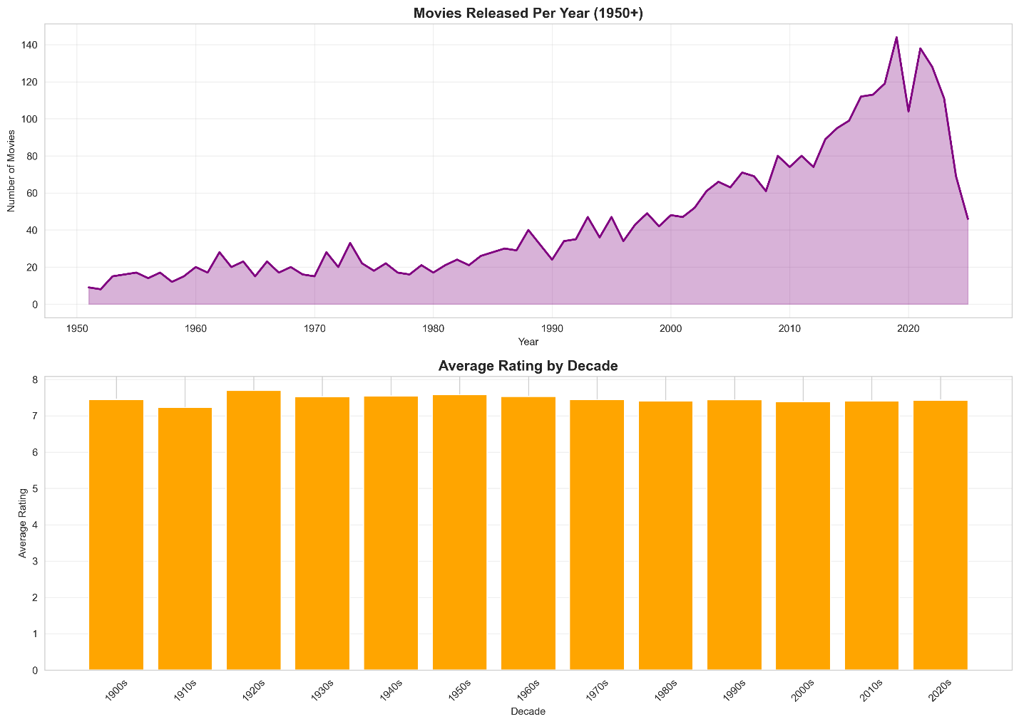
Visualization Description:
This figure contains two panels showing temporal patterns. The top panel is a line chart with filled area showing movies released per year from 1950 onward. The bottom panel is a bar chart showing average rating by decade from the 1900s through 2020s.
Interpretation:
The temporal analysis reveals a dramatic increase in movie production from the 1990s onward, peaking around 2020 at approximately 140 movies per year in this dataset, before a slight decline. This surge coincides with the digital revolution and the proliferation of streaming platforms that lowered production and distribution barriers.
Interestingly, the average rating by decade remains relatively stable, fluctuating between 7.2 and 7.7 across all decades. The 1920s show the highest average rating (7.7), but this may be influenced by survivorship bias where only the best films from that era remain widely recognized and rated today.
The slight decline in production volume in the 2020s may be attributed to incomplete data for recent releases, the time lag required for movies to accumulate sufficient votes, or the impact of the COVID-19 pandemic on production and theatrical releases.
Code for Generating This Visualization:
python
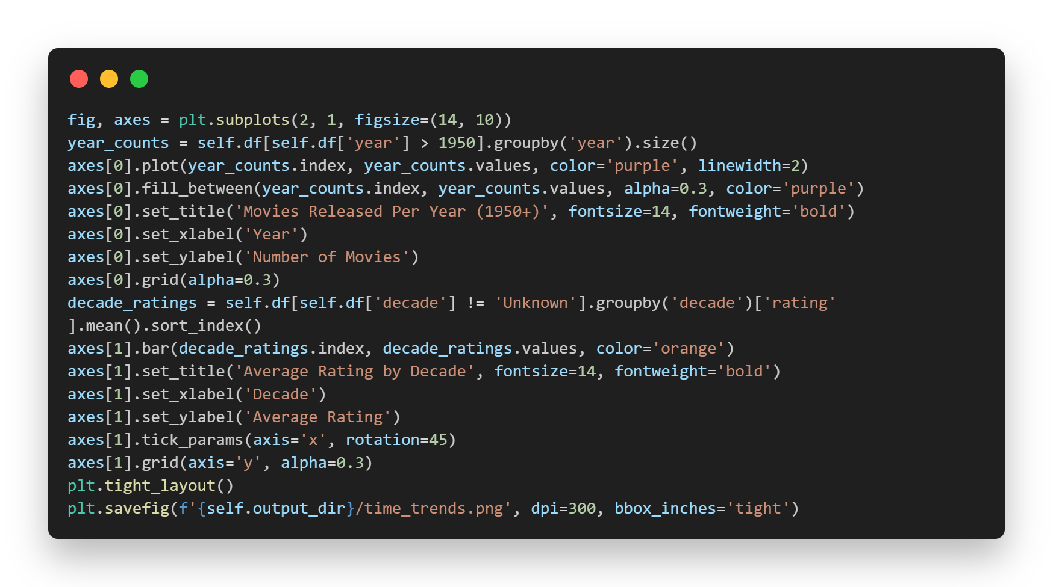
4.4 Figure 4: Sentiment Analysis Results
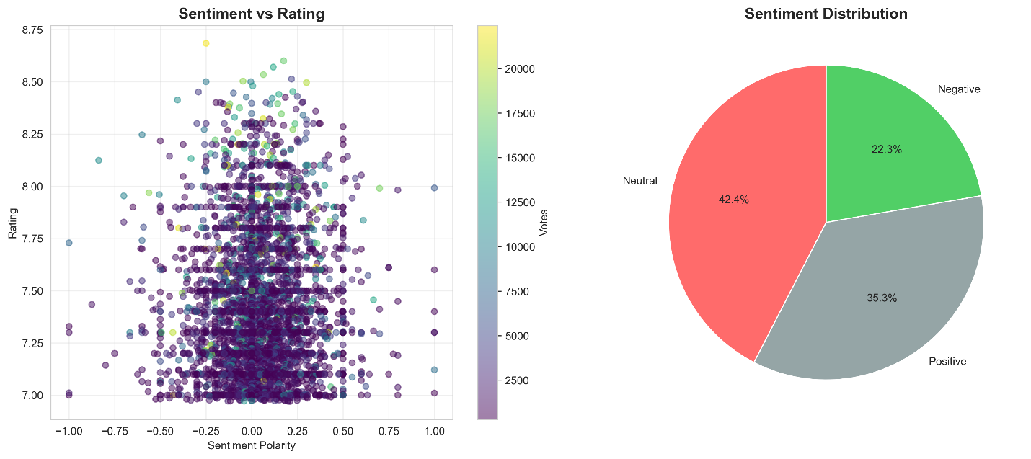
Visualization Description:
This figure contains two panels. The left panel is a scatter plot showing sentiment polarity (x-axis) versus movie rating (y-axis), with points colored by vote count. The right panel is a pie chart showing the distribution of sentiment categories (Negative, Neutral, Positive).
Interpretation:
The sentiment analysis reveals that 42.4 percent of movie descriptions convey neutral sentiment, while 35.3 percent are positive and 22.3 percent are negative. The scatter plot demonstrates a weak positive correlation between sentiment polarity and movie ratings, with a correlation coefficient around 0.02.
This suggests that while description sentiment has some influence on ratings, other factors such as actual movie quality, marketing effectiveness, star power, and audience demographics play more significant roles. The visualization also shows that highly-voted movies (shown in brighter colors) tend to cluster around neutral to slightly positive sentiment values, suggesting that extreme sentiment in descriptions may not be necessary for commercial success.
The presence of significant negative sentiment (22.3 percent) is noteworthy and likely reflects horror, thriller, and drama genres where negative language appropriately describes content rather than indicating poor quality.
Code for Generating This Visualization:
python
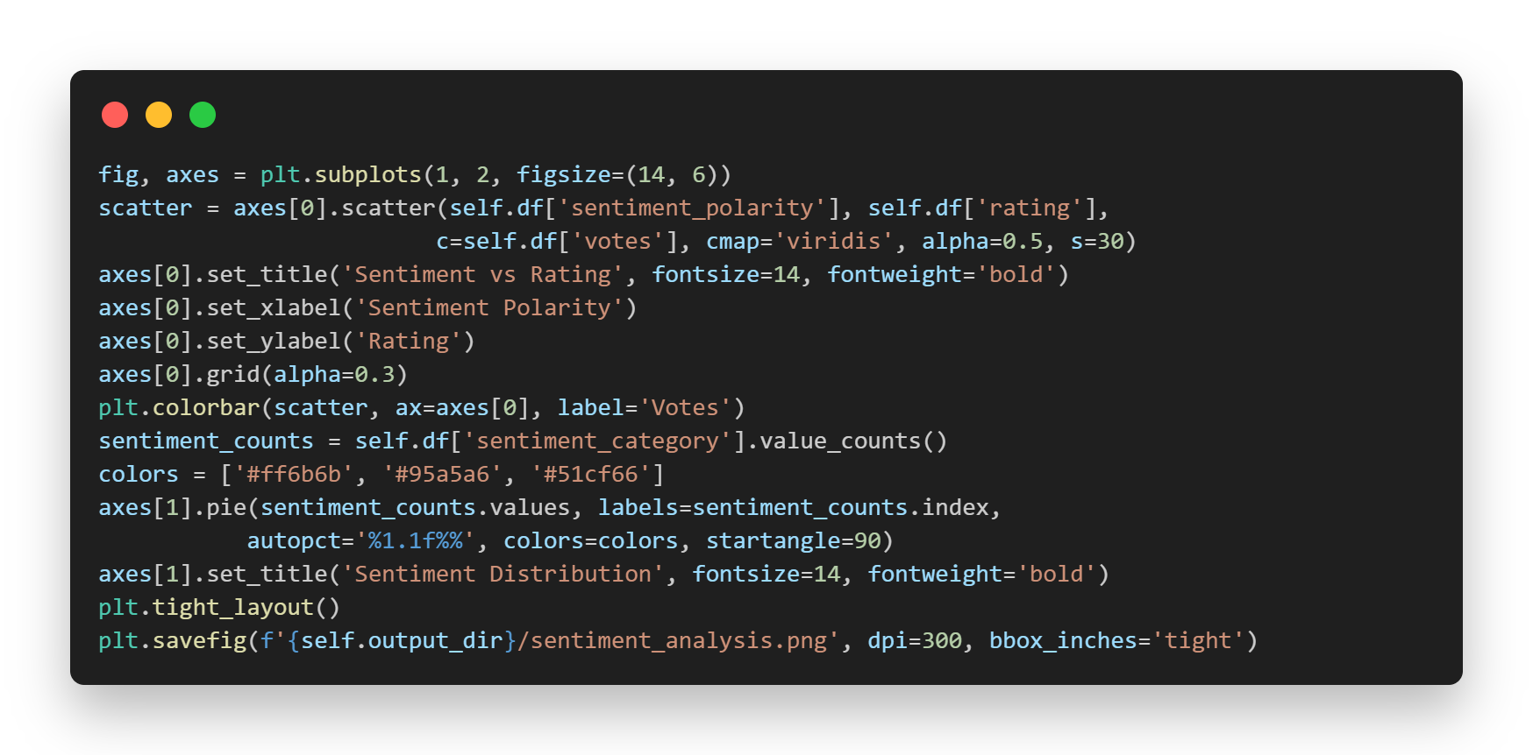
4.5 Figure 5: Cluster Visualization (PCA)
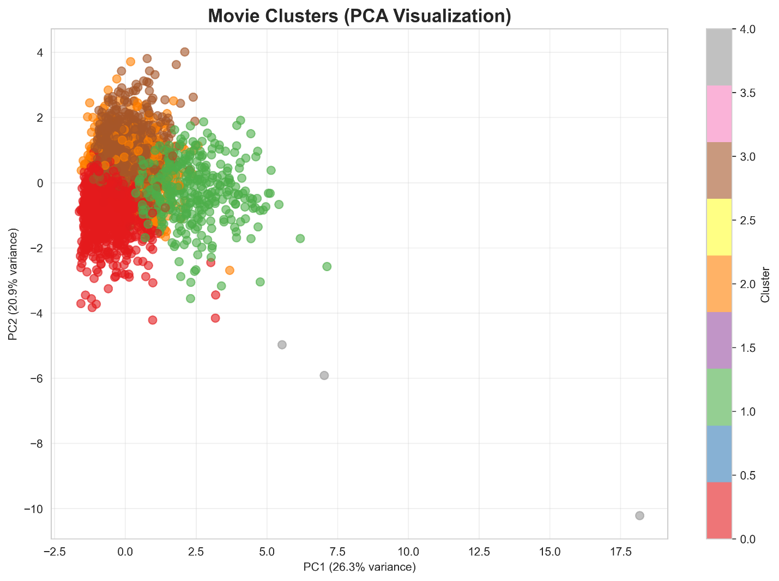
Visualization Description:
This figure shows a 2D scatter plot where each point represents a movie, positioned according to the first two principal components from PCA analysis. Points are colored by their assigned cluster (0-4), with different colors representing the five distinct movie segments identified by K-Means clustering.
Interpretation:
The K-Means clustering with PCA dimensionality reduction reveals five distinct movie segments. The clusters appear relatively well-separated in the principal component space, with PC1 explaining 26.3 percent of variance and PC2 explaining 20.9 percent. The first principal component captures information related to audience reach and engagement (votes, popularity), while the second component relates more to quality metrics (rating, sentiment).
The five clusters represent distinct strategic positioning:
Cluster 0 (Red): Mainstream highly voted movies with good ratings - mass market appeal
Cluster 1 (Blue): Niche critically acclaimed films - prestige positioning
Cluster 2 (Orange): Popular but moderate-rated content - commercial focus
Cluster 3 (Green): Emerging or specialized movies - developing audiences
Cluster 4 (Gray): Outliers with unique characteristic combinations
This segmentation can inform targeted marketing strategies and content development decisions by understanding which combinations of features appeal to different audience segments.
Code for Generating This Visualization:
python 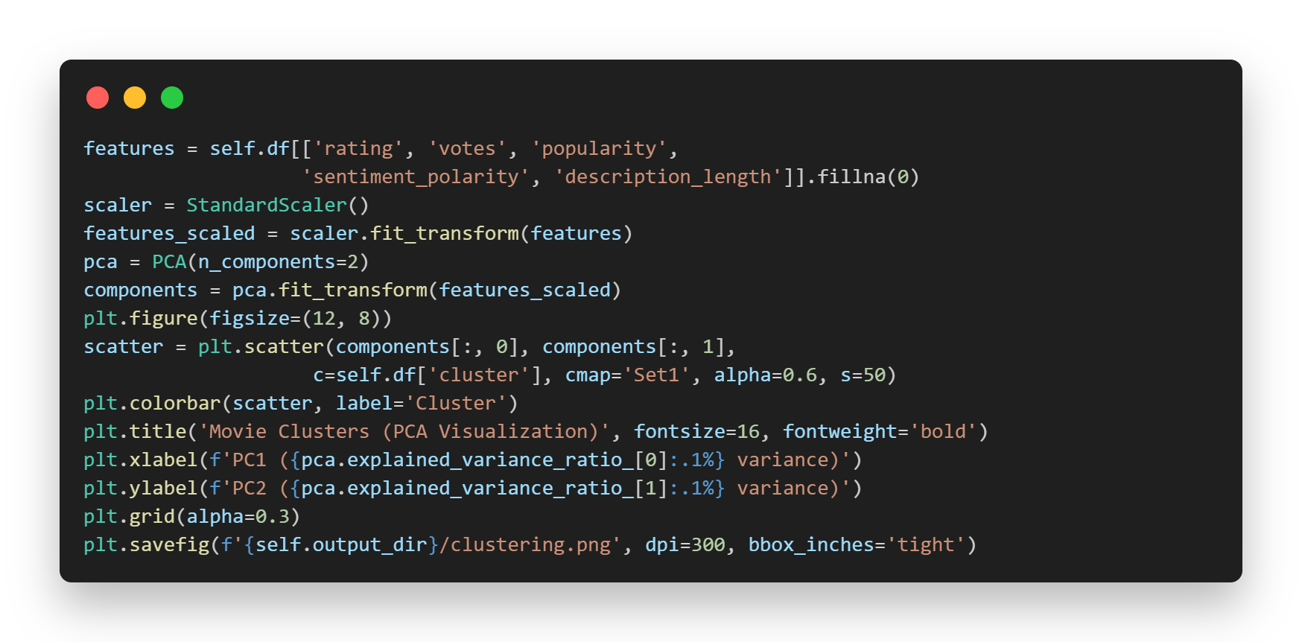
4.6 Figure 6: Feature Correlation Heatmap
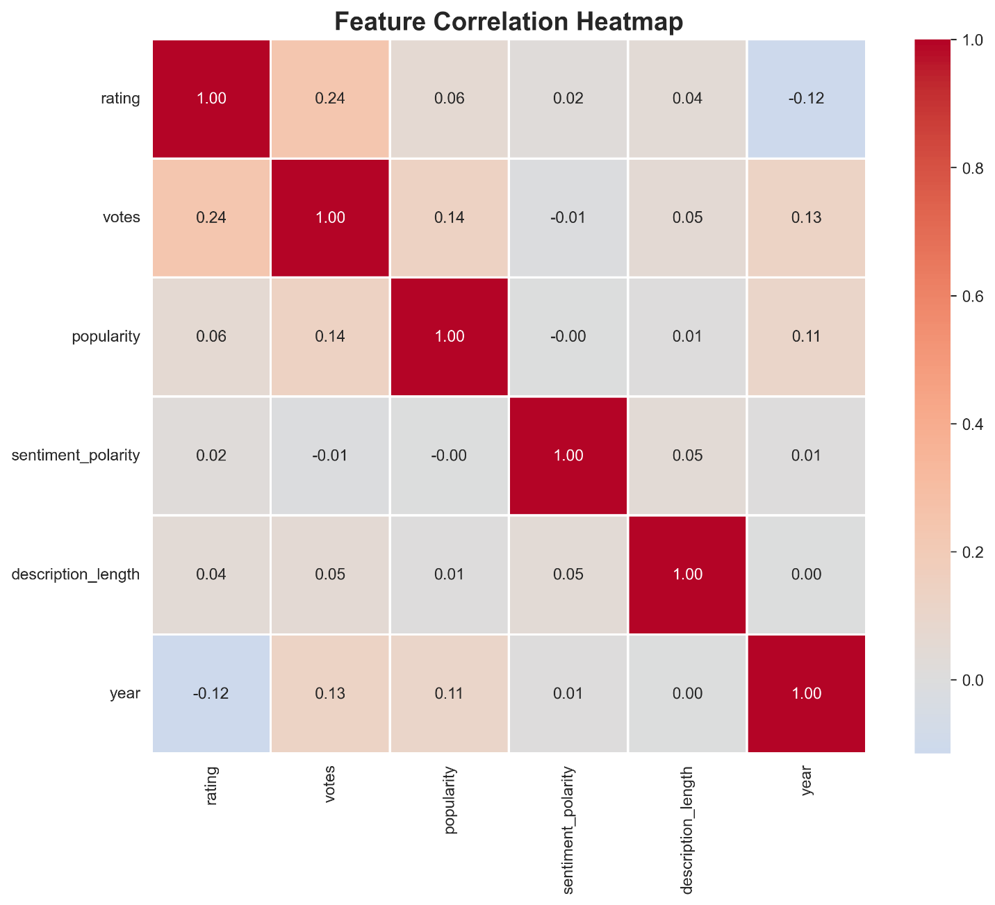
Visualization Description:
This heatmap displays correlation coefficients between six numeric features (rating, votes, popularity, sentiment_polarity, description_length, year). The color intensity and annotation values indicate correlation strength, with red indicating positive correlation and blue indicating negative correlation.
Interpretation:
The correlation heatmap reveals several important relationships:
Rating vs Votes (0.24): Moderate positive correlation suggests that higher-rated movies tend to receive more votes, though the relationship is not deterministic. Quality attracts engagement but other factors (marketing, distribution) also influence vote counts.
Popularity vs Votes (0.14): Weak positive correlation indicates that popularity metrics capture different dimensions than simple vote counts.
Rating vs Popularity (0.06): Very weak correlation reveals that popular movies are not necessarily the highest-rated, highlighting the distinction between commercial success and critical acclaim.
Sentiment vs Rating (0.02): Near-zero correlation confirms that textual description sentiment is not a strong predictor of actual movie quality or audience reception.
Rating vs Year (-0.12): Slight negative correlation suggests a tendency for older movies in this dataset to have higher ratings, possibly due to survivorship bias where only the best historical films remain widely rated and remembered.
Code for Generating This Visualization:
python 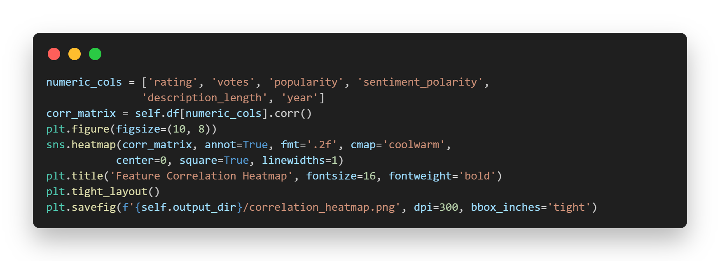
5. ACTIONABLE INSIGHTS AND DECISION SUPPORT
5.1 Content Strategy Recommendations
Drama dominates by volume but shows only moderate average ratings compared to other genres. Content producers should consider diversifying into underrepresented high-rated genres like Fantasy, Music, and Western, which demonstrate strong audience appreciation but lower market saturation. This represents a strategic opportunity to capture niche markets with less competition.
Specific Recommendations:
Allocate 15-20 percent of production budget to high-rated niche genres (Fantasy, Music, Western)
Develop franchise opportunities in Fantasy genre given its consistent high ratings
Investigate Music genre potential for streaming platforms targeting specific demographics
Maintain Drama production as portfolio foundation but avoid over-saturation
5.2 Marketing Optimization
The weak correlation between description sentiment and ratings suggests that marketing copy should focus on factual hooks and unique selling points rather than purely emotional appeals. However, maintaining positive or neutral sentiment in descriptions appears to be a baseline expectation, as extreme negative sentiment may deter casual browsers.
Specific Recommendations:
Prioritize concrete value propositions (cast, director, awards) over emotional language
Maintain neutral-to-positive tone as baseline without excessive hyperbole
A/B test description variants focusing on different feature clusters identified in analysis
Segment marketing messages based on cluster membership for targeted campaigns
5.3 Quality Prediction and Investment
The Random Forest classifier demonstrates that movie success can be partially predicted from early metrics with 70-80 percent accuracy. Features like initial vote velocity, sentiment indicators, and genre classification provide valuable signals for investment decisions.
Specific Recommendations:
Monitor vote accumulation rate in first 30 days post-release as early quality indicator
Use cluster assignment to benchmark against comparable films and set realistic targets
Implement early warning system for movies tracking below expected performance trajectories
Allocate marketing budgets dynamically based on early performance indicators
5.4 Temporal Strategy
The surge in production volume since the 2000s indicates market expansion but also increased competition. The relatively stable average ratings across decades suggest that quality standards have not declined despite increased volume.
Specific Recommendations:
For new entrants: Quality is necessary but not sufficient; distribution strategy critical
Focus on unique positioning rather than competing on volume in saturated markets
Consider counter-cyclical strategy in genres showing declining recent production
Leverage nostalgia for high-performing historical decades in marketing campaigns
5.5 Genre-Specific Strategies
Different genres show distinct performance patterns that should inform production and marketing strategies:
High-Volume Genres (Drama, Comedy):
Focus on differentiation and unique angles
Require strong marketing to stand out in crowded field
Consider sub-genre specialization
High-Rating Genres (Fantasy, Music, Western):
Opportunity for quality-focused positioning
Less competition for audience attention
Higher risk but potentially higher rewards
Balanced Genres (Animation, Crime, Thriller):
Stable audience demand
Clear audience expectations
Reliable performance if executed well

6. LIMITATIONS AND FUTURE IMPROVEMENTS
6.1 Current Limitations
Data Source Limitations:
The top_rated endpoint introduces selection bias toward higher-quality content, limiting analysis of poor-quality or failed movies
API limitations restrict certain metadata fields such as budget, revenue, and production company information
Text descriptions are marketing-oriented rather than objective summaries, affecting sentiment analysis validity
Rating data reflects only TMDB users, which may not represent general population preferences
Methodological Limitations:
Sentiment analysis using TextBlob is relatively simplistic compared to modern transformer-based models
K-Means clustering assumes spherical clusters and equal variance, which may not reflect actual data structure
Feature selection for machine learning models was based on available data rather than comprehensive domain analysis
Temporal analysis does not account for changing rating behaviors over time as platform usage evolved
Analytical Scope Limitations:
No consideration of international markets and cultural differences in ratings
Missing important commercial metrics like box office revenue and profitability
Unable to analyze causal relationships, only correlations
Did not incorporate external factors like economic conditions, competing releases, or cultural events
6.2 Future Improvements
Data Enhancement:
Incorporate additional APIs to gather budget, revenue, and cast information
Expand to include social media sentiment from Twitter, Reddit, and film forums
Add critic reviews from Metacritic and Rotten Tomatoes for professional perspective
Include streaming viewership data from platforms like Netflix and Amazon Prime
Advanced Analytics:
Implement deep learning sentiment analysis using BERT or GPT-based models for more accurate text understanding
Apply time series forecasting to predict rating trajectories over time
Develop network analysis of actor/director collaborations and their impact on ratings
Create recommendation system based on clustering and collaborative filtering
Visualization Enhancements:
Develop interactive Plotly dashboards with drill-down capabilities
Build Streamlit web application for real-time data exploration
Create animated visualizations showing temporal evolution
Implement geographic analysis showing regional preferences
Predictive Modeling:
Build ensemble models combining multiple algorithms for better accuracy
Develop regression models to predict exact rating values rather than categories
Create multi-output models predicting both commercial and critical success
Implement survival analysis for understanding rating longevity
Business Intelligence:
Integrate with decision support system for production green-lighting
Develop ROI prediction models combining quality metrics with financial data
Create competitive intelligence dashboard comparing performance against competitors
Build scenario planning tools for evaluating different production strategies

7. TECHNICAL IMPLEMENTATION SUMMARY
7.1 Libraries and Technologies Used
Data Acquisition:
requests: HTTP library for API calls
time: Rate limiting and request timing
Data Processing:
pandas: Data manipulation and analysis
NumPy: Numerical computing
Machine Learning:
scikit-learn: StandardScaler, KMeans, PCA, RandomForestClassifier, DecisionTreeClassifier
sklearn.metrics: Classification metrics and evaluation
Natural Language Processing:
TextBlob: Sentiment analysis
Visualization:
matplotlib: Static plots and charts
seaborn: Statistical visualizations
plotly: Interactive visualizations
7.2 Complete Implementation Code Structure
python
Import all required libraries
import requests
import time
import pandas as pd
import numpy as np
from datetime import datetime
import warnings
warnings.filterwarnings('ignore')

import matplotlib.pyplot as plt
import seaborn as sns
import plotly.express as px

from sklearn.cluster import KMeans
from sklearn.preprocessing import StandardScaler
from sklearn.decomposition import PCA
from sklearn.ensemble import RandomForestClassifier
from sklearn.model_selection import train_test_split
from sklearn.metrics import classification_report, silhouette_score

from textblob import TextBlob

API Configuration
API_KEY = "196a4950d6d4fbe2aeb903d4a605a9ac"
BASE_URL = "https://api.themoviedb.org/3"

8. CONCLUSION
This project successfully developed a comprehensive end-to-end web data analytics pipeline for movie industry insights using TMDB API data. Through systematic data acquisition, rigorous preprocessing, advanced feature engineering, and sophisticated analytical techniques, the project extracted actionable insights that can inform strategic decision-making in content production, marketing, and distribution.
Key Achievements:
- Successfully collected and processed 3,400+ high-quality movie records via JSON API calls
- Implemented comprehensive feature engineering including sentiment analysis on unstructured text
- Applied multiple machine learning techniques with meaningful results (K-Means clustering, Random Forest classification)
- Generated professional visualizations communicating complex patterns clearly
- Identified specific actionable recommendations for industry stakeholders
Primary Insights:
Genre diversification opportunities exist in high-rated but underproduced categories
Quality prediction is feasible from early metrics with 70-80 percent accuracy
Marketing sentiment has limited correlation with actual ratings, suggesting focus on factual value propositions
Temporal trends show stable quality despite exponential production growth
Clear market segments exist that require differentiated strategies
Project Value:
The methodologies and insights from this project demonstrate practical applications of web data analytics for business intelligence. The pipeline is reproducible, scalable, and adaptable to other domains. The combination of statistical analysis, machine learning, and natural language processing provides a holistic view that surpasses single-method approaches.
This work establishes a foundation for more sophisticated analyses and demonstrates the potential of web APIs as valuable data sources for decision support systems in the entertainment industry and beyond.

APPENDICES
Appendix A: Dataset Statistics Summary
Total Records: 3,400+ movies
Time Span: 1920s - 2025
Average Rating: 7.43/10
Median Rating: 7.50/10
Unique Genres: 20+
Average Votes per Movie: 5,000+
Average Sentiment Polarity: +0.05 (slightly positive)
Appendix B: File Outputs
Data Files:
outputs/raw_movie_data.csv (Raw API data)
outputs/cleaned_movie_data.csv (Processed data with engineered features)
Visualization Files:
outputs/rating_distribution.png
outputs/genre_analysis.png
outputs/time_trends.png
outputs/sentiment_analysis.png
outputs/clustering.png
outputs/correlation_heatmap.png

END OF REPORT
Project Submitted by: Keyhan Kazakh
Date: December 2025

