Blood-Pressure.r

keilasierra

2025-09-18

# 1 Data prep   
  
Frequency <- c(0.6, 0.3, 0.4, 0.4, 0.2, 0.6, 0.3, 0.4, 0.9, 0.2)  
BloodPressure <- c(103, 87, 32, 42, 59, 109, 78, 205, 135, 176)  
  
  
FirstAssess <- c(1, 1, 1, 1, 0, 0, 0, NA, 1, 1)   
SecondAssess <- c(0, 0, 1, 1, 0, 0, 1, 1, 1, 1)  
FinalDecision <- c(0, 1, 0, 1, 0, 1, 1, 1, 1, 1)  
  
# Build data frame  
df_hosp <- data.frame(  
 Frequency, BloodPressure, FirstAssess, SecondAssess, FinalDecision,  
 stringsAsFactors = FALSE  
)  
  
summary(df_hosp)

## Frequency BloodPressure FirstAssess SecondAssess FinalDecision   
## Min. :0.20 Min. : 32.00 Min. :0.0000 Min. :0.0 Min. :0.00   
## 1st Qu.:0.30 1st Qu.: 63.75 1st Qu.:0.0000 1st Qu.:0.0 1st Qu.:0.25   
## Median :0.40 Median : 95.00 Median :1.0000 Median :1.0 Median :1.00   
## Mean :0.43 Mean :102.60 Mean :0.6667 Mean :0.6 Mean :0.70   
## 3rd Qu.:0.55 3rd Qu.:128.50 3rd Qu.:1.0000 3rd Qu.:1.0 3rd Qu.:1.00   
## Max. :0.90 Max. :205.00 Max. :1.0000 Max. :1.0 Max. :1.00   
## NA's :1

df_hosp <- na.omit(df_hosp)  
  
# 2 Generate Vizualizations  
  
boxplot(  
 BloodPressure ~ factor(FirstAssess, levels = c(0,1), labels = c("Good","Bad")),  
 data = df_hosp,  
 ylab = "Blood Pressure",  
 main = "BP by First MD Assessment"  
)

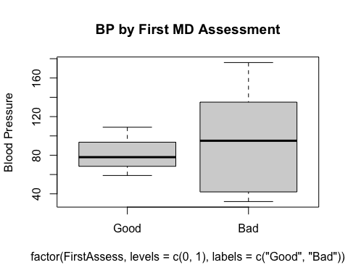

boxplot(  
 BloodPressure ~ factor(SecondAssess, levels = c(0,1), labels = c("Low","High")),  
 data = df_hosp,  
 ylab = "Blood Pressure",  
 main = "BP by Second MD Assessment"  
)

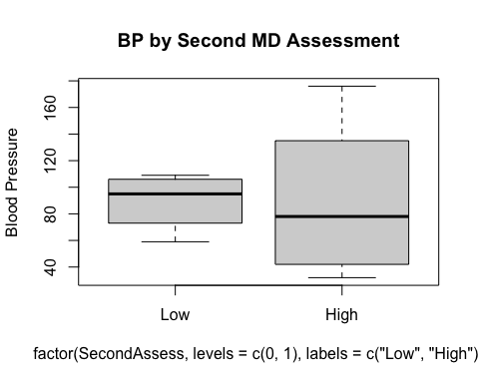

boxplot(  
 BloodPressure ~ factor(FinalDecision, levels = c(0,1), labels = c("Low","High")),  
 data = df_hosp,  
 ylab = "Blood Pressure",  
 main = "BP by Final Decision"  
)

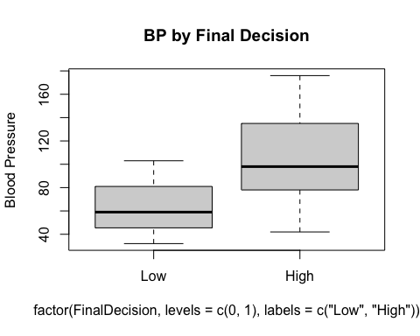

# 3 Histograms   
  
hist(  
 df_hosp$Frequency,  
 breaks = seq(0, 1, by = 0.1),  
 xlab = "Visit Frequency",  
 main = "Histogram of Visit Frequency"  
)

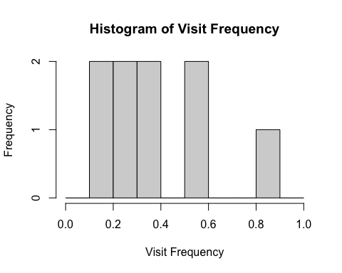

hist(  
 df_hosp$BloodPressure,  
 breaks = 8,  
 xlab = "Blood Pressure",  
 main = "Histogram of Blood Pressure"  
)

