A “Soft Register” for the Carillon

An entry by Keiran Cantilina for Hack The Bells 2018

# Bio

Keiran Cantilina holds a B.S. in Biological Sciences from Cornell University (with a minor in Music) and an M.S. in Bioproducts and Biosystems Engineering (conc. Bioinstrumentation) from the University of Minnesota. His interest in bells began at Cornell in 2012, where he successfully auditioned to play the 21-bell chime housed in the university clock tower. His passion for bells continued through his graduate studies at the University of Minnesota, and he studied carillon with Dave Johnson on the House of Hope Church 49-bell instrument in St. Paul, Minnesota. Currently, Keiran is a student at the Royal Carillon Academy “Jef Denyn” in Mechelen, Belgium. A recipient of the Belgian-American Education Foundation Fellowship for Research for the academic year 2018-2019, he is studying both carillon performance and the sociological aspects of Belgian and Dutch carillon culture. In his free time, Keiran enjoys tinkering, building silly contraptions, and of course sampling the wide variety of beers and cheeses available in Europe.

More about me: [CV](https://github.com/KeiranCantilina/ResumeAndPortfolio/blob/master/Keiran%20Cantilina%20CV%202018_compressed.pdf) and [project portfolio](https://github.com/KeiranCantilina/ResumeAndPortfolio/blob/master/Project%20Portfolio.pdf)

My GitHub repositories (projects, code, engineering drawings, etc.): <https://github.com/KeiranCantilina>

# Category

This Hack the Bells entry is for the “Hack the Bells Prize” category of the 2018 contest.

# Project Description

## Introduction

Given its grand size, superior listening range, and the unique beauty of its sound, the carillon is arguably the king of instruments. With its origin in the 16th to 17th centuries the carillon predates even the piano, and among keyboards frequently played today the carillon is preceded in history only by the pipe organ and the harpsichord. However, unlike the piano and pipe organ, the design of the modern carillon is substantially similar to a carillon one might find in the 1700s. With the exception of incremental refinements in tuning (which serve to ease the ear of the listener) and modernizations of the transmission design (which serve to ease the arm of the carillonist), the modern carillon has experienced few changes over the last 300 years. Perhaps the time is ripe to try something new!

This entry proposes the temporary installation of a prototype “soft register” for the middle two diatonic octaves of the carillon [PUT SCOPE HERE], along with a performance by a skilled carillonist to demonstrate its expressive potential. Similar to the way in which the sustain pedal of a piano enables enhanced timbral and textural control of expression, a soft register or pedal for the carillon would open up a new world of expressive possibilities. It is well known to British change-ringers that the introduction of a leather pad between the clapper and the bell changes both the volume and character of the bell sound, and this effect is used in ringing muffled and half-muffled peals ([example](https://www.youtube.com/watch?v=EJSyZkZ_nQ0)). For carillon bells, the same muffling principle holds true. However, given the different musical nature of the carillon, it would of course be necessary to have both less-severe muffling ([like this](https://soundcloud.com/keiran-cantilina/f1-bell-muffled-comparison)) and the ability to muffle or un-muffle the bells without having to climb into the belfry and move leather strips around the clappers by hand. An electro-mechanical mechanism to accomplish this control has been devised which enables a carillonist to muffle or un-muffle the bells with the press of a button, similar to how an organist might press a piston to change registration.

## Design

The constraints for this design were the following:

* The mechanism must succeed at effectively and quickly placing and removing a leather pad in between the clapper and the bell.
* The mechanism must not interfere in any way with the existing structure or transmission mechanism of the carillon.
* The mechanism must be able to be installed temporarily and be able to be removed as quickly as possible with no impact left on the existing structure or transmission of the carillon.
* The mechanism must be inexpensive to implement.
* The mechanism must be easy to use for the carillonist.
* The mechanism must not be hazardous when operational.
* The mechanism must not consume unreasonable amounts of power.

To this end, the following mechanism was designed. (A full-size version of this drawing can be found at the end of the document, or by following [this link](https://github.com/KeiranCantilina/Carillon-Soft-Register/blob/master/CarillonSoftRegister_drawing_pdf.pdf))

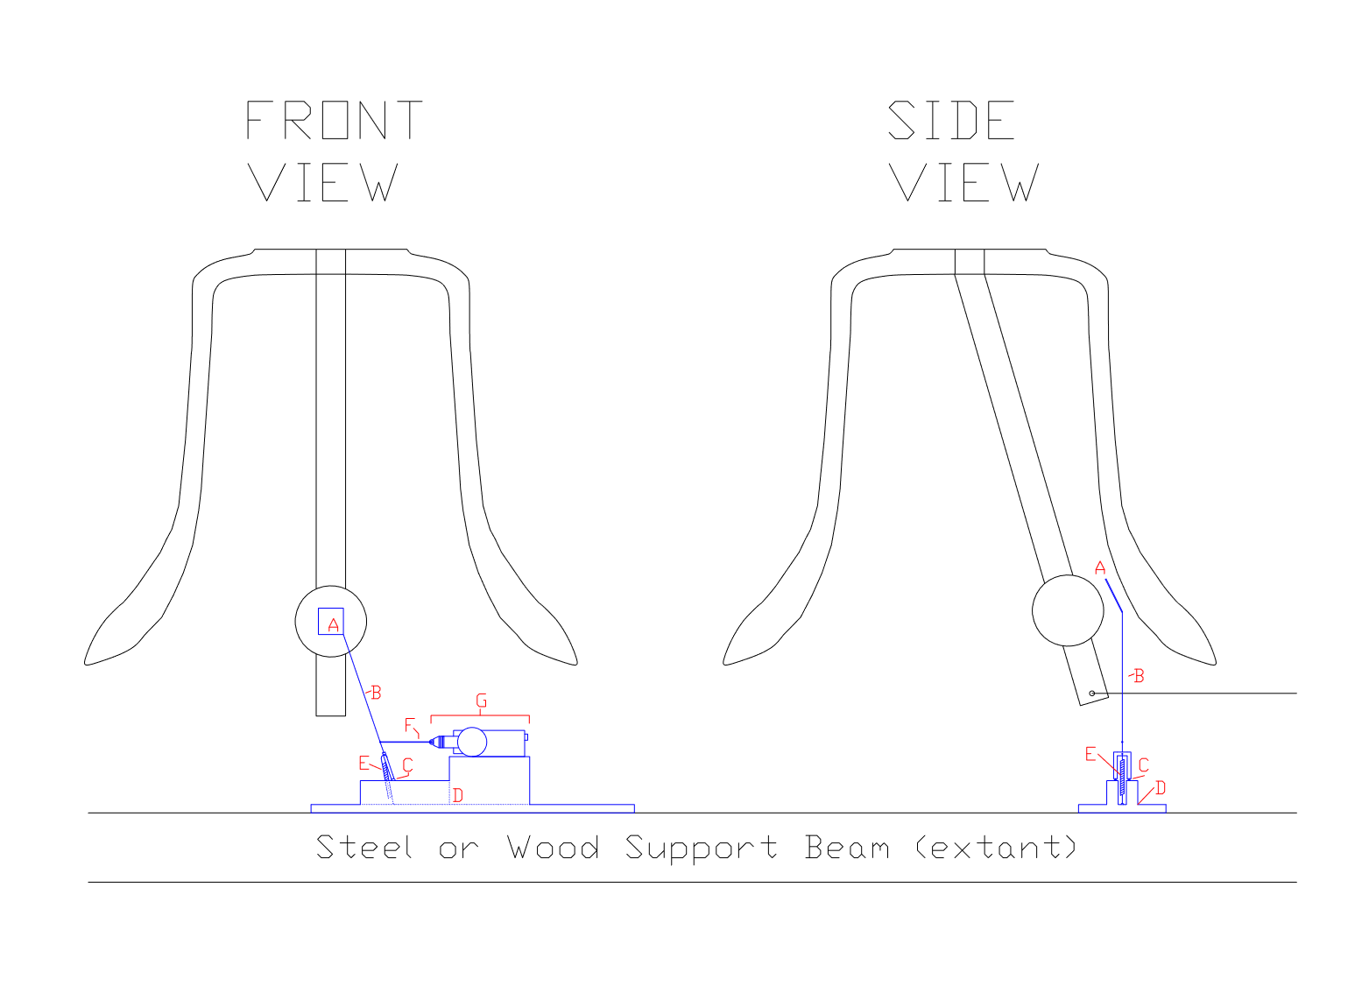

### Formal Description

The design consists of an electrically actuated bistable double-toggle mechanism based on a switching mechanism described by Deb, et al. (2013). A leather pad [A] is mounted at an angle on the end of an arm [B] which bifurcates before ending in hinges [C] at a raised part of the base [D] of the mechanism. The design of the hinge constrains the motion of the arm to a single axis of rotation. The bistable nature of the device is implemented using a tension spring [E] attached at one end to the point of bifurcation on the arm and attached on the other end to a point beneath the hinges. The mechanism is actuated between its bistable states by a rod [F] attached to the electromechanical actuator [G]. The limit of travel of the actuator can serve as the limit of travel for the motion of the arm, or a block can be added (with a slide added to the actuating rod) to limit the travel of the arm.

### Informal Description

The pad for muffling the bell [A] is attached (at an angle, to match the angle of the soundbow of the bell) to an arm [B] which can swing back and forth to move the pad in and out from between the clapper and the bell. The arm is moved by a rod [F] attached to a linear electric motor [G]. The design uses the spring [E] that pulls on the rod to make the arm stay in either the off or on position without requiring power to stay in that position (power is only required to change between positions).

A video of a mock-up of the mechanism operating can be found here: [clickable link](https://vimeo.com/283774080)

A recording of a single carillon bell played without and with a leather pad can be found here: [clickable link](https://soundcloud.com/keiran-cantilina/f1-bell-muffled-comparison)

## Proposed Implementation Method

For ease of assembly and low cost, it was determined that the best way to implement a temporary prototype of the mechanism is to use parts obtainable in a typical neighborhood hardware store or auto parts store. Cheap wood will be used for most structural components (base and hinge body), and heavy wire will be used for the arm, moving part of the hinge, and the actuator rod. The spring will be implemented with an elastic rubber band. The electronic actuator will be implemented using 12-volt automobile door lock actuators (EUR 2.89 on Amazon.de) powered by a car battery, with 2 simple 12-volt momentary button switches used to activate the mechanism (one button for extension, one button for retraction). Each button is wired to two heavy-duty automotive SPST relays such that the assembly of two buttons and four relays forms an H-bridge. Thus, the polarity of the power applied to the actuators with one button is the reverse of the polarity applied to the actuators when the other button is pressed (ie. the muffling pads move forward when one button is pressed and move back when the other button is pressed). Heavy-duty duct tape will be used to attached the two buttons to the keyboard, and duct tape will also be used to fasten the mechanism temporarily to the support structure of the carillon.

Below is a proposed wiring diagram. (A full-size version of this drawing can be found at the end of the document, or by following [this link](https://github.com/KeiranCantilina/Carillon-Soft-Register/blob/master/CarillonSoftRegister_wiring%20diagram.png))

An estimated bill of materials and budget can be found in the following section.

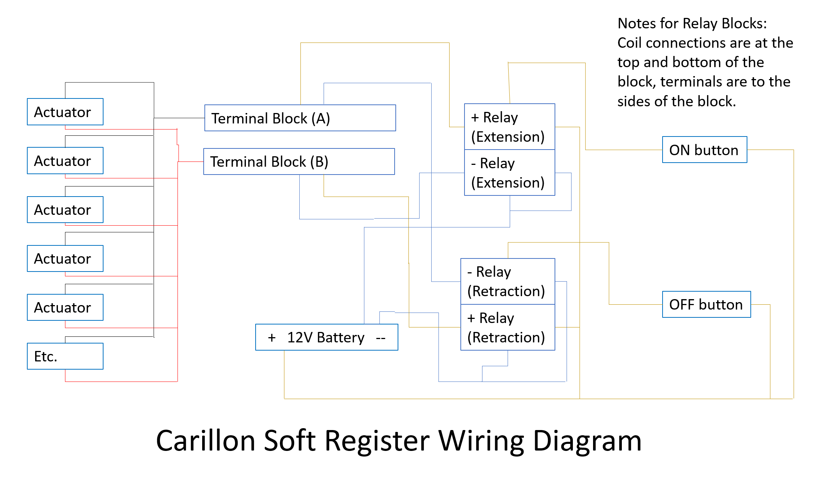

# Project Budget and Bill of Materials

|  |  |  |  |  |
| --- | --- | --- | --- | --- |
| **Item** | **Quantity** | **Price/each** | **Net price** | **Source** |
| Hobby wire 25mx1.25mm (rolls) | 4 | 3.99 | 15.96 | GAMMA |
| Wood stock 4x9mmx270cm | 20 | 1.69 | 33.8 | GAMMA |
| Wood stock 19x100mmx270cm (5 pieces) | 2 | 18.2 | 36.4 | GAMMA |
| Automobile door lock actuator (Pack of 4) | 6 | 11.59 | 69.54 | Amazon.de |
| Duct tape (rolls) | 3 | 12.99 | 38.97 | GAMMA |
| Construction Nails (package of 200) | 2 | 8.79 | 17.58 | GAMMA |
| Elastic bands (package of 100) | 1 | 5 | 5 | HEMA |
| 14 awg wire 2.0mm sq paired (30m roll) | 2 | 19.04 | 38.08 | Amazon.de |
| Car battery 12V 71Ah | 1 | 99 | 99 | GAMMA |
| Car battery charger 12V 3.5A | 1 | 64.99 | 64.99 | GAMMA |
| 12V 500A automotive start relay | 4 | 18.98 | 75.92 | Amazon.de |
| Industrial foot switch | 2 | 13.99 | 27.98 | Amazon.de |
| Momentary button switch | 2 | 1.99 | 3.98 | Amazon.de |
| Wire nuts (50 piece package) | 2 | 6.69 | 13.38 | GAMMA |
| Claw Hammer | 2 | 10 | 20 | GAMMA |
| Hand saw | 1 | 20 | 20 | GAMMA |
| Hot glue gun | 1 | 17.99 | 17.99 | GAMMA |
| Hot glue sticks (bag, 24 pieces) | 2 | 4.19 | 8.38 | GAMMA |
| **TOTAL** |  |  | **606.95** |  |

# Files and Figures

Figure 1 ([link](https://github.com/KeiranCantilina/Carillon-Soft-Register/blob/master/CarillonSoftRegister_drawing_pdf.pdf)): CAD drawing of the proposed muffling mechanism.

Figure 2 ([link](https://github.com/KeiranCantilina/Carillon-Soft-Register/blob/master/CarillonSoftRegister_wiring%20diagram.png)): Wiring diagram for the electrical system of the proposed installation.

File 1 ([link](https://soundcloud.com/keiran-cantilina/f1-bell-muffled-comparison)): A recording of a carillon bell played normally, followed by a recording of the same bell played with a leather pad on the clapper.

File 2 ([link](https://vimeo.com/283774080)): A short video of a mock-up demonstrating the design of the muffling mechanism.

# Citations and Sources

1. Deb, M., & Sen, D. (2014). Design of double toggle switching mechanisms. *Mechanism and Machine Theory*, *71*, 163–190. <https://doi.org/10.1016/J.MECHMACHTHEORY.2013.09.010>
2. GCNA (2012). Carillon History. *Website of the Guild of Carilloneurs in North America.* <https://www.gcna.org/carillon-history.html>
3. Users “03125” & “GACJ” (2011). Muffling Bells. *Changeringing Wiki*. <http://wiki.changeringing.co.uk/Muffling_Bells>
4. User “maidstone10” (2012). All Saints Maidstone - The 10 bells ring out half-muffled for the fallen. *YouTube.* <https://www.youtube.com/watch?v=EJSyZkZ_nQ0>