# Proposal for the Design and Implementation of a Remote Alarm for the Thermo Locator Plus

Table of Contents

Proposal for the Design and Implementation of a Remote Alarm for the Thermo Locator Plus 1

Summary 1

In-Depth Device Description and Operational Description 1

Program Diagram 3

Data Flow Diagram 4

Electrical Diagram 5

Failure Risk Analysis 6

Estimated Bill of Materials and Labor 7

## Summary

A device will be designed and constructed by Keiran Cantilina that will connect to the remote alarm interface of the Thermo Locator Plus owned by the Burberry Lab. The device will detect when the Thermo Locator Plus is in an alarm state and send notification emails from a Gmail account created for this purpose. Notifications can be forwarded by the configured recipient to other email address or to mobile phones by forwarding the email as an SMS message. The device will be capable of connecting to Case campus WiFi, and it will be configurable using a webpage accessed by wirelessly connecting to the device.

Reliability of the device will mostly be dependent on the infrastructure supporting it. The preliminary hardware and software design of the device has been made as simply as possible to provide the least number of potential failure points. For more details, please see the Failure Risk Analysis section.

The device will be designed and built over a period of less than a month. The cost of the finished device will be $298.42, and includes both component/material costs and also design and construction labor estimated at $25/hour. For an estimate bill of materials and estimated hours upon which the price of the device is based, please see the BOM and Labor section.

## In-Depth Device Description and Operational Description

The core of the device consists of an ESP-12E development board. This board features an ESP8266 microcontroller with integrated WiFi, along with the peripheral components needed to program and power the microcontroller using a USB connection. The ESP8266 has multiple digital input/output (DIO) ports which are each capable of detecting and generating 3.3V signals. The integrated WiFi capabilities enable the ESP8266 to either connect to an access point or produce a wireless access point itself, through which information can be transmitted.

The ESP8266 will be programmed to first act as a wireless access point when turned on for the first time. Any device that connects to that access point will be automatically taken to a webpage with a form that allows configuration of the remote alarm. Once configuration information (such as the campus WiFi network name and password, SMTP server information, and alarm recipient email addresses) has been entered, the remote alarm will turn off its own access point and instead attempt to connect to the WiFi network specified during configuration. If successful, it will then try to contact the Google SMTP servers through the email credentials it was given.

If that process is in turn successful, the remote alarm commences monitoring of the Thermo Locator Plus. If any of these connection steps fails, the remote alarm reverts to producing its own configuration access point again. If no device connects to this access point after 2 minutes, the remote alarm reboots and attempts to connect using its stored configuration again. This process loops indefinitely until the device is able to connect.

The ESP8266 will be connected to the remote alarm interface of the Thermo Locator Plus. This interface consists of an optically-triggered switch that, though part of the Thermo Locator’s main circuit board, is electrically isolated from the rest of the device. When the Thermo Locator Plus is in an alarm state, the switch closes, which electrically connects the two pins of the remote alarm interface.

In order to detect the closing of this switch, the ESP8266 will constantly be probing one side of the switch by holding it at 3.3 volts. The other side of the switch (which is normally at 0 volts) will be connected to one of the DIO ports of the ESP8266. As soon as the switch closes, that DIO port will see its side of the switch rise to 3.3V, indicating an alarm state.

The remote alarm will then send an email with the alarm state and a timestamp to the recipient email address specified during configuration. The recipient email address can be configured to forward emails from the remote alarm to other email addresses. SMS messages can be sent by sending emails; for example, a text message can be sent to a Verizon number by emailing [number]@vtext.com.

The electronics of the remote alarm will be installed inside of a custom designed 3D-printed enclosure. This enclosure will be printed out of enhanced-strength PLA.

## Program Diagram

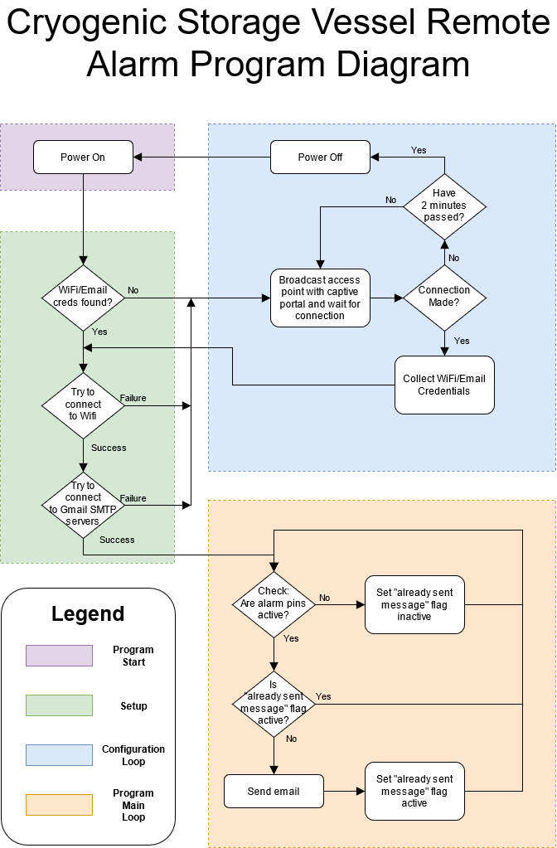

## Data Flow DiagramC:\Users\cantilk\Downloads\LN2 Alarm Data Diagram.png

## Electrical Diagram

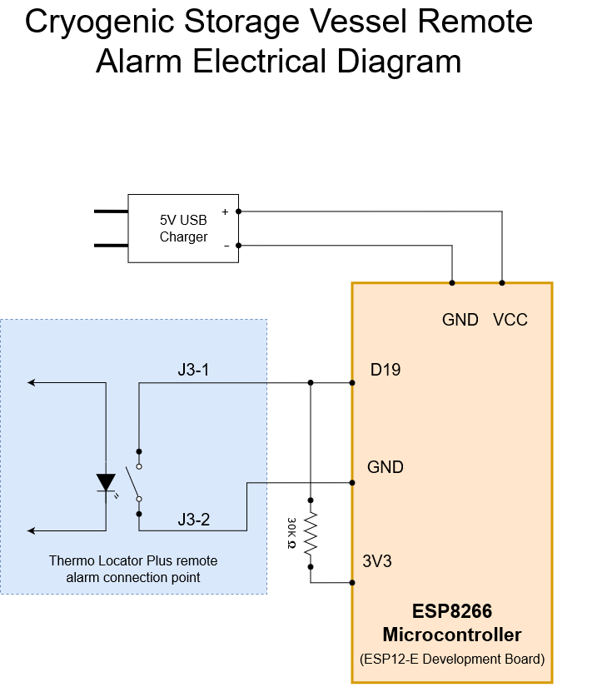

## Failure Risk Analysis

|  |  |  |  |
| --- | --- | --- | --- |
| **Risk Source** | **Probability** | **Impact** | **Description** |
| Local power outage | Medium-high | Low | Device would cease to work while power is off, but would resume functioning after local power is restored under backup power |
| Thermo Locator Plus fails | Low | High | Device would be unable to detect an alarm state if the Thermo Locator Plus stops working correctly |
| Case Campus WiFi fails | Medium | Medium | Device would cease to work while wifi is down, but would resume functioning after wifi is restored. |
| ESP8266 microcontroller fails | Very Low | High | Device would be permanently inoperable |
| USB charger module fails | Low | High | Device would cease to work until USB charger is replaced |
| Gmail SMTP servers go down | Low | Medium | Device would be unable to send alarm emails and SMS messages. During past failures, Gmail SMTP servers have gone back online in less than 2.5 hours. |
| Device becomes detached from Thermo Locator | Medium | Low | Device would not be useful while detached from Thermo Locator, but this condition would be obvious to an operator. |

## Estimated Bill of Materials and Labor

Materials

|  |  |  |
| --- | --- | --- |
| **Item** | **Quantity** | **Cost** |
| ESP-12E Board | 1 | $ 4.67 |
| 2.1A USB Charger | 1 | $ 8.99 |
| 100g eSUN PLA+ 1.75mm filament | 1 | $ 2.30 |
| Misc screws, fasteners, solder, wire | 1 | $ 10.00 |
| 5ft Micro USB charging cable | 1 | $ 8.00 |
| Cable management sleeve | 1 | $ 9.00 |
| **SUBTOTAL** |  | **$ 42.96** |

Labor

|  |  |  |
| --- | --- | --- |
| **Task** | **Est. Time (hrs)** | **Cost** |
| Electrical design | 0.5 | $ 12.50 |
| Mechanical design | 1.5 | $ 37.50 |
| Software design | 2 | $ 50.00 |
| Software implementation | 1.5 | $ 37.50 |
| Electrical assembly | 0.5 | $ 12.50 |
| Mechanical assembly | 0.5 | $ 12.50 |
| Testing and debugging | 1 | $ 25.00 |
| Documentation | 1 | $ 25.00 |
| **SUBTOTAL** | **8.5** | **$ 212.50** |

**TOTAL: $ 298.42**