Keith Lemuel M. Barcinas April 27,2022  
BSIS 4B Ms. Mary Rose Columbres

**Midterm Case Study**

**Guide Questions:**

1. What is the principal competitive strategy of Molson Breweries?  
     
    The principal competitive strategy of Molson Breweries is to become the domestic low provider of beer, by effectively predicting the needs of the market by use of information systems, building an efficient supply chain with their partners and suppliers to meet those demands, and relaying information with their plants, partners, suppliers, and offices.
2. What are the principal competitive forces Molson has to contend with?  
      
    The beer industry in Canada is also open for US brewers and due to NAFTA, the market became wider and US brewers were able to introduce discounted prices as a strategy to increase their own market share. Molson has also shared that one of their problems was putting too much effort competing on time-limited events like Christmas, where they tried to meet forecasts instead of concentrating on actual demand signals from their business partners.
3. What capabilities of information systems does Molson exploit in pursuit of its competitive objective?  
      
    The capabilities of information systems are that it can store, process, and analyze, and share data relatively quick. Molson uses this to their advantage to have a reliable read on the market needs, and the info they get will be shared to their suppliers and business partners, so that the procurement of raw materials will be sufficient to what they will need, and the production of their product supply will definitely meet the demand on the market.
4. 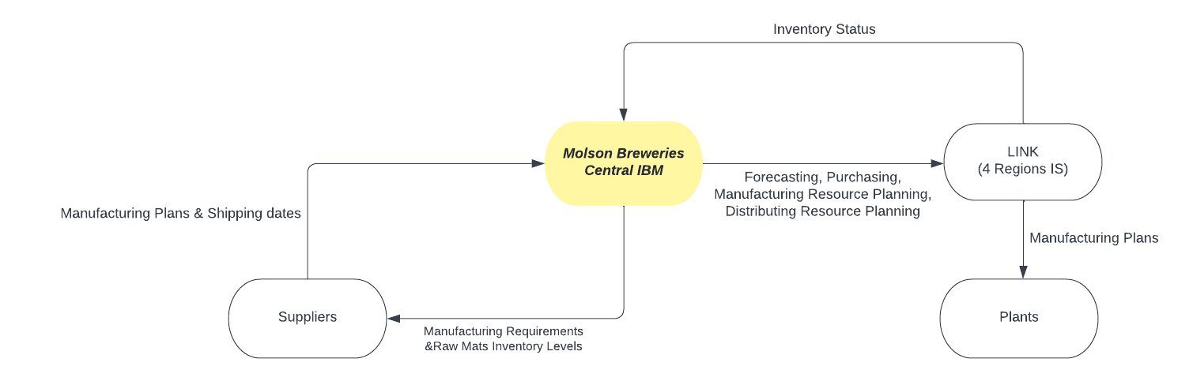Sketch out the information system network of Molson, including its business partners.
5. How can you evaluate the nature of information technologies deployed by Molson? Is it the leading-edge technology?  
     
    The nature of information technologies deployed by Molson is effective. It has effectively and efficiently made possible the principal objective of Molson, which was to become the domestic low provider of beer, without rush production and quality severance.
6. Sketch out Molson’s value chain and the supply chain that Molson Breweries is part of.

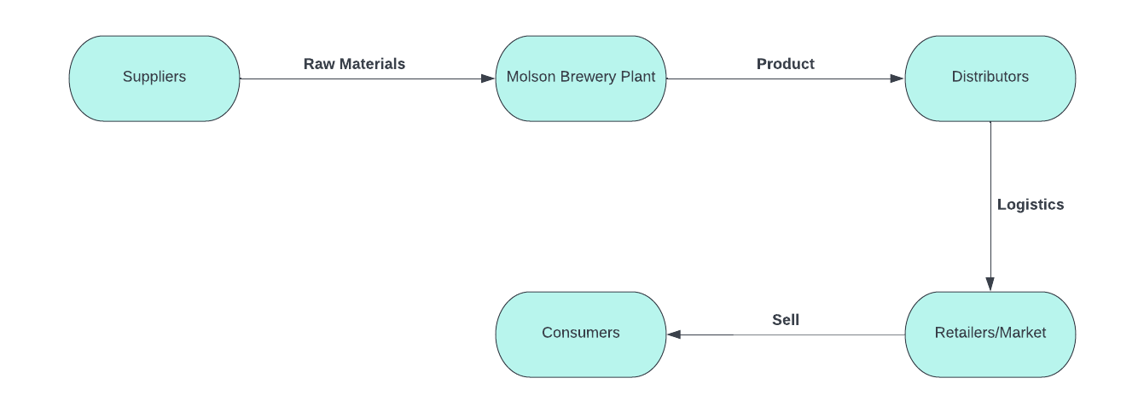  
**Supply Chain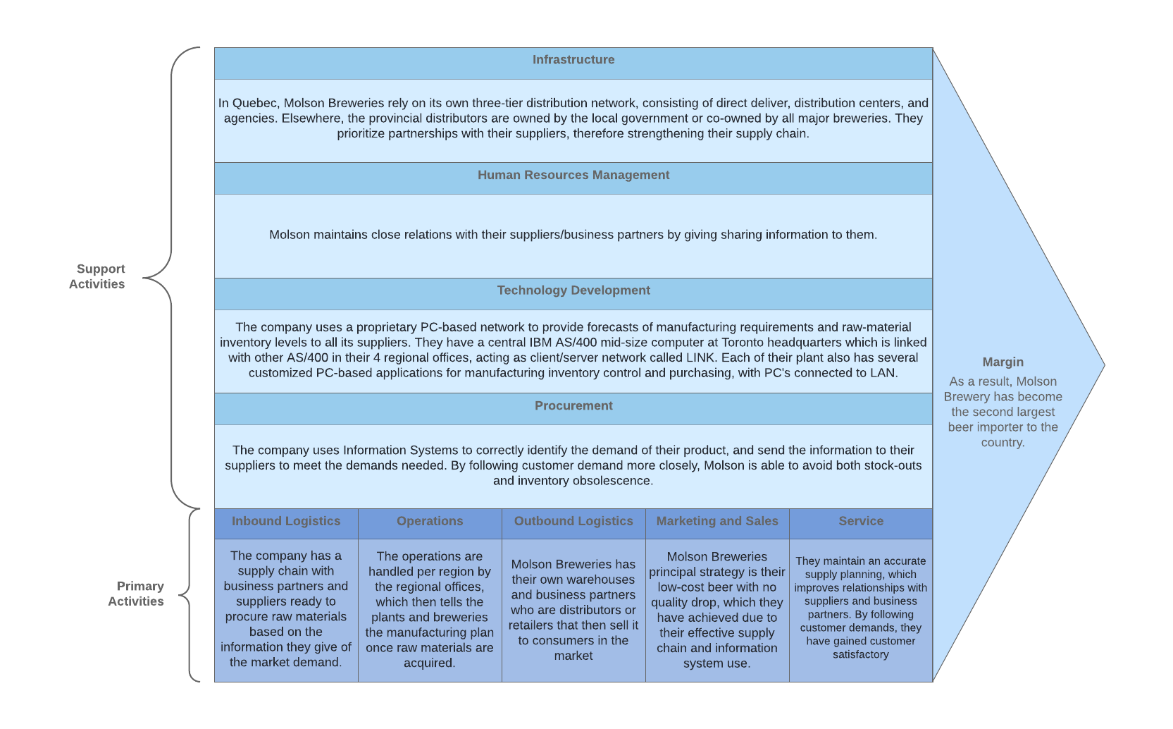Value Chain**

1. What is the principal reason for Molson’s success in achieving its competitive results with information systems?  
     
    Their heavy investments on information technologies have paid off. They used the information to build partnerships withing their supply chain, and with the use of information systems, were able to meet the supply and demand of their product in different locations, effectively dropping their cost production because they avoided both stock outs and inventory obsolescence.