|  |  |  |
| --- | --- | --- |
| Fall 2023 | CS5368 Intelligent Systems | Project 0 Report |

|  |  |
| --- | --- |
| First Name | KanvaKoushik |
| Last Name | Gopavarapu |
| Student ID | R11849414 |

Please answer the following questions and submit them through Blackboard. Be sure to submit it to Project 0 report submission. DO NOT write the report by hand and submit a scanned version. Just write the answers in word document and submit it. Both word and PDF submission are accepted.

1. What did Problem 1 ask for? How did you implement it?
2. Problem 1 asked for the code to return the summation of 2 numbers. I have implemented the following code print("Passed a=%s and b=%s, returning a+b=%s" % (a, b, a + b)) return a + b which returns the summation of 2 numbers. The output is as follows,

*Fig.1 Question 1 Implementation Output.*

1. What did Problem 2 ask for? How did you implement it?
2. Problem 2 asked to put up a list of fruits and their cost and to print the cost or the error if the fruit is not in the list respectively by not changing the fruit price variable. Implementation of the following code

*Fig.2 Question 2 Implementation code.*

The output for the implemented code is as follows giving us the name of the fruit along with it’s price and printing 0.0 if the fruit is not present.

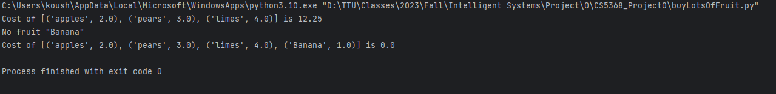

*Fig.2 Question 2 Implemented output.*

1. What did Problem 3 ask for? How did you implement it?
2. Problem 3 asked to create a list of fruits and return the whole order cost in total within 2 shops. By implementing the code below, the output comes as the fruit along with its price and the best shop to buy for that particular order cand its cost.

*Fig.3 Question 3 Implemented code.*

*Fig.4 Question 3 Implemented output.*

1. What happens when you run the following codes?

***python autograder.py -q q3***

*Fig.5 Python autograder-q3.*

***python autograder.py -t test_cases/q3/select_shop1***

**

*Fig.6 Python autograder.py – t test_cases/q3/select shop1*