1.VS

<https://code.visualstudio.com/>

2. Coding Pack for Java

<https://code.visualstudio.com/docs/languages/java>

3.JDK

<https://www.oracle.com/java/technologies/javase/jdk20-archive-downloads.html>

4.

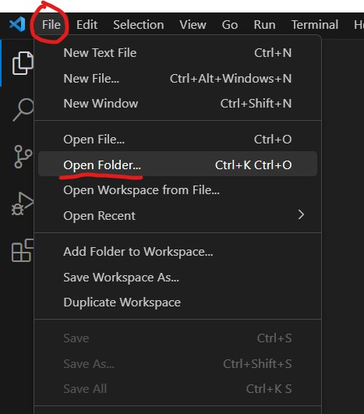

5.

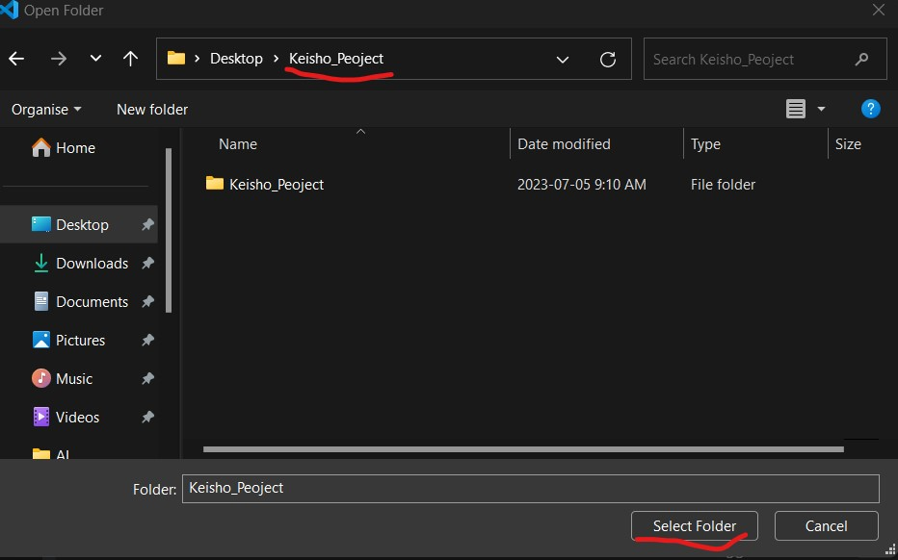

6.

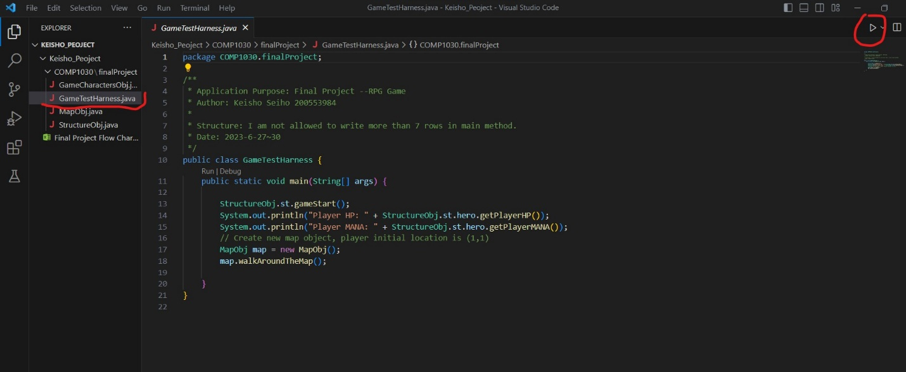

7.

