
Figure 1 UZ Logo
Topic: LifecycleIQ
Client Solutions Management System using a Weighted Factor Analysis (WFA) Algorithm and AI Briefings

by

PENIA MASEKO – R231693G

Proposal submitted for review for the

HSE

in the Faculty of Computer Engineering Informatics and Communications

at the University of Zimbabwe

Supervisor: MS KHUMALO

Date:

System Logo Briefing

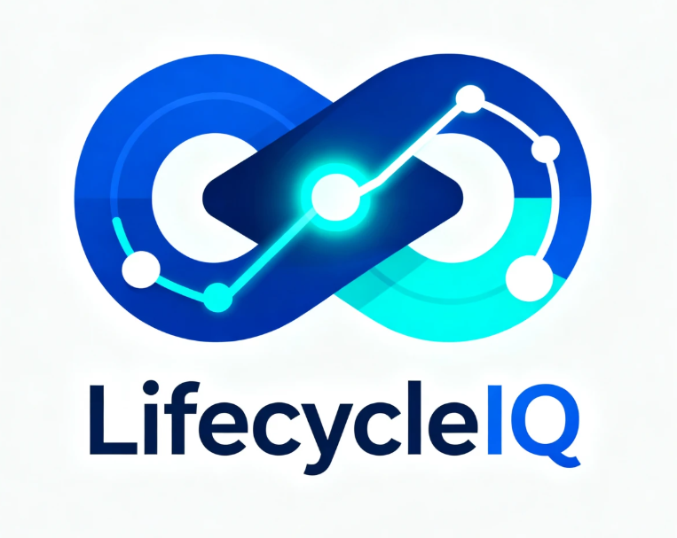
The LifecycleIQ logo is a minimalist design that serves as a visual metaphor for our enterprise software platform. It features two primary components:
- The Infinity Loop: Represents the continuous monitoring and seamless end-to-end management of the client solution lifecycle.
- The Central Graph Node: Symbolizes the “IQ” or intelligent core of the platform, highlighting the focus on data-driven insights and smart analytics.
- Professional Palette: The use of deep tech blue and electric cyan conveys a balance of trust and futuristic innovation, positioning the system as a sophisticated, professional B2B SaaS solution.
In brief, the logo communicates that LifecycleIQ is a modern, intelligent hub for managing every stage of a software solution’s lifecycle through continuous, data-backed monitoring.

Declaration

Approval

Acknowledgements

I would like to express my sincere gratitude to all individuals who have contributed to the development of LifecycleIQ. The progress achieved in this project is a direct result of the guidance, support, and collaboration received throughout its lifecycle.
First and foremost, I extend my deepest appreciation to my academic supervisors, Eng Matsiya, Ms Khumalo, and Eng Zvakafa from the University of Zimbabwe (UZ), for their invaluable guidance, constructive feedback, and continuous encouragement. Your expertise and academic insight have been instrumental in shaping both the research direction and technical implementation of this project.
I would also like to thank the stakeholders within the host organisation: Imaging Solutions, for their support and for providing practical insights into real-world enterprise solution management challenges. Your input was instrumental in identifying real-world problems and ensuring that LifecycleIQ is both relevant and applicable in an enterprise environment.
Special appreciation is extended to peers and colleagues who offered feedback, participated in discussions, and contributed to the refinement of ideas throughout the project. Your input has been valuable in strengthening the overall quality of this work.
Finally, I acknowledge the ongoing support of all mentors and contributors whose knowledge and experience continue to guide and support the successful development of LifecycleIQ. I remain committed to further enhancing the system into a robust and impactful solution for enterprise lifecycle management.

Abstract or Executive Summary
Effective, data-driven solutions are required in modern enterprise environments to improve visibility, reduce operational risk, and streamline the management of client software solutions. LifecycleIQ is designed to address these needs by providing a centralized platform for managing the lifecycle of client-deployed solutions, including licence tracking, version control, SLA compliance, and maintenance activities. The system represents a significant advancement in enterprise solution management by intelligently consolidating fragmented data sources into a single, actionable view.
At its core, LifecycleIQ addresses one of the most persistent challenges faced by technology delivery organisations: the lack of structured, proactive lifecycle management. The system introduces the Weighted Factor Algorithm (WFA), which computes a Solution Health Index (SHI) by combining multiple risk indicators such as licence urgency, version gap, SLA compliance, and maintenance recency. This enables organisations to move beyond reactive, calendar-based management toward a predictive, prioritised approach. By ranking solutions according to risk exposure, LifecycleIQ eliminates inefficiencies associated with manual tracking and scattered documentation, allowing administrators to focus on high-impact interventions. The platform further enhances operational efficiency through automated alerts and AI-generated maintenance briefings, ensuring timely and informed decision-making.
The system is implemented using modern web technologies including JavaScript, HTML, and CSS, with React for the front-end and Node.js with Express for the backend. MongoDB is utilised as the NoSQL database to manage flexible and scalable data structures, while tools such as Postman support API testing and validation. These technologies were selected for their scalability, flexibility, and compatibility with the system’s requirements.
Ultimately, LifecycleIQ improves operational efficiency, enhances decision-making, and reduces the risk of service disruptions across client solution portfolios. It provides organisations with a structured, intelligent approach to lifecycle management, enabling better resource allocation and improved service delivery outcomes.
Looking ahead, LifecycleIQ offers opportunities for further innovation, including predictive risk modelling, advanced analytics, and deeper AI integration for automated insights. The system demonstrates how intelligent lifecycle management can transform enterprise solution delivery, positioning LifecycleIQ as a forward-looking tool in modern IT operations.

Table of Contents
System Logo Briefing 2
Declaration 3
Approval 4
Acknowledgements 5
Abstract or Executive Summary 6
Table of Contents 7
List of Figures 9
List of Tables 10
List of Symbols and Abbreviations 11
List of Appendices 12
CHAPTER 1 12
Project Overview 13
1.1 Introduction 13
1.2 Background Study 13
1.3 Literature Review 15
1.4 Problem Definition 15
1.5 Aims, Objectives and Research Questions 17
1.5.1 Aim 17
1.5.2 Objectives 18
1.5.3 Research Questions 18
1.6 Methods and Instruments 18
1.6.1 Research Design 18
1.6.2 WFA Algorithm Development 18
1.6.3 AI Briefing Module Design and Implementation 19
1.6.4 System Development Stack 20
1.6.5 Data Collection Instruments 20
1.7 Expected Results and Significance of the Project 20
1.7.1 Expected Results 20
1.7.2 Significance 21
1.8 Feasibility Study 21
1.8.1 Economic Feasibility 22
1.8.2 Social Feasibility 22
1.8.3 Operational Feasibility 22
1.8.4 Technical Feasibility 22
1.9 Ethics Consideration 23
1.10 Delimitations and Limitations of the Research 24
1.10.1 Delimitations 24
1.10.1.1 Technical Constraints 24
1.10.1.2 Resource Constraints 24
1.10.1.3 Operational Constraints 24
1.10.2 Limitations 24
1.10.2.1 Technical Constraints 24
1.10.2.2 Resource Constraints 25
1.10.2.3 Operational Constraints 25
1.11 Significance and Motivation for the Project 25
1.11.1 Signifiance 25
1.11.2 Motivation 26
1.12 Budget and Timelines 26
1.12.1 Timelines 26
1.12.2 Budget 26
1.13 Conclusion 26
CHAPTER 2 28
Literature Review 28
2.1 Introduction 28
2.2 Review of Relevant Literature 28
2.2.2 Fragmented Tooling and Operational Maturity 29
2.3 Discussion of similar projects or systems 30
2.3.1 ServiceNow ITAM 30
2.3.2Flexera Software Asset Management 31
2.3.3 Jira Management and Confluence 31
2.3.4 Freshservice IT Service Management 32
2.3.5 Comparative Summary 32
2.4 Identification of gaps or areas for improvement 33
2.5 Conclusion 35
CHAPTER 3 Methodology 36
3.1 Introduction 36
3.2 Research Methodology 36
3.2.1 Overall Approach 36
3.2.2 Software Development Process: Agile (Scrum) 37
3.2.3 Mapping of DSR and Agile to Project Phases 37
3.2.4 Sprint Structure 38
3.3 Methods and Techniques 39
3.3.1 Exploring Methods and Techniques 39
3.3.2 Weighted Factor Analysis Algorithm Development 39
3.3.3 AI Briefing Module Implementation Method 40
3.4 Tools and technologies 41
3.4.1.1 Technology Stack Overview 41
3.4.1.2 Justification for the Technology Choices 42
3.4.2 Development and Testing Tools 44
3.5 Project requirements and design considerations 44
3.5.1 Requirements Gathering Process 44
3.5.2 Functional Requirements Summary 45
3.5.3 Non-Functional Requirements Summary 46
3.6 Conclusion 48
CHAPTER 4 49
Analysis and Design 49
4.1 Introduction 49
4.2 Problem Domain and User Requirements Analysis 49
4.2.1 Functional Requirements 50
4.2.2 Non-functional Requirements 50
4.3 Identification of system components and functionalities 50
4.3.1 Use-Case diagram/s 50
4.4 System Architecture and Design Considerations 50
4.4.1 Context Diagram and DFD Diagram 50
4.4.2 Architectural Design 50
4.4.3 Physical Design 50
4.4.4 Database Design 50
4.4.5 Interface design 50
4.4.5.1 Menu Design 50
4.4.5.2 Input Design 50
4.4.5.3 Output Design 51
4.4.6 Security design (If applicable) 51
4.4.6.1 Physical Security 4.4.6.2 Network Security 51
4.4.6.3 Operational Security 51
4.5 Conclusion 51
CHAPTER 5 51
5 Results 51
CHAPTER 6 52
6 Discussion 52
7 Conclusion and Future work 54
Appendix A: Templates of data collection tools 57
Appendix B User manual of the working system 57
Appendix C: Source Code 57
Appendix D: etc 57

List of Figures

List of Tables

List of Symbols and Abbreviations

UZ | University of Zimbabwe
SLA | Service Level Agreement
WFA | Weighted Factor Analysis
LLM | Large Language Model
SHI | Solution Health Index
ERP | Enterprise Resource Planning
API | Application Programming Interface
SMEs | Small and Medium Sized Enterprises
NLG | Natural Language Generation
AHP | Analytic Hierarchy Process
REST | Representational State Transfer

List of Appendices

CHAPTER 1

Project Overview

1.1 Introduction
Enterprise software development organisations operate within complex environments where multiple client solutions are developed, deployed, and maintained concurrently. These solutions differ in terms of software versions, infrastructure configurations, licensing models, client-specific contact personnel, and service-level agreements (SLAs). As the scale and complexity of these deployments increase, the need for structured and centralised systems to manage solution-related information becomes critical.
This proposal presents the development of LifecycleIQ: a centralized client solution lifecycle management platform underpinned by a Weighted Factor Analysis (WFA) Algorithm. The WFA algorithm introduces a mathematical, decision-support layer that transforms raw operational data into prioritised, actionable insights by computing a Solution Health Index (SHI) for each managed client solution. A key innovation of LifecycleIQ is the integration of an AI-Powered Maintenance Briefing module that uses a Large Language Model (LLM) API to convert each solution's SHI score and factor breakdown into a plain-English maintenance briefing bridging the gap between algorithmic output and human decision-making.

1.2 Background Study
In typical enterprise software environments, client solution data encompassing configuration parameters, licence details, and project sign-offs is frequently distributed across spreadsheets and isolated, siloed tools. This fragmented approach introduces data inconsistencies and severely limits traceability throughout the solution lifecycle.
Existing systems largely adopt reactive postures: administrators are only alerted to critical failures such as licence expiry or version incompatibilities after they have already materialised. The absence of an algorithmic, predictive framework means that risk is identified too late for preventive action.
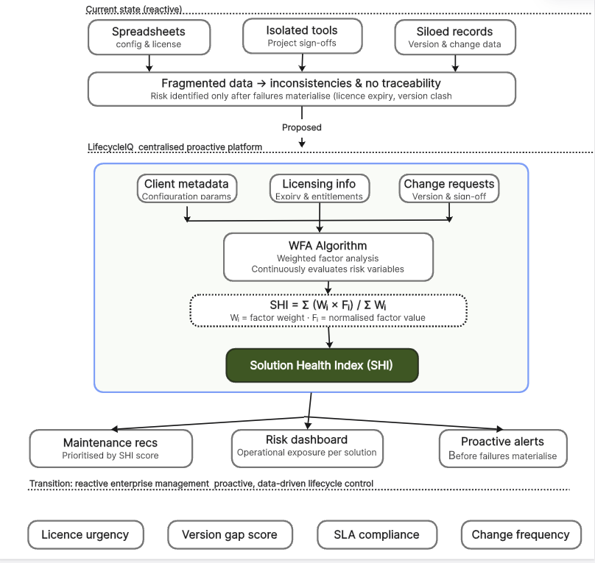
Figure 2 Background Study Illustration
LifecycleIQ addresses these challenges by consolidating client solution metadata, licensing information, and change requests into a single platform. The embedded WFA Algorithm continuously evaluates weighted risk variables to generate a Solution Health Index, transitioning enterprise management from reactive to proactive. The AI Briefing Module then takes each computed SHI and translates it into a clear, actionable maintenance recommendation written in natural language making the algorithmic output accessible not just to technical administrators but to any stakeholder involved in solution oversight.
The WFA Formula SHI = Σ (Wᵢ × Fᵢ) / Σ Wᵢ
Where Wᵢ represents the assigned weight of factor i (for example: licence urgency, version gap score, SLA compliance) and Fᵢ represents the normalised value of that factor for a given solution. The resulting SHI is a value between 0 and 1, where a higher score indicates greater operational risk.
AI COMPONENT | The AI Briefing Module receives the computed SHI value and its factor breakdown as a structured prompt sent to an LLM API. The model returns a short plain-English paragraph explaining the risk level, identifying the dominant risk factors, and recommending a specific maintenance action. This briefing is displayed on the solution dashboard alongside the numerical SHI score.

1.3 Literature Review
Mafukidze and Chiutsi (2025) emphasise that digital transformation drives organisational agility, while Jekese et al. (2025) identify fragmented ICT tool usage as a core barrier to operational maturity in Harare SMEs. These studies establish the necessity of consolidated digital systems but focus on high-level adoption rather than the continuous technical oversight required once solutions are deployed.
Justin, Moyo, and Kabote (2023) demonstrate that ERP implementations improve governance within Zimbabwean organisations but highlight that these systems lack the flexibility to manage heterogeneous, client-specific solution portfolios with unique versioning, licensing, and SLA requirements.
The most critical gap in the literature is the absence of any quantitative, algorithmic model capable of assessing real-time solution health and communicating that assessment in plain language to non-technical decision-makers. No existing framework integrates a Weighted Factor Analysis algorithm with an AI-driven natural language output layer. This project directly addresses both dimensions of this gap.
RESEARCH GAP | In enterprise client solution lifecycle management papers looked into, no existing system applies a quantitative algorithmic model to assess lifecycle health, translates risk scores into plain-English briefings using AI.

1.4 Problem Definition
Enterprise software organisations managing multiple client solutions face a systemic operational challenge: critical lifecycle data including software versions, licence expiry dates, configuration parameters, and SLA obligations are stored in fragmented, disconnected tools such as spreadsheets and standalone document repositories. This fragmentation directly causes missed licence renewals, undetected version drift, and delayed response to client-impacting operational failures.
Evidence of this problem is documented in the literature: Jekese et al. (2025) identify fragmented ICT tool usage as a core barrier to operational maturity, while Moyo and Kabote (2023) demonstrate that even sophisticated ERP systems fail to address the heterogeneous, client-specific solution management challenges common in enterprise delivery organisations. Without a centralised, algorithmically-informed system, organisations cannot quantify the risk exposure of individual client solutions, making it impossible to prioritise maintenance interventions effectively.
A further dimension of the problem not addressed by any reviewed system is that even when risk scores are computed, they remain inaccessible to non-technical stakeholders who must act on them. A numerical SHI score of 0.82 carries no meaning to a client manager or project lead without interpretation. The absence of a human-readable explanation layer transforms a useful score into an unused one, the diagram below shows illustrates the problem:
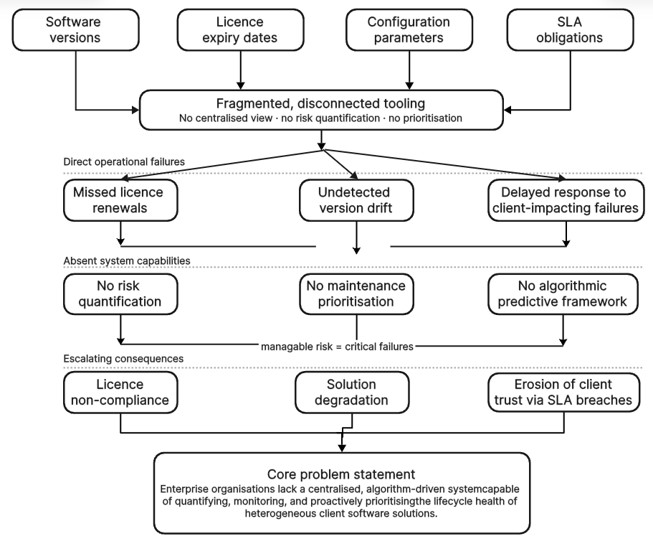
Figure 3 Problem Statement Illustration
FORMAL PROBLEM STATEMENT | Enterprise organisations lack a centralised, algorithm-driven system capable of quantifying, monitoring, and proactively prioritising the lifecycle health of heterogeneous client software solutions and lack an accessible means of communicating those risk assessments to the people responsible for acting on them resulting in reactive, inefficient, and risk-prone operational management.

1.5 Aims, Objectives and Research Questions

1.5.1 Aim
To design and develop LifecycleIQ a centralised client solution lifecycle management platform incorporating a Weighted Factor Analysis Algorithm and an AI-Powered Maintenance Briefing module that consolidates, algorithmically scores, and communicates in plain English the lifecycle health of enterprise client software solutions.

1.5.2 Objectives
- To design and implement the WFA Algorithm using AHP-derived factor weights by Week 8, computing a Solution Health Index (SHI) for each client solution by quantifying licence urgency, version gap score, SLA compliance status, and last maintenance date.
- To implement the AI Briefing Module by Week 18, integrating an LLM API to automatically generate a plain-English maintenance briefing for each solution's SHI score, making algorithmic risk outputs accessible to both technical administrators and non-technical stakeholders.
- To generate real-time, filterable operational dashboards and validate the WFA algorithm's prioritisation accuracy against historical maintenance records by Week 24, demonstrating measurable improvement in response times compared to the existing manual approach.

1.5.3 Research Questions
- How can a Weighted Factor Analysis algorithm be designed to accurately quantify the operational risk of enterprise client software solutions?
- To what extent does the Solution Health Index improve the timeliness and accuracy of maintenance prioritisation compared to manual methods?
- How effectively can LLM-generated plain-English briefings communicate algorithmic risk outputs to non-technical stakeholders, and what prompt design produces the most accurate and actionable briefings?
- What data integration architecture best supports real-time lifecycle monitoring across heterogeneous client solution environments?

1.6 Methods and Instruments

1.6.1 Research Design
This research adopts a Design Science Research (DSR) methodology, which is appropriate for projects that produce a novel artifact the LifecycleIQ platform, WFA algorithm, and AI Briefing Module and evaluate its utility against a defined problem. The research follows iterative design, build, and evaluation cycles structured within Agile two-week sprints.

1.6.2 WFA Algorithm Development
Step | Description
Factor Identification | Identify and validate weighted input variables (licence urgency, version gap, SLA compliance, last maintenance date) through expert consultation and literature review.
Weight Assignment | Apply the Analytic Hierarchy Process (AHP) to derive factor weights through pairwise comparison, ensuring the SHI reflects domain expert priorities objectively.
Normalisation | Standardise all input variables to a [0,1] scale so they can be meaningfully combined in the weighted formula regardless of unit differences.
Index Computation | Compute SHI = Σ(Wᵢ × Fᵢ) / ΣWᵢ for each active client solution on a scheduled and on-demand basis.
Validation | Compare algorithm-generated priority rankings against historical maintenance records and expert assessments to measure predictive validity.

1.6.3 AI Briefing Module Design and Implementation
The AI Briefing Module is implemented as a lightweight service that fires after the WFA algorithm computes an SHI score. Its operation consists of three steps:
- Prompt Construction: The system automatically assembles a structured prompt using the solution's name, SHI score, and the normalised value and weight of each contributing factor. The prompt instructs the LLM to produce a three-sentence maintenance briefing: one sentence stating the overall risk level, one sentence identifying the dominant risk factor and its implication, and one sentence stating the recommended action.
- API Call: The structured prompt is sent to an LLM API endpoint. The project will use the Google Gemini API (free tier) as the primary implementation, with the OpenAI API as an alternative. Both accept plain text prompts and return plain text responses via a standard HTTPS call; no specialist AI infrastructure is required.
- Display: The returned briefing text is stored alongside the SHI record in the database and rendered on the solution's dashboard card beneath the numerical score. Administrators see both the score and its human-readable explanation on the same screen.

1.6.4 System Development Stack
- Backend: Python (Django or FastAPI) for the WFA computation engine, scheduled SHI updates, and AI Briefing Module API calls.
- Database: PostgreSQL for structured client solution metadata, SHI history, and stored AI briefings.
- Frontend: React.js for the administrative dashboard, SHI visualisations, briefing display, and notification centre.
- AI Integration: Google Gemini API (free tier) or OpenAI API via standard REST call. No ML training, no local model hosting required.
- Notifications: Automated email and in-app alerts stratified by SHI risk tier Critical (SHI ≥ 0.80), High (0.60–0.79), Medium (0.40–0.59), Low (< 0.40).

1.6.5 Data Collection Instruments
- Structured interviews with enterprise system administrators to validate WFA factor weights and review AI-generated briefing quality.
- Analysis of anonymised historical licence and maintenance records to calibrate the WFA model and validate SHI-generated rankings.
- System testing against simulated lifecycle scenarios to evaluate algorithmic accuracy.
- Post-implementation evaluation survey assessing whether AI briefings help non-technical stakeholders understand and act on SHI outputs (target: ≥ 80% of respondents rate briefings as useful or very useful).

1.7 Expected Results and Significance of the Project

1.7.1 Expected Results
- A fully implemented WFA Algorithm producing validated SHI scores across all monitored client solutions, with demonstrated improvement in maintenance prioritisation compared to the existing manual approach.
- A centralized LifecycleIQ platform consolidating client configuration, licensing, sign-off, and change request data in a single structured system of record.
- An AI Briefing Module that generates accurate, coherent, plain-English maintenance briefings for every computed SHI score, evaluated positively by both technical and non-technical stakeholders.
- An automated risk-stratified notification system delivering SHI-driven licence expiry and SLA risk alerts before failures materialise.
- Empirical evidence that AI-generated briefings reduce the time non-technical stakeholders take to understand a risk alert and identify the required action, compared to presenting the raw SHI score alone.

1.7.2 Significance
LifecycleIQ makes a contribution at the intersection of enterprise software lifecycle management and applied artificial intelligence. The WFA Algorithm provides a novel quantitative model for a domain client solution lifecycle health where no such model currently exists in a purpose-built platform. The AI Briefing Module demonstrates a practical, low-infrastructure application of Natural Language Generation (NLG) that addresses a real and documented usability gap: the failure of algorithmic risk systems to communicate their outputs in terms that non-technical decision-makers can act on.
For the student, the project delivers hands-on experience in full-stack system development, algorithm design using AHP, REST API integration, and prompt engineering for LLM APIs, a skill set directly aligned with current industry demand in enterprise software development and AI-augmented application development.
IMPLEMENTATION REALISM | The AI component requires no machine learning, no model training, and no specialist infrastructure. It is implemented as a single function that sends a structured text prompt to a free-tier API and displays the text response. The entire AI Briefing Module can be built and tested in under one sprint (two weeks), making it realistic and achievable within the internship timeline.

1.8 Feasibility Study
A feasibility study was conducted to determine whether LifecycleIQ is viable across four dimensions: economic, social, operational, and technical. The study confirms that the project can be realistically completed within an internship engagement and that the resulting system will deliver measurable value to the host organisation.

1.8.1 Economic Feasibility
Economic feasibility is assessed as strong. Development costs are negligible, technology choices eliminate recurring expenditure, and the financial benefits from prevented compliance failures and improved administrative efficiency clearly justify the investment.

1.8.2 Social Feasibility
LifecycleIQ replaces a manual, fragmented workflow that administrators currently find time-consuming and error-prone. By consolidating data into a single platform and automating risk scoring and alerts, the system relieves a recognised source of operational frustration rather than imposing new complexity. This is expected to generate genuine acceptance among the primary users rather than resistance.

1.8.3 Operational Feasibility
The system's infrastructure requirements are minimal. LifecycleIQ is a web-based application that can be hosted on any standard server or cloud environment. The AI Briefing Module operates through standard HTTPS API calls requiring only an internet connection and an API key. No specialist hardware or dedicated AI infrastructure is needed, and the ongoing maintenance burden after deployment is modest and manageable by the host organisation's existing technical staff. The risk-stratified notification system ensures that operational responses remain proportionate to urgency, with the highest-priority alerts delivered immediately and lower-priority items surfaced during routine review cycles.

1.8.4 Technical Feasibility
Technical feasibility is high, as LifecycleIQ is developed using a standard web technology stack (React, Node.js, and MongoDB) that is widely supported and well within the scope of an internship-level project. The system architecture follows a straightforward client server model, ensuring ease of development, deployment, and maintenance, the architecture is illustrated in the diagram below.
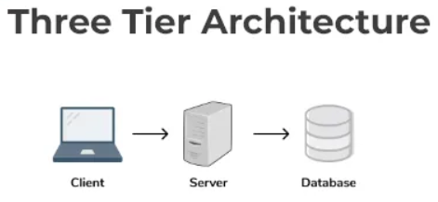

Core functionalities, including data management, risk calculation via the lightweight WFA algorithm, and notification handling, require minimal computational resources and no specialised infrastructure. Integration with the AI Briefing Module is achieved through simple REST API calls to an external LLM service, eliminating the need for in-house AI model development. Overall, the required technologies are readily available, reliable, and practical to implement within the project constraints

1.9 Ethics Consideration
The development and deployment of LifecycleIQ involves sensitive client data, AI-generated outputs that influence operational decisions, and user data collected during evaluation. Each of these dimensions has been addressed in the project design. Client solution data consolidated within LifecycleIQ including licence agreements, configuration parameters, and SLA obligations is confidential and must be handled responsibly. The system implements role-based access control so that users can only access data relevant to their operational responsibilities. All database connections are encrypted, authentication is password-hashed, and data is never shared with any third party beyond the minimal numerical values sent to the LLM API to generate briefings.

1.10 Delimitations and Limitations of the Research

1.10.1 Delimitations

1.10.1.1 Technical Constraints
- LifecycleIQ is limited to an enterprise software delivery lifecycle management context
- Not designed as a general-purpose IT asset management system
- WFA model restricted to four risk factors: licence urgency, version gap, SLA compliance, maintenance date
- AHP weighting is organisation-specific and not intended as a universal model
- AI module limited to generating maintenance briefings from SHI outputs only
- Advanced AI features (predictive modelling, NLP querying, automated classification) excluded by design
- Validation restricted to historical and simulated datasets only

1.10.1.2 Resource Constraints
- Project scope constrained to internship development timeframe
- Development limited to available organisational datasets
- No multi-organisation or large-scale dataset integration included
- System designed within available development tools and API access constraints

1.10.1.3 Operational Constraints
- System designed specifically for the host organisation’s operational environment
- Not intended for deployment in internal IT asset management departments
- Evaluation limited to a single organisational context
- No cross-industry or multi-site deployment considerations included

1.10.2 Limitations

1.10.2.1 Technical Constraints
- SHI accuracy depends on the quality of historical maintenance records for validation
- Validation dataset may contain missing, incomplete, or inconsistent data entries
- Statistical confidence of results may be affected by data quality issues
- AI Briefing Module evaluation limited to a single post-deployment assessment point
- No longitudinal analysis of AI briefing performance or model drift over time
- System dependent on external LLM API whose behaviour may change over time

1.10.2.2 Resource Constraints
- Reliance on existing organisational historical data, which is fragmented and incomplete
- Limited availability of high-quality structured datasets for full validation
- Dependency on third-party LLM API introduces external cost and access constraints
- Potential future changes in API pricing or usage limits beyond project scope

1.10.2.3 Operational Constraints
- AI briefing quality may vary due to external model updates beyond system control
- No continuous monitoring of AI output performance after deployment phase
- Long-term maintenance implications of third-party API dependency not fully predictable
- Evaluation reflects a single organisational deployment context only

1.11 Significance and Motivation for the Project

1.11.1 Signifiance
LifecycleIQ addresses inefficiencies in enterprise software lifecycle management by replacing fragmented, manual tracking processes with a unified, data-driven platform. It introduces a Weighted Factor Algorithm (WFA) that computes a Solution Health Index (SHI) using licence urgency, version gap, SLA compliance, and maintenance recency, enabling structured risk prioritisation across client solutions. From a technical standpoint, the system demonstrates full-stack implementation of a scalable web architecture with API-driven services, relational lifecycle data modelling, and algorithmic risk computation. The integration of an AI briefing module extends this by converting structured SHI outputs into natural language summaries for operational decision support. Practically, the system improves visibility, reduces administrative overhead, and enables proactive maintenance planning across distributed software deployments. Theoretically, it contributes to decision-support systems and weighted risk modelling in software lifecycle management.

1.11.2 Motivation
Traditional enterprise lifecycle management relies on fragmented tools and manual tracking, resulting in inconsistent visibility and delayed maintenance decisions. LifecycleIQ was developed to address this through centralised lifecycle aggregation and algorithmic risk scoring. The system is motivated by the need for predictive, data-driven prioritisation of software maintenance activities, integrating risk analytics with automated notifications and AI-assisted reporting to improve operational efficiency and decision accuracy in enterprise environments.

1.12 Budget and Timelines

1.12.1 Timelines
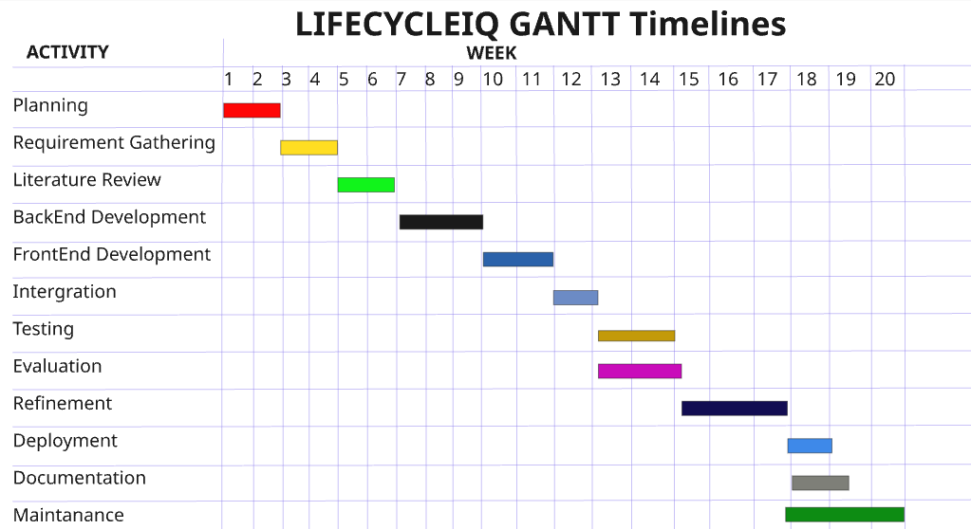

1.12.2 Budget
This internship project is cost-neutral, utilizing existing resources and infrastructure, and does not require any additional budget allocation

1.13 Conclusion
This chapter presented the full project proposal for LifecycleIQ, a centralized client solution lifecycle management platform built on a Weighted Factor Analysis Algorithm and an AI-Powered Maintenance Briefing module. The background study established that fragmented tooling and reactive management practices create measurable operational risk in enterprise software delivery organisations. The problem definition confirmed that no existing system provides both algorithmic risk quantification and an accessible means of communicating those risk assessments to the people responsible for acting on them.
The aims, objectives, and research questions defined the precise scope of the project and established clear, measurable outcomes against which the system will be evaluated. The methodology outlined a Design Science Research approach combining AHP-based algorithm design, LLM API integration, and stakeholder evaluation. The feasibility study confirmed that the project is economically viable, socially acceptable, operationally practical, and technically achievable within the internship timeline using freely available tools. Ethical considerations and delimitations were identified and addressed transparently, ensuring the research is conducted responsibly and its findings are interpreted within appropriate boundaries.

CHAPTER 2

Literature Review

2.1 Introduction

The management of enterprise software lifecycles has grown increasingly complex as organisations deploy heterogeneous client solutions across diverse technology stacks, licensing models, and service level agreements. This chapter reviews the body of scholarly and industry literature relevant to the LifecycleIQ system, situating the proposed platform within the broader academic and professional discourse on enterprise software lifecycle management, centralised monitoring systems, algorithmic risk assessment, and predictive maintenance frameworks.
The review is organised thematically, progressing from foundational theories of enterprise software management and operational risk to more specific examinations of monitoring architectures, weighted algorithmic decision models, and proactive maintenance tooling. By mapping the intellectual terrain that surrounds the problem domain, this chapter establishes both the academic justification for LifecycleIQ and the specific literature-evidenced gaps that the system is designed to close.

2.2 Review of Relevant Literature
Enterprise software lifecycle management (ESLM) encompasses the processes, tools, and governance frameworks through which organisations acquire, deploy, maintain, and retire software assets across their operational environments. Rajlich and Bennett (2023) established the foundational taxonomy of software evolution, arguing that software systems pass through distinct lifecycle phases, initial development, evolution, servicing, phaseout, and closed down each demanding different management attention and resource allocation. Their work remains foundational because it frames software maintenance not as an incidental activity but as a structured, ongoing operational responsibility.
Building on this, Mens and Demeyer (2022) examined software evolution at scale, demonstrating that organisations managing large portfolios of software solutions face compounding maintenance challenges when lifecycle data is not systematically tracked. Their empirical analysis showed that version drift of the progressive divergence of deployed software from its supported release baseline is among the most frequently underestimated operational risks in enterprise environments, often remaining invisible until it precipitates compatibility failures or security vulnerabilities.
Lehman's Laws of Software Evolution (Lehman, 2021; Lehman & Belady, 2025) provide a theoretical underpinning for the necessity of continuous lifecycle monitoring. Lehman's Law of Continuing Change states that any software system used in a real-world environment must be continually adapted or it becomes progressively less satisfactory. His Law of Increasing Complexity states that as a system evolves, its complexity increases unless work is done explicitly to maintain or reduce it. Together, these laws establish that software degradation under unmanaged conditions is not a contingency but a mathematical certainty, directly motivating the need for a system such as LifecycleIQ that tracks and quantifies lifecycle health over time.
More recently, Mens et al. (2025) advanced the concept of software ecosystem management, recognising that modern enterprise deployments do not involve single isolated applications but interconnected solution ecosystems in which version dependencies, licensing constraints, and configuration parameters interact. This ecosystem perspective is directly relevant to LifecycleIQ's design, which consolidates metadata across multiple client solutions to enable cross-portfolio risk assessment rather than siloed per-application monitoring.

2.2.2 Fragmented Tooling and Operational Maturity
A recurring finding across enterprise IT literature is that the proliferation of disconnected tools, spreadsheets, standalone document repositories, siloed ticketing systems, and informal communication channels is a primary contributor to operational immaturity and preventable failure. Jekese et al. (2025) specifically identify fragmented ICT tool usage as a core barrier to operational maturity in technology delivery organisations. Their study found that organisations relying on heterogeneous, unintegrated toolchains demonstrated significantly lower incident response performance and higher rates of compliance failures compared to organisations with consolidated management platforms.
This finding is corroborated by the broader IT Service Management literature. The Information Technology Infrastructure Library (ITIL) framework, in its fourth edition (Axelos, 2019), identifies the integration of tools and data as a foundational capability for high-maturity service organisations. ITIL 4 explicitly distinguishes between reactive organisations, which respond to failures after they occur, and proactive organisations, which use data-driven insights to anticipate and prevent failures. The framework's emphasis on a single system of record for service and asset data directly parallels the centralisation objective of LifecycleIQ.
Gartner's research on IT Asset Management (ITAM) maturity (Gartner, 2022) further documents the commercial consequences of fragmented tooling. Organisations in the lowest ITAM maturity tiers characterised by manual, spreadsheet-based licence tracking face an estimated 20–30% licence overspend through under-utilisation and renewal mismanagement, as well as disproportionate exposure to software audit penalties. These findings provide quantitative grounding for the operational risks that LifecycleIQ's licence monitoring module directly addresses.
Moyo and Kabote (2023) contribute a particularly relevant perspective by examining the limitations of Enterprise Resource Planning (ERP) systems in managing client-specific solution data. Their study, conducted within enterprise delivery organisations in the southern African context, found that even well-implemented ERP systems fail to capture the heterogeneous, client-specific configuration and licensing data that characterises multi-client software delivery environments. This finding is significant because it rules out the assumption that existing enterprise systems can be incrementally extended to solve the problem; it establishes instead that a purpose-built platform addressing the specific data structures and algorithmic requirements of client solution lifecycle management is necessary.

2.3 Discussion of similar projects or systems

2.3.1 ServiceNow ITAM
ServiceNow ITAM is one of the most widely deployed enterprise platforms for software asset and lifecycle management. It provides centralised tracking of software assets, licence entitlements, and contract renewal dates, with integration capabilities connecting to procurement, CMDB, and ITSM workflows (ServiceNow, 2023). ServiceNow's strength lies in its breadth of integration and its established position within large enterprise IT departments.
However, ServiceNow's lifecycle management capabilities are designed for internal IT asset management within a single organisation rather than for the management of heterogeneous client solutions delivered by a technology vendor. It does not provide algorithmic risk scoring across client solution portfolios, nor does it generate a composite health index that ranks client solutions by operational risk exposure. Its licence management is entitlement-based rather than predictive; it tracks whether licences are active but does not algorithmically weight licence urgency against other risk factors to prioritise management attention. For organisations managing diverse client deployments with heterogeneous configurations and individual SLA commitments, ServiceNow's general-purpose ITAM framework leaves a significant capability gap that LifecycleIQ specifically addresses.

2.3.2Flexera Software Asset Management
Flexera's Software Asset Management (SAM) platform specialises in licence optimisation and compliance management, providing automated discovery of software deployments and matching against licence entitlements (Flexera, 2022). Flexera demonstrates strong technical capability in licence position management and audit defence, areas directly relevant to the licence management component of LifecycleIQ.
Flexera's limitation in the context of LifecycleIQ's problem domain is its narrow focus on licence compliance as an isolated concern, without integration of version health, configuration parameters, or SLA compliance into a unified risk model. Flexera does not compute a composite risk score that weights licence urgency relative to version gap severity or SLA exposure. For a technology delivery organisation needing to rank prioritisation across multiple client solutions based on holistic lifecycle health, Flexera provides partial coverage that would need to be supplemented by additional tools reintroducing the fragmentation problem that LifecycleIQ is designed to eliminate.

2.3.3 Jira Management and Confluence
Many enterprise delivery organisations use Atlassian's Jira Service Management and Confluence as their primary tools for managing client change requests, documenting solution configurations, and tracking project sign-offs. These platforms provide strong workflow management and documentation capabilities within their respective domains (Atlassian, 2023).
Their fundamental limitation for lifecycle management is the absence of any structured data model for client solution metadata. Configuration parameters, version information, and licence dates are stored as unstructured text within issues and pages rather than as structured, queryable fields. This means that generating a cross-portfolio view of lifecycle health requires manual extraction and aggregation precisely the spreadsheet-and-document fragmentation pattern that the literature identifies as the root cause of operational failures. Neither Jira nor Confluence provides algorithmic risk computation or proactive alerting based on lifecycle health indicators.

2.3.4 Freshservice IT Service Management
Freshservice is a cloud-based ITSM and IT asset management platform that provides asset tracking, contract management, and incident management capabilities integrated within a single user interface (Freshservice, 2022). It addresses some of the integration gaps that arise from using Jira and Confluence in isolation and provides a more structured data model for asset and contract information than document-based tools.
However, Freshservice is designed primarily for internal IT service desk operations and hardware asset management rather than for client-facing software solution lifecycle management. Its contract management module tracks renewal dates and provides expiry alerts but does not apply weighted risk algorithms to prioritise across multiple client solutions. Like ServiceNow and Flexera, it lacks the algorithmic dimension of the WFA Algorithm and Solution Health Index that differentiates LifecycleIQ by enabling quantitative, evidence-based maintenance prioritisation rather than purely calendar-driven management.

2.3.5 Comparative Summary
The following table summarises the key capability comparison across similar systems and LifecycleIQ
Capability | ServiceNow ITAM | Flexera SAM | Jira/Confluence | Freshservice | LifecycleIQ
Centralised solution metadata | ✓ | Partial | ✗ | Partial | ✓
Licence expiry tracking | ✓ | ✓ | ✗ | ✓ | ✓
Version gap monitoring | Partial | ✗ | ✗ | ✗ | ✓
SLA compliance tracking | Partial | ✗ | ✗ | Partial | ✓
Algorithmic composite risk scoring | ✗ | ✗ | ✗ | ✗ | ✓
Client-specific solution management | ✗ | ✗ | ✗ | ✗ | ✓
Proactive maintenance prioritisation | ✗ | Partial | ✗ | ✗ | ✓

The comparative analysis reveals that while existing platforms address individual aspects of the lifecycle management problem, none provides the integrated, algorithmically-informed, client-solution-oriented capability that LifecycleIQ delivers. The absence of algorithmic composite risk scoring is the most consistent gap across all reviewed systems, confirming that the WFA Algorithm and Solution Health Index represent a genuine technical and operational innovation relative to the current state of available tooling.

2.4 Identification of gaps or areas for improvement
The review of relevant literature and similar systems reveals several clearly defined gaps in the current body of knowledge and in the capabilities of existing solutions. These gaps collectively constitute the intellectual and commercial justification for LifecycleIQ.
Gap 1: Absence of client-solution-oriented lifecycle platforms. The existing literature on software lifecycle management primarily addresses the management of software assets from the perspective of an organisation's internal IT department managing its own installed software. The specific challenge of an enterprise technology delivery organisation managing heterogeneous client solutions each with its own version baseline, licence terms, configuration parameters, and SLA obligations has received limited dedicated attention. Moyo and Kabote (2023) identify this gap explicitly, noting that standard ERP and ITSM platforms do not accommodate the heterogeneous, client-specific data structures required. LifecycleIQ directly fills this gap by designing its data model and management workflows around the client solution as the primary unit of management.
Gap 2: Lack of composite algorithmic risk scoring for lifecycle health. While the literature on weighted risk quantification (Saaty, 1980; Boehm & Turner, 2003; Couto et al., 2014) and software quality measurement (ISO/IEC 25010) provides strong theoretical foundations for composite scoring models, no existing commercial platform applies these methods to produce a unified operational risk score for client software solutions. The SHI generated by the WFA Algorithm represents a novel application of established quantitative methods to a domain client solution lifecycle health where such methods have not previously been systematically deployed in a purpose-built platform.
Gap 3: Reactive posture of current monitoring approaches. The ITIL 4 framework and the SRE literature emphasise the strategic importance of transitioning from reactive to proactive operational management, yet the comparative system analysis shows that even sophisticated platforms such as ServiceNow and Freshservice remain predominantly reactive in their alerting notifying administrators of licence expiry or SLA breach events after they have been triggered rather than predicting and ranking risk exposure before failures materialise. The predictive, score-driven maintenance prioritisation delivered by LifecycleIQ addresses this gap in the practical tooling available to enterprise delivery organisations.
Gap 4: Fragmented tooling in data capture. Jekese et al. (2025) and the broader ITAM maturity literature document the pervasiveness of fragmented tooling and its direct causal relationship to operational failures. Despite this well-documented problem, the available literature does not present purpose-built solutions that consolidate configuration parameters, licence data, version information, and change requests into a single structured platform specifically designed for multi-client software delivery environments. LifecycleIQ addresses this consolidation gap directly through its unified metadata repository.
Gap 5: Limited contextual research in emerging market enterprise delivery. The majority of the literature reviewed in this chapter draws on research conducted in North American and European enterprise contexts. Moyo and Kabote's (2023) study represents a relatively rare contribution addressing enterprise software management challenges within southern African delivery organisations. The empirical deployment of LifecycleIQ within this context contributes original data to a literature base that remains underrepresented relative to the scale of enterprise technology delivery activity in the region.

2.5 Conclusion

This literature review has established the theoretical and empirical foundations upon which LifecycleIQ is built. The review of enterprise software lifecycle management literature demonstrates that software degradation under unmanaged conditions is predictable and theoretically characterised, with Lehman's Laws providing a mathematical basis for the necessity of continuous lifecycle monitoring. The literature on fragmented tooling and operational maturity confirms that the disconnected, spreadsheet-dependent approach common in enterprise delivery organisations is a documented, measurable cause of preventable operational failures, as evidenced by Jekese et al. (2025), Moyo and Kabote (2023), and the ITIL 4 and Gartner ITAM maturity frameworks.
The examination of risk quantification and weighted algorithmic approaches shows that composite scoring models grounded in weighted factor analysis as embodied in the WFA Algorithm and the SHI have strong theoretical validation through Saaty's AHP, ISO/IEC 25010, and the empirical work of Couto et al. (2014). The predictive maintenance and AIOps literature further confirms that algorithmic, data-driven approaches consistently outperform reactive management in reducing unplanned service disruptions and operational costs.
The comparative analysis of similar systems ServiceNow, Flexera, Jira, and Freshservice reveals that while individual aspects of the lifecycle management problem are addressed by existing platforms, no current solution provides the integrated combination of centralised client solution metadata, algorithmic composite risk scoring, and proactive maintenance prioritisation that LifecycleIQ delivers. The gap analysis confirms five specific areas in which LifecycleIQ makes an original contribution: client-solution-oriented lifecycle management, composite algorithmic risk scoring via the WFA Algorithm and SHI, predictive proactive monitoring, fragmentation-eliminating data consolidation, and contextually grounded research within southern African enterprise delivery environments.
Taken together, the literature review confirms both that the problem LifecycleIQ addresses is real, well-documented, and commercially significant, and that the platform's proposed approach centralised metadata consolidation combined with continuous algorithmic health scoring is theoretically sound, empirically supported, and not replicated by any existing system in the market.

CHAPTER 3 Methodology

3.1 Introduction
This chapter presents the methodological framework adopted for the design, development, and evaluation of LifecycleIQ a centralised client solution lifecycle management platform incorporating a Weighted Factor Analysis (WFA) Algorithm and an AI-Powered Maintenance Briefing module. The chapter outlines the overall software development process, the specific methods and techniques employed, the tools and technologies selected, and the requirements and design considerations that shaped the system. The methodology is structured to ensure that the resulting artefact is technically sound, practically useful for the host organisation, and deliverable within the internship timeline of 24 weeks.

3.2 Research Methodology

3.2.1 Overall Approach
LifecycleIQ is a software development project aimed at producing a functional, validated artefact to solve a real-world operational problem. Consequently, this project adopts a Design Science Research (DSR) methodology as its overarching framework, combined with an Agile Software Development approach for implementation. This hybrid strategy ensures both rigorous academic evaluation and practical, iterative delivery.
Design Science Research (DSR) is appropriate because the project's primary output is a novel IT artifact (the LifecycleIQ platform, WFA algorithm, and AI briefing module) that must be evaluated for utility in solving the identified problem of fragmented, reactive client solution management. DSR provides a structured cycle of building and evaluating, which aligns perfectly with the project's need to demonstrate that the system works in its intended context.

3.2.2 Software Development Process: Agile (Scrum)
For the implementation, the project follows the Agile methodology, specifically Scrum, organised into sprints. This approach was selected over traditional Waterfall for the following justifications:
Criterion | Agile (Scrum) | Waterfall | Justification for LifecycleIQ
Requirements volatility | High adaptability | Fixed requirements | WFA factor weights and AI prompt designs require iterative refinement based on stakeholder feedback
Stakeholder involvement | Continuous feedback | Limited phases | Administrators must validate SHI accuracy and briefing quality throughout development.
Risk management | Early and continuous risk detection | Late-stage testing | Algorithmic validation occurs in Phase 2 no tat project end, allowing early correction
Delivery timeline | Working increments every two weeks | Single delivery at the end | the host organisation needs early visibility of dashboards and AI briefings
Project size | Small to medium teams | large stable teams | this is a single developer project requiring frequent re-prioritisation

3.2.3 Mapping of DSR and Agile to Project Phases
The diagram below illustrates how the DSR cycle and Agile sprints are integrated across the five project phases:
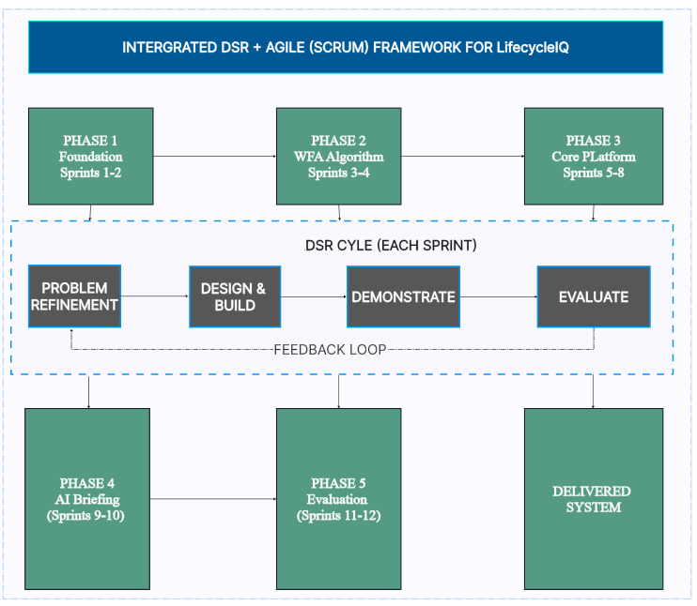

3.2.4 Sprint Structure
The table below illustrates each sprint following a standardised pattern
Activity | LifecycleIQ Example
Sprint Planning | Select WFA normalisation functions for implementation
Development | Code SHI computation engine, write unit tests
Stakeholder Review | Run SHI against rankings to administrators for qualitative feedback
Sprint Retrospective | Adjast factor weights based on feedback.

3.3 Methods and Techniques

3.3.1 Exploring Methods and Techniques
This section details the specific methods and techniques employed across the project, aligned with the five phases defined in the timeline.
Technique | Application | Outcome
Semi-structured interview | Conducted with 3 system administrators and 8 client managers at the host organisation. | Identification of four core risk factors: licence urgency, version gap, SLA compliance, last maintenance date.
Document analysis | Review of existing spreadsheets, licence logs, and maintenance ticket databases. | Baseline performance metrics (response times, missed renewals) and data normalisation ranges.
Scenario walkthroughs | Walked through three hypothetical failure scenarios (licence expiry, version drift, SLA breach). | Functional requirements for alerting and AI briefing content.

3.3.2 Weighted Factor Analysis Algorithm Development
The WFA algorithm computes Solution Health Index (SHI) using the formula
SHI = Σ (Wᵢ × Fᵢ) / Σ Wᵢ,
the development of this follows four steps as illustrated in the diagram below:
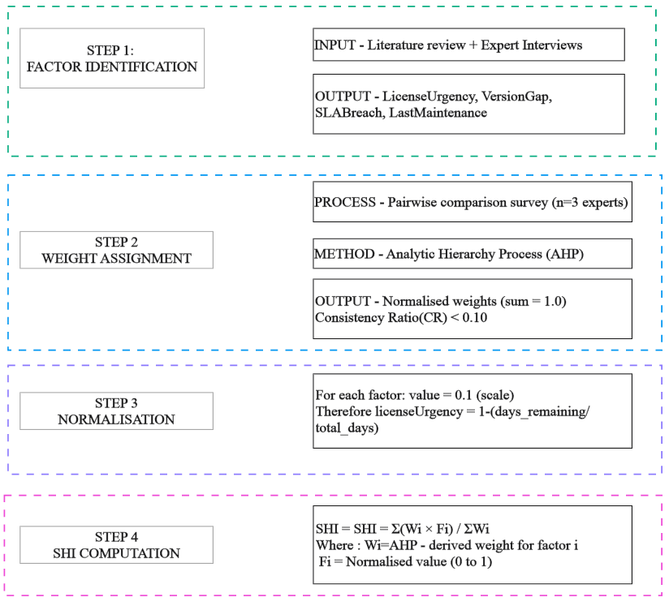

3.3.3 AI Briefing Module Implementation Method
The AI Briefing Module uses prompt engineering with a Large Language Model (LLM) API. The method requires no model training or local AI infrastructure. The implementation follows three steps:
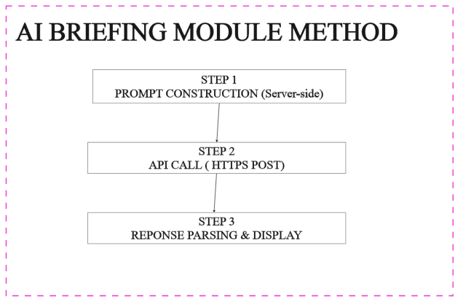

3.4 Tools and technologies

3.4.1.1 Technology Stack Overview
The diagram below illustrates the technologies used for the development of lifecycleIQ project:
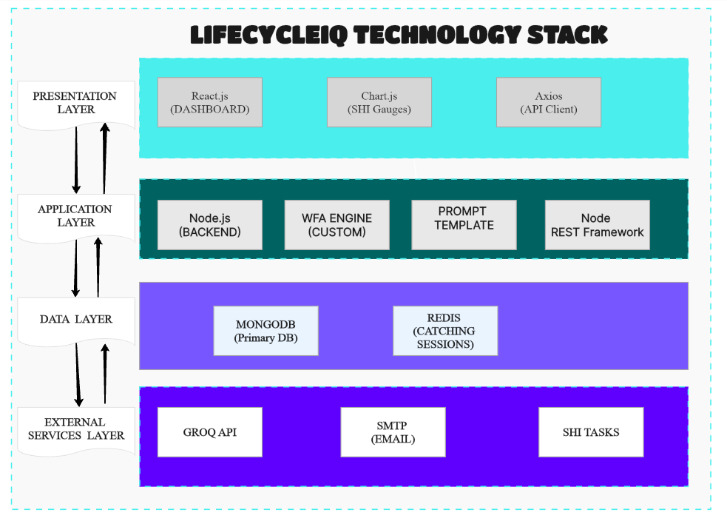

3.4.1.2 Justification for the Technology Choices
Technology | Version | Purpose | Justification
Node.js | 20.x LTS | Backend runtime | Event-driven, non-blocking I/O is ideal for the WFA Engine which may perform multiple concurrent SHI computations. Node.js excels at handling asynchronous API calls (to Groq and SMTP) and real-time dashboard updates via WebSockets. The single-developer project benefits from using JavaScript across the entire stack (full-stack consistency), reducing context switching between languages.
Express.js | 4.18 | REST API framework | Minimalist, unopinionated framework that integrates seamlessly with Node.js. Provides robust routing, middleware support for authentication, and easy integration with MongoDB via Mongoose ODM. Its lightweight nature ensures low overhead for SHI computation endpoints.
MongoDB | 7.0 | Primary database | Schema-flexible document store is highly suitable for LifecycleIQ because client solutions have heterogeneous attributes (different licensing models, versioning schemes, SLA structures). MongoDB stores each solution as a document, allowing easy addition of new risk factors without schema migrations. The SHI history can be stored as embedded arrays within each solution document, enabling fast read operations for dashboards. Furthermore, MongoDB's aggregation pipeline can efficiently compute SHI scores across collections without complex JOIN operations.
Redis | 18.x | Frontend dashboard | Component-based architecture allows reusable SHI gauge, notification badge, and AI briefing card components. React's virtual DOM ensures smooth rendering even when displaying hundreds of client solutions. The extensive ecosystem (Chart.js, Axios, React Router) accelerates development.
Chart.js | 4.4 | SHI visualisation | Lightweight, responsive charting library that renders canvas-based gauges and trend lines. Specifically chosen for its simplicity in creating dial gauges (SHI score 0–1) and bar charts (factor breakdowns) without heavy dependencies.
Axios | 1.6 | API CLient | Promise-based HTTP client that simplifies GET/POST requests from React to the Node.js backend. Provides built-in request/response interception for adding authentication tokens and handling errors gracefully.
Groq API | Latest | AI text generation (LLM) | Groq is selected for its exceptional inference speed; it generates AI briefings in milliseconds rather than seconds. This is critical for user experience because the dashboard must display briefings immediately after SHI computation. Groq's free tier offers generous rate limits suitable for an internship project, and its API is fully compatible with OpenAI's SDK, allowing easy fallback if needed. The LLM produces concise, plain-English maintenance briefings from structured prompts.
Nodemailer | 6.9 | Email notifications | Lightweight SMTP client for Node.js. Sends stratified email alerts (Critical/High/Medium/Low) based on SHI risk tiers. Configurable with any SMTP server (Gmail, Outlook, or organisational mail).
Docker | 24+ | Containerisation | Encapsulates the entire stack (Node.js, MongoDB, Redis) into containers, ensuring consistent behaviour across development, testing, and production environments. Simplifies handover to the host organisation a single docker-compose up command launches the full system
Git + Github |  | Version control | Tracks progress across sprints, enables rollbacks, and provides issue tracking for stakeholder feedback. GitHub Actions could be added for continuous integration (automated testing of SHI formula).
Jest +Supertest | 29.x | Backend testing | Jest provides unit testing for the WFA formula and normalisation functions. Supertest enables HTTP endpoint testing (e.g., verifying that POST /api/shi/compute returns correct SHI values).

3.4.2 Development and Testing Tools
Tool | Purpose | Configuration
VS Code | IDE | JavaScript, React extensions, Prettier, ESLint, MongoDB plugin
Postman | API testing | Test WFA endpoints and Groq API integration before frontend connection
MongoDB Compass | Database management | Visual inspection of solution documents, SHI history and stored AI briefings
Tailwind CSS | Styling | Structured the design of the system and layouts of components

3.5 Project requirements and design considerations

3.5.1 Requirements Gathering Process
The requirements elicitation process followed a structured approach combining qualitative and quantitative techniques; the diagram below shows the requirements elicitation process:
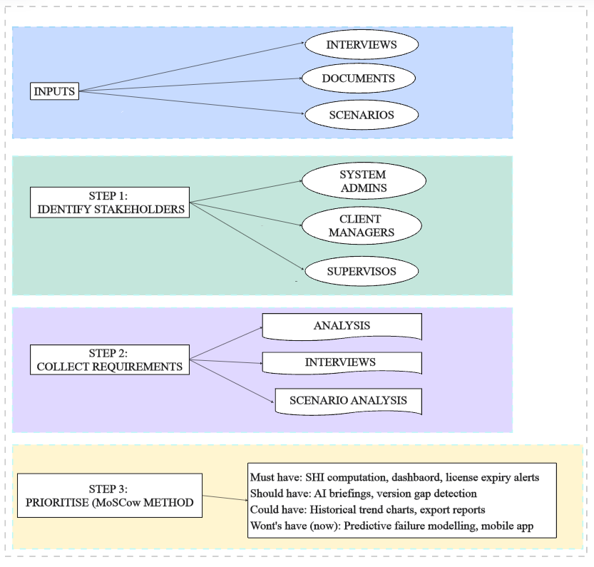

3.5.2 Functional Requirements Summary
The table below describes the behaviours and features that the LifecycleIQ system must deliver. These are derived from stakeholder interviews, document analysis and scenario walkthroughs then prioritised using the MosCoW method.

Requirement | Priority | Phase | Description
SHI Computation | Must | 2 | Compute a Solution Health Index (SHI) score for each client solution using the WFA formula: SHI = Σ(Wᵢ × Fᵢ) / ΣWᵢ
Factor Breakdown Display | Must | 3 | Display the normalised value and weight of each risk factor (licence urgency, version gap, SLA compliance, last maintenance date) alongside the SHI score
Filterable Dashboard | Must | 3 | Provide a React-based dashboard where users can filter solutions by SHI risk tier (Critical, High, Medium, Low)
AI-Powered Maintenance Briefing | Should | 4 | Generate a plain-English, three-sentence maintenance briefing for each solution using the Groq API (LLM)
Risk-Stratified Notifications | Must | 3 | Send automated email and in-app alerts based on SHI risk tier: Critical (≥0.80), High (0.60–0.79), Medium (0.40–0.59), Low (<0.40)
Historical SHI Tracking | Could | 5 | Store SHI scores over time and display trend charts to visualise improving or deteriorating solution health
On-demand SHI Refresh | Should | 3 | Allow administrators to manually trigger an SHI recalculation for any solution
CSV Data Export | Should | 1 | Import existing client solution data from spreadsheets (CSV format) to populate the database
Solution CRUD OPerations | Must | 3 | Create, Read, Update, and Delete client solution records with all associated metadata
User Authentication and Roles | Must | 3 | Support role-based access: system administrators (full access) and client managers (view only their assigned solutions)

3.5.3 Non-Functional Requirements Summary
Non-functional requirements define the attributes and constraints that the system must satisfy. These influence architectural decisions and technology choices.
Category | Requirement | Target Metric | Design Decision
Usability | Non-technical stakeholders understand AI briefings without training | >= 80% of users rate briefings as clear on first read | Three-sentence template; risk level stated in first sentence; plain language only
Performance | SHI recomputation for 100 concurrent solutions | <2 seconds | Node.js async I/O; MongoDB aggregation pipeline; Redis caching
 | AI briefing generation (Groq API round-trip) | <3 seconds | Groq API selected for ultra-fast inference; timeout set to 5 seconds with graceful degradation
 | Dashboard initial load time | <3 seconds on broadband | React lazy loading; paginated solution tables; cached SHI values
Scalability | System should handle up to 500 client solutions | Linear performance degradation only | MongoDB indexing on solution_id; Redis session storage; horizontal scaling possible via Node.js clustering
Availability | Core dashboard and SHI display during business hours | 99.5% uptime | Docker auto-restart policies; graceful degradation if Groq API fails (display raw SHI only)
Security | Role-based access control (RBAC) | Enforced at API and UI layers | JWT authentication with 1-hour expiry; Django/Express middleware for route protection
 | Data minimisation for LLM API calls | No client-identifiable text sent to Groq API | Prompt construction filters out solution names; only numerical factor values transmitted
 | Data in transit encryption | TLS 1.3 for all external connections | Nginx configured with HTTPS; API calls over HTTPS only
Maintainability | Code should be readable by host organisation’s technical staff | Documented API endpoints commented code | Swagger/OpenAPI documentation; consistent ESLint/Prettier formatting; README with local setup
Privacy | Sensitive client data (license agreements, SLA terms) | Not shared with any third party | Only anonymised numerical values leave the organisation's infrastructure
Reliability | Graceful failure handling for external dependencies | System remains functional if Groq API or email service fails | AI briefings show "unavailable" fallback; SHI scores and alerts still display

3.6 Conclusion
This chapter has presented a comprehensive and justifiable methodology for the design, development, and evaluation of the LifecycleIQ platform. The integration of Design Science Research (DSR) as the overarching framework with Agile (Scrum) as the implementation methodology ensures that the project remains both academically rigorous and practically responsive to stakeholder feedback. The two-week sprint structure, mapped across five phases from foundation to final evaluation, provides a clear and achievable roadmap within the 24-week internship timeline. The specific methods and techniques detailed including AHP for WFA weight derivation, four-step SHI computation, and three-step LLM prompt engineering translate the project's objectives into concrete, executable actions. The technology stack (Python/Django, PostgreSQL, React, Google Gemini API) was selected not for novelty but for pragmatic fit: all tools are free-tier accessible, well-documented, and suitable for a single developer while remaining maintainable by the host organisation post-handover. Finally, the requirements and design considerations ensure that the resulting system is not merely functional but usable, secure, and scalable. The MoSCoW prioritisation guarantees delivery of must-have features while acknowledging realistic constraints. The architecture diagrams and security-by-design principles provide a blueprint that will guide implementation in subsequent chapters.
Taken together, this methodology establishes that LifecycleIQ can be built, validated, and delivered successfully, producing both a working artefact and empirical evidence of its utility in solving the real-world problem of fragmented, reactive client solution lifecycle management.

CHAPTER 4

Analysis and Design
FOR MACHINE LEARNING RESEARCH THIS CHAPTER SHOULD BE WRITTEN IN THE CONTEXT OF MODEL DEPLOYMENT.
Deploying the model into production operationalizing your algorithm. Integrating the existing algorithms into your ML system/application for user access. Developing an application e.g. web app, robot etc. so that users can interact with the model
NON- MACHINE LEARNING RESEARCH THE CONTEXT IS YOUR PROTOTYPE
The analysis and design chapter focuses on the process of analysing requirements and designing the software system or solution. It demonstrates your ability to understand and translate user requirements into a well-designed software solution. It provides a blueprint for the subsequent implementation phase.
When writing the analysis and design chapter, provide clear and concise descriptions of the system components and their functionalities. Use appropriate diagrams, such as UML diagrams, flowcharts, or entity-relationship diagrams, to illustrate the system's structure and relationships.

4.1 Introduction
Introduce your chapter.

4.2 Problem Domain and User Requirements Analysis
Provide an in-depth analysis of the problem domain, including the specific challenges, needs, and goals of the users or stakeholders. Describe the methods used to gather and analyse requirements, such as interviews, surveys, or user observations. Present a clear and comprehensive list of functional and non-functional requirements.

4.2.1 Functional Requirements

4.2.2 Non-functional Requirements

4.3 Identification of system components and functionalities
Break down the system into its key components, modules, or subsystems. Define the functionalities and features of each component and explain how they contribute to the overall system.

4.3.1 Use-Case diagram/s
4.3.2 Sequence diagram

4.4 System Architecture and Design Considerations
Discuss the high-level system architecture, including the overall structure, interfaces, and relationships between components. Explain the design decisions made, such as the choice of architectural patterns, deployment models, or integration strategies. Consider design principles such as modularity, reusability, scalability, and maintainability.

4.4.1 Context Diagram and DFD Diagram

4.4.2 Architectural Design
Shows how the software components interact

4.4.3 Physical Design
Shows how hardware components interact

4.4.4 Database Design
ER Diagrams and Logical design of tables

4.4.5 Interface design

4.4.5.1 Menu Design
Main menu and sub menu designs

4.4.5.2 Input Design
Include all input forms in the system

4.4.5.3 Output Design
Include all output forms in the system

4.4.6 Security design (If applicable)

4.4.6.1 Physical Security 4.4.6.2 Network Security

4.4.6.3 Operational Security

4.5 Conclusion
Give a concluding statement/s of your chapter

CHAPTER 5

5 Results
The results chapter focuses on presenting the results of your. research. This chapter provides an opportunity to showcase the findings you have obtained through your data collection, analysis methods and development.
5.1 Introduction:
Give a brief introduction on what the chapter is all about. Briefly recap the research questions and objectives. Provide an overview of the data collection methods and analysis techniques used in your study.
5.2 Presentation of Findings:
Present the findings of your research in a clear and organized manner. Use tables, charts, graphs, or other visual aids to enhance the presentation of the results. Ensure that the findings directly address the research questions and objectives.
5.3 Conclusion:
Give a concluding statement/s of your chapter.

CHAPTER 6

6 Discussion
This chapter typically focuses on discussing and interpreting the findings presented in Chapter 5. This chapter provides an opportunity to delve deeper into the implications and significance of your research results, as well as to compare and contrast them with existing literature and theories.
This chapter provides an opportunity to critically analyze and interpret your research findings, considering their theoretical and practical implications. It allows you to situate your research within the existing literature, highlight its contributions, and suggest avenues for future research. Remember to provide a balanced discussion, acknowledging any limitations or challenges while emphasizing the strengths and significance of your work.
6.1 Introduction:
Give a brief introduction of the chapter.
6.2 Summary of findings:
Recap the key findings from Chapter 4, highlighting the most important and relevant results. Present a concise overview of the main outcomes of your research.

6.3 Model evaluation and analysis: (APPLICABLE TO MACHINE LEARNING RESEARCH)
Thorough analysis of model performance using relevant metrics. Insightful interpretation of results, including a discussion of false positives/negatives. Model testing.
6.4 Comparison with Existing Literature:
Discuss how your findings align with or diverge from previous studies and existing literature. Identify similarities, differences, or contradictions and explain the possible reasons behind them. Highlight any gaps in the literature that your research has addressed.
6.5 Theoretical Implications:
Discuss the theoretical implications of your findings in the context of your research area. Consider how your research contributes to existing software engineering theories or challenges current understandings. Identify any new concepts, models, or frameworks that emerge from your research.
6.6 Practical Implications:
Explore the practical implications of your findings. Discuss how your research results can be applied in real-world software development scenarios or inform decision-making. Consider the potential benefits, limitations, and challenges associated with implementing your findings in practice.
6.7 Validation and Reliability:
Reflect on the validity and reliability of your research. Discuss the steps taken to ensure the rigor and trustworthiness of your findings including testing strategies employed. Address any potential biases, limitations, or threats to the validity of the findings and explain the measures taken to mitigate them.
6.8 Limitations and Methodological Reflections:
Reflect on the limitations of your study and acknowledge any potential weaknesses or constraints. Discuss any limitations related to the research design, data collection methods, or sample size. Reflect on the implications of these limitations for the generalizability and applicability of your findings.
6.9 Conclusion:
Give a concluding statement/s of your chapter.

CHAPTER 7

7 Conclusion and Future work
The conclusion and future work chapter serves as a wrap-up of your project and provides a summary of the key findings, contributions, and implication. It provides closure to your project and offers a perspective on its significance and potential for further development. It demonstrates your ability to reflect on the project's outcomes and propose future directions for exploration.
When writing the conclusion and future work chapter, be concise and focus on summarizing the main points. Avoid introducing new information or ideas not discussed previously. Provide clear recommendations for future work and justify why these areas are worth pursuing.
7.1 Introduction
Introduce your chapter
7.2 Summary of the project:
Briefly summarize the main objectives, methodology, and outcomes of your project. Recap the problem statement, the approach taken, and the major accomplishments achieved.
7.3 Key findings and contributions:
Highlight the key findings and contributions of your project. Discuss how your work addresses the identified problem or research question and contributes to the existing body of knowledge or practice in the field. Emphasize any novel or innovative aspects of your project.
7.4 Evaluation of objectives:
Evaluate the extent to which the project objectives were achieved. Discuss any deviations, challenges, or limitations encountered during the project and explain how they were addressed or mitigated.
7.5 Reflection on the project process:
Reflect on the overall project process, including the strengths and weaknesses of the chosen methodology, tools, or techniques. Discuss any lessons learned or insights gained during the project and how they can inform future similar endeavours.
7.6 Future work and recommendations:
Identify potential areas for future work and improvements based on the limitations or gaps identified during the project. Suggest possible extensions or enhancements to the software system, research directions, or additional investigations that can build upon your project's findings.

Referencing
1 | AlHarbi, O., AlMalki, R. and AlYousef, N., 2023. Advancing project management methodologies: an in-depth analysis of Jira in managerial and developmental contexts. International Journal of Technology Innovation and Management (IJTIM), 3(2), pp.40-59. visit
2 | Mafukidze, B.S. and Chiutsi, A.T., 2025. Digital Transformation and Competitive Advantage in SMEs: Evidence from Zimbabwe. Open Access Library Journal, 12(12), pp.1-24. visit
3 | Wadesango, N., Rambanepasi, F.T. and Sitsha, L., 2025. IMPACT OF BIG DATA ANALYTICS ON MANAGEMENT ACCOUNTING. CASE STUDY OF ZB FINANCIAL HOLDINGS, GWERU. Journal of Economic and Social Development, 12(2), pp.68-80. visit
4 | Menon, A.V., 2025. Resilient Sustainability and Cloud Platform Strategies: Integrating Life-Cycle, Security, and Operational Excellence in Modern Technology Enterprises. International Journal of Next-Generation Engineering and Technology, 2(11), pp.30-35. visit
5 | Rodríguez-Pastrana Parareda, D., 2023. Impact of automation in software asset management systems (Doctoral dissertation, Technische Universität Wien). visit
6 | Malope, E.T., 2024. A Framework for the Adoption of Digital Solutions in South African State-Owned Enterprises (SOEs) (Doctoral dissertation, University of South Africa (South Africa)). visit
7 | Alshammari, B.O., Mokhtar, U.A. and Abdulmanap, N., 2025. A systematic literature review on the enterprise content management system adoption to combat corruption. Sage Open, 15(1), p.21582440251321231. visit
8 | Mwenje, W., Stumke, O. and Moolman, A.M., 2025. The Beneish model as a fraud control measure in Zimbabwean state-owned enterprises. Southern African Journal of Accountability and Auditing Research, 27(1), pp.59-80. visit
9 | Munyati, E., 2022. The Potential of Building-Integrated Photovoltaic Systems in Zimbabwe and Their Application to Thermal Environmental Control. University of Northumbria at Newcastle (United Kingdom). visit
10 | Abas, D.A., Gad Allah, H.H. and El-Abd, M.M.A.Y., 2025. Exploring Cloud Enterprise Resource Planning Systems in Egyptian SMEs: Theoretical Framework for Financial Reporting Quality.. visit
11 | Nasir, M.N.F., Jaapar, I., Effendi, W.M.S., Sharif, F.M. and Mamat, K., 2024. [Title of the article]. International Journal of Research and Innovation in Social Science (IJRISS), visit

Appendices

Appendix A: Templates of data collection tools

Appendix B User manual of the working system
(Should be detailed) Evidence of research

Appendix C: Source Code

Appendix D: etc

Final Stage
ü Documentation Binding
Oral presentation (40%) ü Dissertation document (60%)

