* **KICKSTARTER -**

**Given the provided data, what are three conclusions we can draw about Kickstarter campaigns?**

|  |  |
| --- | --- |
| 1. There seems to be close to a 50/50 chance of success. | Staff Picks are a great indicator of potential success: |
|  |  |

* + 1. 100% of successes have been spotlighted.

|  |  |
| --- | --- |
| 1. Some categories of projects seem to do better than others: | Comments: |
|  | It interesting that Music, Theater and Film have greater than 50% success rates. Perhaps these items have more marketing and a stronger network of supporters prior to becoming posted on Kickstarter. Maybe they are already growing popularity with initial releases and then go to Kickstarter to grow faster. This information also leads me to conclude that it is harder to find financial supporters for tech, games, publishing and especially food than it is for other forms of entertainment. I personally find this to be surprising. Perhaps it is easier to demonstrate talent or value for entertainment than it is to demonstrate the ability to manage the other categories of business. |

1. The popularity of Kickstarter spiked in 2015 but seems to have fallen since then. (although only Q1 of 2017 is included in the data).

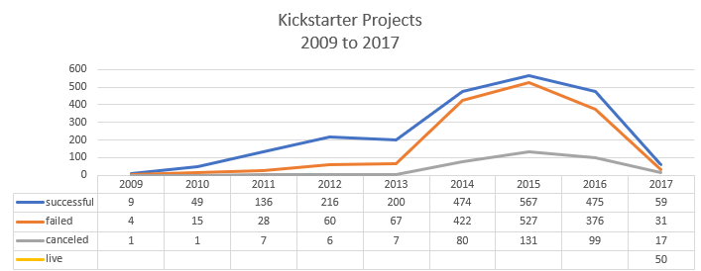

**What are some limitations of this dataset?**

1. It is static data that ends in March 2017. The annual graph above is skewed because of this. The number of projects has still fallen from 2015 levels.
2. Is AU Australia or Austria? I can’t tell. The country abbreviations could be improved or not abbreviated so much. At any rate, I wouldn’t want to try Kickstarter wherever AU is... 74 projects with only 25.7% success...
3. I don’t trust that 100% of successes are marked as spotlighted... It probably means that the folks at Kickstarter want to support the projects that are already taking off so that they can create a buzz about the projects and their product (Kickstarter itself). The projects are probably already successful by the time they are spotlighted. I see this as being valuable to the successful projects for sure, but if you are just starting out, I suspect that Kickstarter uses this fact as an incentive to use their project.

**What are some other possible tables and/or graphs that we could create?**

I like to use Pareto charts. If you view the data of project quantity and success rate by country, it gives a good overall picture of where Kickstarter is used and how effectively.

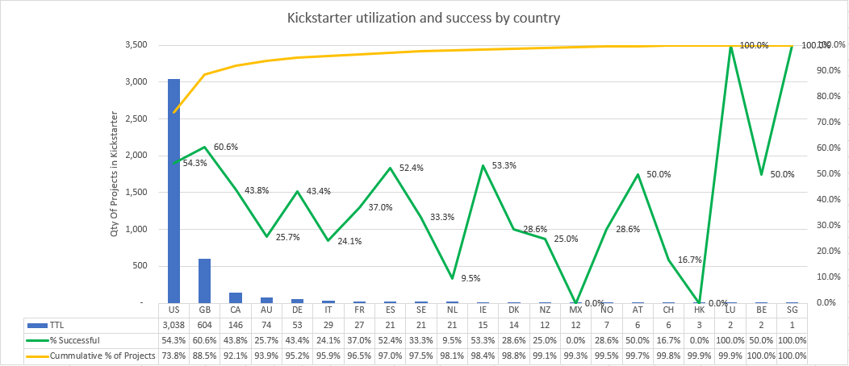

This can also be done by category of project. I would want to see the below chart prior to entering into or investing in any project on Kickstarter.

