High Level Requirements For the “when2meet” program

1. Introduction
Dev Ninjas: Gwen, Aldo, Edward, Keith

1.1 The Purpose
This projects mission is to aid in the planning of group meetings. Often it can be cumbersome to organize a meeting time for people with wildly different (and sometimes conflicting) schedules. We aim to help find a time slot everyone can make and comfortably if possible.
1.2 Scope:
To provide a platform for businesses to schedule meetings without multiple email chains.
1.3 Definitions:
Type 1 Use – defining basic time slot for 25 users or less
GUI - (Graphical User Interface) a computer program designed to allow a computer user to interact easily with the computer typically by making choices from menus or groups of icons
API - (Application Programming Interface) a set of rules that allows programmers to develop software for a particular operating system without having to be completely familiar with that operating system
SQL - (System Query Language) database language
1.4 References:
The non-GUI portions will be POSIX.1-2017 compliant.
Merriam-Webster dictionary used to define words.
1.5 Overview:
This document outlines the parameters for the when2meet application.

2. Overall Description

2.1 Product Perspective
2.1.1 System interface.
The application may interface with Google API.
The application will run on Windows 10.
The application needs an internet connection.
2.1.2 User Interface.
The user will use a GUI that will allow the user to login with a username and password to view their personal meeting time and other information. See figures in Appendix A GUI Section.
2.1.3 Hardware Interface.
The user will use a keyboard and mouse to interact with the GUI.
2.1.4 Software Interface.
The application will use a MySQL database.
2.1.5 Communication Interface.
The user will receive email and pop up notifications from the application.
2.1.6 Memory Constraints.
The application will use at most 1 GB of RAM for Type 1 Usage.
The application will use at least 256 kB for the internet connection
2.1.7 Operations.
The application will subtract occupied time from the given time slots from the user.
The user can import their calendar data into the program.

2.2 Product Function
- The program will return a time frame which maximizes the number of attendees. Meaning that the program will search for a time frame in which most people are unoccupied for a given period.

2.3 User Characteristics
- Languages supported: English.
- Computing Skills: Have basic knowledge of MS Outlook or similar calendar applications.
- Physical and Social Environment: This program will be appropriate for both corporate and family settings. Will take users’ position in company/social group into account.

2.4 Constraints
- Must be human as per the Geneva convention of 1915 and pass a captcha.
- Must have at least Windows 10 1803 or Mac OS 10.14.6 and later.
- Work on Visual C++ 2015 and GNU gcc 9.2.0

3. Specific Requirements

3.1 External interfaces

3.2 Functional requirements
-organized by feature, object, user class, etc.

3.3 Performance requirements

3.4 Logical database requirements
3.4.1 MariaDB

3.5 Design constraints
3.5.1 Standards compliance : Github repo will follow the linux Filesystem Hierarchy Standard 3.0 (FHS).

3.6 Software system attributes
3.6.1 Reliability
3.6.2 Availability
3.6.3 Security : In order to log in, make changes to submitted schedule, or raise an exception the user must log in and or make an account.
3.6.4 Maintainability
3.6.5 Portability: High level functionality must be written to be platform agnostic. That is when possible the program will avoid using non-standard libraries.

3.7 Organizing the specific requirements
3.7.1 System mode - or
3.7.2 User class - or
3.7.3 Objects (see right) - or
3.7.4 Feature - or
3.7.5 Stimulus - or
3.7.6 Response - or
3.7.7 Functional hierarchy – or

3.8 Additional comments

Appendix A
GUIS
Log in Screen
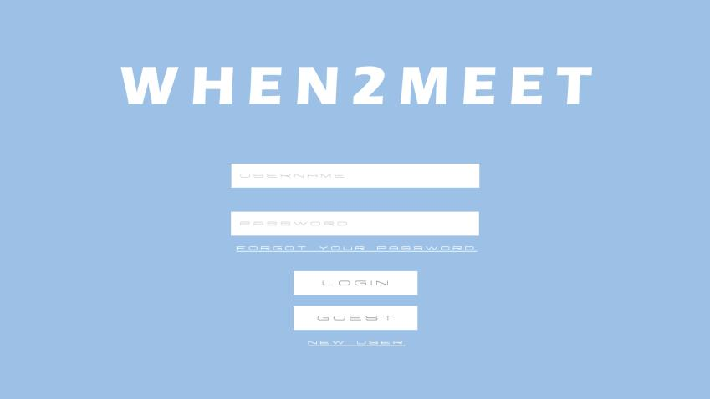
Questions
- What features must the home dashboard have?
- Is there a specific way you want it organized to look?
- Do we need to get more specific with our requirements?
- How do we handle guests?

Lessons Learned
- We need to ask ourselves if the requirements we have written are enough to design/code off of
- Image of basic dashboard idea
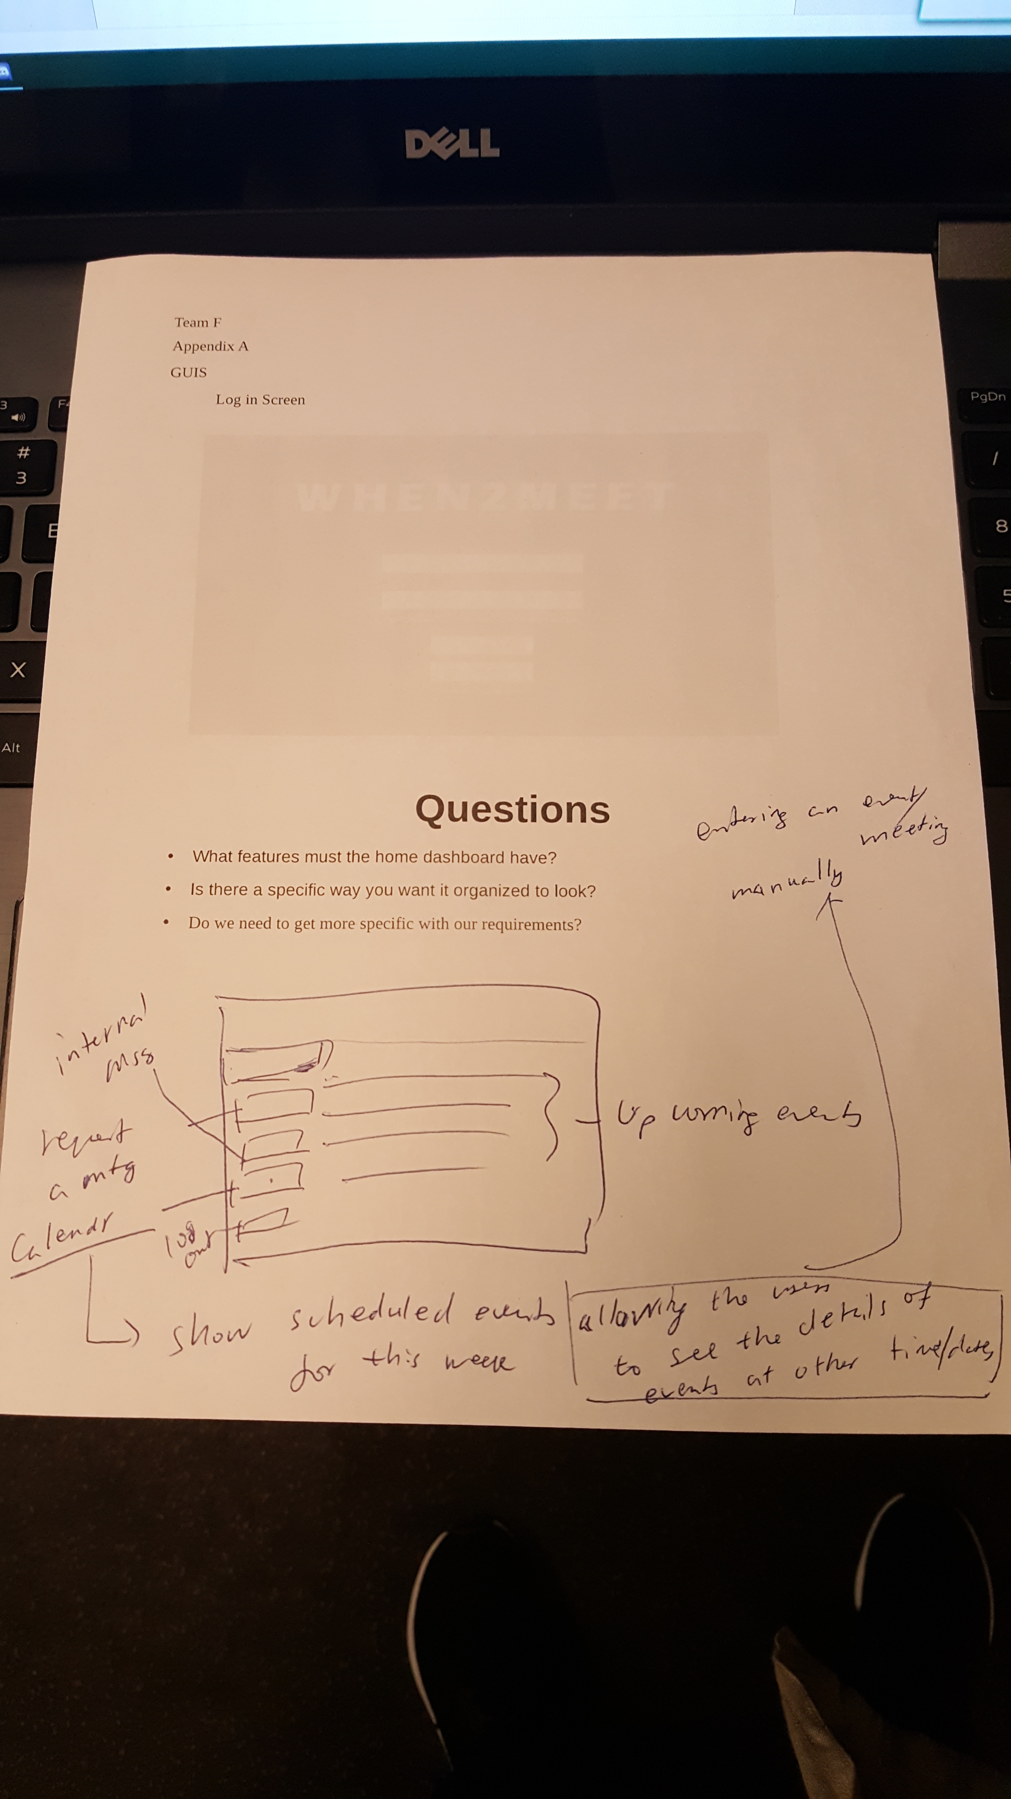
- Assume guests are always available and only need an email

