DOCTORAL APPLICATION TECHNICAL PORTFOLIO
From Calibrated Forecasts to Risk-constrained Storage Decisions
A reproducible mean-CVaR benchmark for day-ahead battery scheduling
Haorui Cai | Revised 1 October 2026 | SIMULATED BENCHMARK - NOT A TRADING SYSTEM

Abstract
Project 1 showed that a forecast interval can look better statistically after calibration. This project asks whether that change leads to a better battery decision. It uses the 83 held-out simulated days from Project 1 and a small linear battery model. The model tracks state of charge (SOC), charging losses, power limits and a required end-of-day SOC. Seven schedules are compared, including risk-neutral and CVaR versions. Adaptive-CVaR earns 9.86 simulated EUR/day. Raw-CVaR earns 9.73, and static-CVaR earns 8.20. Adaptive-CVaR has a simulated empirical CVaR loss of 15.84 EUR and no violations of the simplified constraints. These are benchmark scores, not real revenue. The main lesson is that a wider interval is not automatically a better input for a decision.
Data and contribution boundary Every price, schedule and monetary value is simulated. This is a learning project about forecast-to-decision evaluation. It is not a live bidding tool and it does not use Tarim Oilfield data.

1. Motivation and contribution
At Tarim Oilfield I saw forecast curves, actual photovoltaic output and storage monitoring screens. I did not design the storage schedule, but the work made one point clear: a charging action now changes the energy available later. This experience is only the motivation for the project. No field data are used. I therefore focus on errors near an SOC or power boundary. The same price error can be harmless when the battery has room, but costly when it changes a charge or discharge decision.

The choices that matter most
The project starts with a linear battery model rather than a detailed ageing or bidding model. Every SOC equation and constraint can therefore be inspected. The final SOC is forced to equal the initial SOC. Without this rule, the optimiser can empty the battery at the last hour and make the day look better by borrowing value from tomorrow.
The comparison uses the same battery and scoring rules for raw, static and adaptive forecast inputs. This keeps the decision layer fixed. It is then easier to see whether a change in the forecast distribution changes the schedule, rather than mixing that effect with a different optimiser.

2. Decision model

2.1 Battery physics
The battery can charge or discharge at up to 1 MW and can store 2 MWh. SOC increases by the energy that survives charging losses and falls by the energy needed for discharge. Both efficiencies are 0.94. SOC must stay between zero and 2 MWh. It starts and ends at 1 MWh. A 2 EUR/MWh throughput cost makes unnecessary cycling less attractive.

2.2 Scenario profit and CVaR
Profit is revenue from discharge minus the cost of charging and throughput. The risk-neutral version uses average scenario profit. The risk-aware version also penalises the worst 10% of scenario losses through CVaR. The base weight is 0.55. The model uses the standard Rockafellar-Uryasev linear form and is solved with SciPy/HiGHS.
Assumption | Reason | Consequence
Price taker | Keeps the first portfolio auditable | No market-impact or bid-acceptance model
Day-ahead energy only | Matches the P1 issuance design | No intraday or balancing recourse
Hourly perfect execution | Separates forecast value from controls | No deviation settlement or outage
Linear throughput cost | Transparent degradation proxy | No cycle-depth or ageing state

2.3 Feasibility checks
Every solve records power, SOC, terminal and simultaneous-throughput diagnostics. Across all seven strategies and 83 days, the model reports zero constraint violations and zero simultaneous charge-discharge. An independent unit test recomputes each SOC transition from the recorded starting SOC, charge, discharge and efficiencies, and checks terminal-SOC restoration.

2.4 Relationship to existing work
The optimisation pieces are established. The project uses the CVaR formulation of Rockafellar and Uryasev (2000). Donti et al. (2017) and Elmachtoub and Grigas (2022) show why prediction error and decision loss can disagree. Kim et al. (2020) and Toubeau et al. (2021) study storage under uncertain market outcomes. More recent work links conformal uncertainty to optimisation or storage arbitrage (Yeh et al., 2024; Alghumayjan et al., 2025). This is a small, auditable implementation of that connection, not a new bidding method.
Portfolio contribution The portfolio links Project 1 forecasts to battery schedules, followed by checks of profit, regret, tail loss and feasibility. The code is deliberately small enough to inspect, modify and explain.

3. Forecast scenarios and experimental design
Project 1 gives seven marginal price quantiles for every hour. Interpolation turns them into sixty possible 24-hour paths. The scenario generator uses a Gaussian factor shared by all hours, with a common-factor loading of 0.65. Under this construction, distinct latent hours have pairwise Pearson correlation 0.4225, corresponding to a Gaussian-copula Spearman correlation of about 0.41 before clipping and quantile interpolation. This is an exchangeable toy dependence assumption, not a neighbouring-hour correlation or a lag-specific time-series model. For static and adaptive cases, each hour is rescaled around the median so that the q10-q90 spread matches the calibrated interval. This practical bridge does not establish that complete 24-hour paths are jointly calibrated.
Strategy | Forecast information | Objective
Seasonal naive | Previous-day price | Risk neutral
Median risk neutral | q50 | Risk neutral
Raw CVaR | Raw quantile paths | Mean-CVaR
Static CVaR | Static-CQR-scaled paths | Mean-CVaR
Adaptive risk neutral | Adaptive-scaled paths | Risk neutral
Adaptive CVaR | Adaptive-scaled paths | Mean-CVaR
Oracle | Realised prices | Risk neutral upper bound

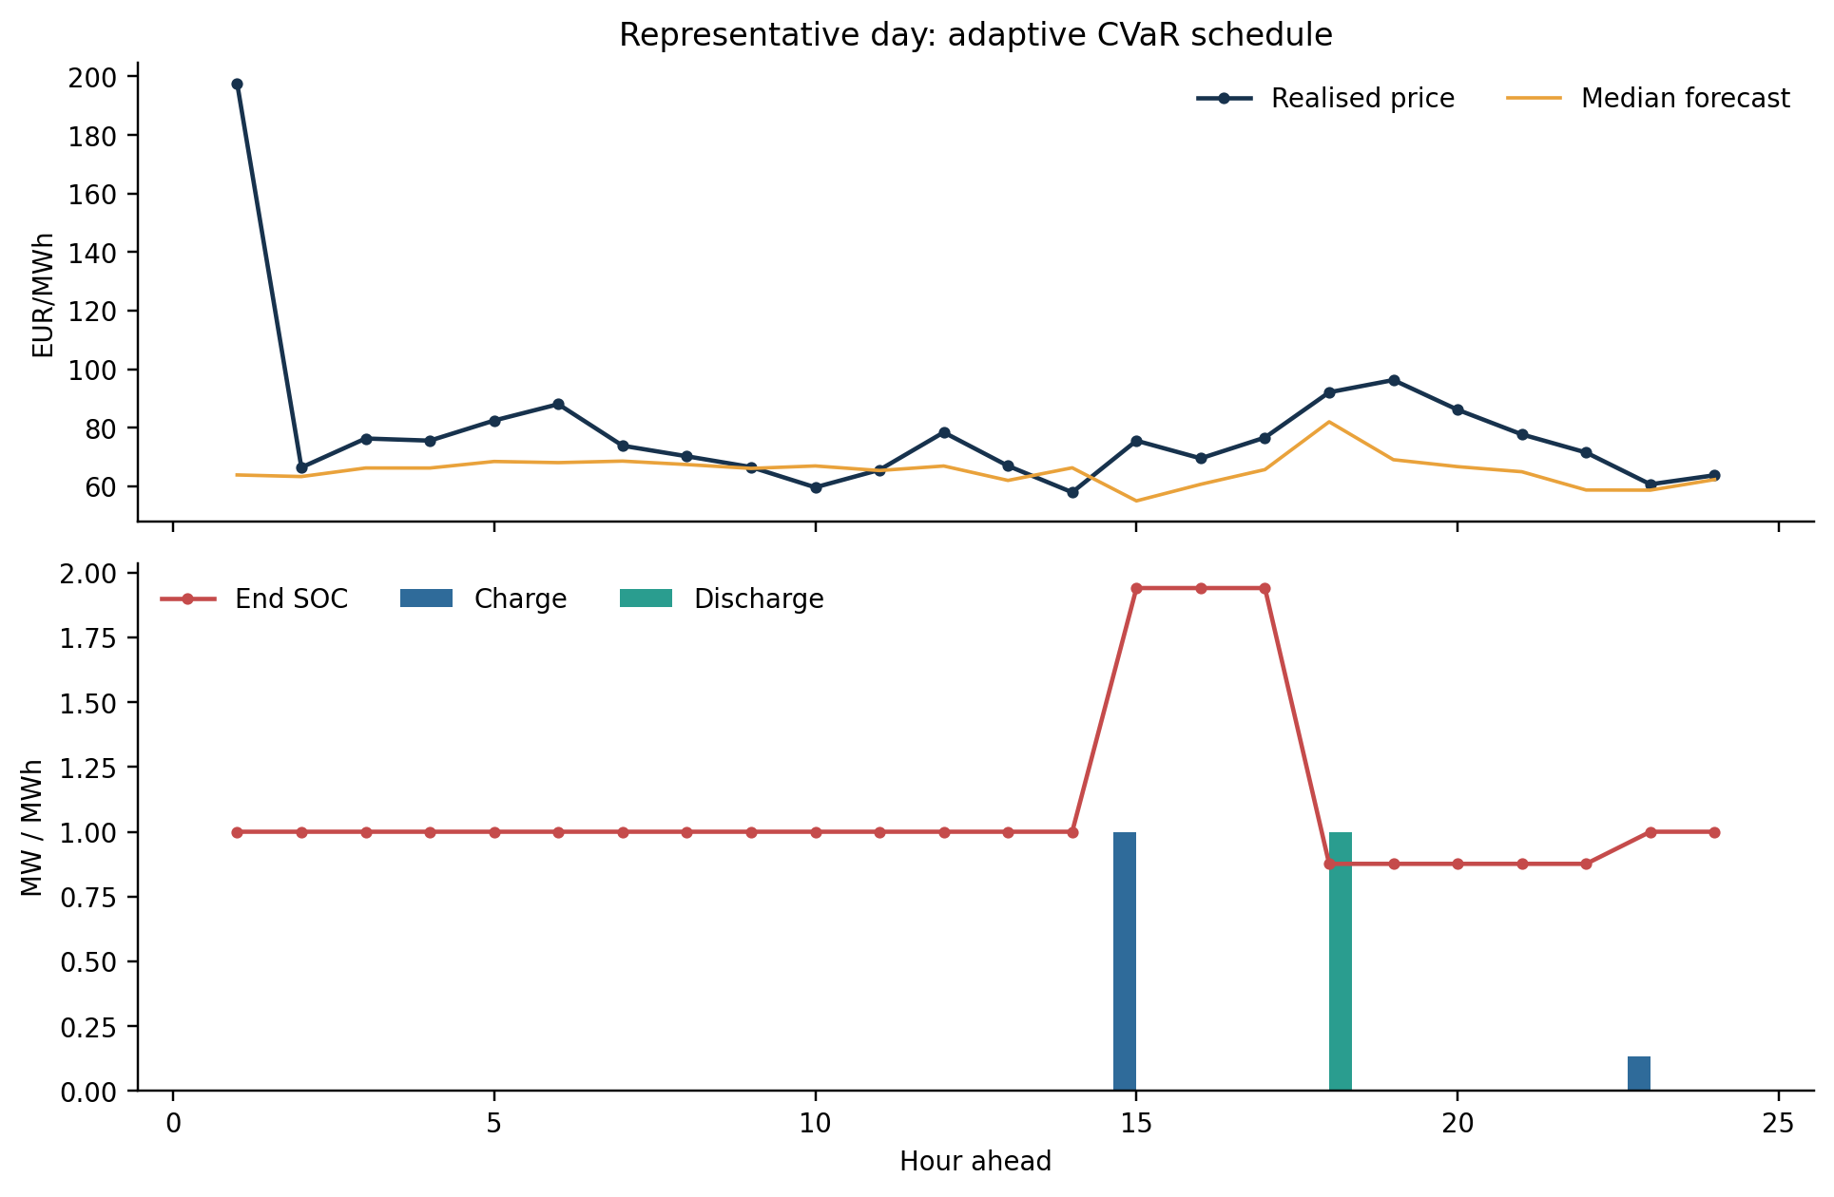
Figure 1. Representative adaptive-CVaR schedule. Charging and discharge respect SOC and terminal constraints.
Evaluation rule The schedule is selected from forecast information only. Realised price is used afterwards to score profit and regret.

4. Main decision results
Simulated-result notice All monetary figures in Sections 4-6 are simulated benchmark scores under the stated assumptions; they are not investable returns, employer results or evidence from a named electricity market.
Strategy | Mean profit | 5th pct profit | CVaR loss | Mean regret
seasonal naive | -28.28 | -80.73 | 81.21 | 84.93
median risk neutral | 8.34 | -18.33 | 22.47 | 48.31
raw cvar | 9.73 | -19.79 | 21.26 | 46.91
static cvar | 8.20 | -17.17 | 19.68 | 48.45
adaptive risk neutral | 9.18 | -19.23 | 22.58 | 47.46
adaptive cvar | 9.86 | -15.24 | 15.84 | 46.79
oracle | 56.65 | 26.24 | -25.21 | 0.00

The seasonal-naive schedule loses 28.28 EUR/day in this simulation. It cycles too much because yesterday's shape transfers poorly into the changed period. The median forecast returns to a positive mean. Raw-CVaR reaches 9.73 EUR/day but still has a 21.26 EUR tail loss. Static-CVaR lowers that loss to 19.68 EUR but also lowers mean profit. Adaptive-CVaR gives the best non-oracle combination in this run: 9.86 EUR/day mean profit and 15.84 EUR CVaR loss.
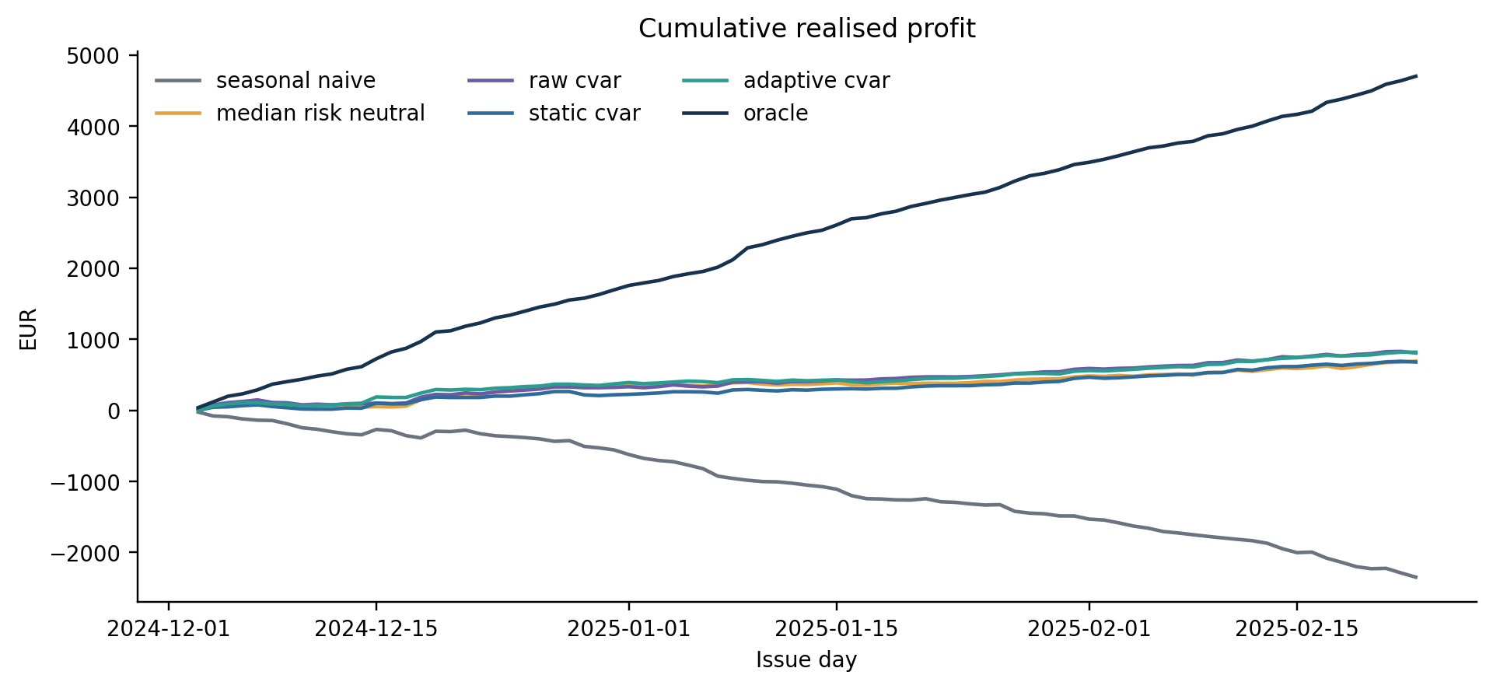
Figure 2. Simulated cumulative held-out profit. The oracle is an unattainable information upper bound.
The oracle earns 56.65 EUR/day, leaving substantial decision regret for every feasible forecast strategy. This gap should not be read as a realistic profit opportunity: it measures the value of perfect future information under the simplified model.

5. Tail risk and decision regret
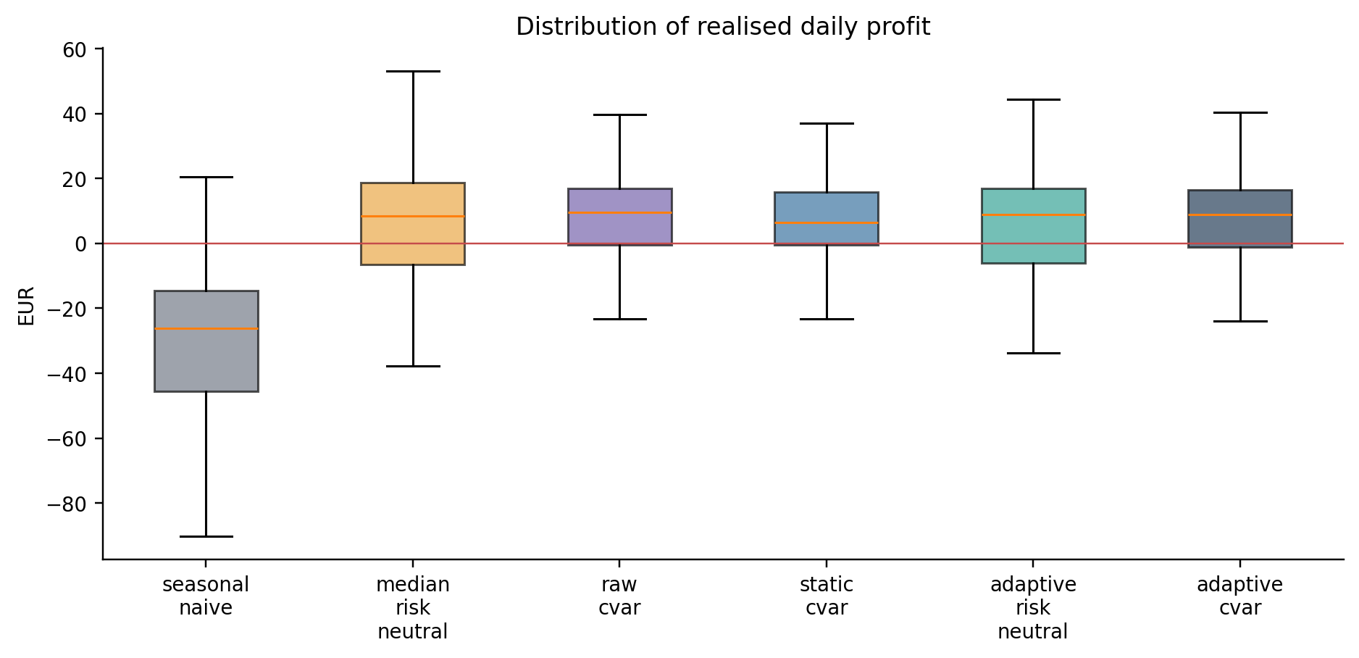
Figure 3. Realised daily profit distributions for feasible strategies.
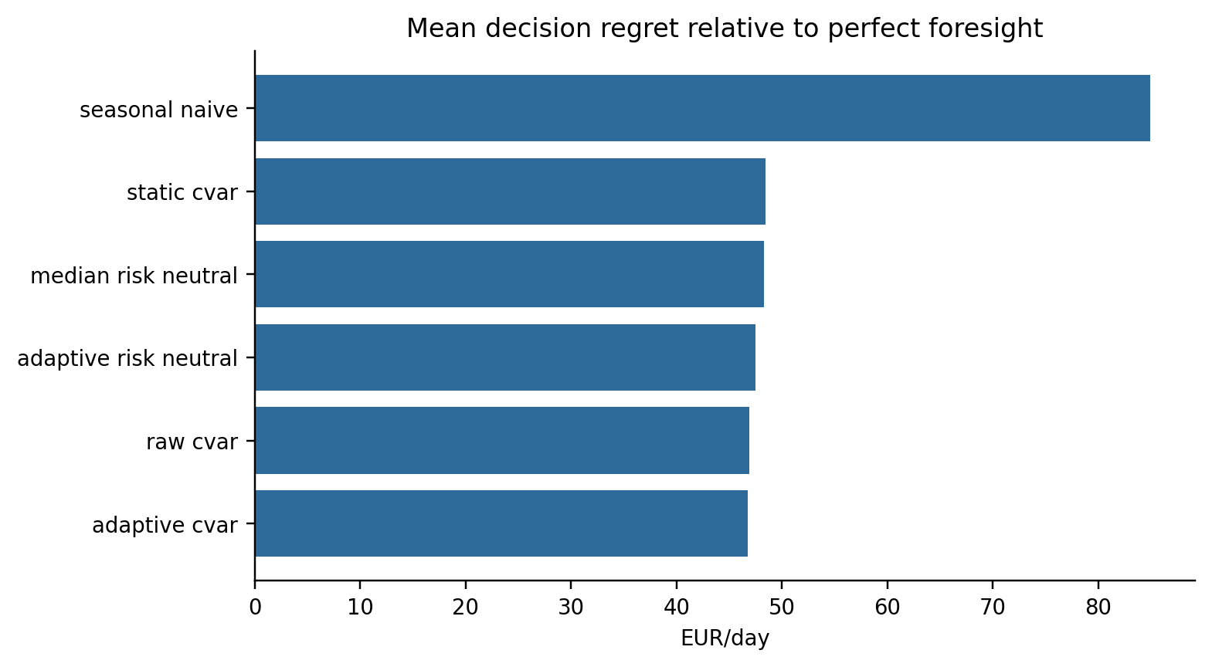
Figure 4. Mean regret relative to perfect foresight; lower is better.

5.1 What calibration changed
Static calibration protects the lower tail but can suppress profitable actions. Adaptive calibration responds to recent score behaviour and produces a different schedule with a better observed profit-tail-risk balance. Coverage alone is therefore not a decision metric.

5.2 A parameter change and a failed expectation
A sensitivity run increased the CVaR weight from 0.55 to 0.85. The prior expectation was a simple trade-off: lower tail loss but lower mean profit. That expectation failed on the main scenario sample. Mean profit rose from 9.86 to 9.99 EUR/day, while CVaR loss fell from 15.84 to 12.28 EUR. Throughput fell from 4.20 to 3.83 MWh/day. The separate frontier run in Figure 5 uses another fixed scenario sample and gives 9.03 EUR/day at weight 0.85, below 9.52 at 0.55. The result therefore depends on scenario sampling and does not prove that 0.85 is better. The base remains 0.55.

6. Risk preference and battery sensitivity
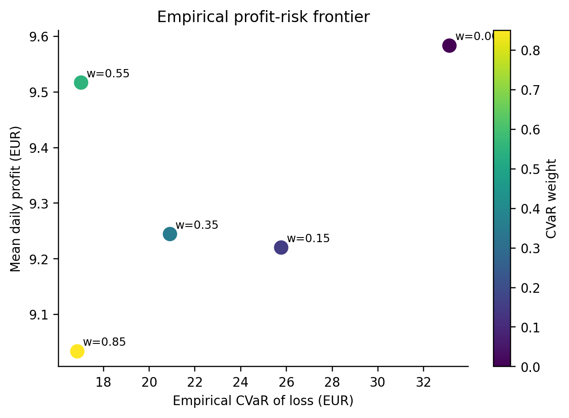
Figure 5. Empirical mean-profit versus tail-loss frontier across CVaR weights.
Increasing the CVaR weight reduces empirical tail loss from 33.13 EUR to 16.86 EUR at weight 0.85. Non-monotone realised mean profit reflects finite forecast scenarios and one realised path.
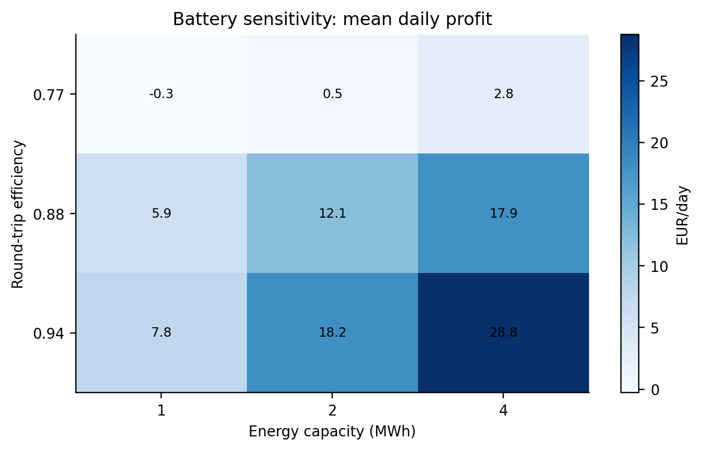
Figure 6. Twenty-eight-day sensitivity of median-forecast profit to energy capacity and efficiency.
Higher efficiency consistently improves value; added capacity helps most when efficiency is high. This is diagnostic, not an investment valuation, because capex and replacement costs are excluded.

7. What this project still cannot answer

7.1 Main limitations in plain language
The biggest limit is the data: prices and forecasts are simulated. The second is the scenario model. Calibrating each hour does not guarantee that an entire 24-hour path is realistic. The third is the battery model. It assumes price-taking, perfect execution and no intraday update. It also leaves out network limits, imbalance settlement and detailed degradation. Finally, CVaR is estimated from only 60 scenarios. Different seeds, correlations or markets may change the ranking.

7.2 Reproducibility
One-command run python scripts/run_experiment.py --config configs/base.yaml
The manifest records seed 20260817, 83 evaluation days, 60 scenarios per day, the battery settings and software versions. Unit tests check SOC transitions, terminal SOC, feasibility and finite CVaR outputs. The folder experiments/cvar_weight_085 keeps the parameter run and its daily results.

7.3 Doctoral extension
My next step would be to repeat the study on publication-time-safe market data and more than one seed. I would then improve the 24-hour scenario model and add intraday recourse and market-specific settlement. The main doctoral question stays the same: when does better uncertainty information lead to a better constrained decision, especially near SOC boundaries?

References
Rockafellar, R. T. and Uryasev, S. (2000). Optimization of Conditional Value-at-Risk. Journal of Risk, 2(3), 21-41. https://www.risk.net/journal-risk/2161159/optimization-conditional-value-risk
Romano, Y., Patterson, E. and Candes, E. (2019). Conformalized Quantile Regression. NeurIPS 32. https://proceedings.neurips.cc/paper/2019/hash/5103c3584b063c431bd1268e9b5e76fb-Abstract.html
Gibbs, I. and Candes, E. (2021). Adaptive Conformal Inference Under Distribution Shift. NeurIPS 34. https://proceedings.neurips.cc/paper/2021/hash/0d441de75945e5acbc865406fc9a2559-Abstract.html
Donti, P. L., Amos, B. and Kolter, J. Z. (2017). Task-based End-to-end Model Learning in Stochastic Optimization. NeurIPS 30. https://proceedings.neurips.cc/paper/2017/hash/3fc2c60b5782f641f76bcefc39fb2392-Abstract.html
Elmachtoub, A. N. and Grigas, P. (2022). Smart Predict, then Optimize. Management Science, 68(1), 9-26. https://doi.org/10.1287/mnsc.2020.3922
Kim, H. J., Sioshansi, R. and Conejo, A. J. (2020). Benefits of Stochastic Optimization for Scheduling Energy Storage in Wholesale Electricity Markets. Journal of Modern Power Systems and Clean Energy, 8(3), 421-433. https://ieeexplore.ieee.org/document/9096503
Toubeau, J.-F., Bottieau, J., De Greve, Z., Vallee, F. and Bruninx, K. (2021). Data-Driven Scheduling of Energy Storage in Day-Ahead Energy and Reserve Markets With Probabilistic Guarantees on Real-Time Delivery. IEEE Transactions on Power Systems, 36(4), 2815-2828. https://ieeexplore.ieee.org/document/9305967
Yeh, C., Christianson, N., Wu, A., Wierman, A. and Yue, Y. (2024). End-to-end conformal calibration for optimization under uncertainty. arXiv:2409.20534. https://arxiv.org/abs/2409.20534
Alghumayjan, S., Yi, M. and Xu, B. (2025). Conformal uncertainty quantification of electricity price predictions for risk-averse storage arbitrage. IEEE Power & Energy Society General Meeting. https://doi.org/10.1109/PESGM52009.2025.11225098
SciPy developers. Linear programming with HiGHS. https://docs.scipy.org/doc/scipy/reference/optimize.linprog-highs.html
Elexon. Insights Solution API documentation. https://bmrs.elexon.co.uk/api-documentation

