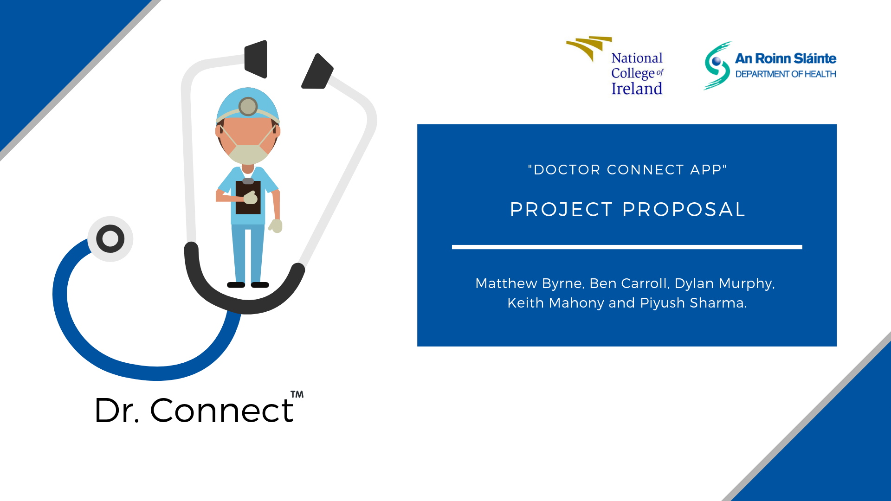

The next few pages will provide a full brief on the intentions of the project, broken down into more detail as outlined in the proposal template. We aim to divide up the work equally between our team, working not only from our past computing module skills, but also venture into new technologies such as NFC and Android Studio.

We hope this provides a greater perspective into how an application can come to life, bringing business entrepreneurial elements such as profit and marketing. It will be a combination of these factors that allow the project to move forward successfully.

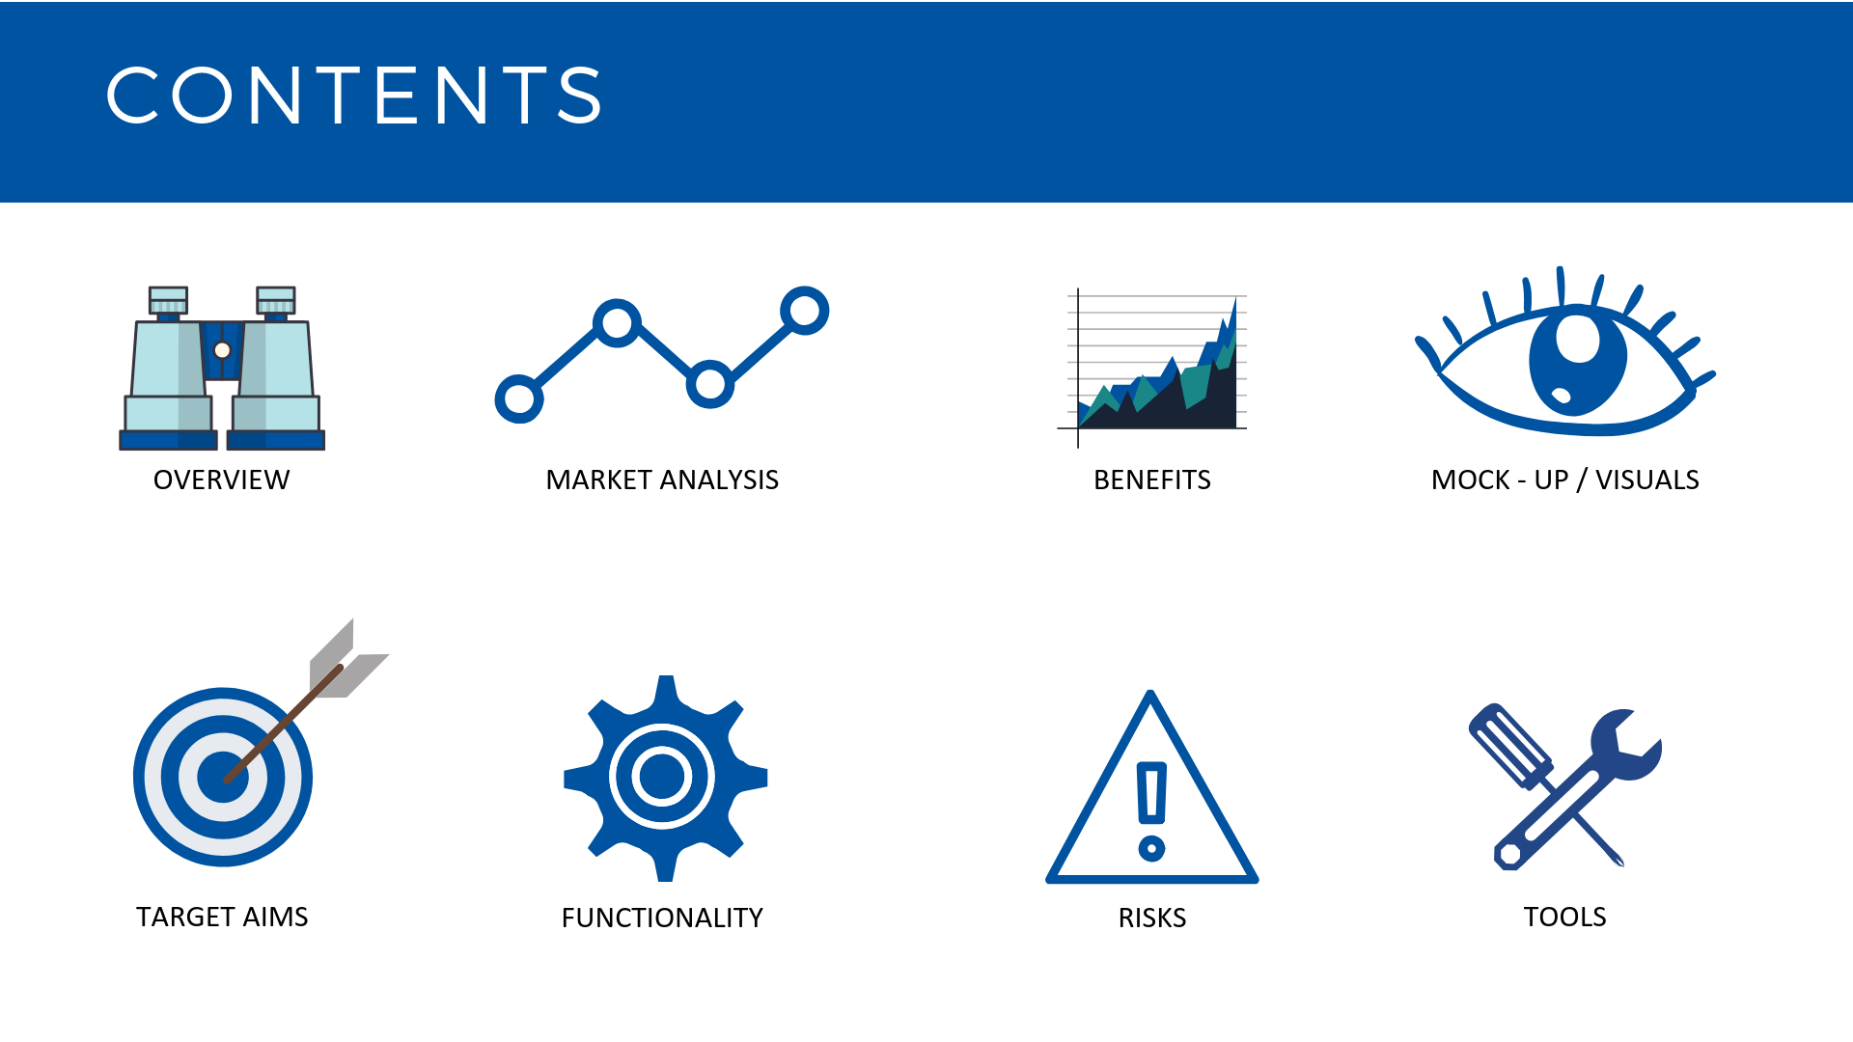As mentioned, the proposal will be sectioned off on each page, wrapped up with at the end with a conclusion.

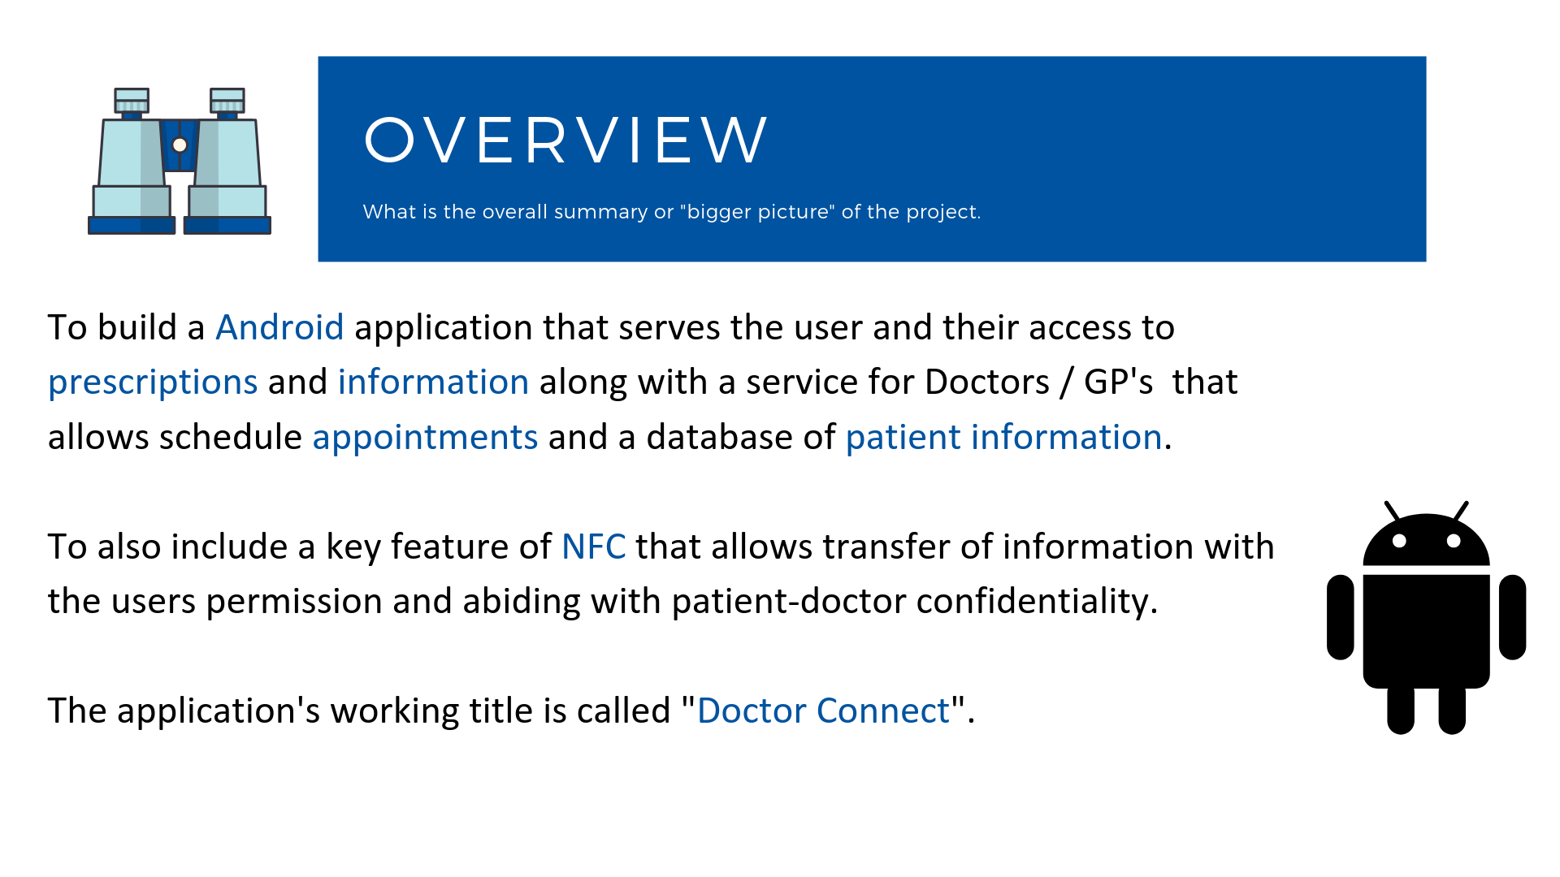

Our overview is simple and to the point, bringing its benefits and practicality to any user who wants to download and use the application.

We want to design an interface that will be practical for any Doctor / G.P or average user. But while having that simple ease of use from a customer perspective, design from a technical standpoint will have layers of great complexity and challenge.

This is where the NFC will come into play along with new software challenges of Android Studio. Some members in the group have not delved into this software yet, but we’re using this project as an opportunity to expand our knowledge in the area.

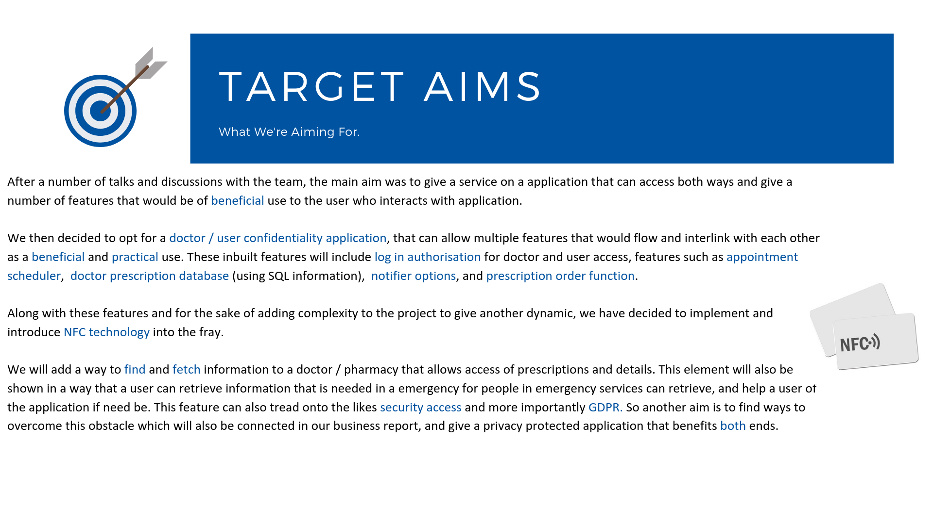

Our target aims break down what we will bring to the table in terms of features and technical information. There were discussions with the team back going back and forth in regards to NFC and Q.R related technologies. Making a call on this so early in our testing stages was the main challenge for us when we were creating the proposal of the project.

At first, we tried to engage with the college, bringing in a system that can work with Moodle. Then the team came up with an idea that would allow us to use the technologies we were toying with in a more practical way. This is where areas like medicine and health care came into the picture, eventually landing on the concept of “Doctor Connect”.

We were satisfied that the original technical premise of the idea in spirit was still there, now appearing in a more complete, constructed form. This then gave us the motivation to proceed with a more detailed plan and visualisation of what a “Doctor Connect” application would be.

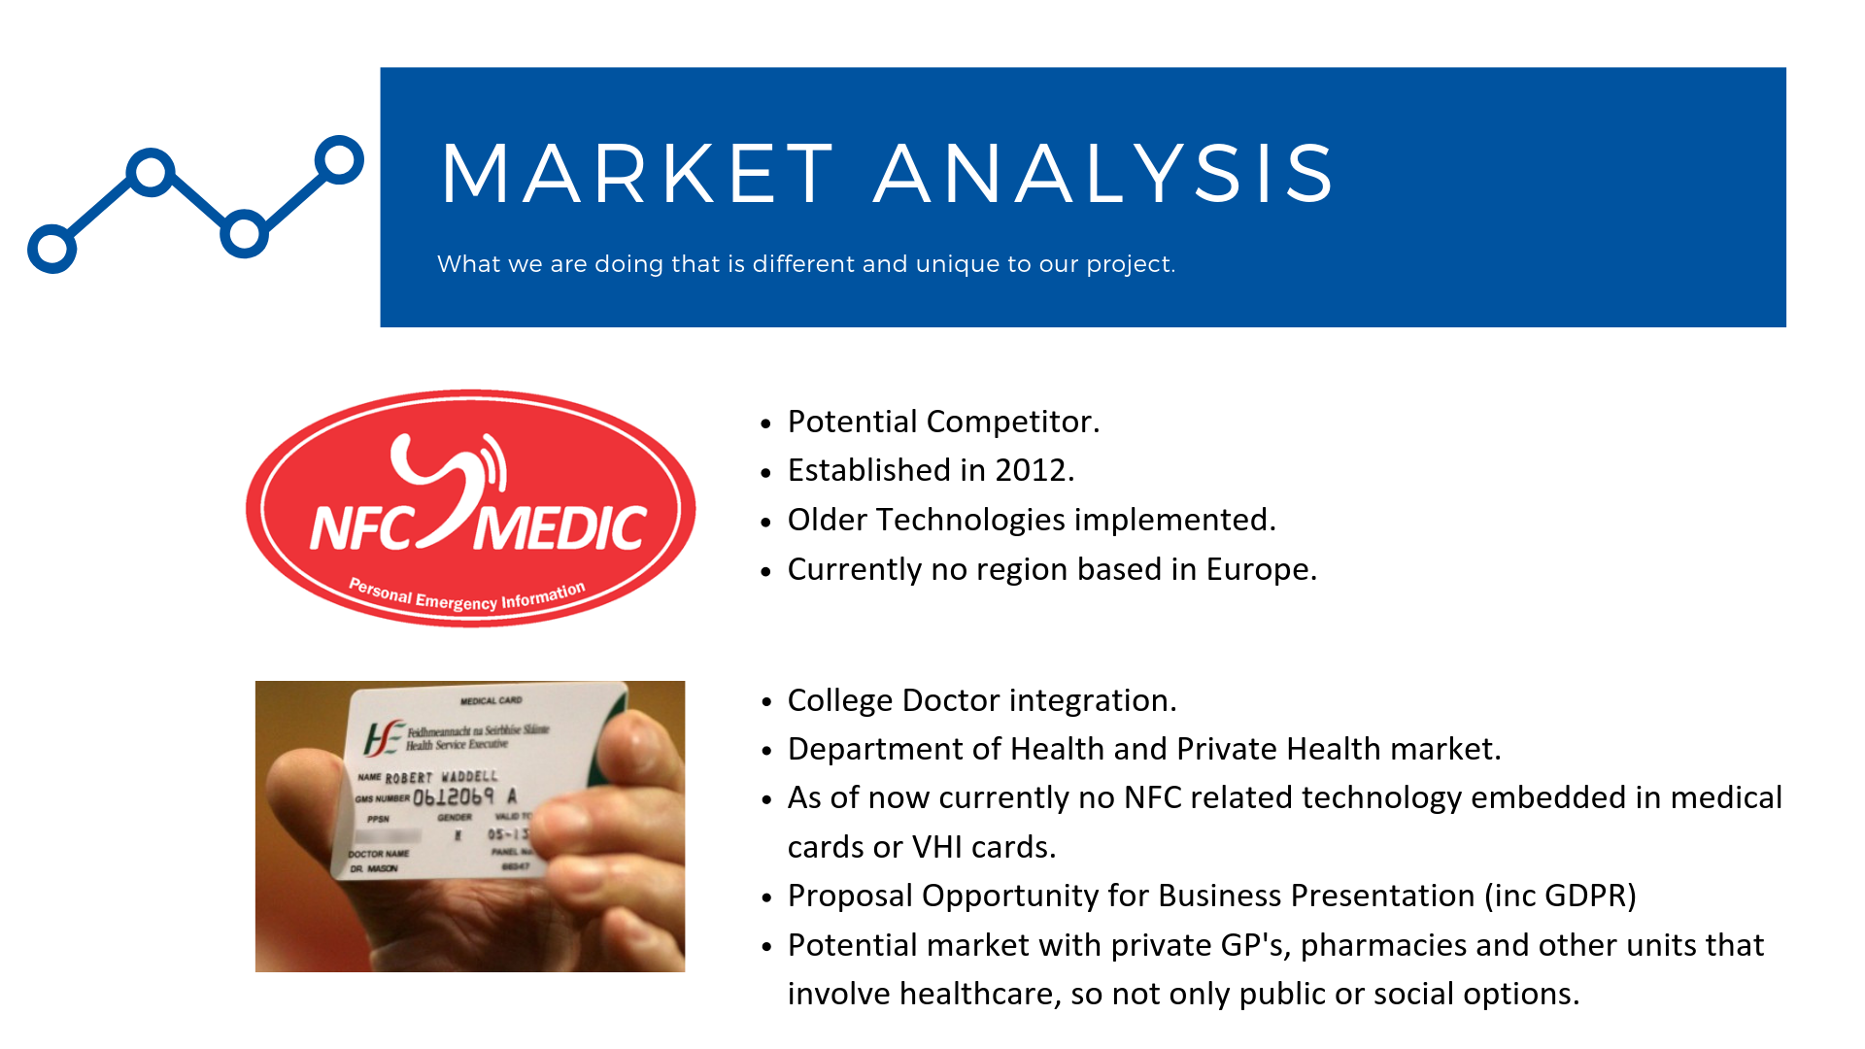

We have done analysis of the market and competitors, and have found that there could be a potential gap in the market for this type of application to be executed. There have been previous efforts that have used “Medic” style application and technology as shown above, but we feel that by adding the ability of NFC and giving an extra dynamic along with more importantly getting NFC right.

There is a lot of programs that include NFC that tend to be not efficient or useable enough in the market. It’s with this research and further details that will be included in the proposed business plan that will interlink with this project application that will highlight and give in more detail this information.

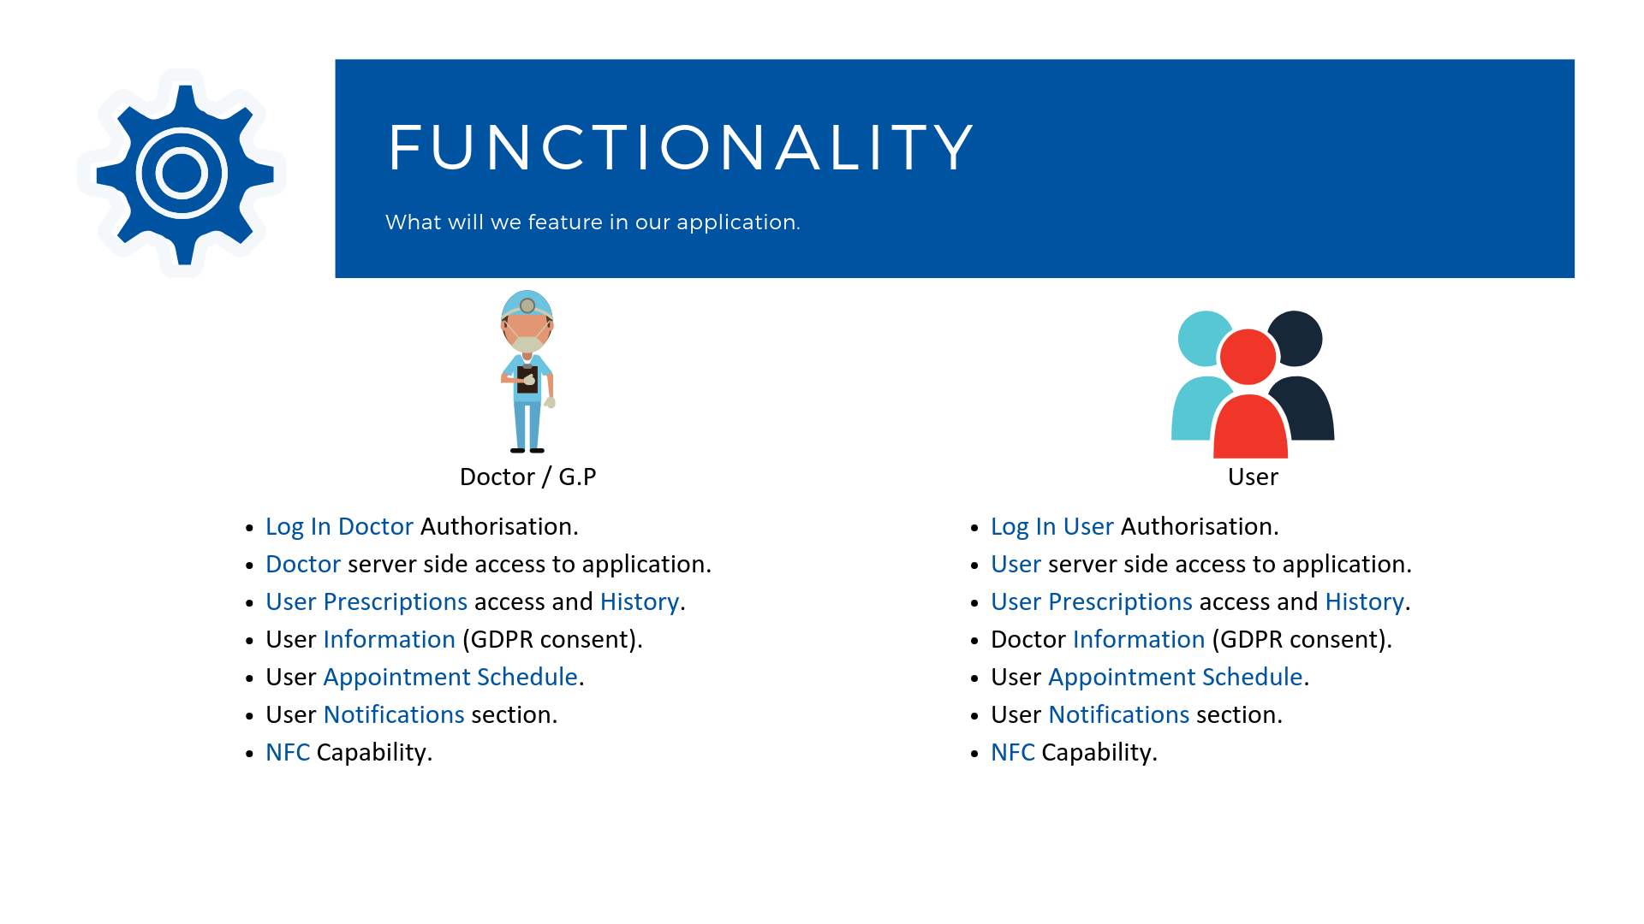

Listed above and then onto the next page will be the main proposed features and attributes of the main program. Due to the development and potential nature of testing and seeing what works and what does not, this is subject to change, but we hope to give these features through to the application in some shape or form. We looked at the idea of having two servers bounce off each other for user and doctor to give another form of complexity. This could be still introduced if we start to think that there can be a beneficial way to show the data onto the screen.

The backend and holding of information will be of massive importance in the project. That and along with the first development of the visual and coding with Android Studio, we look forward to seeing things move off the ground for the key features of this application.

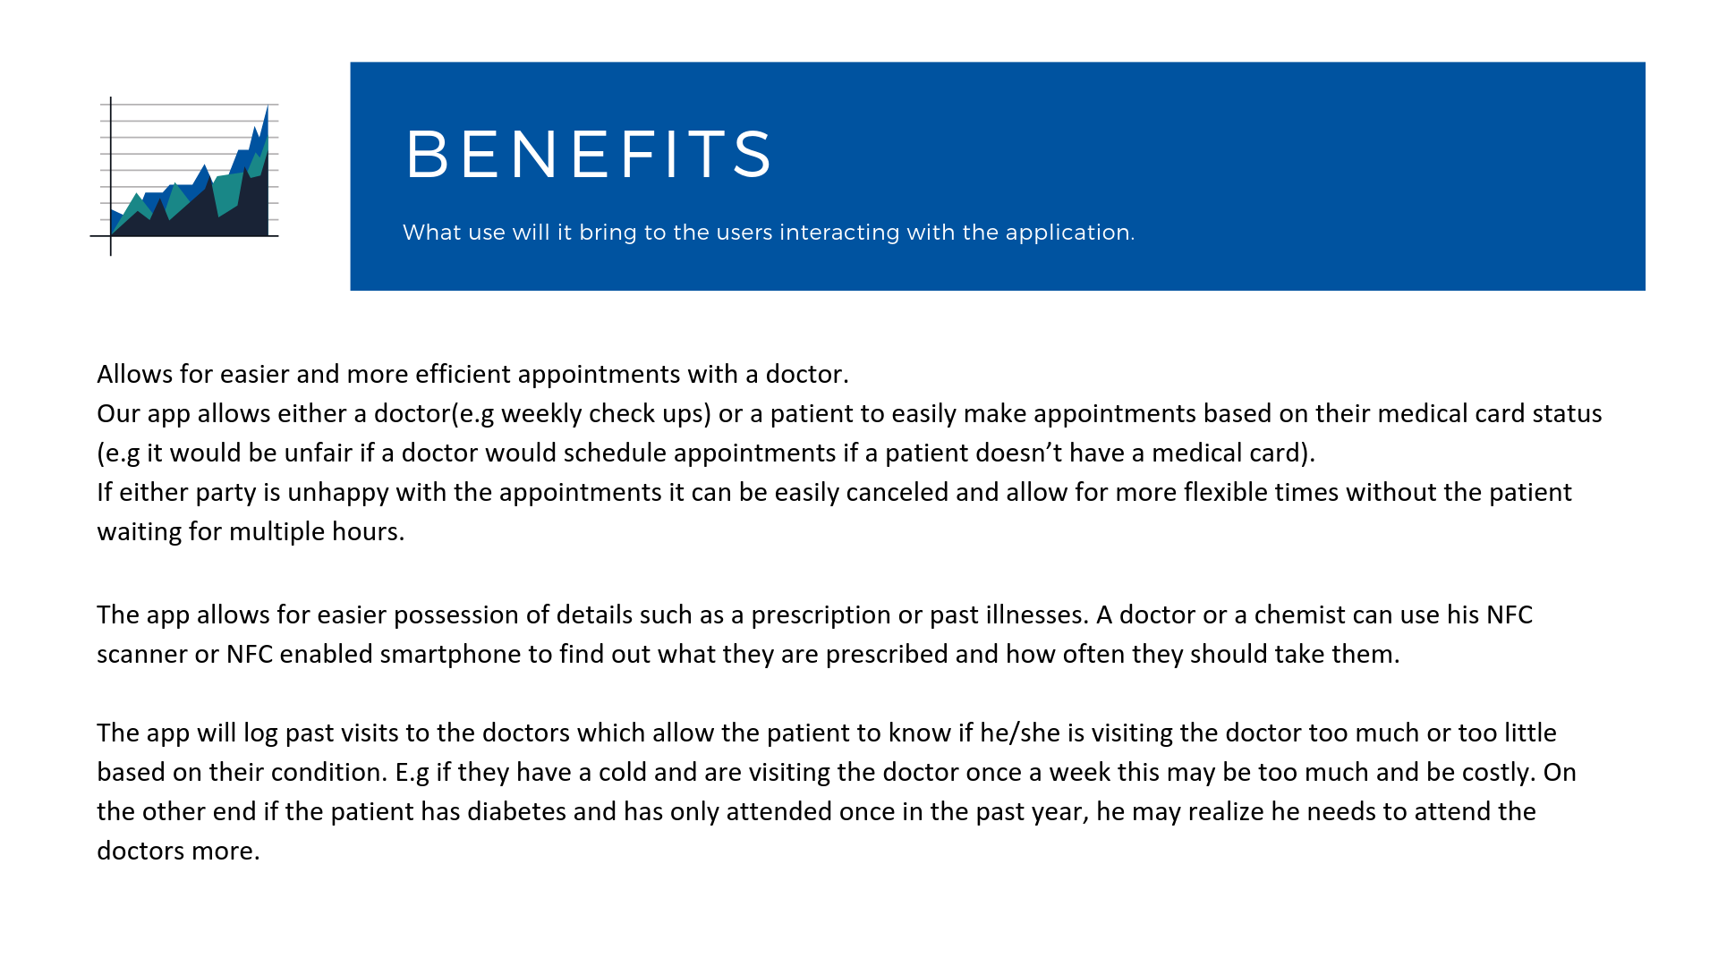

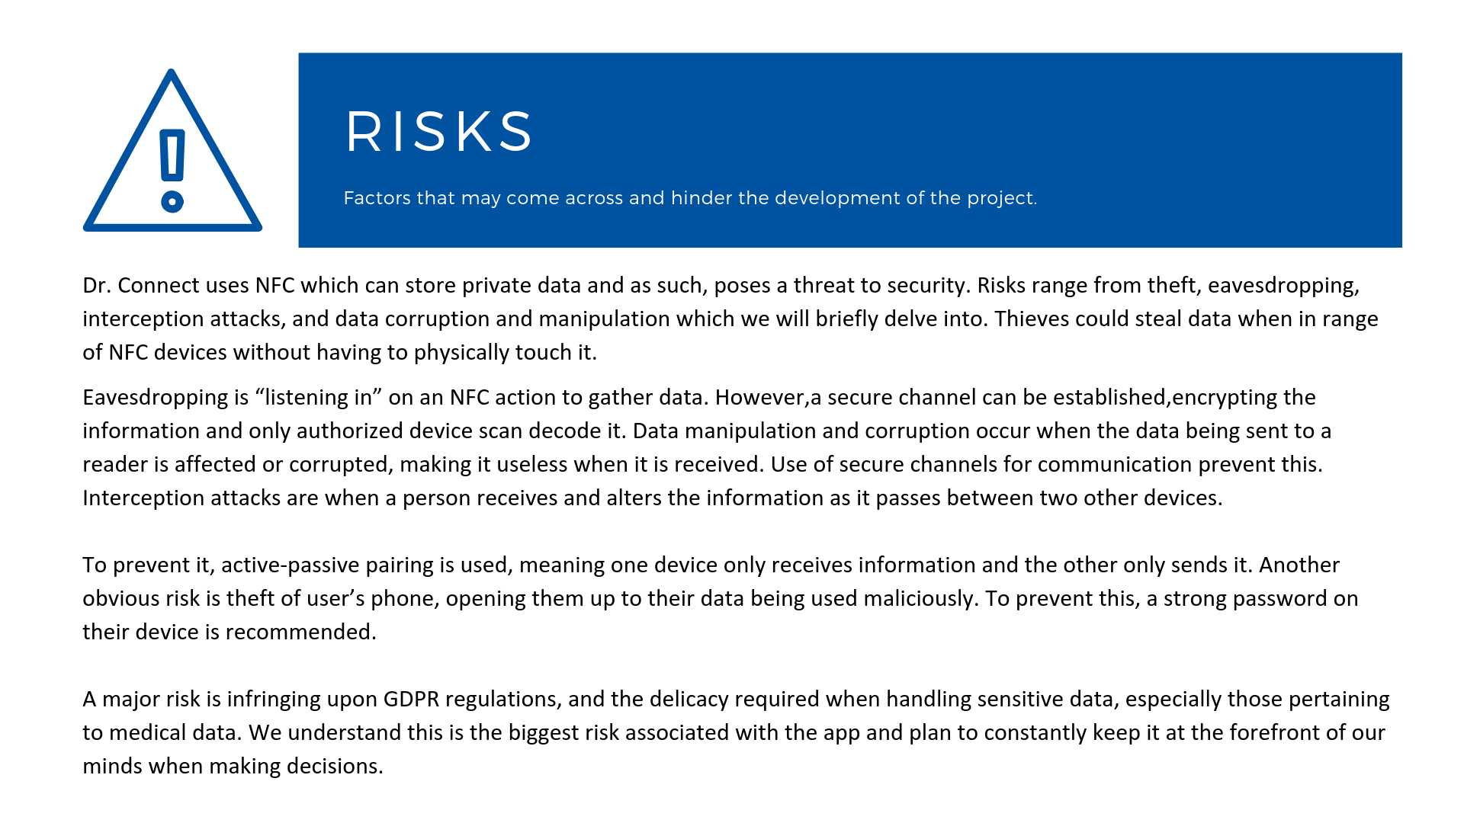

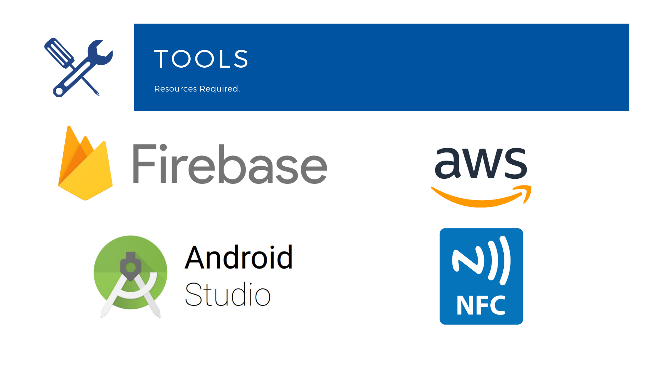

Bringing in previous or current module related skills is mandatory for a project of this scale, and we are delighted to bring in a SQL database as well as a fair chunk of Java, CSS and potentially some python scripting.

The main challenge or task is to bring every feature that we have and let them all connect with each other, allowing the enhancement and development of the application. In the team ourselves, some would favour server side scripting from past modules while others will prefer java or SQL etc.

It’s with this task and the task of the project leader to break up the tasks and have them on rotation so that everyone in the team will have a great technical perspective of working on the project while also getting through the workload. Also included in this document will be a Gantt Chart breaking down the workload of the project even further and give more insight and detail into the development of our project.

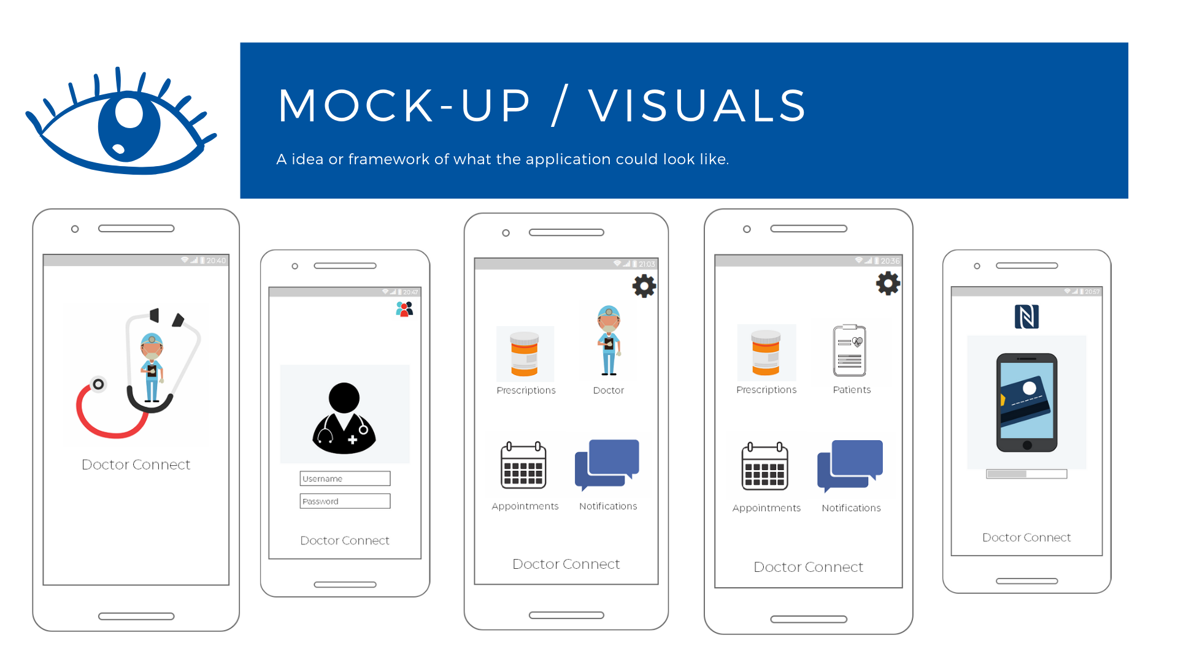

Our visual mock ups were created and designed using Balsamic software and so far with the consensus of the team will bring a prototype vision of what our application would look like. Going back to the introduction and overview, we wanted to give the user a simple yet practical way of accessing the app and it’s features while utilising the Android Studio software to be quick and responsive.

We will also want our interaction with NFC to be clear and shown in detail on the GUI of the application, bringing in a cog wheel for settings and a four-panel option layout of features that you can go in and out of.

For the log in and authorization screen and to keep things more compact and tidy, there will be a way to have two log in pages, one for Doctor and one for User. This can be accessed by clicking the top right icons on the log in screen which will alternate to whatever log in the user’s screen is displaying.

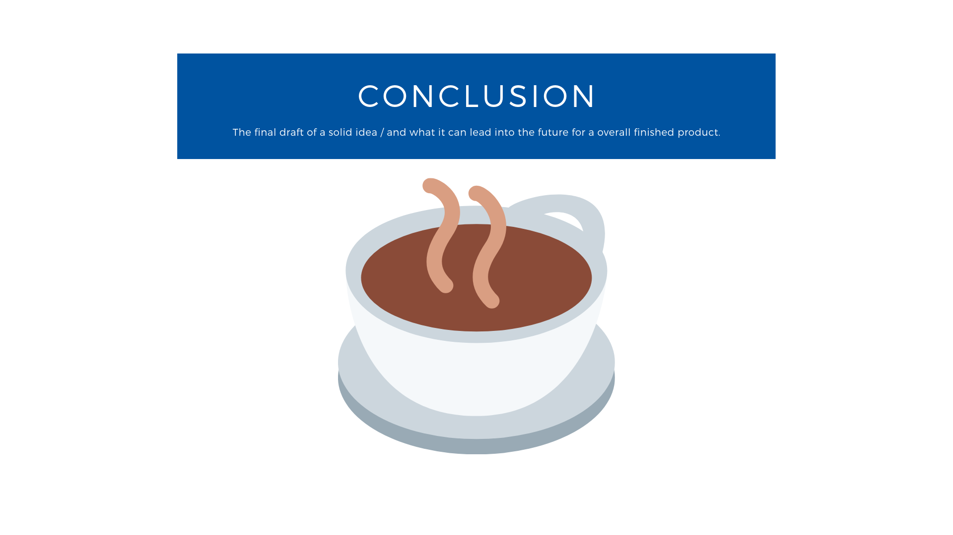

From the aims mentioned above, we hope to implement these services to enhance the relationship between doctor and user in a secure and friendly interface. We recognise there will be challenges faced from a technical standpoint and that patient privacy is priority. This will be one of our main focuses while developing this application. Along with this focus, and with the combination of our business entrepreneurship plan that we have in place for the application, we will present Dr. Connect in the way we envisioned it to be. This proposal can also be the first building block to where the direction of the application will end up in the future.

Challenging ourselves to explore new technologies and truly innovate, the team is jumping head first into software and hardware that we have mixed amounts of experience in. This aspect was particularly worrying when we needed to confirm our team's direction only a week or so after its initial formation. We wouldn’t even be in contact with an NFC Development Kit until after our project proposal was submitted, so we needed to think long and hard about how much pressure we were potentially placing on ourselves. However, we were all in agreement that this was an excellent opportunity to learn and develop our individual skillsets. So, with this in mind, we are incorporating the likes of Android Studio, Firebase and NFC into our design. More than simply a way to learn new things, the team is excited by the concept being proposed. If we could implement the features we intend to, the end result is potentially life changing for our target market.