**Improvements**

* Make color get darker as objects are closer to being destroyed
  + When playing on the endless mode, the difficulty determines the health of the asteroid, so when it is above easy mode the asteroid takes more than one shot to split, so change the color as the health of the object decreases to indicate how many shots it has left before splitting
* Be able to set the player color

**Bugs**

* If you hit the “New User” option twice then the file is written two twice with the same info, resulting in overlap

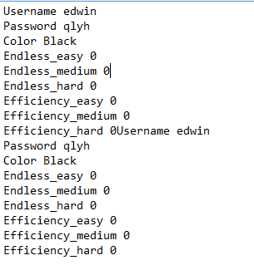

* When you choose the score option from the menu the score is not reset but is only hidden, the score should be reset
* If you choose to use an existing user and none of the fields are entered you will be prompted, but still be able to continue, you shouldn’t be able to play the game without having a user, a null text file is actually created now in the location place, but no file should ever be created.
* When you change difficulty or start a new game from the game over menu the objects on screen do not reset, they should reset to the base.
  + We have a reset ability so this should be easy to implement, it’s just Daimen not actually doing the work
* The player is not invincible when the menu is active, he should be
* Entering in an existing user with a wrong password brings up the correct prompt, but then an additional prompt saying that the username is unknown an then the game starts anyway.