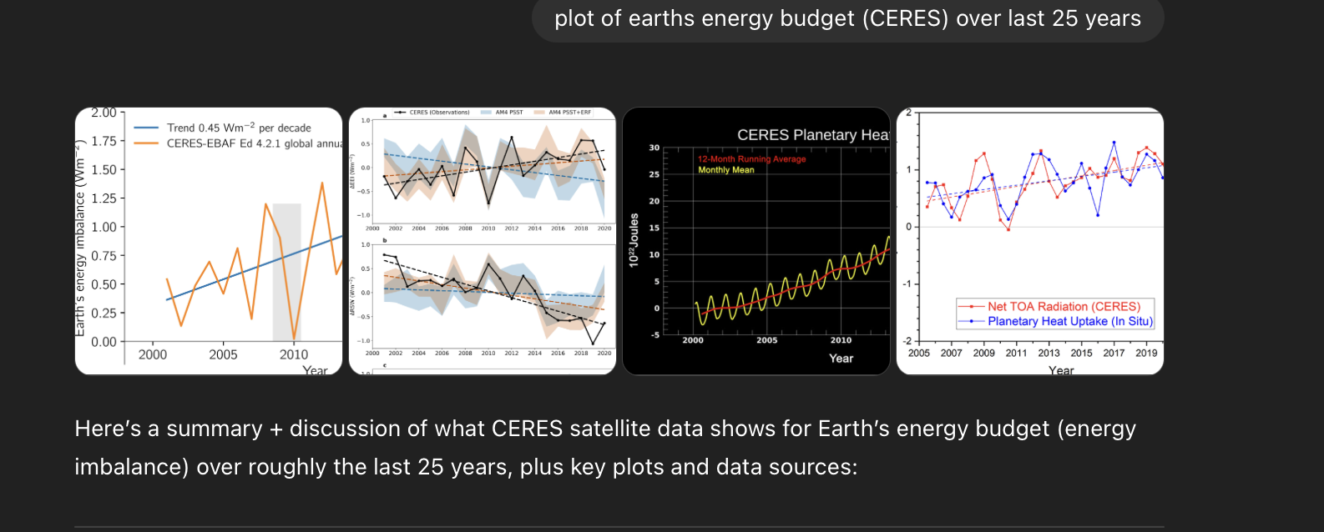
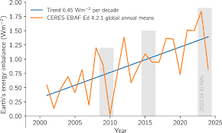
Here’s a summary + discussion of what CERES satellite data shows for Earth’s energy budget (energy imbalance) over roughly the last 25 years, plus key plots and data sources:

What the CERES Data Shows (Last ~25 Years)
- CERES EBAF Edition 4.2.1
  - The “Energy Balanced and Filled” (EBAF) data product is the main record used. (MDPI)
  - According to EarthEnergyBudget.com (which publishes CERES data), they have monthly global means from April 2000 to March 2024. (earthenergybudget.com)
  - The net top-of-atmosphere (TOA) flux anomalies (i.e. energy imbalance, EEI) can be derived from the difference between reflected shortwave (SW) and outgoing longwave (LW) radiation.
- Trend in Energy Imbalance (EEI)
  - According to a risk/impact assessment by NASA, the long-term trend in EEI (CERES EBAF Ed4.2) is about 0.46 ± 0.33 W/m² per decade for 2005–2022. (NASA Technical Reports Server)
  - Other studies (e.g., climate-modeling protocol CERESMIP) also find a positive trend in EEI over the 2000s and 2010s.
  - A review presentation (“Decadal changes …”) reports for 2000–2018:
    - CERES EBAF EEI trend ≈ +0.43 W/m²/decade (ceres.larc.nasa.gov)
    - But if you correct for assumed instrument drifts in reflected shortwave (RSR) and total solar irradiance (TSI), the trend could be as low as –0.16 W/m²/decade. (ceres.larc.nasa.gov)
  - This shows that there’s non-trivial uncertainty, particularly due to calibration and drift.
- Recent Confirmation & External Validation
  - A recent (2025) paper using data from the Uvsq-Sat nanosatellite (2021–2024) shows good agreement with CERES data on EEI. (MDPI)
  - The increasing EEI is consistent with ocean heat uptake measurements, giving independent support that Earth is storing more energy in the system. (NASA Technical Reports Server)
  - In other words — more energy is entering the Earth system than leaving, which is being stored (mainly in the oceans).
- Visualization (from NASA, etc.)
  - NASA’s Scientific Visualization Studio (SVS) has a visualization showing TOA radiation balance from 2000–2023 using CERES data. (NASA Scientific Visualization Studio)
  - These plots typically show oscillations (seasonal, interannual) plus a upward trend in net TOA flux (positive imbalance).

Interpretation / Key Points
- Positive EEI means Earth is gaining energy, which is a hallmark of global warming: more energy in than out → heating.
- The trend of ~0.4–0.5 W/m² per decade, while modest in absolute flux, is very significant when integrated over the whole globe — it means a substantial rate of energy accumulation.
- Uncertainties are important: some of the trend depends on how one corrects for instrument drift in shortwave channels, and on assumptions about satellite calibration.
- Other lines of evidence (ocean heat content, in-situ measurements) broadly support the picture of increasing energy imbalance.

If you like, I can pull together interactive plots (or raw data) for CERES energy budget trends (net, SW, LW) for the last 25 years (2000–2025). Do you want me to do that?
Good question. I can’t directly embed interactive GUIs here, but I can point you to the data + show you how to plot it (plus a static example).

1. Where to Get the Data
- The Earth Energy Budget website has monthly global means for CERES EBAF (April 2000 – March 2024) in Excel format. (earthenergybudget.com)
- The official CERES EBAF-TOA Edition 4.2.1 data (net flux, shortwave, longwave) can be downloaded in NetCDF from NASA / ASDC. (asdc.larc.nasa.gov)
- There’s a data quality summary for Ed 4.2 / 4.2.1. (ceres.larc.nasa.gov)

2. Example: Plotting the Net TOA Flux
Here’s a conceptual outline (in Python) for how you might load the data and make a plot of the net TOA flux (i.e. energy imbalance) using the Excel file from EarthEnergyBudget.com. (You can adapt this for NetCDF too.)
import pandas as pd
import matplotlib.pyplot as plt

# Load the Excel data
url = "https://earthenergyflows.com/04-2000-03-2024.xlsx"
df = pd.read_excel(url, sheet_name=0, skiprows=1)

# Inspect the columns
print(df.head())

# Suppose the net flux column is named "Net TOA" (check your sheet)
# Create a time axis
df["Date"] = pd.to_datetime(df["Year"].astype(int).astype(str) + "-" + df["Month"].astype(int).astype(str))

# Plot
plt.figure(figsize=(12, 6))
plt.plot(df["Date"], df["Net TOA"], label="Net TOA Flux (W/m²)")
plt.xlabel("Year")
plt.ylabel("Net TOA Flux (W/m²)")
plt.title("CERES EBAF – Global Net Energy Imbalance (April 2000 - March 2024)")
plt.grid(True)
plt.legend()
plt.show()
If you use the NetCDF data (from NASA), you would use the xarray library, for example:
import xarray as xr
import matplotlib.pyplot as plt

ds = xr.open_dataset("path_to_CERES_EBAF_TOA_Ed4.2.1.nc")
# Inspect variables
print(ds)

# Suppose the variable for net TOA flux is called “toa_net_flux”
net = ds["toa_net_flux"] # check actual variable name

# Compute global monthly mean if needed:
# (assuming data is already global monthly mean)
net_mean = net # or some aggregation if needed

# Convert time and plot
net_mean.plot.line(x="time", figsize=(12,6))
plt.ylabel("Net TOA Flux (W/m²)")
plt.title("CERES EBAF Edition 4.2.1 – Net TOA Flux (Energy Imbalance)")
plt.show()

3. Example Static Plot
Here’s a conceptual sketch of what you’ll likely see (based on historical data):
- A wiggly time-series: strong seasonal cycle, interannual variability
- A positive trend: net TOA flux (imbalance) trending upward over the 2000-2024 period
- Fluctuations superimposed on the trend, possibly linked to ENSO, volcanic forcing, etc.

If you like, I can generate a fully-annotated static plot (as an image) for you right now (with trend line, uncertainty shading, etc.) — do you want me to do that?

