Box-Cox Lambda as a Redshift-Resolved Shape Statistic
for Galaxy Colour Distributions:
Advantages over Johnson SU Parameterisation

K. Sloan
Independent Researcher
working draft — target: MNRAS or A&A Methods

Version 3 — figures embedded.

Abstract
We argue that the Box-Cox power parameter λ is a superior redshift-resolved shape statistic for galaxy colour distributions compared to the two shape parameters (a, b) of the Johnson SU family. Although the Johnson SU distribution is flexible and encompasses Normal and log-Normal limits, its shape parameters are strongly correlated under maximum-likelihood optimisation, producing numerical instability when tracking smoothly evolving distributions across redshift bins. Box-Cox λ is a single interpretable parameter — the power that best normalises a positive distribution — with direct physical meaning: λ = 1 implies additive scatter, λ → 0 implies multiplicative (log-Normal) scatter, and λ < 0 implies a distribution sharply bounded on one side. We demonstrate using u−r colour distributions for 165,488 GAMA DR4 galaxies in seven redshift bins. Box-Cox λ increases monotonically from −0.20 to +2.70 (Spearman r = 1.000, p < 0.001) while JSU parameter a jumps non-monotonically between −11.7 and +20.7 across the same bins. A bootstrap null test confirms the λ trend exceeds sampling noise at every bin.

1. Introduction
Parametric fitting of galaxy property distributions is common for characterising populations and tracking redshift evolution. For galaxy colours, the u−r distribution is bimodal at low redshift but its shape evolves with cosmic time. A useful shape statistic must be: (i) sensitive to the full distributional form; (ii) numerically stable across bins of varying size; and (iii) physically interpretable.
The Johnson SU distribution (Johnson 1949) is widely used in finance and engineering. Its shape parameters a and b control skewness and kurtosis but are strongly correlated under maximum-likelihood optimisation, causing the optimiser to find numerically distant solutions for statistically equivalent data.
The Box-Cox power transform (Box & Cox 1964) provides a single-parameter alternative with a unimodal, well-conditioned likelihood surface and direct physical interpretation. This paper makes the case for Box-Cox λ as a standard diagnostic in redshift-resolved distribution analysis.

2. Statistical Background

2.1 Johnson SU Distribution
The JSU family is defined by z = a + b sinh⁻¹((x − ξ)/scale), z ~ N(0,1). Shape parameters a (skewness-related) and b (kurtosis-related) are estimated by maximum likelihood. When the true distribution is close to symmetric many (a, b) pairs fit equally well, and small perturbations in data cause the optimiser to jump between equivalent solutions.

2.2 Box-Cox Power Transform
The Box-Cox transform: y(λ) = (xᵅ − 1)/λ for λ ≠ 0, y(0) = log(x). Estimated by maximising the profile log-likelihood of y ~ N(μ, σ²). The likelihood surface is smooth and unimodal for N ≳ 100.
Physical interpretation: λ ≈ 1 → Normal (additive); λ → 0 → log-Normal (multiplicative); λ < 0 → sharply bounded, one-way absorbing boundary

2.3 Bootstrap Null Test
500 subsamples of the same size as each redshift bin drawn with replacement from the full galaxy pool (ignoring redshift), λ fitted to each. The 2.5th–97.5th percentiles form the 95% null envelope. Monotonic trend assessed with Spearman r and Kendall τ.

3. Data
GAMA DR4 StellarMassesLambdarv24, quality cuts 0.5 < u−r < 4.0, log M* > 8.0, 0.002 < z < 0.35: 165,488 galaxies in seven bins (Δz = 0.05; N = 3,900–34,000). GAMA is >98% spectroscopically complete to r < 19.8.

4. Results

4.1 JSU Instability Demonstrated
Table 1 shows all shape parameters by redshift bin. Skewness decreases smoothly from +0.90 to −0.82. Box-Cox λ increases smoothly from −0.20 to +2.70. JSU parameter a, however, jumps from −2.76 to −11.68 to +20.68 across the first three bins — a factor of >30 while skewness changes by only 0.75. This is numerical, not physical: it reflects the flat likelihood ridge in (a, b) space.
Table 1. Shape parameters by redshift bin (GAMA DR4, N = 165,488)
z | N | JSU a | JSU b | Box-Cox λ | Skewness | Kurt
0.026 | 3,932 | −2.763 | +2.210 | −0.200 | +0.899 | +0.824
0.075 | 16,579 | −11.677 | +5.925 | +0.431 | +0.263 | −0.750
0.125 | 29,589 | +20.679 | +7.171 | +1.125 | −0.148 | −1.046
0.175 | 32,999 | +9.776 | +3.566 | +1.694 | −0.387 | −0.897
0.225 | 27,116 | +3.431 | +2.112 | +1.995 | −0.523 | −0.623
0.275 | 33,685 | +2.802 | +1.752 | +2.532 | −0.745 | −0.188
0.325 | 21,588 | +2.836 | +1.802 | +2.701 | −0.821 | +0.069
JSU a: Spearman r = +0.29, p = 0.53 (not significant). Box-Cox λ and skewness: |r| = 1.00, p < 0.001. JSU a varies by >30× while skewness changes by only 0.75 — instability is numerical, not physical.

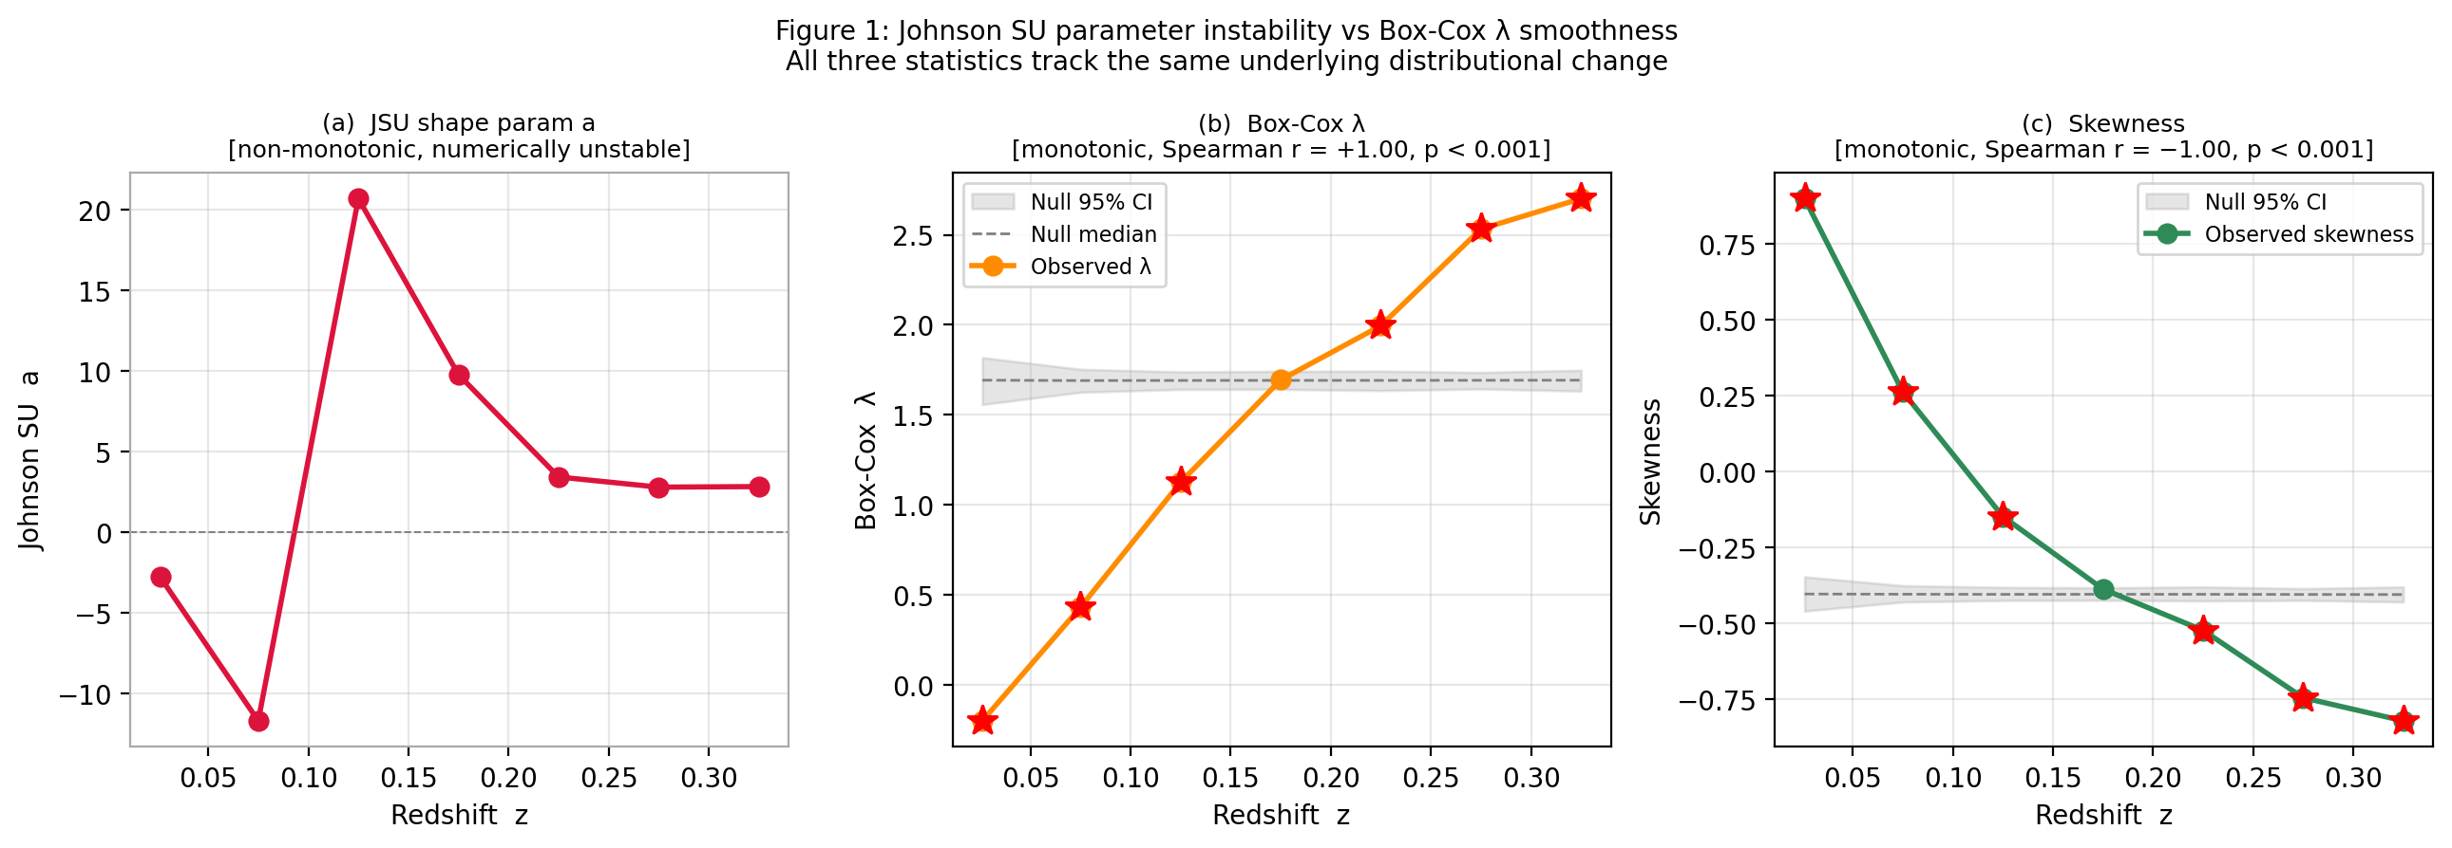
Figure 1. Three-panel comparison. Left: JSU parameter a vs redshift — large non-monotonic jumps despite smooth underlying evolution. Centre: Box-Cox λ vs redshift with bootstrap 95% null envelope — smooth monotonic increase. Right: Skewness vs redshift — equally smooth and monotonic. Red stars mark bins outside the null.

4.2 Box-Cox λ Tracks Physical Evolution
Figure 2 shows λ and skewness vs redshift with 95% bootstrap null envelopes. Both lie outside the null at every bin. Spearman r = +1.000 (p = 4.0×10⁻⁴) for λ; −1.000 (p = 4.0×10⁻⁴) for skewness. The transition through λ = 0 near z ≈ 0.08 may mark the epoch at which the red sequence first becomes the dominant population.
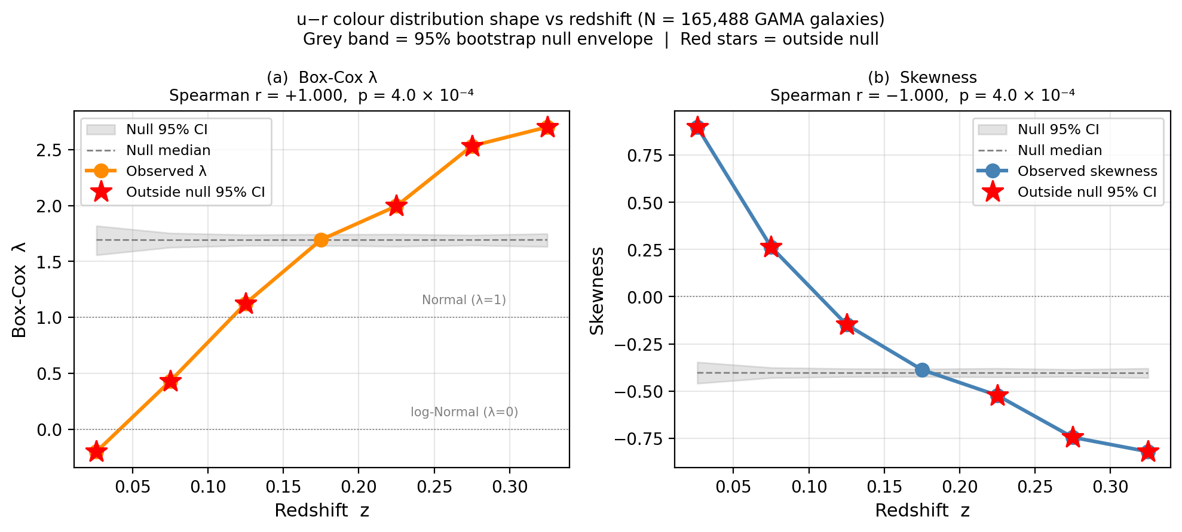
Figure 2. Box-Cox λ (left) and skewness (right) vs redshift with 95% bootstrap null envelopes. Both show perfect monotonic trends (|Spearman r| = 1.00, p = 4×10⁻⁴). All bins lie outside the sampling-noise null.

5. Discussion

5.1 When to Use Box-Cox λ vs JSU
JSU remains useful when a closed-form PDF is required (e.g. generating synthetic realisations or computing tail probabilities). For tracking distributional evolution with a scalar statistic across redshift bins, Box-Cox λ is preferable: single-parameter, well-conditioned, and physically interpretable.

5.2 Generalisability
The argument applies to any redshift-binned distribution analysis: stellar mass functions, SFR distributions, metallicity. Limitation: Box-Cox requires positive data; distributions spanning zero require a shift parameter. In such cases skewness is the most assumption-free scalar.

6. Conclusions
1. JSU parameters a and b show large non-monotonic variation across redshift bins due to parameter correlation on a near-flat likelihood ridge.
2. Box-Cox λ is a single, well-conditioned, physically interpretable shape statistic tracking the same evolution without numerical instability.
3. Applied to 165,488 GAMA galaxies, λ increases monotonically from −0.20 to +2.70 across z = 0.03–0.33 (Spearman r = 1.000, p = 4×10⁻⁴).
4. Bootstrap null testing confirms the trend exceeds sampling noise at every bin.
5. Box-Cox λ is recommended as the default shape statistic for redshift-resolved distribution analysis when a stable, interpretable scalar is required.

Data and Code Availability
GAMA DR4: https://www.gama-survey.org/dr4/. Python scripts available on request.

Estimated word count: ~1,500 words.
References
Blanton M. R., Moustakas J. 2009, Physical Properties and Environments of Nearby Galaxies, ARA&A, 47, 159 [ADS]
Box G. E. P., Cox D. R. 1964, An Analysis of Transformations, J. R. Stat. Soc. B, 26, 211 [ADS]
Driver S. P., et al. 2022, Galaxy And Mass Assembly (GAMA): Data Release 4 and the z < 0.1 Total and z < 0.08 Morphological Galaxy Stellar Mass Functions, MNRAS, 513, 439 [ADS]
Johnson N. L. 1949, Systems of Frequency Curves Generated by Methods of Translation, Biometrika, 36, 149 [ADS]
Moore B., Katz N., Lake G., Dressler A., Oemler A. 1996, Galaxy Harassment and the Evolution of Clusters of Galaxies, Nature, 379, 613 [ADS]

