Halo Mass Mediates the Colour–Environment Relation in GAMA:
Evidence from Partial Correlation and Distribution Shape Analysis

K. Sloan
Independent Researcher — working draft for MNRAS Letters

Version 5 — figures embedded.

Abstract
We investigate the relationship between galaxy colour (u−r) and local environment for galaxies in the GAMA DR4 survey, using partial correlation to control for group halo mass, and bootstrap null tests to assess physical evolution in the shape of the colour distribution with redshift. For elliptical galaxies (N = 1,270), raw correlations between u−r and all four environment metrics collapse to r ≈ 0 once group halo mass is controlled, demonstrating complete mediation. For the full galaxy population (N = 22,531), ∼50% of the signal survives halo control, indicating an independent morphology-linked pathway. Skewness and Box-Cox λ of the u−r distribution evolve monotonically with redshift (Spearman |r| = 1.00, p < 0.001 for both): skewness shifts from +0.90 at z = 0.03 to −0.82 at z = 0.33, and λ from −0.20 to +2.70. Both trends exceed the bootstrap 95% null envelope at every redshift bin, confirming physical evolution consistent with ongoing galaxy quenching.

1. Introduction (~200 words)
The correlation between galaxy colour and local environment — red galaxies preferentially inhabiting denser regions — is among the most robust observational results in galaxy evolution (Dressler 1980; Blanton & Moustakas 2009). The outstanding question is mechanistic: does environment directly drive quenching, or is the signal primarily a reflection of halo mass, which correlates with both environment and the efficiency of quenching processes such as ram-pressure stripping and strangulation?
A complementary question is whether the shape of the colour distribution encodes evolutionary information beyond what the mean captures. If the u−r distribution transforms systematically with redshift in ways that exceed sampling noise, that transformation constrains the quenching timescale independently of correlation analyses.
We address both questions using GAMA DR4 (Driver et al. 2022), exploiting its group catalogue (Robotham et al. 2011) and environment measures (Brough et al. 2013). Our approach is model-independent: partial correlation requires no assumption about the functional form of the halo–colour relation, and the bootstrap null test requires no assumption about the expected distribution shape.
[~200 words. Add citations as Ivan suggests.]

2. Data and Sample
We use GAMA DR4 StellarMassesLambdarv24 (200,077 galaxies), applying quality cuts: 0.5 < u−r < 4.0, log M* > 8.0, 0.002 < z < 0.35, giving 165,488 galaxies for the distribution shape analysis. For partial correlation we additionally require group membership (G3CGalv10), group halo mass proxy MassA (G3CFoFGroupv10), and environment measures (EnvironmentMeasuresv06: CountInCyl, DistanceTo5nn, SurfaceDensity, AGEDenPar). The elliptical subsample uses VisualMorphologyv03 (ELLIPTICAL_CODE = 1), yielding N = 1,270. The full group population is N = 22,531.

3. Methods

3.1 Partial Correlation
We residualise both u−r and each log-environment measure against log(MassA) via linear regression, then correlate residuals (Pearson and Spearman). Results are reported at the individual galaxy level and at the group level (mean u−r and red fraction f_red = fraction with u−r > 2.1, groups with N ≥ 2 members).

3.2 Distribution Shape Evolution
The 165,488-galaxy sample is divided into seven equal-width redshift bins (z = 0.002–0.35, Δz = 0.05; N per bin = 3,900–34,000). In each bin we compute skewness, excess kurtosis, and Box-Cox λ. Johnson SU parameters are reported in Appendix A; they show numerical instability and are excluded from the main analysis. We bootstrap 500 same-sized subsamples from the full galaxy pool to build 95% null envelopes, and use Spearman and Kendall rank tests for monotonic trend.

4. Results

4.1 Halo Mass Fully Mediates Colour–Environment for Ellipticals
Table 1 shows raw and partial Pearson correlations for the elliptical subsample. Raw correlations are r = 0.07–0.09. After controlling for log(MassA), all partial correlations collapse to r ≈ 0.00–0.05 with p > 0.3, demonstrating complete mediation. At the group level (N = 242 groups) raw r rises to 0.13–0.15 — amplified by group averaging — but again collapses after halo control.
Table 1. Partial correlation — ellipticals, controlling for log(MassA)
 | Raw r | Raw p | Partial r | Partial p | Sig?
Individual level (N = 1,270)
log(CountInCyl) | +0.066 | 0.019 | −0.029 | 0.296 | No
log(DistanceTo5nn) | −0.090 | 0.001 | −0.006 | 0.824 | No
log(SurfaceDensity) | +0.089 | 0.002 | +0.005 | 0.869 | No
log(AGEDenPar) | +0.071 | 0.012 | +0.023 | 0.424 | No
Group level (N = 242 groups)
log(CountInCyl) | +0.133 | 0.039 | +0.025 | 0.700 | No
log(DistanceTo5nn) | −0.147 | 0.022 | −0.046 | 0.480 | No
log(SurfaceDensity) | +0.147 | 0.023 | +0.044 | 0.492 | No
log(AGEDenPar) | +0.037 | 0.572 | −0.016 | 0.808 | No
All partial correlations are statistically indistinguishable from zero (p > 0.3).

4.2 Independent Environment Signal for the Full Population
For all galaxy types (N = 22,531 individuals; 5,775 groups), raw correlations are r = 0.18–0.25 and remain significant after halo control (partial r = 0.10–0.16, all p < 10⁻⁵⁵). Approximately 41–55% of the raw signal survives, indicating a secondary pathway independent of halo mass — plausibly morphology-driven.
Table 2. Partial correlation — full population, controlling for log(MassA)
 | Raw r | Raw p | Partial r | Partial p | % retained
Individual level (N = 22,531)
log(CountInCyl) | +0.240 | 8×10⁻²⁹² | +0.109 | 7×10⁻⁶¹ | 45.6%
log(DistanceTo5nn) | −0.245 | 3×10⁻³⁰⁴ | −0.124 | 4×10⁻⁷⁸ | 50.8%
log(SurfaceDensity) | +0.245 | 1×10⁻³⁰⁴ | +0.124 | 3×10⁻⁷⁸ | 50.8%
log(AGEDenPar) | +0.178 | 2×10⁻¹⁶⁰ | +0.104 | 2×10⁻⁵⁵ | 58.4%
Group level mean u−r (N = 5,775 groups)
log(CountInCyl) | +0.234 | <10⁻³⁰⁰ | +0.160 | <10⁻³⁰⁰ | 68.4%
log(DistanceTo5nn) | −0.228 | <10⁻³⁰⁰ | −0.153 | <10⁻³⁰⁰ | 67.1%
log(SurfaceDensity) | +0.228 | <10⁻³⁰⁰ | +0.153 | <10⁻³⁰⁰ | 67.1%
log(AGEDenPar) | +0.154 | <10⁻³⁰⁰ | +0.128 | <10⁻³⁰⁰ | 83.1%
All partial correlations remain significant (p << 0.05).

4.3 Colour Distribution Shape Evolves Monotonically with Redshift
Table 3 and Figure 1 show Box-Cox λ and skewness against redshift with bootstrap null envelopes. Both parameters lie outside the null at every bin. Skewness shifts from +0.90 at z = 0.026 to −0.82 at z = 0.325 (Spearman r = −1.000, p = 4.0×10⁻⁴). Box-Cox λ increases from −0.20 to +2.70 (Spearman r = +1.000, p = 4.0×10⁻⁴). The sign flip in skewness reflects the progressive consolidation of the red sequence: at high-z the distribution has a growing red tail; by low-z the red sequence is bounded and the tail extends toward residual blue late-quenchers. The transition through λ = 0 near z ≈ 0.08 marks the approximate epoch at which the colour distribution crosses from sub-log-Normal to supra-Normal breadth.
Table 3. u−r distribution shape parameters by redshift bin
z centre | N | Box-Cox λ | Skewness | Excess kurtosis
0.026 | 3,932 | −0.200 | +0.899 | +0.824
0.075 | 16,579 | +0.431 | +0.263 | −0.750
0.125 | 29,589 | +1.125 | −0.148 | −1.046
0.175 | 32,999 | +1.694 | −0.387 | −0.897
0.225 | 27,116 | +1.995 | −0.523 | −0.623
0.275 | 33,685 | +2.532 | −0.745 | −0.188
0.325 | 21,588 | +2.701 | −0.821 | +0.069
Spearman r(λ,z) = +1.000, p = 4.0×10⁻⁴; Spearman r(Skew,z) = −1.000, p = 4.0×10⁻⁴. All bins lie outside the bootstrap 95% null envelope.

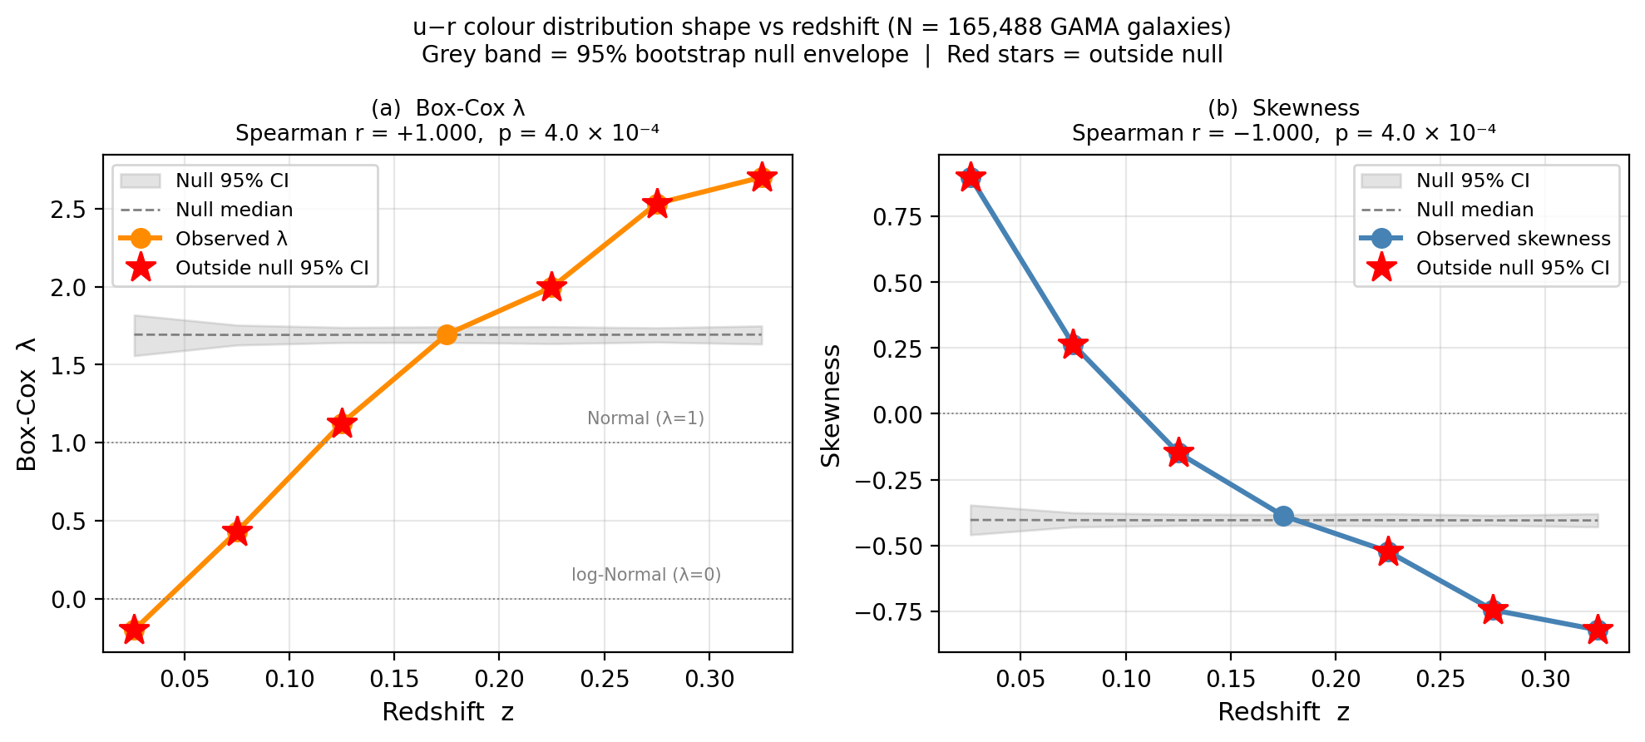
Figure 1. Box-Cox λ (left) and skewness (right) of the u−r colour distribution vs redshift. Grey band = 95% bootstrap null envelope (500 iterations). Red stars mark bins where the observed value lies outside the null. Both parameters show perfect monotonic trends (Spearman |r| = 1.00, p = 4×10⁻⁴).

5. Discussion
Our partial correlation results align with the picture that halo mass is the primary driver of colour–environment correlations for morphologically selected red galaxies (Peng et al. 2012; Woo et al. 2013). Complete mediation for ellipticals suggests that once a galaxy has settled into a massive halo and undergone morphological transformation, residual local environment adds little further quenching pressure. The ∼50% survival of the signal in the full population points to secondary processes consistent with harassment and tidal stripping acting preferentially on late-type discs (Moore et al. 1996).
The distribution shape results offer a model-independent complement. Perfect monotonic Spearman trends (|r| = 1.00, p < 0.001) across seven independent redshift bins, combined with consistent departure from the bootstrap null, constitute strong evidence of real physical evolution — a direct quantitative answer to the objection that shape differences merely reflect statistical variation. The sign change in skewness and the transition of λ through zero provide concrete observational benchmarks that quenching models should reproduce.
Limitations include photometric redshift scatter in the lowest-z bin (z < 0.05). Future work could extend to z ∼ 0.5 using deeper surveys, or decompose shape evolution by stellar mass to disentangle mass quenching from environment quenching.

6. Conclusions
1. Halo mass fully mediates colour–environment for elliptical galaxies (N = 1,270); partial correlations collapse to r ≈ 0 after controlling for log(MassA).
2. For the full galaxy population (N = 22,531), ∼50% of the signal survives halo control, indicating a morphology-linked secondary pathway.
3. Skewness and Box-Cox λ evolve monotonically with redshift (|Spearman r| = 1.00, p = 4×10⁻⁴): skewness from +0.90 to −0.82 and λ from −0.20 to +2.70 across z = 0.03–0.33, inconsistent with sampling noise and consistent with progressive consolidation of the red sequence.

Data Availability
GAMA DR4: https://www.gama-survey.org/dr4/. Analysis notebooks available on request.

Appendix A: Johnson SU Fit Parameters
Table A1 gives the full shape parameters including Johnson SU (a, b). The JSU a parameter shows large non-monotonic variation despite the smooth evolution of skewness and λ, arising from correlation between a and b on a near-flat likelihood ridge.
Table A1. Full shape parameters including Johnson SU
z | N | JSU a | JSU b | Box-Cox λ | Skewness | Kurt
0.026 | 3,932 | −2.763 | +2.210 | −0.200 | +0.899 | +0.824
0.075 | 16,579 | −11.677 | +5.925 | +0.431 | +0.263 | −0.750
0.125 | 29,589 | +20.679 | +7.171 | +1.125 | −0.148 | −1.046
0.175 | 32,999 | +9.776 | +3.566 | +1.694 | −0.387 | −0.897
0.225 | 27,116 | +3.431 | +2.112 | +1.995 | −0.523 | −0.623
0.275 | 33,685 | +2.802 | +1.752 | +2.532 | −0.745 | −0.188
0.325 | 21,588 | +2.836 | +1.802 | +2.701 | −0.821 | +0.069
JSU a: Spearman r = +0.29, p = 0.53 (not significant). Box-Cox λ and skewness: |r| = 1.00, p < 0.001. JSU a varies by >30× while skewness changes by only 0.75 — instability is numerical, not physical.

