Mobile Application Mini Project Report

***Name: Vuong Lam Kiet***

***ID: ITITIU14050***

***Part 1: Brief Description***

This Mini Project is deployed on iOS platform, currently compatible with iPhone display. Main goal of this app named “Place” is for the user to view the many places review and also add or edit the review of places to the app. Currently the app can only contain data in a static device only.

***Part 2: Detail Description***

* **Functions:**

1. *List View – SearchBar:*

The application have the ability to display a certain amount of sample places review (3 places) with full detailed review hidden behind it in a list, there is also a SearchBar for searching the places name via keyword matching

1. *Detailed review:*

Each places review is comprised of many detail information, can be viewed, edited, deleted. The detail information will be shown when we tap on a specific place review.

1. *User Text Authentication:*

In order to keep data clean and avoid messy creation of place, User must enter ID and Places Name in order to unlock the Save button to save the place to the list.

1. *Image – Graphic – Animation:*

The app features many moving animation from iOS platform, to animated the transitions between views and actions.

In the detail review page, we have an ImageView that when tapped will invoke an action sheet, that allow User to choose between taking an image using Camera or choose one from PhotoLibrary

The app has an app icon, a launch screen image that extend from the app icon.

1. *Custom control:*

Beside the rating for the many specific parts like Food Quality, Cost Rate, Service Quality. The app features a custom Star Rating for the Overall Rating of the place

1. *Data Persist:*

After you have added or edited a place from the list, then quit the app, all of the data will still be there the next time you open the app

* **App Demo Images:**

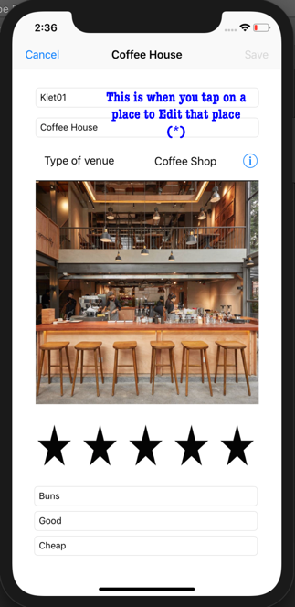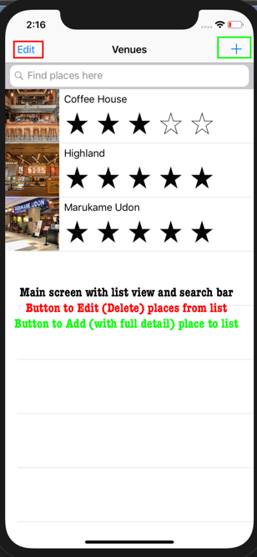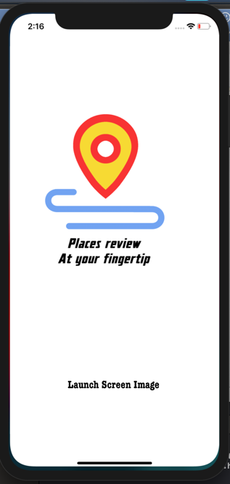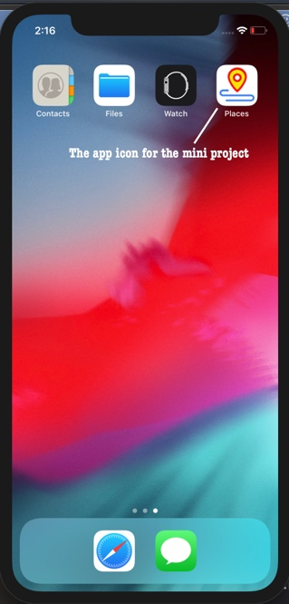Start point:

(*) Notice the Save button is greyed out: this happens when you tap on a TextField, meaning starting to edit the TextField, you need to either press Cancel, or finish editing and then Save.

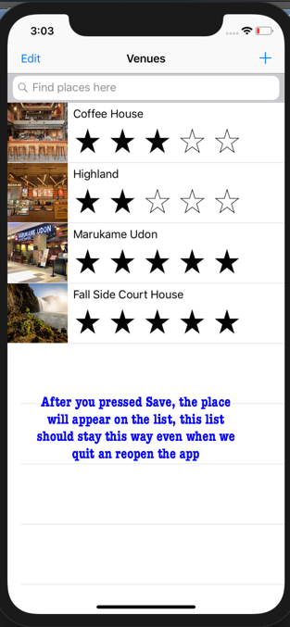

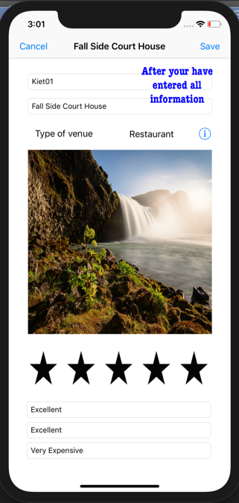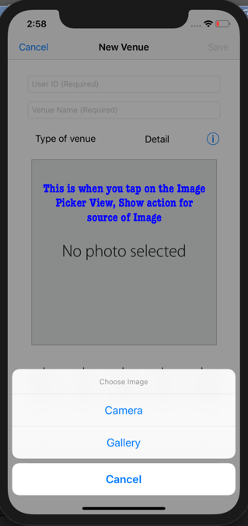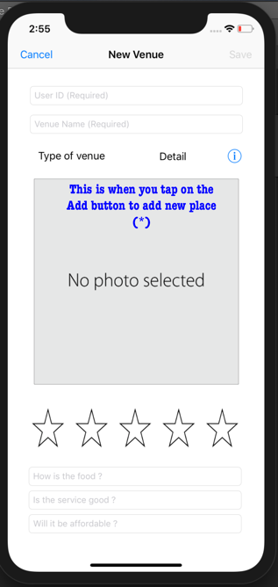(*) Again when you Add a new place, the Save button is greyed out, until you’ve completed the information input for the UserID and the Venue Name. Here you can choose the image for the venue via camera or photolibrary

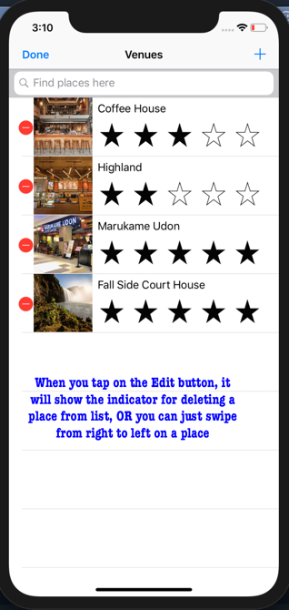

After Add, Edit, Delete, you should have a list of places, and that list should stay that way even after quitting and reopening the app.

***Part 3: Final Remarks:***

The app is very basic, can be called a simple view application, this could extend to a dynamic database rating for many places and can to some extent share the reviews on social media or gather other information like locations, other reviews.