Go Microservices 1

Course Logger Application

Keith Ang

2021

# Components Implemented

## Overview

* Login Authentication REST API
  + Multiplexer setup
  + 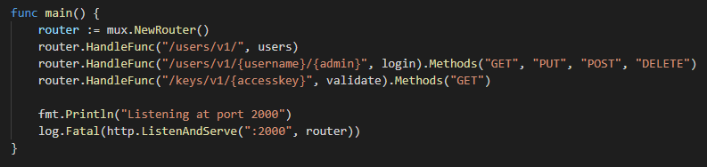
  + Calling HTTP Methods on resources to validate logins, create logins, and provision / revoke access keys
  + 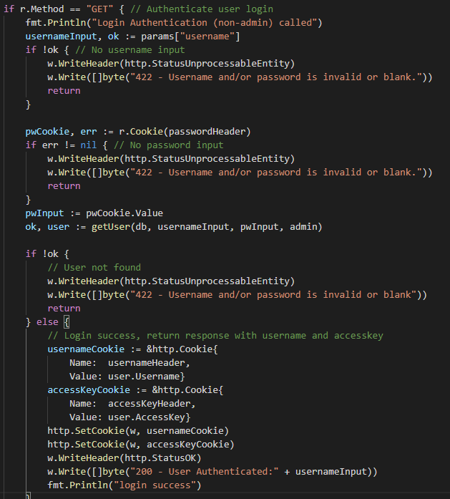
  + 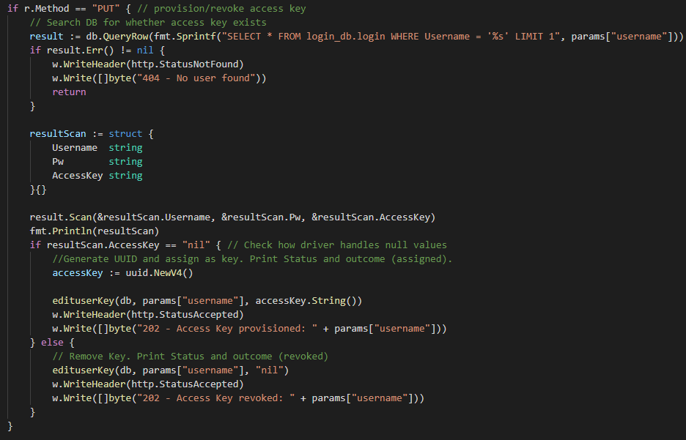
* Course Management REST API
  + Multiplexer setup
  + 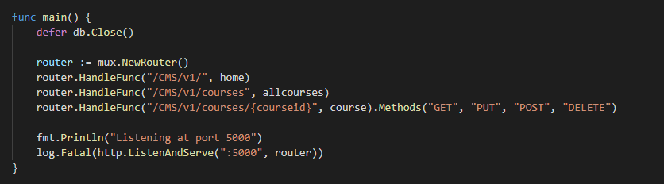
  + Handler function to return all courses or courses following a search criteria, depending on query strings
  + 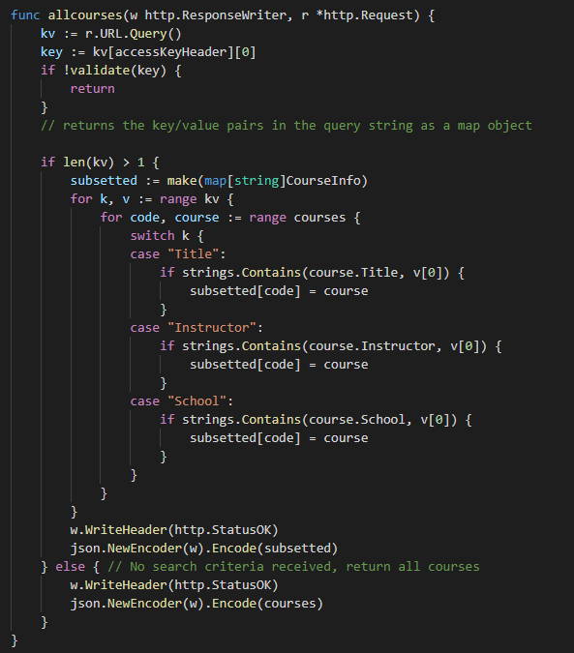
  + Access Key validation from courseService by calling loginService
  + 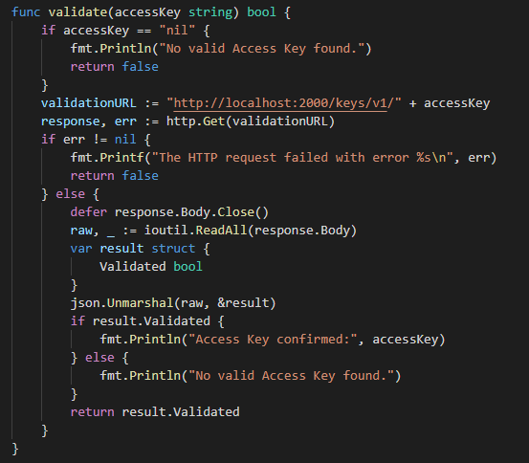
* Admin Client for Access Key Provisioning/Revoking and User Account Management
  + Connects to loginService API to manage which accounts will have access key needed to access courseService
  + 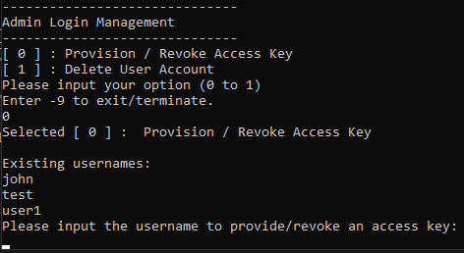
* User Client for Accessing Modifying Course records
  + CRUD implementation by calling HTTP methods on resources (course codes)
  + 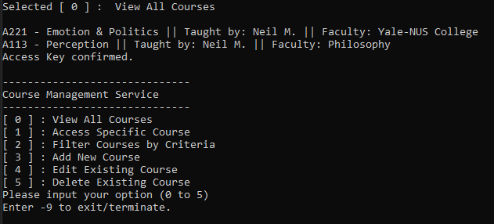

# Setup Guide

1. Database Setup
   1. Set MySQL root account password to ‘veg-kluh!PRIW3hirt’
   2. Run included file, ‘db_setup.sql’ in MySQL Workbench on localhost (port 3306)
2. API Setup
   1. Open file ‘courseService.exe’ in the courseService folder
   2. Open file ‘loginService.exe’ in the loginService folder

# Test Guide

1. Open client.exe and create a new account
   1. 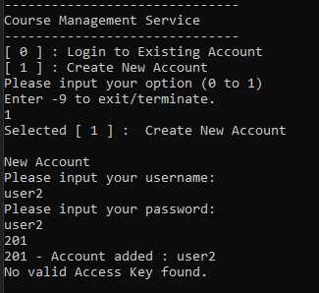
2. Open adminClient.exe and provision an access key to that account
   1. 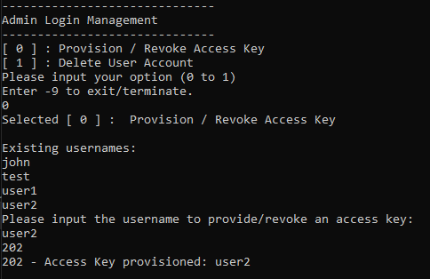
3. Login on client.exe and interact with the CRUD operations for course data shown
   1. 