Find the value of the sum when k = [|r1|], x = [|r2|], and y = [|r3|]:

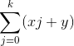
[{make_answer('ans1','number',5,exact_equality(ans),10,ans)}]

