Creating dictionary list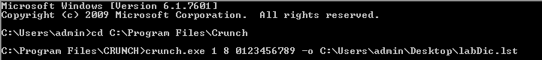

WPA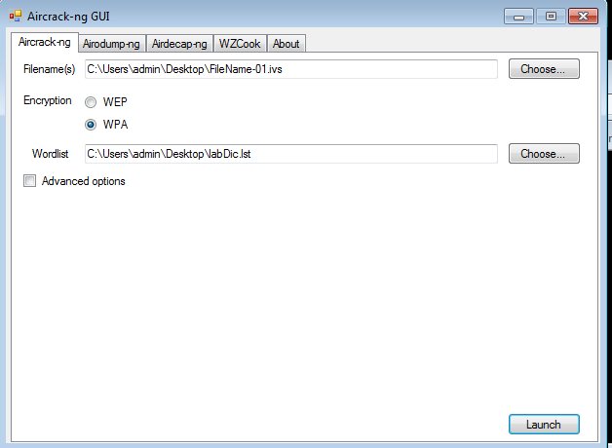

Cracking

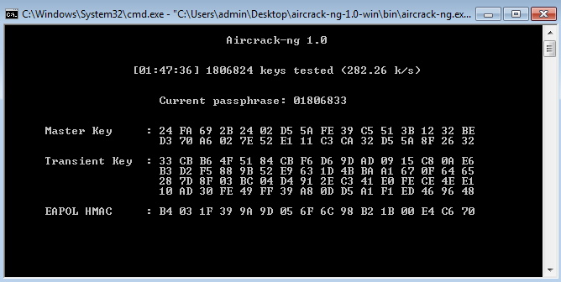

Due to some errors and with the slow processing speed I was not able to complete the assignment but I can still show the process of the crack.

The above image shows that the duration taken so far is a bit less than 2 hours at 1 hour 47 minutes 36 seconds with 1806824 keys tested with a rate of 282.26 keys /seconds at this speed it will take almost 4 days to go through the max value of 8 digits for this key