1. A rule that prevents outgoing traffic to port 80

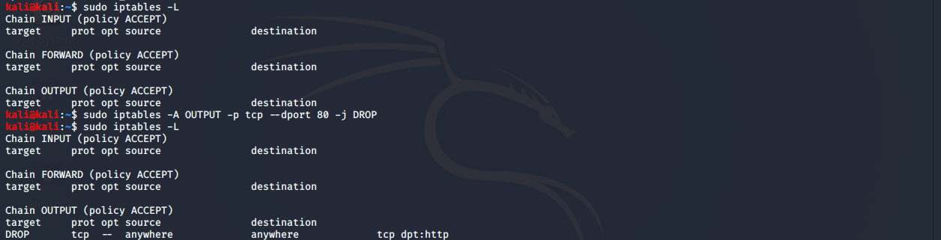

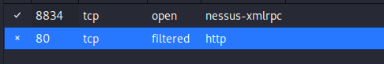

Tested using zenmap checking my own IP to see if port 80 was open or filtered

2.A rule that accepts all packets from eth0



3.

a) allows input traffic from the IP address 192.168.0.4

b)allows input traffic from the ip address 192.168.0.4 from the device with the MAC address of 00:50:8D:FD:E6:32

c) Accepts incoming traffic from the IP address 192.168.0.0 and the 254 hosts under it

d) Accepts incoming traffic from the IP address 192.168.0.0 and the 254 hosts under it

e) Accepts input that are of TCP proto with the destination of port 6881

f) Accepts input that are of TCP proto with the destination of ports ranging from 6881 to 6890