Results gained from provided rule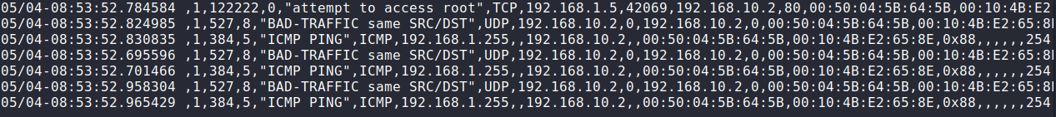

3 rules:

Alert ICMP any any -> 192.168.10.2 any (itype:8;msg:”ping requested”;sid:123456;)

Probing through pinging your machine

Alert tcp any 42069 -> 192.168.10.2 22 (msg:”TCP Retransmission, RST,PSH”;sid: 1234578;) interference with the tcp three way handshake or an DoS attempt

Alert tcp any 42069 -> 192.168.10.2 80(msg:”TCP Retransmission, ACK”;sid 123458;)

interference with the tcp three way handshake or an DoS attempt

4 rules result:

