PART B: NORMALIZATION

Part B-1. Identification of Relations and Dependencies [3 marks]

Initial Unnormalized Relations (UNF)
According to the requirements of the Peer Tutoring Platform, the initial unnormalized relation might look as follows:
TutoringRecord
(StudentID, StudentName, StudentEmail, StudentPhone, TutorID, TutorName, TutorEmail, TutorPhone, {SubjectID, SubjectName}, {AvailabilityDay, AvailabilityTime}, SessionID, SessionDate, SessionTime, SessionDuration, SessionStatus, RatingScore, RatingComment, AdminID, AdminName, AdminEmail)
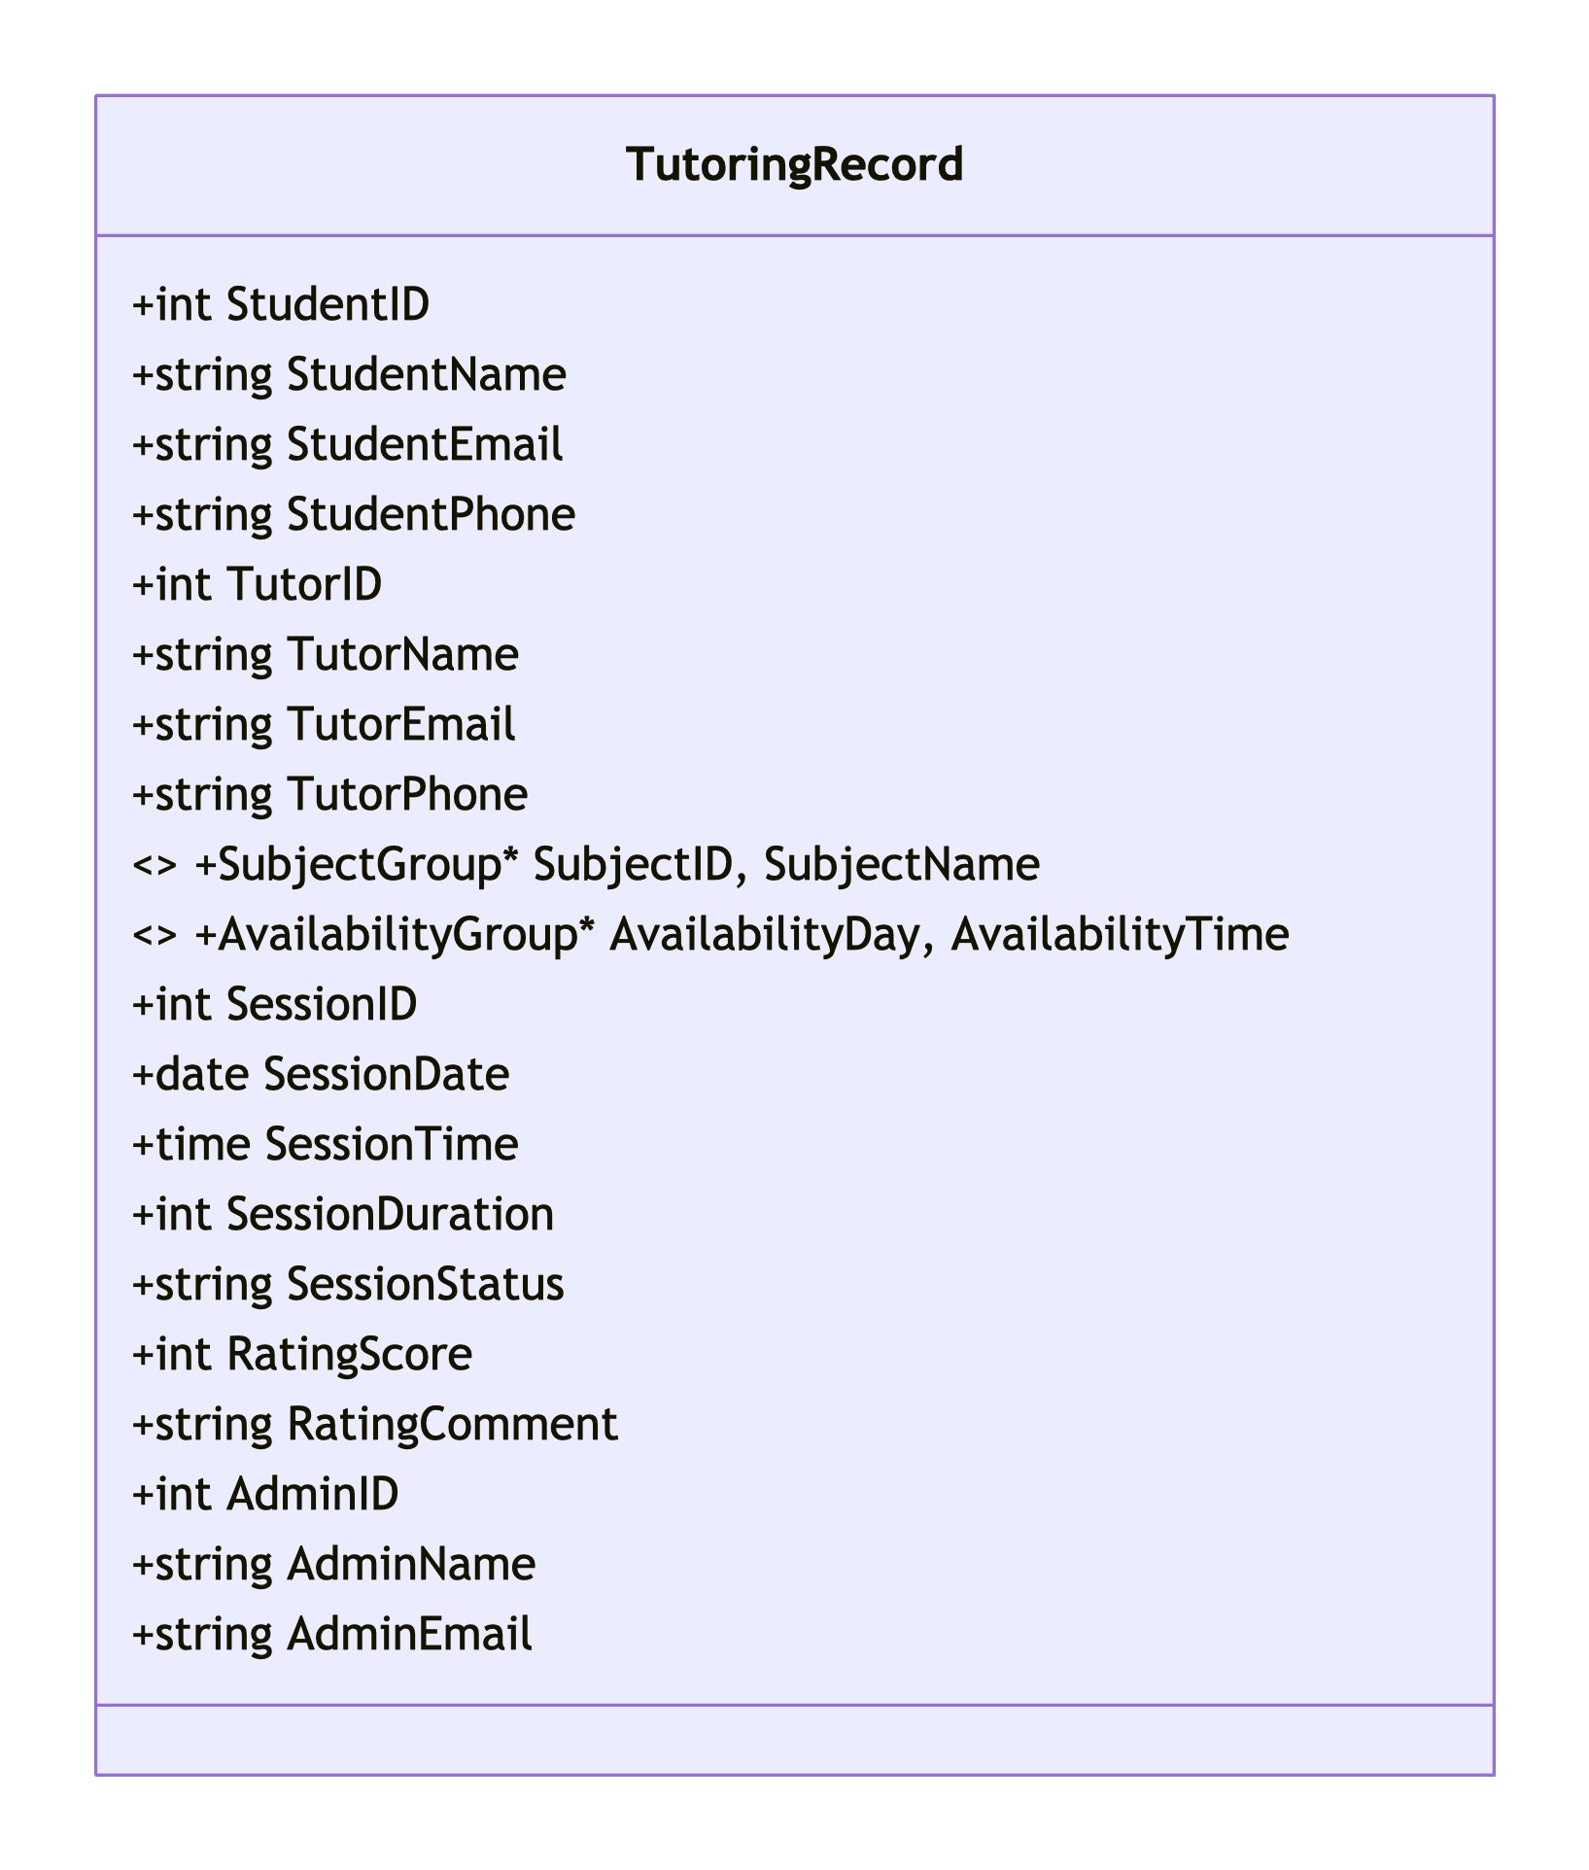
Multivalued attributes identified:
- Subjects offered by a tutor: {SubjectID, SubjectName} — a tutor can teach multiple subjects
- Tutor availability: {AvailabilityDay, AvailabilityTime} — a tutor may have multiple availability slots

Functional dependencies identified:
- StudentID → StudentName, StudentEmail, StudentPhone
- TutorID → TutorName, TutorEmail, TutorPhone
- SubjectID → SubjectName
- SessionID → SessionDate, SessionTime, SessionDuration, SessionStatus, StudentID, TutorID, SubjectID
- SessionID → RatingScore, RatingComment (partial — rating depends on session)
- AdminID → AdminName, AdminEmail

Part B-2. Normalization Steps

Step 1: First Normal Form (1NF)
1NF requires:
- We remove repeating groups and atomic attributes:
- We remove multivalued attributes:
- We extract {SubjectID, SubjectName} into a new Subject relation:
- We extract {AvailabilityDay, AvailabilityTime} into a new TutorAvailability relation:
Each row must be atomic: no repeating groups

After 1NF, relations are:
- Student(StudentID, StudentName, StudentEmail, StudentPhone)
- Tutor(TutorID, TutorName, TutorEmail, TutorPhone)
- Subject(SubjectID, SubjectName)
- TutorAvailability(AvailabilityID, TutorID, AvailabilityDay, AvailabilityTime)
- Session(SessionID, SessionDate, SessionTime, SessionDuration, SessionStatus, StudentID, TutorID, SubjectID)
- Rating(RatingID, SessionID, RatingScore, RatingComment)
- Admin(AdminID, AdminName, AdminEmail)

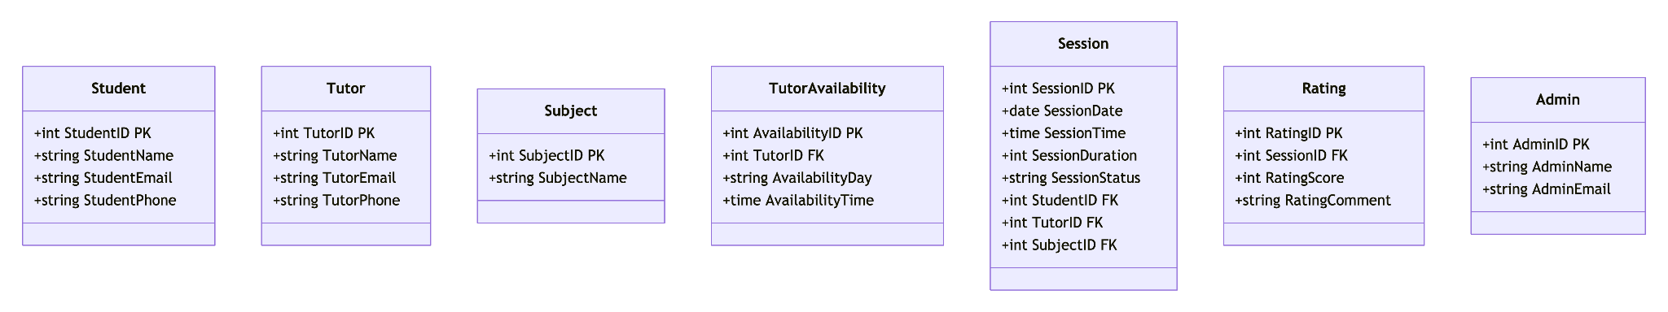

Step 2: Second Normal Form (2NF)
2NF removes partial dependencies (applies to composite keys).
- We have already ensured that all non-composite keys are simple attributes: no partial dependencies.
- We have already ensured that all non-key attributes are fully functionally dependent on the primary key: no partial dependencies.
Our relations are already in 2NF.

Step 3: Third Normal Form (3NF)
We remove transitive dependencies: non-key attribute depending on another non-key attribute.
We have already ensured that non-key attributes depend only on the primary key: no non-transitive dependencies.
- Student: All attributes depend only on StudentID: no non-transitive dependency
- Tutor: All attributes depend only on TutorID: no non-transitive dependency
- Subject: SubjectName depends only on SubjectID: no non-transitive dependency
- Session: All attributes depend only on SessionID: no non-transitive dependency
- Rating: RatingScore and RatingComment depend only on RatingID: no non-transitive dependency
No transitive dependencies exist: we satisfy 3NF

Part B-3. Final Relations in 3NF [3 marks]
The final set of normalized relations in Third Normal Form (3NF) are:
Table | Attributes (PK underlined, FK marked)
Student | StudentID (PK), StudentName, StudentEmail, StudentPhone
Tutor | TutorID (PK), TutorName, TutorEmail, TutorPhone
Subject | SubjectID (PK), SubjectName
TutorSubject | TutorSubjectID (PK), TutorID (FK), SubjectID (FK)
TutorAvailability | AvailabilityID (PK), TutorID (FK), AvailabilityDay, AvailabilityTime
Session | SessionID (PK), StudentID (FK), TutorID (FK), SubjectID (FK), SessionDate, SessionTime, SessionDuration, SessionStatus
Rating | RatingID (PK), SessionID (FK), RatingScore, RatingComment
Admin | AdminID (PK), AdminName, AdminEmail
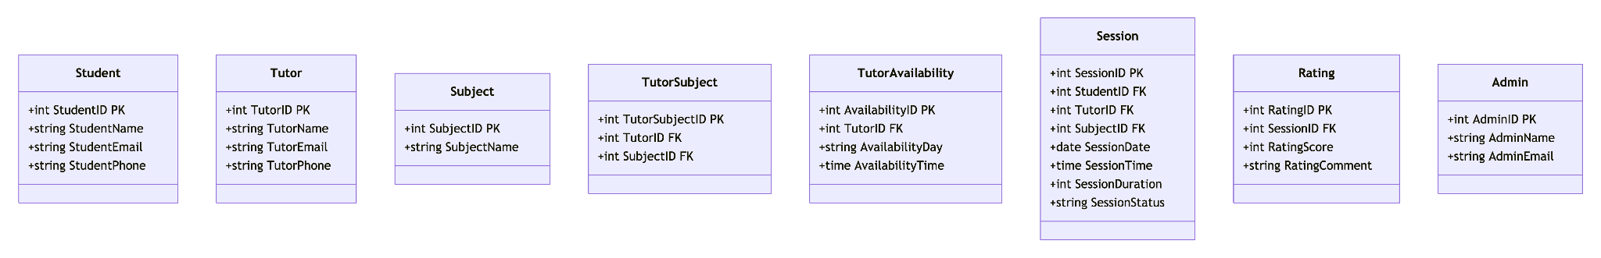
Justification: All tables satisfy 3NF because:
- (1) every attribute is atomic (1NF),
- (2) all non-key attributes are fully functionally dependent on the primary key (2NF), and
- (3) there are no transitive dependencies — no non-key attribute determines another non-key attribute (3NF).

