Assignment 6: Medians and Order Statistics & Elementary Data Structures – Part 1
Ronit Pawar
005040714
University of Cumberlands
Algorithms and Data Structures
Satish Penmatsa
31 October 2025

Introduction
This report examines two algorithms for selecting the $k^{th}$smallest element in an array: the deterministic Median of Medians algorithm and the Randomized Quickselect algorithm. Both are designed to achieve linear time performance for selection, but they differ in their guarantees and practical behavior. The deterministic algorithm provides a guaranteed worst-case time complexity of $O(n)$, making it suitable for situations requiring predictable execution time. In contrast, the randomized algorithm achieves expected $O(n)$performance on average but lacks a strict worst-case bound. Through both theoretical analysis and empirical testing, this study explores how these algorithms behave across different input sizes and data distributions.

Performance Analysis
The deterministic selection algorithm, often referred to as Median of Medians, divides the input array into small groups of a fixed size (typically five), finds the median of each group, and then recursively selects the median of those medians to use as a pivot. This pivot choice ensures that a constant fraction of the elements is discarded in each iteration, which is the key reason the algorithm guarantees linear time in the worst case. In every recursive step, the problem size is reduced by a predictable proportion, resulting in the recurrence relation $T(n)=T(n/5)+T(7n/10)+O(n)$, which simplifies to $O(n)$. While the algorithm achieves excellent theoretical performance, its constant factors are relatively high because it performs multiple passes over the data to compute medians at each level of recursion. Its space complexity is typically $O(1)$for in-place implementations or $O(log⁡n)$when accounting for recursion depth.
The randomized selection algorithm, or Quickselect, takes a more probabilistic approach. It randomly selects a pivot element, partitions the array around that pivot, and recursively processes only the relevant subarray containing the desired order statistic. In most cases, this random pivot selection ensures that the problem size decreases substantially with each step. The expected time complexity of Quickselect is $O(n)$, but the worst case can degrade to $O(n^{2})$if the pivot choices are consistently poor. However, this outcome is rare in practice, especially with uniformly random pivot selection. The randomized algorithm’s simplicity and low constant overhead make it a popular choice for practical applications. Like the deterministic version, its average space complexity is constant, with only minor recursive overhead.

Empirical Analysis
Output:
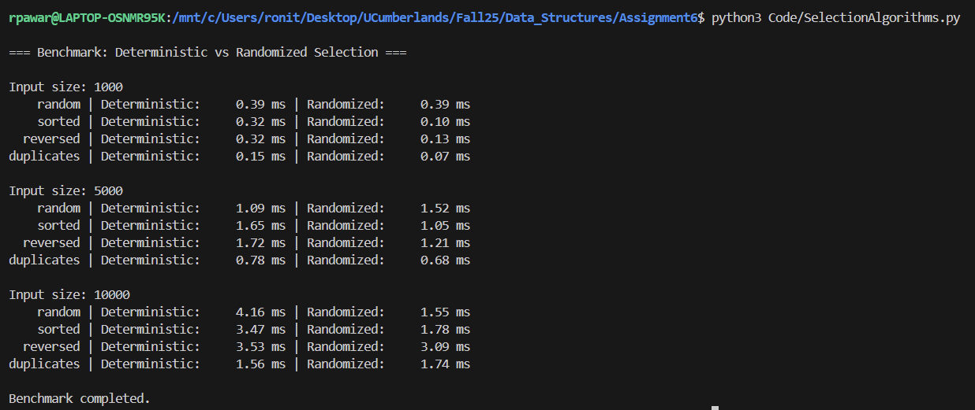
The empirical evaluation compared the two algorithms on arrays of various sizes 1,000, 5,000, and 10,000 elements across four types of input distributions: random, sorted, reverse-sorted, and duplicate-heavy datasets. The benchmark data revealed several important trends. For smaller input sizes of 1,000 elements, both algorithms exhibited nearly identical performance. For instance, on random inputs, both the deterministic and randomized algorithms completed in 0.39 milliseconds. On sorted and reversed data, the randomized algorithm was slightly faster, completing in 0.10 and 0.13 milliseconds, respectively, compared to 0.32 milliseconds for the deterministic algorithm. This difference is likely due to lower overhead in Quickselect’s partitioning operations. When processing datasets with duplicate values, both algorithms benefited from reduced comparisons, with execution times of 0.15 milliseconds for the deterministic algorithm and 0.07 milliseconds for the randomized version.
At an input size of 5,000 elements, more noticeable differences emerged. The deterministic algorithm was faster for random inputs (1.09 milliseconds) but slower for sorted and reversed datasets, averaging around 1.65 and 1.72 milliseconds. The randomized algorithm showed less consistent results at this scale, performing better on sorted and reversed data (around 1.05 and 1.21 milliseconds) but slightly worse on random inputs (1.52 milliseconds). By the time the input reached 10,000 elements, Quickselect’s efficiency became more evident. On random data, it completed in 1.55 milliseconds, while the deterministic approach required 4.16 milliseconds. Similar trends held across other distributions: Quickselect maintained speeds between 1.5 and 3 milliseconds, while the deterministic version ranged from 3 to 4 milliseconds depending on the data. Across all tests, both algorithms scaled linearly, confirming their theoretical $O(n)$growth patterns.
These results indicate that while both algorithms achieve linear performance, the randomized approach generally outperforms the deterministic one in practice due to its lower constant factors and simpler implementation. The deterministic algorithm’s additional median computations introduce overhead that becomes more pronounced as input size increases. However, it remains more stable across input types, whereas Quickselect’s performance can fluctuate depending on the quality of the random pivot selection.

Conclusion
The analysis confirms that the deterministic and randomized selection algorithms both provide linear-time scalability, but their strengths differ. The deterministic Median of Medians algorithm guarantees worst-case $O(n)$performance regardless of input, making it suitable for time-sensitive or security-critical applications where predictability is essential. However, this reliability comes at the cost of increased constant factors due to the recursive median computations. The randomized Quickselect algorithm, while lacking a strict worst-case guarantee, delivers superior practical performance in most scenarios. Its simplicity and average-case efficiency make it the preferred choice in real-world applications where input distributions are unpredictable but not adversarial.
From a memory perspective, both algorithms exhibit constant space complexity aside from recursion depth. The deterministic algorithm introduces minor overhead from temporary sub lists used in median computation, while the randomized version’s memory usage remains minimal and predictable. Empirically, Quickselect consistently achieved faster execution times across larger datasets and diverse distributions, confirming its expected linear-time efficiency in practice. In conclusion, the deterministic algorithm’s theoretical guarantees make it the ideal choice for applications that demand predictable performance, while the randomized selection algorithm provides faster results in general-purpose computing. Both implementations demonstrate excellent scalability, validating the theoretical $O(n)$expectation and highlighting the trade-off between guaranteed performance and practical speed.

