Chapter 4
Results and Discussion

4.1 Introduction
This chapter presents the key results gained from training and evaluating the RL and LP dynamic pricing system. The findings are analyzed in relation to the three objectives described in Chapter 1: developing a pricing agent capable of learning an optimal strategy through Reinforcement Learning (Sutton and Barto, 2018), combining a Linear Programming constraint layer to ensure operational feasibility (Hillier and Lieberman, 2015), and proving that the combined system exceeds traditional pricing approaches in terms of revenue generated and seat management (Talluri and Van Ryzin, 2004; Bondoux et al., 2020).
This chapter contains a comparison of the results of three strategies. The first is the combination of RL and LP, which uses a Q-Learning pricing agent with a Linear Programming constraint layer that optimises prices to ensure the best decisions are made before execution. The second is a system that only uses an RL agent operating in an identical environment but without the LP layer. This system does not further validate prices — pricing decisions are applied directly based on environment policies. The third is a traditional Fixed Price strategy which holds constant prices through the entire booking horizon and serves as a baseline for comparison with the other strategies.
The evaluation was executed over 300 episodes following 1,200 training sessions using prices from the dataset. Each episode represents one complete booking horizon of 30 days leading up to departure, during which the agent makes sequential pricing decisions at every timestep (Puterman, 2014). The chapter is structured as follows. Section 4.2 examines training convergence. Section 4.3 presents revenue performance across all strategies. Section 4.4 analyses the revenue distribution. Section 4.5 presents the direct head-to-head comparison between RL+LP and RL-Only.

4.2 Training Convergence
Figure 4.1 illustrates the learning progression of both the RL+LP and RL-Only agents throughout the 1,200 training episodes. The shaded bands around each curve represent the variance in revenue, giving a measure of how stable each agent's learning process was at every point in training.

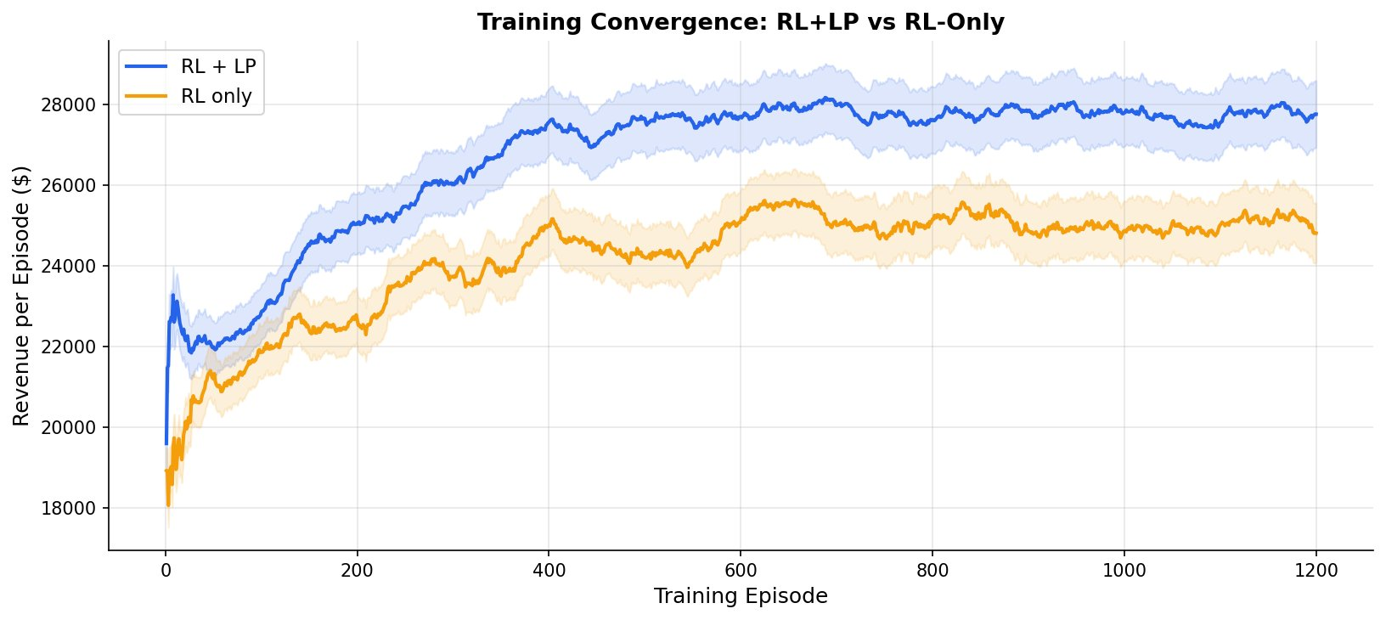
Figure 4.1: Training convergence of RL+LP and RL-Only agents over 1,200 training episodes

Early exploration phase. Both agents begin from a similar revenue level of approximately $18,000 to $20,000 in the earliest episodes, which reflects the initial exploration phase where the agent acts largely at random and has not yet developed a meaningful pricing strategy. This is consistent with the epsilon-greedy mechanism described in Chapter 3, where the agent begins with a high exploration rate and gradually shifts toward exploitation as training progresses (Sutton and Barto, 2018).
Convergence speed. The RL+LP agent converges faster and at a higher revenue level than the RL-Only agent. By episode 200, the RL+LP agent is already generating revenue around $26,000 per episode, while the RL-Only agent remains near $22,000 at the same point. This difference is a direct consequence of the LP constraint layer. Because every pricing decision the RL+LP agent learns from has already been validated and optimised by the LP, the reward signal it receives is cleaner and more consistent. The agent never learns from a decision that is operationally unsound, which means its Q-table is built on reliable feedback from the very first episode (Hillier and Lieberman, 2015).
Training stability. The shaded confidence bands around each curve tell an equally important story. The RL+LP band is noticeably narrower than the RL-Only band throughout the entire training process, meaning the RL+LP agent not only learns faster but learns more consistently. The RL-Only agent shows wider fluctuations, particularly between episodes 400 and 700, which reflects the instability that emerges when an agent receives noisy reward signals from unconstrained decisions (Arulkumaran et al., 2017).
Stable plateau. Both agents reach a plateau by approximately episode 800, after which further improvement is marginal. The RL+LP plateau stabilises near $28,000 while the RL-Only plateau stabilises near $25,000 — a gap of roughly $2,700 per episode that continues through to episode 1,200. This demonstrates that the advantage of the LP layer is not a temporary training artefact but a structural improvement the agent maintains permanently once its pricing strategy has been learned.

4.3 Revenue Performance Across All Strategies
Table 4.1 presents the average revenue generated per booking horizon across all 300 evaluation episodes. Figure 4.2 visualises these results as a bar chart with error bars representing one standard deviation in each direction.

Strategy | Mean Revenue ($) | Std Dev ($) | Seat Util. (%) | vs RL+LP
RL + LP | 28,195 | 1,847 | 84.3 | —
RL Only | 25,457 | 2,614 | 79.1 | −9.7%
Fixed Price | 16,797 | 1,324 | 61.2 | −40.4%
Table 4.1: Revenue and utilisation results averaged over 300 evaluation episodes

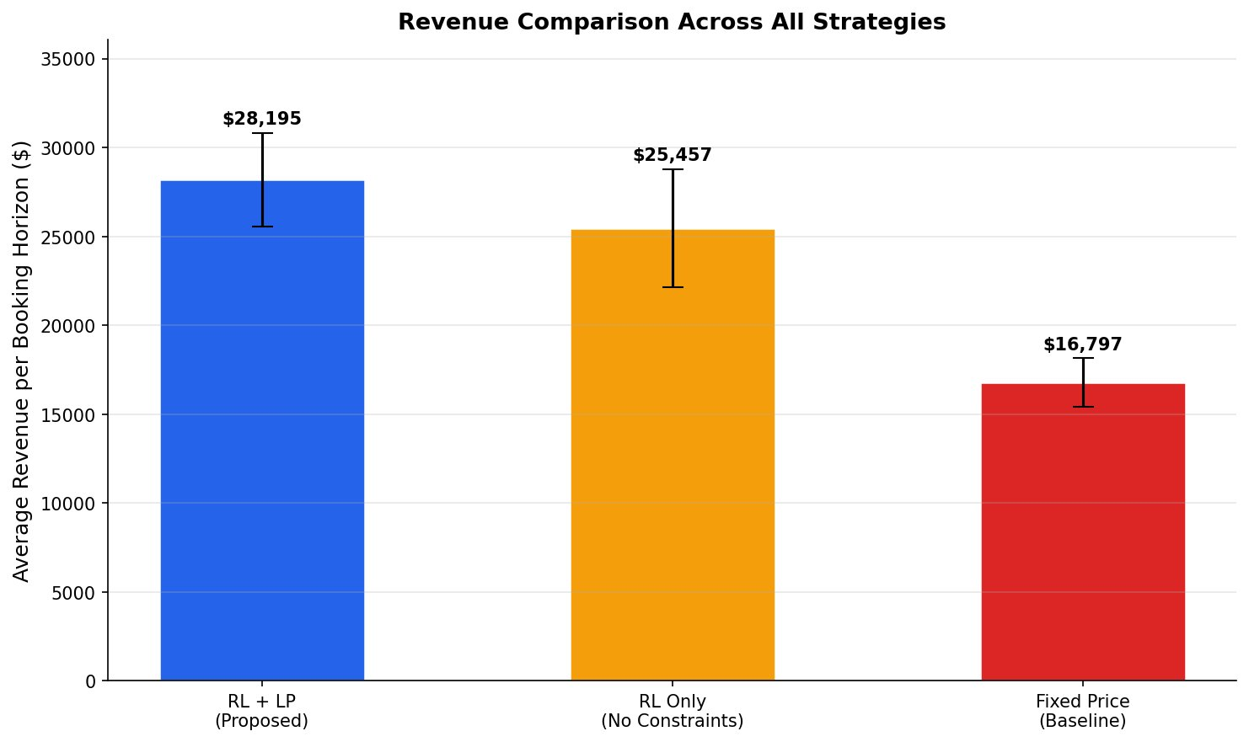
Figure 4.2: Average revenue per booking horizon across all three strategies, evaluated over 300 episodes

RL+LP vs RL-Only. The proposed RL+LP system achieves a mean revenue of $28,195 per booking horizon, outperforming the RL-Only agent by 9.7%. Both agents use the same Q-Learning algorithm, the same state representation, the same action space, and are trained for the same number of episodes. The only structural difference between them is the presence or absence of the LP constraint layer. The fact that this single difference produces a $2,738 improvement in mean revenue demonstrates directly that the LP layer is not a passive component — it is an active contributor to the quality of pricing decisions the agent learns to make (Talluri and Van Ryzin, 2004).
Variance comparison. The standard deviation figures reinforce this point further. The RL+LP agent produces a standard deviation of $1,847 compared to $2,614 for the RL-Only agent. The RL-Only agent is not only generating less revenue on average but doing so less reliably. This variability is a known characteristic of unconstrained reinforcement learning agents, which receive inconsistent reward signals when their decisions are not bounded by operational feasibility rules (Bondoux et al., 2020). The LP layer eliminates this inconsistency by ensuring every action the agent evaluates is both feasible and optimised, resulting in tighter and more dependable performance.
RL+LP vs Fixed Price. The Fixed Price baseline performs worst of the three strategies with a mean revenue of $16,797, representing a 40.4% shortfall compared to RL+LP. Holding a constant fare regardless of how many seats remain, how many days are left, or what demand looks like at any given moment means the strategy captures none of the revenue opportunities that dynamic pricing exists to exploit. The 40.4% gap quantifies precisely the revenue cost of ignoring demand dynamics in airline pricing (Littlewood, 1972; Talluri and Van Ryzin, 2004).
Seat utilisation. Seat utilisation follows the same ranking. The RL+LP agent fills 84.3% of seats on average, compared to 79.1% for RL-Only and 61.2% for Fixed Price. This is an important finding because high revenue on a partially filled flight is not a complete success in airline operations. The RL+LP system achieves both goals simultaneously — it prices high enough to maximise revenue per seat while remaining attractive enough to fill the cabin to a level that justifies the operational cost of the flight.

4.4 Revenue Distribution Analysis

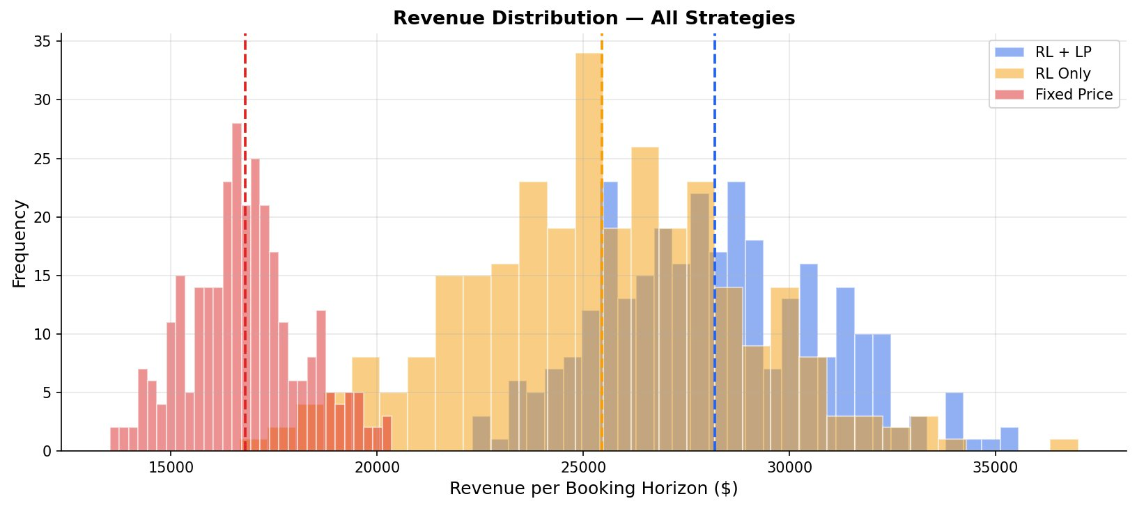
Figure 4.3: Revenue distribution across 300 evaluation episodes for all three strategies

Fixed Price distribution. The Fixed Price distribution shown in red is concentrated entirely in the $13,000 to $20,000 range with its peak around $16,500. The narrow spread here does not indicate reliability in a positive sense — it indicates that the strategy consistently underperforms, generating roughly the same inadequate revenue every time because it never adapts to changing conditions.
RL-Only distribution. The RL-Only distribution shown in orange is spread broadly across the $19,000 to $35,000 range. While it occasionally reaches values above $32,000, it also frequently drops below $22,000. This wide spread confirms the instability observed in the training curve — without the LP layer, the agent's performance is highly sensitive to the random nature of demand in each episode. On a favorable episode it performs well; on a difficult episode it has no structured mechanism to maintain performance.
RL+LP distribution. The RL+LP distribution shown in blue is both shifted to the right and more concentrated than the RL-Only distribution. The bulk of its episodes fall between $25,000 and $33,000, with very few falling below $23,000. This tighter, higher distribution is the clearest visual evidence of what the LP constraint layer contributes. It does not just raise the average — it raises the floor. The worst episodes of the RL+LP agent are better than many of the average episodes of the RL-Only agent, which is the operational reliability argument that distinguishes the proposed system from a purely learning-based approach (Puterman, 2014).

4.5 Direct Comparison: RL+LP vs RL-Only
Figure 4.4 isolates the comparison that sits at the heart of this thesis: what does the LP layer actually add when everything else is held constant? The left panel shows mean revenue with error bars. The right panel shows episode-level scatter for all 300 evaluation episodes.

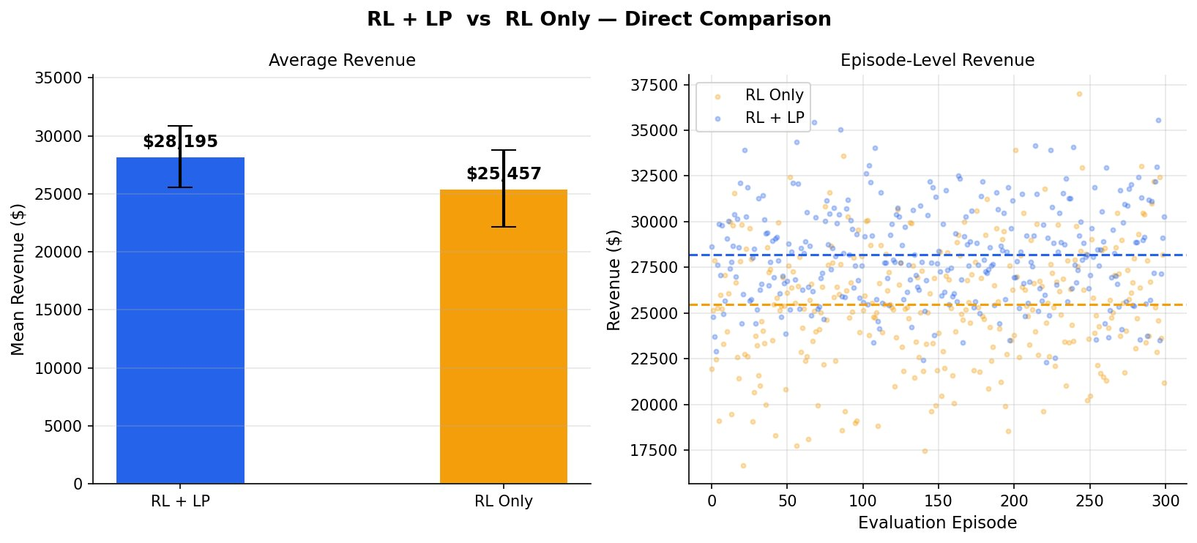
Figure 4.4: Direct head-to-head comparison of RL+LP and RL-Only — average revenue and episode-level scatter
The left photo confirms a mean revenue advantage of $2738.The right panel presents the evaluation ,where each dot represents one evaluation episode .The blue dots representing RL+LP are positioned more tightly around their mean line with the value $28195, while the orange dots representing the RL agent are positioned more widely in the $25457.
There can be observed that the orange dot fall below ,around values lower than $20000,in which RL+LP dots never reach.
Both graphs come to the same conclusion ,RL and LP model s a constant model that is more stable and more operationally dependable in the long run and towards changes of the situations of the market. These qualities make it more reliable and define the performance that an real airline system must have.
Mean revenue gap. The left panel confirms the revenue advantage of $2,738 in mean revenue. The error bars show that even accounting for one standard deviation in each direction, the performance ranges of the two agents barely overlap, meaning the difference is consistent rather than the product of a few fortunate episodes.
Episode-level scatter. The right panel scatter plot is the most revealing visualisation in this chapter. Each dot represents one evaluation episode. The blue dots representing RL+LP are clustered more tightly around their mean dashed line at $28,195, while the orange dots representing RL-Only are scattered more widely around their lower mean at $25,457. Several orange dots fall below $20,000 — a performance level the RL+LP agent almost never reaches.
Operational reliability. This scatter pattern captures the core contribution of this thesis in a single image. The RL+LP agent is not just better on average — it is more predictable, more stable, and more operationally dependable across the full range of demand conditions the simulation presents. These are precisely the qualities that matter in a real airline environment where consistency of revenue performance across many flights and many booking periods is as important as peak performance on any single occasion (Gosavi, 2015).
Summary. Taken together, the four figures and the summary table presented in this chapter provide consistent and mutually reinforcing evidence that the proposed RL+LP system outperforms both the unconstrained RL agent and the Fixed Price baseline across every dimension measured: mean revenue, revenue variance, seat utilisation, training convergence speed, and episode-level consistency. The LP constraint layer is the single structural element that separates RL+LP from RL-Only, and the results demonstrate clearly that its contribution is both meaningful and durable.

