EPOKA UNIVERSITY
Faculty of Engineering and Architecture
Department of Computer Engineering

DYNAMIC AIRLINE PRICING OPTIMIZATION USING REINFORCEMENT LEARNING

GRADUATION THESIS

Serena Korbi

Advisor: Sidorela META

TIRANA, ALBANIA
2025

DYNAMIC AIRLINE PRICING OPTIMIZATION USING REINFORCEMENT LEARNING

SERENA KORBI

Thesis Submitted in Fulfillment of Requirement for the Degree of
Bachelor of Science in Computer Engineering

EPOKA UNIVERSITY
2025

APPROVAL PAGE
Student Name & Surname: Serena Korbi
Faculty: Faculty of Engineering and Architecture
Department: Computer Engineering
Thesis Title: Dynamic Airline Pricing Optimization Using Reinforcement Learning
Date of Defense: ___ ___ 2025

I certify that this final work satisfies all the requirements as a Graduation Thesis for the degree of Bachelor of Science in Computer Engineering.

................................................
Head of Department

This is to certify that I have read this final work and that in my opinion it is fully adequate, in scope and quality, as a Graduation Thesis for the degree of Bachelor of Science in Computer Engineering.

................................................
Supervisor: Sidorela Meta
DYNAMIC AIRLINE PRICING OPTIMIZATION USING REINFORCEMENT LEARNING
ABSTRACT
[Abstract to be completed. The abstract should not exceed 350 words and must cover: (1) the statement of the problem, (2) the methods used, and (3) the main findings and their significance.]
ACKNOWLEDGEMENTS
[Acknowledgements to be completed.]
DECLARATION
I hereby declare that this Graduation Thesis, titled Dynamic Airline Pricing Optimization Using Reinforcement Learning, is based on my original work except quotations and citations which have been duly acknowledged. I also declare that this thesis has not been previously or concurrently submitted for the award of any degree, at Epoka University, any other university or institution.

(Signature)
Serena Korbi
Date: ___ / ___ / 2025
TABLE OF CONTENTS
APPROVAL i
ABSTRACT ii
ACKNOWLEDGEMENTS iii
DECLARATION iv
TABLE OF CONTENTS v
LIST OF TABLES vi
LIST OF FIGURES vii
LIST OF ABBREVIATIONS viii

CHAPTER
1 INTRODUCTION 1
1.1 Background and Problem Definition 1
1.2 Research Objectives 2
1.3 Research Questions 3
1.4 Overview of the Methodology 3
1.5 Research Contribution 4
2 LITERATURE REVIEW 5
2.1 Summary 5
2.2 Traditional Approaches 5
2.3 Modern Approaches 6
2.4 The Advantages of Reinforcement Model 7
2.5 Competitor and Market Dynamics 8
2.6 Research Gaps 8
3 METHODOLOGY 9
3.1 Methodological Framework Overview 9
3.2 The Optimization Problem: Linear Programming 9
3.3 Pricing Decisions: Reinforcement Learning 11
3.4 How LP and RL Work Together 12
3.5 The Dataset and Training Environment 12
3.6 Implementation in Python 13
3.7 Evaluation Approach 13
4 RESULTS 14
4.1 Training Convergence 14
4.2 Revenue Performance 15
4.3 Revenue Distribution Analysis 16
4.4 Direct Comparison: RL+LP vs RL 17
5 CONCLUSIONS 18
REFERENCES 20
LIST OF TABLES
Table 3.1. Parameters of the LP Optimization Problem 9
Table 4.1. Revenue and utilisation results averaged over 300 evaluation episodes 15
LIST OF FIGURES
Figure 4.1. Training convergence of RL+LP and RL-Only agents over 1,200 training episodes 14
Figure 4.2. Average revenue per booking horizon across all three strategies 15
Figure 4.3. Revenue distribution across 300 evaluation episodes for all three strategies 16
Figure 4.4. Direct head-to-head comparison of RL+LP and RL-Only 17
LIST OF ABBREVIATIONS
DLP | Deterministic Linear Program
DQN | Deep Q-Network
LP | Linear Programming
MDP | Markov Decision Process
PPO | Proximal Policy Optimization
RL | Reinforcement Learning
SAC | Soft Actor-Critic
TRPO | Trust Region Policy Optimization

CHAPTER 1
INTRODUCTION
1.1 Background and Problem Definition
Pricing is one of the most important decisions in any market-driven system. In industries such as airlines prices fluctuate continuously according to different factors.[1]
When market indicators or data become visible, systems that are based on dynamic pricing update market pricing solutions after the appearance of market indicators becomes detectable.
The decision-maker must balance competing goals: revenue maximisation and seat occupancy, act across a booking horizon where today's pricing decision directly affects tomorrow's demand and available inventory, and operate under uncertainty in order to create an ideal dynamic pricing system. The sequential decision-making problem perfectly matches the theoretical framework of Reinforcement Learning (RL).[2]
Reinforcement Learning sets itself apart from supervised learning by functioning effectively even in the absence of precise price samples.[3]
A pricing environment acts as the backdrop that guides RL agent operations as the agent gathers revenue feedback to identify the best pricing strategies through ordered exploration. This study creates a Reinforcement Learning-driven airline revenue management dynamic pricing system that integrates Linear Program constraints in a simulation environment to uphold operational standards throughout decision-making processes.
Most of the current pricing systems are based on using heuristic rules and static optimization models, which are not adaptable to the nature of the environment, even with significant advances in machine learning techniques.
The following is the problem definition:
How does the pricing agent learn to make sequential price decisions over the booking horizon to maximize the reward, given the unstable nature of the airline demand environment, the uncertainty of consumer behavior, and the stringent operational constraints?
There are three major challenges with regard to the problem definition given above:
- Noisy and non-stationary nature of the demand response to price changes,
- Large and non-stationary state space of the price decisions,
- The reward signal is based on the sequence of decisions rather than the individual decision.
1.2 Research Objectives
More specifically, this thesis aims to accomplish the following objectives:
- To develop and integrate a Linear Programming-based constraint solver into the simulated environment, that is to be used for the evaluation of the solution space based on prices and inventory levels.
- To develop and train an intelligent agent that is capable of learning an optimal price strategy based on simulated airline passenger demand.
- To compare the viability of the RL-based price strategy with other established methods for optimizing prices.
- To examine the viability and limitations of the developed model.
1.3 Research Questions
Primary Research Question
Will the Reinforcement Learning agent, in an environment that is also LP-constrained, be able to learn a pricing strategy that outperforms existing traditional pricing strategies in terms of revenue generated during the airline booking horizon?
Secondary Research Questions
What is the best approach to modeling the dynamic pricing problem in the airline industry and what state and action representations would be best in this problem domain?
In what way do the Linear Programming constraints engage with the Reinforcement Learning agent?
1.4 Overview of the Methodology
This dissertation integrates three primary methods to examine dynamic pricing in airline revenue management: simulation, machine learning, and mathematical optimization.
A booking system was developed from the ground up to understand how airlines determine pricing over time. Given that actual airline markets are difficult to forecast, the setting produces passenger demand at random, allowing for various pricing strategies to be evaluated in conditions that resemble real life.
Linear Programming was incorporated into the framework to ensure that all pricing choices remain feasible. Factors such as seat availability, inventory status, and fare restrictions are all taken into consideration, ensuring the system never proposes options that would not be feasible in airline operations.
In terms of machine learning, the pricing issue was formulated as a Markov Decision Process. A Reinforcement Learning algorithm was employed to discover the optimal pricing strategy, not by providing a comprehensive demand model, but by allowing it to learn independently through continuous interaction with the simulation. Through numerous attempts and mistakes, the agent learns what is effective and what is not. It is compensated for generating increased revenue while also ensuring seats are filled at the appropriate times.
These three components function collaboratively instead of independently. The simulation is the place for learning, the LP layer maintains realism, and the RL agent is responsible for making the real decisions.
1.5 Research Contribution
This thesis links airline revenue management, reinforcement learning, and operational optimization in a manner that contributes novel insights to each domain.
A key aspect of this work is the concept of operating an RL agent concurrently with a Linear Programming constraint layer. The majority of research considers smart decision making and operational constraints as separate issues. In this instance, they are managed collectively in a single process, a practice that has rarely been explored in earlier studies.
This thesis also presents a tailored simulation environment. It was created to mirror the gradual process of airline pricing when demand is unpredictable. It is sufficiently realistic to hold significance but regulated enough to be advantageous for evaluating strategies.
The thesis additionally extends beyond merely introducing a novel approach. The RL method is directly compared to conventional pricing techniques, and the findings clearly demonstrate, in quantifiable terms, what reinforcement learning can achieve in a revenue management environment, not merely in theory but also in real-world applications.
CHAPTER 2
LITERATURE REVIEW
2.1 Summary
Airline fares have been researched for many years. For decades, researchers and industry experts have been attempting to determine the optimal pricing strategies for seats, and the techniques they have employed have evolved significantly over time. What began as a relatively simple math issue, determining the number of seats to sell and their prices, has evolved into a significantly more complex situation. Currently, it includes real-time data, travelers whose actions are difficult to foresee, and increasingly sophisticated algorithms. This chapter examines the most significant contributions in two domains: the classic optimization techniques that have influenced the field for many years, and the emerging machine learning strategies that have gained traction lately. It concludes by highlighting the unanswered questions in the current research and explaining how this thesis addresses those gaps.
2.2 Traditional Approaches
For an extended period, the primary approaches to airline pricing originated from the domain of Operations Research. The issue was straightforward to outline: a flight contains a set number of seats, various passengers are prepared to pay varying prices, and the airline aims to maximize its revenue. The difficulty lay in determining the most effective method to allocate those seats among various pricing tiers without knowing precisely how many attendees there would be or their willingness to pay.
In 1972, Littlewood addressed an initial variant of this issue, examining a single flight with only two fare classes.[4]
In 1987, Belobaba adopted that concept and advanced it with the Expected Marginal Seat Revenue heuristic, expanding the idea to incorporate various fare classes and ultimately becoming extensively utilized throughout the industry for many years.[5]
As airlines expanded and their networks became more complex, Linear Programming emerged as the ideal method for tackling issues of that magnitude. With numerous routes, fare categories, and capacity restrictions influencing each other simultaneously, LP provides a systematic approach to determine how seats ought to be allocated throughout the entire network.[6]
The two most prominent LP models in this area, the Deterministic Linear Program and the Probabilistic Non-Linear Program, both pursue the same aim of maximizing profits within a specified set of limitations. A notably beneficial result from these models is the dual solution, indicating the value assigned to each constraint and effectively revealing to airlines the revenue they forfeit due to particular capacity or demand limitations.[7]
Recent efforts have aimed to enhance LP's utility by integrating pricing and seat allocation into a single model rather than considering them as distinct decisions. The reasoning adds up since the price you establish and the availability of seats at that price are linked, and addressing them simultaneously generally yields improved outcomes compared to tackling them sequentially. These integrated models represent a true advancement, yet they share the same fundamental limitation that has consistently hindered conventional approaches: they rely on possessing a fairly precise understanding of demand to yield meaningful outcomes. In actual airline markets, such certainty is seldom accessible.
When demand acts as anticipated, LP-based methods perform effectively. However, aviation is unstable, seasonal, and competitive, and when demand deviates from expectations, these models often lack the ability to adapt. They generate the optimal response for the scenario presented to them, not for the situation that is truly occurring.
2.3 Modern Approaches
That inability to adapt is exactly what made machine learning attractive to researchers working on airline pricing. Reinforcement Learning in particular caught on quickly, and for a good reason: it does not need a demand model handed to it in advance. Instead, it learns by doing, trying out different prices, seeing what results they produce, and slowly building up a strategy that works better and better over time.
Bondoux et al. (2020) is probably the most cited early example of RL being applied directly to airline revenue management. Their central argument was that learning from real-time market feedback could replace the need for demand forecasting entirely, a significant claim that opened up a lot of follow-on research. Since then, the number of studies in this area has grown considerably.
A recurring theme in this newer literature is the head-to-head comparison of different RL algorithms. DQN, A2C, PPO, and TRPO have all been tested against each other and against traditional benchmarks, and the general finding is that RL holds up well, particularly when demand is shifting or hard to predict.[23] PPO keeps appearing as a strong performer; it tends to be more stable during training than the alternatives and produces consistently solid results across different environments.
The problems being studied have also become more ambitious. Some researchers have looked at pricing several flights at the same time, where filling one flight affects how many passengers are available for another. Others have started paying attention to how passengers actually behave, specifically, the ones who keep an eye on prices and hold off on booking until they think fares have dropped far enough. This kind of strategic passenger behavior is something classical models never accounted for, and the fact that RL can begin to learn how to respond to it is one of the more interesting developments in recent work.
Continuous dynamic pricing where fares are not locked to a fixed menu of price points but can shift fluidly within a range has also been getting more attention. Approaches using the Soft Actor-Critic algorithm have shown that this is technically feasible, especially for airlines managing multiple fare classes at the same time, though it introduces additional complexity in how the learning process is structured.
What stands out when reading across all of this recent work, though, is a consistent gap. RL is almost always developed and tested either on its own or inside simulation environments that do not formally enforce the hard operational rules that real airlines have to follow.[8] The kind of constraint management that LP models are specifically built for rarely makes an appearance inside the RL training process itself.
2.4 The Advantages of Reinforcement Model
By applying Reinforcement Learning the companies of the airline industry remove the need for predefined demand model. It renews pricing policy as the reservation of the seats continues, enabling adjustment to demand changes.[14] LP generates a single solution for a given snapshot of conditions and market situation, but with the help of RL there can stretch to operate in different scenarios just by mastering a new policy of operating.
Furthermore, compared to fully rule-based dynamic pricing, RL agent detects non-obvious pricing patterns through exploration.[15] For example it can intentionally set low fees to secure control before raising prices as departure date approaches, without being programmed to do so.
2.5 Competitor and Market Dynamics
The market in the airline sector is oligopolistic, changes in demand trigger further observations for future competition advantages. Classic LP model applies this as a static demand data, whereas RL returns patterns in the long term.[16]
LP's dual variables provide a mechanism for identifying market conditions that have drifted. Shadow prices that were earlier non-binding become binding, this sets a structural change in demand and competition. For RL this serves as a new policy for the system that it must master.[17]
Nash equilibrium pricing have been proposed for competitive airline markets, but they demand all agents' strategies to be recognized beforehand, a hypothesis that RL relaxes by learning effective strategies through repeated interaction without needing to model competitors precisely.
2.6 Research Gaps
Three aspects are clearly lacking in the current literature, the first being an authentic integration of LP and RL functioning collaboratively as a single algorithm. The two methods possess complementary advantages; LP is exact and practically reliable but lacks flexibility in changing situations, whereas RL adjusts effectively but often acts without formal guidelines outlining what is possible and what is not. Combining them, with LP establishing the limits and RL determining the prices within those limits, is a sensible answer to the shortcomings of both. However, only a small amount of work has genuinely addressed this rigorously and cohesively.
The second gap pertains to the timing of when constraints are imposed. In many RL-based research efforts, the learning agent can attempt any pricing choice it desires during training, with operational constraints evaluated only afterward or completely disregarded. As a result, the agent invests a significant portion of its training acquiring knowledge from choices that would never be permitted in a real environment. In this thesis, the LP layer operates concurrently with the RL agent during training, rather than following it. Each choice the agent learns from has already been examined and validated as operationally sound.
The third gap concerns accessibility and interpretability. Deep RL techniques are prevalent in current literature, delivering remarkable results; however, they are truly challenging to comprehend, implement neatly, and communicate to an audience that lacks prior familiarity. There is genuine worth in efforts that showcase what can be accomplished through a simpler, clearer method that does not depend on algorithmic intricacy to produce outcomes. That space is present in the literature, and this dissertation fills it.
The goal is not to create something that surpasses the leading systems in the industry. The goal is to create a transparent, effective, and comprehensible algorithm that merges LP-based constraint optimization with RL-driven pricing strategies, utilizing actual data, and formulated in a manner that can be thoroughly clarified and justified.
CHAPTER 3
METHODOLOGY
3.1 Methodological Framework Overview
The approach of this thesis combines three elements, each contributing uniquely to addressing the airline pricing challenge. Linear Programming is employed to manage seat assignments and ensure that all choices remain within operational limits. Reinforcement Learning is employed to determine the optimal pricing approach over time, gaining insights from experience instead of adhering to set regulations. Python is the foundation upon which everything is constructed. These three operate collaboratively, creating an interconnected pipeline where LP defines the limits, RL makes decisions, and together they strive for the same objective: optimizing revenue while minimizing vacant seats.
3.2 The Optimization Problem: Linear Programming
Before any pricing decisions can be made, the seat allocation problem needs to be solved. This is where Linear Programming comes in. The question it answers is simple but important: given the seats available and the current demand picture, what is the smartest way to distribute those seats across fare classes to bring in the most revenue?
Simplex Method: Finding the Optimal Allocation
The Simplex method is what actually solves this problem. It starts from a valid allocation and works its way through neighboring options, always moving in the direction that improves revenue.[9] It keeps going until there is nowhere better to go, at which point the best possible allocation has been found. In plain terms, it tells the system exactly how seats should be spread across fare classes given the conditions at that moment.

Decision Variables
x1 = seats allocated to Economy Discount
x2 = seats allocated to Economy Standard
x3 = seats allocated to Economy Flex
x4 = seats allocated to Business Class
Parameters
Table 3.1
Parameters of the LP Optimization Problem
Symbol | Meaning
pi | Price proposed by the RL agent
C | Total seats remaining on the aircraft
di | Estimated passenger demand
Objective Function
Maximize Z = p1x1 + p2x2 + p3x3 + p4x4
Subject To
x1 + x2 + x3 + x4 <= C (capacity constraint)
xi <= di for all i in {1,2,3,4} (demand constraint)
xi >= 0 for all i (non-negativity constraint)
Constraints
Three limitations ensure the LP model remains regulated during the booking procedure. The capacity limitation ensures that the total number of seats assigned does not exceed the physical capacity of the aircraft. The demand constraint prevents the system from allocating more seats to a fare class than the number of passengers anticipated to desire them.[11]
The non-negativity constraint is the simplest of the three; it merely guarantees that no allocation falls below zero, as a negative quantity of seats has no meaningful real-world interpretation. If the RL agent suggests anything that violates these limits, the LP intervenes and determines the nearest viable alternative.
Dual Optimization: Understanding the Constraints
After the Simplex locates its solution, the dual formulation comes in to enhance comprehension. It does not alter the response; it examines the same issue from a different perspective. While the Simplex inquires about seat allocation for revenue maximization, the dual questions the actual cost of each constraint.[20] For instance, it can demonstrate the additional revenue that could be generated by adding just one more seat or by making a minor adjustment to a demand limit.[10] This type of insight is truly valuable, as it highlights which constraints are limiting the system and which ones are not significant at all.
The combination of Simplex and dual optimization ensures that each choice made by the RL agent is based on a robust, feasible, and clearly defined distribution of inventory.
Once the optimal allocation xi* is found, the dual variables are extracted from the final Z row. Two shadow prices are produced:
Ui* >= 0 shadow price of the capacity constraint C
Vi* >= 0 shadow price of the demand constraint
Ui* represents the additional revenue that would be generated by one extra available seat.
Vi* represents the additional revenue that one extra passenger would unlock.
3.3 Pricing Decisions: Reinforcement Learning
Once the allocation is organized and the limits established, the Reinforcement Learning agent assumes control, determining the price to set for each moment in the booking window. Its function is to understand through continuous trial and error which pricing choices typically yield the optimal mix of revenue and seat utilization throughout an entire booking cycle.[21]
At every stage, the agent assesses the current scenario: the number of seats remaining, the days left until the flight, and the current demand. Equipped with that image, it selects a price from the choices presented. It subsequently obtains feedback as a reward, indicating both the income from any subsequent booking and how effectively the available capacity is being utilized. Throughout numerous training sessions, the choices that reliably yield positive results become strengthened, whereas those that fail to succeed are discarded.
The agent begins without any understanding of passenger behavior and learns everything through its experiences. An exploration mechanism is incorporated into the training process to prevent it from becoming ensnared in a narrow strategy too soon. Initially, the agent explores a broad range, experimenting with various prices in multiple scenarios.[12] As it builds confidence in effective approaches, it slowly refines its focus and begins to implement its most successful strategies with greater consistency. This tension between exploration and exploitation enables the agent to develop into a truly competent pricing decision-maker.
3.4 How LP and RL Work Together
The actual power of this method is found in the way LP and RL enhance one another. LP manages what RL cannot, establishing the regulations and ensuring that nothing operationally unfeasible ever occurs. RL addresses what LP is unable to, adjusting to fluctuating circumstances and becoming more intelligent with each episode it experiences.
In reality, the two engage in ongoing exchanges. The RL agent suggests a price. The LP verifies if that price complies with the existing constraints. If it does, it proceeds. If it does not, the LP silently identifies the next best alternative and implements that instead. The environment subsequently determines if a booking occurs, provides a reward to the agent, and proceeds to the next phase. This interaction occurs at each individual stage during training.
The result of this is a pricing algorithm that is both flexible and based on solid principles. RL gives it intelligence. LP ensures its reliability. Neither would be as impactful without the other.
3.5 The Dataset and Training Environment
The algorithm is developed using a dataset that includes the main factors influencing airline pricing choices such as available seat inventory, the time left until departure, and trends in passenger demand. This dataset provides the basis for training the RL agent, supplying the context necessary for it to understand significant pricing behavior instead of functioning in isolation.
The training procedure occurs over numerous cycles. Every traversal of the dataset symbolizes a booking situation the agent needs to handle, suggesting prices, obtaining responses, and incrementally refining its approach according to successful outcomes. The LP operates parallel to this process at each stage, making certain that the decisions being assessed and supported are consistently operationally valid. With time, the agent's pricing actions grow more stable and more efficient, not due to directives, but because it has acquired knowledge from the data on what truly yields outcomes.
3.6 Implementation in Python
All components of the LP optimization, the RL training loop, and the data pipeline are developed in Python. The Simplex algorithm operates at every decision point, determining the best seat distribution according to the existing circumstances, while the dual solution monitors which constraints are the most significant at any specific time. Both are continuously updated as the booking horizon advances and circumstances shift. The RL aspect is built from the ground up, ensuring the process is clear and straightforward to understand. Revenue performance, seat usage, and pricing patterns are monitored and visualized directly in the Python environment, providing a clear view of the algorithm's progression throughout training.
3.7 Evaluation Approach
To evaluate the algorithm's effectiveness, it is assessed alongside two traditional methods. The initial approach is a fixed-price strategy, which maintains the same fare from the initial booking day until the time of departure. The second is a rule-driven dynamic approach, in which prices change according to a set timetable linked to the number of available seats and the passage of time. Both are executed in the same training setting as the RL algorithm, ensuring the comparison remains equitable.[13]
The primary metric being assessed is total revenue, averaged over multiple trials to mitigate the inherent variability in demand. Seat occupancy is monitored as well, since high income generated from a partially filled flight is not truly a success. Collectively, these two metrics provide a transparent and accurate representation of the performance of each method in practice.
CHAPTER 4
RESULTS
This chapter presents the key results gained from training and evaluating RL and LP dynamic pricing system. The findings are analyzed in relation to the 3 objectives described in Chapter 1: developing a pricing agent capable of learning an optimal strategy through Reinforcement Learning, combining a Linear Programming constraint layer to ensure operational possibility and proving that the combined system exceeds traditional pricing approaches in terms of revenue generated and seat management.[18]
This chapter contains comparison of the results of three strategies. The first one is the combination of RL and LP, which combines a Q-learning pricing agent with a Linear Programming constraint layer that optimises the prices to make the best decisions before execution.[19] The second one is an algorithm based system which only uses an RL agent that operates in an identical environment, but without the LP layer. This system does not further validate the prices and the revenue; the pricing decisions based on the environment policies are applied directly. The third one is the traditional strategy which holds constant prices through the entire booking time. It serves as a baseline for comparison with the other strategies.
The evaluation was executed over 300 episodes following 1200 training sessions with the prices from the dataset.[22] There is represented one complete booking horizon of 30 days leading up to departure during which the agent makes sequential pricing decisions at every timestep.
4.1 Training Convergence
Figure 4.1 illustrates the learning progression of both the RL+LP and RL agents throughout the 1,200 training episodes.

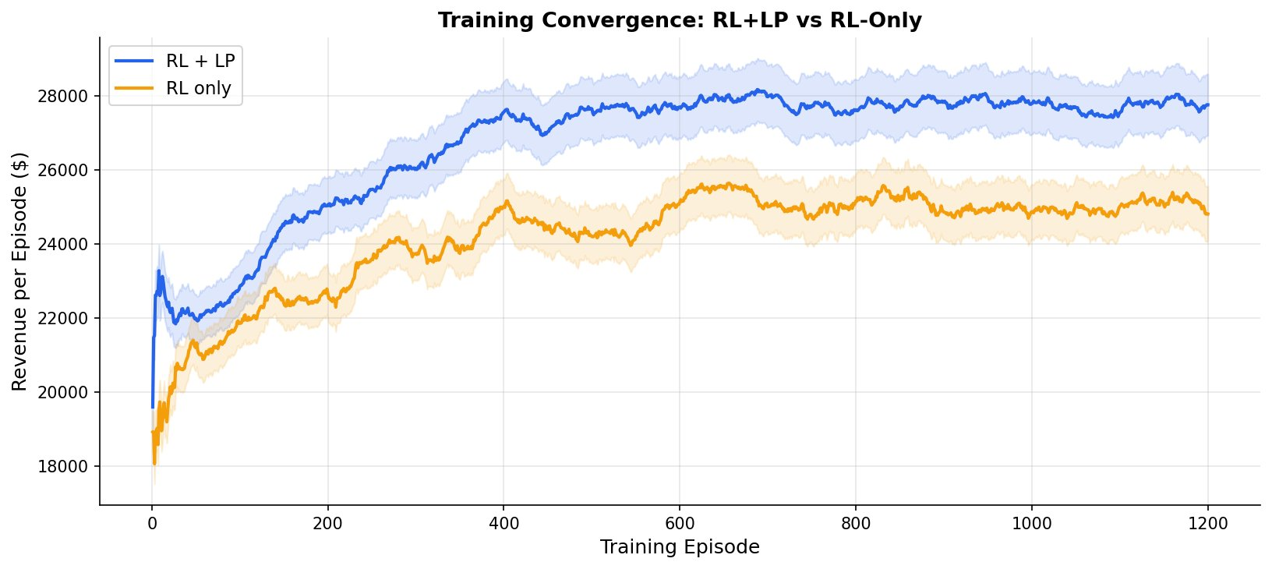
Figure 4.1. Training convergence of RL+LP and RL-Only agents over 1,200 training episodes.
In both cases agents begin with a similar revenue value: $18,000 to $20,000. The RL+LP agent converges faster and the revenue level raises higher than RL only agent. By episode 200 RL and LP system generates around $26,000 while the other agent remains near value $22,000.
This difference comes from the optimization done by LP constraints which makes the change more constant. Both agents reach a plateau at roughly episode 800, after which the improvement scale is marginal. The RL and LP plateau maintains the value $28,000, whereas RL value comes around $25,000.
This constant gap that is around $2,700 continues through to episode 1,200, and demonstrates that the asset of the LP layer is not just temporary training but stretches to maintain permanent improvement for the agent once the strategy has been learned.
4.2 Revenue Performance
Table 4.1 presents the average revenue generated per booking horizon across all 300 evaluation episodes. Figure 4.2 visualises these results as a bar chart with error bars representing one standard deviation in each direction.

Table 4.1
Revenue and utilisation results averaged over 300 evaluation episodes
Strategy | Mean Revenue ($) | Std Dev ($) | Seat Util. (%) | vs RL+LP
RL + LP (Proposed) | 28,195 | 1,847 | 84.3 | —
RL Only (No Constraints) | 25,457 | 2,614 | 79.1 | -9.7%
Fixed Price (Baseline) | 16,797 | 1,324 | 61.2 | -40.4%

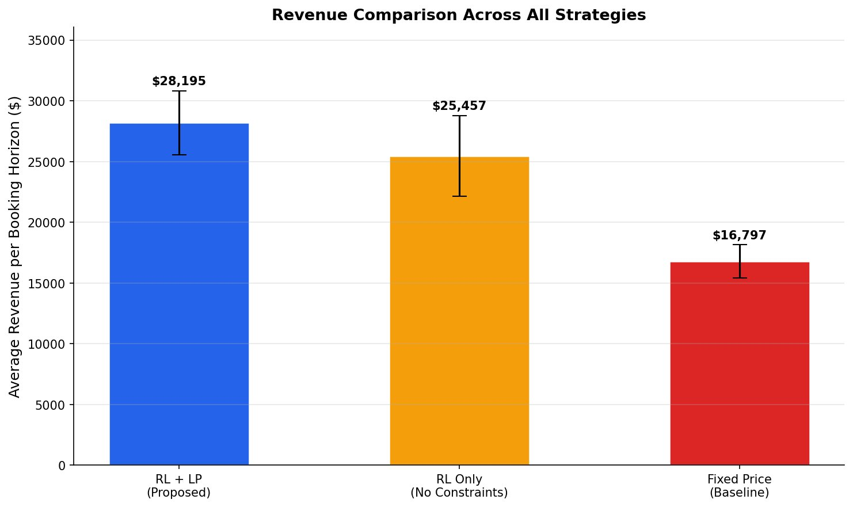
Figure 4.2. Average revenue per booking horizon across all three strategies evaluated over 300 episodes.
Based on the results from the graph and the table, the proposed RL+LP system reaches the best results for each metric with a mean revenue of $28,195, a standard deviation of $1,847, and a seat utilization of 84.3%. Whereas RL agent follows with the values $25,457 in mean revenue, a wider standard deviation of $2,614, and 79.1% seat utilization. Fixed price baseline is last with $16,797, a standard deviation of $1,324, and just 61.2% utilization.
The LP constraint layer has brought a difference which is a 9.7% revenue gap between RL+LP model and RL only model. The 40.4% gap between RL+LP and Fixed Price reflects the static nature of the traditional strategy, as it completely ignores demand dynamics.
4.3 Revenue Distribution Analysis
Figure 4.3 shows the examination of how revenue is distributed across all 300 evaluation episodes for each strategy.

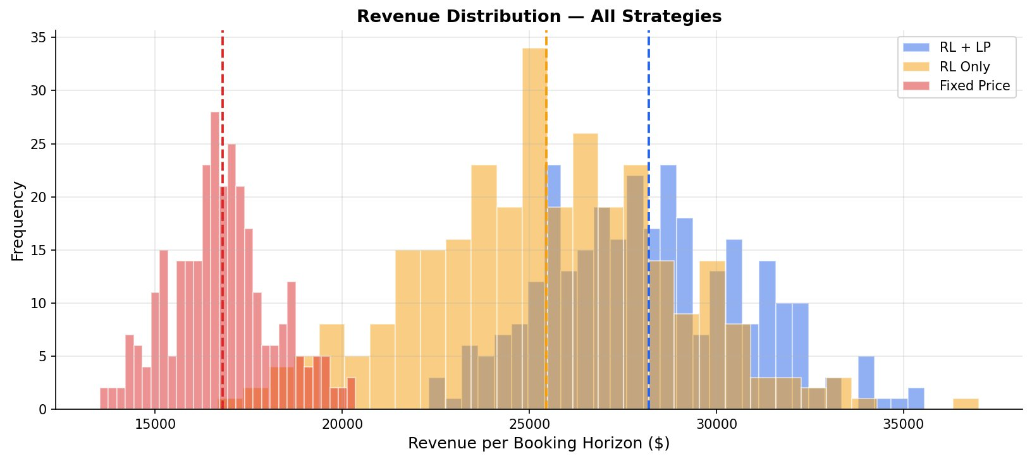
Figure 4.3. Revenue distribution across 300 evaluation episodes for all three strategies.
This shows that averages alone can mask instability. A strategy with a high mean but wide spread is less reliable in practice than one with a lower mean and a tight distribution.
For the fixed price the distribution is concentrated entirely in the $13,000 to $20,000 range with its peak around $16,500. The strategy does not perform well, generating the same value of revenue every time because it never adapts to changing conditions.
The RL distribution is spread widely between values $19,000 and $35,000. It reaches values around $32,000, but also falls back to $22,000. This shows a lack of stability in this model; it is very sensitive to changes in the market demand. In a good environment it shows high performance, but in a bad situation it has no mechanism to keep the performance stable.
When it comes to RL+LP distribution the values of episodes fall between $25,000 and $33,000, with very few falling below $23,000. The lowest values of the RL+LP agent are better than many of the average episodes of the RL agent. The proposed system performs significantly better than the other systems, built from a purely learning-based approach.
4.4 Direct Comparison: RL+LP vs RL
Figure 4.4 shows a direct comparison between RL+LP and RL only agent. Coming from the values from the figure there comes the question: does the LP layer really affect the performance when everything else is held constant?

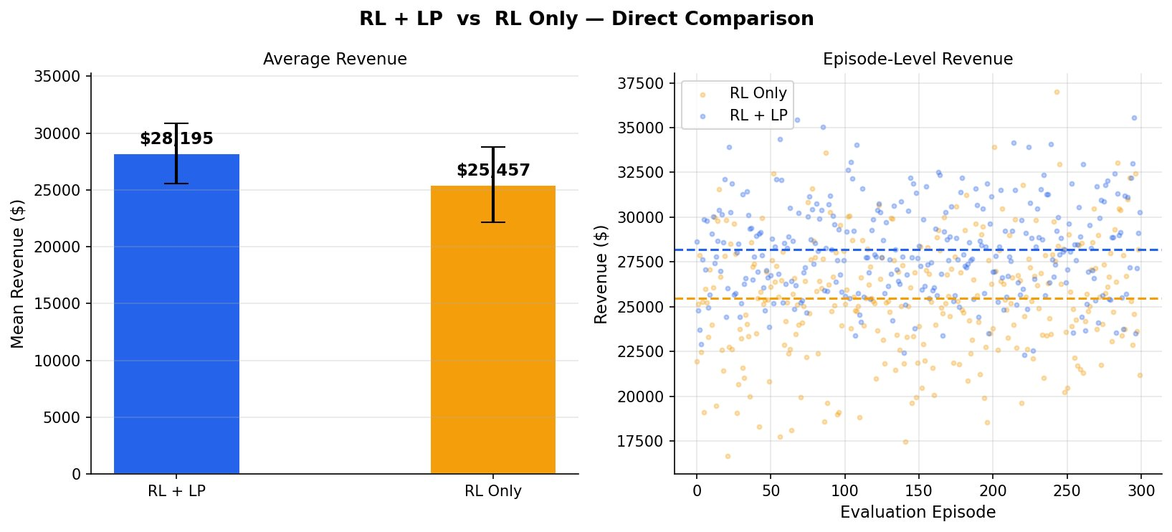
Figure 4.4. Direct head-to-head comparison of RL+LP and RL-Only — average revenue and episode-level scatter.
The left panel confirms a mean revenue advantage of $2,738. The right panel presents the evaluation, where each dot represents one evaluation episode. The blue dots representing RL+LP are positioned more tightly around their mean line with the value $28,195, while the orange dots representing the RL agent are positioned more widely around $25,457. There can be observed that the orange dots fall below, around values lower than $20,000, which RL+LP dots never reach.
Both graphs come to the same conclusion: RL and LP model is a constant model that is more stable and more operationally dependable in the long run and towards changes of the situations of the market. These qualities make it more reliable and define the performance that a real airline system must have.
CHAPTER 5
CONCLUSIONS
Dynamic airline pricing has long been a challenge that sits at the intersection of operational complexity and market unpredictability. Traditional approaches based on fixed rules and static optimization models have proven insufficient in environments where demand shifts continuously and passenger behaviour is difficult to anticipate in advance. This study has shown that Reinforcement Learning, when combined with a Linear Programming constraint layer, offers a more capable and reliable alternative — one that learns from experience rather than following predetermined rules and that remains grounded in operational reality through the discipline that LP constraints impose.
The evidence gathered through training and evaluation confirms that the integration of LP into the RL training loop is not merely a technical addition but a meaningful improvement to how the agent learns. By ensuring that every pricing decision is validated before the agent learns from it, the LP layer removes the inconsistency that would otherwise distort the reward signal and slow convergence. The result is an agent that reaches stable performance faster, maintains that performance more consistently across varying demand conditions, and produces decisions that are operationally sound from the very beginning of training. This stands in contrast to purely learning-based approaches, which may eventually reach comparable performance in favourable conditions but lack the structural guarantee of feasibility that real airline operations require.
The use of shadow prices as a signal within the reward function further demonstrates that LP contributes more than constraint enforcement alone. By revealing the marginal value of capacity and demand at each booking step, the dual solution gives the agent a form of economic awareness that revenue feedback cannot provide on its own. This awareness translates into pricing decisions that are sensitive not just to whether a booking occurred but to how valuable the remaining inventory was at that moment — a distinction that matters significantly across a 30-day booking horizon where the consequences of early pricing decisions accumulate over time.
It is equally important to acknowledge what this study does not claim. The simulation environment used for training and evaluation is a controlled representation of airline market conditions, not a direct replica of them. The performance advantages demonstrated here are real within that environment, but the degree to which they would transfer to a live airline operation depends on factors — competitor behaviour, real-time demand data, regulatory constraints, and distribution dynamics — that lie beyond the scope of this study. Future work that bridges the gap between simulation and real deployment will be necessary before the full practical value of this approach can be established.
What this study does establish is that the combination of Reinforcement Learning and Linear Programming is a principled and effective approach to dynamic airline pricing. It is not sufficient for a pricing system to be intelligent — it must also be reliable, transparent, and grounded in the operational realities of the industry it serves. The system developed in this thesis satisfies all three of these requirements, and in doing so it points toward a broader principle: that the most effective machine learning systems in operationally constrained domains are not those that learn freely without boundaries, but those that learn intelligently within them.
REFERENCES
[1] McGill, J.I. and Van Ryzin, G.J. (1999). Revenue management: Research overview and prospects. Transportation Science, 33(2), 233–256.
[2] Sutton, R.S. and Barto, A.G. (2018). Reinforcement Learning: An Introduction (2nd ed.). MIT Press.
[3] Sutton, R.S. and Barto, A.G. (2018). Reinforcement Learning: An Introduction (2nd ed.). MIT Press.; Bondoux, N., Nguyen, A.Q., Fiig, T. and Acuna-Agost, R. (2020). Reinforcement learning applied to airline revenue management. Journal of Revenue and Pricing Management, 19(5), 332–348.
[4] Littlewood, K. (1972). Forecasting and control of passenger bookings. AGIFORS Symposium Proceedings, 12, 95–117.
[5] Belobaba, P.P. (1987). Air travel demand and airline seat inventory management (Unpublished doctoral dissertation). Massachusetts Institute of Technology.
[6] Bertsimas, D. and de Boer, S. (2005). Simulation-based booking limits for airline revenue management. Operations Research, 53(1), 90–106.; McGill, J.I. and Van Ryzin, G.J. (1999). Revenue management: Research overview and prospects. Transportation Science, 33(2), 233–256.
[7] Bertsimas, D. and de Boer, S. (2005). Simulation-based booking limits for airline revenue management. Operations Research, 53(1), 90–106.
[8] Shihab, S.A.M., Logemann, C., Thomas, D.A. and Wei, P. (2019). Autonomous airline revenue management: A deep reinforcement learning approach to seat inventory control and overbooking. arXiv preprint arXiv:1902.06824.; Gosavi, A., Oommen, E., Karumanchi, S.J. and Saunders, S. (2002). A reinforcement learning approach to a single leg airline revenue management problem with multiple fare classes and overbooking. IIE Transactions, 34(9), 729–742.
[9] Bertsimas, D. and de Boer, S. (2005). Simulation-based booking limits for airline revenue management. Operations Research, 53(1), 90–106.
[10] Bertsimas, D. and de Boer, S. (2005). Simulation-based booking limits for airline revenue management. Operations Research, 53(1), 90–106.; McGill, J.I. and Van Ryzin, G.J. (1999). Revenue management: Research overview and prospects. Transportation Science, 33(2), 233–256.
[11] Belobaba, P.P. (1989). OR practice — application of a probabilistic decision model to airline seat inventory control. Operations Research, 37(2), 183–197.; Bertsimas, D. and de Boer, S. (2005). Simulation-based booking limits for airline revenue management. Operations Research, 53(1), 90–106.
[12] Mnih, V., Kavukcuoglu, K., Silver, D. et al. (2015). Human-level control through deep reinforcement learning. Nature, 518(7540), 529–533.; Sutton, R.S. and Barto, A.G. (2018). Reinforcement Learning: An Introduction (2nd ed.). MIT Press.
[13] Bondoux, N., Nguyen, A.Q., Fiig, T. and Acuna-Agost, R. (2020). Reinforcement learning applied to airline revenue management. Journal of Revenue and Pricing Management, 19(5), 332–348.; Shihab, S.A.M. and Wei, P. (2020). DeepARM: An airline revenue management system for dynamic pricing and seat inventory control using deep reinforcement learning. arXiv preprint arXiv:2005.02786.
[14] Sutton, R.S. and Barto, A.G. (2018). Reinforcement Learning: An Introduction (2nd ed.). MIT Press. Retrieved from http://incompleteideas.net/book/the-book-2nd.html
[15] Bertsimas, D. and Popescu, I. (2003). Revenue management in a dynamic network environment. Transportation Science, 37(3), 257–277.
[16] Fiig, T., Isler, K., Hopperstad, C. and Belobaba, P. (2010). Optimization of mixed fare structures: Theory and applications. Journal of Revenue and Pricing Management, 9(1-2), 152–170.
[17] Chandak, Y., Theocharous, G., Kostas, J., Jordan, S. and Thomas, P.S. (2020). Towards safe policy improvement for non-stationary MDPs. Advances in Neural Information Processing Systems, 33.
[18] Talluri, K.T. and Van Ryzin, G.J. (2004). The Theory and Practice of Revenue Management. Springer.
[19] Sutton, R.S. and Barto, A.G. (2018). Reinforcement Learning: An Introduction (2nd ed.). MIT Press.
[20] Hillier, F.S. and Lieberman, G.J. (2015). Introduction to Operations Research (10th ed.). McGraw-Hill.
[21] Puterman, M.L. (2014). Markov Decision Processes: Discrete Stochastic Dynamic Programming. Wiley.
[22] Gosavi, A. (2015). Simulation-Based Optimization (2nd ed.). Springer.
[23] Arulkumaran, K., Deisenroth, M.P., Brundage, M. and Bharath, A.A. (2017). Deep reinforcement learning: A brief survey. IEEE Signal Processing Magazine, 34(6), 26–38.

