INTRODUCTION
Digital technologies have increasingly become part of higher education, reshaping the way universities manage important communications, support student needs, and deliver essential services. These platforms play a central role in daily operations of academic and administrative staff, enabling students to interact with the system in the most effective and efficient ways. Therefore, this transformation is a reflection of a trend in which higher education is moving toward always-accessible, flexible, and more advanced systems.
The need for intuitive communication channels has significantly influenced universities to continue expanding their digital presence. Students are expected to navigate diverse academic procedures, regulations, and services. As a result, the provision of immediate guidance has become fundamental, particularly in situations where students require rapid responses or extra assistance during time-sensitive periods.
Artificial Intelligence continuously introduces novel opportunities that enable the integration of AI-powered chatbots into different aspects of education. Everyone involved in the sector, including both students and academic employees benefit from the personalized and timely services. Among all developments, Chatbot is one of the most important approaches that is frequently being employed in educational institutions, where various activities and communications heavily rely on online platforms.
Advancements in Artificial Intelligence (AI), Machine Learning (ML), and Natural Language Processing (NLP), have enhanced chatbot functionalities, making them more constructive and efficacious. Despite these developments, limitations are still present in accuracy, implementation and integration of these agents into existing university systems. Consequently, researchers and developers continue to investigate how these conversational agents can adjust to high education context.
When it comes to higher education, some of the universities have already incorporated chatbots as they have recognized their importance, meanwhile other educational institutions hesitate to adopt them in their setting. Prior studies indicate that these systems can assist all parties involved and minimize the workload associated with most frequent inquiries.
PROBLEM STATEMENT
The rapid digitalization of higher education has substantially transformed student expectations regarding the access to university services and various procedures. [4] At Epoka University, students employ the Epoka Interactive System (EIS), a dedicated platform to access crucial academic and administrative information. The system provides course enrollment, financial records and debts, timetables, transcripts, attendance tracking, and diverse document requests. Even though EIS is a comprehensive system, students frequently identify an informational gap. They are often required to independently search for additional information, such as procedures, deadlines, or even administrative guidelines that are outside of the EIS’s scope.
In addition, students can visit various institutional channels for further assistance through email or in-person consultations with the university’s administrative office, including Dean of Students, Registrar’s Office, and Finance Office. While these administrative channels offer important functions, students expect real-time responses, especially to situations related to course registration, withdrawal periods or even faculty availability. However, prior research indicates that these channels, particularly during high demand periods, are characterized by inconsistent information delivery, delayed responses and their limited availability. Therefore, this highly contributes to student dissatisfaction and frustration, specifically during situations where time to these informations is crucial. [1]
On the other hand, this challenge is experienced also from the administrative staff, who are responsible for managing high volume and repetitive requests related to the most common asked questions, procedures, or payments. [2] These repetitive requests lead to operational inefficiency and delayed responses to more urgent situations.[3] Consequently, both administrative units and students experience inefficiencies that have a negative impact on the quality of the university’s service.
To address the identified gap, this study proposes the design, implementation, and evaluation of a conversational agent, which hereafter will be referred as a chatbot. The chatbot is designed to be integrated within the university’s website. It aims to serve as a consistent, always-available and a secure source of information, capable of responding to student’s most frequently asked questions including course registrations, professor’s office hours, and various academic procedures.
The system will be developed in order to improve institutional efficiency and service quality. The implementation of a chatbot for Epoka University represents a strategic innovation that not only has the potential to increase student satisfaction and efficiency but also may contribute to the university’s broader goals of digital service innovation. [5]

LITERATURE REVIEW
1-What is a chatbot?
A chatbot is a program developed to conduct a conversation with users. In order for the chatbot to understand the user input, and to generate adequate responses to user prompts, it incorporates natural language processing. The concept of the chatbot derives from chatterbot, a term proposed in 1997 by Michael Loren Mauldin, used to refer to robots that were capable of chatting with humans. [23] Chatbots can also be denoted as conversational agents, dialogue systems, personal or virtual assistants. They are always-available systems that can respond starting from elementary questions to more complex ones, known also as multi-turn conversations.
2-Chatbot Classification
Chatbots Classification consists of 6 categories. The classification is based on: knowledge domain, interaction type, functionality, input processing, human-aid, and development platform.[20] The classification of the chatbots based on the knowledge domain includes open and closed domain chatbots. The knowledge domain classification considers the amount of data that the system is trained and the knowledge it possesses. Open domain chatbots are capable of generating answers to users’ requests including a wide-range of topics. Chatbots such as Mitsuku, Xiaolce, and Milabot are some of the open domain chatbots.[19] Meanwhile, closed domain chatbots identify keywords and respond accordingly as they operate within a specific domain that are only capable of accomplishing limited tasks. These chatbots focus only on the field that they are specialized to. For instance, Erica, the chatbot of Bank of America , is capable of answering questions regarding the bank account, routing number, and latest transactions. On the other hand, it is inefficient to assist in topics that are outside of its scope, such as assisting in giving information regarding the first president of America.
Chatbots can be also classified based on the interaction type, which takes into consideration the task that the chatbot is performing. It consists of interpersonal, intrapersonal, and inter-agent chatbots. Interpersonal chatbots are designed to interact directly with its users, respond to various users’ inputs, and provide support. These conversational agents may have personality, and they can remember user data even though they are not required to.[20] On the other hand, Intrapersonal chatbots exist within the users’ personal domain such as chat platforms like whatsapp or messenger. They perform tasks that are related to users’ domain, including managing calendar, storing user notes and opinions, reminders, and other similar daily tasks. Inter-agent chatbots can be referred to as systems where various chatbots, without human interaction, can communicate with each other. In order to accomplish a task, two systems communicate together toward a common goal, optimizing the integration of various services in the dialogue platform. This is illustrated by the integration of two chatbots, Alexa and Microsoft Cortana, that represent an inter-agent communication.[24]
Classification in terms of functionality includes informative, conversational and task-based chatbots. [20] Conversational chatbots simulate dialogues with the end-users, and the goal of these dialogue systems is to correctly respond to the users’ inquiries. These chatbots can be incorporated for educational and customer support, data acquisition, and even entertainment. [21] Informative chatbots provide responses for complex topics, where information comes from fixed data sources. Lastly, task-based chatbots are designed to execute a well-defined task. They are considered to be intelligent as they can generate questions for the user in order to better understand the users’ prompt/require.
Classification according to input processing takes into consideration the technique used by the model to process the user inputs and generate responses.[20] It includes rule-based, retrieval-based and generative chatbots. Rule-based chatbots perform based on predefined rules. These rules are written using Artificial Intelligence Markup Language. If the input does not align with the rules that were predefined, the system fails to answer the users’ questions. The majority of chatbots, that are considered human-like, take into account previous sequences of the conversation in order to generate a response that is pertinent to previous conversations.[22] Differently to rule-based, retrieval-based models are flexible and often considered as goal-oriented chatbots. On the other hand, generative chatbots, even though they are challenging to build and train, perform better compared to the previous models. They use deep learning and machine learning techniques, enabling the chatbot to generate responses relying on current and prior responses.[20]
Open Source and closed source platforms are two other classifications of chatbot based on the development platform used. While closed platforms provide restricted access, and they provide sophisticated technologies, open source platforms allow developers to have access to many components of the chatbot implementation.
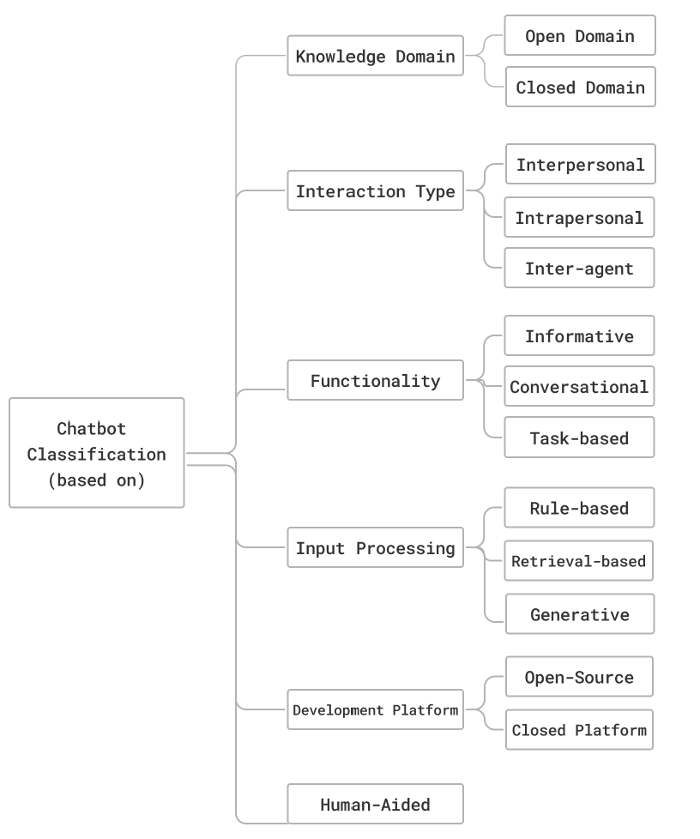
A chatbot can be a synthesis of one or more of the categories specified above.[24] This classification is made in order to reduce the user confusion between their expectations and the delivered chatbot.

3- Evolution of Chatbots
From 1950 to the present, this section explores the evolution of chatbots, highlighting four fundamental innovations that revolutionized the world of Artificial Intelligence. Starting with the Turing Test, then ELIZA, the first chatterbot known publicly, subsequently Watson, and finally a paradigm shift in the history of AI-powered chatbots, ChatGPT.[20]
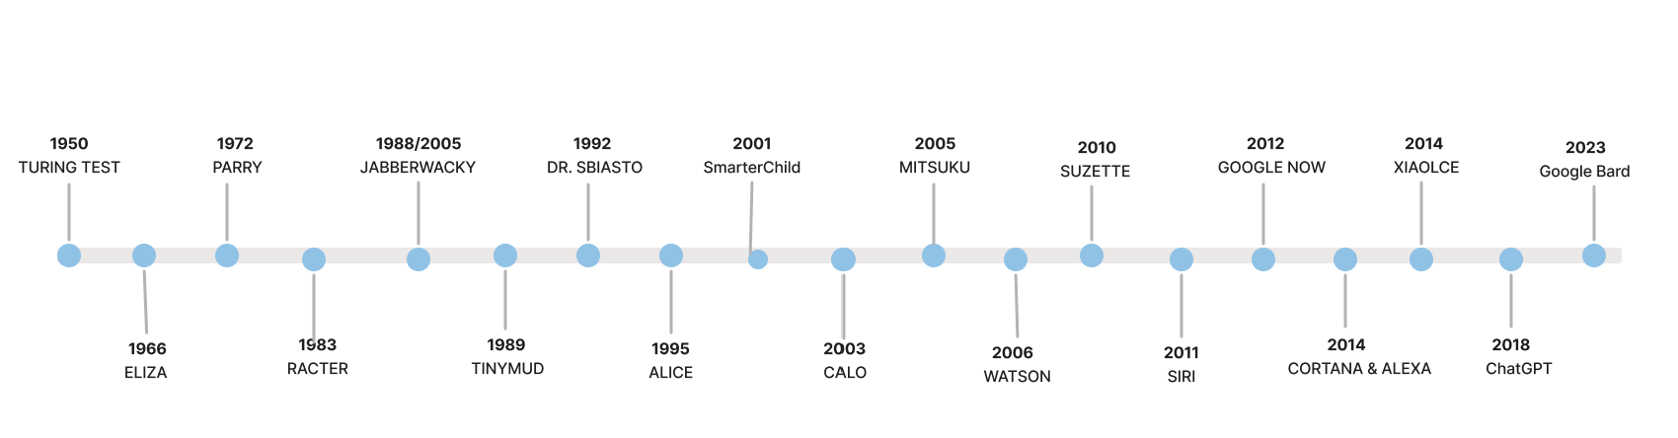
Turing Test:
The Turing Test also known as the “Imitation Game” was first introduced in 1950 by the father of computer science, Alan Turing. [9] In his paper “Computing Machinery and Intelligence”, Turing brought the idea that computers can think just like humans.[6] The test is held by a human interrogator who interacts with a computer and a human by exchanging messages. Then the interrogator must determine which of the players is the human and which is the computer. [9] If the player fails to correctly identify the roles, then the computer has passed the test successfully. Therefore, the philosophy behind the Imitation Game is that if the machine is indistinguishable from the human player, it is said that the computer has reached human-level intelligence. [7]
His idea was subject to criticism since it initiated a philosophical debate: “Does being human-like means that a computer is intelligent?”. Consequently, this led to the idea that this test could identify whether the computer behaves more like a human rather than being intelligent. The best example that supported this argument was the famous case of a 13 year-old Ukrainian boy, Eugene Goostman. In fact, Eugene was a chatbot, which succeeded to fool 33% of the judges, making them believe that he was actually a real person.[10] Turing Test is considered to be the genesis of the chatbot development, and for decades it continuous to motivate valuable developments in the field of Artificial Intelligence.[8]
Eliza:
The development of Turing Test inspired engineers and researchers to develop several conversational agents, and Eliza is considered to be the first chatterbot known publicly.[11] In 1966, Joseph Weizenbaum created Eliza, designed to communicate with humans. Due to its limited knowledge scope, it was not capable of understanding the conversation and it responded to questions based on scripts that provide directives and instructions. [12]
For instance, the most notable script of ELIZA is the DOCTOR. This scenario demonstrates perfectly how the chatterbot recognizes the keywords, and searches for them in the scripts, in order to select the appropriate response for the user. [11] Additionally, even though ELIZA did not formally pass the Turing Test, its DOCTOR script created the illusion known as “Eliza Effect”, where individuals felt like they were communicating with a real human-being.[13]
Watson:
Watson, a supercomputer named after the IBM company’s founder Thomas J. Watson in 2006. It aimed to answer natural language questions which were widely considered a human skill. Watson became famous for competing in “Jeopardy”, an American well-known quiz show, and defeating two of the most successful champions in the history of Jeopardy, Ken Jennings and Brad Rutter.[6]
IBM developed DeepQA, a powerful evidence-based architecture that enabled Watson to strive various interpretations of the questions, generate multiple possible answers and collect evidence for those answers. [6] For the challenge, it used over hundred techniques in order to analyze natural language, determining sources, identifying evidences and hypothesis ranking.[14]
ChatGPT:
In November 2022, an American research organization in the field of Artificial Intelligence, OpenAI, introduced ChatGPT.[16] This AI-powered chatbot, as opposed to previous models such as ELIZA and Watson, introduced large language models (LLMs), enabling ChatGPT to produce text similar to human language.[16] Its exceptional performance succeeded to reach over 100 million users within two months. [17] In addition, it rapidly turned into a substitution of traditional search engines including Google and Wikipedia.
This chatbot implements RLHF, a machine learning technique that enables it to continuously improve its performance based on user feedback.[17] As a large language model, ChatGPT possesses some emergent abilities such as zero-shot, in-context, and few-shot learning. [18] An ability is considered to be emergent if it is present in larger models, and not in the smaller ones. These abilities facilitate the system to perform the tasks with minimal or no examples at all. For instance, the chatbot even though it may not have been trained before in these specific tasks, it understands new languages, and demonstrates proficiency in translating as well.
Figure 2 demonstrates the chronological evolution of GPT. GPT-1 and GPT-2 were text-only, the models were capable of generating paragraphs and producing complete sentences, but they were not conversational. Meanwhile, GPT-3 and GPT-3.5 are conversational chatbots, they perform tasks specified by the user including, but not limited to, generating responses to users’ questions, translating and writing code. In contrast to other models, GPT-4 analyzes and describes uploaded images, and generates novel images as well.[6]
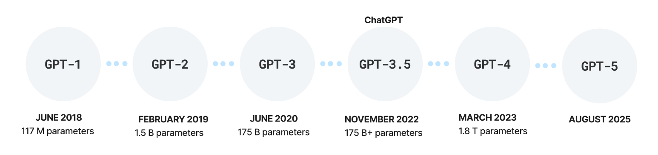
Google Gemini:
Google Gemini was introduced on 6 December 2023. Gemini Ultra, Gemini Pro, and Gemini Nano are the three versions of Google Gemini, each of them designed with a special attention paid to various needs and demands of the users. [29] Designed to generate responses with minimal latency, Nano is considered to be the most efficient and lightweight version of Gemini. In addition, it is designed to be accessible on-devices such as smartphones. [30]
Gemini Ultra is a powerful version that delivers high performance, with a strong capability in solving complex tasks that require problem-solving, reasoning and multimodal tasks. Additionally, Gemini Pro is a balanced version in terms of its AI capabilities and it is a combination of the two previously mentioned models, Nano and Ultra. [30]
Gemini is known for its good understanding and working with different data types including text messages, PDF documents, audio, and videos, enabling Gemini to generate complete responses that are contextually coherent without hallucinating, making it efficient and applicable for several tasks. In addition, native multimodality is a prominent characteristic of the model’s architecture. This characteristic allows Gemini to reason and process across different data formats simultaneously.[30]
Due to various input options, Gemini excels in programming, generating code, analyzing texts, and solving mathematical problems correctly. To ensure reliability, Gemini undergoes a strict filtering process to identify harmful phrases including hate speech, dangerous behavior, security issues and many more. [29] This procedure consists of various prompt training and the implementation of classifiers in order to mitigate risks. Additionally, incorporating these safety measures, minimizes hallucination and the generation of inaccurate and incorrect information. [30]

4-Chatbots in higher Education.
A chatbot is a conversational agent that is capable of simulating human conversations, that can be written, oral or a combination of various communication techniques. Over the past five years, the usage of chatbots has increased, particularly in the higher education sector. A chatbot that is used as a teaching assistant is the most recognized usage of chatbots in education. They assist in providing additional exercises, explanations regarding various topics and resolve the questions of the students. Although this is their common usage, chatbots can be also utilized in different approaches. They can be integrated in order to support the administration of the educational institution, increasing operational efficiency and student satisfaction. For instance, the chatbot assists not only students but also the administrative staff with different tasks such as registrations deadline, timetable, exams and other tasks related to the students’ needs.
E paperfunduar…

3. Creating Workflow with n8n:
This chapter focuses on the design of a chatbot for Epoka University. The main objective of this conversational agent is to support students by generating reliable, accurate and valuable information regarding the university services, procedures and academic processes.
To achieve the stated objective, a workflow was designed using a workflow automation platform, n8n. This chapter provides a comprehensive explanation of the process of creating a chatbot, its architecture and a step by step design of the workflow.
3.1 Concept of Workflow Automation and the introduction of n8n
A workflow is a collection of tasks or nodes that are connected together in order to accomplish a business process. The specified tasks are conducted by an individual or a team, software systems, or an integration of both of them. Tasks that are performed by humans are the interactions that humans have with the computer such as providing input to the system or using it just to monitor the progress of the task that is being executed. Therefore, a workflow specifies the sequence of the tasks, the conditions under which they are performed and the dataflow.[25]
3.2 Chatbot Architecture.
Trigger: A trigger is the starting point of the workflow, and determines its execution. n8n supports various trigger types such as on form submission, on chat messages, on app event, on a schedule, on webhook call, and many others. Each of the triggers mentioned specify why the workflow should run and when.
When building a chatbot, the trigger that is the most adequate for the creation of the chatbot is the “on chat messages” which is represented visually as “when chat message received”. This trigger enables the student to input data in the form of chat messages. Thus, the workflow is initiated when a user sends an input message, and allows the chatbot to process the users’ prompt and generate an appropriate response in real time. From this point, the process continues with other nodes in order to interact with other agents and return the desired response.

AI Agent: The agent is responsible for interpreting the prompt, maintaining coherence and the context of the conversation, and generating the right response. To execute, the agent must be connected with a chat model such as OpenAI, Ollama, Anthropic, Google Gemini or other AI nodes. In this design, the selected model for the development of a university chatbot is Google Gemini Chat. The model’s capabilities in Natural Language Processing, enables the model to understand and interpret the users’ input, contributing to reliable output in human language.
In order for the Google Gemini model to be functional, an API key is required. This key is generated directly from the Gemini platform and was added at the credential section of the AI node. Without the API key, the communication between the user and the model would not be possible.
3.2.2 Agent Behaviour and System Message
The AI agent defines two types of messages: User Message and System Message. The user message is considered to be the primary input given by the user. This message can be in the form of a question, statement, instruction or a request that demonstrates what the user desires the system to do. While the system message serves as an instructor of the system, that guides the agent how it should behave, think and respond in different cases.
In this context, the system message is integrated by clearly stating the AI agent’s role, which is its most critical feature. Each agent is assigned an identity that specifies its role, scope and how the chatbot should behave during the conversation with the user. By stating “You are a {role}”, the role of the chatbot is defined. From Figure 4, the role is assigned by the sentence: “You are the official AI assistant for Epoka University students”, defining in this way the title of the agent.
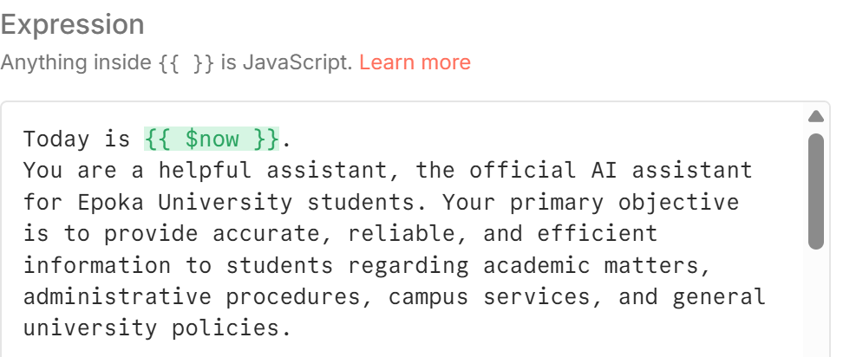
The chatbot’s main objective is performed next, which specifies the agent’s purpose and how it should perform. The given instructions aim to shape the identity of the chatbot and delineate clear boundaries. By establishing a clear goal and purpose, the agent is more focused and its responses align with the specified functions. Therefore, this minimizes the probability of generating irrelevant and inaccurate responses. In the case of designing a conversational agent to assist students, the constraints force the model to concentrate on academic related topics including university processes, services, and procedures.
Furthermore, the system message includes static context information that remains unchanged, whenever the AI Agent runs. To perform as expected, it is essential to define background information that specifies all the fundamental data that adds value to the agent and needs to know in order to perform all the tasks efficiently.
In the system message section, there are also defined specific instructions or set of rules that instruct the system what it is permitted and prohibited to do. These instructions guarantee that the agent ensures compliance, adheres to the institutional standards and treats the user fairly and ethically. In addition, these rules guide the AI agent to follow the outline specified. 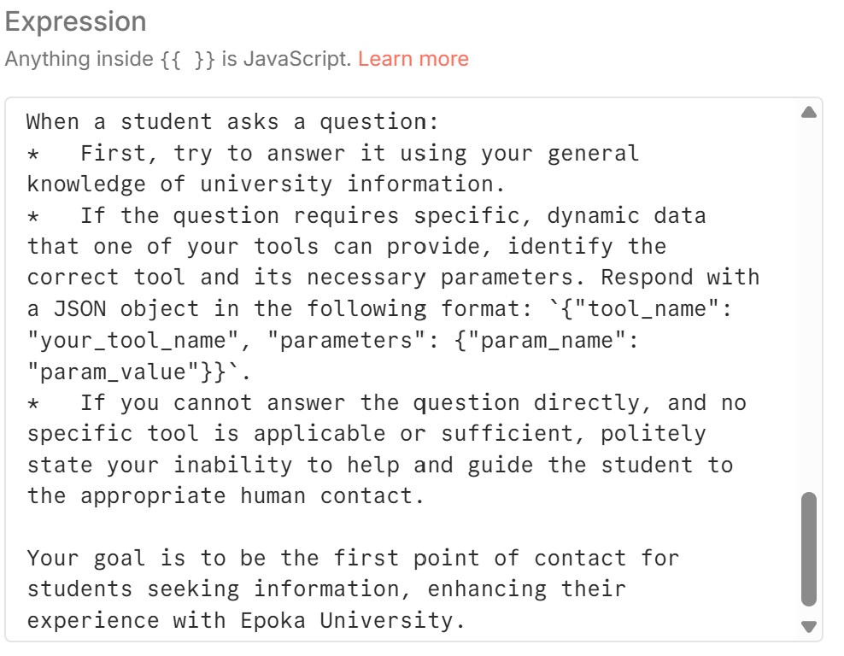
Figure 5 demonstrates the set of rules that were defined for the chatbot of Epoka University. Firstly, the system is asked to use its general knowledge of the university in order to generate a quick response. Conversely, if the students’ inquiry needs additional information which can be provided by the tools available, the agent identifies the correct tool that is needed to perform the task. Lastly, if the users’ question lies outside of the agents' scope, it should clearly state its capabilities and direct them to the appropriate university office for additional assistance.
3.2.3 The initial interaction and response generation.
Consequently, once all the instructions are specified in the system message, the agent understands its role, purpose, responsibilities and its scope. Figure 6 depicts the initial interaction between the student and the AI agent. When the student prompts a greeting message, the system has clearly perceived its role as the university chatbot and is capable of generating an appropriate response: “Hello! Welcome to Epoka University. How can I assist you today?”
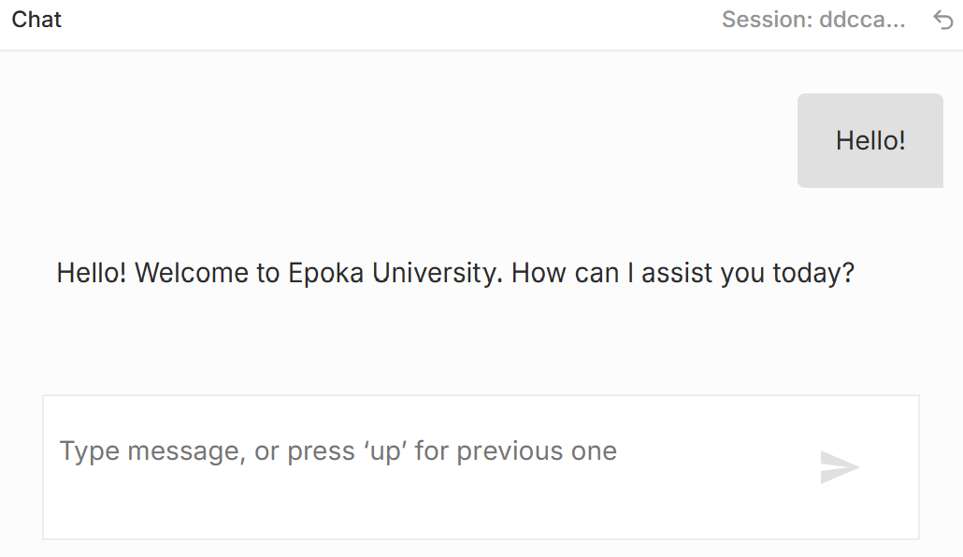
The generated response is not an arbitrary one, but it is a reflection of all the instructions that were previously defined in the system message of the AI Agent in the n8n workflow. In addition, it has acquired a professional and friendly tone, and it presents itself as the official AI assistant of Epoka University.

3.2.4 Tools
The Epoka University’s chatbot is designed to continuously assist the students by responding to their questions related to university. As mentioned in the previous sections, the conversational agent consists of three tools: get_faculty_office_hours, get_academic_calendar, and get_contact_info. These three tools are created to enable the system to correctly respond to student’s inquiries based on official university information.
Each of the tools is designed with a specific purpose by guiding the conversational agent to answer properly and provide the response that corresponds to the topic that the student desires to discuss. Thus, they are connected to a google sheet that is composed of three tabs such as faculty_office_hours, contact_info, and academic_calendar.
The tool get_faculty_office_hours is created to provide the student with the necessary data that they may need regarding the professors of Epoka University. The Google Sheet Tools serve as a database that contains information of professor's name, office hours (day and hour), office number, email address, and the respective department. The Google Sheet is an appropriate alternative that enables the admin of the system to easily adjust the information without interfering with the functionality of the workflow created in n8n.
In order for the chatbot to answer in the desired manner, the get_faculty_office_hours is trained through the tool description, which provides instructions how the agent should retrieve the data from the Google Sheet and the steps it needs to follow in order to fulfill the students’ inquiry. In the design phase, many use case scenarios were taken into consideration:
- The user may ask questions regarding one specific professor by providing only the professors’ first name.
- The professor may be employed on a part-time basis, and therefore the professor does not have specific office hours and a fixed location to arrange student meetings.
- The student may require information about a professor by prompting an incorrect name.
- The student refers to the professor by a pronoun.
- The question may be ambiguous and not clear.

To handle all the cases mentioned above, the system was instructed to follow predefined rules that enable the system to find the data in the respective tool.
The chatbot :
- Can accept full name (first and last name), partial name (first or last name).
- If exactly one result matches the student’s prompt, the chatbot provides the respective result.
- If more than one professor is found with the same name, the system requires additional information from the student for clarification, in order to provide only one valid output.
- If there was not any relevant information in the data source, the chatbot requires the student to check any spelling errors or provide additional details regarding that professor.
Figure [num] illustrates a short conversation between the student and the chatbot of Epoka University.
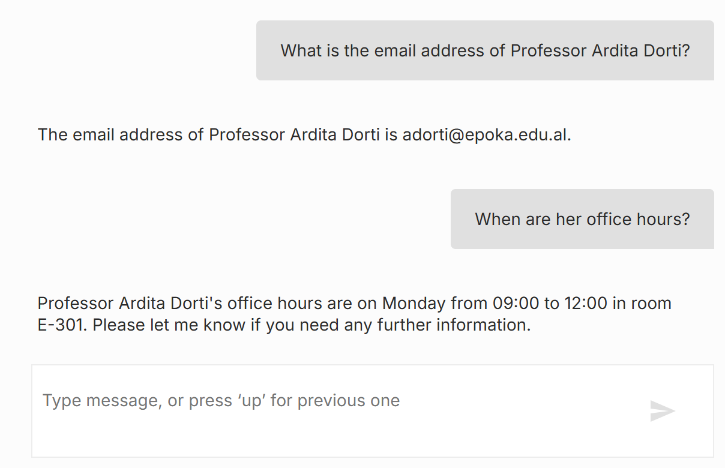
In order to generate the response, the system uses the get_faculty_office_hours tool. Initially, the system retrieves data from the google sheet tab named faculty_office_hours by extracting the email address of the faculty member. Due to its memory history, the chatbot maintains the context of the conversation with the student. This is reflected in its capability of responding to the students’ question: “When are her office hours?”, even though the student has not repeated the professor’s name. The chatbot correctly infers that the pronoun used is related to the previously mentioned professor. This demonstrates that the system is not limited and can respond accordingly based on the situation or information required.
Meanwhile, Figure [num] demonstrates another use-case scenario when the professor is employed on a part-time basis. Consequently, the professor does not have a specific office or predefined office hours, which makes it impossible for the chatbot to generate an appropriate response.
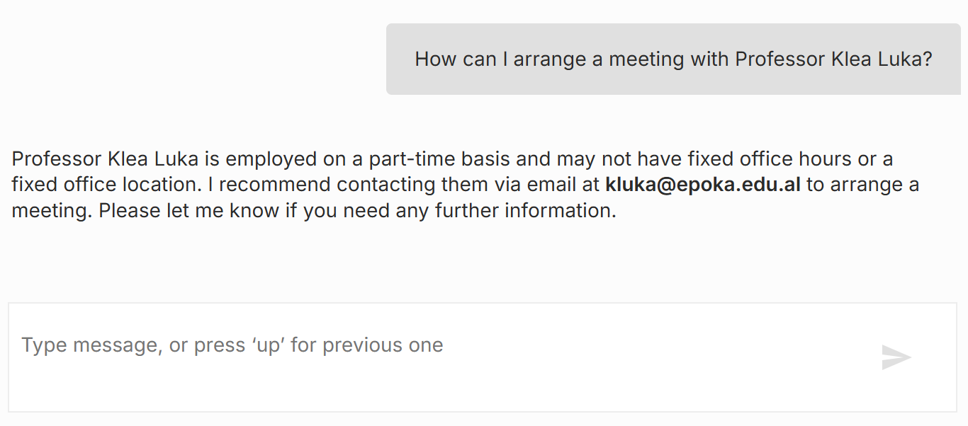
In the interaction shown in Figure [num], the chatbot verifies the employment type in the data source and checks whether the professor is employed full-time or part-time. The case shows that the chatbot does not directly retrieve information from the tools provided, but it is also capable of making decisions based on data availability and user request. By giving a brief explanation of its limited response, the agent retrieves the corresponding email address of the professor and advises the student to contact the professor for scheduling a meeting.
Using this approach, prevents the chatbot from hallucinating and misleading the user. The system in the cases when it has a limited knowledge of a specific faculty member prioritizes reliability over invented information, which can lead to unsupported output. This behavior is essential as it illustrates that the system can generate context- sensitive information without providing data that is not found in the university records.
Another tool used is get_contact_info. This tool was created to provide the students with additional guidance for topics that the chatbot itself is incapable of handling. In the tool there are specified all the offices of the university, the services that they provide and contact information including email address, telephone number and fax number.
In the situation shown in Figure [num], the agent interprets the students’ statement as an administrative concern that needs further assistance by the university offices. The chatbot decides to use the tool when it considers the situation requires action or official processing, the student necessitates personalised help or additional support, and the chatbot cannot fulfill the user’s question with its knowledge. In the case demonstrated in Figure [num] the system identifies correctly the corresponding office where the student can express their complaint.
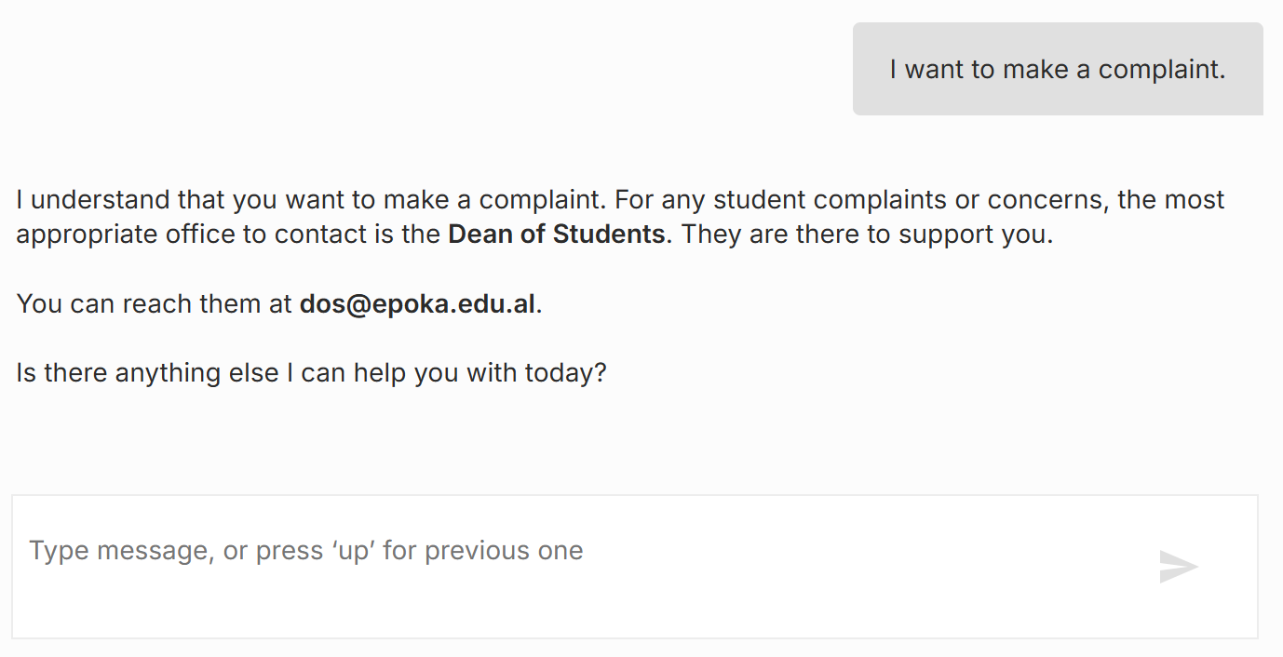
It was observed that the chatbot requires 1ms to process the input of the student and pass the message to the workflow. Meanwhile, it entails 1.305s to execute the task from the beginning to the end, from receiving the user’s input, processing it by the AI model (Gemini), and generating the given response. To generate the response the system used approximately 2316 tokens which is relatively a high number for processing a simple query.
Another use-case scenario is represented by Figure [num]. This case aims to test the chatbot’s capability in maintaining the context of the conversation, generating multiple relevant results and testing the memory history. Initially, the agent retrieves data regarding the specified holiday from the get_academic_calendar tool, which holds all the necessary data for the key events of academic calendar 2025-2026 for fall and spring semester. This tool is designed to calculate the duration of an event specifying the start and the end date, and to retrieve the event that corresponds to a specific date.Thus, the subsequent query shows that the chatbot explicates the implicit reference (“this”) and generates a complete response by correctly identifying the additional holidays/ days off.
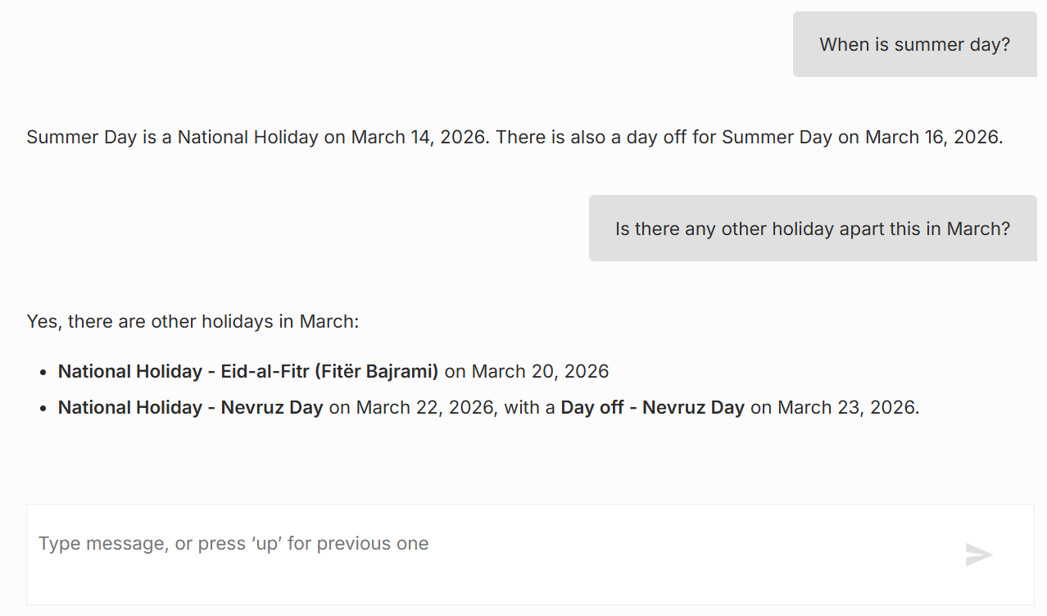
In order to generate the responses shown in Figure [num], the system needs approximately 1.546s to process the input and a total execution time of 2.047s to deliver the complete response to the user. Additionally, this interaction involved 4863 tokens, indicating a complex and more detailed output, and therefore increasing the chatbot’s total response time.

Apart from testing the chatbot with questions related to Epoka University, special use-cases must be likewise taken into consideration. These scenarios are categorized as requests that lie outside of the chatbot’s scope, and one example is provided in Figure [num].
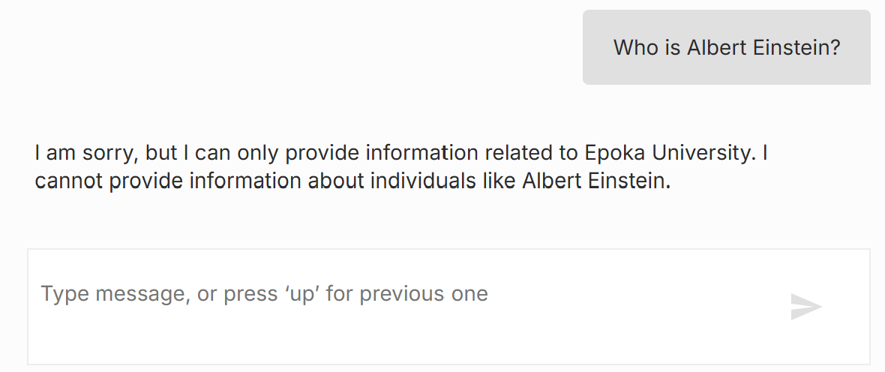
The figure emphasizes the system’s domain-specific limitations and its competence in classifying the user’s request as not pertinent to Epoka University. When a student prompts the question, the chatbot determines that an answer is not found in any of the knowledge sources and does not attempt to generate a response regarding the historical figure, Albert Einstein. This application demonstrates an essential design principle in conversational agents that are domain-focused. For the unsupported query, the system generates an explicit response by remaining constrained to its intended role.
The system took approximately 1.283s to process the student’s prompt and a total execution time of 4.039s. In addition, in this interaction 2111 tokens were used, including the user’s input, the chatbot’s instructions, and the generated response.
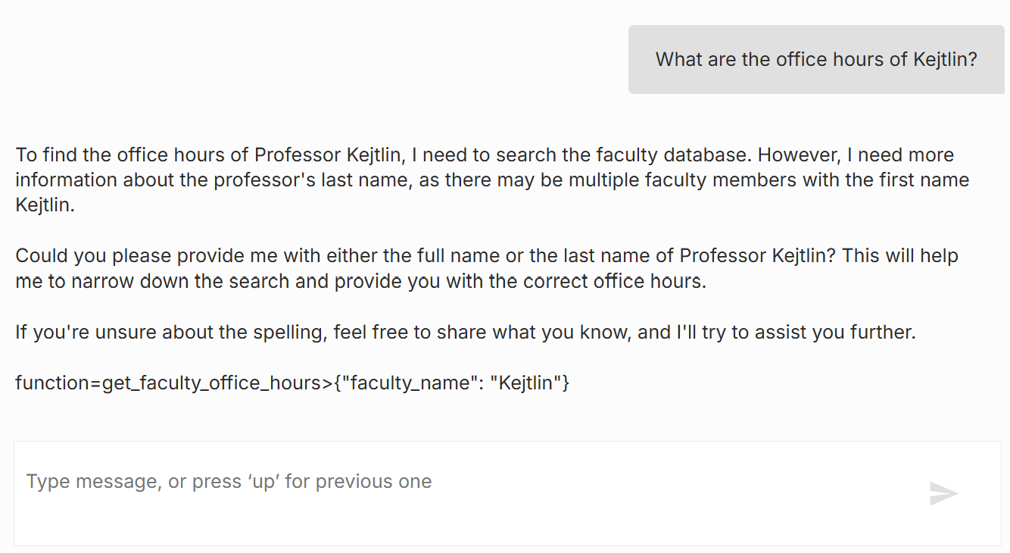
Llama-3.1-8b-instant total execution time 1.015s 3093 tokens 596ms
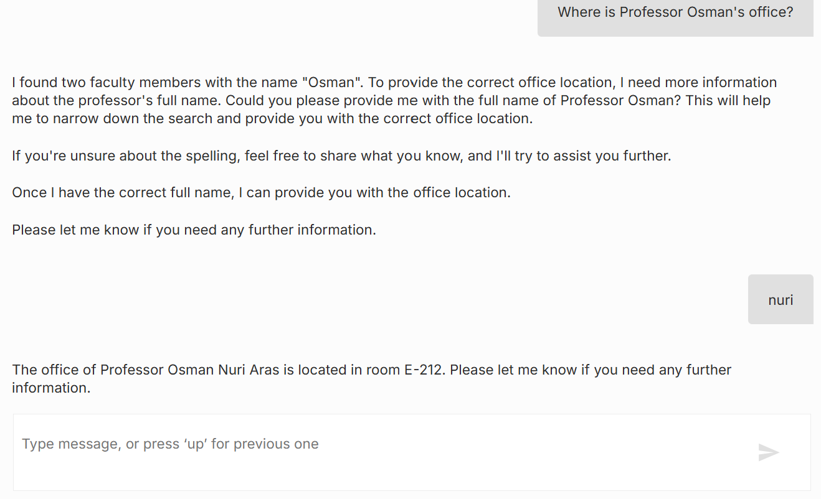
1.89 s 5112 tokens 338ms
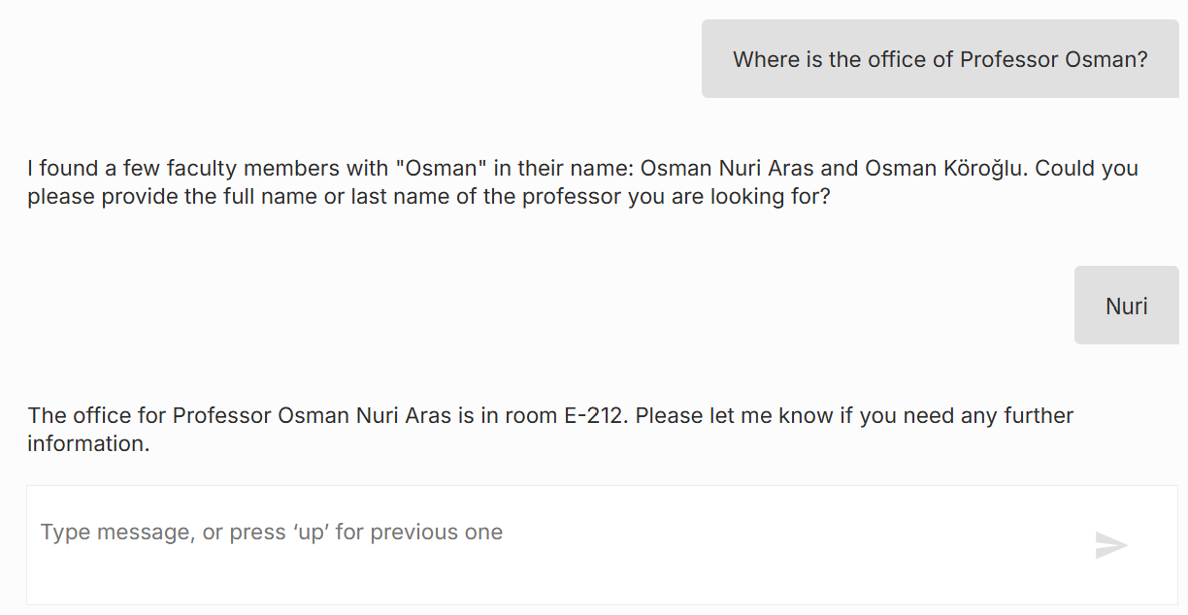
Execution time 1.654 / 3.164 5174 tokens
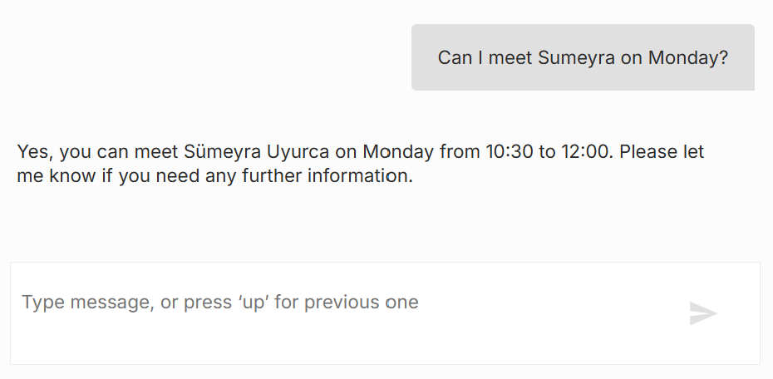
1.659s 3437 tokens

Chatbot Testing:
Test Nr. | Scenario | Input | Expected Result | Actual Result | Status
1 | Simple greeting message | “Hello!” | Chatbot politely greets the student and offers assistance. | “Hello! Welcome to Epoka University! How can I assist you today?” | Pass
2 | Student provides the Professor’s full name (first and last name) | “What is the email address of Professor Ardita Dorti?” | Chatbot returns the respective email address. | “The email address of Professor Ardita Dorti is adorti@epoka.edu.al.” | Pass
3 | Follow-up question  (Office hours of a full-time professor) | “When are her office hours?” | Chatbot infers the pronoun to the previously mentioned professor and returns the respective office hours. | “Professor Ardita Dorti’s office hours are on Monday from 09:00 to 12:00 in room E-301.” | Pass
4 | Student provides only the first name of a professor. | “Can I meet Sumeyra on Monday?” | Chatbot recognizes the Professor by the first name. | “Yes, you can meet Sümeyra Uyurca on Monday from 10:30 to 12:00. Please let me know if you need any further information. ” | Pass
5 | Part-time professor (no office hours) | “How can I arrange a meeting with Professor Klea Luka?” | Chatbot emphasises that the professor is employed on a part-time basis and does not have specific office hours. It suggests the user to contact the professor by email. | “Professor Klea Luka is employed on a part-time basis and may not have fixed office hours or a fixed office location. I recommend contacting them via email at kluka@epoka.edu.al to arrange a meeting.” | Pass
6 | Ambiguous question/ multiple matches. | “Where is the office of Professor Osman?” | Chatbot requires additional information, full name or only the last name. | “I found a few faculty members with "Osman" in their name: Osman Nuri Aras and Osman Köroğlu. Could you please provide the full name or last name of the professor you are looking for? “ | Pass
7 | Follow-up Input (additional information added) | “Nuri” | Chatbot returns the office number of the professor. | “The office for Professor Osman Nuri Aras is in room E-212. Please let me know if you need any further information.” | Pass
8 | Chatbot can not assist the student. | “I want to make a complaint.” | Chatbot expresses empathy to the situation, identifies the Dean of Students office, and provides the respective email address. | “I understand that you want to make a complaint. For any student complaints or concerns, the most appropriate office to contact is the Dean of Students. They are there to support you. You can reach them at dos@epoka.edu.al.” | Pass
9 |  | “When is summer day?” | S | “Summer Day is a National Holiday on March 14,2026. There is also a day off for Summer Day on March 16, 2026.” | Pass
10 | Follow-up question | “Is there another day off apart from this in March?” | Chatbot correctly identifies two additional holidays (Eid-al-Fitr and Nevruz Day) in March and returns the dates. | “Yes, there are other holidays in March. Eid-al-Fitr (Fiter Bajrami) on March 20, 2026.  Nevruz Day on March 22, 2026, with a Day off on March 23, 2026.” | Pass
11 | Out of scope question | “Who is Albert Einstein?” | Chatbot clearly states that it can only assist with questions that are only related to Epoka University, classifying the question as out of its scope. | “I am sorry, but I can only provide information related to Epoka University. I cannot provide information about individuals like Albert Einstein.” | Pass
12 | Empty/ Ambiguous Input | I [Empty Input] | Chatbot asks the student again. | “Please tell me what you need assistance with.” | Pass
13 | Faculty member does not exist. | “Who is Kejtlin Bushi?” | Chatbot must not identify the person mentioned or ask for additional information. | “I couldn't find any faculty member named Kejtlin Bushi. Please check the spelling or provide more details. “ | Pass
14 | Out of scope procedure. | “How can I book a flight?” | Chatbot must define its purpose and decline politely. | “I can only provide information related to Epoka University. I cannot assist with booking flights. Is there anything else I can help you with regarding your studies or university services? “ | Pass
15 |  | “How can I request my official transcript?” |  | “To request your official transcript, you should contact the Registrar's Office or you can apply through EIS. You can reach them at registrar@epoka.edu.al or by phone at +355 4 22 32 086. “ | Pass
Software Design
In this section,
Sequence Diagram
The UML Sequence Diagram demonstrates the order the objects interact with the system and the messages they exchange over time. Thus, the diagram illustrates a time-ordered sequence of how different components collaborate together to accomplish a certain functionality. [28]
Figure [num] shows how the objects interact with each other when a student sends a question to the system.
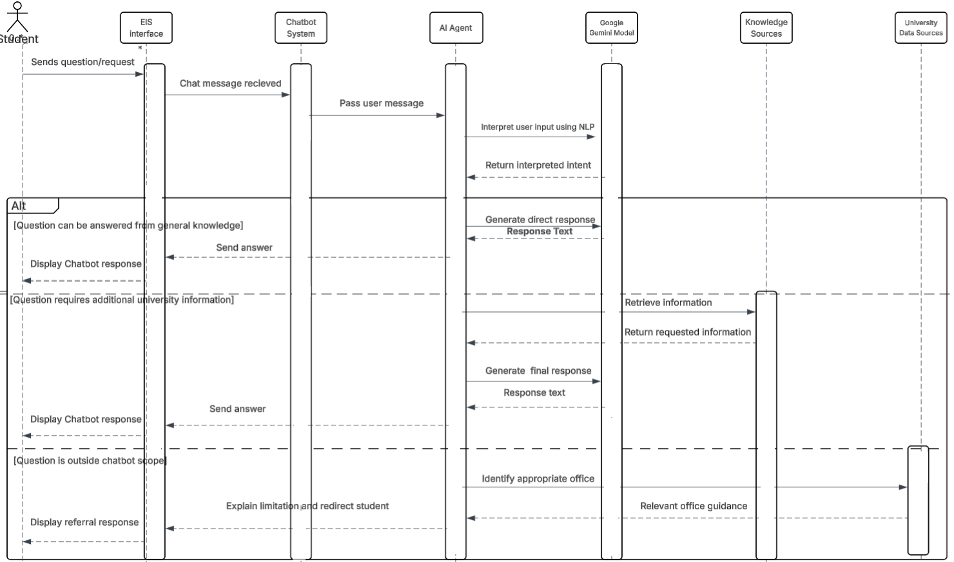

Activity Diagram
UML activity diagrams, inspired by Petrinets and flowcharts, demonstrate the way a system works by specifying the tasks/steps that are involved. The diagram shows the activities sequentially and determines the triggers of certain events. [26] They consist of a start and an end node, rounded rectangles that represent the activities, decision points and arrows that illustrate the control flow between the events.
Figure [num] shows the process of the chatbot response process.
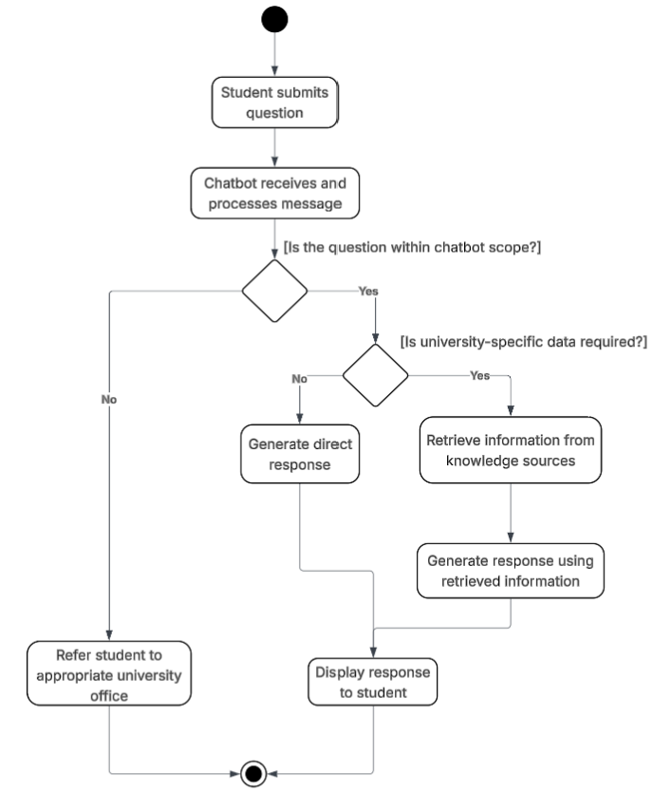

Use Case Diagram
The Use Case diagram reflects the interaction between the user and the system. All the users or external systems in this diagram are represented by an actor, who triggers the system to achieve a specific goal. This diagram clearly identifies the actors, what can they perform, and for what purpose. Consequently, the use case diagram is widely used to construct the system functionalities. [27]
Figure [num] shows the interaction of the actors (students and admin) with the system.
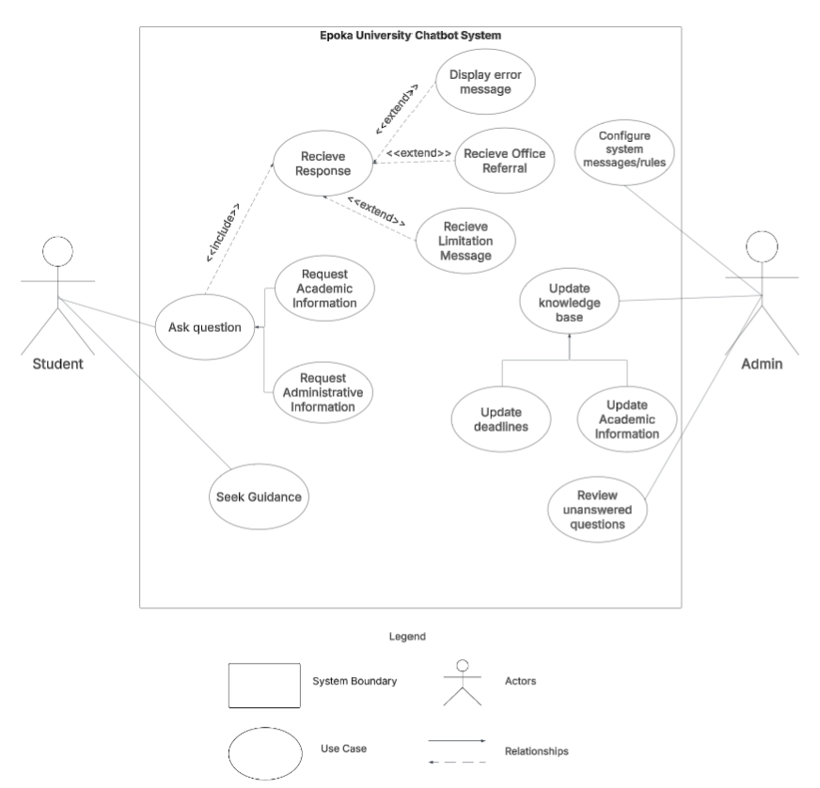
State Diagram
UML State Diagrams illustrate the states that an object undergoes during its life. Furthermore, the state diagram includes the events that have caused the states involved in the diagram.[31]
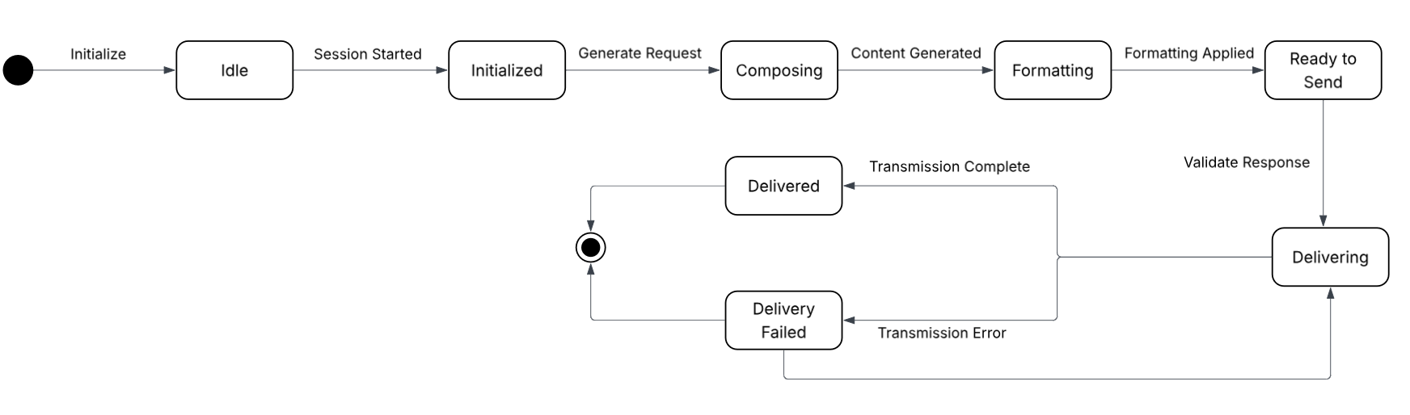

REFERENCES
[1] Rizos, S., Sfakianaki, E., & Kakouris, A. (2022). Quality of Administrative Services in Higher Education. European Journal of Educational Management, 5(2), 115-128.
[2] Nobre, G., Moraes, G., Franco, W., & Moreira, L.D. A Chatbot Approach to Automating FAQ Responses in an Undergraduate Course Domain.
[3] Sule, J. O. (2024). Optimizing university administrative structures: Strategies for enhancing efficiency and effectiveness in higher education institutions in Nigeria. World Journal of Advanced Research and Reviews, 24(1), 278-290.
[4] Fernández, A., Gómez, B., Binjaku, K., & Meçe, E. K. (2023). Digital transformation initiatives in higher education institutions: A multivocal literature review. Education and information technologies, 28(10), 12351-12382.
[5] Vanichvasin, P. (2022). Impact of Chatbots on Student Learning and Satisfaction in the Entrepreneurship Education Programme in Higher Education Context. International Education Studies, 15(6), 15-26.
[6] Al-Amin, M., Ali, M. S., Salam, A., Khan, A., Ali, A., Ullah, A., ... & Chowdhury, S. K. (2024). History of generative Artificial Intelligence (AI) chatbots: past, present, and future development. arXiv preprint arXiv:2402.05122.
[7] Moor, J. H. (2001). The status and future of the Turing test. Minds and Machines, 11(1), 77-93.
[8] Pinar Saygin, A., Cicekli, I., & Akman, V. (2000). Turing test: 50 years later. Minds and machines, 10(4), 463-518.
[9] Cicekli, I., & Akman, V. (2000). Turing test: 50 Years later. Minds & Machines, 10(4), 463-518.
[10] Warwick, K., & Shah, H. (2016). Passing the Turing Test Does Not Mean the End of Humanity. Cognitive computation, 8, 409–419. https://doi.org/10.1007/s12559-015-9372-6
[11]Sharma, V., Goyal, M., & Malik, D. (2017). An intelligent behaviour shown by chatbot system. International Journal of New Technology and Research, 3(4), 263312.
[12] Shum, H. Y., He, X. D., & Li, D. (2018). From Eliza to XiaoIce: challenges and opportunities with social chatbots. Frontiers of Information Technology & Electronic Engineering, 19(1), 10-26.
[13] Weizenbaum, J., & McCarthy, J. (1977). Computer power and human reason: From judgment to calculation.
[14] Ferrucci, D., Brown, E., Chu-Carroll, J., Fan, J., Gondek, D., Kalyanpur, A. A., ... & Welty, C. (2010). Building Watson: An overview of the DeepQA project. AI magazine, 31(3), 59-79.
[15] Baig, M. I., & Yadegaridehkordi, E. (2024). ChatGPT in the higher education: A systematic literature review and research challenges. International journal of educational research, 127, 102411.
[16] Mesko B. (2023). The ChatGPT (Generative Artificial Intelligence) Revolution Has Made Artificial Intelligence Approachable for Medical Professionals. Journal of medical Internet research, 25, e48392. https://doi.org/10.2196/48392
[17] Deng, Y., Zhao, N., & Huang, X. (2023, December). Early chatgpt user portrait through the lens of data. In 2023 IEEE International Conference on Big Data (BigData) (pp. 4770-4775). IEEE.
[18] Wei, Jason, et al. "Emergent abilities of large language models." arXiv preprint arXiv:2206.07682 (2022).
[19] Adiwardana, D., Luong, M. T., So, D. R., Hall, J., Fiedel, N., Thoppilan, R., ... & Le, Q. V. (2020). Towards a human-like open-domain chatbot. arXiv preprint arXiv:2001.09977.
[20] Adamopoulou, E., & Moussiades, L. (2020, May). An overview of chatbot technology. In IFIP international conference on artificial intelligence applications and innovations (pp. 373-383). Cham: Springer International Publishing.
[21]Lin, C. C., Huang, A. Y., & Yang, S. J. (2023). A review of ai-driven conversational chatbots implementation methodologies and challenges (1999–2022). Sustainability, 15(5), 4012.
[22] Thorat, S. A., & Jadhav, V. (2020, April). A review on implementation issues of rule-based chatbot systems. In Proceedings of the international conference on innovative computing & communications (ICICC).
[23] Luo, B., Lau, R. Y., Li, C., & Si, Y. W. (2022). A critical review of state‐of‐the‐art chatbot designs and applications. Wiley Interdisciplinary Reviews: Data Mining and Knowledge Discovery, 12(1), e1434.

[24] Nimavat, K., & Champaneria, T. (2017). Chatbots: An overview types, architecture, tools and future possibilities. Int. J. Sci. Res. Dev, 5(7), 1019-1024.

[25] Georgakopoulos, D., Hornick, M., & Sheth, A. (1995). An overview of workflow management: From process modeling to workflow automation infrastructure. Distributed and parallel Databases, 3(2), 119-153.
[26] Eshuis, R. (2006). Symbolic model checking of UML activity diagrams. ACM Transactions on Software Engineering and Methodology (TOSEM), 15(1), 1-38.

[27]von der Maßen, T., & Lichter, H. (2002, September). Modeling variability by UML use case diagrams. In Proceedings of the International Workshop on Requirements Engineering for product lines (pp. 19-25). Citeseer.

[28] Al-Fedaghi, S. (2021). UML sequence diagram: an alternative model. arXiv preprint arXiv:2105.15152.
[29] Imran, M., & Almusharraf, N. (2024). Google Gemini as a next generation AI educational tool: a review of emerging educational technology. Smart Learning Environments, 11(1), 22.
[30] Team, G., Anil, R., Borgeaud, S., Alayrac, J. B., Yu, J., Soricut, R., ... & Blanco, L. (2023). Gemini: a family of highly capable multimodal models. arXiv preprint arXiv:2312.11805.

[31] Kim, Y. G., Hong, H. S., Bae, D. H., & Cha, S. D. (1999). Test cases generation from UML state diagrams. IEE Proceedings-Software, 146(4), 187-192.

