ANKARA UNIVERSITY
ENGINEERING FACULTY
DEPARTMENT OF COMPUTER ENGINEERING


INTERNSHIP REPORT
Basic SPA & Web API
Mehmet KEKEÇ
15290106
10.08.2020

ABSTRACT
This report was written by Mehmet KEKEÇ after Havelsan summer internship. The internship project is a simple web project and the project content is to create a permit request & demand tracking application using SPA (Single Page Application) and web api (Application Programming Interface). The frontend part of the application is coded with the Angular framework, in addition, the .net core web api is used in the Backend part. SQLite was used as the database technology of the project.
The content of the project aims to enable a person working in havelsan to request various types of leave and to follow the approval status of the leaves they request. This project was required due to the difficulty of managing the currently used system. Since the responsibility of the demand tracking part of the project is given to me, I will explain the demand tracking part of the report, not the demand part. In addition, the tasks given to me include user login and new user registration, database design and screen layout that will welcome the user when the user logs in successfully.

INSTITUTION INFORMATION
Institutions;
Name : HAVELSAN A.Ş.
Deparment : Bilgi ve İletişim Teknolojileri Genel Müdür Yardımcılığı

Address : HAVELSAN A.Ş. Ankara Merkez. Mustafa Kemal Mahallesi 2120 Cad. No:39 P.K. : 06510 Çankaya/Ankara.

Telephone : 0312 219 5787 (35 hat Pbx). 0312 219 5797.
E-mail : info@havelsan.com.tr
Web Page (if exists) : https://www.havelsan.com.tr/
HAVELSAN is founded in the year 1982 as a corporation owned by and affiliated to the Turkish Armed Forces Foundation. HAVELSAN does not only develop and produce technology in defense, security and information sectors, along with high technology and software solutions developed in-house, but also combines its own solutions and products with the solutions and products of other firms included in its business ecosystem, thus being able to present end to end solutions to its customers.
fields:
-Defense
-Simulation
-Information and Communication
-Homeland Security and Cyber Security

TABLE OF CONTENTS
ABSTRACT i
INSTITUTION INFORMATION ii
TABLE OF CONTENTS iii
1. INTRODUCTION 4
2. CONSTRUCTİON 6
2.1.1 FRONTEND 6
2.1.2 BACKEND 8
2.1.3 DATABASE 10
2.1.4 CHRONOS 11
3. CONCLUSION 14
3.1. TASKS 14
3.1.1 DB DESIGN 14
3.1.2 LOGIN&REGISTRATION SCREEN 15
3.1.3 HOME SCREEN 16
3.1.4 DATEOFF QUOTA QUERY BUTTON 16
3.1.5 DETAIL MODAL BUTTON 17
3.1.6 TRAINING 18
APPENDICES 19
Appendix 1. HOME COMPONENT (SPA PART) 20
Appendix 2. HOME CONTROLLER(API PART) 21

INTRODUCTION
I had to complete my internship remotely due to the pandemic. My internship, which progressed from afar, took 20 working days. During this period, we held meetings with my mentor twice in each working day, in the morning and evening. In the morning meetings, the work to be done during the day was discussed, and at the end of the day, the status of the work done was discussed. The first 3 days of the internship were spent with orientation and various distance trainings. These trainings included trainee awareness, cyber security, company employee policies, and occupational health and safety issues. During the progress of the internship, the company contributed to us with various technology trainings and webinars.
The progress of the internship after the orientation was completed in the first week with the research process related to the project requirements and competencies we determined with the mentor. At the end of the first week, the frontend designed a fronted Angular framework. The backend was designed for a system built with DotNet Core Web API. During this period, we decided to use the SQLite as the database of the project. Since the project is not a one-man project, we learned to use git technology in order to work in harmony with our teammates. We designated Git technology as Bitbucket, its free distribution. An example of the process operation scheme is given below.
Angular is a JavaScript based open source web application development library published by Google that can be developed with the TypeScript language. In the Angular project, the codes written in TypeScript are first compiled in the JavaScript language and processed in the browser.
ASP.NET Core Web API; It is a framework developed by Microsoft for web service architecture, which enables us to develop http services to be used in our web and mobile based projects and is used to provide data exchange between platforms. Using ASP.NET Core Web API, our applications written in different languages can exchange data with each other by outputting to media types (XML, JSON) accepted by the web.
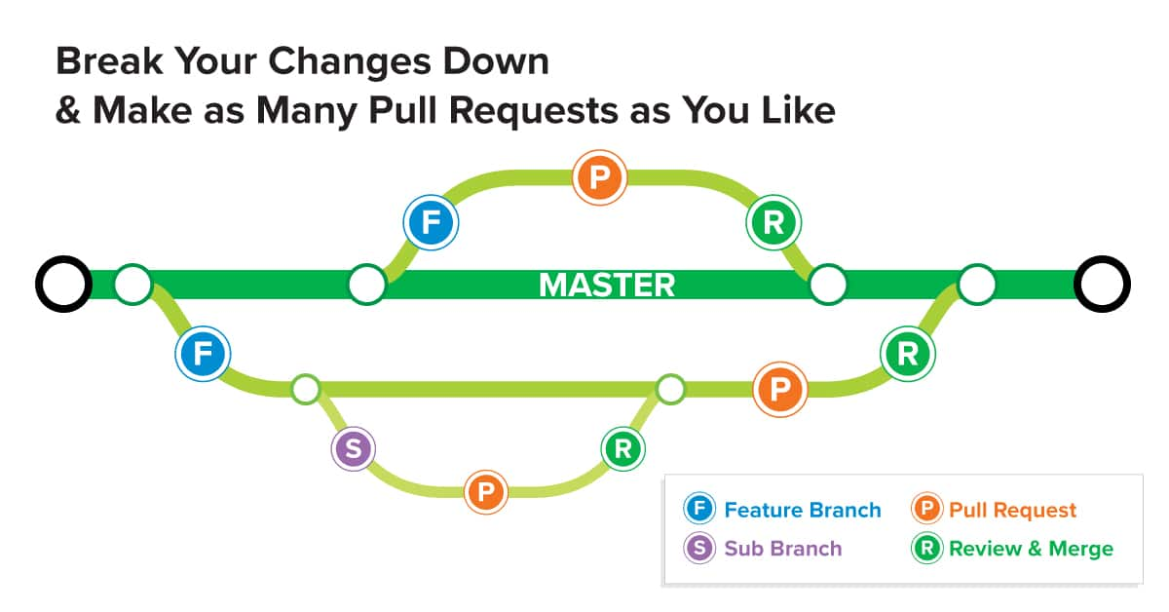Figure 1
To briefly summarize the use of Git technology, when the main running code goes to the server, the developer pulls the final version of the master code and creates a new branch in order to add on it. An understandable name is given for this branch, for example feature / mk_login & registration. The acronym mk (Mehmet KEKEÇ) is an abbreviation for proper name (developer name). Continuation is the short title of the work done. When the branch development is completed, it is merge with the local master. To merge with the server master, first the master is pulled again. After merge with the latest version, pull request is opened and sent to the server with a push. The code must be approved by other developers in order to merge with the original master. After this process, the code merge process takes place and a new master is created. (These operations were done with bitbucket extensions in visual studio.)

CONSTRUCTION
In the internship report, the project carried out during the internship is explained in 3 different parts. In the internship report, the project carried out during the internship is explained in 3 different parts. If we talk about the reasons in short, new classifications and definitions have emerged in the sector as a result of the rapid development of web technologies today and the increase in demand for these technologies. In fact, even though the concepts are new, there have always been people doing this job. The workload has increased substantially only today, due to the need for more detailed, large infrastructure and comprehensive websites compared to the past. For this reason, it was desired to save time by dividing this workload into different branches and to produce healthier projects with experts in their own fields.
These parts are;
-Front-end
-Back-end
-Database.
There are two main layers in the construction of the web page, namely Frontend and Backend. In a software or web software, the necessary structure is prepared systematically and functionally, after this stage, the necessary designs are made to present the software to the user visually.
    - Front-End
The process of creating the visual side of the website using technologies such as HTML, CSS and JavaScript of the client-side of the website is defined as frontend. Color, content placement, font, etc. to be used in the construction of the website. It covers design studies. The people doing this job are called "Front-end Developer". The frontend developer, on the other hand, dresses the software with a design and arranges it visually, making the software a complete and understandable whole for the user.
While we were programming the frontend of CHRONOS (our internship project), we used the Angular framework, which can be considered as a new technology. Angular; It is a Javascript-based framework used to create web, mobile and desktop applications. Angular applications include the use of Typescript, which is a language built on Javascript, together with Html, Css. The code written in Typescript is first compiled into Javascript and then processed in the browser. The use of Typescript is not mandatory for Angular application development, but it will be more useful to use it thanks to its ease of use and advantages. With Typescript, you can define objects with a certain type and by mapping these objects with service responses, more legible and less error rate codes can be written. In addition, developing code with javascript can be called easier now, since it is more similar to the familiar OOP-based languages (C #, Java, etc.) in terms of syntax (class definition, function definition, etc.). For Angular installation and setup, running a few simple commands in the visual studio code will be sufficient.
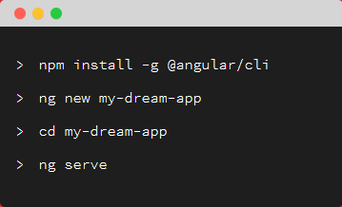 Figure 2
Angular working principle
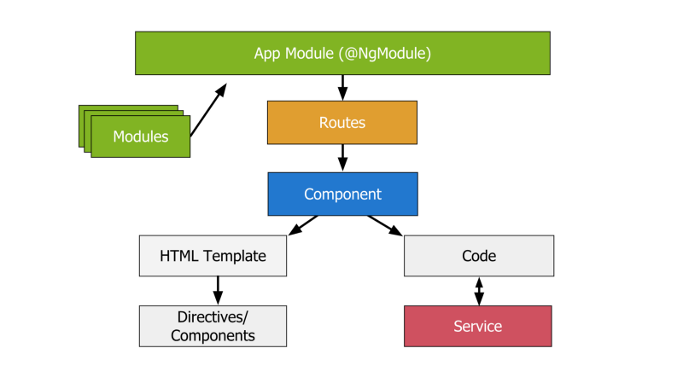 Figure 3
    - Back-End
It is a server-side development job that users do not see. In other words, it is the system that creates the architecture of the system, plans the database management, is responsible for server adjustments, and ensures that the system operates efficiently and quickly at the maximum level. We can summarize back-end technologies as Python, PHP, Ruby, Java, C #, ASP.NET. As technologies developed, these two concepts emerged and over time began to branch out among themselves. For example, sub-branches such as CSS Developer, (or UI / UX Developer) and JavaScript Developer started to appear in the front-end section. In the back-end part, sub-breakdowns such as Java Developer or Software / Application Developer started to occur. Sub-breakdowns in both areas actually bring along specialization.
In the backend part of the intership project entity framework core with .net core web API. ASP.NET Core Web API; It is a framework developed by Microsoft for web service architecture, which enables us to develop http services to be used in our web and mobile based projects and is used to provide data exchange between platforms. Using ASP.NET Core Web API, our applications written in different languages can exchange data with each other and work as integrated systems by outputting media types (XML, JSON) accepted by the web.
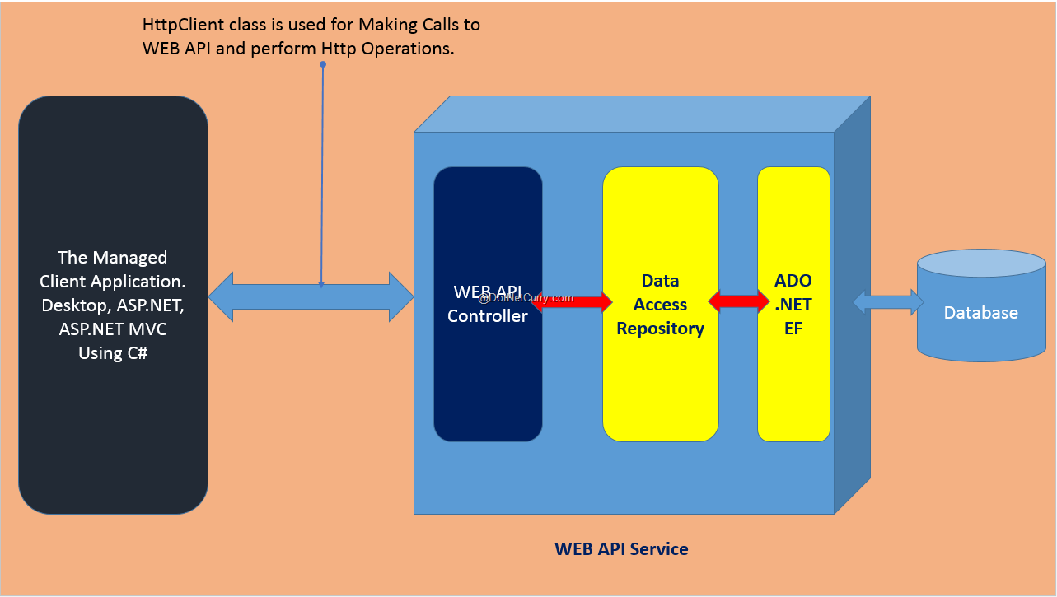 Figure 4
Entity Framework Core is an Object Relational Mapping Framework. Some concepts related to Entity Framework Core are;
-Context: With the Entity Framework Core, the transactions between our project and the database are made over the (transaction) context.
-Migration: The templates of Entity Classes in the Data-Model structure created in the Code-First approach are provided by migration.
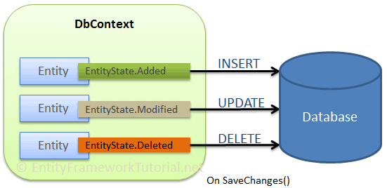 Figure 5
Postman was used throughout the project in order to control the operation of the backend and how it works in active condition. Postman is the world's most used "rest client", used by more than 3 million software developers to share, test, document and monitor APIs. The most prominent feature is that it offers a very useful interface for all these. Throughout the project, many http requests were carried out with the help of the post method due to the weaknesses of the get method. Since the post method is used intensively, it is necessary to use postman.

    - Database
Nowadays, most of the Web applications and especially dynamic Web applications require a database. As the name suggests, they are the environments where the information is hosted according to some procedures. Databases are data sets that allow information to be saved and updated appropriately, and advanced queries can be made on this information. It is one of the indispensable structures for knowledge management in our age.
In the project, db browser for sqlite is used as the database manager. SQLite is a storage solution that is not dependent on external resources, can work on all operating systems, is self-hosting, highly reliable, we can attribute its use to it, it is an embedded system, so it does not need a server, it writes data writing and reading operations directly to the database file on the disk, the index considered for SQL, trigger vs. It has all the features; it is an open source public domain.
While working on the project, Code first logic was used while creating the database also seeddata was used because there was no original dateoff, shift and tourniquet data available. There are basically three approaches in the Entity Framework architecture.
-Code First
-Database First
-Model First
What is Code First? It is a technique that establishes a link between the database and programming language. It is an approach that allows you to perform database operations in your project by writing code on the Visual Studio side as much as possible. With this approach, the relationship between the database interface and the software developer is minimized. In the Code First structure, the "class" structures in the programming language correspond to the "table" structures in the database, and the "property" structures to the "column" structures in the database. In addition, thanks to Attributes, Validations can be applied to database structures and certain conditions or restrictions can be placed on columns. Most importantly, it allows you to feel the auto control of the model in your project in your hand and use it as you wish with full control. Database First approach works with drag and drop logic as in Linq To SQL structure and takes care of everything automatically. The other two approaches are not disclosed as they were not used in the project.
What is seeddata? Database seeding is the initial seeding of a database with data. Seeding a database is a process in which an initial set of data is provided to a database when it is being installed. It is especially useful when we want to populate the database with data we want to develop in future. This is often an automated process that is executed upon the initial setup of an application. The data can be dummy data or necessary data such as an initial administrator account.
    - CHRONOS
After briefly summarizing these important definitions (Frontend-Backend), if we discuss these concepts specifically for Chronos. The purpose of the chronos is for havelsan employees to request dateoff. The types of permissions allowed by this system are;
- Annual dateoff: Employees who have completed 1 year of work in Havelsan are entitled to 14 days of annual dateoff. After this type of leave is requested, it goes to the approval of the employee's 2 top managers. The request is processed in the system according to the approval of the manager. Requests for more than 14 days can be used if there is manager approval.
- Excuse dateoff: Used to compensate for flexible, compulsary working hours and is limited to 25 hours per year. It is used outside of the mandatory hours and is limited to five hours a day.
- Compensated dateoff: It is used to compensate the mandatory shift type is minute. There is no manager approval. Its limit is 60 minutes each week.
- Hospital dateoff: It cannot exceed 5 hours during the day. Any time period can be entered. Admin approval is required. Hospital dateoff are not borrowed like compulsory dateoff, and those hours are considered as worked.
-Service dateoff: There are 3 different types. It is 07:30 to 08:00 in the morning, 16:30 to 17:00 in the evening and 19:00 to 19:30 in the evening. It is fixed for 30 minutes. It is approved but is not approved by the manager. For this reason, we will consider it without approval. More than one service dateoff cannot be entered in a day. Service dateoff counts shift(compulsory&flexible hour).
-In-city duty: If the personnel did not come to the company for a day, the system will appear to have a 2-hour flexible 6.30-hour compulsory work missing in the system. The manager asks for approval. There should be no turnstile registration for that day.
- Local duty (hourly): Entered hourly. It cannot exceed 5 hours in a day. The manager asks for approval. It can be entered in any time period. Most importantly, more than one hour of in-city duty can be entered in a day and there may not even be a turnstile registration.
There are two types of shift in Havelsan. These types are flexible and compulsory work. Mandatory work is between 9.30 and 17.00. Flexible work can be done between 6.30 and 9.30 and 17.00 and 21.00. The calculation of the mandatory and flexible shift is made according to the turnstile records used in the entrance and exit.
Chronos is a project where users can request these dateoff types, follow their requests, access turnstile records and working hours, and manage these requests. The task given to me in the Chronos project is the home screen for tracking the requested permissions, the database structure set up for the system to operate, the user registration and login screen, the dateoff quota query modal, the day detail modal, the turnstile display modal, and the dateoff request table according to the selected month and day.

CONCLUSION
    - TASKS
In this section, I will explain the duties given to me during the project and their results.
    - DB DESIGN
In this section, 10 tables have been created for the project and the data types of the data in this table are specified. In fact, these definitions were created with the code first logic and the final image was formed in this way. Dateoff table is shown as an example.
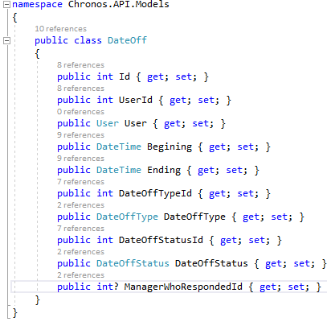 Figure 6

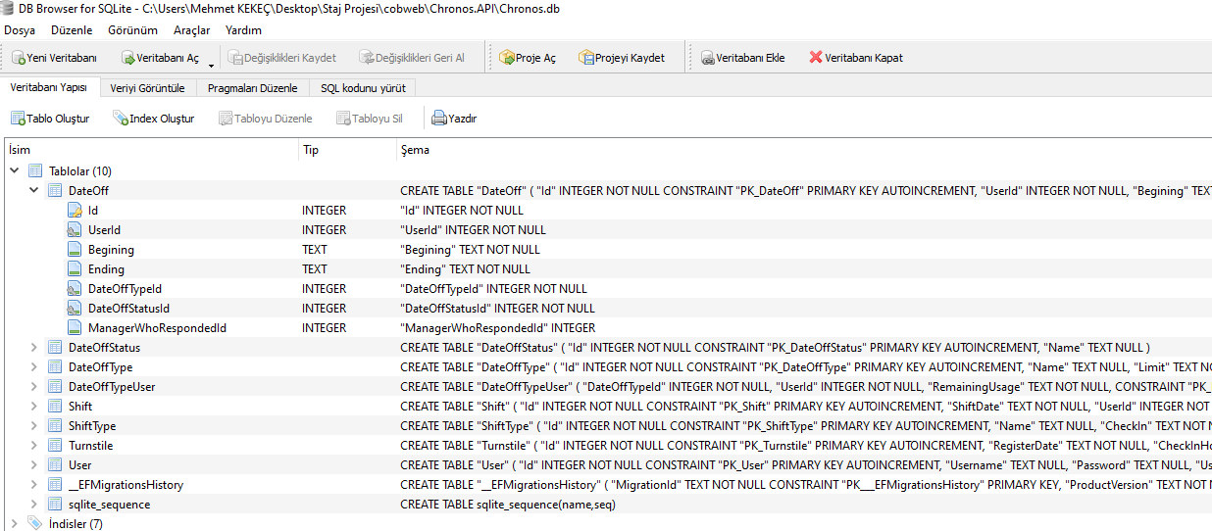 Figure 7
    - Login&Registration Screen
Thanks to these two screens, unregistered users can register and log into the system, registered users log in with the user's name and password, and if the login is successful, they are directed to the home screen.
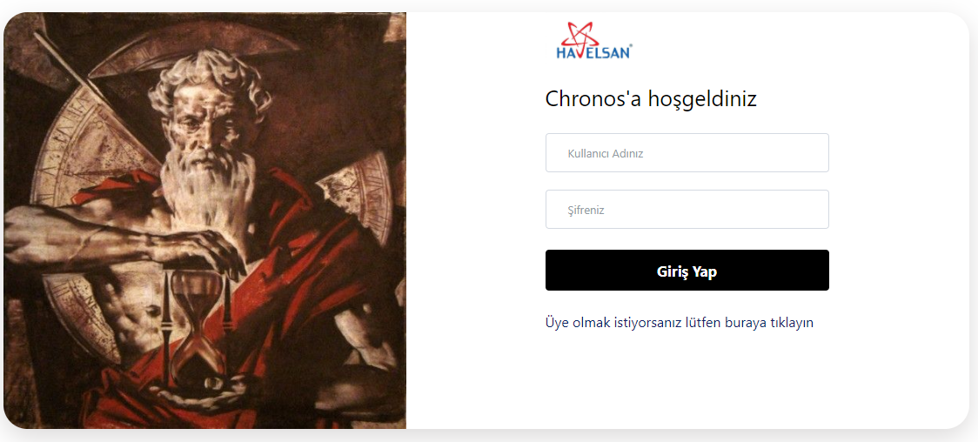 Figure 8
 Figure 9

The user must specify the administrator id when registering, because this information is required to send the dateoff request to the required admin screen.

    - Home Screen
On this screen, there is a button linked to the quota query modal, the home page calendar, the detailed modal button for the day connected to the calendar, and the exit button connected to the navbar.
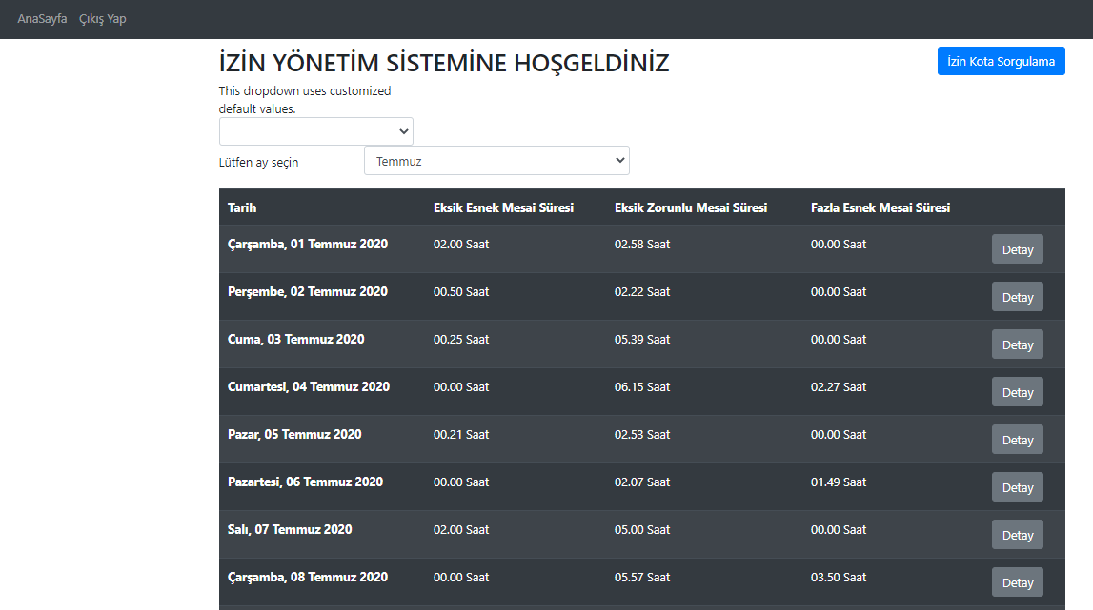Figure10
    - Dateoff Quota Query Button
A modal opens when the button is pressed. This modal shows Dateoff types and how many of these types are used and how much quota is left with a table in the modal.
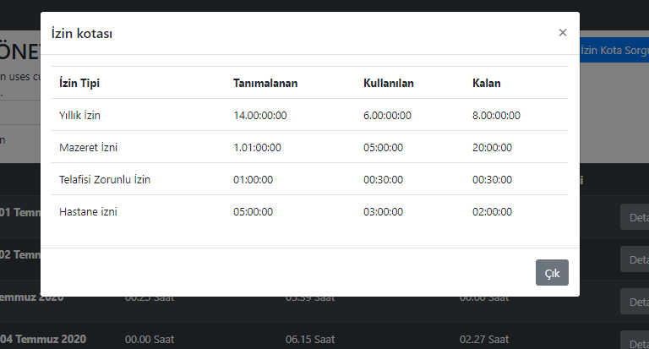 Figure 11

    - Detail modal button
Thanks to this button, if there are turnstile records for that day and the dateoff record of that day, the modal is opened on the screen and shown with two tables on the modal. In these tables, the user's company entry and exit records for that day and the status of leaves, if any, are shown.
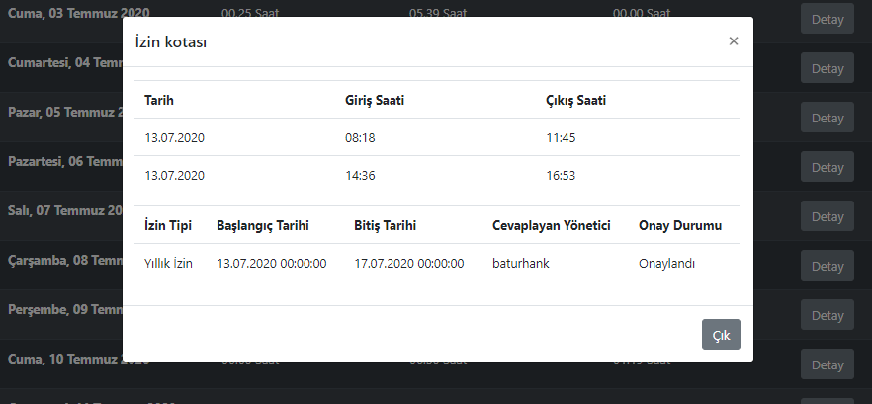 Figure 12

3.1.6 Training
During my internship, I completed 52 different distance trainings in 20 working days, in addition to internship projects and mentor meetings, online trainings and webinars. I would like to thank Havelsan and my mentor Gürcan DİNLER, who are interested in my personal development as well as my internship. Some of the trainings I have received are;
-Orientation training
- OHS Training
-Information Security and Awareness Training
-Quality Awareness Training
-Basic Cyber Security Training
-E-mail and Mobile Security Training
-Password Security Training
-Project Management Training
-System Engineering Education

APPENDICES
I will give a few examples of code snippets and images in this section.
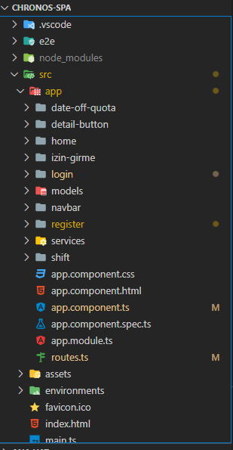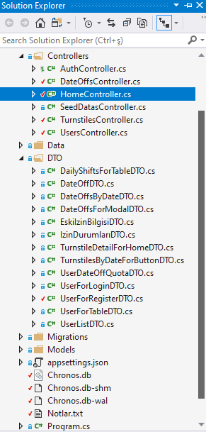
Figure 13 Figure 14

Home Component (SPA PART)
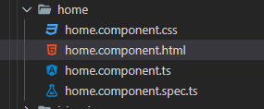 Figure 15
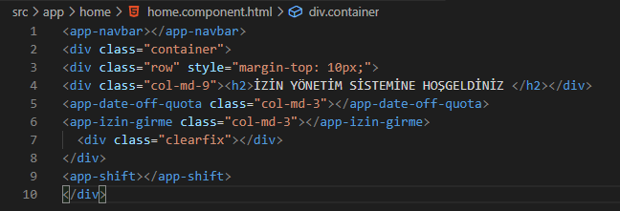 Figure 16
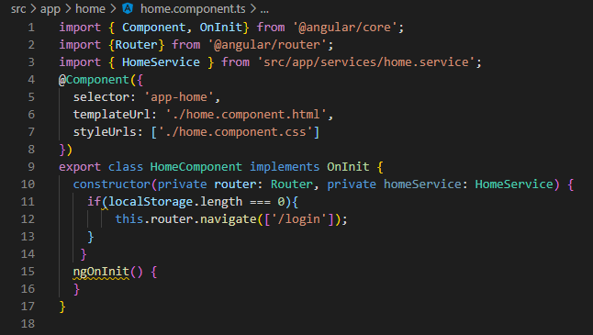
Figure 17

Home Controller (API PART)
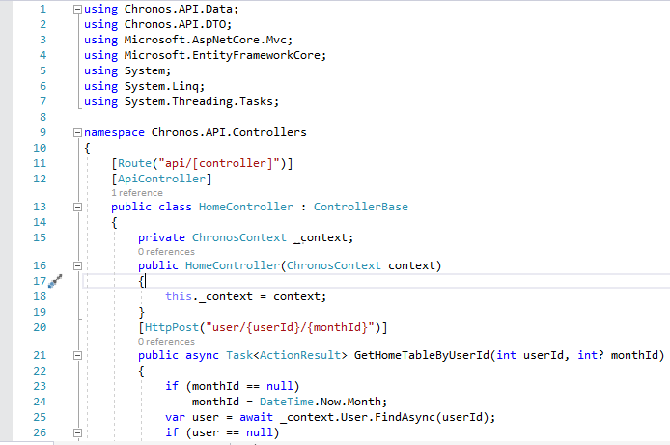Figure 19
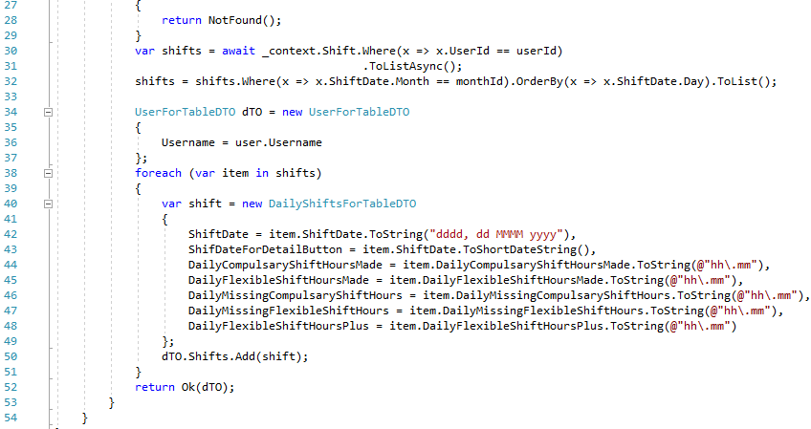Figure 20

