Coursework Report

Kai Fan [40413817@napier.ac.uk](mailto:40413819@napier.ac.uk)

**Edinburgh Napier University Algorithms and Data Structures(SET08122)**

# 

**Abstract**

The algorithms and data structures course aim to teach us how to use the algorithms and data structures in c programming. The coursework is to design and make a game which named tictactoe for two people to play. This report will introduce the game which I created. The rules about the game, the design about the game and the enhancements.

# Introduction

According to this class, I have learned more knowledge about the computer’s algorithms and data structures. Although this class is a little difficult to me, but I also can make a simple game by using algorithms and data structures.

I use the C language to create a game named TicTacToe. This game is a paper and pencil game for tow players, X and O, who take turns marking the spaces in a 3x3 grid. The player who succeeds in placing three of their marks in a horizontal, vertical, or diagonal row wins the game. This game could implement the basic requirements: Game board, Players, Pieces and Positions. Player 1 will play as X, player 2 will play as O. Then player just need to insert the number of row, and then insert the number of column. This is a step for one player. I use the notepad++ to write the game code. And then I download the visual studio. Open the command prompt to run the program. I made five parts: main, analize_board, draw_board, analize_board(char) and calculate winner.

**Design**

I will introduce my game’s details in this part. The rules are important for a game, so the first page you will see is that the game rules and the game board. The third line is a choose for players to select the X or O. And then the game board is follow in the next. The first structures I select is switch structure because the two players need to switch insert when one finish their step. So the game need this structure to help switch efficiently. The first line in code is lnitialize three subfunctions: draw_board, analize_board and calculate_winner. The functions about the subfunctions I write later. I use the two_dimensional array to define them. And then is main function. I also use two-dimensional array to lnitialize some variables and then is welcome statement and the rules. And then call the draw_board function to create a 3-row, 3-column board. Two players begin to chat with each other. Use the while statement to cycle. And call the analize_board function to determin whether it is a player 1 victory or a player 2 victory, if the case is 0 it means the game is not over, keep playing. If the case is 1, it means player1 victory, if the case is 2, it means player2 victory. And then is to judge who is currently playing chess. The next cycle statement use while is waiting for players insert the correct row and column. If the players insert the wrong row or column, it will require repeat input until its right. The next is turn to another player. The code assign the player’s corresponding X or O to the corresponding rank. And then draw the board again. The draw_board is draw the side of the board and the chess which players had done. The analize_board is to calculate all possible wins by using if statement. The calculate_winner is to judge which player could win also use if statement.

# Enhancements

This work which I complete can be played by player and worked. However, it just can achieve some basic function. Because these are simple and not so hard for me. There are many additional functions can be achieved. Such as the history of play and allow earlier games to be automatically replayed from this record, undo and redo. Although it is a very common function but it still hard for me. It is not difficult to think about it. I dont lack the ideas, what I lack is the skill to achieve them. So I need to learn more about the structures and algorithms. But it is happy for me to make a game successfully. I will continue learning the knowledge about this side and improve my game.

# Critical Evaluation

When I write the code for the game, I find it is not as I thought. The code of a simple game is really complicated. I always write and get confused by complicated code. I will find my friends to help me when I meet the difficult. Or I also find the material on the internet by myself such as Wikipedia. I think my advantage is concentrating on the code even it is so complex. However, the shortage of me is obviously: the professional knowledge is hard. Lack of the knowledge cause obstacles to the function. For example, I wanna add the undo to my code, I search for many pages on the internet, I still can’t make it. So I will keep learning the data structures and algorithms to continuously improve this program.

# Personal Evaluation

I write code while reviewing the previous knowledge points because I found that a lot of knowledge points are not solid. This action can help me constantly consolidate old knowledge such as data structures. When I miss the difficult which I can not solve it by myself, I will search on the internet. However the network is not omnipotent. Fortunately, I have many friends. When I meet the problems which I can not solve by myself, I will ask them for help. What I need to improve is that I should think differently about the problem.

.

# References

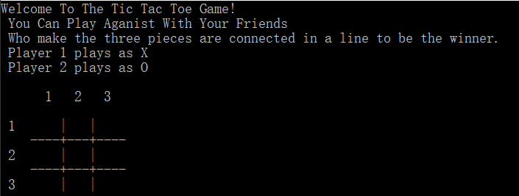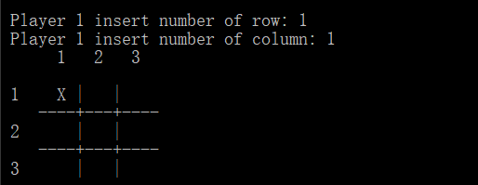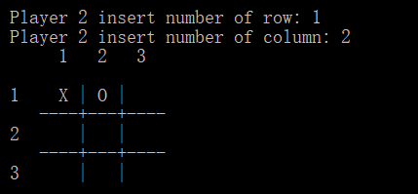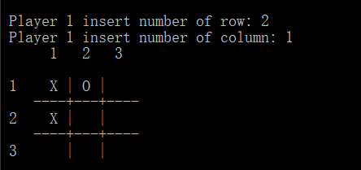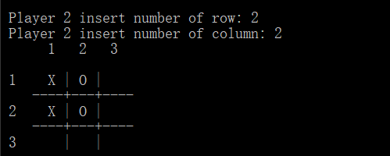

This is all the step of my game.

1. The introduction of TicTacToe ref from wikipedia. *"Tic Tac Toe" and "Noughts and crosses" redirect here. For other uses, see [Tic Tac Toe (disambiguation)](https://en.wikipedia.org/wiki/Tic_Tac_Toe_(disambiguation)" \o "Tic Tac Toe (disambiguation)) and [Noughts and crosses (disambiguation)](https://en.wikipedia.org/wiki/Noughts_and_crosses_(disambiguation)" \o "Noughts and crosses (disambiguation)).*
2. 二维数组的定义(The definitions of two-dimensional array) ref from http://c.biancheng.net/cpp/html/51.html