Finance Tracker
Technical Documentation

Architecture
Finance Tracker follows Clean Architecture with four layers:
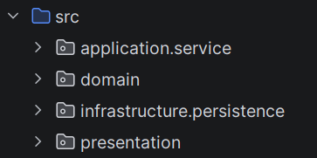

Dependencies only point inward — presentation depends on application, application depends on domain, infrastructure implements domain interfaces.

Project Structure

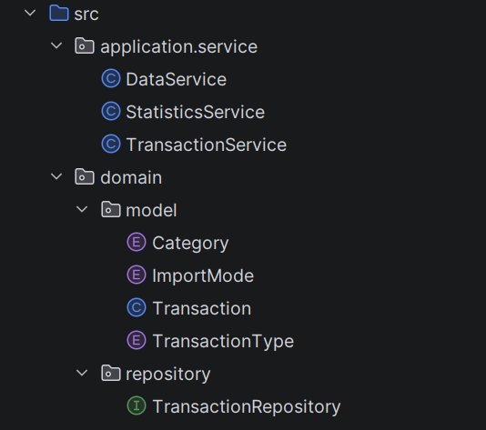
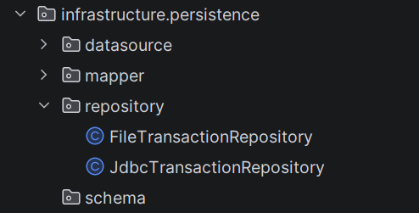
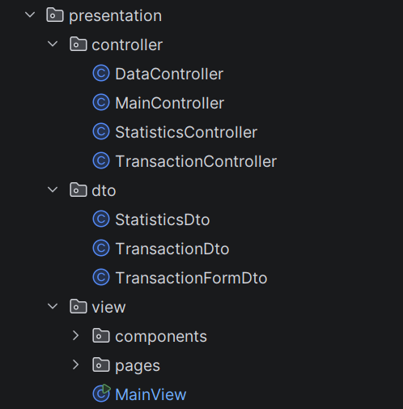

Dependency Injection
All dependencies are wired manually in MainView.start():

FileTransactionRepository
↓
TransactionService → TransactionController → DashboardPage
StatisticsService → StatisticsController → StatisticsView
DataService → DataController → DataPage

Data Storage
Transactions are stored in data/transactions.json as a JSON array:

[
{"id":1,"amount":250.0,"type":"EXPENSE","category":"FOOD","date":"2026-05-01","note":"lunch"},
{"id":2,"amount":5000.0,"type":"INCOME","category":"JOB","date":"2026-05-02","note":"salary"}
]

No external JSON libraries are used — serialization and parsing are implemented manually.
New IDs are assigned as max(existing IDs) + 1 at save time.

Key Classes

Class | Layer | Responsibility
Transaction | Domain | Core entity with id, amount, type, category, date, note
TransactionRepository | Domain | CRUD interface + bulk operations
FileTransactionRepository | Infrastructure | JSON file-based implementation
TransactionService | Application | Add, delete, update, validate transactions
StatisticsService | Application | Income, expense, balance aggregations
DataService | Application | JSON export and import with Replace/Merge modes
MainView | Presentation | JavaFX entry point, wiring, layout
AppLogger | Util | Centralized logging configuration

Logging
Logging is handled by AppLogger using java.util.logging.

Setting | Value
Logged packages | domain, application, infrastructure, presentation
Suppressed | JavaFX internal logs
Enable at launch | --debug flag
Enable at runtime | Debug checkbox in the application header

Testing
Tests are located in java/application/service/ and use JUnit 5 with an in-memory repository stub.

mvn test

Test class | Coverage
TransactionServiceTest | Add with valid/invalid amount, delete, fetch all
DataServiceTest | Export creates file, import REPLACE/MERGE, invalid record skipping

Known Limitations

Limitation | Notes
JdbcTransactionRepository | Stub only — SQLite is not yet implemented
JSON parser | Does not support nested objects in field values
Storage | Local only — no cloud sync

