8 WEEK ULTIMATE WR TRAINING SCHEDULE

This is an 8 week workout schedule with daily WR on field workouts and daily WR gym workouts you can do! We have over 500+ different drills and exercises contained in this plan to help WRs with their on field performance.

This is a bundle product where you will gain access to our 28 Day On Field WR Workout Plan version 1 (4 weeks) & version 2 (4 weeks) & you will also gain access to our 28 Day WR Gym Workout Plan version 1 (4 weeks) & version 2 (4 weeks). I hope you enjoy!

Please contact support@firstdowntraining.com if you have any questions!

(PAGE 29 IS WHERE THE GYM WORKOUT PLAN IS LOCATED)

8 WEEK WR FIELD Workout Plan

Day 1 (Releases)

DYNAMIC WARM UP (warm up can be anything you like or normally do- just try to break a little sweat and get blood pumping. Do not stretch cold muscles)
Split 1:
Hopping Over Line Of Cones Single Leg (5 sets each side)
https://youtube.com/shorts/QSpUGuPsxHQ?si=3yM5HeVF2kgW7pg1
Single Jab With Cones (4 reps each side)
https://youtube.com/shorts/QIw38XDHWqE?si=3V5KJ2GEp-Sux710

Split 2:
Rocker step 6 cone drill ( 4 reps each side)
https://youtube.com/shorts/bWA5np7ek1c?si=yQKputq1aAxIbKSM

Split 3:
Wide Step Towel Re Stack ( 4 reps each side)
https://youtube.com/shorts/OmXfh1DU1Qo?si=W2sLwOs9TX-9BjvW

Cross Over Towel Re Stack( 4 reps each side)
https://youtube.com/shorts/0oia8b-cx68?si=1XV9hk329ocVRQ59

Day 2 Top Of The Route

DYNAMIC WARM UP

Split 1
Hopping Over Line Of Cones Single Leg (5 sets each side)
https://youtube.com/shorts/QSpUGuPsxHQ?si=3yM5HeVF2kgW7pg1
Single Jab With Cones (4 reps each side)
https://youtube.com/shorts/QIw38XDHWqE?si=3V5KJ2GEp-Sux710

Split 2
Snap Fall Drill Single Leg ( 8 reps each side)
https://youtube.com/shorts/3ed84Lisf2Y?si=2EKPa6XsWPNL7Dds
Snap Fall 2 Steps ( 8 reps each side)
https://youtube.com/shorts/pML7q0cpMqM?si=zt9rI6briswscbg7
High Knee Hip Drop (4 sets of 2 reps)
https://youtube.com/shorts/P4-6sQNioEY?si=55vBRvQUkMh3gZCP

Split 3
Run Then Drop (6 sets)
https://youtube.com/shorts/BAnDEm1g7zo?si=1TAh6kjbTm1Z1d9d
Half 90s ( 4 reps each side)
https://youtube.com/shorts/BQPIl2OVl9k?si=KdEb8a1f8o9tQ_C9

Day 3: Releases & Top Of The Route

DYNAMIC WARM UP

Split 1
Hopping Over Line Of Cones Single Leg (5 sets each side)
https://youtube.com/shorts/QSpUGuPsxHQ?si=3yM5HeVF2kgW7pg1

Single Jab With Cones (4 reps each side)
https://youtube.com/shorts/QIw38XDHWqE?si=3V5KJ2GEp-Sux710

Cross Over With Cones ( 4 reps each side)
https://youtube.com/shorts/h4IzS-36MO8?si=JKaOFjvtFnpGJyCN

Split 2
High Knee Hip Drop (4 sets of 2 reps)
https://youtube.com/shorts/P4-6sQNioEY?si=55vBRvQUkMh3gZCP
Run Then Drop (6 sets)
https://youtube.com/shorts/BAnDEm1g7zo?si=1TAh6kjbTm1Z1d9d

Split 3
Hip flip stick drill 3 cones (4 reps each side)
https://youtube.com/shorts/gvdyDSU10No?si=w0gay8z1HeAhJfny
Half 45s (4 reps each side)
https://youtube.com/shorts/bAllh7O9B80?si=Z_4ipEJ-Evl8uQx4

Day 4: REST DAY

Make sure you hydrate, rest, ice, and massage/roll out.

Day 5: Press Releases
DYNAMIC WARM UP

Split 1
Hopping Over Line Of Cones Single Leg (5 sets each side)
https://youtube.com/shorts/QSpUGuPsxHQ?si=3yM5HeVF2kgW7pg1
Single Jab With Cones (4 reps each side)
https://youtube.com/shorts/QIw38XDHWqE?si=3V5KJ2GEp-Sux710

Split 2
Cross Over Hop & Balance ( 8 reps each side)
https://youtube.com/shorts/pq_z0PE8ZBU?si=dDg9J5IqxYnaPI8F

Split 3
45 Degree L Stick ( 4 reps each side)
https://youtube.com/shorts/2g7LmllTahI?si=0du6KcPygHkXJKD7
Wide Step Towel Re Stack ( 4 reps each side)
https://youtube.com/shorts/OmXfh1DU1Qo?si=W2sLwOs9TX-9BjvW
Cross Over Towel Re Stack( 4 reps each side)
https://youtube.com/shorts/0oia8b-cx68?si=1XV9hk329ocVRQ59

Day 6: Full Route Running Day

DYNAMIC WARM UP

Split 1
High Knee Hip Drop (4 sets of 2 reps)
https://youtube.com/shorts/P4-6sQNioEY?si=55vBRvQUkMh3gZCP
Run Then Drop (6 sets)
https://youtube.com/shorts/BAnDEm1g7zo?si=1TAh6kjbTm1Z1d9d
Half 90s ( 4 reps each side)
https://youtube.com/shorts/BQPIl2OVl9k?si=KdEb8a1f8o9tQ_C9
Full 90s (4 reps each side)
https://youtube.com/shorts/AKu1D_HXPw4?si=bQshuBC95KD6jiDs
Half 45s (4 reps each side)
https://youtube.com/shorts/bAllh7O9B80?si=Z_4ipEJ-Evl8uQx4
Full 45s (4 reps each side)
https://youtube.com/shorts/QmckdHrhM18?si=sq-YfLkkWqxA5tOo

Day 7: REST DAY

Make sure you hydrate, ice, stretch and massage/roll out

Day 8 Press Releases/Cutting

DYNAMIC WARM UP

Split 1
Jab push jab push jab ( 4 reps each side)
https://youtube.com/shorts/8PSbwJSkgco?si=WVnB3QU9qH5-9qfV
Double Hop then push to jab opposite way ( 4 reps each side)
https://youtube.com/shorts/b4dMEiOLyz8?si=NFZUEp7APhndsKS4

Split 2
90 Degree L Stick ( 4 reps each side)
https://youtube.com/shorts/7K-tiSUyMHk?si=Pa9u2l67Bb57SG7J
45 Degree L Stick ( 4 reps each side)
https://youtube.com/shorts/2g7LmllTahI?si=0du6KcPygHkXJKD7

Split 3
Cross Over Hop & Balance ( 4 reps each side)
https://youtube.com/shorts/pq_z0PE8ZBU?si=dDg9J5IqxYnaPI8F
Split Release Sequence (4 reps releasing right- 4 reps releasing left)
https://youtube.com/shorts/bCizN8gX6Fo?si=smHch-_gyjVR1r7T
Diamond Release 3 cones under ( 4 reps each side)
https://youtube.com/shorts/AJzhJ3jne3k?si=afoYGQRY6SR_xoMi

Day 9 Top Of The Route

DYNAMIC WARM UP

Split 1
Jab push jab push jab ( 4 reps each side)
https://youtube.com/shorts/8PSbwJSkgco?si=WVnB3QU9qH5-9qfV
Double Hop then push to jab opposite way ( 4 reps each side)
https://youtube.com/shorts/b4dMEiOLyz8?si=NFZUEp7APhndsKS4

Split 2
Snap Fall 2 Steps ( 8 reps each side)
https://youtube.com/shorts/pML7q0cpMqM?si=zt9rI6briswscbg7
High Knee Hip Drop (4 sets of 2 reps)
https://youtube.com/shorts/P4-6sQNioEY?si=55vBRvQUkMh3gZCP
Run Then Drop (6 sets)
https://youtube.com/shorts/BAnDEm1g7zo?si=1TAh6kjbTm1Z1d9d
Hip flip stick drill 3 cones (4 reps each side)
https://youtube.com/shorts/gvdyDSU10No?si=w0gay8z1HeAhJfny
3 Cone Quick Feet Around (4 reps each side)
https://youtube.com/shorts/YkJhT5CWFHQ?si=bb2F-EmIHHSGdR25

Split 3
Med Ball Lunge Slams (3x8 reps each side)
https://youtube.com/shorts/E6-knPv5Bds?si=MifbaTI74Ylwfbub

Day 10 Releases/Top Of The Route

DYNAMIC WARM UP

Split 1
Hopping Over Line Of Cones Single Leg (5 sets each side)
https://youtube.com/shorts/QSpUGuPsxHQ?si=3yM5HeVF2kgW7pg1
Single Jab With Cones (4 reps each side)
https://youtube.com/shorts/QIw38XDHWqE?si=3V5KJ2GEp-Sux710
Cross Over With Cones ( 4 reps each side)
https://youtube.com/shorts/h4IzS-36MO8?si=JKaOFjvtFnpGJyCN
Jab push jab push jab ( 4 reps each side)
https://youtube.com/shorts/8PSbwJSkgco?si=WVnB3QU9qH5-9qfV

Split 2
Run Then Drop (6 sets)
https://youtube.com/shorts/BAnDEm1g7zo?si=1TAh6kjbTm1Z1d9d
45 Degree L Stick ( 4 reps each side)
https://youtube.com/shorts/2g7LmllTahI?si=0du6KcPygHkXJKD7

Split 3

Day 11: REST DAY

Make sure you hydrate, rest, ice, and massage/roll out.

Day 12 Press Releases & Cutting
DYNAMIC WARM UP

Split 1
Single Jab With Cones (4 reps each side)
https://youtube.com/shorts/QIw38XDHWqE?si=3V5KJ2GEp-Sux710
Cross Over With Cones ( 4 reps each side)
https://youtube.com/shorts/h4IzS-36MO8?si=JKaOFjvtFnpGJyCN

Split 2
Double Hop then push to jab opposite way ( 4 reps each side)
https://youtube.com/shorts/b4dMEiOLyz8?si=NFZUEp7APhndsKS4

Rocker step 6 cone drill ( 4 reps each side)
https://youtube.com/shorts/bWA5np7ek1c?si=yQKputq1aAxIbKSM
Cross Over Hop & Balance ( 4 reps each side)
https://youtube.com/shorts/pq_z0PE8ZBU?si=dDg9J5IqxYnaPI8F

Split 3
Wide Step Towel Re Stack ( 4 reps each side)
https://youtube.com/shorts/OmXfh1DU1Qo?si=W2sLwOs9TX-9BjvW
Cross Over Towel Re Stack( 4 reps each side)
https://youtube.com/shorts/0oia8b-cx68?si=1XV9hk329ocVRQ59

Day 13 Full Route Running Day

DYNAMIC WARM UP

Split 1
Run Then Drop (6 sets)
https://youtube.com/shorts/BAnDEm1g7zo?si=1TAh6kjbTm1Z1d9d
Half 90s ( 4 reps each side)
https://youtube.com/shorts/BQPIl2OVl9k?si=KdEb8a1f8o9tQ_C9
Full 90s (4 reps each side)
https://youtube.com/shorts/AKu1D_HXPw4?si=bQshuBC95KD6jiDs
Half 45s (4 reps each side)
https://youtube.com/shorts/bAllh7O9B80?si=Z_4ipEJ-Evl8uQx4
Full 45s (4 reps each side)
https://youtube.com/shorts/QmckdHrhM18?si=sq-YfLkkWqxA5tOo
Med Ball Lunge Slams (3x8 reps each side)
https://youtube.com/shorts/E6-knPv5Bds?si=MifbaTI74Ylwfbub

Day 14: REST DAY

Make sure you hydrate, ice, stretch and massage/roll out
Day 15 (Releases)

DYNAMIC WARM UP (warm up can be anything you like or normally do- just try to break a little sweat and get blood pumping. Do not stretch cold muscles)
Split 1:
Hopping Over Line Of Cones Single Leg (5 sets each side)
https://youtube.com/shorts/QSpUGuPsxHQ?si=3yM5HeVF2kgW7pg1
Single Jab With Cones (4 reps each side)
https://youtube.com/shorts/QIw38XDHWqE?si=3V5KJ2GEp-Sux710

Split 2:
Rocker step 6 cone drill ( 4 reps each side)
https://youtube.com/shorts/bWA5np7ek1c?si=yQKputq1aAxIbKSM

Split 3:
Wide Step Towel Re Stack ( 4 reps each side)
https://youtube.com/shorts/OmXfh1DU1Qo?si=W2sLwOs9TX-9BjvW

Cross Over Towel Re Stack( 4 reps each side)
https://youtube.com/shorts/0oia8b-cx68?si=1XV9hk329ocVRQ59

Day 16 Top Of The Route

DYNAMIC WARM UP

Split 1
Hopping Over Line Of Cones Single Leg (5 sets each side)
https://youtube.com/shorts/QSpUGuPsxHQ?si=3yM5HeVF2kgW7pg1
Single Jab With Cones (4 reps each side)
https://youtube.com/shorts/QIw38XDHWqE?si=3V5KJ2GEp-Sux710

Split 2
Snap Fall Drill Single Leg ( 8 reps each side)
https://youtube.com/shorts/3ed84Lisf2Y?si=2EKPa6XsWPNL7Dds
Snap Fall 2 Steps ( 8 reps each side)
https://youtube.com/shorts/pML7q0cpMqM?si=zt9rI6briswscbg7
High Knee Hip Drop (4 sets of 2 reps)
https://youtube.com/shorts/P4-6sQNioEY?si=55vBRvQUkMh3gZCP

Split 3
Run Then Drop (6 sets)
https://youtube.com/shorts/BAnDEm1g7zo?si=1TAh6kjbTm1Z1d9d
Half 90s ( 4 reps each side)
https://youtube.com/shorts/BQPIl2OVl9k?si=KdEb8a1f8o9tQ_C9

Day 17- Releases & Top Of The Route

DYNAMIC WARM UP

Split 1
Hopping Over Line Of Cones Single Leg (5 sets each side)
https://youtube.com/shorts/QSpUGuPsxHQ?si=3yM5HeVF2kgW7pg1

Single Jab With Cones (4 reps each side)
https://youtube.com/shorts/QIw38XDHWqE?si=3V5KJ2GEp-Sux710

Cross Over With Cones ( 4 reps each side)
https://youtube.com/shorts/h4IzS-36MO8?si=JKaOFjvtFnpGJyCN

Split 2
High Knee Hip Drop (4 sets of 2 reps)
https://youtube.com/shorts/P4-6sQNioEY?si=55vBRvQUkMh3gZCP
Run Then Drop (6 sets)
https://youtube.com/shorts/BAnDEm1g7zo?si=1TAh6kjbTm1Z1d9d

Split 3
Hip flip stick drill 3 cones (4 reps each side)
https://youtube.com/shorts/gvdyDSU10No?si=w0gay8z1HeAhJfny
Half 45s (4 reps each side)
https://youtube.com/shorts/bAllh7O9B80?si=Z_4ipEJ-Evl8uQx4

Day 18 REST DAY

Make sure you hydrate, rest, ice, and massage/roll out.

Day 19: Press Releases
DYNAMIC WARM UP

Split 1
Hopping Over Line Of Cones Single Leg (5 sets each side)
https://youtube.com/shorts/QSpUGuPsxHQ?si=3yM5HeVF2kgW7pg1
Single Jab With Cones (4 reps each side)
https://youtube.com/shorts/QIw38XDHWqE?si=3V5KJ2GEp-Sux710

Split 2
Cross Over Hop & Balance ( 8 reps each side)
https://youtube.com/shorts/pq_z0PE8ZBU?si=dDg9J5IqxYnaPI8F

Split 3
45 Degree L Stick ( 4 reps each side)
https://youtube.com/shorts/2g7LmllTahI?si=0du6KcPygHkXJKD7
Wide Step Towel Re Stack ( 4 reps each side)
https://youtube.com/shorts/OmXfh1DU1Qo?si=W2sLwOs9TX-9BjvW
Cross Over Towel Re Stack( 4 reps each side)
https://youtube.com/shorts/0oia8b-cx68?si=1XV9hk329ocVRQ59

Day 20: Full Route Running Day

DYNAMIC WARM UP

Split 1
High Knee Hip Drop (4 sets of 2 reps)
https://youtube.com/shorts/P4-6sQNioEY?si=55vBRvQUkMh3gZCP
Run Then Drop (6 sets)
https://youtube.com/shorts/BAnDEm1g7zo?si=1TAh6kjbTm1Z1d9d
Half 90s ( 4 reps each side)
https://youtube.com/shorts/BQPIl2OVl9k?si=KdEb8a1f8o9tQ_C9
Full 90s (4 reps each side)
https://youtube.com/shorts/AKu1D_HXPw4?si=bQshuBC95KD6jiDs
Half 45s (4 reps each side)
https://youtube.com/shorts/bAllh7O9B80?si=Z_4ipEJ-Evl8uQx4
Full 45s (4 reps each side)
https://youtube.com/shorts/QmckdHrhM18?si=sq-YfLkkWqxA5tOo

Day 21: REST DAY

Make sure you hydrate, ice, stretch and massage/roll out

Day 22 Press Releases/Cutting

DYNAMIC WARM UP

Split 1
Jab push jab push jab ( 4 reps each side)
https://youtube.com/shorts/8PSbwJSkgco?si=WVnB3QU9qH5-9qfV
Double Hop then push to jab opposite way ( 4 reps each side)
https://youtube.com/shorts/b4dMEiOLyz8?si=NFZUEp7APhndsKS4

Split 2
90 Degree L Stick ( 4 reps each side)
https://youtube.com/shorts/7K-tiSUyMHk?si=Pa9u2l67Bb57SG7J
45 Degree L Stick ( 4 reps each side)
https://youtube.com/shorts/2g7LmllTahI?si=0du6KcPygHkXJKD7

Split 3
Cross Over Hop & Balance ( 4 reps each side)
https://youtube.com/shorts/pq_z0PE8ZBU?si=dDg9J5IqxYnaPI8F
Split Release Sequence (4 reps releasing right- 4 reps releasing left)
https://youtube.com/shorts/bCizN8gX6Fo?si=smHch-_gyjVR1r7T
Diamond Release 3 cones under ( 4 reps each side)
https://youtube.com/shorts/AJzhJ3jne3k?si=afoYGQRY6SR_xoMi

Day 23 Top Of The Route

DYNAMIC WARM UP

Split 1
Jab push jab push jab ( 4 reps each side)
https://youtube.com/shorts/8PSbwJSkgco?si=WVnB3QU9qH5-9qfV
Double Hop then push to jab opposite way ( 4 reps each side)
https://youtube.com/shorts/b4dMEiOLyz8?si=NFZUEp7APhndsKS4

Split 2
Snap Fall 2 Steps ( 8 reps each side)
https://youtube.com/shorts/pML7q0cpMqM?si=zt9rI6briswscbg7
High Knee Hip Drop (4 sets of 2 reps)
https://youtube.com/shorts/P4-6sQNioEY?si=55vBRvQUkMh3gZCP
Run Then Drop (6 sets)
https://youtube.com/shorts/BAnDEm1g7zo?si=1TAh6kjbTm1Z1d9d
Hip flip stick drill 3 cones (4 reps each side)
https://youtube.com/shorts/gvdyDSU10No?si=w0gay8z1HeAhJfny
3 Cone Quick Feet Around (4 reps each side)
https://youtube.com/shorts/YkJhT5CWFHQ?si=bb2F-EmIHHSGdR25

Split 3
Med Ball Lunge Slams (3x8 reps each side)
https://youtube.com/shorts/E6-knPv5Bds?si=MifbaTI74Ylwfbub

Day 24 Releases/Top Of The Route

DYNAMIC WARM UP

Split 1
Hopping Over Line Of Cones Single Leg (5 sets each side)
https://youtube.com/shorts/QSpUGuPsxHQ?si=3yM5HeVF2kgW7pg1
Single Jab With Cones (4 reps each side)
https://youtube.com/shorts/QIw38XDHWqE?si=3V5KJ2GEp-Sux710
Cross Over With Cones ( 4 reps each side)
https://youtube.com/shorts/h4IzS-36MO8?si=JKaOFjvtFnpGJyCN
Jab push jab push jab ( 4 reps each side)
https://youtube.com/shorts/8PSbwJSkgco?si=WVnB3QU9qH5-9qfV

Split 2
Run Then Drop (6 sets)
https://youtube.com/shorts/BAnDEm1g7zo?si=1TAh6kjbTm1Z1d9d
45 Degree L Stick ( 4 reps each side)
https://youtube.com/shorts/2g7LmllTahI?si=0du6KcPygHkXJKD7

Split 3

Day 25: REST DAY

Make sure you hydrate, rest, ice, and massage/roll out.

Day 26 Press Releases & Cutting
DYNAMIC WARM UP

Split 1
Single Jab With Cones (4 reps each side)
https://youtube.com/shorts/QIw38XDHWqE?si=3V5KJ2GEp-Sux710
Cross Over With Cones ( 4 reps each side)
https://youtube.com/shorts/h4IzS-36MO8?si=JKaOFjvtFnpGJyCN

Split 2
Double Hop then push to jab opposite way ( 4 reps each side)
https://youtube.com/shorts/b4dMEiOLyz8?si=NFZUEp7APhndsKS4

Rocker step 6 cone drill ( 4 reps each side)
https://youtube.com/shorts/bWA5np7ek1c?si=yQKputq1aAxIbKSM
Cross Over Hop & Balance ( 4 reps each side)
https://youtube.com/shorts/pq_z0PE8ZBU?si=dDg9J5IqxYnaPI8F

Split 3
Wide Step Towel Re Stack ( 4 reps each side)
https://youtube.com/shorts/OmXfh1DU1Qo?si=W2sLwOs9TX-9BjvW
Cross Over Towel Re Stack( 4 reps each side)
https://youtube.com/shorts/0oia8b-cx68?si=1XV9hk329ocVRQ59

Day 27 Full Route Running Day

DYNAMIC WARM UP

Split 1
Run Then Drop (6 sets)
https://youtube.com/shorts/BAnDEm1g7zo?si=1TAh6kjbTm1Z1d9d
Half 90s ( 4 reps each side)
https://youtube.com/shorts/BQPIl2OVl9k?si=KdEb8a1f8o9tQ_C9
Full 90s (4 reps each side)
https://youtube.com/shorts/AKu1D_HXPw4?si=bQshuBC95KD6jiDs
Half 45s (4 reps each side)
https://youtube.com/shorts/bAllh7O9B80?si=Z_4ipEJ-Evl8uQx4
Full 45s (4 reps each side)
https://youtube.com/shorts/QmckdHrhM18?si=sq-YfLkkWqxA5tOo
Med Ball Lunge Slams (3x8 reps each side)
https://youtube.com/shorts/E6-knPv5Bds?si=MifbaTI74Ylwfbub

Day 28: REST DAY

Make sure you hydrate, ice, stretch and massage/roll out
Day 29 (Releases)

DYNAMIC WARM UP (warm up can be anything you like or normally do- just try to break a little sweat and get blood pumping. Do not stretch cold muscles)
Split 1
Single Jab With Cones (4 reps each side)
https://youtube.com/shorts/QIw38XDHWqE?si=3V5KJ2GEp-Sux710
Cross Over With Cones ( 4 reps each side)
https://youtube.com/shorts/h4IzS-36MO8?si=JKaOFjvtFnpGJyCN
Jab push jab push jab ( 4 reps each side)
https://youtube.com/shorts/8PSbwJSkgco?si=WVnB3QU9qH5-9qfV
Split 2
Karaoka Speed Cut ( 4 reps each side)
https://youtube.com/shorts/A-V3a0nSNDc?si=zGLFdIeXkOfrBsxM
Speed Cut 2 Step Round ( 4 reps each side)
https://youtube.com/shorts/U0yhrpih8bA?si=XjkydWRteALX5BtS
Split 3
Double Hop then push to jab opposite way ( 4 reps each side)
https://youtube.com/shorts/b4dMEiOLyz8?si=NFZUEp7APhndsKS4
90 Degree L Stick ( 4 reps each side)
https://youtube.com/shorts/7K-tiSUyMHk?si=Pa9u2l67Bb57SG7J

Day 30 Top Of The Route

DYNAMIC WARM UP

Split 1
Single Jab With Cones (4 reps each side)
https://youtube.com/shorts/QIw38XDHWqE?si=3V5KJ2GEp-Sux710
Cross Over With Cones ( 4 reps each side)
https://youtube.com/shorts/h4IzS-36MO8?si=JKaOFjvtFnpGJyCN
Snap Fall Drill Single Leg ( 8 reps each side)
https://youtube.com/shorts/3ed84Lisf2Y?si=2EKPa6XsWPNL7Dds
Split 2
Run Then Drop (6 sets)
https://youtube.com/shorts/BAnDEm1g7zo?si=1TAh6kjbTm1Z1d9d
Half 90s ( 4 reps each side)
https://youtube.com/shorts/BQPIl2OVl9k?si=KdEb8a1f8o9tQ_C9
Full 90s (4 reps each side)
https://youtube.com/shorts/AKu1D_HXPw4?si=bQshuBC95KD6jiDs
Split 3
Med Ball Lunge Slams (3x8 reps each side)
https://youtube.com/shorts/E6-knPv5Bds?si=MifbaTI74Ylwfbub
Day 31- Releases & Top Of The Route

DYNAMIC WARM UP

Split 1
Single Jab With Cones (4 reps each side)
https://youtube.com/shorts/QIw38XDHWqE?si=3V5KJ2GEp-Sux710
Cross Over With Cones ( 4 reps each side)
https://youtube.com/shorts/h4IzS-36MO8?si=JKaOFjvtFnpGJyCN
Jab push jab push jab ( 4 reps each side)
https://youtube.com/shorts/8PSbwJSkgco?si=WVnB3QU9qH5-9qfV
Split 2
Single Jab With Cones (4 reps each side)
https://youtube.com/shorts/QIw38XDHWqE?si=3V5KJ2GEp-Sux710
Cross Over With Cones ( 4 reps each side)
https://youtube.com/shorts/h4IzS-36MO8?si=JKaOFjvtFnpGJyCN
Snap Fall Drill Single Leg ( 8 reps each side)
https://youtube.com/shorts/3ed84Lisf2Y?si=2EKPa6XsWPNL7Dds
Split 3
Split Release Sequence (4 reps releasing right- 4 reps releasing left)
https://youtube.com/shorts/bCizN8gX6Fo?si=smHch-_gyjVR1r7T
Diamond Release 3 cones under ( 4 reps each side)
https://youtube.com/shorts/AJzhJ3jne3k?si=afoYGQRY6SR_xoMi
Day 32: REST DAY

Make sure you hydrate, rest, ice, and massage/roll out.

Day 33: Press Releases
DYNAMIC WARM UP

Split 1
Single Jab With Cones (4 reps each side)
https://youtube.com/shorts/QIw38XDHWqE?si=3V5KJ2GEp-Sux710
Cross Over With Cones ( 4 reps each side)
https://youtube.com/shorts/h4IzS-36MO8?si=JKaOFjvtFnpGJyCN
Jab push jab push jab ( 4 reps each side)
https://youtube.com/shorts/8PSbwJSkgco?si=WVnB3QU9qH5-9qfV
Split 2
Wide Step Towel Re Stack ( 4 reps each side)
https://youtube.com/shorts/OmXfh1DU1Qo?si=W2sLwOs9TX-9BjvW
Cross Over Towel Re Stack( 4 reps each side)
https://youtube.com/shorts/0oia8b-cx68?si=1XV9hk329ocVRQ59
Split 3
Burst Release 3 Cone Sequence ( 4 reps each side)
https://youtube.com/shorts/SlZA00rhyrs?si=em3JjmuJd89nplub

Day 34: Full Route Running Day

DYNAMIC WARM UP

Split 1
Run the Full Route Tree (2 reps of each route on each side)
(here is a video below where I explain what the route tree should look like)
https://youtu.be/3aZB8SkAUkE?si=GzgUWfhr89myYwSo

Day 35: REST DAY

Make sure you hydrate, ice, stretch and massage/roll out

Day 36 Press Releases/Cutting

DYNAMIC WARM UP

Split 1
Cross Over With Cones ( 4 reps each side)
https://youtube.com/shorts/h4IzS-36MO8?si=JKaOFjvtFnpGJyCN

Jab push jab push jab ( 4 reps each side)
https://youtube.com/shorts/8PSbwJSkgco?si=WVnB3QU9qH5-9qfV
Cross Over Hop & Balance ( 4 reps each side)
https://youtube.com/shorts/pq_z0PE8ZBU?si=dDg9J5IqxYnaPI8F
Split 2
Speed Cut Circle ( 4 reps each side)
https://youtube.com/shorts/yIQCFKFDKgM?si=Sz7VOfVYFnev1AKQ
Rocker step 6 cone drill ( 4 reps each side)
https://youtube.com/shorts/bWA5np7ek1c?si=yQKputq1aAxIbKSM
Split 3
45 Degree L Stick ( 4 reps each side)
https://youtube.com/shorts/2g7LmllTahI?si=0du6KcPygHkXJKD7
Diamond Release 3 cones under ( 4 reps each side)
https://youtube.com/shorts/AJzhJ3jne3k?si=afoYGQRY6SR_xoMi
Day 37 Top Of The Route

DYNAMIC WARM UP

Split 1
High Knee Hip Drop (4 sets of 2 reps)
https://youtube.com/shorts/P4-6sQNioEY?si=55vBRvQUkMh3gZCP
Run Then Drop (6 sets)
https://youtube.com/shorts/BAnDEm1g7zo?si=1TAh6kjbTm1Z1d9d
Hip flip stick drill 3 cones (4 reps each side)
https://youtube.com/shorts/gvdyDSU10No?si=w0gay8z1HeAhJfny
Split 2
Half 45s (4 reps each side)
https://youtube.com/shorts/bAllh7O9B80?si=Z_4ipEJ-Evl8uQx4
Full 45s (4 reps each side)
https://youtube.com/shorts/QmckdHrhM18?si=sq-YfLkkWqxA5tOo

Split 3
Med Ball Lunge Slams (3x8 reps each side)
https://youtube.com/shorts/E6-knPv5Bds?si=MifbaTI74Ylwfbub
Day 38 Releases/Top Of The Route

DYNAMIC WARM UP

Split 1
Cross Over With Cones ( 4 reps each side)
https://youtube.com/shorts/h4IzS-36MO8?si=JKaOFjvtFnpGJyCN

Jab push jab push jab ( 4 reps each side)
https://youtube.com/shorts/8PSbwJSkgco?si=WVnB3QU9qH5-9qfV
Cross Over Hop & Balance ( 4 reps each side)
https://youtube.com/shorts/pq_z0PE8ZBU?si=dDg9J5IqxYnaPI8F
Split 2
High Knee Hip Drop (4 sets of 2 reps)
https://youtube.com/shorts/P4-6sQNioEY?si=55vBRvQUkMh3gZCP
Run Then Drop (6 sets)
https://youtube.com/shorts/BAnDEm1g7zo?si=1TAh6kjbTm1Z1d9d
Hip flip stick drill 3 cones (4 reps each side)
https://youtube.com/shorts/gvdyDSU10No?si=w0gay8z1HeAhJfny
Split 3
Split Release Sequence (4 reps releasing right- 4 reps releasing left)
https://youtube.com/shorts/bCizN8gX6Fo?si=smHch-_gyjVR1r7T
Diamond Release 3 cones under ( 4 reps each side)
https://youtube.com/shorts/AJzhJ3jne3k?si=afoYGQRY6SR_xoMi
Burst Release 3 Cone Sequence ( 4 reps each side)
https://youtube.com/shorts/SlZA00rhyrs?si=em3JjmuJd89nplub

Day 39: REST DAY

Make sure you hydrate, rest, ice, and massage/roll out.

Day 40 Press Releases & Cutting
DYNAMIC WARM UP

Split 1
Cross Over With Cones ( 4 reps each side)
https://youtube.com/shorts/h4IzS-36MO8?si=JKaOFjvtFnpGJyCN

Jab push jab push jab ( 4 reps each side)
https://youtube.com/shorts/8PSbwJSkgco?si=WVnB3QU9qH5-9qfV
Cross Over Hop & Balance ( 4 reps each side)
https://youtube.com/shorts/pq_z0PE8ZBU?si=dDg9J5IqxYnaPI8F
Split 2
Wide Step Towel Re Stack ( 4 reps each side)
https://youtube.com/shorts/OmXfh1DU1Qo?si=W2sLwOs9TX-9BjvW
Cross Over Towel Re Stack( 4 reps each side)
https://youtube.com/shorts/0oia8b-cx68?si=1XV9hk329ocVRQ59
Split 3
Diamond Release 3 cones under ( 4 reps each side)
https://youtube.com/shorts/AJzhJ3jne3k?si=afoYGQRY6SR_xoMi
Burst Release 3 Cone Sequence ( 4 reps each side)
https://youtube.com/shorts/SlZA00rhyrs?si=em3JjmuJd89nplub

Day 41 Full Route Running Day

DYNAMIC WARM UP

Split 1
Run the Full Route Tree (2 reps of each route on each side)
(here is a video below where I explain what the route tree should look like)
https://youtu.be/3aZB8SkAUkE?si=GzgUWfhr89myYwSo
Day 42: REST DAY

Make sure you hydrate, ice, stretch and massage/roll out
Day 43 (Releases)

DYNAMIC WARM UP (warm up can be anything you like or normally do- just try to break a little sweat and get blood pumping. Do not stretch cold muscles)
Split 1
Single Jab With Cones (4 reps each side)
https://youtube.com/shorts/QIw38XDHWqE?si=3V5KJ2GEp-Sux710
Cross Over With Cones ( 4 reps each side)
https://youtube.com/shorts/h4IzS-36MO8?si=JKaOFjvtFnpGJyCN
Jab push jab push jab ( 4 reps each side)
https://youtube.com/shorts/8PSbwJSkgco?si=WVnB3QU9qH5-9qfV
Split 2
Karaoka Speed Cut ( 4 reps each side)
https://youtube.com/shorts/A-V3a0nSNDc?si=zGLFdIeXkOfrBsxM
Speed Cut 2 Step Round ( 4 reps each side)
https://youtube.com/shorts/U0yhrpih8bA?si=XjkydWRteALX5BtS
Split 3
Double Hop then push to jab opposite way ( 4 reps each side)
https://youtube.com/shorts/b4dMEiOLyz8?si=NFZUEp7APhndsKS4
90 Degree L Stick ( 4 reps each side)
https://youtube.com/shorts/7K-tiSUyMHk?si=Pa9u2l67Bb57SG7J

Day 44 Top Of The Route

DYNAMIC WARM UP

Split 1
Single Jab With Cones (4 reps each side)
https://youtube.com/shorts/QIw38XDHWqE?si=3V5KJ2GEp-Sux710
Cross Over With Cones ( 4 reps each side)
https://youtube.com/shorts/h4IzS-36MO8?si=JKaOFjvtFnpGJyCN
Snap Fall Drill Single Leg ( 8 reps each side)
https://youtube.com/shorts/3ed84Lisf2Y?si=2EKPa6XsWPNL7Dds
Split 2
Run Then Drop (6 sets)
https://youtube.com/shorts/BAnDEm1g7zo?si=1TAh6kjbTm1Z1d9d
Half 90s ( 4 reps each side)
https://youtube.com/shorts/BQPIl2OVl9k?si=KdEb8a1f8o9tQ_C9
Full 90s (4 reps each side)
https://youtube.com/shorts/AKu1D_HXPw4?si=bQshuBC95KD6jiDs
Split 3
Med Ball Lunge Slams (3x8 reps each side)
https://youtube.com/shorts/E6-knPv5Bds?si=MifbaTI74Ylwfbub
Day 45- Releases & Top Of The Route

DYNAMIC WARM UP

Split 1
Single Jab With Cones (4 reps each side)
https://youtube.com/shorts/QIw38XDHWqE?si=3V5KJ2GEp-Sux710
Cross Over With Cones ( 4 reps each side)
https://youtube.com/shorts/h4IzS-36MO8?si=JKaOFjvtFnpGJyCN
Jab push jab push jab ( 4 reps each side)
https://youtube.com/shorts/8PSbwJSkgco?si=WVnB3QU9qH5-9qfV
Split 2
Single Jab With Cones (4 reps each side)
https://youtube.com/shorts/QIw38XDHWqE?si=3V5KJ2GEp-Sux710
Cross Over With Cones ( 4 reps each side)
https://youtube.com/shorts/h4IzS-36MO8?si=JKaOFjvtFnpGJyCN
Snap Fall Drill Single Leg ( 8 reps each side)
https://youtube.com/shorts/3ed84Lisf2Y?si=2EKPa6XsWPNL7Dds
Split 3
Split Release Sequence (4 reps releasing right- 4 reps releasing left)
https://youtube.com/shorts/bCizN8gX6Fo?si=smHch-_gyjVR1r7T
Diamond Release 3 cones under ( 4 reps each side)
https://youtube.com/shorts/AJzhJ3jne3k?si=afoYGQRY6SR_xoMi
Day 46: REST DAY

Make sure you hydrate, rest, ice, and massage/roll out.

Day 47: Press Releases
DYNAMIC WARM UP

Split 1
Single Jab With Cones (4 reps each side)
https://youtube.com/shorts/QIw38XDHWqE?si=3V5KJ2GEp-Sux710
Cross Over With Cones ( 4 reps each side)
https://youtube.com/shorts/h4IzS-36MO8?si=JKaOFjvtFnpGJyCN
Jab push jab push jab ( 4 reps each side)
https://youtube.com/shorts/8PSbwJSkgco?si=WVnB3QU9qH5-9qfV
Split 2
Wide Step Towel Re Stack ( 4 reps each side)
https://youtube.com/shorts/OmXfh1DU1Qo?si=W2sLwOs9TX-9BjvW
Cross Over Towel Re Stack( 4 reps each side)
https://youtube.com/shorts/0oia8b-cx68?si=1XV9hk329ocVRQ59
Split 3
Burst Release 3 Cone Sequence ( 4 reps each side)
https://youtube.com/shorts/SlZA00rhyrs?si=em3JjmuJd89nplub

Day 48: Full Route Running Day

DYNAMIC WARM UP

Split 1
Run the Full Route Tree (2 reps of each route on each side)
(here is a video below where I explain what the route tree should look like)
https://youtu.be/3aZB8SkAUkE?si=GzgUWfhr89myYwSo

Day 49: REST DAY

Make sure you hydrate, ice, stretch and massage/roll out

Day 50 Press Releases/Cutting

DYNAMIC WARM UP

Split 1
Cross Over With Cones ( 4 reps each side)
https://youtube.com/shorts/h4IzS-36MO8?si=JKaOFjvtFnpGJyCN

Jab push jab push jab ( 4 reps each side)
https://youtube.com/shorts/8PSbwJSkgco?si=WVnB3QU9qH5-9qfV
Cross Over Hop & Balance ( 4 reps each side)
https://youtube.com/shorts/pq_z0PE8ZBU?si=dDg9J5IqxYnaPI8F
Split 2
Speed Cut Circle ( 4 reps each side)
https://youtube.com/shorts/yIQCFKFDKgM?si=Sz7VOfVYFnev1AKQ
Rocker step 6 cone drill ( 4 reps each side)
https://youtube.com/shorts/bWA5np7ek1c?si=yQKputq1aAxIbKSM
Split 3
45 Degree L Stick ( 4 reps each side)
https://youtube.com/shorts/2g7LmllTahI?si=0du6KcPygHkXJKD7
Diamond Release 3 cones under ( 4 reps each side)
https://youtube.com/shorts/AJzhJ3jne3k?si=afoYGQRY6SR_xoMi
Day 51 Top Of The Route

DYNAMIC WARM UP

Split 1
High Knee Hip Drop (4 sets of 2 reps)
https://youtube.com/shorts/P4-6sQNioEY?si=55vBRvQUkMh3gZCP
Run Then Drop (6 sets)
https://youtube.com/shorts/BAnDEm1g7zo?si=1TAh6kjbTm1Z1d9d
Hip flip stick drill 3 cones (4 reps each side)
https://youtube.com/shorts/gvdyDSU10No?si=w0gay8z1HeAhJfny
Split 2
Half 45s (4 reps each side)
https://youtube.com/shorts/bAllh7O9B80?si=Z_4ipEJ-Evl8uQx4
Full 45s (4 reps each side)
https://youtube.com/shorts/QmckdHrhM18?si=sq-YfLkkWqxA5tOo

Split 3
Med Ball Lunge Slams (3x8 reps each side)
https://youtube.com/shorts/E6-knPv5Bds?si=MifbaTI74Ylwfbub
Day 52 Releases/Top Of The Route

DYNAMIC WARM UP

Split 1
Cross Over With Cones ( 4 reps each side)
https://youtube.com/shorts/h4IzS-36MO8?si=JKaOFjvtFnpGJyCN

Jab push jab push jab ( 4 reps each side)
https://youtube.com/shorts/8PSbwJSkgco?si=WVnB3QU9qH5-9qfV
Cross Over Hop & Balance ( 4 reps each side)
https://youtube.com/shorts/pq_z0PE8ZBU?si=dDg9J5IqxYnaPI8F
Split 2
High Knee Hip Drop (4 sets of 2 reps)
https://youtube.com/shorts/P4-6sQNioEY?si=55vBRvQUkMh3gZCP
Run Then Drop (6 sets)
https://youtube.com/shorts/BAnDEm1g7zo?si=1TAh6kjbTm1Z1d9d
Hip flip stick drill 3 cones (4 reps each side)
https://youtube.com/shorts/gvdyDSU10No?si=w0gay8z1HeAhJfny
Split 3
Split Release Sequence (4 reps releasing right- 4 reps releasing left)
https://youtube.com/shorts/bCizN8gX6Fo?si=smHch-_gyjVR1r7T
Diamond Release 3 cones under ( 4 reps each side)
https://youtube.com/shorts/AJzhJ3jne3k?si=afoYGQRY6SR_xoMi
Burst Release 3 Cone Sequence ( 4 reps each side)
https://youtube.com/shorts/SlZA00rhyrs?si=em3JjmuJd89nplub

Day 53: REST DAY

Make sure you hydrate, rest, ice, and massage/roll out.

Day 54 Press Releases & Cutting
DYNAMIC WARM UP

Split 1
Cross Over With Cones ( 4 reps each side)
https://youtube.com/shorts/h4IzS-36MO8?si=JKaOFjvtFnpGJyCN

Jab push jab push jab ( 4 reps each side)
https://youtube.com/shorts/8PSbwJSkgco?si=WVnB3QU9qH5-9qfV
Cross Over Hop & Balance ( 4 reps each side)
https://youtube.com/shorts/pq_z0PE8ZBU?si=dDg9J5IqxYnaPI8F
Split 2
Wide Step Towel Re Stack ( 4 reps each side)
https://youtube.com/shorts/OmXfh1DU1Qo?si=W2sLwOs9TX-9BjvW
Cross Over Towel Re Stack( 4 reps each side)
https://youtube.com/shorts/0oia8b-cx68?si=1XV9hk329ocVRQ59
Split 3
Diamond Release 3 cones under ( 4 reps each side)
https://youtube.com/shorts/AJzhJ3jne3k?si=afoYGQRY6SR_xoMi
Burst Release 3 Cone Sequence ( 4 reps each side)
https://youtube.com/shorts/SlZA00rhyrs?si=em3JjmuJd89nplub

Day 55 Full Route Running Day

DYNAMIC WARM UP

Split 1
Run the Full Route Tree (2 reps of each route on each side)
(here is a video below where I explain what the route tree should look like)
https://youtu.be/3aZB8SkAUkE?si=GzgUWfhr89myYwSo
Day 56: REST DAY

Make sure you hydrate, ice, stretch and massage/roll out

WR GYM PROGRAM 2.0

This is a more advanced WR gym training program that builds off of our first WR gym training program. It has more advanced exercises and has a more advanced output level. You will be doing heavier weight in some cases, higher reps and more explosive/advanced movements as mentioned above. I hope you enjoy!

Disclaimer: This is a strength program designed to increase performance of WRs. Results may vary because certain people are not as athletically gifted or work as hard as others. Some of these movements may be too advanced for your fitness level. Please consult with a doctor before beginning this program. If you do not understand these movements please consult with myself or the Internet. Never perform these exercises alone. Safety First.

The main things that receivers need to focus on in the gym is the following: explosiveness, grip strength and stability/balance. That’s going to be the main focus of this program. We will give you the exercises to improve your leg strength and core strength which help with balance, grip strength and upper body exercises to help with tough catches over the middle and strength in blocking and lastly we provide conditioning workouts so receivers can stay on the field for 4 quarters with a high tempo. I hope this plan gives you some value and I can promise that it will help you become a better receiver on the field.

WRs need explosion from their hips in their routes and that comes from developing your fast twitch muscle fibers from doing explosive exercises like Olympic lifts. That’s going to also be a focus of this program. Grip strength helps you catch every ball and explosiveness helps you get in and out of breaks. Against press and to be able to perform cuts downfield you need balance and stability that’s why we have included balance work and core work mixed into the explosive work. Hope this program helps!

Day 1 Leg Work/ Core work

Warm Up

30 seconds jumping jacks
30 seconds high knees in place
10 jump squats
10 jumping lunges (alternating 5 each side)
10 side to side lunges (alternating 5 each side)
10 burpees
10 push-ups
30 seconds of sit ups
30 second of bicycle kicks

These are all performed back to back. The goal of this dynamic warm up is to get a sweat going.

SPLIT 1 (Explosiveness)

Hang Cleans 5 sets of 8 reps

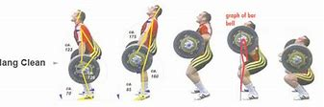

Superset with (exercises performed back to back)

Alternating Jumping Lunges Weighted 5 sets of 8 reps each side

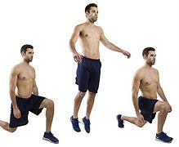

1 minute 30 seconds rest in between each set

Jump Squats 5 sets of 8-10 reps

Superset with

Pause Squats 5 sets of 5 reps (hold 3 second pause at the bottom)

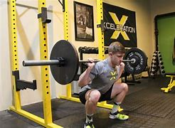

1 minute 30 seconds rest in between sets

SPLIT 2

Thrusters 5 sets of 8 reps (start with a front squat right into a shoulder press)


Superset with

Barbell Walking Lunges 5 sets of 20 reps each leg
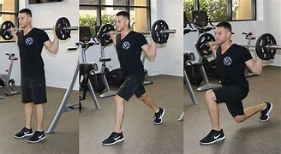

2 minutes rest in between each set

SPLIT 3 (AB Finisher)

Med Ball Slams 3 sets of 10
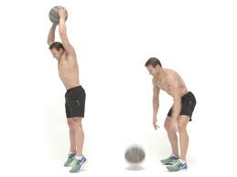
Superset with

Kneeling Med Ball Rotation Throws 3 sets of 10 each side

Superset with

AB Wheel Rollouts or Barbell Rollouts V-Ups 3 sets of 10
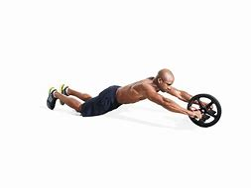
1 minute 30 seconds rest in between each set

Day 2 Grip Strength/ Upper Body

Warm Up

30 seconds jumping jacks
20 arm circles forward
20 arm circles backwards
20 pushups
20 sit ups
10 jump squats
10 lunges
30 seconds of sit ups
30 seconds bicycle kicks

SPLIT 1

Clean & Jerk 5 sets of 8-10 reps

Superset with

Pull Ups 5 sets of AMRAP (as many reps possible)

Superset with

Band Push Ups 5 sets of 10-12

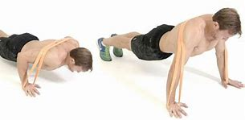

1 minute 30 seconds rest in between sets

SPLIT 2

Barbell Bicep Curls 5 sets of 8 reps

Superset with

DB Tricep Extension 5 sets of 8 reps

Superset with

DB Hammer Curls 5 sets of 6 reps each side

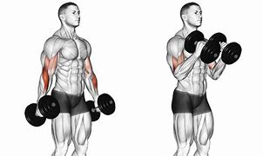

1 minute rest in between sets

SPLIT 3

DB Reverse Forearm Curls 5 sets of 8 reps
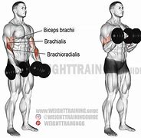
Superset with

Barbell Forearm Curls 5 sets of 8 reps
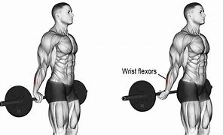
1 minute rest in between sets

Day 3 Conditioning Day

Warm up

A skip 4 sets working 20 yd space
B skip 4 sets working 20 yd space
C skip 4 sets working 20 yd space
High knees 4 sets working 20 yd space
Karaoka 4 sets working 20 yd space
Toy Soldiers 4 sets working 20 yd space
Quad Pull 4 sets working 20 yd space

SPLIT 1
800yd jog
Walk 100yds for rest

8x200yd sprints for time
Walk 100yds for rest

8x100yd sprints
Walk 100 for rest

8x50yd sprints
Walk 25yds for rest

Day 4 Active Recovery Day

Make sure to rest, stretch and hydrate

Day 5 Leg Work

Warm up

30 seconds jumping jacks
30 seconds high knees in place
10 jump squats
10 jumping lunges (alternating 5 each side)
10 side to side lunges (alternating 5 each side)
10 burpees
10 push-ups
30 seconds of sit ups
30 second of bicycle kicks

These are all performed back to back. The goal of this dynamic warm up is to get a sweat going.

SPLIT 1

Power Clean 8 sets of 3 reps
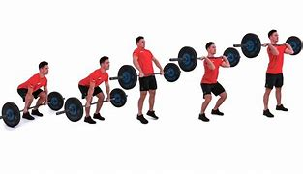
Superset with

Front Squats 8 sets of 10-12 reps
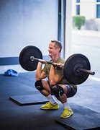
1 minute 30 seconds rest in between sets

SPLIT 2

Barbell Step Ups 5 sets of 8 reps each side

Superset with

DB Split Squats 5 sets of 8 reps on each side
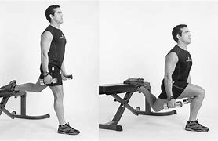
Superset with

Walking Lunges 5 sets of 20yds

2 minutes rest in between sets

SPLIT 3 (Ab finisher)

Pull Up Bar Toes To Bar 3 sets of AMRAP
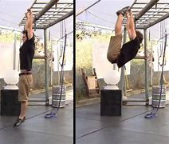
Superset with

V-Ups Med Ball 3 sets of 30
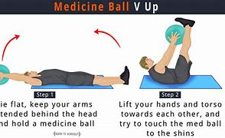
Superset with

Leg Lifts 3 sets of 20 reps
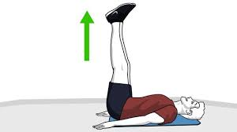
1 minute 30 seconds rest in between sets

Day 6 Grip Strength/ Upper Body

Warm up

30 seconds jumping jacks
20 arm circles forward
20 arm circles backwards
20 pushups
20 sit ups
10 jump squats
10 lunges
30 seconds of sit ups
30 seconds bicycle kicks

SPLIT 1

Barbell Pause Bench Press 5 sets of 8 reps (pause for 2-3 seconds when bar hits your chest then explode up)

Superset with

DB Tempo Bench Press5 sets of 8-10 reps (count for 5 seconds on the way down then 5 seconds on the way up) SLOW IT DOWN

Superset with

DB Shoulder Press 5 sets of 8 reps
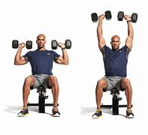
2 minutes rest in between sets

SPLIT 2

Plate Front Raises 5 sets of 10-12 reps
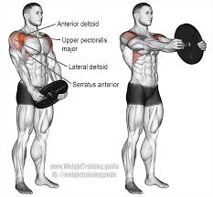
Superset with

DB Side Raises 5 sets of 10-12 reps
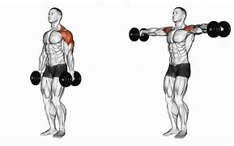
Superset with

Plate Flips 5 sets of 8-10 each hand
Alabama TE, O.J. Howard, Flips and Catches 55-Pound Weights With One Hand - YouTube (google.com)

2 minutes rest in between sets

SPLIT 3

Plank To Push Up (2 sets of As Long As You Can Hold )
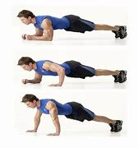
2 minutes rest in between sets

Day 7 Active Rest Day

Make sure to rest, stretch and hydrate

Day 8 Leg Work

Warm Up

30 seconds jumping jacks
30 seconds high knees in place
10 jump squats
10 jumping lunges (alternating 5 each side)
10 side to side lunges (alternating 5 each side)
10 burpees
10 push-ups
30 seconds of sit ups
30 second of bicycle kicks

These are all performed back to back. The goal of this dynamic warm up is to get a sweat going.

SPLIT 1

Barbell Tempo Back Squat 5 sets of 5 reps (count to 5 on the way down then count to 5 on the way up. Take the rep slow)

Superset with

DB Box Jumps 5 sets of 8 reps (put box at a height you can handle)
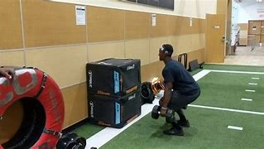
1 minute 30 seconds rest in between sets

Barbell Split Squats 5 sets of 8 reps each side
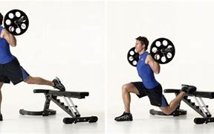
Superset with

DB Jump Squats 5 sets of 10

1 Minute 30 seconds rest in between sets

SPLIT 2

Walking Lunges 200yds

Every step make sure you lunge, rest at 50yds

SPLIT 3

Med Ball Rotation Throws 5 sets of 8 each side
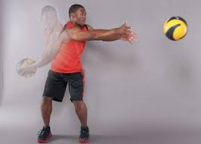
Superset with

Plate Russian Twists 5 sets of 20

Superset with

Bicycle Kicks 5 sets of 40

30 seconds rest in between sets

Day 9 Grip Strength/ Upper Body

Warm Up

30 seconds jumping jacks
20 arm circles forward
20 arm circles backwards
20 pushups
20 sit ups
10 jump squats
10 lunges
30 seconds of sit ups
30 seconds bicycle kicks

SPLIT 1

Barbell 21s (Curls) 5 sets (7 reps halfway, 7 reps halfway to up then 7 full reps)

Superset with

Barbell Reverse Curls 5 sets of 8 reps
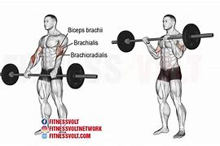
Superset with

DB Hammer Curls 5 sets of 8 reps

2 minutes rest in between sets

SPLIT 2

Cable Tricep Pull Downs 5 sets of 10-12
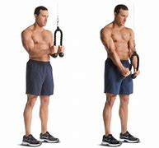
Superset with

Cable Tricep Overhead Extension 5 sets of 8 reps (can be done with resistance bands if no cable machine)

Superset with

Barbell Skull Crushers 5 sets of 10-12 reps
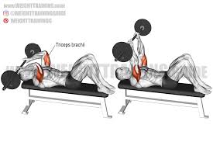
1 minute 30 seconds rest in between sets

SPLIT 3

Forearm Curls 3 sets of AMRAP
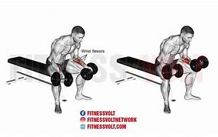
Superset with

Plate Farmers Carry 3 sets of 30yds
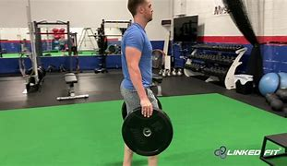
1 minute rest in between sets

Day 10 Conditioning Day

Warm Up

A skip 4 sets working 20 yd space
B skip 4 sets working 20 yd space
C skip 4 sets working 20 yd space
High knees 4 sets working 20 yd space
Karaoka 4 sets working 20 yd space
Toy Soldiers 4 sets working 20 yd space
Quad Pull 4 sets working 20 yd space

25x100yd sprints (walk 100yds for rest)

Day 11 Active Rest Day

Day 12 Leg work

Warm up

30 seconds jumping jacks
30 seconds high knees in place
10 jump squats
10 jumping lunges (alternating 5 each side)
10 side to side lunges (alternating 5 each side)
10 burpees
10 push-ups
30 seconds of sit ups
30 second of bicycle kicks

These are all performed back to back. The goal of this dynamic warm up is to get a sweat going.

SPLIT 1

Barbell Back Squats (hole for a 2 second count at the bottom) 8 sets of 3 reps

Superset with

Plate Wall Sit 8 sets 1 minute 30 second hold

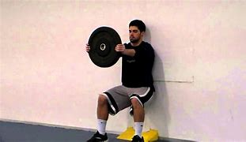
2 minutes rest in between sets

SPLIT 2

Barbell or Trap Bar Deadlifts 5 sets of 3-5 reps (heavier)

Superset with

Barbell RDL 5 sets of 8 reps each side

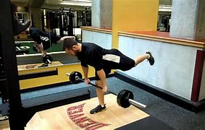

1 minute 30 seconds rest in between sets

SPLIT 3

Plate Russian Twists 3 sets of 40-50 reps

Superset with

Barbell Roll Out 3 sets of 15-20

1 minute rest in between sets

Day 13 Grip Strength/upper body

Warm up

30 seconds jumping jacks
20 arm circles forward
20 arm circles backwards
20 pushups
20 sit ups
10 jump squats
10 lunges
30 seconds of sit ups
30 seconds bicycle kicks

SPLIT 1

Barbell Rows 5 sets of 5-8 reps

Superset with

L-Sit Pull Ups 5 sets of AMRAP

1 Minute 30 seconds rest in between sets

SPLIT 2

Bench Press 5 sets of 5 reps

Superset with

DB Chest Fly Flat Bench 5 sets of 8 reps

Superset with

DB Incline Bench Press 5 sets of 8-10 reps (highest incline)
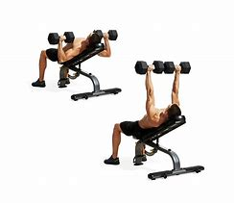
1 minute 30 seconds rest in between sets

SPLIT 3
Reverse DB Curls 5 sets of 8 reps

Superset with

Barbell Forearm Curls 5 sets of 10 reps

Superset with

Plate Hammer Curls 5 sets of 10 reps

30 seconds rest in between sets

Day 14 Active Rest Day

Day 15 Leg Work/ Core work

Warm Up

30 seconds jumping jacks
30 seconds high knees in place
10 jump squats
10 jumping lunges (alternating 5 each side)
10 side to side lunges (alternating 5 each side)
10 burpees
10 push-ups
30 seconds of sit ups
30 second of bicycle kicks

These are all performed back to back. The goal of this dynamic warm up is to get a sweat going.

SPLIT 1 (Explosiveness)

Hang Cleans 5 sets of 8 reps



Superset with (exercises performed back to back)

Alternating Jumping Lunges Weighted 5 sets of 8 reps each side



1 minute 30 seconds rest in between each set

Jump Squats 5 sets of 8-10 reps

Superset with

Pause Squats 5 sets of 5 reps (hold 3 second pause at the bottom)



1 minute 30 seconds rest in between sets

SPLIT 2

Thrusters 5 sets of 8 reps (start with a front squat right into a shoulder press)


Superset with

Barbell Walking Lunges 5 sets of 20 reps each leg


2 minutes rest in between each set

SPLIT 3 (AB Finisher)

Med Ball Slams 3 sets of 10

Superset with

Kneeling Med Ball Rotation Throws 3 sets of 10 each side

Superset with

AB Wheel Rollouts or Barbell Rollouts V-Ups 3 sets of 10

1 minute 30 seconds rest in between each set

Day 16 Grip Strength/ Upper Body

Warm Up

30 seconds jumping jacks
20 arm circles forward
20 arm circles backwards
20 pushups
20 sit ups
10 jump squats
10 lunges
30 seconds of sit ups
30 seconds bicycle kicks

SPLIT 1

Clean & Jerk 5 sets of 8-10 reps

Superset with

Pull Ups 5 sets of AMRAP (as many reps possible)

Superset with

Band Push Ups 5 sets of 10-12



1 minute 30 seconds rest in between sets

SPLIT 2

Barbell Bicep Curls 5 sets of 8 reps

Superset with

DB Tricep Extension 5 sets of 8 reps

Superset with

DB Hammer Curls 5 sets of 6 reps each side



1 minute rest in between sets

SPLIT 3

DB Reverse Forearm Curls 5 sets of 8 reps

Superset with

Barbell Forearm Curls 5 sets of 8 reps

1 minute rest in between sets

Day 17 Conditioning Day

Warm up

A skip 4 sets working 20 yd space
B skip 4 sets working 20 yd space
C skip 4 sets working 20 yd space
High knees 4 sets working 20 yd space
Karaoka 4 sets working 20 yd space
Toy Soldiers 4 sets working 20 yd space
Quad Pull 4 sets working 20 yd space

SPLIT 1
800yd jog
Walk 100yds for rest

8x200yd sprints for time
Walk 100yds for rest

8x100yd sprints
Walk 100 for rest

8x50yd sprints
Walk 25yds for rest

Day 18 Active Recovery Day

Make sure to rest, stretch and hydrate

Day 19 Leg Work

Warm up

30 seconds jumping jacks
30 seconds high knees in place
10 jump squats
10 jumping lunges (alternating 5 each side)
10 side to side lunges (alternating 5 each side)
10 burpees
10 push-ups
30 seconds of sit ups
30 second of bicycle kicks

These are all performed back to back. The goal of this dynamic warm up is to get a sweat going.

SPLIT 1

Power Clean 8 sets of 3 reps

Superset with

Front Squats 8 sets of 10-12 reps

1 minute 30 seconds rest in between sets

SPLIT 2

Barbell Step Ups 5 sets of 8 reps each side

Superset with

DB Split Squats 5 sets of 8 reps on each side

Superset with

Walking Lunges 5 sets of 20yds

2 minutes rest in between sets

SPLIT 3 (Ab finisher)

Pull Up Bar Toes To Bar 3 sets of AMRAP

Superset with

V-Ups Med Ball 3 sets of 30

Superset with

Leg Lifts 3 sets of 20 reps

1 minute 30 seconds rest in between sets

Day 20 Grip Strength/ Upper Body

Warm up

30 seconds jumping jacks
20 arm circles forward
20 arm circles backwards
20 pushups
20 sit ups
10 jump squats
10 lunges
30 seconds of sit ups
30 seconds bicycle kicks

SPLIT 1

Barbell Pause Bench Press 5 sets of 8 reps (pause for 2-3 seconds when bar hits your chest then explode up)

Superset with

DB Tempo Bench Press5 sets of 8-10 reps (count for 5 seconds on the way down then 5 seconds on the way up) SLOW IT DOWN

Superset with

DB Shoulder Press 5 sets of 8 reps

2 minutes rest in between sets

SPLIT 2

Plate Front Raises 5 sets of 10-12 reps

Superset with

DB Side Raises 5 sets of 10-12 reps

Superset with

Plate Flips 5 sets of 8-10 each hand
Alabama TE, O.J. Howard, Flips and Catches 55-Pound Weights With One Hand - YouTube (google.com)

2 minutes rest in between sets

SPLIT 3

Plank To Push Up (2 sets of As Long As You Can Hold )

2 minutes rest in between sets

Day 21 Active Rest Day

Make sure to rest, stretch and hydrate

Day 22 Leg Work

Warm Up

30 seconds jumping jacks
30 seconds high knees in place
10 jump squats
10 jumping lunges (alternating 5 each side)
10 side to side lunges (alternating 5 each side)
10 burpees
10 push-ups
30 seconds of sit ups
30 second of bicycle kicks

These are all performed back to back. The goal of this dynamic warm up is to get a sweat going.

SPLIT 1

Barbell Tempo Back Squat 5 sets of 5 reps (count to 5 on the way down then count to 5 on the way up. Take the rep slow)

Superset with

DB Box Jumps 5 sets of 8 reps (put box at a height you can handle)

1 minute 30 seconds rest in between sets

Barbell Split Squats 5 sets of 8 reps each side

Superset with

DB Jump Squats 5 sets of 10

1 Minute 30 seconds rest in between sets

SPLIT 2

Walking Lunges 200yds

Every step make sure you lunge, rest at 50yds

SPLIT 3

Med Ball Rotation Throws 5 sets of 8 each side

Superset with

Plate Russian Twists 5 sets of 20

Superset with

Bicycle Kicks 5 sets of 40

30 seconds rest in between sets

Day 23 Grip Strength/ Upper Body

Warm Up

30 seconds jumping jacks
20 arm circles forward
20 arm circles backwards
20 pushups
20 sit ups
10 jump squats
10 lunges
30 seconds of sit ups
30 seconds bicycle kicks

SPLIT 1

Barbell 21s (Curls) 5 sets (7 reps halfway, 7 reps halfway to up then 7 full reps)

Superset with

Barbell Reverse Curls 5 sets of 8 reps

Superset with

DB Hammer Curls 5 sets of 8 reps

2 minutes rest in between sets

SPLIT 2

Cable Tricep Pull Downs 5 sets of 10-12

Superset with

Cable Tricep Overhead Extension 5 sets of 8 reps (can be done with resistance bands if no cable machine)

Superset with

Barbell Skull Crushers 5 sets of 10-12 reps

1 minute 30 seconds rest in between sets

SPLIT 3

Forearm Curls 3 sets of AMRAP

Superset with

Plate Farmers Carry 3 sets of 30yds

1 minute rest in between sets

Day 24 Conditioning Day

Warm Up

A skip 4 sets working 20 yd space
B skip 4 sets working 20 yd space
C skip 4 sets working 20 yd space
High knees 4 sets working 20 yd space
Karaoka 4 sets working 20 yd space
Toy Soldiers 4 sets working 20 yd space
Quad Pull 4 sets working 20 yd space

25x100yd sprints (walk 100yds for rest)

Day 25 Active Rest Day

Day 26 Leg work

Warm up

30 seconds jumping jacks
30 seconds high knees in place
10 jump squats
10 jumping lunges (alternating 5 each side)
10 side to side lunges (alternating 5 each side)
10 burpees
10 push-ups
30 seconds of sit ups
30 second of bicycle kicks

These are all performed back to back. The goal of this dynamic warm up is to get a sweat going.

SPLIT 1

Barbell Back Squats (hole for a 2 second count at the bottom) 8 sets of 3 reps

Superset with

Plate Wall Sit 8 sets 1 minute 30 second hold


2 minutes rest in between sets

SPLIT 2

Barbell or Trap Bar Deadlifts 5 sets of 3-5 reps (heavier)

Superset with

Barbell RDL 5 sets of 8 reps each side



1 minute 30 seconds rest in between sets

SPLIT 3

Plate Russian Twists 3 sets of 40-50 reps

Superset with

Barbell Roll Out 3 sets of 15-20

1 minute rest in between sets

Day 27 Grip Strength/upper body

Warm up

30 seconds jumping jacks
20 arm circles forward
20 arm circles backwards
20 pushups
20 sit ups
10 jump squats
10 lunges
30 seconds of sit ups
30 seconds bicycle kicks

SPLIT 1

Barbell Rows 5 sets of 5-8 reps

Superset with

L-Sit Pull Ups 5 sets of AMRAP

1 Minute 30 seconds rest in between sets

SPLIT 2

Bench Press 5 sets of 5 reps

Superset with

DB Chest Fly Flat Bench 5 sets of 8 reps

Superset with

DB Incline Bench Press 5 sets of 8-10 reps (highest incline)

1 minute 30 seconds rest in between sets

SPLIT 3
Reverse DB Curls 5 sets of 8 reps

Superset with

Barbell Forearm Curls 5 sets of 10 reps

Superset with

Plate Hammer Curls 5 sets of 10 reps

30 seconds rest in between sets

Day 28 Active Rest Day

WR GYM PROGRAM 3.0

This is a more advanced WR gym training program that builds off of our first and second WR gym training programs. It has more advanced exercises and has a more advanced output level. You will be doing heavier weight in some cases, higher reps and more explosive/advanced movements as mentioned above. I hope you enjoy!

Disclaimer: This is a strength program designed to increase performance of WRs. Results may vary because certain people are not as athletically gifted or work as hard as others. Some of these movements may be too advanced for your fitness level. Please consult with a doctor before beginning this program. If you do not understand these movements please consult with myself or the Internet. Never perform these exercises alone. Safety First.

The main things that receivers need to focus on in the gym is the following: explosiveness, grip strength and stability/balance. That’s going to be the main focus of this program. We will give you the exercises to improve your leg strength and core strength which help with balance, grip strength and upper body exercises to help with tough catches over the middle and strength in blocking and lastly we provide conditioning workouts so receivers can stay on the field for 4 quarters with a high tempo. I hope this plan gives you some value and I can promise that it will help you become a better receiver on the field.

WRs need explosion from their hips in their routes and that comes from developing your fast twitch muscle fibers from doing explosive exercises like Olympic lifts. That’s going to also be a focus of this program. Grip strength helps you catch every ball and explosiveness helps you get in and out of breaks. Against press and to be able to perform cuts downfield you need balance and stability that’s why we have included balance work and core work mixed into the explosive work. Hope this program helps!

Day 1 Leg Work/ Core work

Warm Up

30 seconds jumping jacks
30 seconds high knees in place
10 jump squats
10 jumping lunges (alternating 5 each side)
10 side to side lunges (alternating 5 each side)
10 burpees
10 push-ups
30 seconds of sit ups
30 second of bicycle kicks

These are all performed back to back. The goal of this dynamic warm up is to get a sweat going.

SPLIT 1 (Explosiveness)

Single Leg Hang Cleans 5 sets of 6 reps

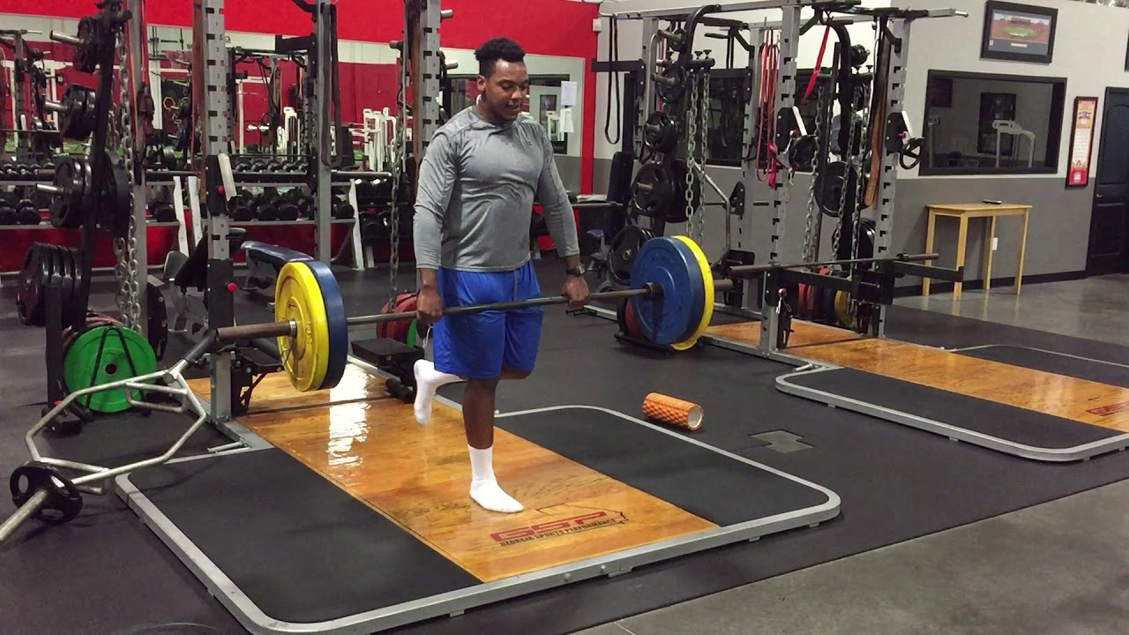

Superset with (exercises performed back to back)

Explosive Split Squats On Bench (jump up on 1 leg) 5 sets of 6-8 reps each side

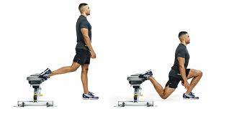 (instead of just standing straight up you jump, almost like a jump squat)

1 minute 30 seconds rest in between each set

Jump Squats 5 sets of 8-10 reps

Superset with

Pistol Squats (weighted) 5 sets of 8-10 reps
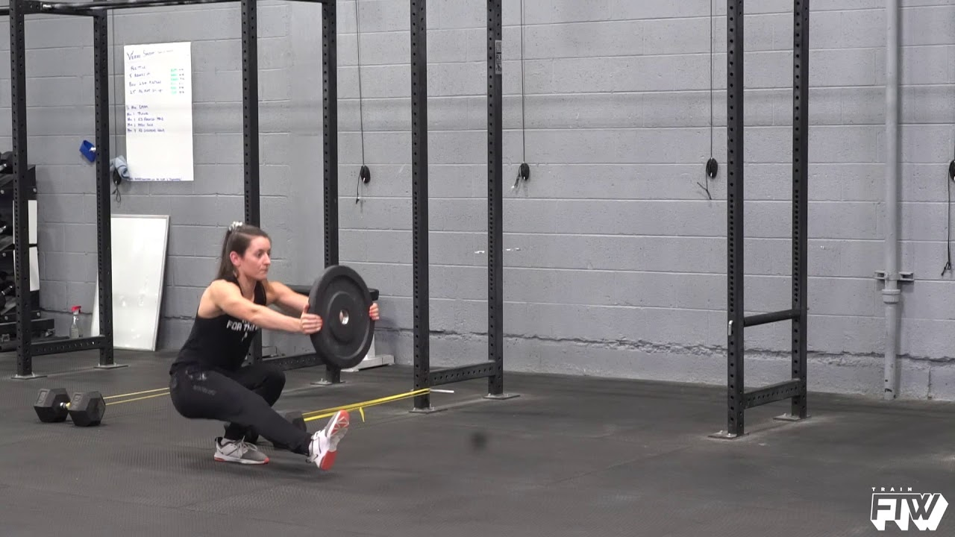
(can be done to a bench instead of the floor)

1 minute 30 seconds rest in between sets

SPLIT 2

Barbell Front Squat Reverse Lunge 5 sets of 8 reps each side
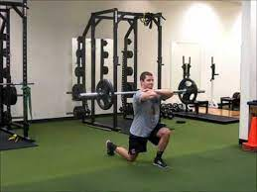
Superset with

Dumbbell Bosu Ball Reverse Lunge 5 sets of 10 reps each leg
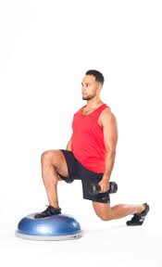

2 minutes rest in between each set

SPLIT 3 (AB Finisher)

Bosu Med Ball Wall Slams 3 sets of 10

Superset with

Med Ball Overhead Rotation Slams 3 sets of 6 each side
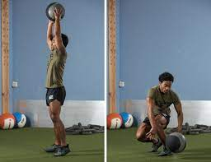
Superset with

AB Wheel Rollouts or Barbell Rollouts V-Ups 3 sets of 10
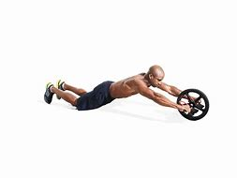
1 minute 30 seconds rest in between each set

Day 2 Grip Strength/ Upper Body

Warm Up

30 seconds jumping jacks
20 arm circles forward
20 arm circles backwards
20 pushups
20 sit ups
10 jump squats
10 lunges
30 seconds of sit ups
30 seconds bicycle kicks

SPLIT 1

Barbell Snatch 5 sets of 6-8 reps (light weight)
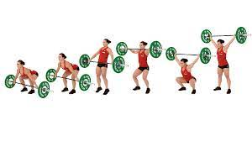
Superset with

Tempo (control the weight down for 3 seconds, then go up with it for 3 seconds) Dumbbell Bench Press 5 sets of 5

Superset with

Band Push Ups 5 sets of 10-12

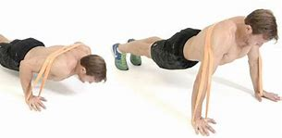

1 minute 30 seconds rest in between sets

SPLIT 2

Barbell Bicep Curls 5 sets of 8 reps

Superset with

DB Tricep Extension 5 sets of 8 reps

Superset with

DB Hammer Curls 5 sets of 6 reps each side

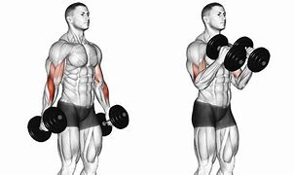

1 minute rest in between sets

SPLIT 3

DB Reverse Forearm Curls 5 sets of 8 reps
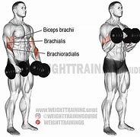
Superset with

Barbell Forearm Curls 5 sets of 8 reps
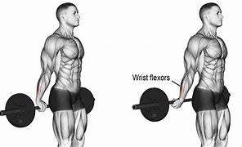
1 minute rest in between sets

Day 3 Conditioning Day

Warm up

A skip 4 sets working 20 yd space
B skip 4 sets working 20 yd space
C skip 4 sets working 20 yd space
High knees 4 sets working 20 yd space
Karaoka 4 sets working 20 yd space
Toy Soldiers 4 sets working 20 yd space
Quad Pull 4 sets working 20 yd space

SPLIT 1
800yd jog
Walk 100yds for rest

16x100yd sprints
Walk 100 for rest

Day 4 Active Recovery Day

Make sure to rest, stretch and hydrate

Day 5 Leg Work

Warm up

30 seconds jumping jacks
30 seconds high knees in place
10 jump squats
10 jumping lunges (alternating 5 each side)
10 side to side lunges (alternating 5 each side)
10 burpees
10 push-ups
30 seconds of sit ups
30 second of bicycle kicks

These are all performed back to back. The goal of this dynamic warm up is to get a sweat going.

SPLIT 1

Power Clean 8 sets of 3 reps
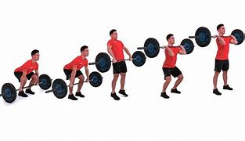
Superset with

Kneeling Plate Jumps 8 sets of 6-8 reps
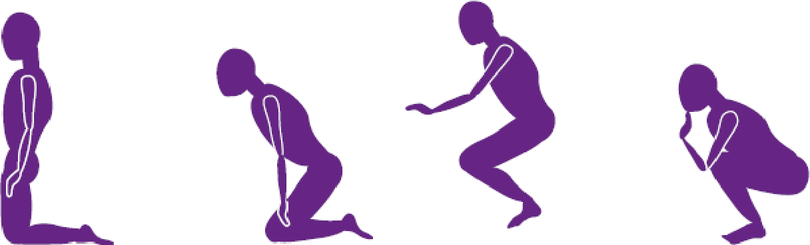

(do this exercise but holding a plate in your chest)

1 minute 30 seconds rest in between sets

SPLIT 2

Barbell Explosive Step Ups 5 sets of 8 reps each side
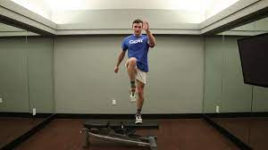

(perform this exercise but with a weighted barbell on your back instead of body weight)

Superset with

Trap Bar Deadlift Jumps 5 sets of 8 reps
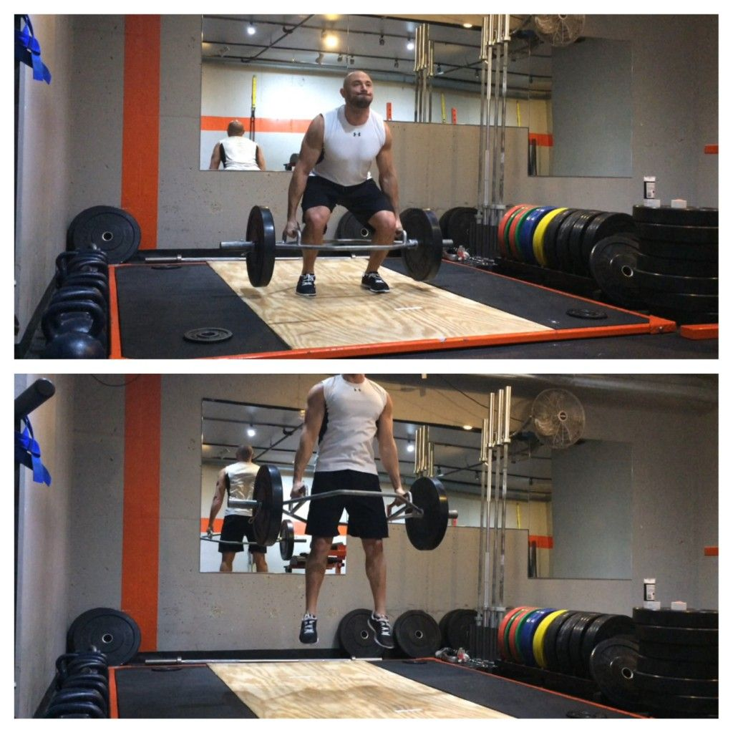
Superset with

Walking Lunges 5 sets of 20yds

2 minutes rest in between sets

SPLIT 3 (Ab finisher)

Pull Up Bar Toes To Bar 3 sets of AMRAP
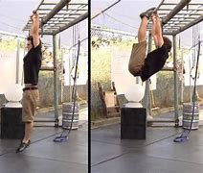
Superset with

V-Ups Med Ball 3 sets of 30
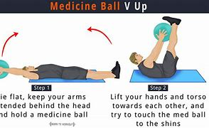
Superset with

Leg Lifts 3 sets of 20 reps
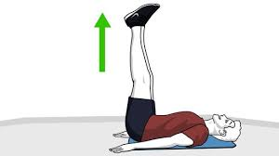
1 minute 30 seconds rest in between sets

Day 6 Grip Strength/ Upper Body

Warm up

30 seconds jumping jacks
20 arm circles forward
20 arm circles backwards
20 pushups
20 sit ups
10 jump squats
10 lunges
30 seconds of sit ups
30 seconds bicycle kicks

SPLIT 1

Barbell Pause Bench Press 5 sets of 8 reps (pause for 2-3 seconds when bar hits your chest then explode up)

Superset with

DB Tempo Bench Press5 sets of 8-10 reps (count for 5 seconds on the way down then 5 seconds on the way up) SLOW IT DOWN

Superset with

1 Arm DB Snatchh 5 sets of 8 reps each side
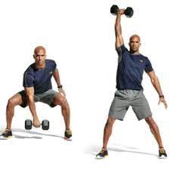
2 minutes rest in between sets

SPLIT 2

Plate Front Raises 5 sets of 10-12 reps
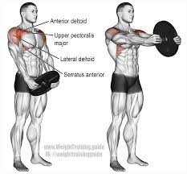
Superset with

BOSU BALL SHOULDER PRESS5 sets of 10-12 reps

Superset with

1 Leg Bosu Ball Plate Flips 5 sets of 8-10 each hand
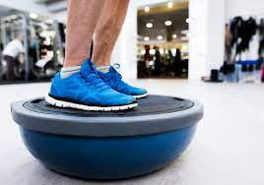

(turn the bosu ball to this end; stand on 1 leg; perform the exercise)

2 minutes rest in between sets

SPLIT 3

Plank To Push Up (2 sets of As Long As You Can Hold )
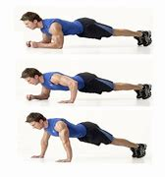
2 minutes rest in between sets

Day 7 Active Rest Day

Make sure to rest, stretch and hydrate

Day 8 Leg Work

Warm Up

30 seconds jumping jacks
30 seconds high knees in place
10 jump squats
10 jumping lunges (alternating 5 each side)
10 side to side lunges (alternating 5 each side)
10 burpees
10 push-ups
30 seconds of sit ups
30 second of bicycle kicks

These are all performed back to back. The goal of this dynamic warm up is to get a sweat going.

SPLIT 1

Barbell Tempo Back Squat 5 sets of 5 reps (count to 5 on the way down then count to 5 on the way up. Take the rep slow)

Superset with

DB Box Jumps 5 sets of 8 reps (put box at a height you can handle)
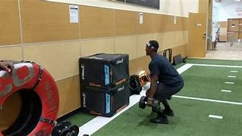
1 minute 30 seconds rest in between sets

Box Fall Off Broad Jump 5 sets of 8 reps
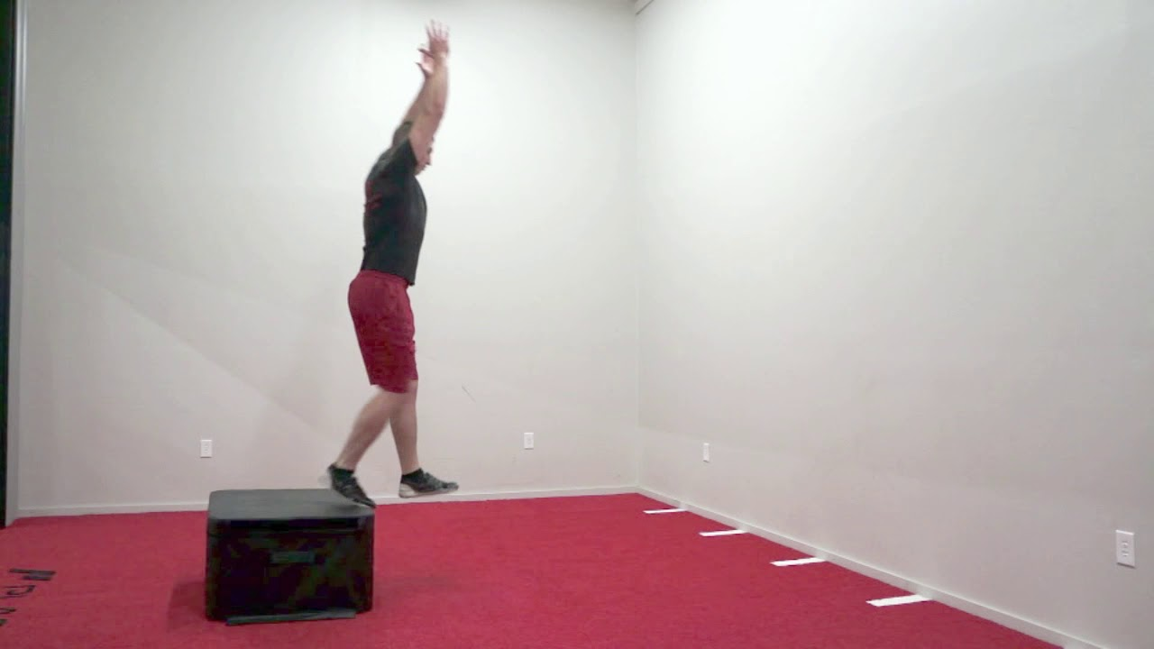
(fall off box, land with 2 feet then broad jump out as soon as you land)
Superset with

DB Jump Squats 5 sets of 10

1 Minute 30 seconds rest in between sets

SPLIT 2

Walking Lunges 200yds

Every step make sure you lunge, rest at 50yds

SPLIT 3

Box Fall Med Ball Rotation Throws 5 sets of 8 each side
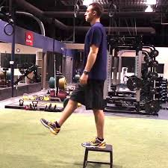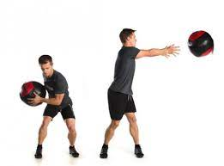

(fall off the box with a med ball and throw at the wall with a rotation)

Superset with

Box Fall Med Ball Slams 5 sets of 8
(fall off the box and instead of rotating to throw the ball, slam it down)

Superset with

Bicycle Kicks 5 sets of 40

30 seconds rest in between sets

Day 9 Grip Strength/ Upper Body

Warm Up

30 seconds jumping jacks
20 arm circles forward
20 arm circles backwards
20 pushups
20 sit ups
10 jump squats
10 lunges
30 seconds of sit ups
30 seconds bicycle kicks

SPLIT 1

Barbell Curl Burnouts 5 sets (AMRAP then drop set to just the bar and curl for AMRAP)

Superset with

Barbell Reverse Curls 5 sets of 8 reps
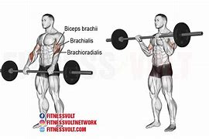
Superset with

Plate BOSU BALL Hammer Curls 5 sets of 8 reps
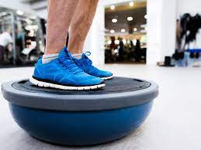
2 minutes rest in between sets

SPLIT 2

Resistance Band Tricep Pull Downs(2 second pause at the top) 5 sets of 10-12
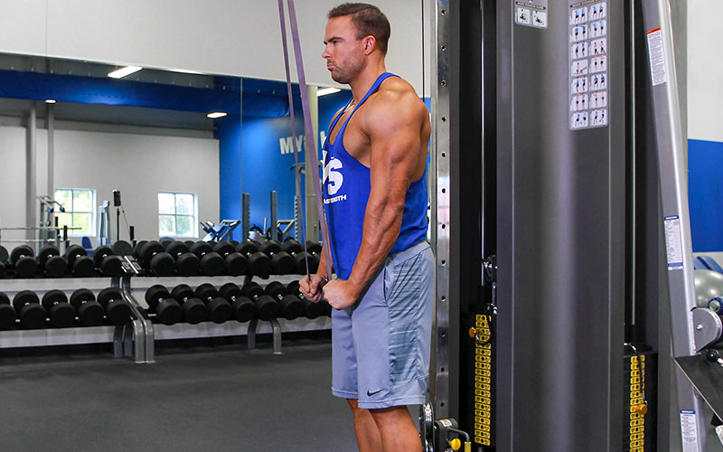
Superset with

Resistance Band Tricep Overhead Extension 5 sets of 8 reps
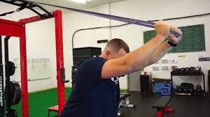
Superset with

Barbell Skull Crushers 5 sets of 10-12 reps
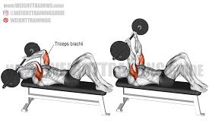
1 minute 30 seconds rest in between sets

SPLIT 3

Forearm Curls 3 sets of AMRAP
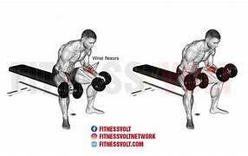
Superset with

Plate Farmers Carry 3 sets of 30yds
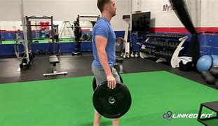
1 minute rest in between sets

Day 10 Conditioning Day

Warm Up

A skip 4 sets working 20 yd space
B skip 4 sets working 20 yd space
C skip 4 sets working 20 yd space
High knees 4 sets working 20 yd space
Karaoka 4 sets working 20 yd space
Toy Soldiers 4 sets working 20 yd space
Quad Pull 4 sets working 20 yd space

40x50yd sprints (walk 100yds for rest)

Day 11 Active Rest Day

Day 12 Leg work

Warm up

30 seconds jumping jacks
30 seconds high knees in place
10 jump squats
10 jumping lunges (alternating 5 each side)
10 side to side lunges (alternating 5 each side)
10 burpees
10 push-ups
30 seconds of sit ups
30 second of bicycle kicks

These are all performed back to back. The goal of this dynamic warm up is to get a sweat going.

SPLIT 1

Band Split Squat 5 sets of 8-10 reps each side
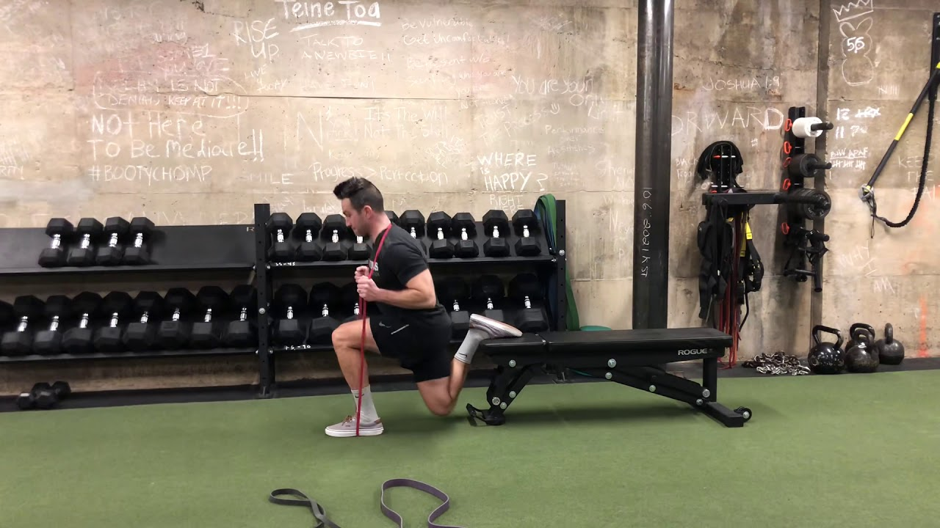
Superset with

Bosu Ball Kettlebell Front Squat 5 sets of 8-10 reps
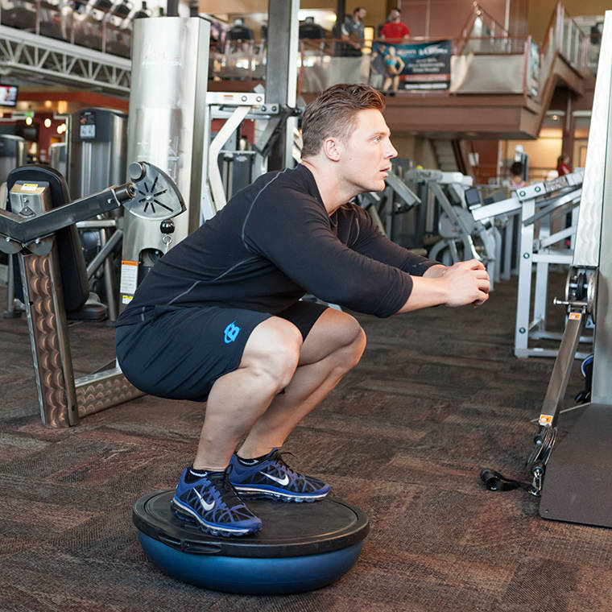
(do this but holding a kettlebell in a front squat)

2 minutes rest in between sets

SPLIT 2

Barbell or Trap Bar Deadlifts 5 sets of 3-5 reps (heavier)

Superset with

DB Overhead Walking Lunge 5 sets of 20yds

 (can hold two dumbbells at one; be safe with the weight)

1 minute 30 seconds rest in between sets

SPLIT 3

Bosu Ball Wall Throws/Catch 3 sets of 10-15 reps
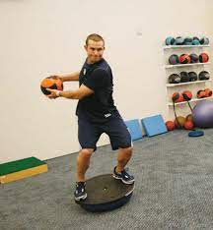
Superset with

Kneeling Jump Med Ball Side Throws 3 sets of 8-10 each side

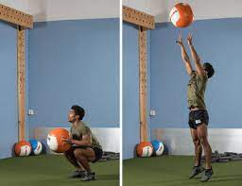
1 minute rest in between sets

Day 13 Grip Strength/upper body

Warm up

30 seconds jumping jacks
20 arm circles forward
20 arm circles backwards
20 pushups
20 sit ups
10 jump squats
10 lunges
30 seconds of sit ups
30 seconds bicycle kicks

SPLIT 1

1 Leg Barbell Rows 5 sets of 5-8 reps
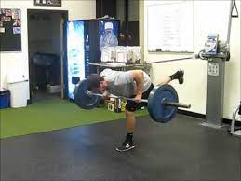
Superset with

Regular Pull Ups 5 sets of AMRAP

1 Minute 30 seconds rest in between sets

SPLIT 2

Bench Press 5 sets of 5 reps

Superset with

Band Push Ups Into Drop Set 5 sets of 8 reps then AMRAP on drop set

Superset with

DB Incline Chest fly 5 sets of 8-10 reps (highest incline)
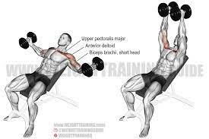
1 minute 30 seconds rest in between sets

SPLIT 3
Reverse DB Curls 10 sets of 8 reps

Superset with

Plate Flips (lighter weight) 10 sets of 15-20 reps

30 seconds rest in between sets (this is fast paced)

Day 14 Active Rest Day

Day 15 Leg Work/ Core work

Warm Up

30 seconds jumping jacks
30 seconds high knees in place
10 jump squats
10 jumping lunges (alternating 5 each side)
10 side to side lunges (alternating 5 each side)
10 burpees
10 push-ups
30 seconds of sit ups
30 second of bicycle kicks

These are all performed back to back. The goal of this dynamic warm up is to get a sweat going.

SPLIT 1 (Explosiveness)

Single Leg Hang Cleans 5 sets of 6 reps

Superset with (exercises performed back to back)

Explosive Split Squats On Bench (jump up on 1 leg) 5 sets of 6-8 reps each side

1 minute 30 seconds rest in between each set

Jump Squats 5 sets of 8-10 reps

Superset with

Pistol Squats (weighted) 5 sets of 8-10 reps

1 minute 30 seconds rest in between sets

SPLIT 2

Barbell Front Squat Reverse Lunge 5 sets of 8 reps each side

Superset with

Dumbbell Bosu Ball Reverse Lunge 5 sets of 10 reps each leg
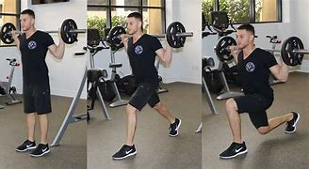

2 minutes rest in between each set

SPLIT 3 (AB Finisher)

Bosu Med Ball Wall Slams 3 sets of 10

Superset with

Med Ball Overhead Rotation Slams 3 sets of 6 each side

Superset with

AB Wheel Rollouts or Barbell Rollouts V-Ups 3 sets of 10

1 minute 30 seconds rest in between each set

Day 16 Grip Strength/ Upper Body

Warm Up

30 seconds jumping jacks
20 arm circles forward
20 arm circles backwards
20 pushups
20 sit ups
10 jump squats
10 lunges
30 seconds of sit ups
30 seconds bicycle kicks

SPLIT 1

Barbell Snatch 5 sets of 6-8 reps (light weight)

Superset with

Tempo Dumbbell Bench Press 5 sets of 5

Superset with

Band Push Ups 5 sets of 10-12



1 minute 30 seconds rest in between sets

SPLIT 2

Barbell Bicep Curls 5 sets of 8 reps

Superset with

DB Tricep Extension 5 sets of 8 reps

Superset with

DB Hammer Curls 5 sets of 6 reps each side



1 minute rest in between sets

SPLIT 3

DB Reverse Forearm Curls 5 sets of 8 reps

Superset with

Barbell Forearm Curls 5 sets of 8 reps

1 minute rest in between sets

Day 17 Conditioning Day

Warm up

A skip 4 sets working 20 yd space
B skip 4 sets working 20 yd space
C skip 4 sets working 20 yd space
High knees 4 sets working 20 yd space
Karaoka 4 sets working 20 yd space
Toy Soldiers 4 sets working 20 yd space
Quad Pull 4 sets working 20 yd space

SPLIT 1
800yd jog
Walk 100yds for rest

16x100yd sprints
Walk 100 for rest

Day 18 Active Recovery Day

Make sure to rest, stretch and hydrate

Day 19 Leg Work

Warm up

30 seconds jumping jacks
30 seconds high knees in place
10 jump squats
10 jumping lunges (alternating 5 each side)
10 side to side lunges (alternating 5 each side)
10 burpees
10 push-ups
30 seconds of sit ups
30 second of bicycle kicks

These are all performed back to back. The goal of this dynamic warm up is to get a sweat going.

SPLIT 1

Power Clean 8 sets of 3 reps

Superset with

Kneeling Plate Jumps 8 sets of 6-8 reps

1 minute 30 seconds rest in between sets

SPLIT 2

Barbell Explosive Step Ups 5 sets of 8 reps each side

Superset with

Trap Bar Deadlift Jumps 5 sets of 8 reps

Superset with

Walking Lunges 5 sets of 20yds

2 minutes rest in between sets

SPLIT 3 (Ab finisher)

Pull Up Bar Toes To Bar 3 sets of AMRAP

Superset with

V-Ups Med Ball 3 sets of 30

Superset with

Leg Lifts 3 sets of 20 reps

1 minute 30 seconds rest in between sets

Day 20 Grip Strength/ Upper Body

Warm up

30 seconds jumping jacks
20 arm circles forward
20 arm circles backwards
20 pushups
20 sit ups
10 jump squats
10 lunges
30 seconds of sit ups
30 seconds bicycle kicks

SPLIT 1

Barbell Pause Bench Press 5 sets of 8 reps (pause for 2-3 seconds when bar hits your chest then explode up)

Superset with

DB Tempo Bench Press5 sets of 8-10 reps (count for 5 seconds on the way down then 5 seconds on the way up) SLOW IT DOWN

Superset with

1 Arm DB Snatchh 5 sets of 8 reps each side

2 minutes rest in between sets

SPLIT 2

Plate Front Raises 5 sets of 10-12 reps

Superset with

BOSU BALL SHOULDER PRESS5 sets of 10-12 reps

Superset with

1 Leg Bosu Ball Plate Flips 5 sets of 8-10 each hand

2 minutes rest in between sets

SPLIT 3

Plank To Push Up (2 sets of As Long As You Can Hold )

2 minutes rest in between sets

Day 21 Active Rest Day

Make sure to rest, stretch and hydrate

Day 22 Leg Work

Warm Up

30 seconds jumping jacks
30 seconds high knees in place
10 jump squats
10 jumping lunges (alternating 5 each side)
10 side to side lunges (alternating 5 each side)
10 burpees
10 push-ups
30 seconds of sit ups
30 second of bicycle kicks

These are all performed back to back. The goal of this dynamic warm up is to get a sweat going.

SPLIT 1

Barbell Tempo Back Squat 5 sets of 5 reps (count to 5 on the way down then count to 5 on the way up. Take the rep slow)

Superset with

DB Box Jumps 5 sets of 8 reps (put box at a height you can handle)

1 minute 30 seconds rest in between sets

Box Fall Off Broad Jump 5 sets of 8 reps

Superset with

DB Jump Squats 5 sets of 10

1 Minute 30 seconds rest in between sets

SPLIT 2

Walking Lunges 200yds

Every step make sure you lunge, rest at 50yds

SPLIT 3

Box Fall Med Ball Rotation Throws 5 sets of 8 each side

Superset with

Box Fall Med Ball Slams 5 sets of 8

Superset with

Bicycle Kicks 5 sets of 40

30 seconds rest in between sets

Day 23 Grip Strength/ Upper Body

Warm Up

30 seconds jumping jacks
20 arm circles forward
20 arm circles backwards
20 pushups
20 sit ups
10 jump squats
10 lunges
30 seconds of sit ups
30 seconds bicycle kicks

SPLIT 1

Barbell Curl Burnouts 5 sets (AMRAP then drop set to just the bar and curl for AMRAP)

Superset with

Barbell Reverse Curls 5 sets of 8 reps

Superset with

Plate BOSU BALL Hammer Curls 5 sets of 8 reps

2 minutes rest in between sets

SPLIT 2

Resistance Band Tricep Pull Downs(2 second pause at the top) 5 sets of 10-12

Superset with

Resistance Band Tricep Overhead Extension 5 sets of 8 reps
Superset with

Barbell Skull Crushers 5 sets of 10-12 reps

1 minute 30 seconds rest in between sets

SPLIT 3

Forearm Curls 3 sets of AMRAP

Superset with

Plate Farmers Carry 3 sets of 30yds

1 minute rest in between sets

Day 24 Conditioning Day

Warm Up

A skip 4 sets working 20 yd space
B skip 4 sets working 20 yd space
C skip 4 sets working 20 yd space
High knees 4 sets working 20 yd space
Karaoka 4 sets working 20 yd space
Toy Soldiers 4 sets working 20 yd space
Quad Pull 4 sets working 20 yd space

40x50yd sprints (walk 100yds for rest)

Day 25 Active Rest Day

Day 26 Leg work

Warm up

30 seconds jumping jacks
30 seconds high knees in place
10 jump squats
10 jumping lunges (alternating 5 each side)
10 side to side lunges (alternating 5 each side)
10 burpees
10 push-ups
30 seconds of sit ups
30 second of bicycle kicks

These are all performed back to back. The goal of this dynamic warm up is to get a sweat going.

SPLIT 1

Band Split Squat 5 sets of 8-10 reps each side

Superset with

Bosu Ball Kettlebell Front Squat 5 sets of 8-10 reps

2 minutes rest in between sets

SPLIT 2

Barbell or Trap Bar Deadlifts 5 sets of 3-5 reps (heavier)

Superset with

DB Overhead Walking Lunge 5 sets of 20yds

1 minute 30 seconds rest in between sets

SPLIT 3

Bosu Ball Wall Throws/Catch 3 sets of 10-15 reps

Superset with

Kneeling Jump Med Ball Side Throws 3 sets of 8-10 each side

1 minute rest in between sets

Day 27 Grip Strength/upper body

Warm up

30 seconds jumping jacks
20 arm circles forward
20 arm circles backwards
20 pushups
20 sit ups
10 jump squats
10 lunges
30 seconds of sit ups
30 seconds bicycle kicks

SPLIT 1

1 Leg Barbell Rows 5 sets of 5-8 reps

Superset with

Regular Pull Ups 5 sets of AMRAP

1 Minute 30 seconds rest in between sets

SPLIT 2

Bench Press 5 sets of 5 reps

Superset with

Band Push Ups Into Drop Set 5 sets of 8 reps then AMRAP on drop set

Superset with

DB Incline Chest fly 5 sets of 8-10 reps (highest incline)

1 minute 30 seconds rest in between sets

SPLIT 3
Reverse DB Curls 10 sets of 8 reps

Superset with

Plate Flips (lighter weight) 10 sets of 15-20 reps

30 seconds rest in between sets (this is fast paced)

Day 28 Active Rest Day

