**Lab 3**

**Using Minikube to Create a Cluster**



Deploy an application on the cluster

**Viewing Pods and Nodes**

View the pods on the node

Describe pods for more information



Store the name of the pod in a variable

Executing commands on the pod

**Using a Service to Expose Your App**



Expose the node on port 8080

Describe the services on the node

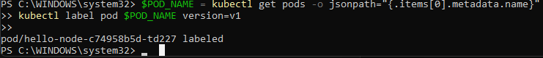

Give a label to the pod

Delete the service

**Running Multiple Instances of Your App**



scale the pod to have 4 replicas

scale back down to 2 replicas

**Performing a Rolling Update**



Update the image with a rolling update

Observe newer updated pod

Roll back the update and view that it has been rolled back