**Lab 4**

**Kelan morgan – C00262090**

**Download Istio**

**Install Istio**

**Install the Kubernetes Gateway API CRDs**

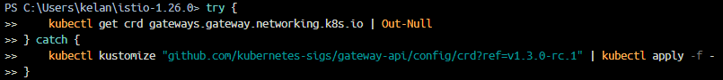

**Deploy the sample application**

Get services and pod information

**Open the application to outside traffic**

**Access the application**

