AXI4_LITE_SLAVE MODULE
Kelgiorgis Georgios – Meng Electrical and Electronic Engineering (UEL)
ASAT Rocketry Department

Module Description
The Axi4_Lite_Slave Module is responsible for the communication between the physical wires of the Zynq 7000 series CPU Unit and Programmable Logic Unit (PL, FPGA)
The AXI4-Lite interface consists of five channels: Read Address, Read Data, Write Address, Write Data, and Write Response. An AXI4 read transaction using the Read Address and Data channels is shown in figure 1. Similarly an AXI4 write transaction using the Write Address, Data, and Response channels is shown in figure 2. Note that these figures depict burst transfers, which AXI4-Lite is incapable of.
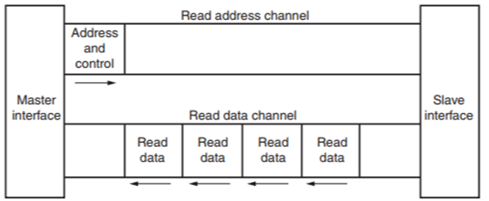

Interface(I/O)

 | Inputs | Outputs
Global Signals | ACLK  ARESETn | -
Read Address Channel | ARADDR  ARVALID | ARREADY
Read Data Channel | RREADY | RVALID  RDATA  RRESP
Write Address Channel | AWADDR(32bit)  AWVALID | AWREADY
Write Data Channel | WDATA  WVALID  WSTRB | WREADY
Write Response Channel | BREADY | BVALID  BRESP

Internal Logic and Architecture
The datapath of this AXI4-Lite slave acts as a bridge between the standard AXI bus and a local 32-deep by 32-bit wide memory array (register[31:0]). The flow of data is strictly governed by a 5-state Finite State Machine (FSM), ensuring data is only captured or emitted when the proper handshakes occur.

The Write Datapath (Inbound)
When the AXI Master wants to write data into the slave, the datapath operates as follows:
- Simultaneous Arrival: The master presents the target address on AWADDR and the payload on WDATA.
- Word Alignment (Address Math): Because AXI uses byte-addressing and our internal registers are 32 bits (4 bytes) wide, the raw address cannot be used directly. The datapath slices the bottom two bits off the address (AWADDR[ADDRESS-1:2]). For example, byte address 0x04 becomes word index 1.
- Data Capture: Once the FSM enters the WRITE_CHANNEL state and both address and data handshakes are valid (write_addr && write_data), the 32-bit WDATA payload is routed directly into the register array at the calculated word index.
- Response: The datapath routes a hardcoded 2'b00 (OKAY) to BRESP to indicate a successful write.

The Read Datapath (Outbound)
Because AXI splits the read address and read data phases, the read datapath requires an intermediate holding register.
- Address Capture: The master presents the requested address on ARADDR. During the READ_ADDR_CHANNEL state, when the handshake fires, this address is latched into an internal addr register. This frees up the AXI address bus while the slave processes the data.
- Data Retrieval: The FSM transitions to the READ_DATA_CHANNEL state. The datapath takes the latched addr, slices off the bottom two bits for word alignment (addr[ADDRESS-1:2]), and uses it to index the register array.
- Data Emission: The selected 32-bit value is routed combinationally to the RDATA output port. Simultaneously, RRESP is driven with 2'b00 (OKAY).
- Completion: Once the master asserts RREADY, the data is successfully consumed, and the FSM drops the valid signals, closing the datapath.

FSM and Logic Diagrams
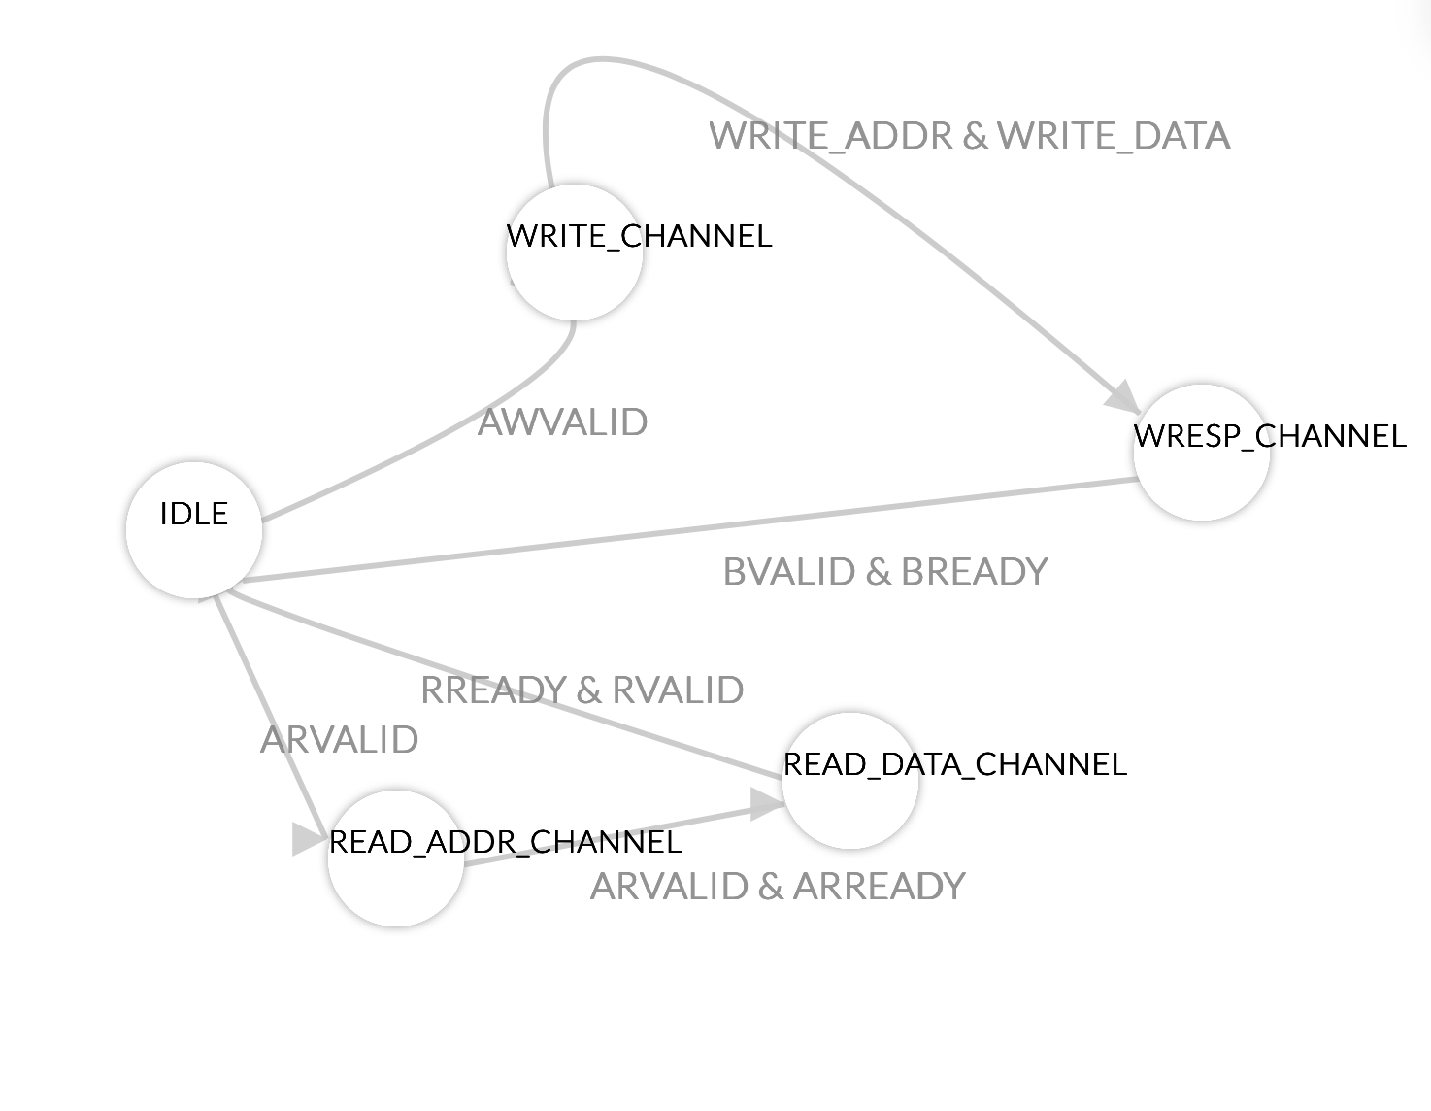

Testbench Structure
The testbench (tb_axi4_lite_slave.sv) implements a self-checking, directed verification environment for the AXI4-Lite slave module. It utilizes Transaction-Level Modeling (TLM) via SystemVerilog tasks to emulate an AXI4-Lite Master device.

1. Parameterization and Signal Declaration
- Parameters: The testbench defines ADDRESS and DATA_WIDTH constants to match the Device Under Test (DUT), ensuring bus width consistency. CLK_PERIOD defines the temporal resolution for the simulation clock.
- Signals: SystemVerilog logic types are declared for all corresponding AXI4-Lite interface ports (Clock, Reset, Read channels, Write channels, and Response channels).

2. Device Under Test (DUT) Instantiation
- The axi4_lite_slave module is instantiated within the testbench.
- The declared logic signals are mapped directly to the DUT ports, establishing the physical connections required for stimulus application and response monitoring.

3. Clock Generation and Reset Initialization
- Clock Generation: A continuous background process (forever loop) toggles the ACLK signal at intervals defined by CLK_PERIOD/2, providing a stable synchronous clock domain.
- Reset Sequence: An initial block asserts the active-low ARESETn signal to 0 to initialize the DUT's Finite State Machine (FSM) and clear the internal register array, followed by a deassertion to 1 to commence standard operation.

4. Transaction-Level Modeling (SystemVerilog Tasks)
To abstract signal-level manipulation, the AXI4-Lite protocol handshaking is encapsulated into two reusable SystemVerilog tasks:
- axi_write(addr, data) Task: Drives the Write Address (AWADDR, AWVALID) and Write Data (WDATA, WVALID, WSTRB) channels. It utilizes wait() statements to stall testbench execution until the DUT asserts the corresponding AWREADY and WREADY signals. It subsequently waits for the BVALID write response before terminating.
- axi_read(addr, data) Task: Drives the Read Address (ARADDR, ARVALID) channel, waits for the ARREADYacknowledgment, asserts RREADY, and captures the resulting RDATA upon the assertion of RVALID.

5. Stimulus Generation and Automated Checking
The primary execution sequence resides within the main initial block:
- Initialization and Logging: Signals are driven to default states, and $dumpfile/$dumpvars system tasks are invoked to enable Value Change Dump (VCD) waveform logging.
- Write Stimulus: The axi_write task applies sequential write transactions to specific byte-aligned addresses (e.g., 0x00, 0x04, 0x08, and the upper boundary 0x7C). This systematically verifies the address truncation logic (addr[ADDRESS-1:2]) within the DUT.
- Read-back and Verification: The axi_read task requests data from the previously written addresses.
- Assertion Logic: A strict inequality operator (!==) compares the captured read_val against the expected hexadecimal constants. Discrepancies trigger a $error system function and increment an internal error accumulator.
- Termination: Upon sequence completion, the testbench evaluates the error accumulator, prints a deterministic pass/fail status to the console, and halts the simulation via $finish.

Testing flow and Coverage

1. Execution Flow
The verification environment executes a deterministic, sequential testing flow to validate the AXI4-Lite slave module operations.
- 1.1 Initialization and Reset Phase: System clock generation commences. The ARESETn signal is asserted low, forcing the internal Finite State Machine (FSM) into the IDLE state and clearing the 32-element memory array to deterministic zero states. ARESETn is subsequently deasserted to begin normal operation.
- 1.2 Write Stimulus Phase: The Bus Functional Model (BFM) initiates independent AXI Write transactions. Hexadecimal data payloads are written to the base address (0x0000_0000), sequential address offsets (0x0000_0004, 0x0000_0008), and the maximum allowable address boundary (0x0000_007C).
- 1.3 Read Verification Phase: The BFM initiates AXI Read transactions targeting the addresses utilized in the Write Stimulus Phase. The internal FSM retrieves the stored data and drives it onto the RDATA bus.
- 1.4 Automated Checking: The testbench captures the read outputs and performs strict inequality (!==) evaluations against the expected constants. Errors trigger simulation alerts and increment a failure counter. A final execution block evaluates the counter to output a definitive pass/fail status.

2. Functional Coverage
The provided testbench infrastructure provides functional coverage for the following architectural components and protocol requirements:
- 2.1 Handshake Protocol Compliance: Verifies the correct generation and assertion of READY signals (AWREADY, WREADY, ARREADY) in response to master VALID assertions. Validates the proper emission of slave VALID signals (BVALID, RVALID) upon transaction completion.
- 2.2 FSM Transition Coverage: Exercises the primary operational paths of the internal state machine.
  - Write Path: IDLE → WRITE_CHANNEL → WRESP_CHANNEL → IDLE.
  - Read Path: IDLE → READ_ADDR_CHANNEL → READ_DATA_CHANNEL → IDLE.
- 2.3 Memory Mapping and Alignment: Validates the combinational address truncation logic (addr[ADDRESS-1:2]). Successfully writing to byte-aligned addresses (multiples of 4) and reading the exact payload verifies that the module correctly translates AXI byte addressing into 32-bit word-aligned memory indices.
- 2.4 Boundary Conditions: Exercises the maximum physical limit of the memory array. Writing to and reading from 0x0000_007C (register index 31) proves the absence of truncation errors or segmentation faults at the upper bounds of the parameterized address space.

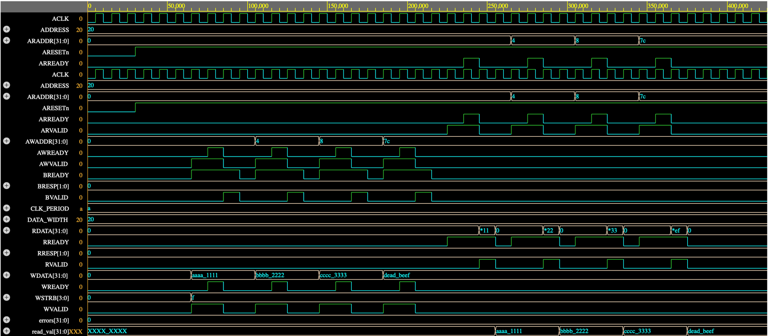
Figure 1: GTKWave Waveform

Synthesised module

Performance Metrics

Appendices

Appendix 1) axi4_lite_slave (RTL code)
module axi4_lite_slave #(
parameter ADDRESS = 32,
parameter DATA_WIDTH = 32
) (
//global signals
input ACLK, //clock signal
input ARESETn, //active low reset signal

//read address channel
input [ADDRESS-1:0] ARADDR, //address of the read transaction
input ARVALID, //indicates that the read address is valid
output ARREADY, //indicates that the slave is ready to accept the read address

//read data channel
input RREADY, //indicates that the master is ready to accept the read data
output RVALID, //indicates that the read data is valid
output [DATA_WIDTH-1:0] RDATA, //data being read from the slave
output [1:0] RRESP, //read response (00: OKAY, 01: EXOKAY, 10: SLVERR, 11: DECERR)

//write address channel
input [ADDRESS-1:0] AWADDR, //address of the write transaction
input AWVALID, //indicates that the write address is valid
output AWREADY, //indicates that the slave is ready to accept the write address
//write data channel
input [DATA_WIDTH-1:0] WDATA, //data being written to the slave
input WVALID, //indicates that the write data is valid
input [DATA_WIDTH/8-1:0] WSTRB, //write strobe (indicates which bytes of WDATA are valid)
output WREADY, //indicates that the slave is ready to accept the write data

//write response channel
input BREADY, //indicates that the master is ready to accept the write response
output BVALID, //indicates that the write response is valid
output [1:0] BRESP //write response (00: OKAY, 01: EXOKAY, 10: SLVERR, 11: DECERR)
);

localparam number_of_registers = 32; // 32 registers of 32 bits each = 128 bytes total address space

logic [DATA_WIDTH-1:0] register [number_of_registers-1:0]; // Register array to hold the data
logic [ADDRESS-1:0] addr; // Register to hold the current address being accessed
logic write_addr; // Signal to indicate a valid write address handshake
logic write_data; // Signal to indicate a valid write data handshake

typedef enum logic [2:0] {IDLE, WRITE_CHANNEL, WRESP_CHANNEL, READ_DATA_CHANNEL, READ_ADDR_CHANNEL} state_t;
state_t state, next_state;

// --- ASSIGNMENTS ---
// Read Channel
assign ARREADY = (state == READ_ADDR_CHANNEL); // Only ready to accept address in the READ_ADDR_CHANNEL state
assign RVALID = (state == READ_DATA_CHANNEL); // Only valid to provide data in the READ_DATA_CHANNEL state
assign RDATA = (state == READ_DATA_CHANNEL) ? register[addr[ADDRESS-1:2]] : '0; // [FIX 1] Address Math: Drop bottom 2 bits to index correctly (4 -> 1)
assign RRESP = 2'b00; // OKAY

// Write Channel
assign AWREADY = (state == WRITE_CHANNEL); // Only ready to accept address in the WRITE_CHANNEL state
assign WREADY = (state == WRITE_CHANNEL); // Only ready to accept data in the WRITE_CHANNEL state
assign write_addr = AWVALID && AWREADY; // Valid handshake for write address
assign write_data = WVALID && WREADY; // Valid handshake for write data

assign BVALID = (state == WRESP_CHANNEL); // Only valid to provide response in the WRESP_CHANNEL state
assign BRESP = 2'b00; // OKAY

integer i;

// --- SEQUENTIAL LOGIC (Registers) ---
always_ff @(posedge ACLK or negedge ARESETn) begin
if (!ARESETn) begin
for (i=0; i<32; i++) begin
register[i] <= 32'b0; // Reset all registers to 0 on reset
end
end
else begin // Handle write operations and address capture for read operations
if (state == WRITE_CHANNEL && write_addr && write_data) begin // Only write to the register when both address and data handshakes are valid
register[AWADDR[ADDRESS-1:2]] <= WDATA; //bottom 2 bits are ignored to index correctly (4 -> 1)
end
else if (state == READ_ADDR_CHANNEL && ARVALID && ARREADY) begin // Capture the address for the read transaction when the handshake is valid
addr <= ARADDR; // Store the address for use in the read data channel (address math will be handled in the combinational logic for RDATA)
end
end
end

// --- SEQUENTIAL LOGIC (State Machine) ---
always_ff @(posedge ACLK or negedge ARESETn) begin
if (!ARESETn) begin
state <= IDLE; //default to IDLE state on reset
end
else begin
state <= next_state;
end
end

// --- COMBINATIONAL LOGIC (Next State) ---
always_comb begin
next_state = state;

case (state)
IDLE: begin
if (AWVALID) begin // If a write address is valid, prioritize the write channel
next_state = WRITE_CHANNEL;
end
else if (ARVALID) begin // If a read address is valid, go to the read address channel
next_state = READ_ADDR_CHANNEL;
end
else begin
next_state = IDLE;
end
end

READ_ADDR_CHANNEL: begin // Wait for the read address handshake to complete before moving to the read data channel
if (ARVALID && ARREADY) next_state = READ_DATA_CHANNEL; // Once the address handshake is complete, move to the read data channel to provide the data and response
end

READ_DATA_CHANNEL: begin // Wait for the read data handshake to complete before returning to IDLE
if (RVALID && RREADY) next_state = IDLE; // Once the data handshake is complete, return to IDLE to wait for the next transaction
end

WRITE_CHANNEL: begin // Wait for both the write address and write data handshakes to complete before moving to the write response channel
if (write_addr && write_data) next_state = WRESP_CHANNEL; // Once both handshakes are complete, move to the write response channel to provide the response
end

WRESP_CHANNEL: begin // Wait for the write response handshake to complete before returning to IDLE
if (BVALID && BREADY) next_state = IDLE; // Once the response handshake is complete, return to IDLE to wait for the next transaction
end
endcase
end
endmodule

Appendix 2) tb_axi4_lite_slave (Testbench code)
`timescale 1ns / 1ps

module tb_axi4_lite_slave();

// ---------------------------------------------------------
// Parameters
// ---------------------------------------------------------
parameter ADDRESS = 32;
parameter DATA_WIDTH = 32;
localparam CLK_PERIOD = 10; // 100 MHz clock

// ---------------------------------------------------------
// Signals
// ---------------------------------------------------------
logic ACLK;
logic ARESETn;

// Read Address Channel
logic [ADDRESS-1:0] ARADDR;
logic ARVALID;
logic ARREADY;

// Read Data Channel
logic RREADY;
logic RVALID;
logic [DATA_WIDTH-1:0] RDATA;
logic [1:0] RRESP;

// Write Address Channel
logic [ADDRESS-1:0] AWADDR;
logic AWVALID;
logic AWREADY;

// Write Data Channel
logic [DATA_WIDTH-1:0] WDATA;
logic WVALID;
logic [DATA_WIDTH/8-1:0] WSTRB;
logic WREADY;

// Write Response Channel
logic BREADY;
logic BVALID;
logic [1:0] BRESP;

// ---------------------------------------------------------
// Device Under Test (DUT) Instantiation
// ---------------------------------------------------------
axi4_lite_slave #(
.ADDRESS(ADDRESS),
.DATA_WIDTH(DATA_WIDTH)
) dut (
.ACLK(ACLK),
.ARESETn(ARESETn),
.ARADDR(ARADDR), .ARVALID(ARVALID), .ARREADY(ARREADY),
.RREADY(RREADY), .RVALID(RVALID), .RDATA(RDATA), .RRESP(RRESP),
.AWADDR(AWADDR), .AWVALID(AWVALID), .AWREADY(AWREADY),
.WDATA(WDATA), .WVALID(WVALID), .WSTRB(WSTRB), .WREADY(WREADY),
.BREADY(BREADY), .BVALID(BVALID), .BRESP(BRESP)
);

// ---------------------------------------------------------
// Clock Generation
// ---------------------------------------------------------
initial begin
ACLK = 0;
forever #(CLK_PERIOD/2) ACLK = ~ACLK;
end

// ---------------------------------------------------------
// AXI4-Lite Master Tasks
// ---------------------------------------------------------

// Task: AXI Write
task axi_write(input [ADDRESS-1:0] addr, input [DATA_WIDTH-1:0] data);
begin
@(posedge ACLK);
AWADDR <= addr;
AWVALID <= 1'b1;
WDATA <= data;
WVALID <= 1'b1;
WSTRB <= 4'hF; // All bytes valid
BREADY <= 1'b1;

// Wait for Slave to accept Address and Data
wait(AWREADY && WREADY);
@(posedge ACLK);
AWVALID <= 1'b0;
WVALID <= 1'b0;

// Wait for Write Response
wait(BVALID);
@(posedge ACLK);
BREADY <= 1'b0;
$display("[TIME: %0t] AXI WRITE -> Addr: 0x%08h | Data: 0x%08h", $time, addr, data);
end
endtask

// Task: AXI Read
task axi_read(input [ADDRESS-1:0] addr, output [DATA_WIDTH-1:0] data);
begin
@(posedge ACLK);
ARADDR <= addr;
ARVALID <= 1'b1;
RREADY <= 1'b1;

// Wait for Slave to accept Address
wait(ARREADY);
@(posedge ACLK);
ARVALID <= 1'b0;

// Wait for Read Data
wait(RVALID);
data = RDATA;
@(posedge ACLK);
RREADY <= 1'b0;
$display("[TIME: %0t] AXI READ <- Addr: 0x%08h | Data: 0x%08h", $time, addr, data);
end
endtask

// ---------------------------------------------------------
// Main Test Sequence
// ---------------------------------------------------------
logic [DATA_WIDTH-1:0] read_val;
int errors;

initial begin
// 1. Initialize Signals
ARESETn = 1'b0;
ARADDR = 0; ARVALID = 0; RREADY = 0;
AWADDR = 0; AWVALID = 0; WDATA = 0; WVALID = 0; WSTRB = 0; BREADY = 0;
errors = 0;

// Setup VCD dumping for waveform viewers (like GTKWave)
$dumpfile("axi_slave_tb.vcd");
$dumpvars(0, tb_axi4_lite_slave);

// 2. Apply Reset
$display("\n--- Applying Reset ---");
#(CLK_PERIOD * 3);
ARESETn = 1'b1;
#(CLK_PERIOD * 3);
$display("--- System Ready ---\n");

// 3. Write Data Sequence (Note: Byte addresses, so we increment by 4)
axi_write(32'h0000_0000, 32'hAAAA_1111); // Register[0]
axi_write(32'h0000_0004, 32'hBBBB_2222); // Register[1]
axi_write(32'h0000_0008, 32'hCCCC_3333); // Register[2]
axi_write(32'h0000_007C, 32'hDEAD_BEEF); // Register[31] (Max offset)

$display("\n--- Starting Read Verification ---");

// 4. Read Data Sequence & Verification
axi_read(32'h0000_0000, read_val);
if (read_val !== 32'hAAAA_1111) begin $error("Mismatch at 0x00!"); errors++; end

axi_read(32'h0000_0004, read_val);
if (read_val !== 32'hBBBB_2222) begin $error("Mismatch at 0x04!"); errors++; end

axi_read(32'h0000_0008, read_val);
if (read_val !== 32'hCCCC_3333) begin $error("Mismatch at 0x08!"); errors++; end

axi_read(32'h0000_007C, read_val);
if (read_val !== 32'hDEAD_BEEF) begin $error("Mismatch at 0x7C!"); errors++; end

// 5. End Simulation
#(CLK_PERIOD * 5);
if (errors == 0)
$display("\n>>> ALL TESTS PASSED SUCCESSFULLY <<<\n");
else
$display("\n>>> FINISHED WITH %0d ERRORS <<<\n", errors);

$finish;
end

endmodule

