Chapter One
Introduction
- Background of the Research
For about 3,000 years ago, wind energy and windmills have been used as an essential source of power for grinding grains, pumping water and in sailing ships (Tony et al., 2001). As a result of the industrial revolution and technological advances, more attractive sources of energy like fossil fuel (coal, oil, and natural gas), hydroelectricity, and nuclear energy were discovered. These conventional sources of energy have served the world for a very long time now and are used for generating electricity to power our homes and industries, our transportation systems like cars, airliners, ocean liners etc. However, these conventional sources of energy are not without their downsides. Fossil fuels are known to emit gasses which cause pollution and global warming. Burning coal, oil and natural gas are responsible for two-thirds of the world’s emission of greenhouse gasses (Jim k., 2016). There is also fear of the possible decrease/depletion of fossil fuel in the future, and fuel prices have been on the rise for some time now. Nuclear energy, on the other hand, has enormous potential to produce electricity but there are enormous dangers associated with radioactive leakage, radioactive waste disposal, and nuclear accidents. The incidents at the Three mile island in the U.S, on March 28, 1979 where a partial meltdown resulted in the release of radioactive gases and radioactive iodine into the environment, Chernobyl nuclear disaster in Ukraine on April 26, 1986 where a reactor exploded during a station black out power-failure safety test which resulted in radioactive material fall-out, and the Fukushima Daiichi nuclear accident in Japan, where an earthquake and tsunami caused a nuclear meltdown, on March 11, 2011 have cast a dark shadow on the future of nuclear power plants. Several groups in the industrialized world have held various campaigns against the use of nuclear energy. In view of the aforementioned dangers of fossil and nuclear energy sources, There is a call globally for countries of the world to key into renewable energy which is part of the 2016 Paris agreement. (UN, 2016).
Renewable energy also called alternative or non-conventional energy sources includes Biomass Energy, Wind Energy, Solar energy, Geothermal energy, and Hydro electric Energy sources. These energy sources are clean and do not cause pollution to the environment. According to the US Energy Information Administration, renewable energy are now the fastest-growing energy source, and are expected to increase by 2.6% per year through 2040, and hydropower and wind energy are the two largest contributors to the increase in the world electricity generation from renewable energy sources (EIA, 2017). However there are some challenges associated with connecting wind energy to the electric grid.
Firstly, the variability and the unpredictability of the wind present some challenges, and secondly, wind turbines are usually decoupled from the grid through the use of inverters and as such do not provide any form of inertia to the grid. Moreover, wind turbines were not originally required to participate in frequency control ancillary services. With the current and future high penetration of wind energy into the grid, this can cause grid frequency instability which could lead to under frequency load shedding an ultimately to blackout.
In light of the aforementioned challenges, this research work seeks to develop and simulate an inertia and primary frequency controller for wind turbines. This has become a matter of necessity since renewable energy in general and wind energy in particular are increasing being added to the generation mix.
- Problem Statement
An electrical grid is an interconnected network for delivering electricity from producers to consumers. It consists of generation stations that produce electrical power, high voltage transmission lines that carry power from distant sources to demand centers, and distribution lines that connect individual centers.
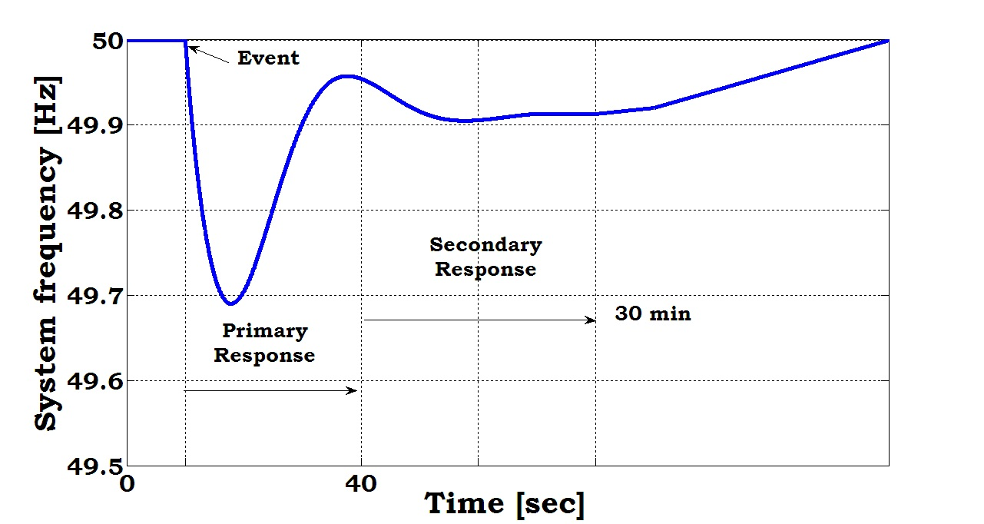
Every grid has a fixed frequency of operation. Small deviations from nominal system frequency are very important in regulating individual generators and assessing the equilibrium of the grid as a whole. When the grid is heavily loaded or when a generator trips the frequency slows and when the grid is lightly loaded the grid frequency runs above the rated nominal frequency. This could compromise grid security and could cause sudden disconnection of load, generator trip, or machine damage and as such appropriate actions must be taken, and in timely manner too, to bring the frequency of the grid back to its nominal value. In a conventional synchronous grid the generators have large rotating masses and must run at the same frequency. During a frequency event, the generators can reduce the rate of change of frequency by using their large mechanical inertia. Governor systems fitted on the generators provide primary frequency response which stabilizes the frequency at a steady-state value, and then the frequency is driven back to its normal value by automatic generation control (AGC) or secondary frequency response. This process
Fig 1.1: Power system response for a typical frequency event
is shown in figure 1.1 above. This process is called Frequency Control Ancillary Services (FCAS). The world is currently diversifying in its electric energy portfolio. Renewable energy is increasing being added to the generation mix and most conventional energy sources are in the process of being retired. Renewable energy sources like Wind energy previously constituted a very small part of the grid and were not required to contribute to the grid frequency response. During frequency events those wind turbines were disconnected from the grid and the conventional sources provided the frequency control ancillary services. Recently, because of the large penetration of renewable power in general and wind power in particular into the grid, this model is fast becoming obsolete and a better model is already replacing it. Wind turbines and wind farms are now required to provide frequency control ancillary services to the grid. This provides a big challenge since the inertial of wind turbine generators is disconnected from the grid by using inverter systems, and wind turbines were not traditionally built to respond to frequency events. This gives rise to the question of how to provide frequency control ancillary services using wind turbines.
- Objectives of the Study
The main objective of this project work is to develop a controller to provide inertia and primary frequency response for Brushless Doubly Fed Reluctance Generator (BDFRG) Wind Turbines (WT). This will provide wind turbines with the ability to provide frequency control ancillary services to ensure the reliability and the stability of the grid. The secondary objectives of this project work are;
- Determination of parameters for the inertial and the primary frequency controllers
- Determination of the appropriate level of the power reserve for the brushless doubly fed reluctance generator wind energy conversion system to participate in grid frequency stabilization.
- Simulation of the developed controllers using Matlab/Simulink
- Test the system behaviours under constant and variable wind conditions
- Justification of Study
Renewable energy sources (RES) like Photovoltaic (PV) systems and Wind Energy Conversion Systems are now gradually dominating the energy generation mix, replacing the traditional generation sources (EIA, 2017). This is the current trend all over the world now and will last for decades to come. Nigeria is not left out of this trend as can be seen by the construction of a 10MW wind farm in Katsina state by the federal government, which is the largest wind installation in west Africa (Aliyu al, 2014). Traditionally, wind energy sources connected to the grid are disconnected during frequency events. With the current high penetration of wind power in the grid and the possibility of replacement of the traditional generation sources by renewable sources the traditional approach of treating wind energy conversion systems as grid following units can lead to grid instability. It has now become a matter of importance to provide wind turbines with the ability to provide frequency control ancillary services and respond to frequency events. High penetration of renewable energy sources like wind energy conversion systems into the grid has a lot of benefits which include reduction of the emission of greenhouse gasses thereby improving public health since wind energy conversion systems have zero emission. Economic benefits which would result in the reduction in the price of electric energy since after the initial cost of construction and setup of renewable energy is covered, it can quickly begin to pay for itself because wind energy is free and requires no fuel cost.
- Scope
This work is limited to the development of inertia and primary frequency controllers to provide inertia and primary frequency response for grid connected Brushless Doubly Fed Reluctance Generator (BDFRG) Wind Turbine (WT). The inertia controller will emulate virtual inertia and reduce the Rate of Change Frequency (ROCOF) and the frequency nadir. The primary frequency controller, on the other hand, will provide a droop-like control for the wind turbine during frequency event.
Chapter Two
Literature Review
- Overview
Air in motion is called wind. Wind is a natural phenomenon occurring everywhere on the earth surface. This occurrence is due to the unequal heating of various points of the earth’s surface by the sun (Ogbulezie F., 2012). The direction and the speed of wind vary in the short and long term. In general, wind has higher speed at higher attitudes. This is because wind moving across the earth’s surface encounters friction caused by the turbulent flow over and around mountains, hills, trees, buildings and other objects. The kinetic energy contained in the wind could be harnessed and converted into other forms of energy, like mechanical and electrical, and be used to meet various human needs. This is especially important now due to the recent green movement, the threats of emissions from burning fossil fuels and the dangers associated with running nuclear plants. Also, no matter the quantity of crude oil and natural gas reserves human beings have, we still run the danger of depleting the reserves since the population of the earth is always increasing and energy usage continues to increase. As such, it has become necessary to harness and include all possible available forms of energy, especially renewable or the so called free energy, including wind energy, into the generation mix.
- History and Development of Wind Power
Long before the advent of electricity and fossil fuels, the process of extracting the kinetic energy in wind and transforming it into mechanical power has been applied by mankind for thousands of years. As early as 5000BC, people used sails to navigate the Nile River. By 900AD, the Persian had already been using wind mills for 400 years (Ogbulezie F., 2012).
The earliest known machine to harness the power of the wind, on land, to power a machine was the wind wheel of the Engineer Heron of Alexandria, in the 1st-century AD, which was used to power and operate an organ (Ogbulezie F., 2012). Heron’s wind wheel is shown in figure 2.1
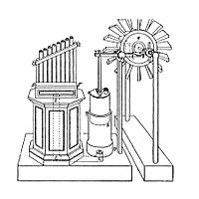
Figure 2.1 : The wind wheel of Heron of Alexandria
Another early example of wind driven wheel was the prayer wheel, which has been used in ancient India, Tibet and China since the 4th century BC.
- Early Wind Power Development
The first practical windmills were used in Iran in a town called Sistan around 7th century BC. These were called Panemone windmills. It had a rotating axis positioned vertical (VAWT) while the blades moved parallel to the direction of the wind as can be seen in fig 2.1 below. By contrast, the shaft of a horizontal axis wind turbine (HAWT) points into the wind while its blades move at right-angle to the wind direction. There were used to pump water in the sugar cane and gristmilling industries. As at then, the windmills were very popular across the Middle East and later Spread to China and India. In North Western Europe, vertical windmills were
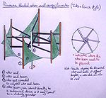 | 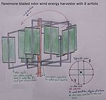
Figure 2.1: Ancient Panemone windmill used by the Turks and the Persians
used to grind flour starting in 1180s, and were used to pump seawater for salt making in China and Sicily as at 1000AD. In the mid-8th century, automata powered by wind were in public displays in some parts of Asia: The wind-powered statues that “turned with the wind over the domes of the four gates and the palace complex of the Round City of Baghdad” (Meri, Josef W., 2005) is a good example. There were also various types of automata displayed in other places in the Middle East. The earliest European windmills called the sunk post mills appeared in the 12th century AD. Figure 2.2 shows a picture of a sunk post mill. The second figure in figure 2.2 shows a medieval representation of a sunk post mill.
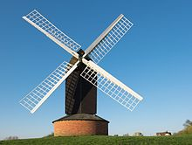 | 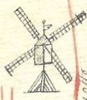
Figure 2.2: Sunk post wind mill
The major feature of the post mill is that the whole body of the mill that houses the machinery is mounted on a single vertical post around which it can be turned to bring the sail into the wind. In the 18th century, windmills were used for salt making on the island of Bermuda, and on Cape Cod during the American revolution (Mark K., 2002). Wind mills were also used to mine flour in some parts of Greece and remained in use till the 20th century. Wind mills were a very attractive source of power during the middle ages because unlike water mills, windmills were not rendered inoperable by the freezing of water in the winter
- 19th Century Wind Power Development
Wind power witnessed a significant growth in the 19th century as this was the first time wind energy was converted into electrical energy. In July 1887, Prof James Blythe of Anderson’s college in Glasgow (now called Strathclyde University) built the world’s first wind turbine used for electricity production (Price Trevor J., 2005). Blyth’s Wind turbine was 10m high, with a cloth sail. This turbine was installed in the garden of his holiday cottage at Marykirk in Kincardineshire and was used to charge accumulators developed by the Frenchman Camille Alphonse Faure, to power the lighting in the cottage, thereby, making Blyth’s cottage the first house in the world to have its electricity supplied by wind (Price Trevor J., 2005). Blyth offered the surplus electricity for lighting the main street of Marykirk but the people of the town rejected the offer, saying electricity was the work of the devil (Price Trevor J., 2005). Prof Blyth later built a wind turbine to supply emergency power to the local Lunatic Asylum, Infirmary and Dispensary of Montros in Scotland, however, the invention was not considered economically viable.
In the US, in 1887 to 1888, Charles F. Brush designed and constructed a wind turbine to produce electricity. The Brush’s wind turbine had a 17m diameter rotor and was mounted on an 18m high tower. Although, the turbine was large physically, it had a power of 12kw only; it turned relatively slow because it had 144 blades. The wind turbine was used to either charge a bank of batteries or to operate up to 100 incandescent light bulbs, three arc lamps, and various motors in Brush’s laboratory. When electricity became available from Cleveland’s central stations the machine fell into disuse after 1900, and was ultimately abandoned in 1908 (Cutler J. Cleveland, 2007).
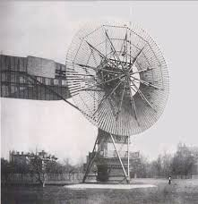
Figure 2.3: Brush’s wind turbine
Figure 2.3 above shows brush’s wind turbine. It had a weight of 4 tonnes and was the first automatically operated wind turbine in the world
In 1891, the Danish scientist, Pour la Cour, constructed a wind turbine to generate electricity. He used the electricity generated from the turbine to produce hydrogen by electrolysis to be stored for use in experiments and to light the Askov High school (Price Trevor J., 2005). Later, he solved the problem of producing a steady supply of power from wind turbine by inventing a regulator, the Kratostate, and in 1895 converted his windmill into a prototype electrical power plant that was used to light the village of Askov (Warmes K., 2013). Figure 2.4 below shows Pour la Cour’s windmill
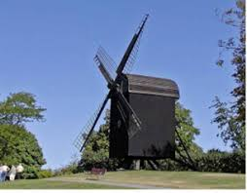
Figure 2.4: Pour la Cour’s windmill
There were as many as 2,500 windmills in Denmark by the end of the 19th century, and produced an estimated combined peak power of about 30MW. In the American Midwest between 1850 and 1900, a large number of small windmills, perhaps six million, were installed on farms to operate irrigation pumps. Wind power was very popular in America then, and some windmill manufacturers like Star, Eclipse, Fairbanks-Morse, and Aeromotor companies were famous suppliers.
- 20th Century Wind Power Development
The wind power development experienced a boom-burst cycle in the 20th century, and many of the theoretical and practical improvements in the wind turbine industry occurred in this period. Developments during this period could be divided into two. The first is the period from 1900 to 1973 and the second is the period from 1973 to 2000.
During the period from 1900 to 1973, because of Pour la Cour’s successful practical development in 1891, wind power was an important part of decentralized electrification in Europe, especially in Denmark. By 1908, there were about 72 wind-driven electric generators in Denmark ranging from 5kw to 25kw. In 1919 the German physicist, Albert Betz published his research which showed that the maximum power that could be extracted from the wind independent of the design of the wind turbine cannot be more than 16/27 (59.3%) of the kinetic energy in this wind. The factor 16/27 (59.3%) is known as Betz’s coefficient. Today practical utility-scale wind turbine have been built that achieve up to 75% to 80% of the Betz’s limit (Ogbulezie F., 2012).
The savonius wind turbine was in invented in 1922 by the Finnish engineer Sigurd Johannes Savonius. Savonius wind turbines are a type of vertical-axis wind turbine (VAWT), used for converting the force of the wind into torque on a rotating shaft. The turbine consists of a number of aerofoils, usually—but not always—vertically mounted on a rotating shaft or framework, either ground stationed or tethered in airborne systems. Figure 5 below shows an example of a Savonius wind turbine design.
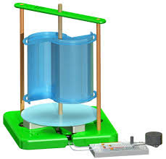 | 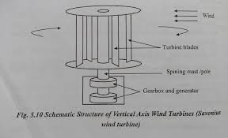
Figure 2.5: Savonius Wind Turbine Concept
In 1926, Georges Jean Marie Darrieus, a French aeronautical engineer, filled a patent for a vertical axis wind turbine design called the Darrieus wind turbine. As shown in figure 2.6, the turbine consists of a number of curved aerofoil blades mounted on a vertical rotating shaft or framework.
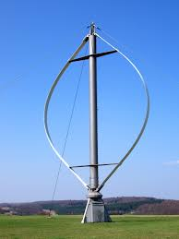 | 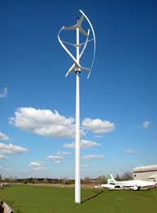
Figure 2.6: Darrieus Wind Turbine Design Concept
There are major difficulties in protecting the Darrieus turbine from extreme wind conditions and in making it self-starting. Unlike the Savonius wind turbine, which is a drag-type VAWT, the Darrieus is a lift-type VAWT. Rather than collecting the wind in cups dragging the turbine around, a Darrieus uses lift forces generated by the wind hitting its aerofoils to create rotation. A combined Darrieus-Savonius wind turbine has been built which uses both drag and lift forces as shown in figure 2.7.
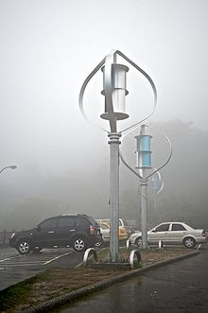
Figure 2.7: Combined Darrieus-Savonius Wind Turbine.
In 1927 the brothers Joe Jacobs and Marcellus Jacobs, known as the Jacobs brothers, opened a factory, Jacobs Wind in Minneapolis to produce wind turbine generators for farm use. These wind turbines were used for charging batteries or lighting farms that were out of the reach of centrally generated electricity and distribution lines. These machines usually had generating capacities of a few hundred watts to several kilowatts (Ogbulezie F., 2012). By the 1930’s, wind power was not only used on farms beyond the reach of centrally generated electricity but were also used for isolated applications such as electrifying bridge structures to prevent corrosion in the US.
A forerunner of the modern horizontal-axis utility-scale wind generators was the WIME D-30 in service in Balaklava, near Yalta, USSR from 1931 until 1942. This was a 100 kW generator on a 30 m (100ft) tower, connected to the local 6.3 kV distribution system. It had a three-bladed 30m rotor on a steel lattice tower (Erich H., 2006). In 1941 the world's first megawatt-size wind turbine, rated 1.25MW, was connected to the local electricity distribution system on the mountain known as Grandpa's Knob in Castleton, Vermont, United States. This turbine was designed by Palmer Cosslett Putnam and manufactured by the S. Morgan Smith Company.
In October 1973, in retaliation for the west’s support of Israel in the Yom Kippur war, the Arab members of OPEC cartel imposed oil embargo on the US and western Europe. This caused a major energy crises and the US government sought for alternative sources of energy. From 1974 through the mid-1980s the United States government worked with the wind energy industry to advance and enable large commercial utility-scale wind turbines. With fundings from the National Science Foundation and later the United States Department of Energy (DOE), a total of 13 experimental wind turbines were put into operation, in four major wind turbine designs. This research and development program pioneered many of the multi-megawatt turbine technologies in use today, including: steel tube towers, variable-speed generators, composite blade materials, partial-span pitch control, as well as aerodynamic, structural, and acoustic engineering design capabilities. The large wind turbines developed under this program set several world records for diameter and power output. Figure 2.8 below shows height and maximum rated power comparisons for some of the turbines developed under this program.
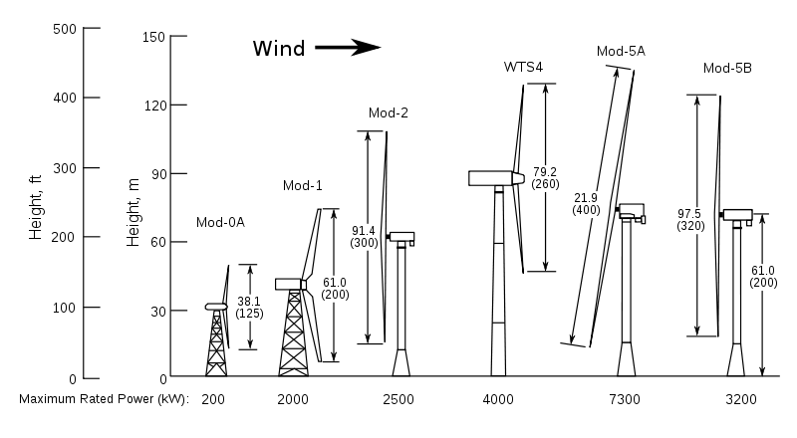
Figure 2.8: Comparison of NASA Experimental wind turbines
The MOD-2 wind turbine cluster of three turbines produced 7.5 megawatts of power in 1981. In 1987, the MOD-5B was the largest single wind turbine operating in the world with a rotor diameter of nearly 100 meters and a rated power of 3.2 megawatts. The MOD-5B had the first large-scale variable speed drive train and a sectioned, two-blade rotor that enabled easy transport of the blades.
When oil prices declined by a factor of three from 1980 through the early 1990s, many wind turbine manufacturers, both small and big, left the business because oil prices made wind turbines for electricity generation uneconomical.
- 21st Century Wind Power Development
In the 21st century, rising concerns over energy security, global warming, clean energy, and eventual fossil fuel depletion led to an expansion of interest in all available forms of renewable energy, as opposed to the oil embargo that caused an increased interest in other forms of renewable energy in the 20th century. The wind power industry began expanding at a robust growth rate of about 25% per year, driven by the readily availability of large wind resources, and falling costs due to improved technology and wind farm management. Technological innovations, enabled by advances in computer aided engineering (Hewitt S., et al, 2017), continue to drive new developments in the application of wind power (Clive P, 2008). In 2010, the Nigerian Government started a 10MW wind farm project, which is able to power up to 2,200 homes, in Katsina state. This is the biggest wind farm in Africa. By late 2011, Japan announced plans to build a multiple-unit floating wind farms, with six 2-megawatt turbines, off the Fukushima coast of northeast Japan where the 2011 tsunami and nuclear disaster has created a scarcity of electric power. By 2014, over 240,000 commercial-sized wind turbines were operating in the world, producing 4% of the world's electricity. Total installed capacity exceeded 336GW in 2014 with China, the U.S., Germany, Spain and Italy leading in total cumulative installations. By 2016, the largest wind turbine, Vestas V164, with a capacity of 8MW, was installed at Burbo Bank, off the west coast of the United Kingdom for offshore use.
Figure 2.9: Top 10 New Installed Wind Capacity January to December 2016
Figure 2.9 above shows the world’s total installed wind capacity in 2016 alone.
- Electricity Grid
An electrical grid is an interconnected network for delivering electricity from producers to consumers. It consists of generation stations that produce electrical power, high voltage transmission lines that carry power from distant sources to demand centers, and distribution lines that connect individual centers. Power stations may be located near a fuel source, at a dam site, or located in some other areas to take advantage of renewable energy sources and are often located away from heavily populated areas. They are usually quite large to take advantage of economies of scale. The generated electric power is stepped to a higher voltage at which it connects to the electric power transmission network. The bulk power transmission network will move the power long distances, sometimes across international boundaries until it reaches its wholesale customer (usually the company that owns the local electric power distribution network). On arrival at a substation, the power will be stepped down from the transmission level voltage to a distribution level voltage. As it exits the substation, it enters the distribution wiring. Finally, upon arrival at the service location, the power is stepped down again from the distribution voltage to the required service voltage(s). Electrical grids vary in size from covering a single building through national grids which cover whole countries, to trans-national grids which can cross continents. Every grid has a fixed frequency of operation. If it is required to connect two or more grids that operate with different frequencies then frequency conversion is required. High voltage direct current links (HVDC) can connect two or more grids that operate at different frequencies or that are not maintaining synchronism.
In a synchronous grid all the generators must run at the same frequency and must stay very nearly in phase with each other and the grid. Generation and consumption must be balanced across the entire grid, because energy is consumed as it is produced.
- History of the Electricity Grid
Early electric energy was produced near the device or service requiring that energy. In 1880s, electricity competed and became advantageous to steam and gas power. Electricity utility companies took advantage of economies of scale and moved to centralized power generation, distribution and management.
In the United Kingdom, the Electricity Supply Bill of 1919 was the first step towards an integrated electricity system. The Electricity (Supply) Act of 1929 led to the setting up of the National Grid.
In the United States in 1920s, utilities formed joint-operations to share peak load coverage and backup power. In 1934, with the passage of the Public Utility Holding Company Act (USA), electric utilities were recognized as public goods of importance. The Energy Policy Act of 1992 required transmission line owners to allow electric generation companies open access to their network (Borberly A., et al, 2001) and led to a restructuring of how the electric industry operated in an effort to create competition in power generation. No longer were electric utilities built as vertical monopolies, where generation, transmission and distribution were handled by a single company. Now, the three stages could be split among various companies, in an effort to provide fair accessibility to high voltage transmission. The Energy Policy Act of 2005 allowed incentives and loan guarantees for alternative energy production and advance innovative technologies that avoided greenhouse emissions (Glover J.D., et al, 2010).
The current trend of the grid is the smart grid. The smart grid uses two-way flows of electricity and information with embedded intelligent devices to improve the electricity delivery networks.
- Electricity Grid Ancillary Services
According to the United States Federal Energy Regulatory Commission (FERC) ancillary services are those services necessary to support the transmission of electric power from seller to purchaser given the obligations of control areas and transmitting utilities within those control areas to maintain reliable operations of the interconnected transmission system. These services are necessary to assure grid security and stability and includes: scheduling and dispatch, reactive and power and voltage control, frequency control, operating reserve and spinning reserve.
- Frequency Control Ancillary Services
Frequency Control Ancillary services (FCAS) are those services required to ensure that the grid frequency stays within a specified range of the nominal frequency. Mismatch between electric power generation and consumption causes variations in frequency, so control services are required to bring the frequency back to its nominal value and ensure it does not vary out of range. In the case of synchronous generators with large rotating masses, the rotating masses provide inertia that reduces the rate of change of frequency of the grid, thereby reducing the frequency nadir. This happens in a matter of few seconds. The governors provide primary frequency response in a matter of minutes to bring the frequency to a steady state value.
- Review of Related Research Works
Research in the field of grid integration of Wind Energy Conversion Systems (WECS) and the issues associated with it is a rapidly growing one. One of this issues is the inertia and primary frequency response of the grid. A number of researchers have conducted researches to study the effect of connecting wind turbines and wind farms to the grid, emulate virtual inertia and provide primary frequency response for wind turbines to participate in grid frequency response. The research works reviewed in the course of this study provided insights on the available technologies for virtual inertia emulation and primary frequency response for various kinds of wind turbines, and research gaps and how to fill those gaps.
Ioannis et al., (2012) studied the frequency stability of an autonomous grid with high penetration of wind power. In their research, a frequency controller was proposed for VSWTs, which incorporates the basic concepts of inertia and droop type of control. The controller was implemented and investigated in DFIG- and PMSG- based WTs. Simulations were also performed both for large transient events, as well as for normal and stochastically varying wind conditions. From his analysis, it was found that VSWTs could provide valuable active power support during transient event that affect system frequency, as well as in normal operation, and under varying wind conditions. The research gap is that the emerging Brushless Doubly Fed Reluctance Generated was not studied nor used in the work.
Yuan et al., (2016) investigated an integrated controller for wind turbines with both inertial response and primary frequency regulation to provide dynamic frequency support for grid with high wind power penetration. The wind turbine control governor contained two cross-coupled controllers: pitch controller and MPPT controller with a proposed Virtual Inertia Controller (VIC) scheme. Under de-loading operation condition, the VIC scheme proposed would switch the wind turbine’s active power reference from the MPPT curve to the VIC curve according to the system frequency variation to provide fast controlled active power for inertia support to the grid. The shortcomings of the work is that the simulation was done under constant wind conditions and was only carried out for Doubly Fed Induction Generator (DFIG).
Vidyanandan et al., (2013) presented an active power control method to enable variable speed DFIG based wind turbines to participate in primary frequency regulation. This controller worked by de-loading the Wind Turbine Generators (WTGs) by 10% to 20% from the optimum power condition, the actual percentage depending on the existing wind speed and the allowable maximum limit of the DFIG rotor speed. Then, by continuously adjusting the droop (Variable Droop) of the WTGs in response to the wind velocity it was found that the primary frequency support improved and frequency smoothing after frequency event was better than using fixed droop. The shortfall was that the research was carried out under fixed wind conditions and the Emerging Brushless Doubly Fed Reluctance Generator was not considered.
Obichere et al., (2016) presented a Vector Control (VC) method for controlling the power factor of the emerging Brushless Doubly-Fed Reluctance Generator (BDFRG). This method was evaluated under the Optimum Power Factor Control (OPFC) conditions, using Matlab and Simulink, which resulted in the improved efficiency of the generator-converter set and the entire Wind Energy Conversion System (WECS). However, the inertia and the primary frequency control for the BDFRG contribution to the grid was not considered.
Maryam et al., (2016) proposed a Predictive Direct Power Control (PDPC) method for tracking the active and reactive power of Brushless Doubly Fed Reluctance Generator (BDFRG). The active and reactive power variations of the primary (power) winding of the generator were predicted by the controller and used to calculate the required voltage of the secondary (control) winding to eliminate power errors. MATLAB/Simulink software was utilized to simulate the BDFRG and the proposed control method. The original Direct Power Control (DPC) strategy was simulated for comparison. The proposed method showed a good power tracking. The proposed method also showed lower power ripple and a better precise control of both the active and reactive powers were achieved. However, the inertia and primary frequency control was not considered, and the simulation was conducted under constant wind condition.
- Wind Farm
A Wind Farm (WF) is a group of wind turbines in the same location used to produce electricity. A large wind farm may consist of several hundred individual wind turbines and cover an extended area of hundreds of square miles, but the land between the turbines may be used for agriculture or other purposes. A wind farm may also be located offshore.
As a general rule, economic wind generators require windspeed of 4.5 m/s (16 km/h) or greater. An ideal location would have a near constant flow of non-turbulent wind throughout the year, with a minimum likelihood of sudden power bursts of wind. Another important factor in siting wind farms is access to local demand or transmission capacity.
- Wind Turbine
A wind turbine is a device that converts the wind’s kinetic energy into electrical energy. Wind turbines can rotate about either a the horizontal axis, called Horizontal Axis or vertical axis, the former being both older and more common. Figure 2.10 shows the internal view of a wind turbine. The wind hitting the rotor causes it to rotate. This rotation is transferred to the generator through the shaft and gearbox. The
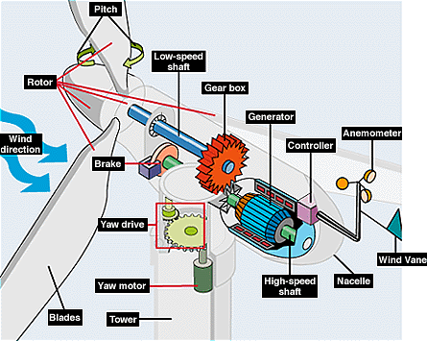
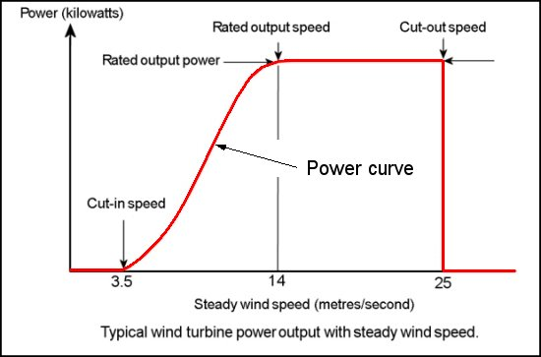
Figure 2.10: Internal View of a Wind Turbine
Figure 2.11: Power Curve for wind turbines
rotation of the generator produces Alternating Current (AC) electricity. The turbine then drives an AC/DC/AC converter which converts the AC to Direct Current (DC) with a rectifier and then back to AC with an inverter in order to match the frequency and phase of the grid.
The speed at which a wind turbine rotates must be controlled for efficient power generation and to keep the turbine component within designed speed and torque limits. Wind turbines are designed to produce power over a range of wind speeds. The cut-in speed is around 3-4 m/s for most turbines, and cut-out at 25 m/s. Below rated wind speed, the generator torque control is active while the blade pitch is typically held at constant angle that captures the most power, above rated wind speed, the generator torque is typically held constant while the blade pitch is active.

Chapter Three
Materials and Method
The materials and the method to be employed in the course of this research work include the following:
- Materials
- Laptop Computer
- Matlab/Simulink Software
- Model of a Wind Energy Conversion System
- Model of Electricity Grid
- Simulink Power System Toolbox
- Method
The methodology consists in counteracting grid frequency deviations by controlled active power injection into the grid. This will be achieved by concerted effort between Virtual Inertia Response (VIR) and Primary Frequency Response (PFR).
Figure 3.1 shows a conceptual view of the entire system. The focus of this research work is on the controller shown in the diagram. A PD controller will be used and modified accordingly to achieve the desired result.
Aero-dynamic Sub-system
Mechanical Sub-System
Electrical Sub-System
Grid
Controller

Fig 3.1: Conceptual Model of a Wind Energy Conversion System

REFERENCES
Tony, B., David, s., Nick, J., & Ervin, B. (2001). Wind Energy Handbook. John Wiley and Sons Ltd
Jim, K. (2016). Climate and Fossil Fuel Industry: Two feet High and Rising. Rice University’s Institute for Public Policy. Retrieved from : https://www.bakerinstitute.org/media/files/research_document/6b58fc69/WorkingPaper-ClimateRisk-072116.pdf
United Nations (2016). Adoption of the Paris Agreement. Retrieved from: https://unfccc.int/resource/docs/2015/cop21/eng/l09r01.pdf
U.S Energy Information Administration (2017). International Energy Outlook 2016. Retrieved from: https://www.eia.gov/outlooks/ieo/pdf/0484(2017).pdf
U.S Energy Information Administration. Annual Energy Outlook 2017; U.S Department of Energy: Washington, DC, USA, 2017. Retrieved from: https://www.eia.gov/outlooks/aeo/pdf/0383/(2017).pdf (accessed on 21 June 2017)
Aliyu D., Mohammed A. (2014). Assessment of Wind Energy Alternative in Nigeria from the Lessons of the Katsina Wind Farm. Civil and Environmental Research. Retreived from www.iiste.org/Journals/index.php/CER/article/download/12147/12499 (accessed on 5 October 2017)
Ogbulezie Francis., (2012). Computer-aided Design of Horizontal-axis Wind Turbine Blades: A Thesis submitted to the Postgraduate School Federal University of Technology
Meri, Josef W., (2005). Medieval Islamic Civilization: An Encyclopedia 2. Routledge. P. 711. ISBN 0-415-96690-6
Mark Kurlansky., (2002) Salt: a word history, Penguin Books, London ISBN 0-14-200161-9, pg. 419
Price, Trevor J. (2005). “James Blyth – Britain’s First Modern Wind Power Engineer”. Wind Engineering. 29 (3): 191-200
Cutler J. Cleveland (2007) History of Wind Energy: Encyclopedia of Energy Vol. 6, Elsevier, ISBN 978-1-60119-433-6, pp. 421-422
Warmes, Kathy “Poul la Cour Pioneered Wind Mill Power in Denmark”. History, because it’s there. Retrieved from https://web.archive.org/web/20130129092021/http://historybecauseitshere.weebly.com/poul-la-cour-pioneered-wind-mill-power-in-denmark.html (accessed on 21 December 2017)
Erich Hau, Wind turbines: fundamentals, technologies, application, economics, Birkhauser, 2006 ISBN 3-54024240-6, page 32
Hewitt Sam, Margetts Lee & Revell, Alistair (2017). “Building a digital wind farm”. Archives of Computational Methods in Engineering. Retrieved 20 April 2017
Clive, P. J. M., (2008)Windpower 2.0: Technology rises to the challenge; Environmental Research. Retrieved from http://environmentalresearchweb.org/cws/article/opinion/36322
Borberly, A. and Kreider, J.F. (2001). Distributed Generation: The Power Paradigm for the New Millennium. CRC Press, Boca Raton, FL.
Glover J. D., Sarma M. S., Overbyte T. J. (2010) Power System Analysis 5th Edition. Cengage Learning. Pg 10.
Ioannis, D. M., Stavros, A. P., Nikos, D. H., Anca D. H., & Poul S. (2012). Frequency Control in Autonomous Power Systems with High Wind Power Penetration. IEEE Transaction on Sustainable Energy, Vol. 3, No. 2, April 2012
Yuan, F., Yi, W., Xiangyu, Z., (2016). An Integrated Wind Turbine Controller with Virtual Inertia and Primary Frequency Response for Grid Dynamic Frequency Support. IET Renewable Power Generation, Vol. 11, Issue. 8
Vidyanandan, K. V., Nilanjan, S. (2013). Primary Frequency Regulation by De-loaded Wind Turbines using Variable Droop. IEEE Transaction on Power Systems, Vol. 28, Issue. 2
Obichere, K. O., Jovanovic, M., & Ademi, S. (2016). Improved Power Factor Controller for Wind Generator and Applications. Engineering Letters, 24:2, EL_24_2_01
Maryam, M., Rasool, K., & Mohammed-Reza, A. (2016). Model-based predictive Direct Power Control of Brushless Doubly Fed Reluctance Generator for Wind Power Applications. Alexandria Engineering Journal. doi: dx.doi.org/10.1016/j.aej.2016.08.004

