Test & Design Document

References
- https://www.cleveroad.com/blog/how-to-create-a-chatbot-for-business--step-by-step-guide-with-an-estimation
- https://blog.chatteron.io/how-to-build-a-kick-ass-ux-for-your-chat-bot-f01b46c551db
- https://medium.freecodecamp.org/what-does-it-take-to-build-a-chatbot-lets-find-out-b4d009ea8cfd
- https://moz.com/blog/chat-bot
- https://apps.worldwritable.com/tutorials/chatbot/
- https://www.webmd.com/allergies/food-triggers#1
- http://allrecipes.co.uk/?o_is=TopNav_Logo
- https://veganuary.com/recipe-categories/quick-easy-vegan-recipes/?gclid=EAIaIQobChMI1s_k7L632gIVDhoYCh3vnwRqEAAYASAAEgJDt_D_BwE

Design
Large Scale

The task at hand is to create a chatbot. An important point to note about the task I selected is that due to its complexity, I have been given a lot of freedom in both my implementation of the program and what the program will do. This means that at the application level, I will mostly have to define the functionality of the the program myself other than the two parts I have been given:

- “Reading input from the user and trying to understand it”
- “Writing a reply to the user that makes sense”

With only the input and output barely defined, the whole process part of the program is up to me to define.

The first thing to do with the task is to simply it by placing my own constraints. As someone with no experience in AI, a very complex field, the more constraints I can add to the task, the better. The first and most effective contrast is to make it scripted chatbot rather than an intelligent one. This means that rather than focusing on artificial intelligence, I have shifted the focus to the clever use of databases and scripted questions.

The second constraint is to select a topic. A general purpose chatbot would require an extensive understanding of human conversation and an equally impressive database to back it up. We combat this by selecting a niche area where we can limit the expected input and output, reducing the size of the database and the size of valid information the program will have to take. The key point here is to find a niche that will massively reduce the size of the program, but not over simplify the task, as this is still a graded piece of coursework.

After a lot of consideration I have decided on a chatbot based on food. It will have a structured conversation with the user, gaining information about there tastes and eating habits with the ultimate end goal of recommending them a meal to cook. This conversation can be broken down into stages:
- The introduction; this will be a polite exchange of greetings, as it is customary to start a conversation like this. This opens up the option for the bot to learn the name of the user.
- The next bit will be the bot querying the user about their taste in food, with the end goal of giving them a suggestion. The information that is important is:
- The degree of cooking skill, either as a number on a scale of 1-10 or statements such as easy, medium or difficult.
- Any allergies or hated foodstuffs that will negate the validity of recipes.
- Any ingredients or flavours that they enjoy to prioritise a recipe.
- Time they are willing to spend cooking.
- What kind of meal are they cooking for (although depending on complexity, it might be limited to one meal, but I'd rather have the option).
- The actual suggestion and then some closing options and the ability to get another suggestion if the one given was not to the users liking.

An overview of the average process would be introduction → update user profile → loop(query → update profile) → use the profile to navigate a database of recipes → option to “re-roll” suggestion → closing lines.

Now that we have the three stages of the conversation that makes up the functionality of the bot we can start to look at some of the programming aspects before looking at things at a closer scale. The input will be entered text, meaning that I will be using C's string library for a lot of string manipulation and comparison, as well as the standard I/O library to enter the text and output replies.

The recipes will probably be saved as structures, those are supported in C so no libraries would be required. The ingredients would also need to be stored, the least complex option would be to store them as boolean types, this isn't supported in C and while there is a library to include the boolean type, I can very easily create the type. Allergies will certainly be stored as booleans.

The output of the program will always text, as such it will require the same standard I/O library that is needed for the user to input text. The text itself will probably either be static or a few similar phrases that are chosen from random, meaning that the random library would also need to be used.

With all the high level implementations, we can take our three stages of the discussion, sandwich it between methods of getting input and producing output and start thinking about a modular method to these five steps, and the iterative approach to take a working model with limited functionality to an acceptable end product.

Medium Scale

Let express the program as a model, there we can easily visualise the components of it and isolate modules and work out dependencies, giving us an idea of what functions will need to be implemented first.

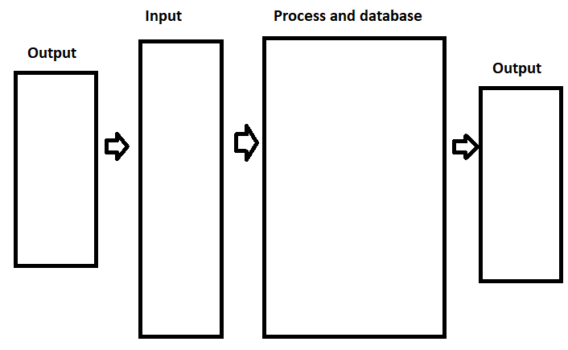
This is the standard operating loop for the program. As you can see it is a little different from the standard input, process, output cycle, as everything starts and ends with the bot talking. She will start with a reply to the previous statement and end with a query for the next one. It is also worth noting that these two outputs are not the same, as they will both have their own modules, and the second output indirectly relies on the first.

Output (1)
The first output exists to ask questions to the user, directing the nature of the input. This will mostly follow a set script, with some pathing based off key limits like allergies or being a vegetarian. This will consist of one module that will be mostly conditional print statements that will take no inputs itself, but will rely on conditions based on the user profile that is updated on a different module, this part is likely to exist on the main, what will lower overall efficiency, but also lowers complexity.

Input
This is the only part of the program that takes input and consists of two parts. The first part is easy, it just scans the entered input. This will most likely be part of the main as well, paired with the first output. The second part of this second is a function that takes the input string and changes it into tokens. A token would be every word, or every character that isn't separated by a space. These tokens would have to be saved as the function doesn't use them, meaning some type of array or list would be required.

Process and Database
By far the most complex part of the program it consists of:
- an ingredient database;
- a recipe database;
- a profile database that will need to be filled with variables and booleans. This database will be implemented as a structure type, as it would be able to be modified by functions defined outside of the main, but passed back into the main;
- a function that reads the array or list from the input function and updates the database;

Output (2)
While still a script like the first output that would be in the main, this script involves heavy pathing and is dependant on the users profile to pick the next output, as they are all direct replies to the input from the user. The size of this script due to all the possible conditions will probably be its own module as it would very well likely will be much longer than the rest of the main, and will be a major part of the iterative process of refining and increasing the output.

Testing

Due to the nature of a chatbot, there are two different types of testing that I will have to perform throughout development:
- Functional: This first part concerns itself in the early stages of development and will test the functions that will make up the key processes of the program.
- Performance: The second part is more exclusive to this program, as while all the functions will work as intended, a lot of input testing will have to be run to ensure that the program is able to perform under a lot of varied responses.

Due to the bulk of early development will be performed outside of labs, I will have to leave the valgrind tests to much later in the development cycle. The vast majority of test will be with printf statements and paper based testing to try to plan for multiple inputs for a single output.

The test cases for the first part of the program will be simple:
- The first test will be to take full sentence inputs. This will consist of a printf function after the input printing the result. I will then visually compare the output to my input. The test cases will be single words, full sentences, full sentences with punctuation and integers. Later testing will follow this function to decide an appropriate size of the inputs.
- The next test will be a test of the databases. I'll by trying to define two ingredients, bacon and bread. I will then create an if statement that will print only if bacon is classed as a meat.
- The next test would be the for the scanner function. I'd have a statement that prints the contents of the array, and compare this output to my input, it should be each word printed on its own line, the cases are identical to the ones in the first test case.
- The next test would be for the function that reads the array created by the scanner and updates the user's profile. This test will ask the user if they can eat meat, there will be two conditions based on if the user database says that they can eat meat or not, each with two printf statements. At this level, the responses will be yes or no.
- At this point, the program can take input, update a profile and choose it's response based on the answer given, the set of tests will be based on expected inputs and outputs and all relate to the update function taking multiple different inputs

Development notes:
Some errors with the food database has lead to a change in how the program will work. There will be be a shift away from the importance of the ingredients and more on getting information from the user, this will make the bot less structured, but this may be for the better. This change has also came from the thought that the ingredients can be abstracted to the recipes, and branching can take care of the allergies and other constraints.

